Sr. No. | Practical Name | Page No. | Teachers Sign
1 | Explain Client-Server Architecture and Observation of HTTP Requests and Responses using Browser Developer Tools.
2 | Create a basic blog webpage that includes a header, paragraph text, and both ordered and unordered lists.
3 | Insert an image and add hyperlinks, including both internal (within the same website) and external (to other websites) links.
4 | Structure the blog content using semantic HTML tags such as <header>, <main>, and <footer> for better readability and SEO.
5 | Design a contact form that includes a variety of input elements such as text fields, radio buttons, checkboxes, dropdown selections, and a textarea.
6 | Construct a product listing section using an HTML table, incorporating borders, cell spacing, and alignment features for proper layout.
7 | Enhance the webpage with a favicon and appropriate meta tags to improve SEO and user experience.
8 | Apply internal and external CSS styles to format the blog page, demonstrating control over presentation.
9 | Utilize class selectors, ID selectors, and element selectors to style specific components of the webpage. Demonstrate CSS rule precedence and specificity by combining inline, internal, and external styles in one project.
10 | Use CSS to apply text formatting, background colors, borders, padding, and margins to different webpage elements.
11 | Illustrate the CSS box model by styling elements with borders and adjusting their spacing properties.
12 | Implement a variety of CSS units such as em, rem, % and px to observe how different units impact design.
13 | Design a responsive navigation bar using Flexbox properties such as justify-content and align-items.
14 | Implement media queries to ensure the layout adapts correctly on different screen sizes like mobile and desktop.
15 | Apply responsive design properties like min-width, max-width, and include the viewport meta tags for mobile optimization.
16 | Create interactive hover effects using pseudo-classes like: hover and :active on various elements.
17 | Use pseudo-elements ::before and ::after to insert decorative or functional content without modifying HTML.
18 | Develop a simple CSS animation (e.g., fading in/out or transforming a button on hover).
19 | Develop a Web Page Layout using Bootstrap Grid System and Utility Class.

Program 1
  - Title of Program: Explain Client-Server Architecture and Observation of HTTP requests and responses using Browser Developer Tools.
Code:
Client-Server Architecture
Client-server architecture is a distributed computing model where tasks are divided between "clients" and "servers" over a network. Clients are typically user-facing applications (like web browsers or mobile apps) that initiate requests for resources or services. Servers are powerful computers or programs that provide those resources or services in response to client requests.
The interaction follows a request-response model:
- Client Request:
A client sends a request to the server, specifying the desired resource or action (e.g., retrieving a webpage, submitting data).
- Server Processing:
The server receives the request, processes it (e.g., retrieves data from a database, executes an application logic), and prepares a response.
- Server Response:
The server sends the response back to the client, which may contain the requested data, an acknowledgment of an action, or an error message.
Observing HTTP Requests and Responses with Browser Developer Tools
Browser developer tools provide a powerful suite of features for web developers to inspect and debug web applications, including the ability to observe the HTTP requests and responses exchanged between the browser (client) and web servers.
- Opening Developer Tools:
Most browsers (Chrome, Firefox, Edge, Safari) allow opening developer tools by right-clicking on a webpage and selecting "Inspect" or by pressing F12 (Windows) or Cmd + Option + I (macOS).
- Navigating to the Network Tab:
Within the developer tools, navigate to the "Network" tab. This tab displays a chronological log of all network activity, including HTTP requests and responses.
- Initiating Network Activity:
To observe requests and responses, perform an action on the webpage that triggers network communication, such as:
  - Reloading the page.
  - Clicking a link.
  - Submitting a form.
  - Interacting with dynamic content (e.g., loading more items in an infinite scroll).
- Inspecting Individual Requests:
Each row in the Network tab represents an individual HTTP request. Clicking on a specific request reveals detailed information in a separate panel, typically including:
  - Headers: Request headers (e.g., User-Agent, Accept) and response headers (e.g., Content-Type, Set-Cookie).
  - Payload/Request: The data sent in the request body (e.g., form data for a POST request).
  - Preview/Response: The raw content of the server's response (e.g., HTML, JSON, images).
  - Timing: A timeline showing the different stages of the request (e.g., DNS lookup, connection, sending, waiting, receiving).
By utilizing the Network tab in browser developer tools, developers can gain insights into how a web application communicates with its backend, troubleshoot network-related issues, and optimize performance.

Output:

Program 2

Title of Program: Create a basic blog webpage that includes a header, paragraph text, and both ordered and unordered lists.

Code:
<header>
<h1>Welcome to My Blog</h1>
</header>
<article>
<h2>My First Blog Post</h2>
<p>Today, I'm starting my new blog! I'll be sharing my thoughts on technology, learning, and personal development.
Here are a few things I'll be writing about:
</p>
<h3>Topics I'll cover (Unordered List)</h3>
<ul>
<li>Web development</li>
<li>Artificial intelligence</li>
<li>Productivity tips</li>
<li>Personal projects</li>
</ul>
<h3>My Blogging Goals (Ordered List)</h3>
<ol>
<li>Write one post every week</li>
<li>Engage with readers in the comment</li>
<li>Improve my writing skills</li>
<li>Share valuable knowledge</li>
</ol>
</article>
</body>
</html>

Output:
Welcome to My Blog
My First Blog Post
Today, I'm starting my new blog! I'll be sharing my thoughts on technology, learning, and personal development. Here are a few things I'll be writing about:
Topics I'll cover (Unordered List)
- Web development
- Artificial intelligence
- Productivity tips
- Personal projects
My Blogging Goals (Ordered List)
- Write one post every week
- Engage with readers in the comment
- Improve my writing skills
- Share valuable knowledge

Program 3
Title of Program: Insert an image and add hyperlinks, including both internal (within the same website) and external (to other websites) links.

Code:
  - <!DOCTYPE html>
  - <html>
  - <head>
  - <title>Image and Hyperlink Example</title>
  - </head>
  - <body>
  - <h2>Example of Image and Hyperlinks</h2>
  - <!-- External hyperlink-->
  - <p>Visit
  - <a href-"https://www.openai.com" target="_blank">
  - OpenAI's Website
  - </a>
  - for more information.
  - </p>
<!-- Internal hyperlink -->
  - <p>Go to our
  - <a href="about.html">About Us</a>
  - page (internal link).
  - </p>
  - <!-- Image insertion -->
  - <img src="C:\Users\Rajes\OneDrive\Attachments\disneyland.jpg" alt="sample image" width="300" height="200">
  - <!-- Image as a hyperlink (external) -->
  - <p>
  - <a href="https://wikipedia.org" target="_blank">
  - <img src="C:\Users\Rajes\OneDrive\Attachments\disneyland.jpg" alt="wikipedia logo" width="150">
  - </a>
  - </p>
  - <!-- Image as an internal hyperlink -->
  - <p>
  - <a href="contact.html".
  - <img src="C:\Users\Rajes\OneDrive\Attachments\disneyland.jpg" alt="Contact Us" width="100">
  - </a>
  - </p>
  - </body>
  - </html>

Output:

Example of Image and Hyperlinks
Visit OpenAI's Website for more information.
Go to our About Us page (internal link).



Program 4
Title of Program: Structure the blog content using semantic HTML tags such as <header>, <main>, and <footer> for better readability and SEO.

Code:
<header>
<h1>Web Dev Insights</h1>
<nav>
<ul>
<li><a href="#home">Home</a></li>
<li><a href="#articles">Articles</a></li>
<li><a href="#about">About</a></li>
</ul>
</nav>
</header>

<!-- Main Blog Content -->
<main>
<article>
<header>
<h2>Understanding Semantic HTML for Better SEO</h2>
<p><time datetime="2025-11-02">November2, 2025</time> by <strong>Tamana Aggarwal</strong></p>
</header>

<section>
<h3>What is Semantic HTML?</h3>
<p>Semantic HTML uses tags that have a specific meaning to both the browser and the developer. Examples include &lt;header&gt;, &lt;main&gt;, &ltarticle&gt;, and &lt;footer&gt;.</p>
</section>

<section>
<h3>Why Semantic HTML improves SEO</h3>
<p>Search engines use semantic tags to better understand the structure and importance of content on a webpage. This helps improve your website's search rankings.</p>
</section>

<section>
<h3>Conclusion</h3>
<p>By structuring your blog with semantic HTML, you enhance accessibility, readability, and
SEO performance.</p>
</section>
</article>
</main>

<!-- Footer Section -->
<footer>
<p>&copy; 2025 Web Dev Insights. All rights reserved.</p>
<nav>
<a href="#privacy">Privacy Policy</a>
<a href="#contact">Contact Us</a>
</nav>
</footer>

</body>
</html>

Output:
Web Dev Insights
- Home
- Articles
- About
Understanding Semantic HTML for Better SEO
November2, 2025 by Tamana Aggarwal
What is Semantic HTML?
Semantic HTML uses tags that have a specific meaning to both the browser and the developer. Examples include <header>, <main>, <article>, and <footer>.
Why Semantic HTML improves SEO
Search engines use semantic tags to better understand the structure and importance of content on a webpage. This helps improve your website's search rankings.
Conclusion
By structuring your blog with semantic HTML, you enhance accessibility, readability, and SEO performance.
© 2025 Web Dev Insights. All rights reserved.
Privacy Policy Contact Us

Program 5
Title of Program: Design a contact from that includes a variety of input elements such as text fields, radio buttons, checkboxes, dropdown selections, and a textarea.

Code:
<body>
<h2>Contact Us</h2>
<form action="#" method="post">
<!-- Name -->
<label for="name">Full Name:</label>
<input type="text" id="name" name="name" placeholder="Enter your full name" required>

<!-- Email -->
<label for="email">Email Address:</label>
<input type="email" id="email" name="email" placeholder="Enter your email" required>

<!-- Gender -->
<label>Gender:</label>
<input type="radio" id="male" name="gender" value="Male">
<label for = "male" style="display:inline;">Male</label>
<input type="radio" id="female" name="gender" value="Female">
<label for="female" style=display:inline;">Female</label>
<input type="radio" id="other" name="gender" value="Other">
<label for="other" style="display:inline;">Other</label>

<!-- Services (Checkboxes) -->
<label>Services Intersted In:</label>
<input type="checkbox" id="web" name="services" value="Web Development">
<label for="web" style="display:inline;">Web Development</label> <br>
<input type="checkbox" id="app" name="services" value="App Design">
<label for="app" style="display:inline;">App Design</label><br>
<input type="checkbox" id="seo" name="services" value="SEO Optimization">
<label for="seo" style="display:inline;">SEO Optimization</label>

<!-- Country Dropdown -->
<label for="country">Country:</label>
<select id="country" name="country">
<option value="">--Select Your Country--</option>
<option value="India">India</option>
<option value="USA">USA</option>
<option value="UK">UK</option>
<option value="Canada">Canada</option>
<option value="Australia">Australia</option>
</select>

<!-- Message -->
<label for="message">Your Message:</label>
<textarea id="message" name="message" rows="5" placeholder="Type your message here..."></textarea>

<!-- Submit Button -->
<button type="submit">Submit</button>
</form>
</body>
</html>

Output:

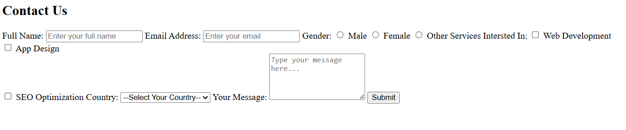

Program 6
Title of Program: Construct a product listing section using an HTML table, incorporating borders, cell spacing, and alignment features for proper layout.

Code:
<body>
<h2>Product Listing</h2>
<table>
<thead>
<tr>
<th>Product Image</th>
<th>Product Name</th>
<th>Category</th>
<th>Price (USD)</th>
<th>Availability</th>
</tr>
</thead>

<tbody>
<tr>
<td><img src="C:\Users\Rajes\OneDrive\Desktop\laptop.jpeg" alt="Laptop"></td>
<td>Ultrabook Pro 14</td>
<td>Electronics</td>
<td>$999</td>
<td>In Stock</td>
</tr>

<tr>
<td><img src="C:\Users\Rajes\OneDrive\Attachments\headphones.jpeg" alt="Headphones"></td>
<td>Noise Cancelling Headphones</td>
<td>Accessories</td>
<td>$199</td>
<td>In Stock</td>
</tr>

<tr>
<td><img src="C:\Users\Rajes\OneDrive\Desktop\smartwatch.jpeg" alt="Smartwatch"></td>
<td>Smartwatch X5</td>
<td>Wearables</td>
<td>$249</td>
<td>In Stock</td>
</tr>

<tr>
<td><img src="C:\Users\Rajes\OneDrive\Desktop\tablet.jpeg" alt="Tablet"></td>
<td>TabMate 10.1</td>
<td>Electronics</td>
<td>$499</td>
<td>In Stock</td>
</tr>
</body>
</table>
</body>
</html>

Output:
  - Product Listing
- Product Image | - Product Name | - Category | - Price (USD) | - Availability
-  | - Ultrabook Pro 14 | - Electronics | - $999 | - In Stock
-  | - Noise Cancelling Headphones | - Accessories | - $199 | - In Stock
- 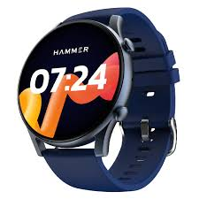 | - Smartwatch X5 | - Wearables | - $249 | - In Stock
- 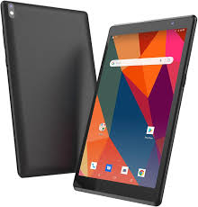 | - TabMate 10.1 | - Electronics | - $499 | - In Stock

Program 7

Input of Program: Enhance the webpage with a favicon and appropriate meta tags to improve SEO and user experience.

Code:
<!DOCTYPE html>
<html lang="en">
<head>
<!-- Basic Page Setup -->
<meta charset="UTF-8">
<meta name="viewport" content="width=device-width, initial-scale=1.0">
<title>TechSphere | Innovative Tech Solutions</title>

<!-- SEO Meta Tags -->
<meta name="description" content="TechSphere provides the latest insights and solutions in technology, innovation, and software development. Stay updated with expert blogs and tutorials.">
<meta name="keywords" content="technology, software, innovation, coding, AI, web development, programming tutorials">
<meta name="author" content="Tamana Aggarwal">

<!-- Open Graph (Social Media Sharing) -->
<meta property="og:title" content="TechSphere | Innovative Tech Solutions">
<meta property="og:description" content="Stay updated with the latest trends in technology and innovation at TechSphere.">
<meta property="og:image" content="https://example.com/images/preview.jpg">
<meta property="og:url" content="https://example.com">
<meta property="og:type" content="website">

<!-- Favicon Links -->
<link rel="icon" type="image/png" sizes="32x32" href="https://example.com/favicon-32x32.png">
<link rel="icon" type="image/png" sizes="16x16" href="https://example.com/favicon-16x16.png">
<link rel="apple-touch-icon" href="https://example.com/apple-touch-icon.png">
<link rel="manifest" href="https://example.com/site.webmanifest">

<!-- Theme Color for Mobile Browsers -->
<meta name="theme-color" content="#007BFF">

<!-- Optional: Robots Meta Tag (controls indexing) -->
<meta name="robots" content="index, follow">

<style>
body {
font-family: Arial, sans-serif;
margin: 40px;
background-color: #f8f9fa;
}
header {
text-align: center;
margin-bottom: 40px;
}
h1 {
color: #007BFF;
}
p {
font-size: 1.1em;
color: #333;
line-height: 1.6;
}
</style>
</head>
<body>
<header>
<h1>Welcome to TechSphere</h1>
<p>Your hub for technology news, coding tutorials, and innovation insights.</p>
</header>

<main>
<p>Explore articles, guides, and resources designed to keep you ahead in the world of tech. Whether you're a beginner or a pro, TechSphere has something for everyone.</p>
</main>
</body>
</html>

Output:
Welcome to TechSphere
Your hub for technology news, coding tutorials, and innovation insights.
Explore articles, guides, and resources designed to keep you ahead in the world of tech. Whether you're a beginner or a pro, TechSphere has something for everyone.

Program 8

Input of Program: Apply internal and external CSS styles to format the blog page, demonstrating control over presentation.

Code:
<!DOCTYPE html>
<html lang="en">
<head>
<meta charset="UTF-8">
<meta name="viewport" content="width-deivce-width, initial-scale=1.0">
<title>My Tech Blog</title>

<!-- External CSS -->
<link rel="stylesheet" href="styles.css">

<!-- Internal CSS -->
<style>
<body {
background-color: #f9fafb;
margin: 0;
font-family: "Segoe UI", Arial, sans-serif;
}
header {
background-color: #007BFF;
color: white;
text-align: center;
padding: 20px 0;
}
h1 {
margin: 0;
}
article {
background-color: #fff;
margin: 40px auto;
padding: 20px;
width: 70%;
border-radius: 8px;
box-shadow: 0 0 10px rgba(0,0,0,0.1);
}
footer {
background-color: #333;
color: #fff;;
text-align: center;
padding: 15px 0;
margin-top: 40px;
}
/* Internal style overriding external link color */
a{
color: #007BFF;
text-decoration: none;
font-weight: bold;
}
a:hover {
text-decoration: underline;
}
</style>
</head>
<body>
<header>
<h1>TechTalk Blog</h1>
<p>Your daily dose of tech insights</p>
</header>

<main>
<article>
<h2>Understanding CSS Styling Techniques</h2>
<p><em>Published on November 2, 2025</em></p>
<p>CSS allows developers to control the visual appearance of web pages. There are three main ways to include CSS: inline, internal, and external. This article focuses on internal and external styles for flexibility and maintainability.</p>
<p>For Example, <a href="#">exrternal stylesheets</a> make it easier to manage consistent designs across multiple pages, while internal CSS helps override specific styles for unique sections.</p>
</article>
</main>
<footer>
<p>&copy; 2025 TechTalk Blog. All rights reserved.</p>
</body>
</html>

Output:
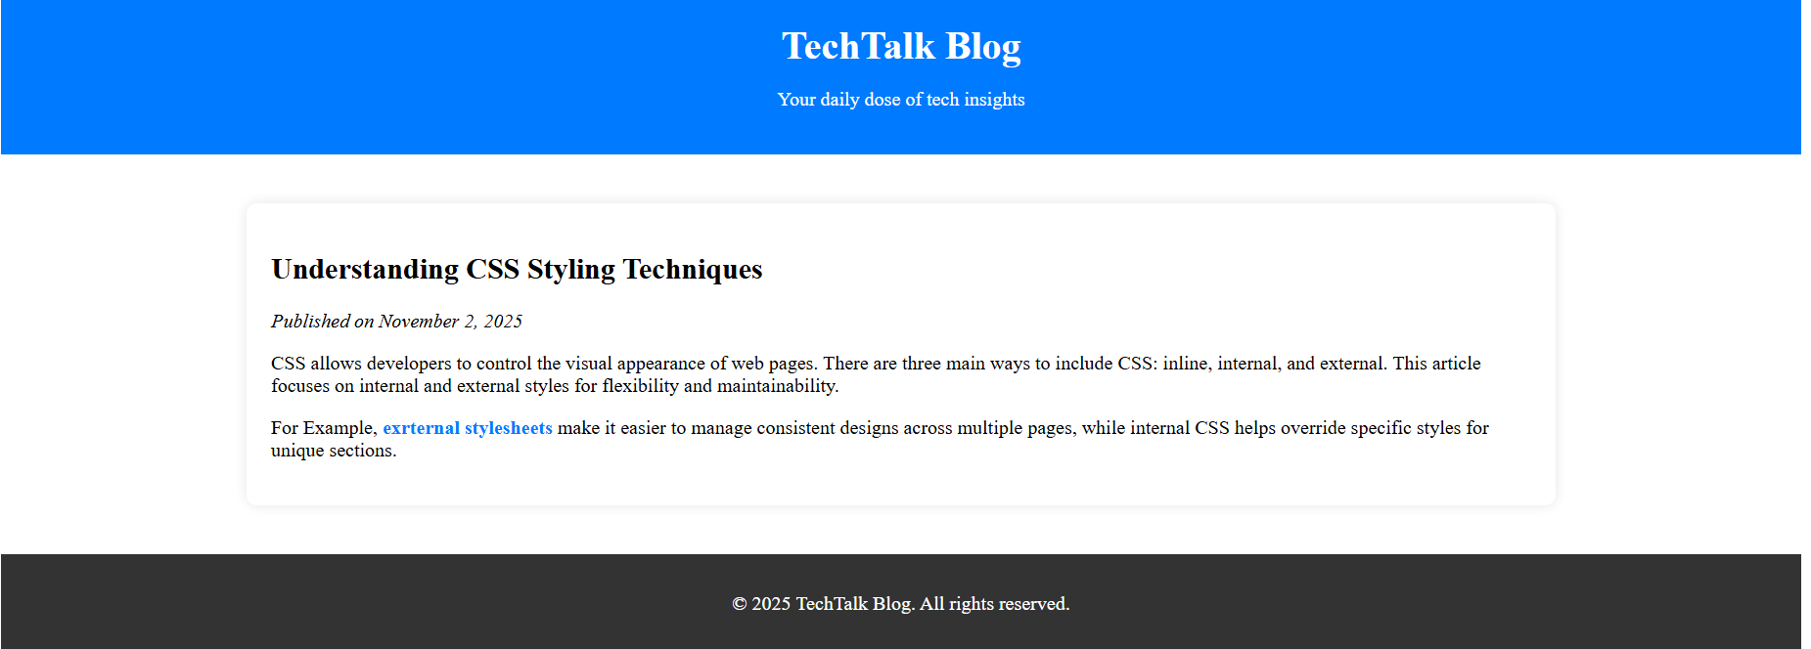

Program 9

Input of program: Utilize class selectors, ID selectors, and element selectors to style specific components of the webpage. Demonstrate CSS rule precedence and specificity by combining inline, internal, and external styles in one project.

Code:
<!DOCTYPE html>
<html lang="en">
<head>
<meta charset="UTF-8">
<meta name="viewport" content="width=device-width, initial-scale=1.0">
<title>CSS Styling Demo</title>

<style>
/* General Page Styling */
body {
font-family: "Segoe UI", Arial, sans-serif;
background-color: #f4f6f8;
margin: 40px;
color: #333;
}

/* Header Section */
header {
background-color: #007BFF;
color: white;
text-align: center;
padding: 20px;
border-radius: 10px;
}

/* Paragraph Styling */
p {
background-color: #fff;
padding: 15px;
margin: 20px 0;
border-left: 5px solid #007BFF;
border-radius: 5px;
line-height: 1.6;
}

/* Highlight Class - for important text */
.highlight {
background-color: #fff3cd;
border: 1px solid #ffeeba;
color: #856404;
padding: 10px;
margin: 10px 0;
font-style: italic;
}
/* Section Box Styling */
.content-box {
background-color: #e9ecef;
border: 2px solid #ccc;
border-radius: 8px;
padding: 20px;
margin: 30px auto;
width: 80%;
}

/* Headings */
h2 {
text-decoration: underline;
color: #0056b3;
margin-bottom: 10px;
}

/* Footer Styling */
footer {
background-color: #343a40;
color: white;
text-align: center;
padding: 15px;
margin-top: 40px;
border-radius: 8px;
}
</style>
</head>n
<body>

<header>
<h1>CSS Styling Demonstration</h1>
<p>Applying text formatting, colors, borders, padding, and margins</p>
</header>

<main>
<section class="content-box">
<h2>Text Formatting & Backgrounds</h2>
<p>This paragraph shows how to use <strong>background colors</strong> and <em>text formatting</em> together. The text is readable, structured, and visually separated from the page background using <code>padding</code> and <code>margin</code>.</p>

<p class="highlight">This highlighted section uses a light yellow background, custom border, and italic text to draw attention to important information.</p>
</section>

<section class="content-box">
<h2>Borders, Padding, and Margins</h2>
<p>Each content box has <strong>padding</strong> to create space inside the border and <strong>margin</strong> to separate it from other sections. These properties enhance the layout and readability of the page.</p>
</section>
</main>

<footer>
<p>&copy; 2025 Web Design Demo | Created by Tamana Aggarwal</p>
</footer>

</body>
</html>

Output:
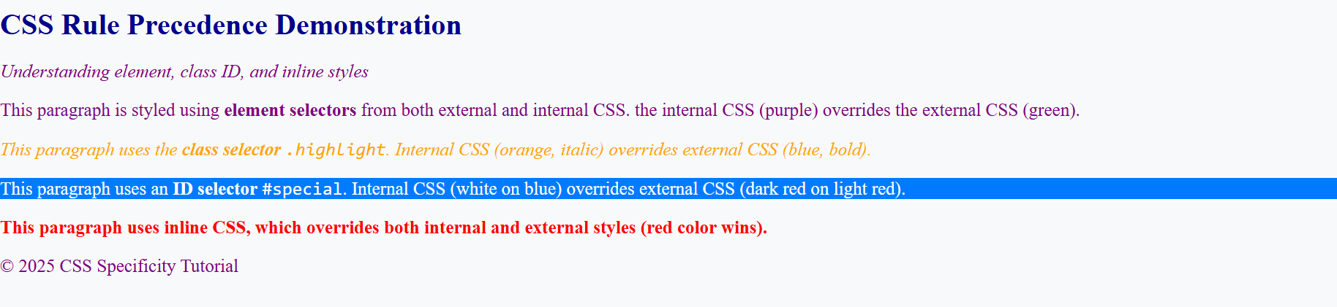

Program 10

Input of program: Use CSS to apply text formatting, background colors, borders, padding, and margins to different webpage elements.

Code:
<!DOCTYPE html>
<html lang="en">
<head>
<meta charset="UTF-8">
<meta name="viewport" content="width=device-width, initial-scale=1.0">
<title>CSS Box Model Demonstration</title>

<style>
body {
font-family: Arial, sans-serif;
background-color: #f8f9fa;
margin: 40px;
text-align: center;
}

h1 {
color: #007BFF;
margin-bottom: 30px;
}

.box {
width: 300px;
background-color: #fff;
border: 5px solid #007BFF;
padding: 20px; /* Space inside border */
margin: 30px auto; /* Space outside border */
box-sizing: content-box; /* Default box model */
border-radius: 10px;
box-shadow: 0 0 10px rgba(0,0,0,0.1);
text-align: left;
}

.box p {
margin: 0;
font-size: 16px;
color: #333;
}

/* Second box using border-box model */
.border-box {
box-sizing: border-box; /* Includes padding and border inside width */
background-color: #e9f5ff;
border: 5px dashed #007BFF;
width: 300px;
padding: 20px;
margin: 30px auto;
}
.info {
font-size: 14px;
color: #555;
margin-top: 10px;
font-style: italic;
}

.example-area {
display: flex;
flex-direction: column;
align-items: center;
gap: 10px;
}
</style>
</head>
<body>

<h1>Understanding the CSS Box Model</h1>

<div class="example-area">
<!-- Example 1: Default (content-box) -->
<div class="box">
<p><strong>Content Box Example</strong></p>
<p>This box uses <code>box-sizing: content-box;</code> (default). The total size = content + padding + border + margin.</p>
</div>

<!-- Example 2: Border-box -->
<div class="border-box">
<p><strong>Border Box Example</strong></p>
<p>This box uses <code>box-sizing: border-box;</code>. The width includes content, padding, and border for simpler layouts.</p>
</div>
</div>

<p class="info">Tip: Use developer tools (F12) to inspect each box and see how padding, border, and margin affect layout.</p>

</body>
</html>

Output:
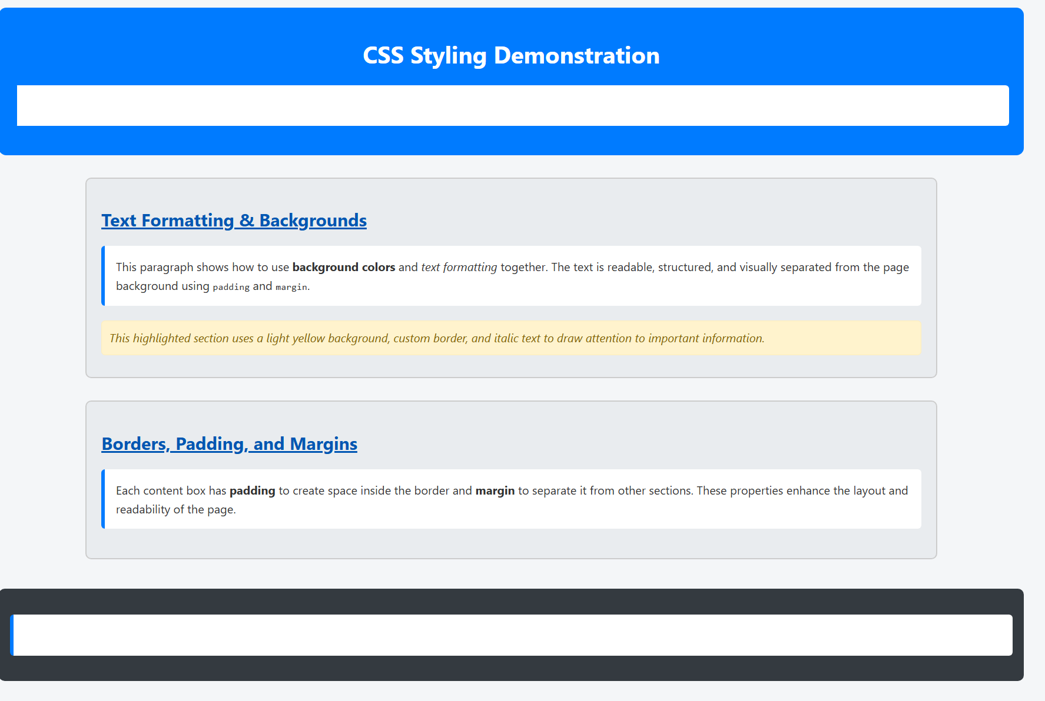

Program 11

Input of Program: Illustrate the CSS box model by styling elements with borders and adjusting their spacing properties.

Code:
<!DOCTYPE html>
<html lang="en">
<head>
<meta charset="UTF-8">
<meta name="viewport" content="width=device-width, initial-scale=1.0">
<title>CSS Units Demonstration</title>

<style>
/* Base font size — affects rem units */
html {
font-size: 16px;
}

body {
font-family: Arial, sans-serif;
background-color: #f8f9fa;
margin: 40px;
color: #333;
line-height: 1.6;
}

h1 {
text-align: center;
color: #007BFF;
margin-bottom: 40px;
}

.unit-box {
background-color: #fff;
border: 2px solid #007BFF;
border-radius: 10px;
padding: 20px;
margin: 20px auto;
width: 60%;
box-shadow: 0 0 10px rgba(0,0,0,0.1);
}

/* Using px units */
.px-box {
font-size: 18px; /* Fixed font size */
width: 400px; /* Fixed width */
padding: 20px;
}

/* Using em units (relative to parent element) */
.em-box {
font-size: 1.5em; /* 1.5 × parent font size */
width: 30em; /* Width depends on parent font size */
padding: 2em; /* Padding grows with font size */
}

/* Using rem units (relative to root element) */
.rem-box {
font-size: 1.5rem; /* 1.5 × root (html) font size */
width: 30rem; /* Fixed based on root font size */
padding: 1.5rem;
}

/* Using % units (relative to parent container) */
.percent-box {
font-size: 120%;
width: 80%;
padding: 2%;
background-color: #e9f5ff;
}

p {
margin: 0;
}
.note {
font-size: 0.9em;
color: #555;
margin-top: 10px;
font-style: italic;
}
</style>
</head>
<body>

<h1>CSS Units Demonstration</h1>

<div class="unit-box px-box">
<h2>Pixels (px)</h2>
<p>This box uses fixed <strong>px</strong> values for size and spacing. It does not scale with screen or font changes.</p>
<p class="note">Width: 400px | Font: 18px</p>
</div>

<div class="unit-box em-box">
<h2>EM Units (em)</h2>
<p>This box uses <strong>em</strong> units that scale relative to the <em>parent element’s font size</em>.</p>
<p class="note">Width: 30em | Font: 1.5em | Padding: 2em</p>
</div>
<div class="unit-box rem-box">
<h2>REM Units (rem)</h2>
<p>This box uses <strong>rem</strong> units that scale relative to the <em>root (html) font size</em>, ensuring consistency across elements.</p>
<p class="note">Width: 30rem | Font: 1.5rem | Padding: 1.5rem</p>
</div>

<div class="unit-box percent-box">
<h2>Percentage (%)</h2>
<p>This box uses <strong>%</strong> units for width and padding. The size adjusts dynamically based on its parent container.</p>
<p class="note">Width: 80% | Padding: 2%</p>
</div>

</body>
</html>
Output:
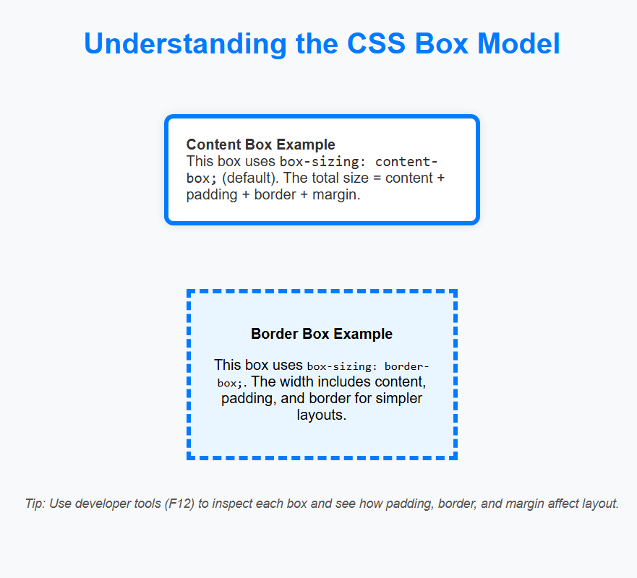

Program 12

Input of Program: Implement a variety of CSS units such as em, rem, % and px to observe how different units impact design.

Code:
<!DOCTYPE html>
<html lang="en">
<head>
<meta charset="UTF-8">
<meta name="viewport" content="width=device-width, initial-scale=1.0">
<title>Responsive Flexbox Navigation Bar</title>

<style>
/* Global Reset */
* {
margin: 0;
padding: 0;
box-sizing: border-box;
}

body {
font-family: 'Segoe UI', Arial, sans-serif;
background-color: #f8f9fa;
}

/* Navigation Bar Styling */
nav {
background-color: #007BFF;
color: white;
display: flex;
justify-content: space-between; /* Space between logo and menu */
align-items: center; /* Vertically center content */
padding: 15px 30px;
flex-wrap: wrap; /* Allow wrapping for smaller screens */
}

/* Logo */
.logo {
font-size: 1.5rem;
font-weight: bold;
}

/* Navigation Links */
.nav-links {
display: flex;
list-style: none;
gap: 25px; /* Space between links */
}

.nav-links a {
text-decoration: none;
color: white;
font-weight: 500;
transition: color 0.3s;
}

.nav-links a:hover {
color: #ffdd57;
}

/* Mobile Menu (hamburger) */
.menu-toggle {
display: none;
font-size: 1.5rem;
cursor: pointer;
}

/* Responsive Styles */
@media (max-width: 768px) {
.nav-links {
flex-direction: column;
width: 100%;
display: none; /* Hidden by default on mobile */
background-color: #0056b3;
text-align: center;
padding: 10px 0;
}

.nav-links.active {
display: flex; /* Show when active */
}

.menu-toggle {
display: block; /* Show hamburger icon on small screens */
}
}
</style>
</head>
<body>

<!-- Navigation Bar -->
<nav>
<div class="logo">FlexNav</div>

<!-- Hamburger Menu -->
<div class="menu-toggle" id="menu-toggle">&#9776;</div>

<!-- Navigation Links -->
<ul class="nav-links" id="nav-links">
<li><a href="#home">Home</a></li>
<li><a href="#about">About</a></li>
<li><a href="#services">Services</a></li>
<li><a href="#blog">Blog</a></li>
<li><a href="#contact">Contact</a></li>
</ul>
</nav>

<script>
// Toggle Menu on Small Screens
const menuToggle = document.getElementById('menu-toggle');
const navLinks = document.getElementById('nav-links');

menuToggle.addEventListener('click', () => {
navLinks.classList.toggle('active');
});
</script>

</body>
</html>

Output:
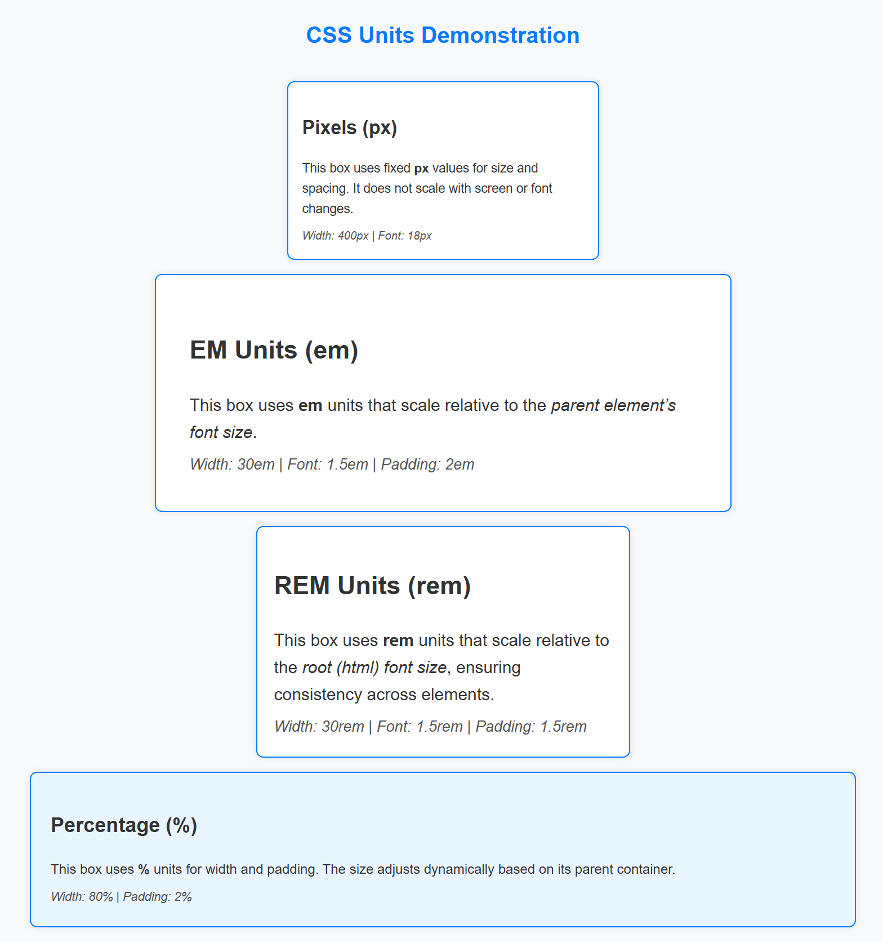

Program 13

Input of Program: Design a responsive navigation bar using Flexbox properties such as justify-content and align-items.

Code:
<!DOCTYPE html>
<html lang="en">
<head>
<meta charset="UTF-8">

<!-- Viewport meta tag for mobile optimization -->
<meta name="viewport" content="width=device-width, initial-scale=1.0">

<title>Responsive Design with min-width and max-width</title>

<style>
/* ===== Base Styles ===== */
body {
margin: 0;
font-family: 'Segoe UI', Arial, sans-serif;
background-color: #f8f9fa;
color: #333;
line-height: 1.6;
}

header {
background-color: #007BFF;
color: white;
text-align: center;
padding: 20px 10px;
}

main {
margin: 20px auto;
padding: 20px;
background: white;
border-radius: 10px;
max-width: 1000px; /* Restrict content width on large screens */
min-width: 300px; /* Ensure readability on very small screens */
box-shadow: 0 2px 8px rgba(0,0,0,0.1);
}

h1 {
text-align: center;
color: #007BFF;
}

.container {
display: flex;
justify-content: space-between;
gap: 20px;
flex-wrap: wrap; /* Allow items to wrap on smaller screens */
}
.box {
flex: 1;
min-width: 250px; /* Prevent columns from getting too narrow */
padding: 20px;
background-color: #e9f2ff;
border-radius: 8px;
text-align: center;
border: 1px solid #007BFF;
}

footer {
text-align: center;
background-color: #343a40;
color: white;
padding: 15px 0;
margin-top: 30px;
}

/* ===== Responsive Media Queries ===== */

/* Medium screens (tablets, up to 900px) */
@media (max-width: 900px) {
.container {
flex-direction: column;
align-items: center;
}
.box {
width: 80%;
}
main {
max-width: 90%;
}
}

/* Small screens (mobiles, up to 600px) */
@media (max-width: 600px) {
body {
background-color: #eef6ff;
}

header {
font-size: 1.2rem;
padding: 15px 5px;
}

.box {
font-size: 0.95rem;
width: 100%;
}

footer {
font-size: 0.9rem;
}
}
</style>
</head>
<body>

<header>
<h2>Responsive Design Example</h2>
<p>Using min-width, max-width, and viewport meta tag</p>
</header>

<main>
<h1>Welcome to the Responsive Page</h1>
<p>
This example demonstrates how to use <strong>min-width</strong> and
<strong>max-width</strong> properties along with the
<strong>viewport meta tag</strong> to optimize content layout
for different screen sizes.
</p>
<div class="container">
<div class="box">
<h3>Box 1</h3>
<p>Resizes gracefully between devices using flexible widths.</p>
</div>

<div class="box">
<h3>Box 2</h3>
<p>Flexbox + min-width keeps layout readable on smaller screens.</p>
</div>

<div class="box">
<h3>Box 3</h3>
<p>Max-width centers content and limits overly wide text lines.</p>
</div>
</div>
</main>

<footer>
&copy; 2025 Responsive Layout | Designed with CSS Flexbox and Media Queries
</footer>

</body>
</html>

Output:
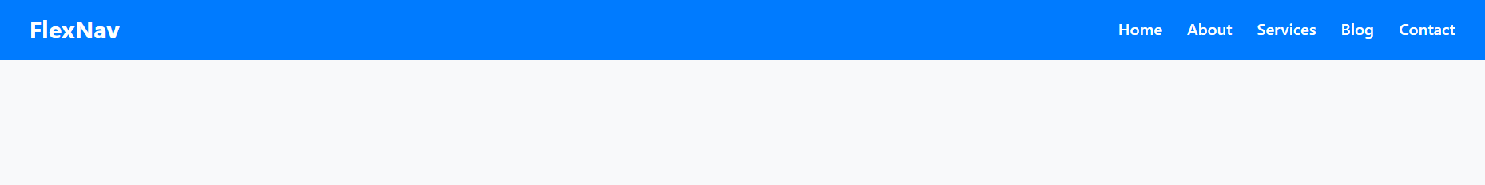

Program 14

Input of Program: Implement media queries to ensure the layout adapts correctly on different screen sizes like mobile and desktop.

Code:
/* Base Styles (Desktop-first approach) */
body {
margin: 0;
font-family: Arial, sans-serif;
}

header, footer {
background-color: #004c99;
color: white;
text-align: center;
padding: 1rem;
}

.container {
display: flex;
justify-content: space-between;
padding: 1rem;
}

.sidebar {
flex: 1;
background-color: #e6f0ff;
padding: 1rem;
margin-right: 1rem;
}

.content {
flex: 3;
background-color: #f2f2f2;
padding: 1rem;
}

/* --- MEDIA QUERIES --- */

/* For tablets (width <= 768px) */
@media (max-width: 768px) {
.container {
flex-direction: column;
}

.sidebar {
margin-right: 0;
margin-bottom: 1rem;
}
}

/* For mobile devices (width <= 480px) */
@media (max-width: 480px) {
header, footer {
font-size: 1rem;
padding: 0.5rem;
}

.container {
padding: 0.5rem;
}

.sidebar, .content {
padding: 0.5rem;
}
}

Output:
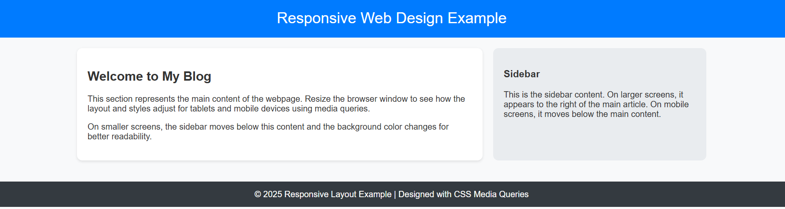

Program 15

Input of Program: Apply responsive design properties like min-width, max-width, and include the viewport meta tags for mobile optimization.

Code:

