**User Manual**

**DHI Compact Automation System**



Submitted by: Thimphu TechPark Ltd

Table of Contents

**1.** **User Creation** 3

**2.** **Company Registration** 3

**3.** **Financial Year Setup** 4

**4.** **User Access Permission** 5

**5.** **Compact Negotiation** 5

5.1 Submission by initiator Financial Compact 5

5.2 Submission by initiator Customer Service and Organization management 5

5.3 Submission by initiator Production and Sales 6

5.4 Review Financial Compact 7

5.5 Review Customer Service and Organization management 7

5.6 Review Production and Sales 7

**6. Monitoring and Evaluation (ME)** 8

6.1 Submission by initiator Financial Compact 8

6.2 Submission by initiator Customer Service and Organization management 8

6.3 Submission by initiator Production and Sales 9

6.4 Review Financial Compact 9

6.5 Review Customer Service and Organization management 10

6.6 Review Production and Sales 10

7. **Board Members** 11

**8. Report generation** 12

## **User Creation**

1. Navigate to Common Control and click User Creation from the menu.
2. Enter required fields and click save button.
3. To update user, click the user from User List table and system populate to the fields. Update the fields and click save button.
4. To add user as board members, select User Role Others and select companies from Company mapping.

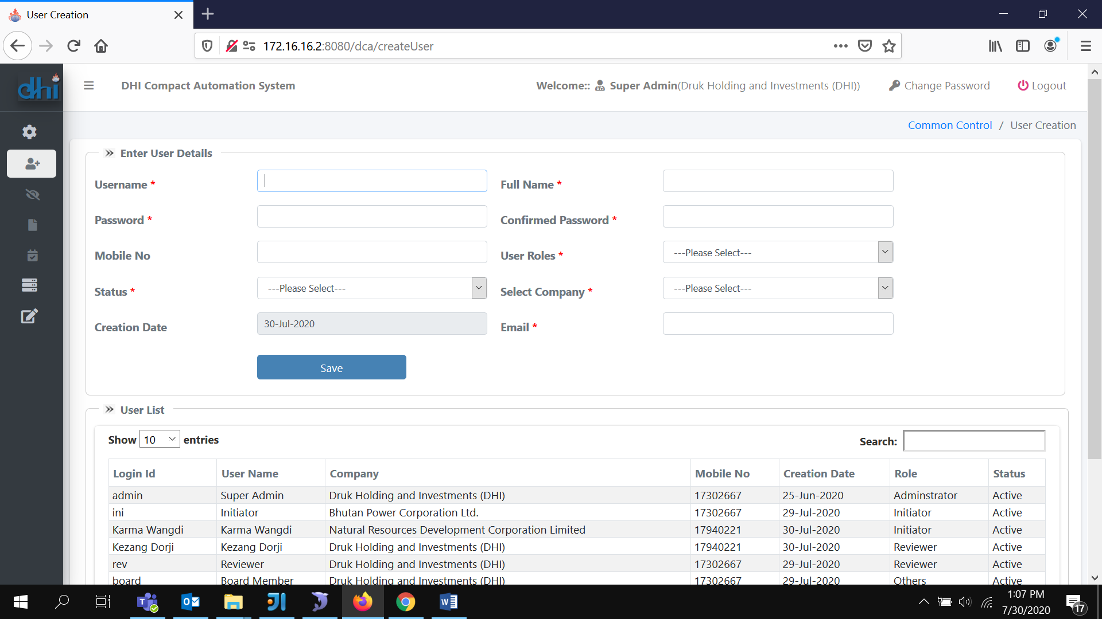

*Figure 1: User Registration Screen*

## **Company Registration**

1. Navigate to Common Control and click Company Registration from the menu.
2. Enter Required fields and click Save button
3. Check Parent company if registering company is DHI.
4. Enter Financial Compact, Customer Service, Production and Organization. These fields are total weight companies need to maintain during compact submission. If it is not applicable, enter zero.
5. To update company, click on the company list. System will populate the fields. Make changes and click save button.

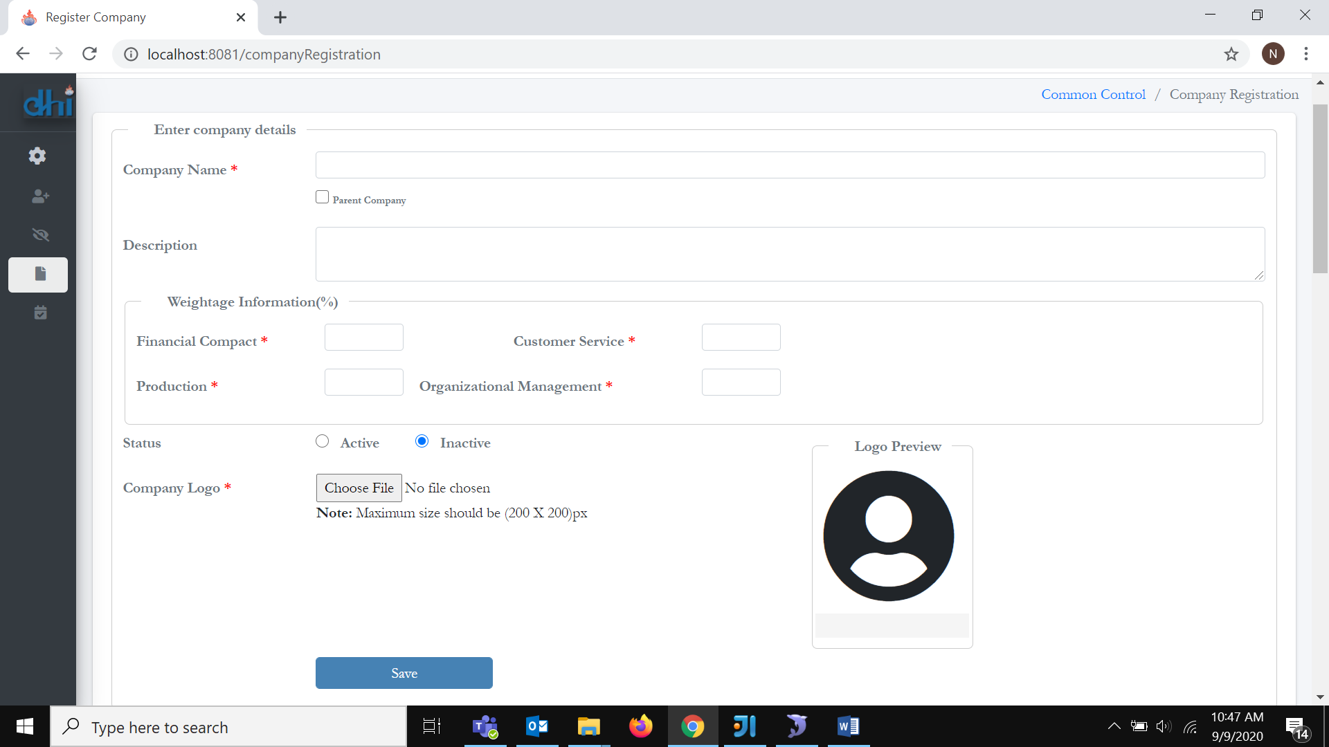

*Figure 2: Company Registration Screen*

## 

## **Financial Year Setup**

1. Navigate to Common Control and click Financial Year Setup from the menu.
2. Enter required date field and click save button. Check active radio button if it current financial year. There should be only one active financial year in the financial year list.
3. 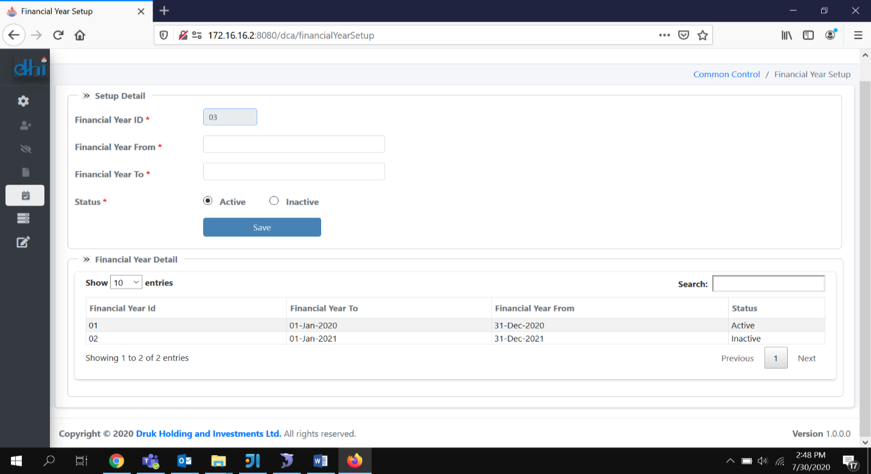To update financial year click the financial year from the financial year detail table. System will populate to the fields. Make change and click save button.

*Figure 3: Financial Year Setup Screen*

## **User Access Permission**

1. Navigate to Common Control and click User Access Permission from the menu
2. Select User Roles. List of screen names will appear.
3. Check or uncheck access and click save button. Checked means access allowed.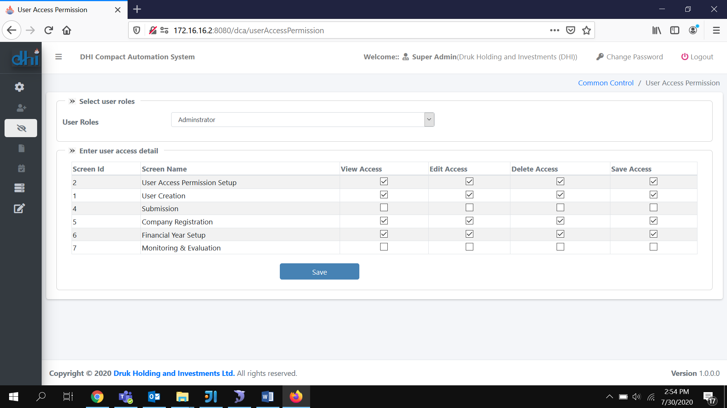

*Figure 4: User Access Permission Screen*

## **Compact Negotiation**

### 5.1 Submission by initiator Financial Compact

1. Login as initiator and navigate to Negotiation, click Negotiation from the menu. Click financial tab.
2. Enter required fields and click save as draft button. Click submit button when all the data is valid. Click plus button to add more rows. User may remove the row by click minus button.
3. Click show/hide variance to show or hide variances in the table.
4. Click preview button to check the report in pdf mode.
5. Total weight should be exactly equal to Financial Compact value set during company registration.
6. Initiator may write detailed write up before submitting. Detailed write up is allowed only after saving as draft. Until the compact reaches BCPM approval stage detailed writeup will be in draft mode. Detailed writeup can be only review after BCPM approval.

### 5.2 Submission by initiator Customer Service and Organization management

1. Login as initiator and navigate to Negotiation, click Negotiation from the menu. Click Non-financial tab for customer service or Organization management tab.
2. Click New Activity button and enter the activity details, click save as draft button. Click plus button to add more rows. User may remove the row by click minus button. Click submit button when all the data is valid.
3. Click preview button to check the report in pdf mode.
4. Total weight should be exactly equal to assigned weight during company registration.
5. Initiator may write detailed write up before submitting. Detailed write up is allowed only after saving as draft. Until the compact reaches BCPM approval stage detailed writeup will be in draft mode. Detailed writeup can be only review after BCPM approval.

### 5.3 Submission by initiator Production and Sales

1. Login as initiator and navigate to Negotiation, click Negotiation from the menu. Click non-financial tab.
2. Click Plus(+) button from the parent row to add child row. To add parent click plus button from the top right of the grid.
3. Enter required fields and click save as draft button. Click submit button when all the data is valid. Click plus button to add more rows. User may remove the row by click minus button.
4. Click show/hide variance to show or hide variances in the table.
5. Click preview button to check the report in pdf mode.
6. Total weight should be exactly equal to Financial Compact value set during company registration.
7. Initiator may write detailed write up before submitting. Detailed write up is allowed only after saving as draft. Until the compact reaches BCPM approval stage detailed writeup will be in draft mode. Detailed writeup can be only review after BCPM approval.

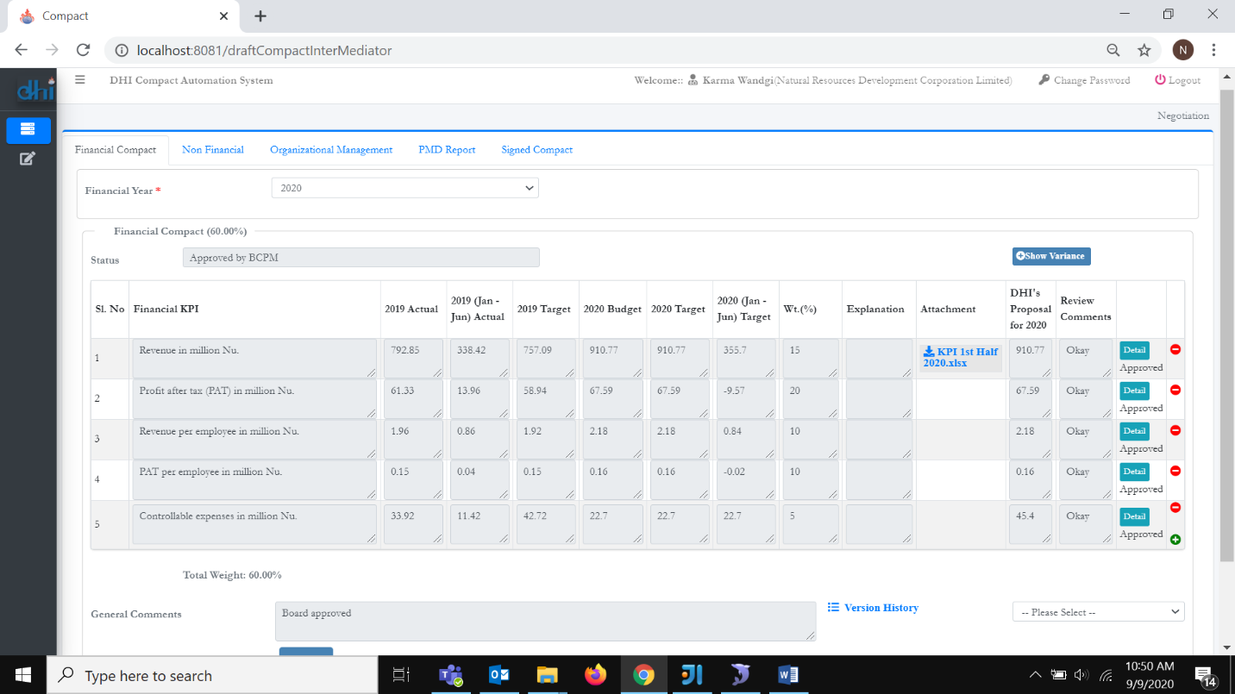

*Figure 5: Compact Submission Screen (Initiator)*

### 5.4 Review Financial Compact

1. Login as reviewer and navigate to Negotiation, click Negotiation from the menu. Click financial tab and select company. By default, current financial year will be selected.
2. Click Save Draft if there is a need to change. Click Revert to Company to revert, click Submit to BCPM to submit to BCPM if it is approved by PMD. Click Approved by BCPM after it approved by BCPM.
3. Click show/hide variance to show or hide variances in the table.
4. Click preview button to check the report in pdf mode.
5. Total weight should be exactly equal to Financial Compact value set during company registration.

### 5.5 Review Customer Service and Organization management

1. Login as reviewer and navigate to Negotiation, click Negotiation from the menu. Click non -financial or organization management tab and select company. By default, current financial year will be selected.
2. Click Save Draft if there is a need to change. Click Revert to Company to revert, click Submit to BCPM to submit to BCPM if it is approved by PMD. Click Approved by BCPM after it approved by BCPM.
3. Click preview button to check the report in pdf mode.

Total weight should be exactly equal to the weight set during company registration.

### 5.6 Review Production and Sales

1. Login as reviewer and navigate to Negotiation, click Negotiation from the menu. Click non-financial tab and select company. By default, current financial year will be selected.
2. Click Save Draft if there is a need to change. Click Revert to Company to revert, click Submit to BCPM to submit to BCPM if it is approved by PMD. Click Approved by BCPM after it approved by BCPM.
3. Click show/hide variance to show or hide variances in the table.
4. Click preview button to check the report in pdf mode.
5. Total weight should be exactly equal to weight set during company registration.

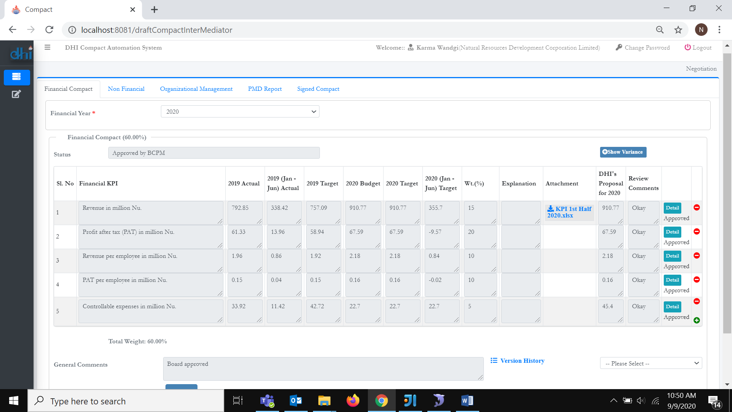

*Figure 6: Compact Review Screen(Reviewer)*

## **6. Monitoring and Evaluation (ME)**

### 6.1 Submission by initiator Financial Compact

1. Login as initiator and navigate to Negotiation, click ME from the menu. Click financial tab.
2. Enter required fields and click save as draft button. Click submit button when all the data is valid. Click plus button to add more rows. User may remove the row by click minus button.
3. By default, review type midterm will be selected if initiator is submitting for the first time in a financial year. Once midterm is approved by PCPM annual will be selected.
4. Click show/hide variance to show or hide variances in the table.
5. Click preview button to check the report in pdf mode.
6. Total weight should be exactly equal to weight set during company registration.

### 6.2 Submission by initiator Customer Service and Organization management

1. Login as initiator and navigate to ME. Click Non-financial tab for customer service and Organization management tab for organization management.
2. Enter the required fields in each activity and click Save button. Click submit button when all the data is valid.
3. By default, review type midterm will be selected if initiator is submitting for the first time in a financial year. Once all midterm targets are approved by PCPM annual will be selected.
4. Click preview button to check the report in pdf mode.
5. Total weight should be exactly equal to assigned weight during company registration.

### 6.3 Submission by initiator Production and Sales

1. Login as initiator and navigate to ME. Click non-financial tab.
2. Enter required fields and click save as draft button. Click submit button when all the data is valid. Click plus button to add more rows. User may remove the row by click minus button.
3. By default, review type midterm will be selected if initiator is submitting for the first time in a financial year. Once midterm is approved by PCPM annual will be selected.
4. Click preview button to check the report in pdf mode.
5. Total weight should be exactly equal to weight set during company registration.

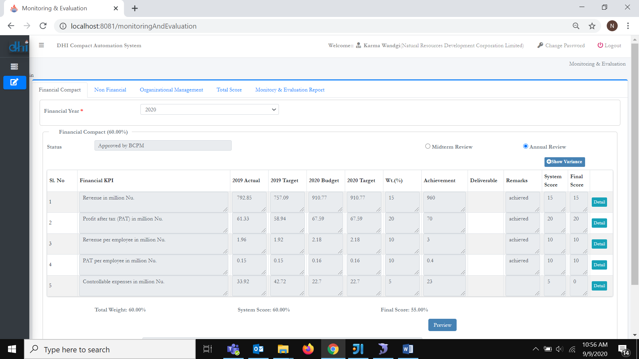

*Figure 7: Monitoring and Evaluation Submission Screen(Initiator)*

### 6.4 Review Financial Compact

1. Login as reviewer and navigate to ME. Click financial tab and select company. By default, current financial year will be selected.
2. Click Save Draft if there is a need to change. Click Revert to Company to revert, click Submit to BCPM to submit to BCPM if it is approved by PMD. Click Approved by BCPM after it approved by BCPM.
3. Click show/hide variance to show or hide variances in the table.
4. Click preview button to check the report in pdf mode.
5. Total weight should be exactly equal to Financial Compact value set during company registration.

### 6.5 Review Customer Service and Organization management

1. Login as reviewer and navigate to ME. Click non -financial or organization management tab and select company. By default, current financial year will be selected.
2. Click Save Draft if there is a need to change. Click Revert to Company to revert, click Submit to BCPM to submit to BCPM if it is approved by PMD. Click Approved by BCPM after it approved by BCPM.
3. Click calculate button to calculate score and Dismiss button to clear the score. Click particular activity name to view the detail write up.
4. Click preview button to check the report in pdf mode.

Total weight should be exactly equal to the weight set during company registration.

### 6.6 Review Production and Sales

1. Login as reviewer and navigate to ME. Click non-financial tab and select company. By default, current financial year will be selected.
2. Click Save Draft if there is a need to change. Click Revert to Company to revert, click Submit to BCPM to submit to BCPM if it is approved by PMD. Click Approved by BCPM after it approved by BCPM.
3. Click preview button to check the report in pdf mode.
4. Total weight should be exactly equal to weight set during company registration.

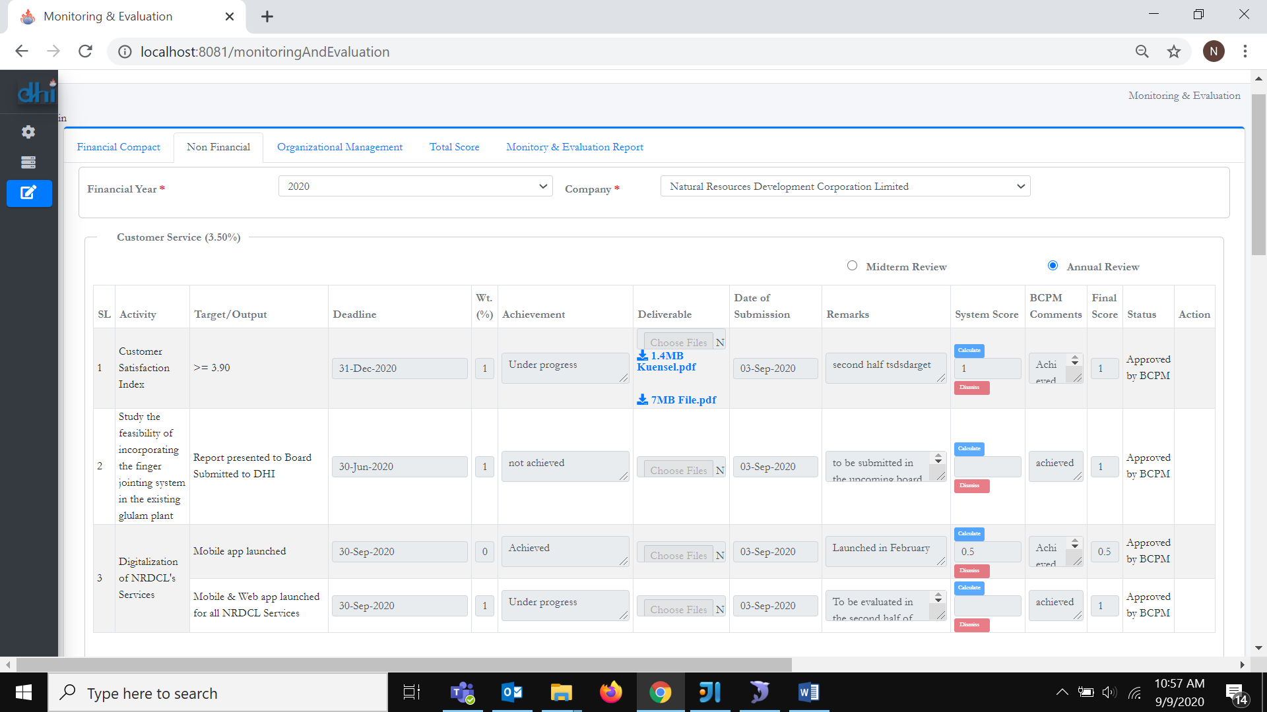

*Figure 8: Monitoring and Evaluation Review Screen(Reviewer)*

## 7. **Board Members**

1. Login as board member.
2. List of assigned companies will appear in the dashboard.
3. Select filtering criteria and click company logo to view reports detail.

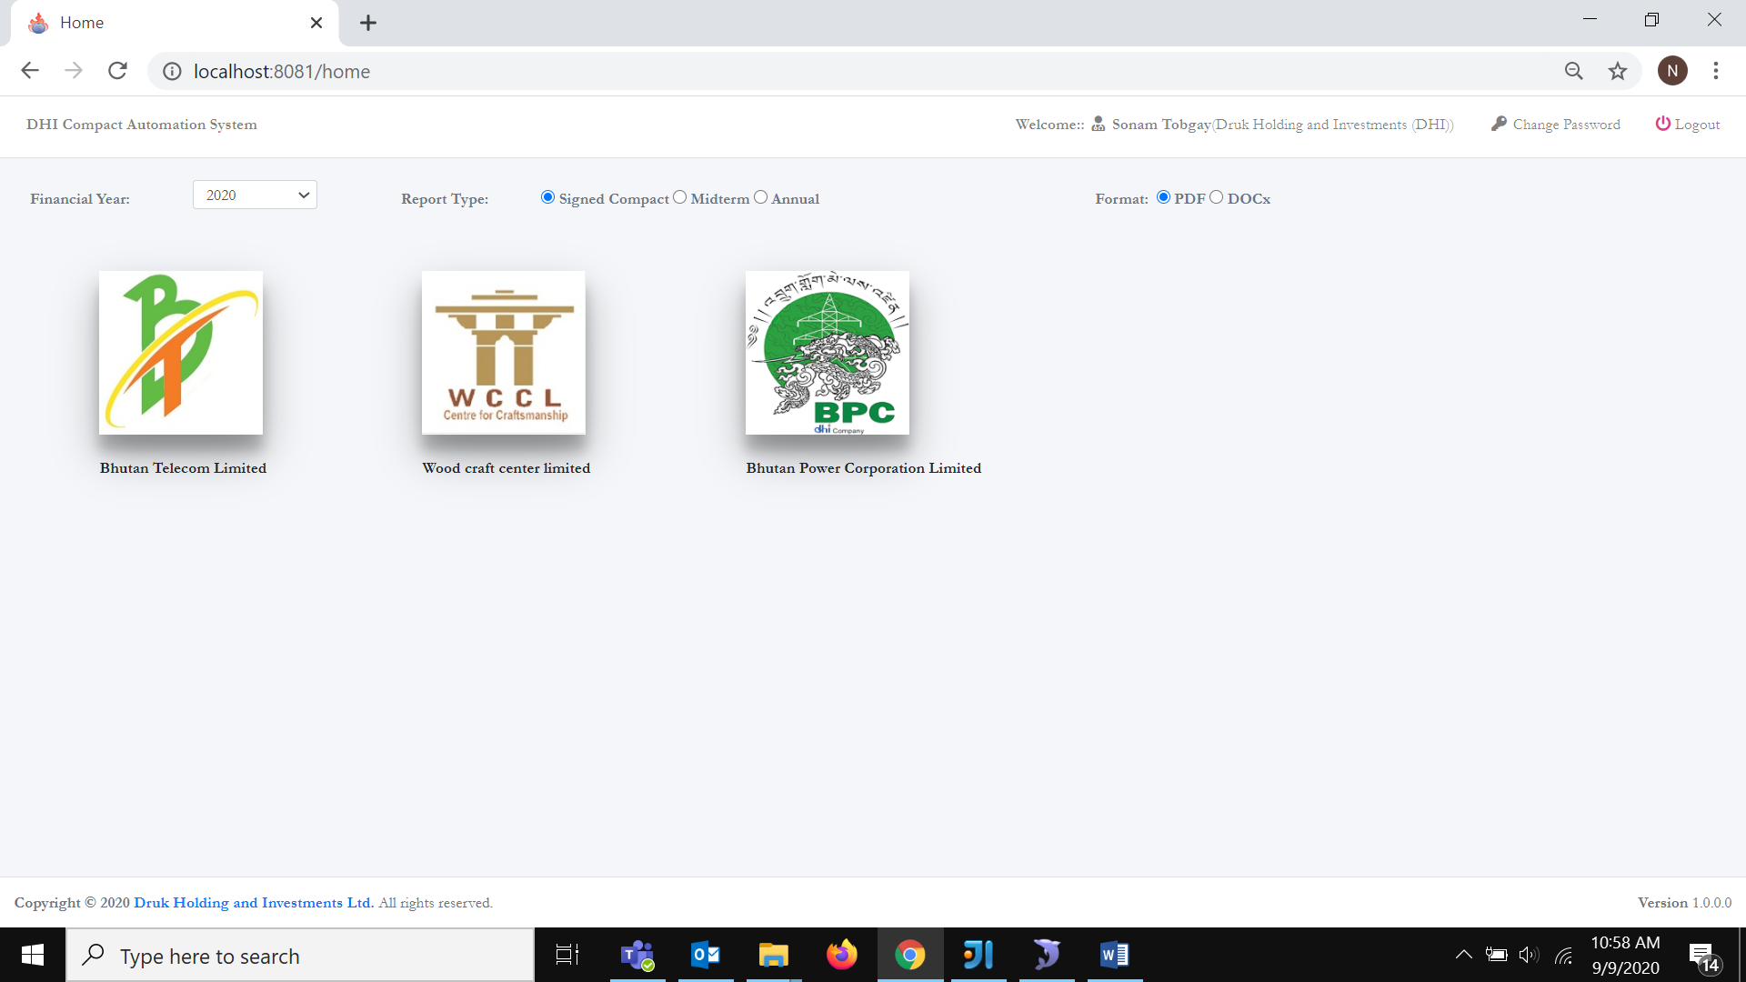

*Figure 9: Board Member Screen*

## **8. Report generation**

1. PMD report
2. Signed Compact
3. Monitoring and evaluation reports
4. Total Sore
5. All the above reports can be generated by selecting the filtering criteria.