Crontab

**To check the cronjob in server**

crontab –l

**To assign cronjob in server**

* 1. Crontab –e
  2. Choose editor
  3. * * * * * bin/sh /home/tamang/backup.sh (inside editor)
  4. save the crontab file

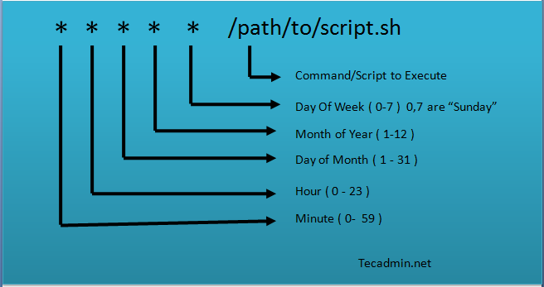

**Script inside the file backup.sh (to backup dB)**

**m**ysqldump –u user –p dBname > /destionation

https://tecadmin.net/crontab-in-linux-with-20-examples-of-cron-schedule/