Contents

ABSTRACT 9

CHAPTER 1 10

INTRODUCTION 10

1.1 Motivation 10

1.2 Programming Language 10

1.3 HTML (Hypertext Markup Language) 10

1.4 CSS (Cascading Style Sheet) 11

1.5 JavaScript 11

1.6 Laravel Framework 12

1.7 Limitations of Laravel: 13

1.8 Project Description 14

1.9 Introduction to Job Portal Website 14

1.10 Advantages of Job Portal Website 15

1.11 Problem Statement 15

1.12 Objectives 16

1.13 Scope 17

1.14 Team Structure and Roles 18

CHAPTER 2 19

SYSTEM DESIGN 19

2.1 Working Principle: 19

2.2 Algorithm 20

2.3 Flowchart 21

2.4 Use Case Diagram 22

2.5 Gantt Chart 23

CHAPTER 3 24

REQUIREMENT ANALYSIS AND IMPLEMENTATION OF SYSTEM 24

3.1 Requirements 24

3.2 System Methodology 25

3.3 Entity relation diagram 28

3.4 Controller Module 29

CHAPTER 4 30

FUTURE SCOPE AND CONCLUSION 30

4.1 Future Scope 30

4.2 Conclusion 31

CHAPTER 5 32

APPENDIX 32

5.1 Screenshots 32

# ABSTRACT

In the ever-evolving landscape of employment, finding the perfect fit between talented individuals and thriving organizations has become both an art and a science. Our job portal website emerges as the beacon of this intricate synergy, offering a seamless platform where aspirations meet opportunities.

Embark on a journey where job seekers are empowered to showcase their unique skills and experiences, while employers unveil captivating narratives about their company culture and growth aspirations. With intuitive search functionalities and personalized recommendation algorithms, our portal transcends conventional job search paradigms, guiding each user towards their professional zenith.

Driven by a commitment to inclusivity and diversity, our platform fosters a community where every voice is heard and every talent revered. From entry-level enthusiasts to seasoned professionals, our job portal cultivates an ecosystem where dreams flourish and ambitions soar.

Join us in shaping the future of work, where aspirations are not just sought after, but passionately pursued and realized. Welcome to a realm where every click resonates with the promise of a brighter tomorrow. Welcome to the Job **Portal Website**, where opportunities await, and possibilities abound.

# CHAPTER 1

# INTRODUCTION

## 1.1 Motivation

We found that we were good at coding and has the ability to reason about the code very well and it didn’t take long for us to realize that this is what we wanted to do for the rest of our life. Though when we began college we still wanted to go into programming as the state of web applications became more interesting in the last few days, we got into that and that’s what we are doing now! We really couldn’t imagine doing anything else, and programming is definitely one of the top skills too.

## 1.2 Programming Language

A programming language is a formal language that specifies a set of instructions that can be used to produce various kinds of output. Programming languages generally consist of instructions for a computer. Programming languages can be used to create programs that implement specific algorithms. We have used different programming languages and their frameworks in our project to develop this website. The languages and their frameworks are listed below.

## 1.3 HTML (Hypertext Markup Language)

HTML is the standard markup language used to create web pages. It provides the structure and content of a webpage.

**Advantages of HTML:**

* **Ease of Use:** HTML is relatively easy to learn and understand, making it accessible to beginners.
* **Platform Independence**: HTML can be rendered on any platform or device that has a web browser, making it a universal language for creating web content.
* **Semantics**: HTML provides semantic elements that describe the structure and meaning of content, improving accessibility and search engine optimization (SEO).
* **Integration with Other Technologies**: HTML seamlessly integrates with other web technologies such as CSS and JavaScript to create interactive and visually appealing web pages.
* **Support for Multimedia**: HTML supports embedding multimedia elements such as images, videos, and audio, enhancing the user experience.

## 1.4 CSS (Cascading Style Sheet)

CSS is a style sheet language used to define the presentation and layout of HTML documents.

**Advantages of CSS:**

* **Separation of Concerns:** CSS separates the content and presentation layers of a web page, making it easier to maintain and update the design without affecting the underlying HTML structure.
* **Consistency:** CSS allows you to define styles once and apply them consistently across multiple pages, ensuring a uniform look and feel throughout a website.
* **Flexibility:** CSS offers a wide range of styling options, including colors, fonts, spacing, and layout, allowing developers to create visually appealing and responsive designs.
* **Efficiency:** By using CSS, you can reduce the amount of code needed to style a webpage, resulting in faster load times and improved performance.
* **Accessibility:** CSS enables developers to create accessible designs that are compatible with assistive technologies and support users with disabilities.

## 1.5 JavaScript

JavaScript is a high-level, interpreted programming language used to add interactivity and dynamic behavior to web pages.

**Advantages of JavaScript:**

* **Interactivity:** JavaScript allows us to create interactive elements such as dropdown menus, sliders, and form validation, enhancing user engagement and functionality.
* **Dynamic Content:** JavaScript enables you to dynamically update content on a webpage without reloading the entire page, creating a smoother and more responsive user experience.
* **Client-Side Processing:** JavaScript executes code on the client-side (in the user's browser), reducing server load and improving performance by offloading processing tasks**.**
* **Extensibility:** JavaScript has a vast ecosystem of libraries and frameworks (such as React, Angular, and Vue.js) that extend its capabilities and simplify complex tasks like building single-page applications (SPAs).
* **Cross-Platform Compatibility:** JavaScript is supported by all modern web browsers and can be used to develop web applications that run on various platforms, including desktops, tablets, and mobile devices.

## 1.6 Laravel Framework

Laravel is a powerful and widely-used open-source PHP web framework known for its elegant syntax, developer-friendly features, and robust ecosystem. It's designed to make web development faster, more efficient, and enjoyable by providing a clean and expressive syntax, along with a variety of built-in tools and libraries.

**Advantages of Laravel:**

* **Elegant Syntax:** Laravel offers a clean and expressive syntax that allows developers to write code that is both readable and maintainable. It follows modern PHP principles and design patterns, making it easy to understand and work with.
* **Modularity:** Laravel is built on a modular architecture, allowing developers to organize their code into reusable and interchangeable components. This promotes code reusability, scalability, and maintainability, making it easier to manage large and complex projects.
* **MVC Architecture:** Laravel follows the Model-View-Controller (MVC) architectural pattern, which separates the application logic from the presentation layer. This promotes code organization and separation of concerns, making it easier to manage and maintain your application.
* **Blade Templating Engine:** Laravel comes with Blade, a powerful templating engine that simplifies the process of creating dynamic, data-driven web pages. Blade provides features like template inheritance, control structures, and reusable components, allowing developers to build complex layouts with ease.
* **Database Migration System:** Laravel includes a built-in database migration system that allows developers to version control the database schema and easily share database changes across team members. This helps streamline the database management process and ensures consistency across different environments.
* **Artisan CLI:** Laravel comes with Artisan, a powerful command-line interface (CLI) tool that automates repetitive tasks and simplifies common development tasks. With Artisan, developers can generate code, run database migrations, seed databases, and perform other tasks with just a few keystrokes, boosting productivity and efficiency.
* **Security:** Laravel takes security seriously and includes built-in features to help developers protect their applications from common security threats. This includes features like cross-site request forgery (CSRF) protection, SQL injection prevention, and encryption, as well as built-in authentication and authorization mechanisms.
* **Community and Ecosystem:** Laravel has a large and active community of developers who contribute to the framework's development, share knowledge, and provide support through forums, tutorials, and documentation. Additionally, Laravel has a rich ecosystem of third-party packages and extensions that extend its functionality and provide additional features and integrations.

## 1.7 Limitations of Laravel:

* **Learning Curve:** Although Laravel aims to simplify web development, it still has a learning curve, especially for beginners or developers new to PHP frameworks. Understanding Laravel's concepts, such as routes, controllers, and Blade templating, may require some time and effort.
* **Performance Overhead:** Like any framework, Laravel introduces a performance overhead compared to raw PHP.
* **Community Support:** While Laravel has a large and active community, it may not be as extensive or mature as some other frameworks like Symfony or Django. This could result in fewer third-party packages or extensions for specific niche functionalities.
* **Version Updates**: Laravel releases new versions regularly, introducing new features, improvements, and changes. While these upgrades are generally beneficial, they can sometimes introduce compatibility issues with existing codebases or third-party packages, requiring additional effort to update projects.
* **Security Risk:** While Laravel includes built-in security features and best practices, no framework can guarantee absolute security.
* **Flexibility Vs. Convention:** Laravel follows the "convention over configuration" principle, which promotes consistency and reduces decision-making.
* **Resource Convention:** Some developers may find Laravel's resource consumption, including memory usage and CPU overhead, to be higher compared to lighter-weight frameworks or raw PHP.
* **Lack of Built-in Support for Microservices:** While Laravel is suitable for building monolithic applications, it may not be the best choice for projects requiring a microservices architecture out-of-the-box. While Laravel can be adapted for microservices, it may require additional effort and architectural considerations.
* **Documentation Quality:** While Laravel's documentation is generally comprehensive and well-maintained, some developers may find certain areas lacking in detail or clarity.

## 1.8 Project Description

Our project aims to create a dynamic and user-friendly job portal website that connects job seekers with employers seamlessly. With an intuitive interface and robust features, our platform will empower job seekers to explore diverse opportunities, showcase their skills, and connect with potential employers effortlessly. For employers, our portal will offer streamlined recruitment processes, advanced candidate search capabilities, and comprehensive applicant tracking tools, enabling them to find the perfect candidates efficiently. Through innovative features such as personalized job recommendations, real-time notifications, and interactive job postings, we aim to revolutionize the job search experience for both job seekers and employers alike. Our goal is to create a vibrant online community where talent meets opportunity, fostering growth, prosperity, and mutual success.

## 1.9 Introduction to Job Portal Website

Welcome to the Job Portal Website, your ultimate destination for career exploration and advancement. Whether you're seeking your first job, a career change, or the next step in your professional journey, our platform is here to guide you. With an extensive database of job opportunities spanning various industries and locations, curated specifically to match your skills and preferences, finding the perfect job has never been simpler. Join our community of motivated individuals, access valuable resources, and embark on a transformative journey towards achieving your career goals. Get started today with the Job Portal Website and unlock endless possibilities for growth and success.

## 1.10 Advantages of Job Portal Website

* **Accessibility:** Job portal websites provide round-the-clock access to job listings, allowing users to browse and apply for jobs at their convenience, regardless of their location or time zone.
* **Wide Range of Opportunities:** Job portal websites aggregate job listings from various industries, companies, and locations, offering users a diverse range of career opportunities to explore and apply for.
* **Efficiency:** Job portal websites streamline the job search process by providing advanced search filters, personalized job recommendations, and automated application tracking systems, saving users time and effort.
* **Cost-Effectiveness:** Job portal websites often offer free or low-cost services for job seekers, eliminating the need for traditional methods of job searching such as newspaper classifieds or job fairs, which can be expensive.
* **Global Reach:** Job portal websites have a global reach, allowing job seekers to explore job opportunities not only within their local area but also in other cities, countries.
* **Transparency:** Job portal websites provide transparency in the job application process by displaying detailed job descriptions, salary information, and company profiles, empowering job seekers to make informed decisions about their career options.

## 1.11 Problem Statement

In today's rapidly evolving job market, both job seekers and employers face numerous challenges in navigating the recruitment process effectively. Job seekers struggle to find relevant job opportunities tailored to their skills and preferences, often facing information overload, impersonal interactions, and uncertainty about the legitimacy of job postings. Similarly, employers encounter difficulties in attracting qualified candidates, managing large volumes of job applications, and ensuring a seamless recruitment experience.

Existing job portal websites, while providing a platform for job seekers and employers to connect, fail to address these challenges comprehensively. They often lack personalized job recommendations, efficient candidate screening tools, and mechanisms to verify the authenticity of job listings. Additionally, the reliance on traditional job search methods and outdated recruitment practices hinders the efficiency and effectiveness of the recruitment process for both parties involved.

Therefore, there is a critical need for a Job Portal Website that addresses these pain points and revolutionizes the recruitment landscape. Such a platform should leverage advanced technology, data-driven insights, and user-centric design principles to offer a seamless and personalized experience for job seekers and employers alike. By providing innovative solutions to streamline job searching, enhance candidate matching, and foster meaningful connections, the proposed Job Portal Website aims to empower individuals to find their dream careers and companies to recruit top talent efficiently in today's competitive job market.

## 1.12 Objectives

* **Connect Job Seekers with Employment Opportunities:** The primary objective of a job portal website is to connect job seekers with a wide range of employment opportunities that match their skills, qualifications, and career aspirations.
* **Facilitate Efficient Job Search:** A job portal website aims to provide job seekers with efficient tools and resources to search for relevant job listings, including advanced search filters, personalized recommendations, and job alerts.
* **Promote Transparency and Information Accessibility:** Job portal websites aim to promote transparency and accessibility by providing comprehensive information about job listings, including job descriptions, requirements, salary details, company profiles, and application procedures.
* **Enhance User Experience:** The website strives to provide a user-friendly and intuitive interface that enhances the overall user experience for both job seekers and employers, making it easy to navigate, search for jobs, submit applications, and manage recruitment activities.
* **Ensure Data Privacy and Security:** Job portal websites prioritize data privacy and security by implementing robust security measures, such as encryption, secure authentication protocols, and compliance with data protection regulations, to safeguard user information and prevent unauthorized access or breaches.
* **Continuous Improvement and Innovation:** Finally, job portal websites aim for continuous improvement and innovation by regularly updating features, incorporating user feedback, adopting emerging technologies, and staying abreast of industry trends to provide the best possible service to users.

## 1.13 Scope

* **User Registration and Profiles**
  + Job seekers and employers can register and create profiles.
  + Profile customization options for both parties, including uploading resumes, job preferences, company information, etc.
* **Job Search and Matchings**
  + Advanced search filters for job seekers based on criteria like location, industry, experience, salary, etc.
  + Matching algorithms to suggest relevant jobs to job seekers based on their profiles and preferences.
  + Employers can search for suitable candidates based on various criteria.
* **Job Postings**
  + Employers can post job listings with detailed descriptions, requirements, and application instructions.
  + Job postings management tools for employers, including editing, renewing, and removing postings.
* **Application Management**
  + Job seekers can apply for jobs directly through the platform, submitting resumes and cover letters.
  + Application tracking system for both job seekers and employers to manage applications and responses.
* **Company Profiles**
  + Detailed profiles for companies, including information about the company, culture, benefits, and current job openings.
* **Mobile Compatibility**
  + Responsive design for mobile devices, allowing users to access the platform on smartphones and tablets.
  + Mobile apps for iOS and Android platforms for convenient access.
* **Privacy and Security**
  + Secure user authentication and data encryption to protect personal information.
  + Compliance with data protection regulations like GDPR, ensuring user privacy.

## 1.14 Team Structure and Roles

|  |  |  |  |  |  |
| --- | --- | --- | --- | --- | --- |
| Members | Study & Analysis | Designing | Coding | Debugging | Documentation |
| Adison Giri | Adison Giri | Adison Giri | Adison Giri | Adison Giri | Adison Giri |
| Hawana Tamang | Hawana Tamang | Hawana Tamang | Hawana Tamang | Hawana Tamang | Hawana Tamang |
| Priya Kushwaha | Priya Kushwaha | Priya Kushwaha | Priya Kushwaha | Priya Kushwaha | Priya Kushwaha |

# CHAPTER 2

# SYSTEM DESIGN

## 2.1 Working Principle:

The working principle of a job portal website involves several key steps and processes that facilitate the interaction between job seekers and employers. Here's an overview of how a job portal website operates:

* **User Registration:** Job seekers and employers register on the platform, creating profiles that showcase their skills, qualifications, and requirements**.**
* **Job Posting:** Employers post job vacancies with detailed descriptions, including job roles, responsibilities, qualifications, and any other relevant information.
* **Job Search:** Job seekers browse through the posted job listings using various filters such as location, industry, salary range, and job type to find positions that match their skills and preferences.
* **Application Submission:** Interested candidates apply for jobs by submitting their resumes and cover letters through the portal's application system.
* **Matching Algorithm:** Some portals utilize algorithms to match job postings with suitable candidates based on keywords, skills, experience, and other parameters.
* **Interviews and Selection:** Employers conduct interviews with shortlisted candidates either through the portal's video conferencing features or by arranging in-person meetings. They then select the most suitable candidate for the job.
* **Job Offer:** Once a candidate is selected, the employer extends a job offer through the portal, detailing the terms and conditions of employment.
* **Acceptance and Onboarding:** The selected candidate accepts the job offer through the portal, initiating the onboarding process, which may include signing contracts, completing paperwork, and undergoing orientation.
* **Continuous Updates:** The portal regularly updates job listings, resumes, and user profiles to ensure that the information remains current and relevant.

## 2.2 Algorithm

Step1: Start

Step2: User Registration

* Users should register by providing necessary details like name, email and password.

Step3: Authentication

* User’s credentials will be verified during process to ensure secure access to the platform.

Step4: Profile Creation

* After verification, the profile will be created.

Step5: Job Posting

* The employers can post the jobs.

Step6: Job Search

* The job seekers can search the jobs that fits for them.

Step7: Application Submission

* After searching the job, the job seekers can apply for the jobs.

Step8: Logout

* The employers and the job seekers can logout after their works are finished.

Step9: End

## 2.3 Flowchart

Flowchart is a diagram that represents the workflow or the process of the system. The flowchart of the Job Portal Website is drawn below:

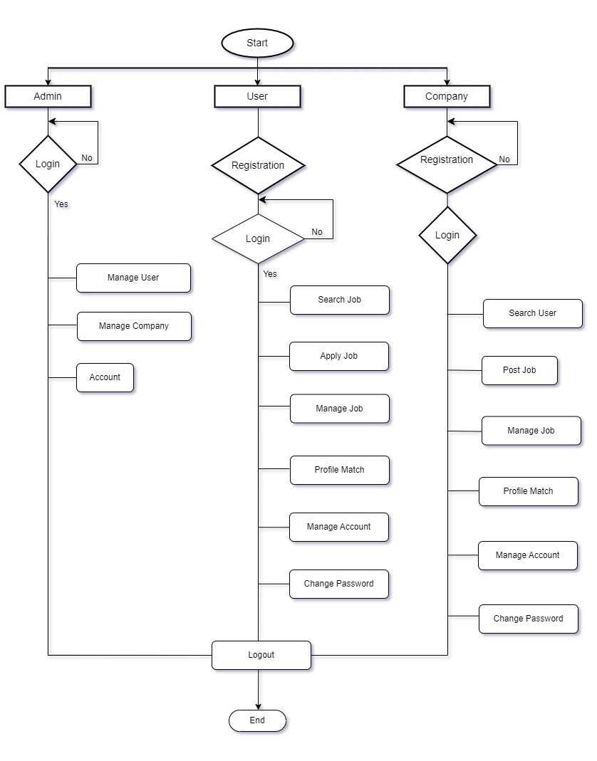

## 2.4 Use Case Diagram

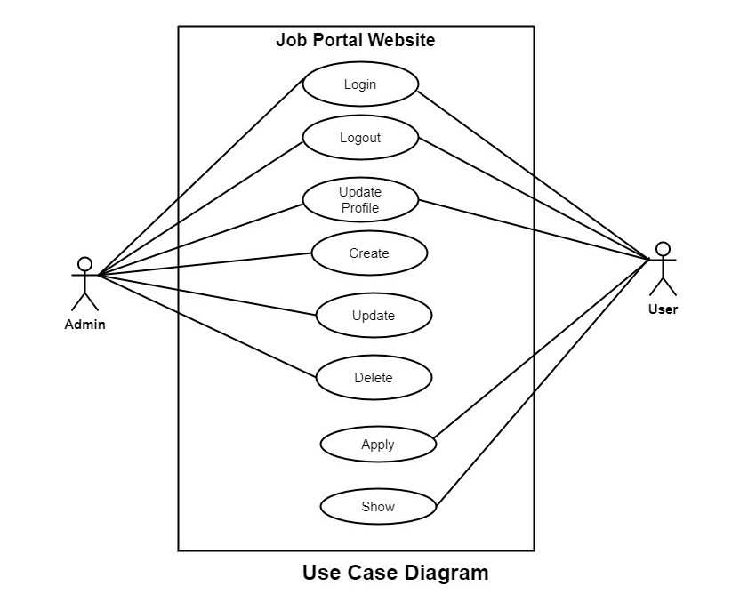

## 2.5 Gantt Chart

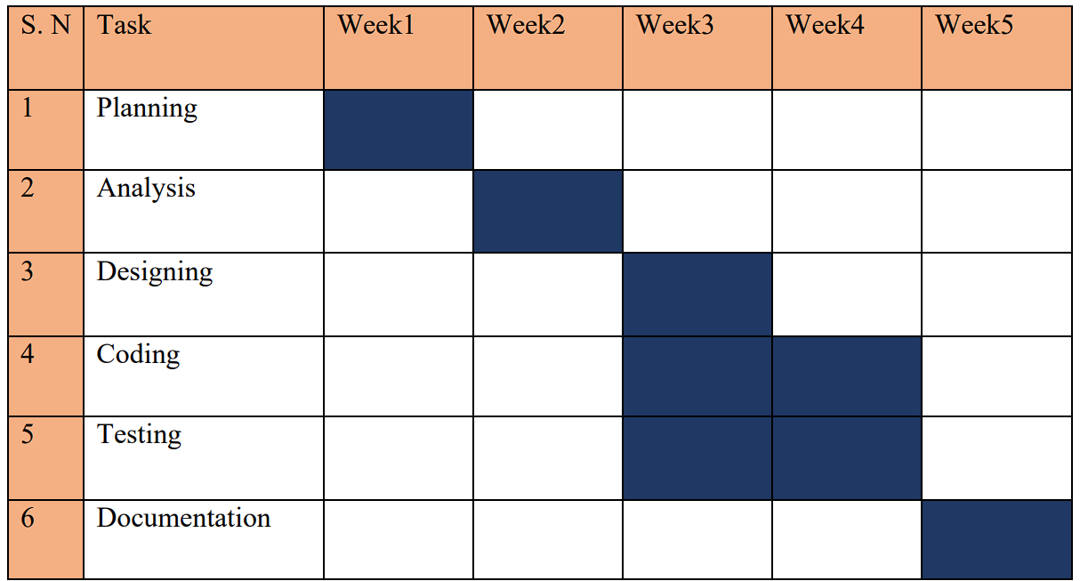

Total time: 5 weeks(1.15months)

# CHAPTER 3

# REQUIREMENT ANALYSIS AND IMPLEMENTATION OF SYSTEM

## 3.1 Requirements

**Hardware Requirements:**

* Memory (RAM): 6.00GB
* System Type: 64-bit OS, x-64 based processor
* Storage Capacity: 30GB HDD
* CPU: 2.50GHZ

**Software Requirements:**

* Operating System: Windows 7 or Higher
* Development Tools: VS Code

**Programming Languages used:**

* Frontend: HTML, CSS, JavaScript
* Framework: Laravel
* Backend: PHP
* Database: MySQL

## 3.2 System Methodology

System Methodology is a methodology for systematically organizing the best ways to develop systems efficiently. It is a step-by-step process for developing any system. There are many system development methodologies. Some of them are Waterfall Model, Iterative Model, Develop Model, V-Model, Spiral Model, Lean and Agile Model, Prototype Model, etc.

In this project, we are going to use the Agile Development Methodology. Agile development methodology is an iterative and flexible approach to software development that emphasizes collaboration, adaptability, and customer satisfaction. It contrasts with traditional waterfall methods, which follow a linear, sequential approach. Agile is characterized by its principles and practices, which enable teams to respond to changing requirements and deliver high-quality software in shorter cycles.

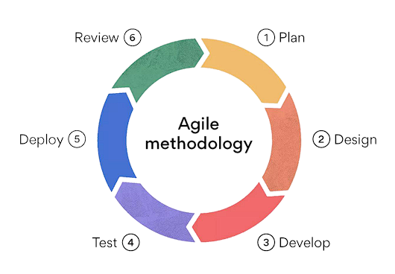

* + 1. **Plan:** In the planning phase, the Agile team collaborates with stakeholders to define project objectives and requirements. This involves creating a product backlog, which is a prioritized list of features, user stories, or tasks. The team discusses and estimates the effort required for each backlog item and decides what to include in the upcoming development cycle, known as a sprint or iteration.
    2. **Design:** Design on Agile focuses on creating a blueprint for how the software will look and function. This includes detailing user interfaces, workflows, and architectural considerations. Agile teams often use techniques like user stories, wireframes, and mock-ups to visualize the design. Design activities may occur before or during development, depending on the Agile framework being used.
    3. **Develop:** During the development phase, the team works on implementing the features and functionality defined in the design and selected for the sprint. Development is typically broken down into smaller tasks, often referred to as user stories or work items, to allow for incremental progress. Continuous integration and collaboration within the development team are essential to ensure that code is integrated smoothly.
    4. **Test:** Testing is an integral part of Agile and runs in parallel with development. Testers validate that each feature or user story meets acceptance criteria and is free of defects. Automated testing and test-driven development (TDD) practices may be employed to maintain code quality and identify issues early. The goal is to ensure that the software functions correctly and aligns with user expectations.
    5. **Deploy:** Deployment involves releasing the developed features to a live or staging environment where end-users can access them. Agile promotes frequent and incremental deployments, allowing users to benefit from new features and improvements as soon as they are ready. Continuous integration and deployment (CI/CD) pipelines may be used to automate the deployment process, ensuring efficiency and reliability.
    6. **Review:** The review phase occurs after deployment and focuses on gathering feedback from users and stakeholders. Agile teams hold regular review meetings, such as sprint reviews or demos, where they showcase the completed work. Feedback is crucial for assessing whether the project is meeting its goals and satisfying user needs. Based on this feedback, the team may update the backlog, reprioritize items, and plan the next sprint or iteration. Continuous improvement is a core principle of Agile, and the review phase plays a central role in this iterative process.

In summary, Agile methodology emphasizes iterative development, collaboration, and responsiveness to change. These six steps represent a continuous cycle that allows Agile teams to adapt to evolving requirements, deliver incremental value, and maintain a high level of customer satisfaction throughout the software development process.

## 3.3 Entity relation diagram

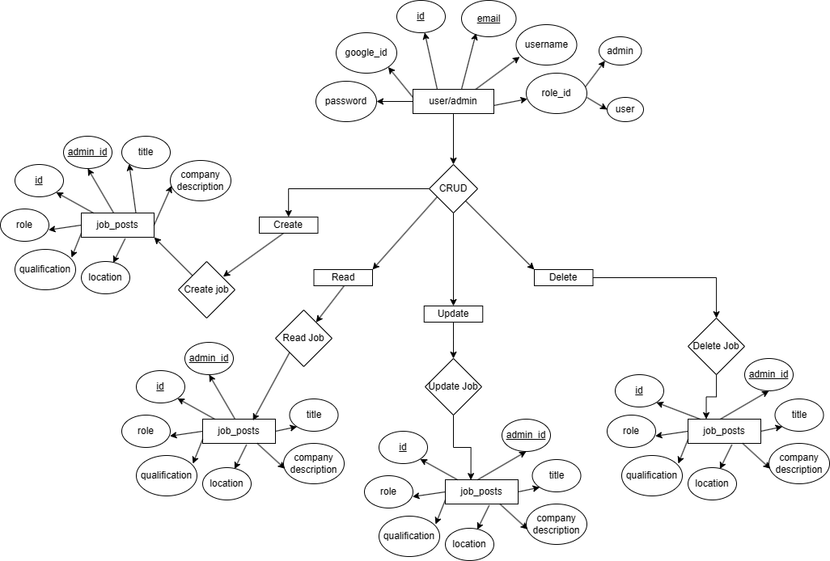

## 3.4 Controller Module

|  |  |  |
| --- | --- | --- |
| **S.N.** | **Controller** | **Controller Description** |
| 1. | Admin Controller | It handles all the admin interactions such as dashboard, job analytics candidate management etc. |
| 2. | Contact Controller | It handles the contact information of the user and uses php mailer for the contact. |
| 3. | Controller | It is the default controller given by the Laravel. |
| 4. | Google Auth Controller | It handles the google authorization and stores the information including google id in the database |
| 5. | Job Application Controller | It handles the application interactions the job displayed can be applied and the read operation can be conducted for the whole description |
| 6. | Job Controller | It handles the job create, edit, post, delete features. |
| 7. | Profile Controller | It handles the profile information and stores them to the database. |
| 8. | User Controller | It handles all the user interactions such as dashboard, profile, search, applications etc. |

# CHAPTER 4

# FUTURE SCOPE AND CONCLUSION

## 4.1 Future Scope

1. **Advanced Matching Algorithm:** Implementing more sophisticated algorithms powered by machine learning and AI can improve job recommendations, ensuring better matches between job seekers and employers based on skills, experience, preferences, and cultural fit.
2. **Personalization:** Tailoring the user experience based on individual preferences and behavior can enhance engagement. Features like personalized job recommendations, customized job alerts, and career path suggestions can make the platform more valuable to users.
3. **Remote Work Opportunities:** With the rise of remote work trends, Job Portal Websites can focus on aggregating remote job opportunities across various industries and geographical locations, catering to a global workforce.
4. **Blockchain for Verification:** Leveraging blockchain technology for verifying credentials, certifications, and work histories can enhance trust and transparency in the hiring process, reducing the risk of resume fraud and improving the quality of candidate profiles.
5. **Data Analytics for Insights**: Employing advanced data analytics techniques to analyze user behavior, job market trends, and recruitment patterns can provide valuable insights for both job seekers and employers, enabling data-driven decision-making.
6. **Mobile Optimization:** With the increasing prevalence of mobile devices, optimizing the platform for mobile usage and developing dedicated mobile applications can improve accessibility and convenience for users.
7. **Partnerships and Integration:** Collaborating with other platforms and services such as professional networking sites, educational institutions, and HR software providers can expand the range of features and resources available to users, creating a more comprehensive ecosystem for job seekers and employers.

## 4.2 Conclusion

In conclusion, Job Portal Websites serve as invaluable platforms that bridge the gap between job seekers and employers, streamlining the recruitment process and facilitating meaningful connections in the ever-evolving job market. These platforms offer a multitude of benefits, including accessibility to a wide range of job opportunities, personalized job recommendations, and tools for skill assessment and career development. Additionally, they play a crucial role in promoting diversity and inclusion initiatives, supporting remote work trends, and fostering a more transparent and data-driven approach to hiring.

Looking ahead, the future of Job Portal Websites holds immense promise, with opportunities for further innovation and enhancement. By embracing advanced technologies such as AI, machine learning, and blockchain, these platforms can continue to evolve, offering more tailored and effective solutions for job seekers and employers alike. Moreover, partnerships and integrations with other platforms and services can expand the scope and reach of Job Portal Websites, creating a comprehensive ecosystem that addresses the diverse needs of the modern workforce.

In essence, Job Portal Websites remain essential tools for navigating the complexities of the job market, empowering individuals to find fulfilling employment opportunities and enabling organizations to discover top talent. As they continue to evolve and adapt to changing trends and technologies, Job Portal Websites will undoubtedly play a pivotal role in shaping the future of work.

# CHAPTER 5

# APPENDIX

## 5.1 Screenshots

