Testing Checklist
Testing question | Yes/No | Evidence or notes
Does the prototype open/start correctly? | Yes | 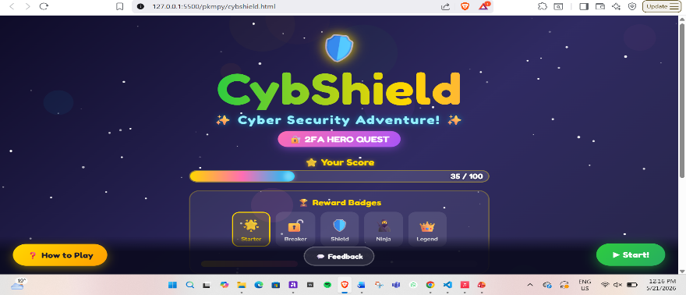
Is the welcome/title screen clear? | Yes | The game title is easily visible in the welcome page.
Are the instructions easy to understand? |  | 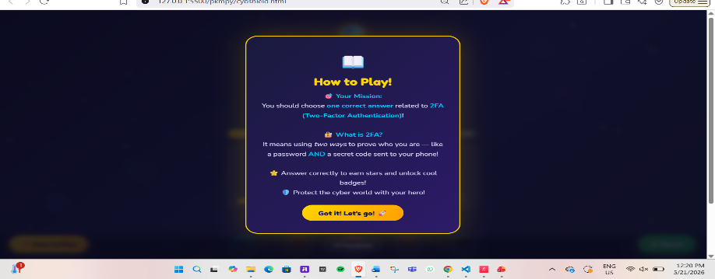
Can the player identify what to click/do? | Yes | The buttons are highlighted in easy to find colors and are easily spotted.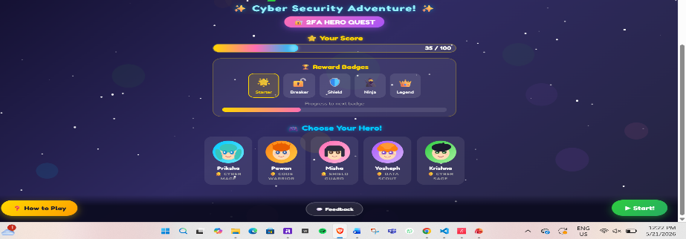
Does the first cyber-safety challenge work? | Yes | 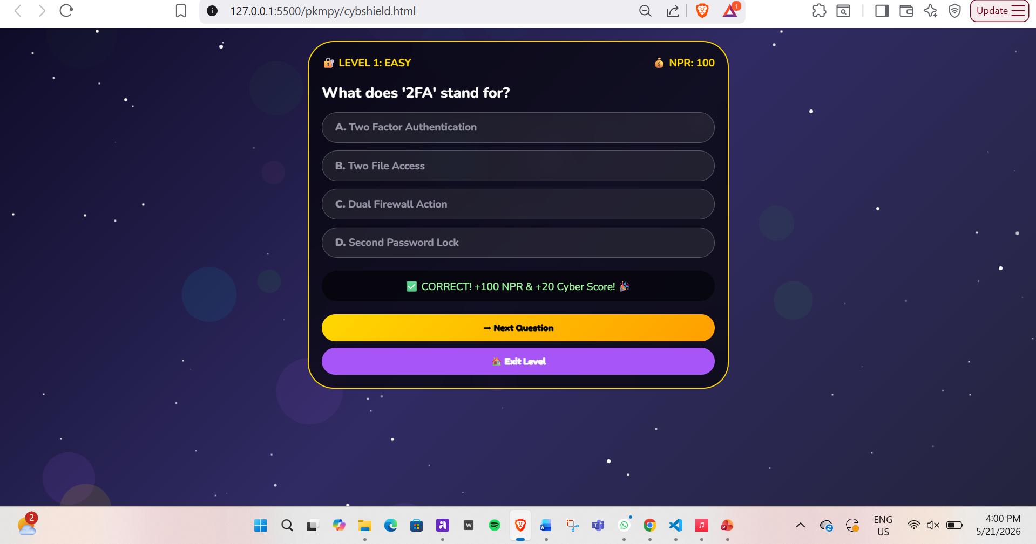
Does any new challenge/interaction work? | yes | 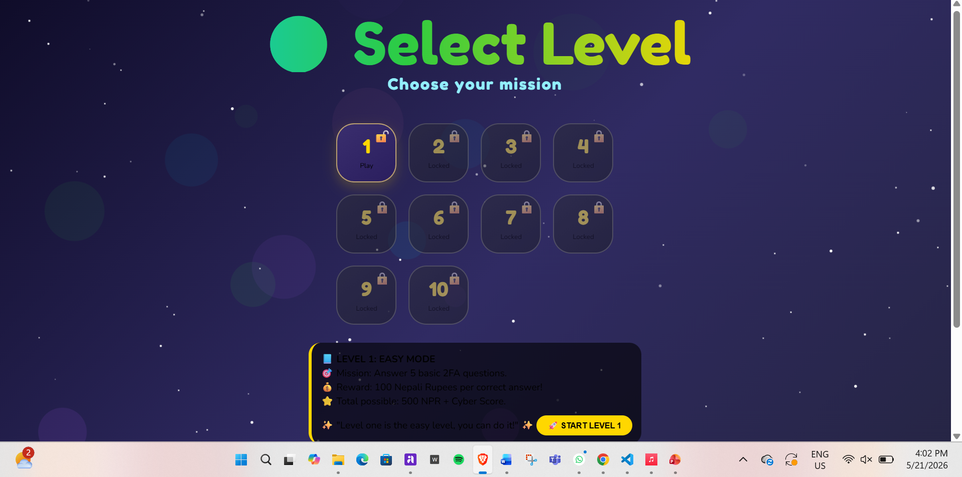
Does the correct answer show useful feedback? | No/in progress | 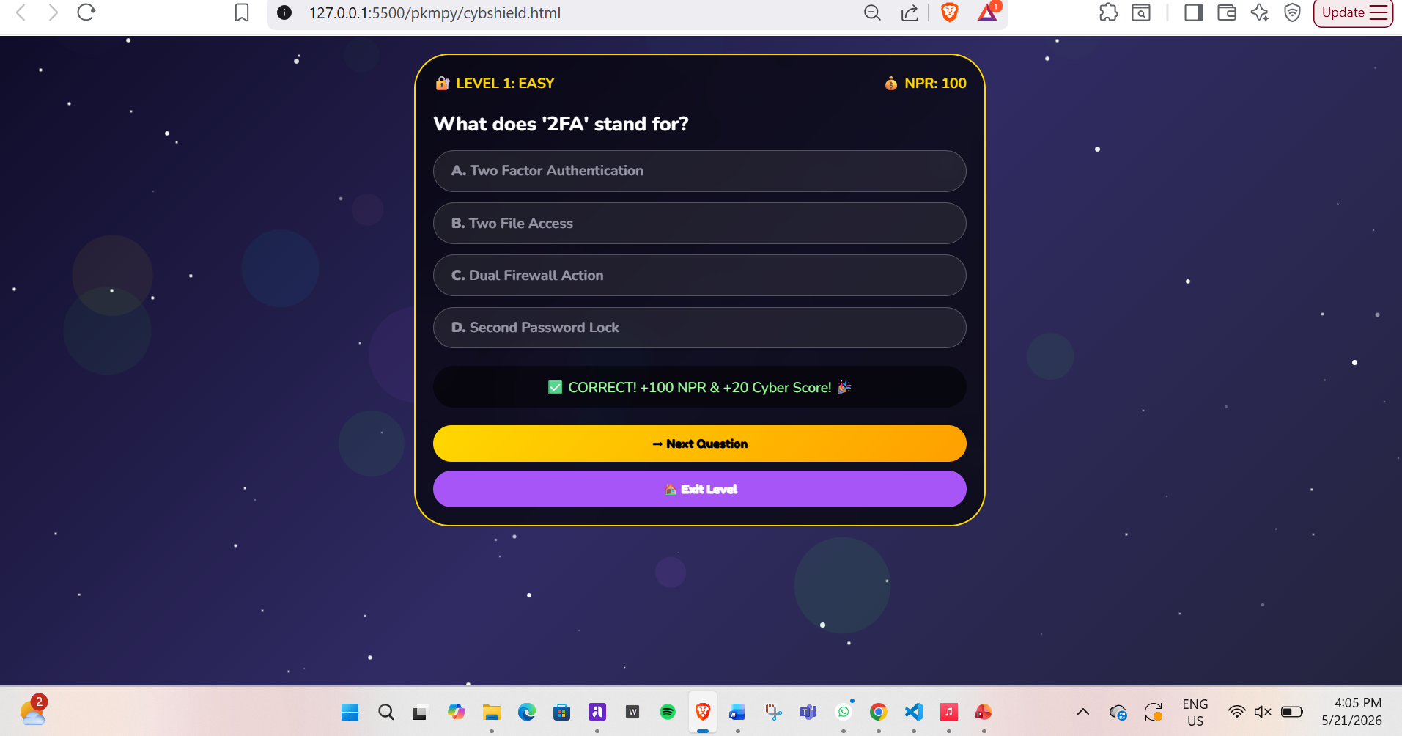
Does the wrong answer show helpful feedback? | No/ in progress | 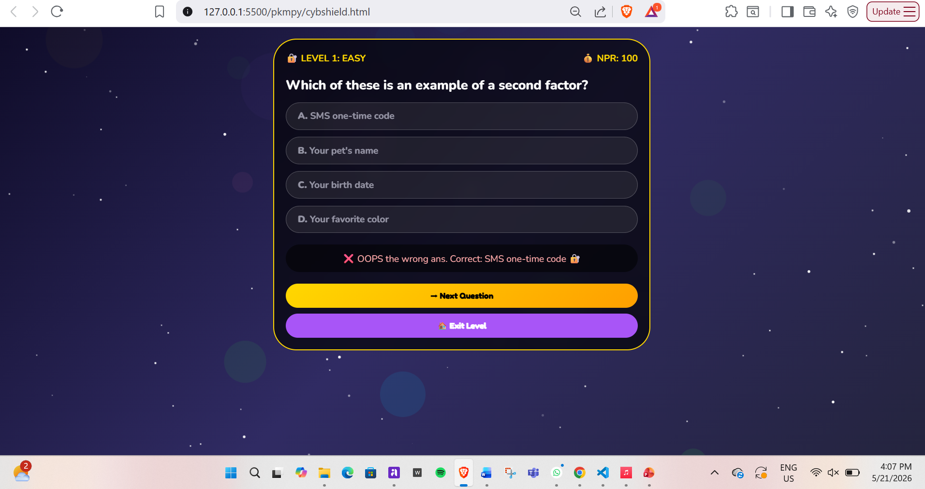
Does the feedback teach a cyber-safety lesson? | No/in progess | Shows it is an incorrect answer but not the cyber safety lesson yet.
Is there a reward, score, star, badge or progress message? | Yes | 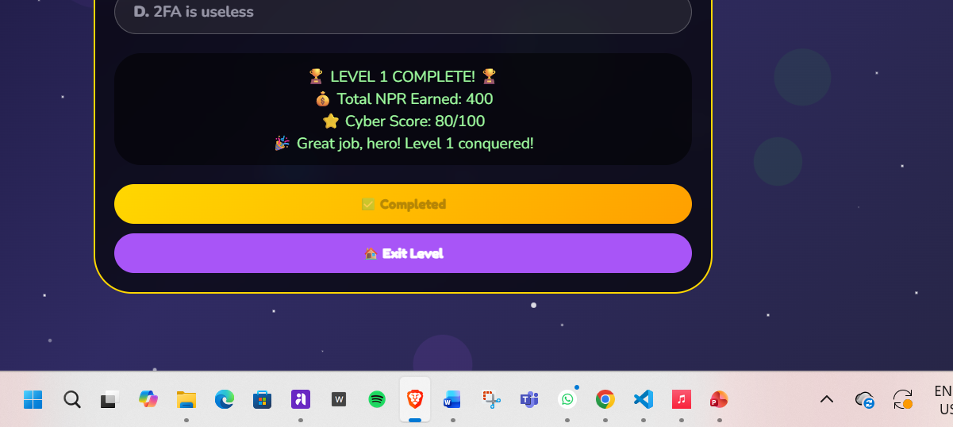
Is the prototype suitable for the target audience? | Yes | the colors are children friendly and engaging, and the instructions are easy to understand.
What must be improved before next week? | Yes | while the instructions are clear, it could be improved by reducing the word count and enlarging the font, and the instructions after the first interface cn be improved

