Testing Checklist
Testing question | Yes/No | Evidence or notes
Does the prototype open/start correctly? | Yes | 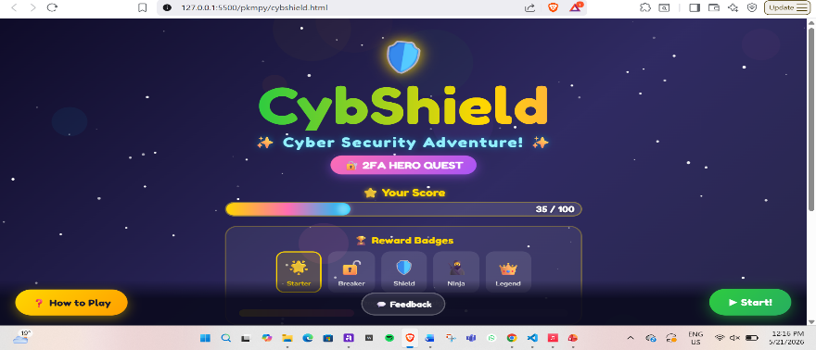
Is the welcome/title screen clear? | Yes | The game title is easily visible in the welcome page.
Are the instructions easy to understand? |  | 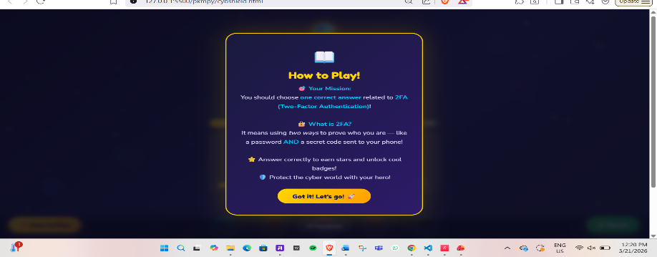
Can the player identify what to click/do? | Yes | The buttons are highlighted in easy to find colors and are easily spotted.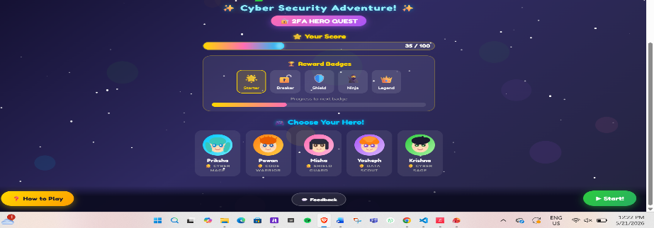
Does the first cyber-safety challenge work?
Does any new challenge/interaction work?
Does the correct answer show useful feedback?
Does the wrong answer show helpful feedback? | Yes
Does the feedback teach a cyber-safety lesson? | Yes
Is there a reward, score, star, badge or progress message? | Yes
Is the prototype suitable for the target audience? | Yes
What must be improved before next week?

