Q. 1
create database ecommerce;
use ecommerce;

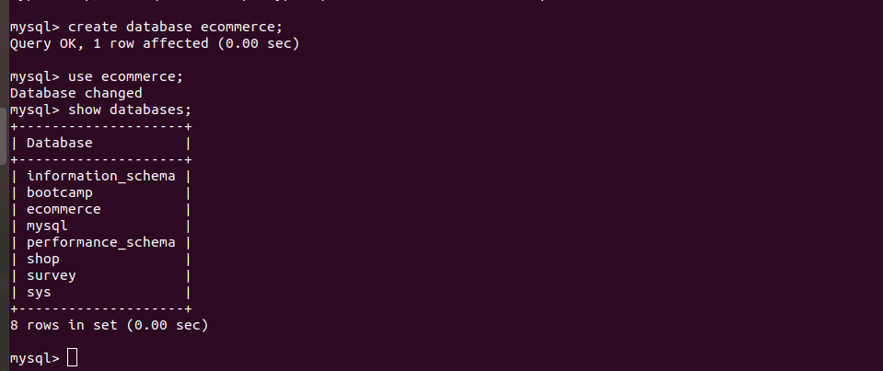
Q. 2
Schema For Ecommerce

Customer
Id int primary key
Name varchar
Address varchar
Sales Person
Id int primary key

Name varchar

Id int primary key
Name varchar

Product
Sales Order
O_id int primary key

C_id int foreign key

S_id int foreign key

P_id int foreign key

Q .3
Create Table
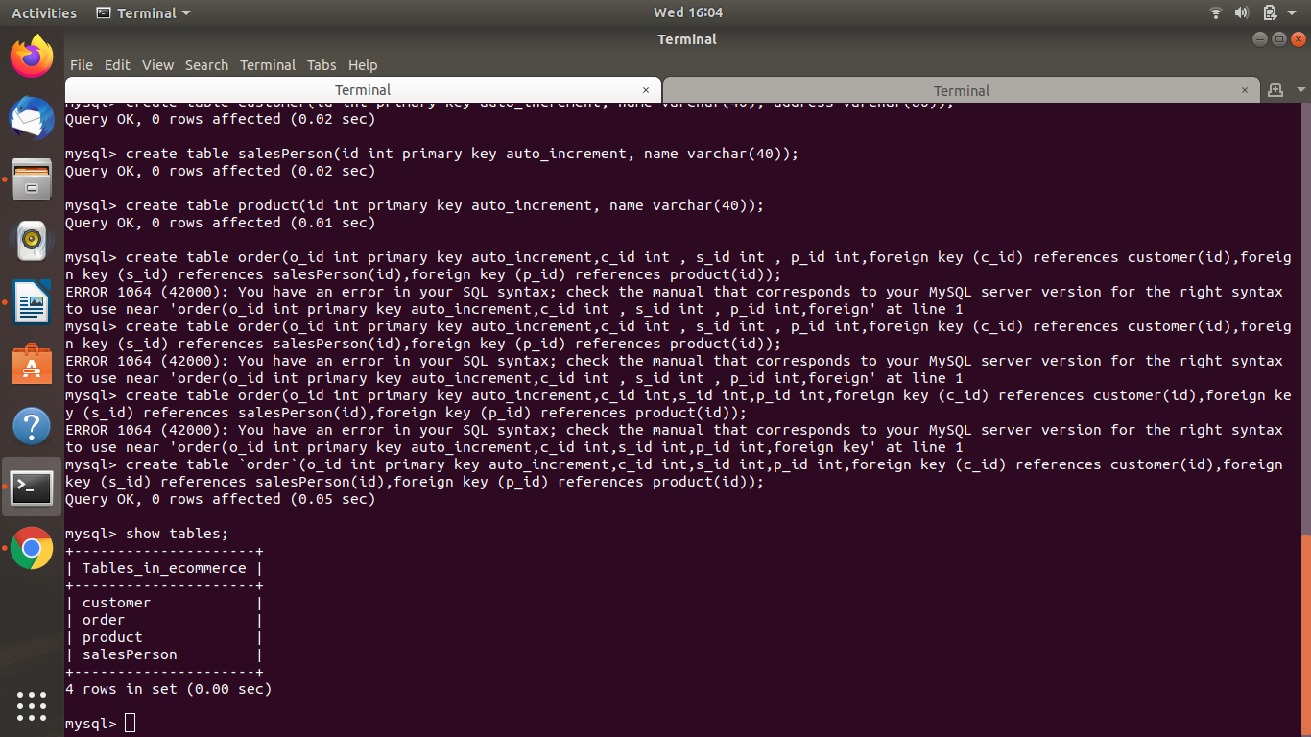
Q. 4

Insert Data Into Table By Commands
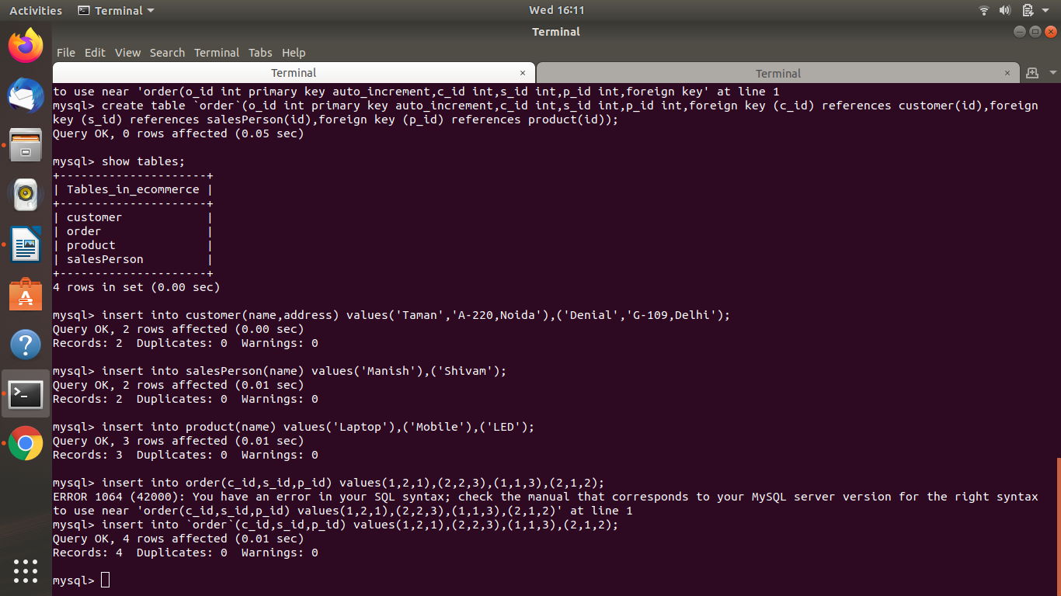

Showing Data Which is inserted
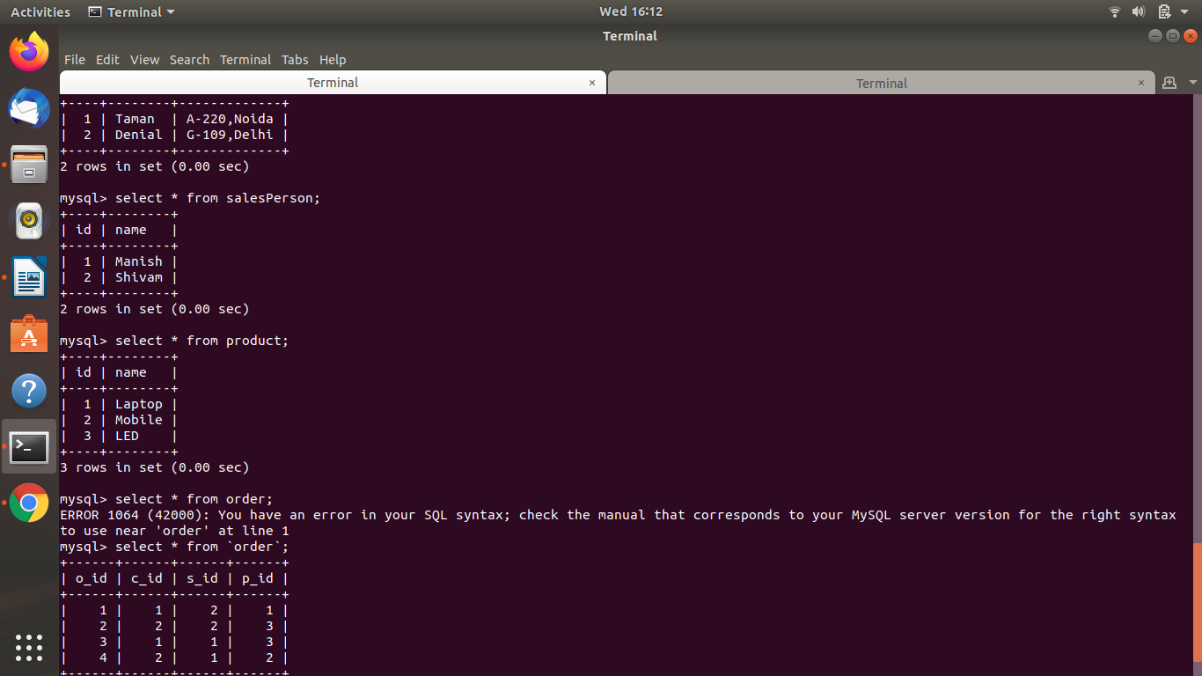
Q. 5
Find the sales person have multiple orders.

Query -
select s.name from salesPerson s , (select s_id from `orders` GROUP BY s_id HAVING count(*)>1) as tmp where s.id=tmp.s_id;
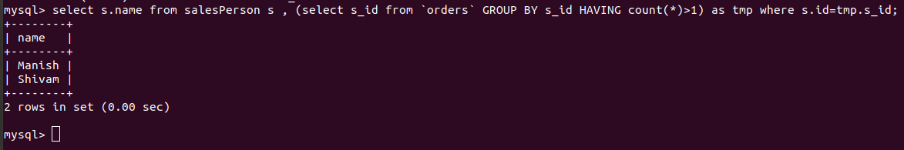

Q. 6
Find the all sales person details along with order details.
Query -
select s.name,c.name,c.address,p.name from `orders` o join salesPerson s on s.id=o.s_id join product p on p.id=o.p_id join customer c on c.id=o.c_id;

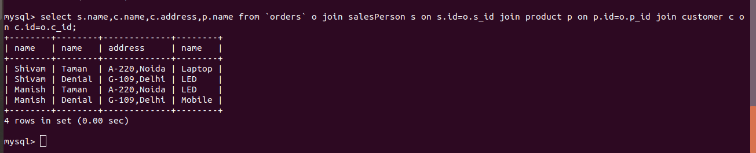

Q. 7
Create index
Query - alter table customer ADD INDEX c_name(name);


Q. 8
How to show index on a table
Query - show index from customer;
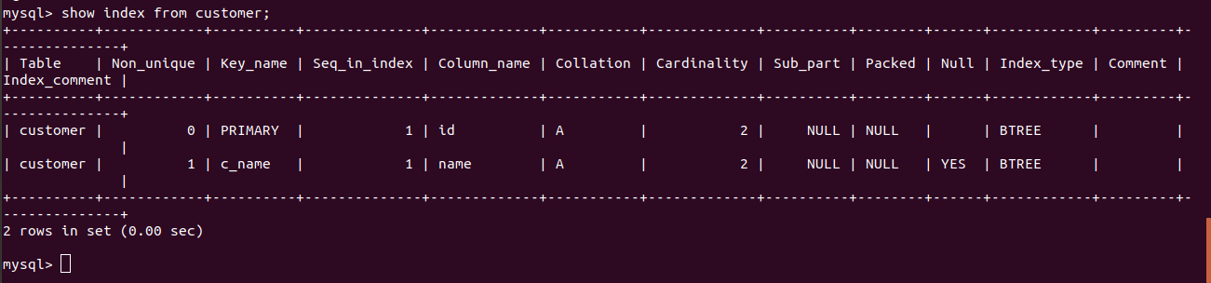

Q. 9
Find the order number, sale person name, along with the customer to whom that order belongs to
Query -

select o.o_id,s.name,c.name from `orders` o join customer c on c.id=o.c_id join salesPerson s on s.id=o.s_id;

