**KALINDI COLLEGE,**

**UNIVERSITY OF DELHI**

**PRACTICAL FILE OF COMPUTER NETWORKS**

**Kashish**

**22570074**

**Ques 2-To study and perform PC to PC communication using Ethernet**

1. Launch Cisco Packet Tracer on your computer.
2. Click on "File" > "New" to create a new empty network.
3. From the bottom left corner of the screen, select PCs or laptops to represent your end devices.
4. Drag and drop the PCs onto the workspace. You can place them wherever you like.
5. Use the connection tool (looks like a straight line) to connect the PCs with Ethernet cables. Click on one PC, then click on the other PC to create a connection. Repeat this process for each pair of PCs you want to communicate with each other.
6. If you want the PCs to communicate using IP addresses, you'll need to configure them. Right-click on each PC, select "Config," and configure the IP address settings. Make sure each PC has a unique IP address within the same sub net.

7.Once you've configured the IP addresses (if necessary), you can verify connectivity by opening a command prompt on each PC (use the "Desktop" tab and select "Command Prompt") and pinging the other PC's IP address.

1. For example, if PC1 has IP address 172.16.0.1 and PC2 has IP address 172.16.0.2 from PC1's command prompt, you can type:
2. Ping 172.16.0.2
3. This will send ICMP echo requests to PC2. If the communication is successful, you'll receive replies.
4. Once you're done testing the communication between PCs, it's a good idea to save your work. Go to "File" > "Save As" and choose a location and filename to save your Packet Tracer file.

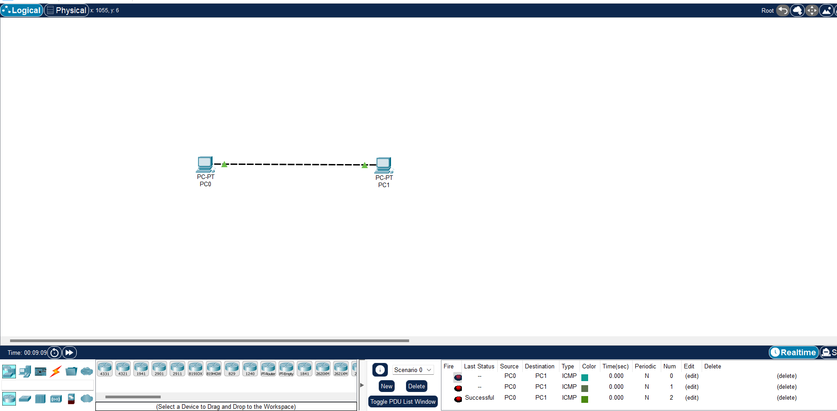

**Ques 3-To create Star topology using hub and switch**

1. Open the Cisco Packet Tracer application on your computer.
2. Click on "File" > "New" to create a new empty network project.
3. From the bottom left corner of the screen, select the devices you need for your Star topology. You will need a hub and a switch as central devices, and PCs or laptops as end devices.
4. Drag and drop the selected devices onto the workspace. Position the hub and the switch centrally, and place the PCs or laptops around them to represent the star topology.
5. Use the connection tool (straight line icon) to connect each end device (PC or laptop) to either the hub or the switch. Click on one device, then click on the hub or switch to create a connection. Repeat this process until all devices are connected.
6. You can configure IP addresses on PCs or laptops if you want them to communicate with each other. Right-click on a PC, select "Config," and configure the IP address settings.
7. Once you've completed setting up your Star topology, save your work. Go to "File" > "Save As" and choose a location and filename to save your Packet Tracer file.
8. You can now simulate the network and test connectivity between devices to ensure everything is working as expected. Verify that devices can communicate with each other through the hub or switch.

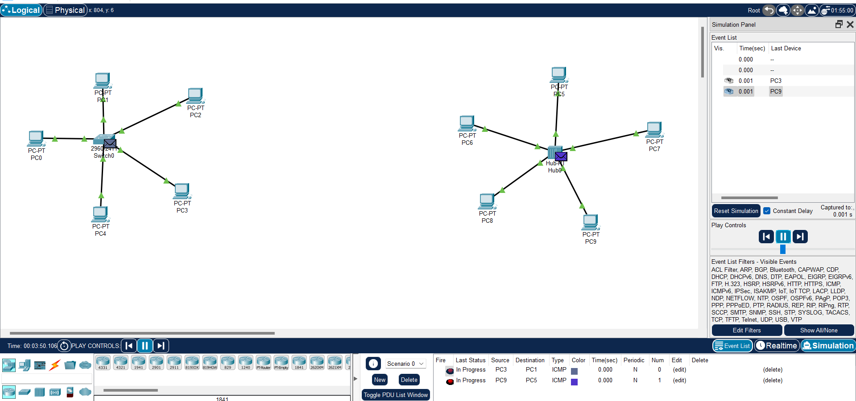

**Ques 4- To create Bus, Ring, Tree, Hybrid, Mesh topologies.**

**Creating a bus topology:**

1. Launch the Cisco Packet Tracer application on your computer.
2. Click on "File" > "New" to start a new empty network project.
3. From the bottom left corner of the screen, select the devices you need for your bus topology. You'll typically need PCs or laptops as end devices and a switch or a router to act as the backbone of the bus.
4. Drag and drop the selected devices onto the workspace. For a bus topology, place the switch or router at one end of the workspace. Arrange the PCs or laptops in a linear manner, connecting them to the switch or router.
5. Use the connection tool (straight line icon) to connect each end device (PC or laptop) to the switch or router. Click on one device, then click on the switch or router to create a connection. Continue this process until all devices are connected.
6. You can configure IP addresses on PCs or laptops if you want them to communicate with each other. Right-click on a PC, select "Config," and configure the IP address settings.
7. Once you've set up your bus topology, it's a good idea to save your work. Go to "File" > "Save As" and choose a location and filename to save your Packet Tracer file.
8. You can now simulate the network and test connectivity between devices to ensure everything is working as expected. Verify that devices can communicate with each other through the switch or router.

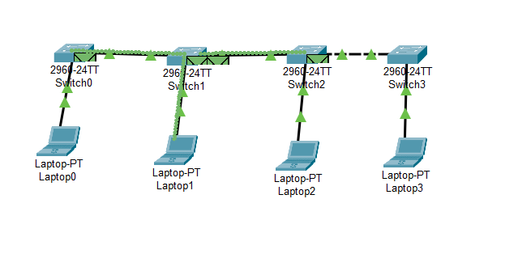

**Creating a ring topology:**

1. Open Cisco Packet Tracer on your computer.
2. Click on "File" > "New" to start a new empty network project.
3. From the bottom left corner of the screen, select the devices you need for your ring topology. You'll typically need PCs or laptops as end devices and switches or routers to connect them in a ring.
4. Drag and drop the selected devices onto the workspace. Arrange them in a circular manner to represent the ring topology. Each device should connect to two other devices forming a ring.
5. Use the connection tool (straight line icon) to connect each device in the ring. Click on one device, then click on the next device in the ring to create a connection. Repeat this process until all devices are connected in a ring.
6. You can configure IP addresses on PCs or laptops if you want them to communicate with each other. Right-click on a PC, select "Config," and configure the IP address settings.
7. Once you've set up your ring topology, save your work. Go to "File" > "Save As" and choose a location and filename to save your Packet Tracer file.

8.Simulate the network and test connectivity between devices to ensure everything is working as expected. Verify that devices can communicate with each other around the ring.

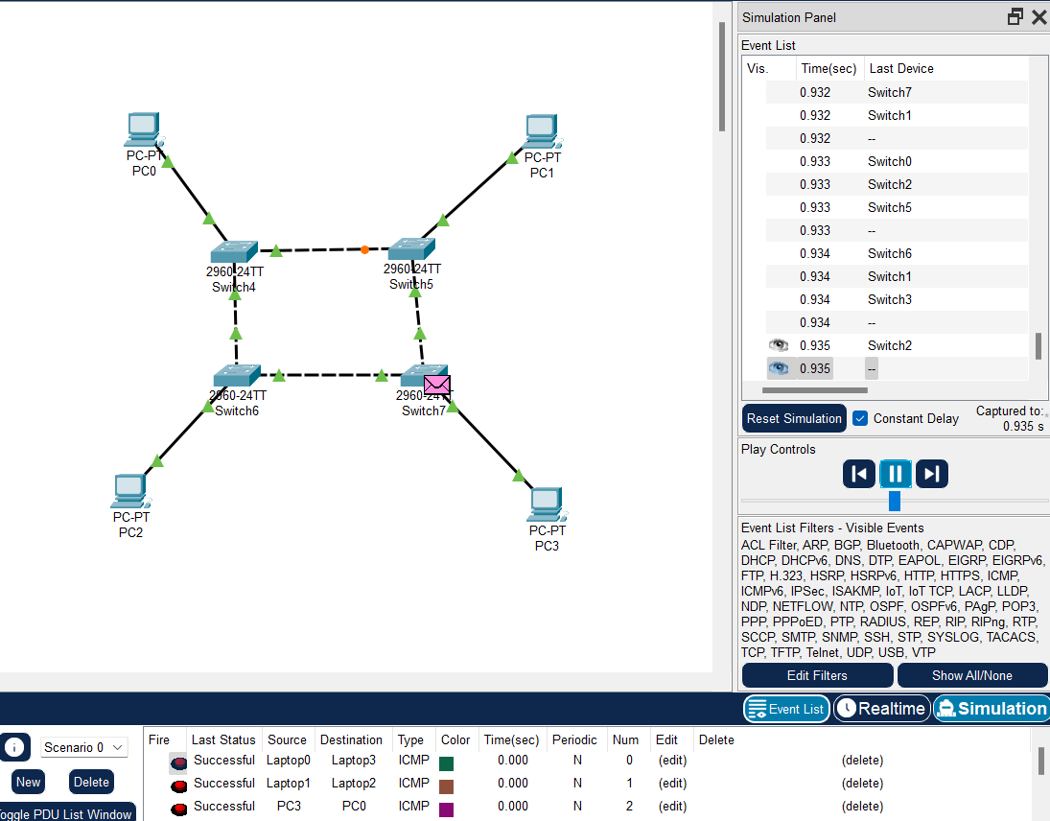

**Creating a tree topology:**

Open Cisco Packet Tracer on your computer.

1. Click on "File" > "New" to start a new empty network project.
2. From the bottom left corner of the screen, select the devices you need for your tree topology. Common devices include PCs or laptops as end devices, switches or routers as intermediary devices, and possibly a server or router as the root node.
3. Drag and drop the selected devices onto the workspace. Position them in a hierarchical manner to represent the tree structure. Place the root node (e.g., server or router) at the top, with switches or routers connecting to it as parent nodes, and end devices connected to those switches or routers as child nodes.
4. Use the connection tool (straight line icon) to connect the devices according to the tree structure. Click on one device, then click on the other device to create a connection. Continue this process until all devices are connected in the desired hierarchy.
5. You can configure IP addresses on PCs or laptops if you want them to communicate with each other. Right-click on a PC, select "Config," and configure the IP address settings. Similarly, configure any necessary settings on switches or routers.
6. Once you've set up your tree topology, save your work. Go to "File" > "Save As" and choose a location and filename to save your Packet Tracer file.

7.Simulate the network and test connectivity between devices to ensure everything is working as expected. Verify that devices can communicate with each other according to the tree structure.

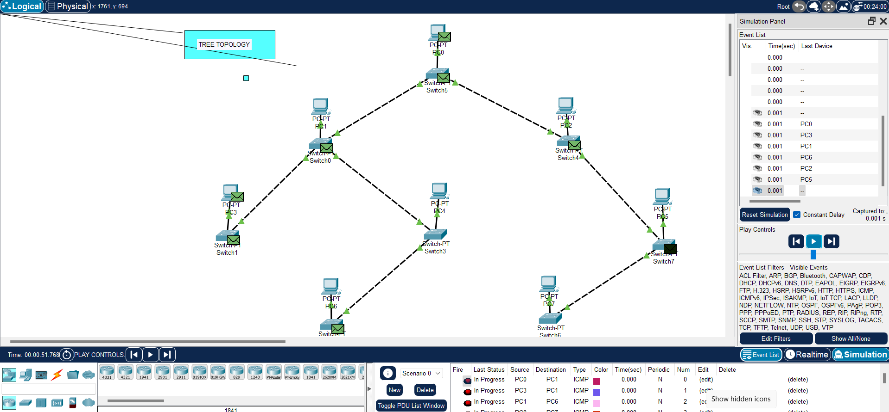

**Creating a hybrid topology:**

1. Open Cisco Packet Tracer on your computer
2. Click on "File" > "New" to start a new empty network project.
3. From the bottom left corner of the screen, select the devices you need for your hybrid topology. Choose a combination of devices, including PCs or laptops as end devices, switches or routers as intermediary devices, and possibly servers or other specialized devices.
4. Drag and drop the selected devices onto the workspace. Position them according to the topology you want to create. You can combine different topologies by placing devices in various configurations.
5. Use the connection tool (straight line icon) to connect the devices according to the desired topology. Click on one device, then click on the other device to create a connection. Repeat this process to establish connections between devices as required by your hybrid topology.
6. Configure IP addresses, VLANs, or other settings on devices as necessary for your specific network requirements. Right-click on a device, select "Config," and configure the settings accordingly.
7. Once you've set up your hybrid topology, save your work. Go to "File" > "Save As" and choose a location and filename to save your Packet Tracer file.

8.Simulate the network and test connectivity between devices to ensure everything is working as expected. Verify that devices can communicate with each other according to the hybrid topology you've created.

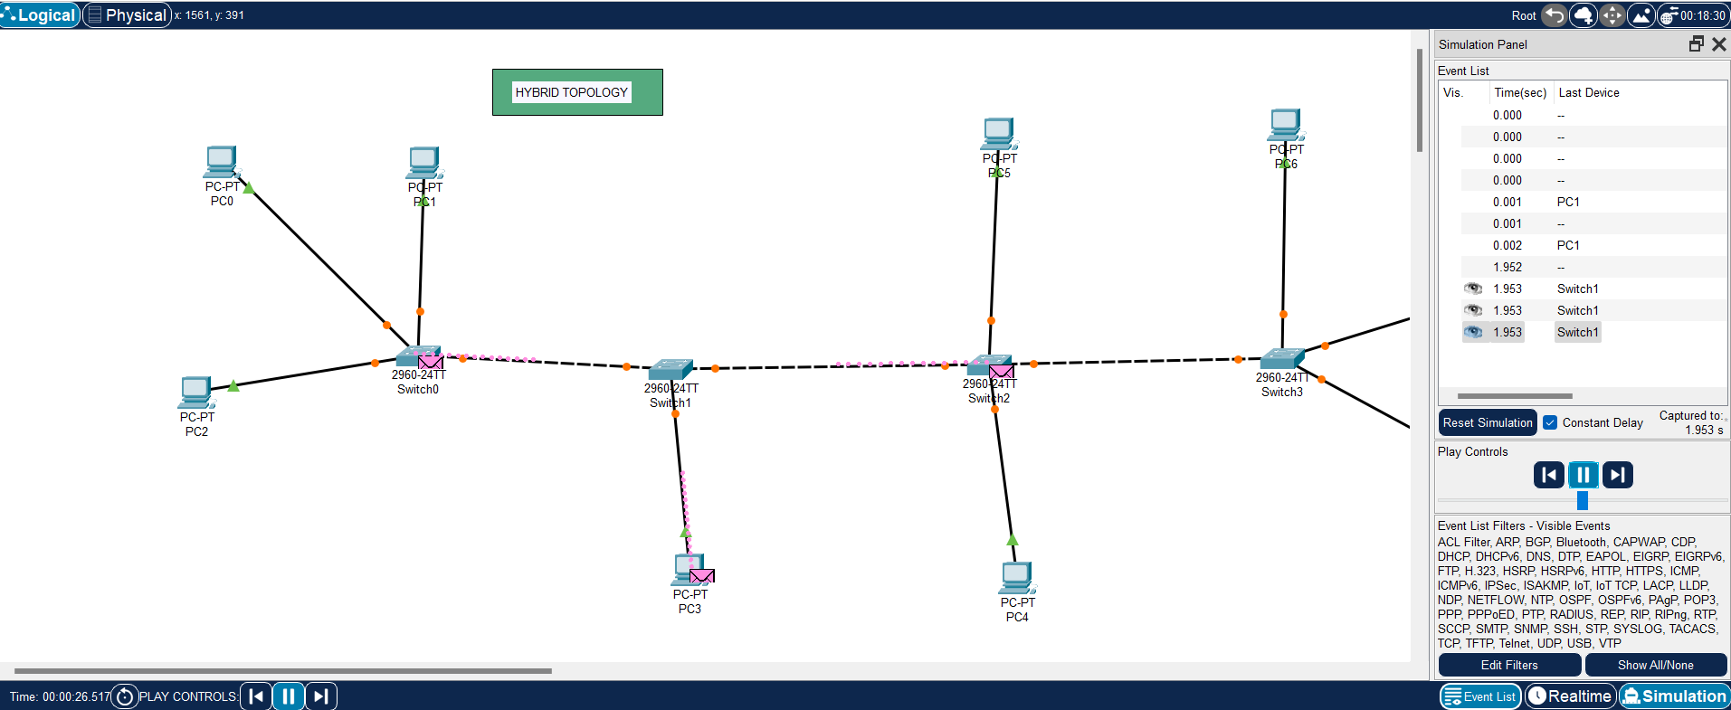

**Creating a mesh topology:**

1. Open Cisco Packet Tracer on your computer.
2. Click on "File" > "New" to start a new empty network project.
3. From the bottom left corner of the screen, select the devices you need for your mesh topology. Common devices include PCs or laptops as end devices, switches or routers as intermediary devices, and possibly servers or other specialized devices.
4. Drag and drop the selected devices onto the workspace. Position them in such a way that each device is connected to every other device. This might require careful arrangement and some planning.
5. Use the connection tool (straight line icon) to create connections between devices. Click on one device, then click on another device to establish a connection. Repeat this process until every device is connected to every other device.
6. Configure IP addresses, VLANs, or other settings on devices as necessary for your specific network requirements. Right-click on a device, select "Config," and configure the settings accordingly.
7. Once you've set up your mesh topology, save your work. Go to "File" > "Save As" and choose a location and filename to save your Packet Tracer file.

8.Simulate the network and test connectivity between devices to ensure everything is working as expected. Verify that devices can communicate with each other, considering the fully interconnected nature of the mesh topology.

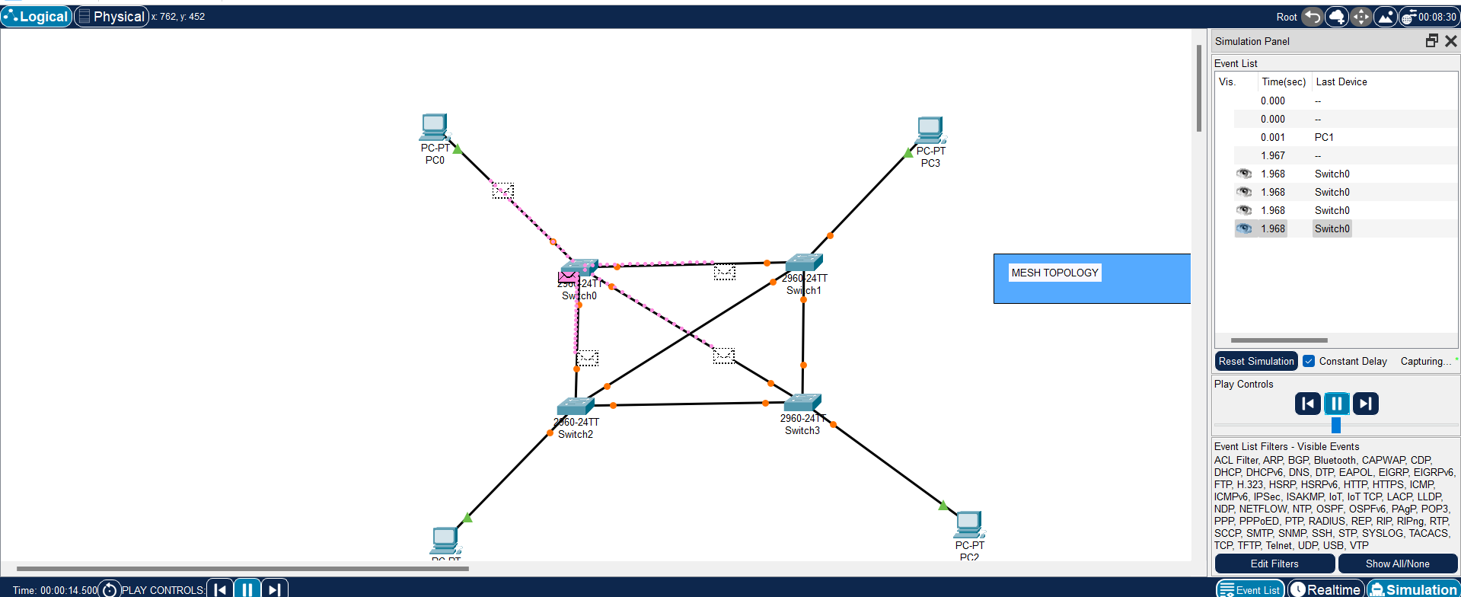

**Ques 5-Perform an initial Switch configuration .**

1. Open Cisco Packet Tracer on your computer.

2. Drag and drop a switch from the bottom toolbar onto the workspace area.

3. Connect your switch to a PC or another device if you want to configure inter-device communication. Use copper straight-through cables for this purpose.

4. Click on the switch, then click on the green power button to turn it on.

5. Double-click on the switch to access its command-line interface (CLI). This will open the CLI tab where you can enter commands.

6. By default, you're in User EXEC mode, indicated by the ">" prompt.

“ enable”

You will now see the "#" prompt, indicating you have entered privileged EXEC mode.

7. From privileged EXEC mode, enter global configuration mode by typing:

“configure terminal”

This will allow you to make changes to the switch's global configuration.

8.While in global configuration mode, set the hostname for your switch using the following command:

“hostname”

9. Assign an IP address to the switch for remote management purposes. Use the following command:

“ interface vlan 1

ip address

no shutdow “

10. Save the configuration changes to the switch's memory using the following command:

``end

write memory”

Alternatively, you can use the command `copy running-config startup-config` to achieve the same result.

11. You can verify your configuration by using various show commands such as `show running-config` to display the current running configuration.

12. Once you have finished configuring the switch, exit global configuration mode and return to privileged EXEC mode by typing:

```

exit

```

This will take you back to privileged EXEC mode.

13. Finally, exit the CLI by typing:

```

exit

```

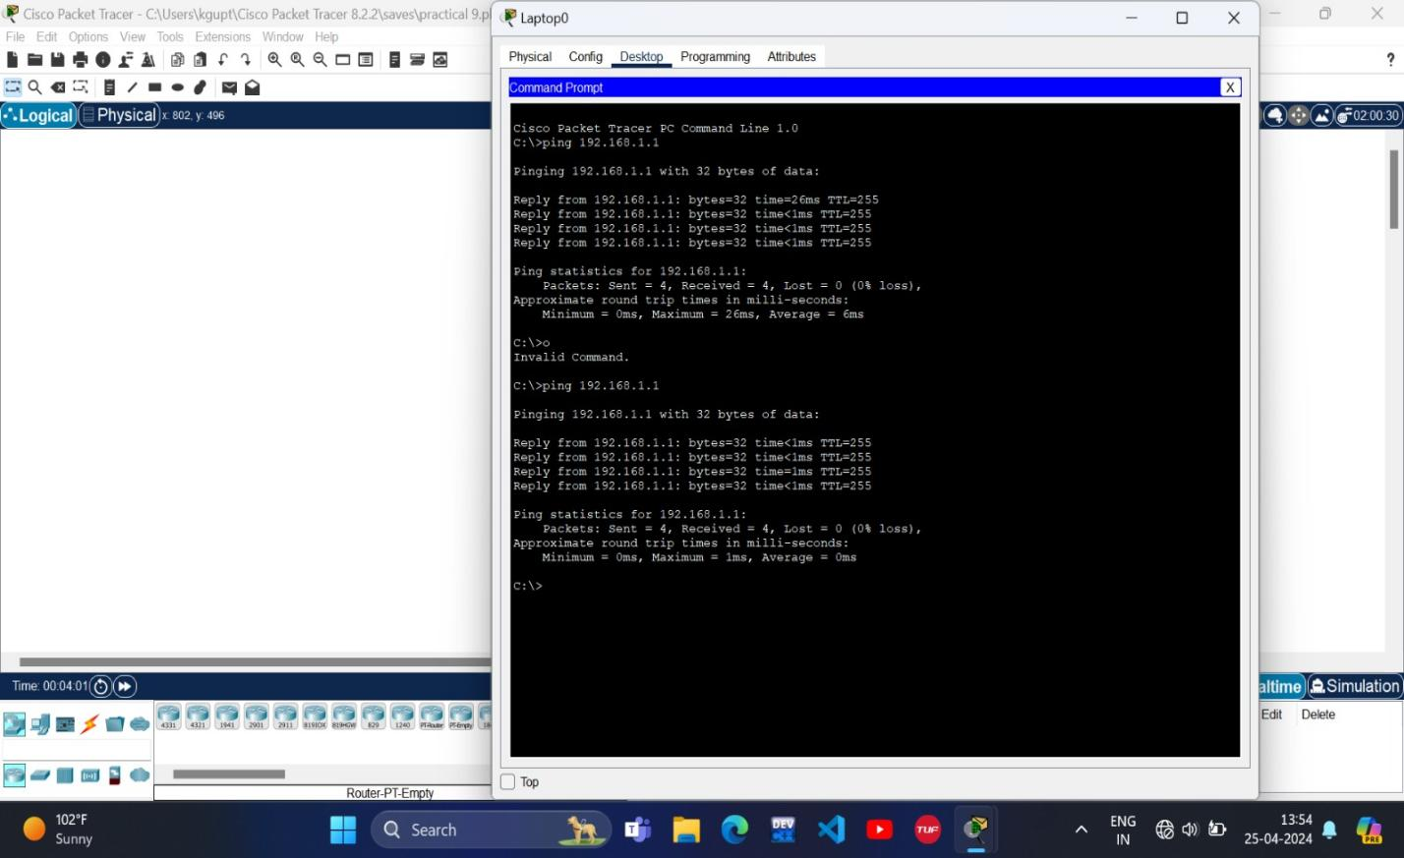

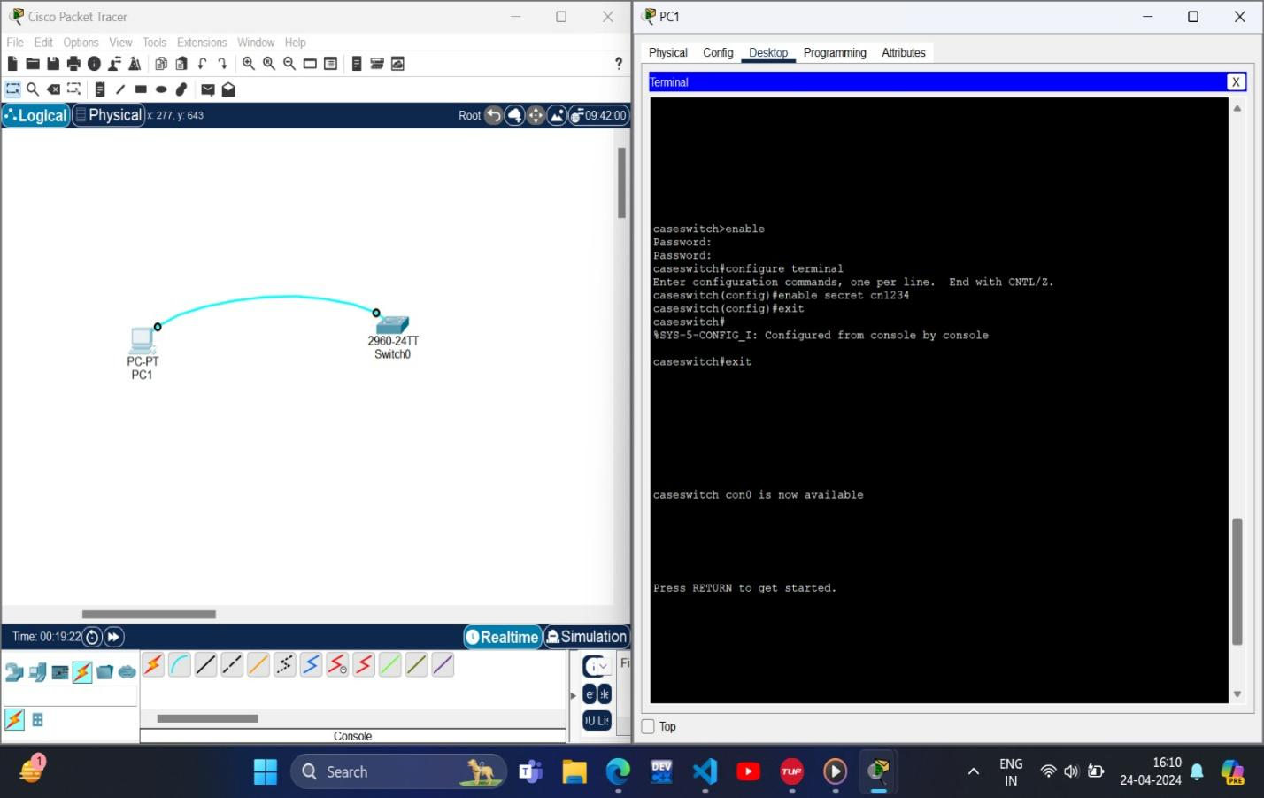

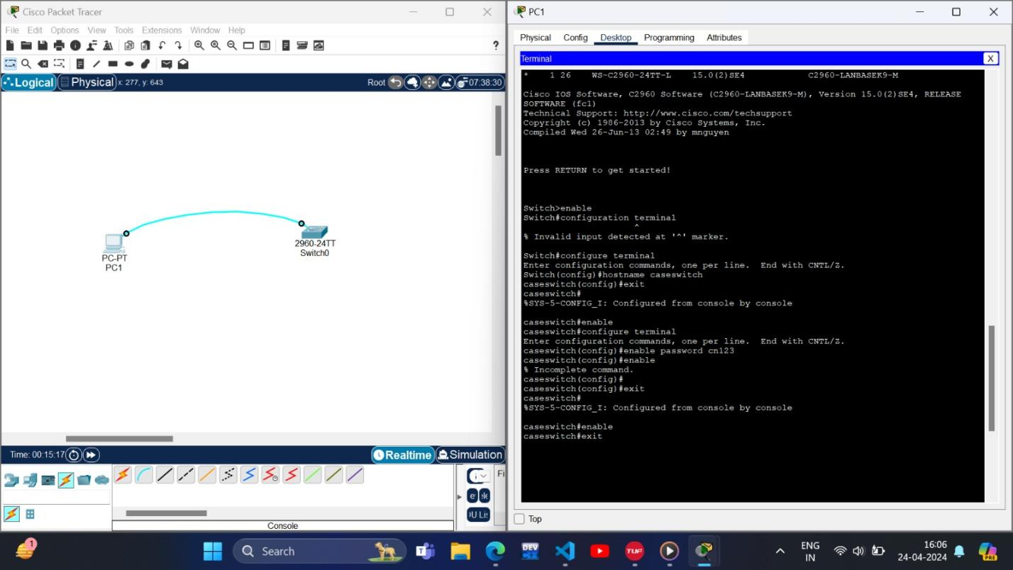

**Ques 6-Perform an initial Router configuration.**

1. Open Cisco Packet Tracer on your computer.

2. Drag and drop a router from the bottom toolbar onto the workspace area.

3. Connect your router to other devices if needed. Use copper straight-through cables for connections to switches or PCs.

4. Click on the router, then click on the green power button to turn it on.

5. Double-click on the router to access its command-line interface (CLI). This will open the CLI tab where you can enter commands.

6. By default, you're in User EXEC mode, indicated by the ">" prompt. Enter privileged EXEC mode by typing:

“enable”

You will now see the "#" prompt, indicating you have entered privileged EXEC mode.

7. From privileged EXEC mode, enter global configuration mode by typing:

“configure terminal”

This will allow you to make changes to the router's global configuration.

8. While in global configuration mode, set the hostname for your router using the following command:

“ hostname [desired hostname]”

Replace `[desired hostname]` with the name you want to give to your router.

9. Assign an IP address to the router's interface for remote management purposes. Use the following command:

“interface [interface type and number]

ip address [IP address] [Subnet mask]

no shutdown”

10. If your router connects to other networks, set the default gateway using the following command:

“ ip default-gateway [gateway IP address]”

11. Save the configuration changes to the router's memory using the following command:

“end

write memory”

Alternatively, you can use the command `copy running-config startup-config` to achieve the same result.

12. You can verify your configuration by using various show commands such as `show running-config` to display the current running configuration.

13. Once you have finished configuring the router, exit global configuration mode and return to privileged EXEC mode by typing:

“exit”

This will take you back to privileged EXEC mode.

14. Finally, exit the CLI by typing:

“exit”

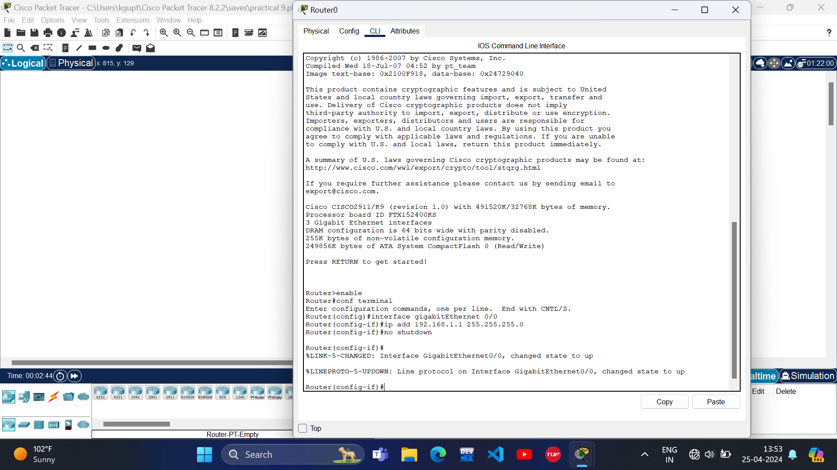

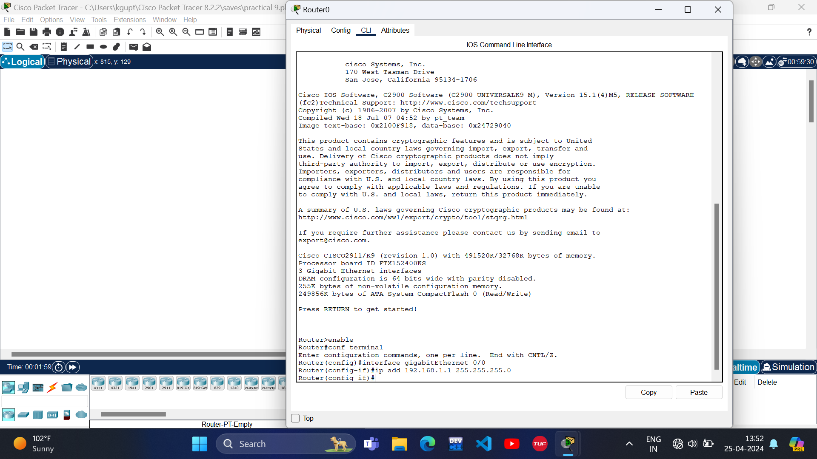

**Ques 7-To implement Client Server Network.**

1. Open Cisco Packet Tracer on your computer.

2.- Drag and drop a router (such as the Cisco 2911) onto the workspace.

- Drag and drop a switch (like the Cisco 2960) onto the workspace.

- Drag and drop two PCs (such as the Generic PC) onto the workspace.

3. - Connect the router to the switch using a straight-through copper cable. Plug the cable into any available FastEthernet port on the router and any available FastEthernet port on the switch.

- Connect both PCs to the switch using straight-through copper cables. Plug one end of each cable into a FastEthernet port on the switch and the other end into the PCs.

4. - Double-click on the router to access its CLI. Configure IP addresses for its interfaces:

“ interface FastEthernet0/0

ip address [Router IP Address] [Subnet Mask]

no shutdown

Exit”

- Double-click on each PC to access its configuration. Configure IP addresses for their network interfaces:

- For the server PC:

- IP Address: [Server IP Address]

- Subnet Mask: [Subnet Mask]

- Default Gateway: [Router IP Address]

- For the client PC:

- IP Address: [Client IP Address]

- Subnet Mask: [Subnet Mask]

- Default Gateway: [Router IP Address]

5. If you want the router to act as a DHCP server to automatically assign IP addresses to the client PC, configure DHCP on the router:

“ip dhcp pool CLIENTS

network [Client Network Address] [Subnet Mask]

default-router [Router IP Address]”

6. Ping from the client PC to the server PC to ensure connectivity:

“ping [Server IP Address]”

7. Set up services on the server PC (e.g., web server, file server) if desired.

8. Save the configurations of all devices to ensure they are not lost upon closing Cisco Packet Tracer.

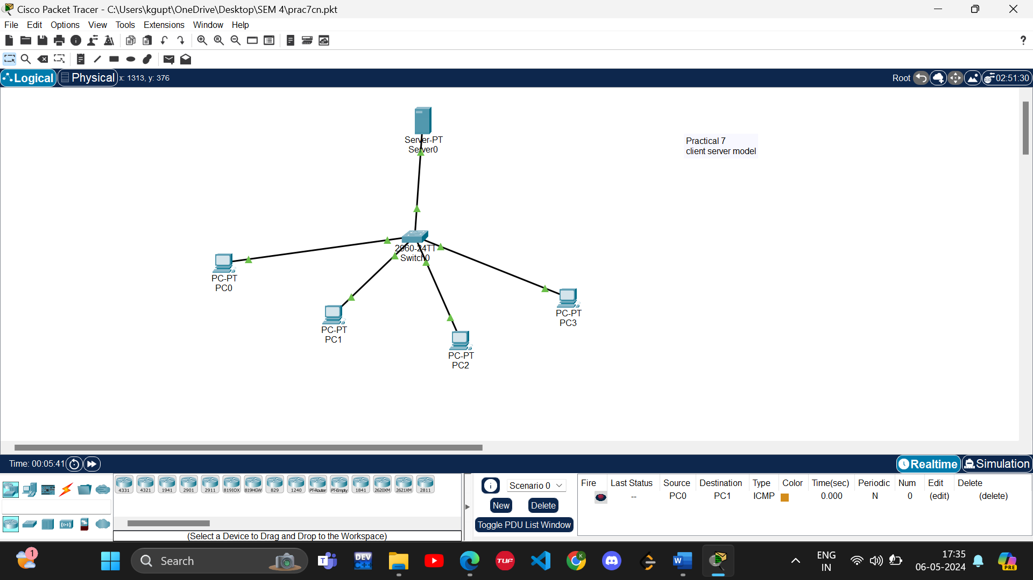

**Ques 8-To implement connection between devices using router.**

1. Open Cisco Packet Tracer on your computer.

1. Drag and drop a router onto the workspace.

- Drag and drop at least two PCs onto the workspace.

3. Connect the PCs to the router:

- Use copper straight-through cables to connect each PC's FastEthernet interface to one of the router's FastEthernet interfaces.

- Click on a PC, select a FastEthernet interface, and then click on a FastEthernet interface of the router to establish the connection.

- You can connect multiple PCs to different router interfaces if needed.

4. Double-click on the router to access its CLI.

- Configure IP addresses on the router's interfaces:

“enable

configure terminal

interface FastEthernet0/0

ip address [IP Address] [Subnet Mask]

no shutdown

exit

interface FastEthernet0/1

ip address [IP Address] [Subnet Mask]

no shutdown

Exit”

Replace `[IP Address]` and `[Subnet Mask]` with appropriate values for each interface. You can configure additional interfaces if necessary.

5. Double-click on each PC to access its configuration.

- Configure IP addresses and default gateways:

- For PC1:

- IP Address: Use an IP address within the same sub net as the router's interface connected to PC1.

- Subnet Mask: Use the same sub net mask as configured on the router's interface.

- Default Gateway: Set it to the IP address of the router's interface connected to PC1.

- Repeat the same configuration for PC2 using an IP address within the same sub net as the router's interface connected to PC2.

6. Ping from one PC to another to ensure connectivity:

- Open the command prompt on PC1 and ping the IP address of PC2.

- Open the command prompt on PC2 and ping the IP address of PC1.

- Ensure that the ping requests are successful.

7. Save the configurations of all devices to ensure they are not lost upon closing Cisco Packet Tracer.

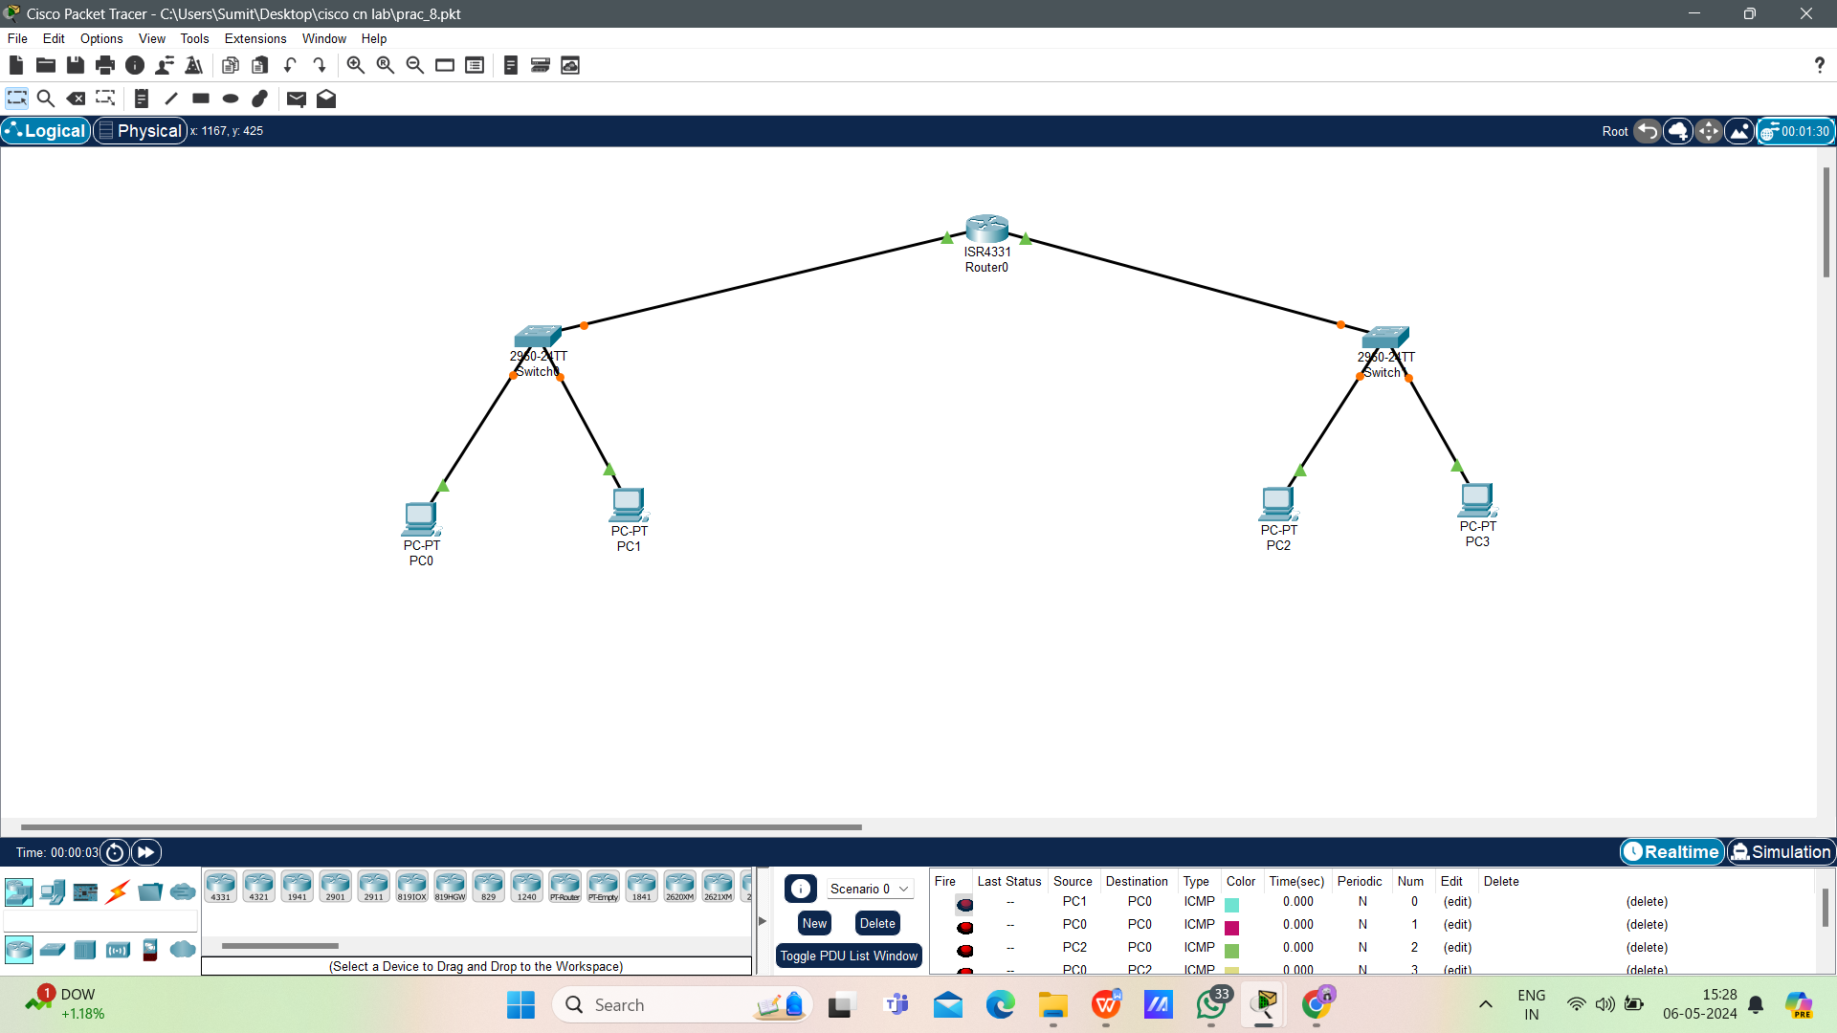

**Ques 9-To perform remote desktop sharing within LAN connection.**

