
School of Engineering and Technology

Capstone Project
Smart City Traffic Management and Route Optimization System
Submitted By:  Tamanna  2401201138  BCA (AI & DS) - A | Submitted To:  Ms. Aarti Sangwan

1. Introduction
Modern cities depend on road networks that must move people quickly and safely. A road network can be represented as a weighted graph in which every intersection is a vertex and every road is an edge whose weight is the distance or travel time. Once the city is a graph, classic algorithms can plan routes, react to congestion and design cheaper infrastructure.
Objective. This capstone project builds a Smart City Traffic Management and Route Optimization System in Python with a Streamlit interface. It implements and compares Dijkstra, Bellman-Ford, BFS, DFS, Prim and Kruskal on a sample city of 8 intersections and 12 roads, and benchmarks them on networks of 10, 25, 50 and 100 intersections.
Module | File | Algorithm
Road network model | graph_model.py | Adjacency list and matrix
Route planning | route_planner.py | Dijkstra
Traffic analysis | traffic_analysis.py | Bellman-Ford
Connectivity | connectivity_module.py | BFS, DFS
Infrastructure planning | mst_planner.py | Prim, Kruskal
Comparison | benchmark.py | Time and memory tests

2. Road Network Modelling
The RoadNetwork class stores intersections as nodes and roads as undirected weighted edges. It validates every road (two different intersections and a positive cost) and can produce both an adjacency list and an adjacency matrix.
Code (graph_model.py)
class RoadNetwork:
def __init__(self):
self.nodes = []
self.edges = {} # (u, v) with u < v -> weight

def add_road(self, u, v, w):
if u == v:
raise ValueError("A road must connect two different intersections.")
if w <= 0:
raise ValueError("Travel cost must be positive.")
self.add_intersection(u)
self.add_intersection(v)
self.edges[tuple(sorted((u, v)))] = float(w)

def adjacency_list(self):
adj = {n: [] for n in self.nodes}
for (u, v), w in self.edges.items():
adj[u].append((v, w))
adj[v].append((u, w))
for n in adj:
adj[n].sort()
return adj

def adjacency_matrix(self):
df = pd.DataFrame(0.0, index=self.nodes, columns=self.nodes)
for (u, v), w in self.edges.items():
df.loc[u, v] = w
df.loc[v, u] = w
return df
Output
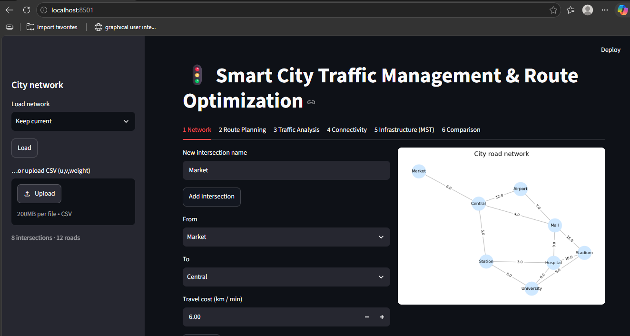
Figure 1: Network tab: add intersections and roads, city road network graph
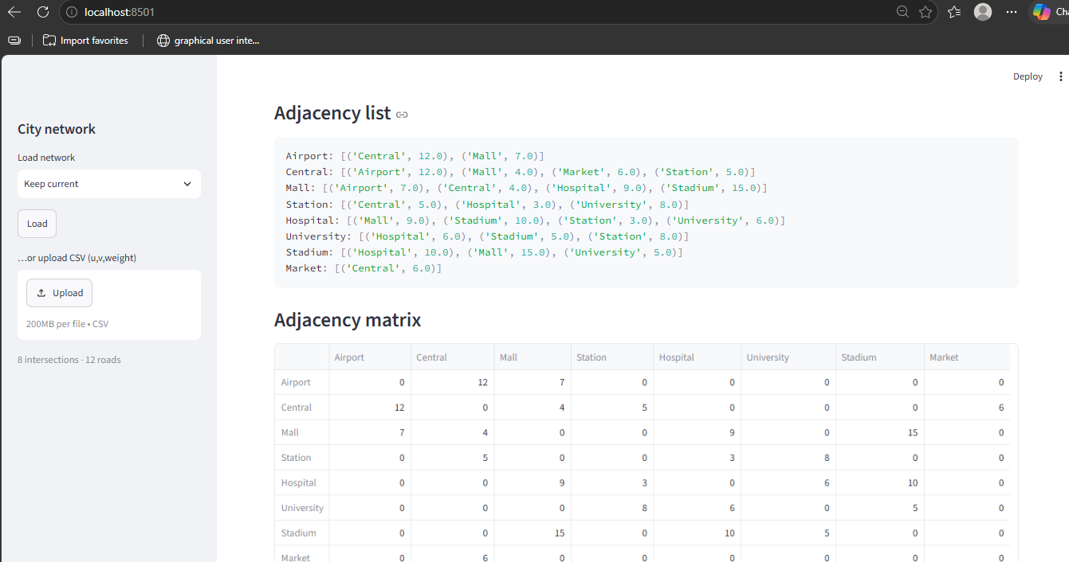
Figure 2: Adjacency list and adjacency matrix of the network
The sample city has 8 intersections (Airport, Central, Mall, Market, Station, Hospital, University and Stadium) joined by 12 roads.

3. Route Planning using Dijkstra
Dijkstra's algorithm uses a priority queue to always expand the nearest unvisited intersection. Every distance update is stored in a step log so the working can be shown in the interface.
Code (route_planner.py)
def dijkstra(g, source, target=None):
"""Return (dist, prev, steps). steps logs every distance update."""
adj = g.adjacency_list()
dist = {n: float("inf") for n in g.nodes}
prev = {n: None for n in g.nodes}
dist[source] = 0
pq = [(0, source)]
visited = set()
steps = []
while pq:
d, u = heapq.heappop(pq)
if u in visited:
continue
visited.add(u)
steps.append({"Visit": u, "Dist(u)": d, "Updated": "-", "New Dist": "-", "Via": "-"})
if u == target:
break
for v, w in adj[u]:
if d + w < dist[v]:
dist[v] = d + w
prev[v] = u
heapq.heappush(pq, (dist[v], v))
steps.append({"Visit": u, "Dist(u)": d, "Updated": v, "New Dist": dist[v], "Via": u})
return dist, prev, steps
Output
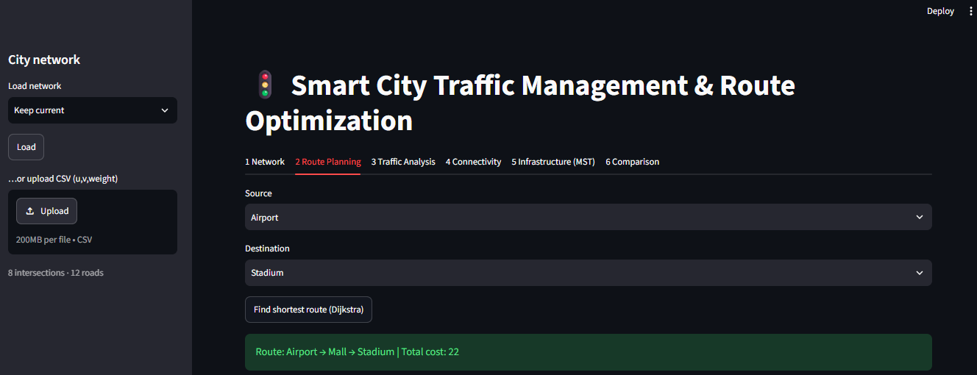
Figure 3: Route planning: shortest route found by Dijkstra
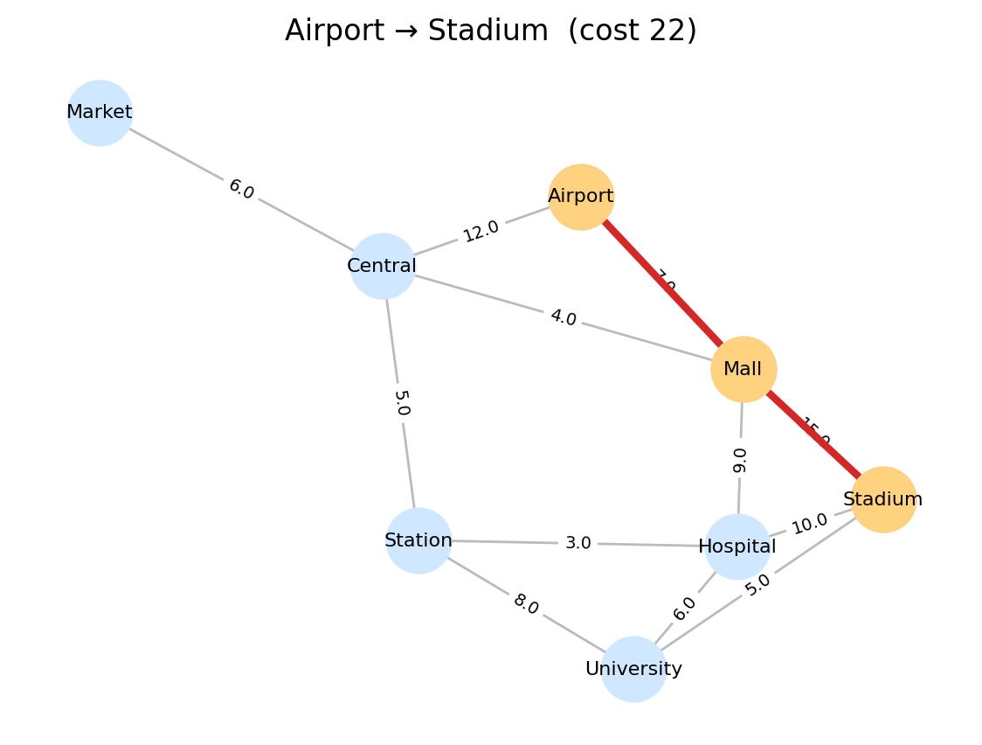
Figure 4: Shortest path highlighted on the city graph
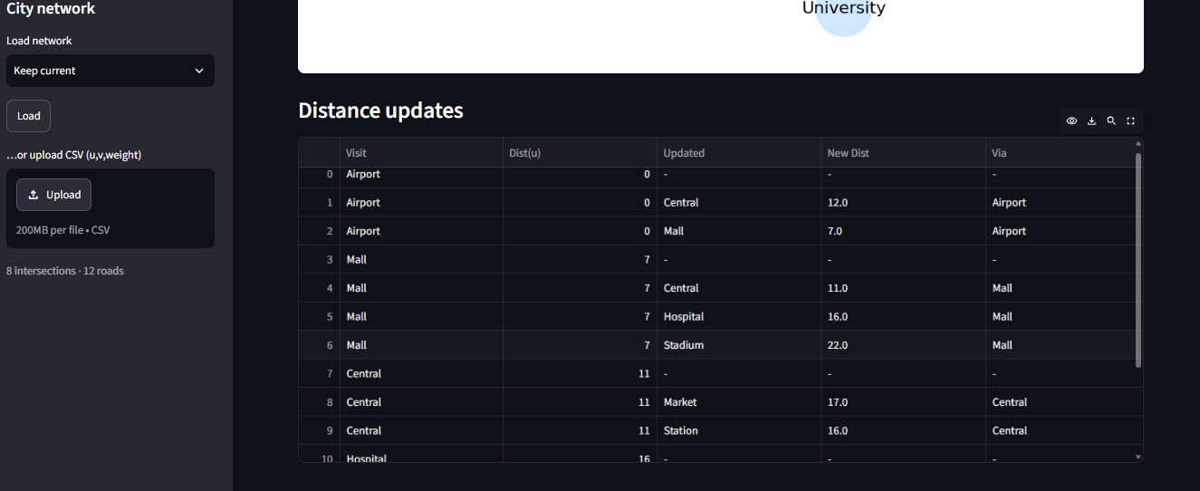
Figure 5: Dijkstra distance-update table
Result: the shortest route from Airport to Stadium is Airport → Mall → Stadium with a total cost of 22.

4. Traffic Analysis using Bellman-Ford
Bellman-Ford relaxes every road repeatedly, so it also works when weights change. To simulate traffic, apply_congestion() multiplies the weight of selected roads and compare_routes() checks whether the best route changes.
Code (traffic_analysis.py)
def bellman_ford(g, source):
"""Each undirected road = two directed arcs. Returns (dist, prev, log)."""
arcs = []
for (u, v), w in g.edges.items():
arcs += [(u, v, w), (v, u, w)]
dist = {n: float("inf") for n in g.nodes}
prev = {n: None for n in g.nodes}
dist[source] = 0
log = []
for i in range(1, len(g.nodes)):
changed = False
for u, v, w in arcs:
if dist[u] + w < dist[v]:
dist[v] = dist[u] + w
prev[v] = u
changed = True
log.append({"Pass": i, "Relaxed": f"{u} -> {v}", "New Dist": dist[v]})
if not changed:
break
return dist, prev, log

def apply_congestion(g, changes):
"""changes: list of (u, v, multiplier). Returns a new congested network."""
g2 = g.copy()
for u, v, factor in changes:
key = tuple(sorted((u, v)))
g2.edges[key] = g.edges[key] * factor
return g2
Output
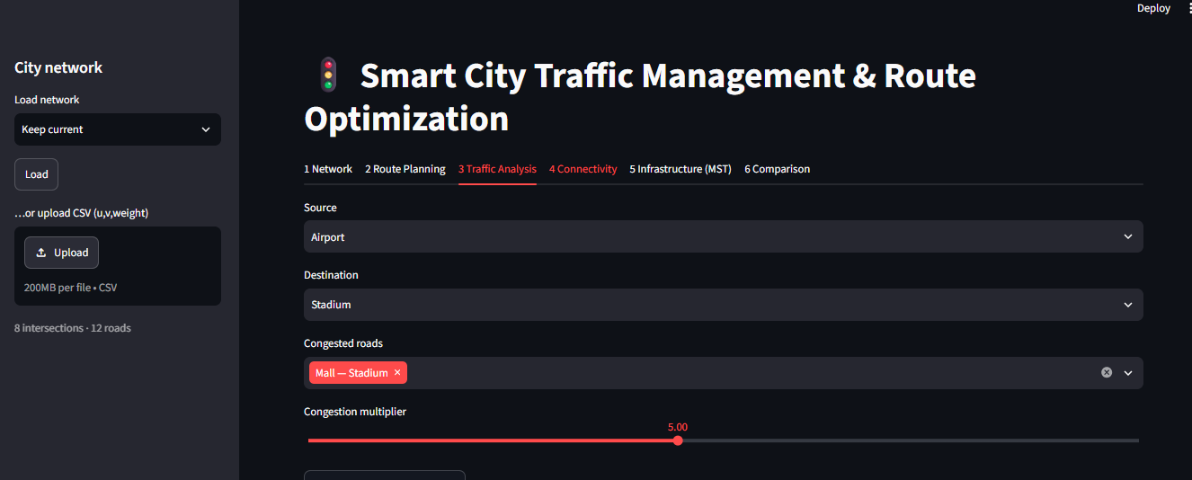
Figure 6: Traffic analysis: selecting the congested road and multiplier
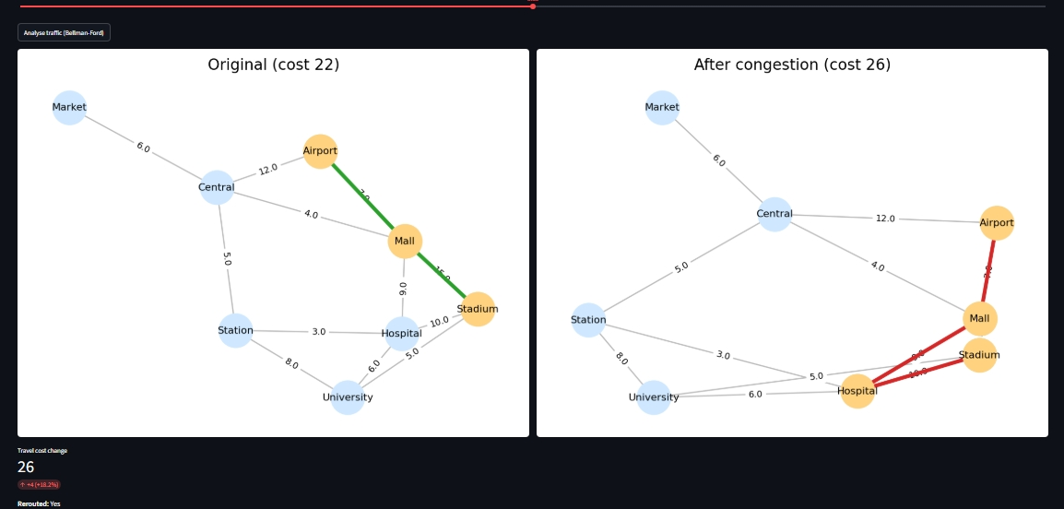
Figure 7: Original network (cost 22) versus congested network (cost 26)
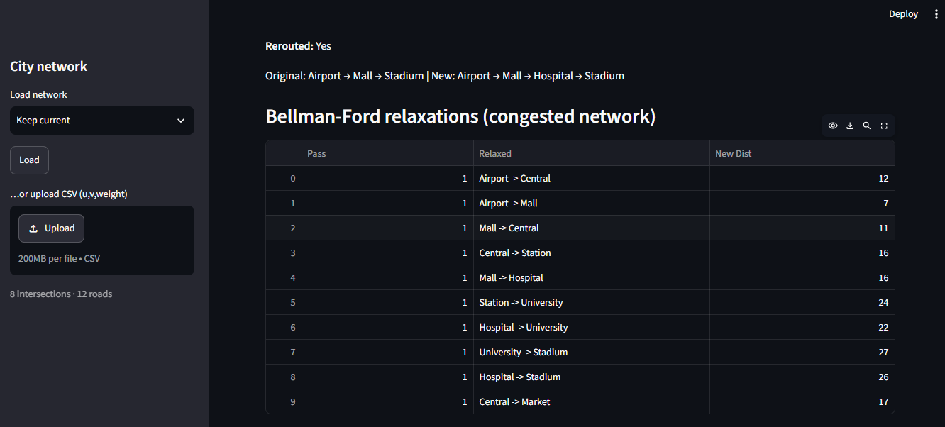
Figure 8: Bellman-Ford relaxation table for the congested network
Result: after multiplying the Mall–Stadium road by 5, the system reroutes to Airport → Mall → Hospital → Stadium. The cost rises from 22 to 26, an increase of about 18%.

5. Connectivity using BFS and DFS
BFS explores the network level by level using a queue, while DFS goes as deep as possible using recursion. Both are used to find which intersections can be reached from a starting point.
Code (connectivity_module.py)
def bfs(g, start):
adj = g.adjacency_list()
seen, order, q = {start}, [], deque([start])
while q:
u = q.popleft()
order.append(u)
for v, _ in adj[u]:
if v not in seen:
seen.add(v)
q.append(v)
return order

def dfs(g, start):
adj = g.adjacency_list()
seen, order = set(), []

def visit(u):
seen.add(u)
order.append(u)
for v, _ in adj[u]:
if v not in seen:
visit(v)
visit(start)
return order
Output
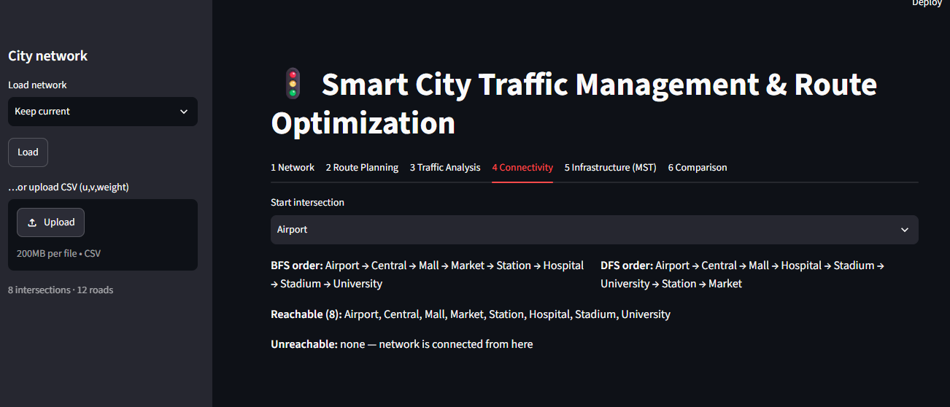
Figure 9: Connectivity tab: BFS and DFS traversal from Airport
- BFS order: Airport, Central, Mall, Market, Station, Hospital, Stadium, University
- DFS order: Airport, Central, Mall, Hospital, Stadium, University, Station, Market
All 8 intersections are reachable, so the network is fully connected.

6. Infrastructure Planning using MST
A minimum spanning tree connects every intersection with the lowest total road cost. Prim grows the tree from a starting node using a priority queue; Kruskal sorts all roads and adds the cheapest one that does not form a cycle (union-find).
Code (mst_planner.py)
def prim(g, start=None):
adj = g.adjacency_list()
start = start or g.nodes[0]
seen, mst, total = {start}, [], 0.0
pq = [(w, start, v) for v, w in adj[start]]
heapq.heapify(pq)
while pq and len(seen) < len(g.nodes):
w, u, v = heapq.heappop(pq)
if v in seen:
continue
seen.add(v)
mst.append((u, v, w))
total += w
for x, wx in adj[v]:
if x not in seen:
heapq.heappush(pq, (wx, v, x))
return mst, total

def kruskal(g):
parent = {n: n for n in g.nodes}

def find(x):
while parent[x] != x:
parent[x] = parent[parent[x]]
x = parent[x]
return x

mst, total = [], 0.0
for (u, v), w in sorted(g.edges.items(), key=lambda e: e[1]):
ru, rv = find(u), find(v)
if ru != rv:
parent[ru] = rv
mst.append((u, v, w))
total += w
return mst, total
Output
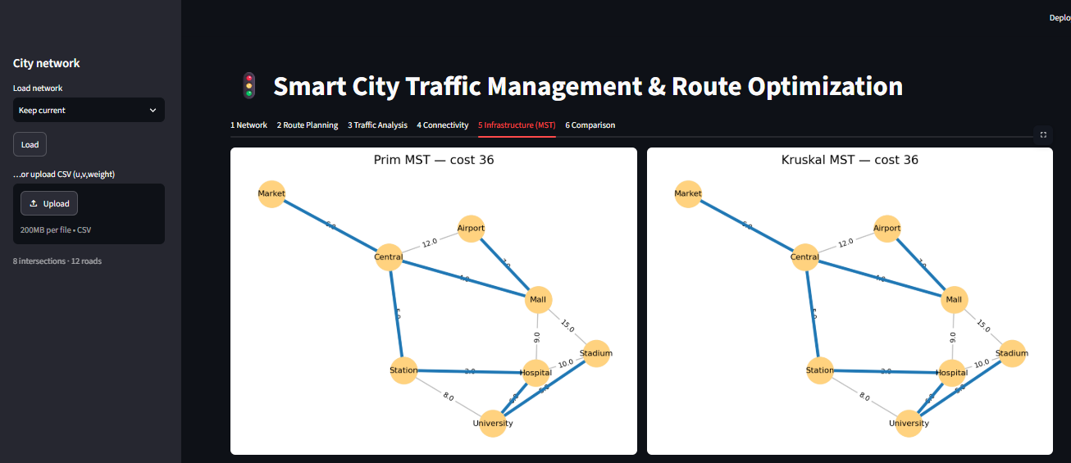
Figure 10: Prim MST and Kruskal MST (cost 36 each)
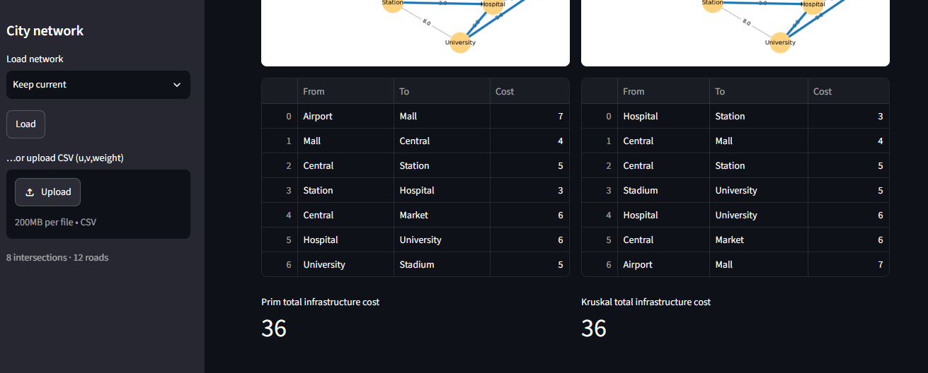
Figure 11: Roads selected by Prim and Kruskal
Result: both algorithms give the same minimum infrastructure cost of 36.

7. Performance Comparison
benchmark.py runs every algorithm on random networks of 10, 25, 50 and 100 intersections. It measures the average time over 20 runs and the peak memory using tracemalloc.
Code (benchmark.py)
def timed(fn, *a, repeat=20):
tracemalloc.start()
t0 = time.perf_counter()
for _ in range(repeat):
out = fn(*a)
ms = (time.perf_counter() - t0) / repeat * 1000
mem = tracemalloc.get_traced_memory()[1] / 1024
tracemalloc.stop()
return out, ms, mem
Output
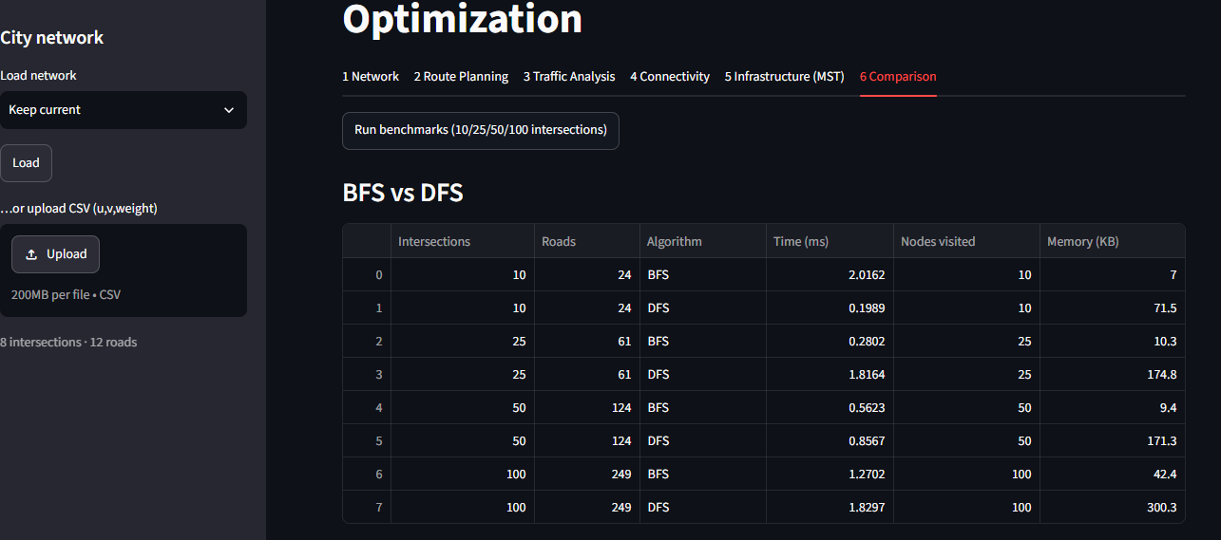
Figure 12: BFS versus DFS benchmark
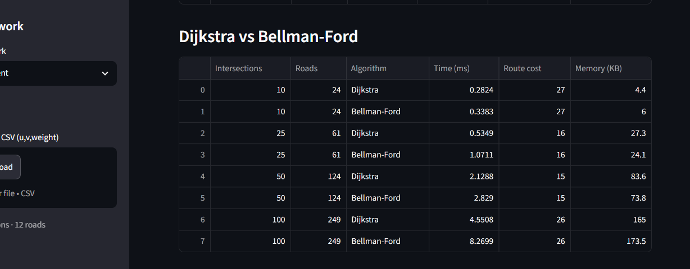
Figure 13: Dijkstra versus Bellman-Ford benchmark
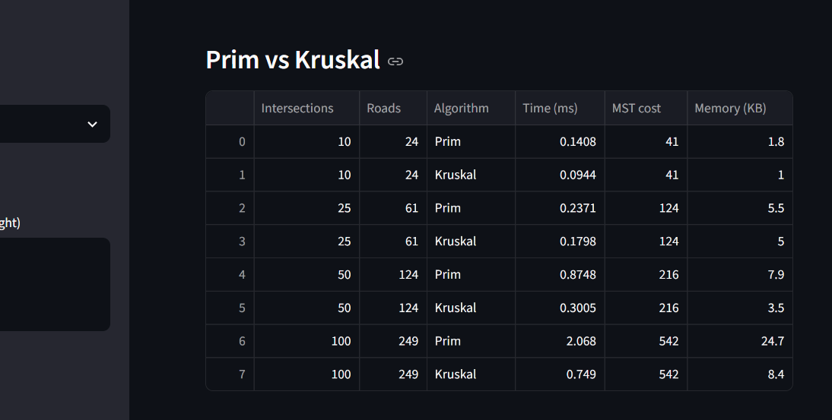
Figure 14: Prim versus Kruskal benchmark
Intersections | Roads | Dijkstra (ms) | Bellman-Ford (ms) | Prim / Kruskal (ms)
10 | 24 | 0.2824 | 0.3383 | 0.1408 / 0.0944
25 | 61 | 0.5349 | 1.0711 | 0.2371 / 0.1798
50 | 124 | 2.1288 | 2.8290 | 0.8748 / 0.3005
100 | 249 | 4.5508 | 8.2699 | 2.0680 / 0.7490

Algorithm | Complexity | Best used for
BFS / DFS | O(V+E) | Reachability; BFS for fewest junctions, DFS for exploring
Dijkstra | O((V+E) log V) | Fast live navigation with non-negative weights
Bellman-Ford | O(VE) | What-if analysis; handles negative weights
Prim | O(E log V) | Dense networks
Kruskal | O(E log E) | Sparse networks (faster in these tests)

8. Conclusion
This project shows that a city road network can be managed effectively with graph algorithms. Dijkstra found the shortest route (cost 22) and was about twice as fast as Bellman-Ford, which in turn made it possible to test congestion and see the route change to cost 26. BFS and DFS confirmed that all intersections are connected, and Prim and Kruskal produced the same minimum road network of cost 36, with Kruskal faster on these sparse graphs.
Overall, graph algorithms give fast, explainable and optimal decisions for navigation, rerouting and infrastructure planning. The system can be extended with one-way roads, A* search, live traffic data, real map import from OpenStreetMap and time-dependent weights.

