
School of Engineering and Technology

Capstone Project
Smart City Traffic Management and Route Optimization System
Submitted By:  Tamanna  2401201138  BCA (AI & DS) - A | Submitted To:  Ms. Aarti Sangwan

1. Introduction
Smart city concepts. Smart cities use data and algorithms to manage transport, utilities and public services. A road network maps naturally onto a graph, so classic graph algorithms can answer routing and planning questions quickly and explainably.
Importance of traffic optimization. Congestion wastes time and fuel, delays emergency response and raises emissions. Fast shortest-path computation, rerouting under congestion and well-planned infrastructure reduce these costs.

2. Objectives
- Model a city as a weighted graph where intersections are vertices, roads are edges and the weight is distance or travel time.
- Find the shortest route between two intersections (Dijkstra) and show every step of the distance updates.
- Simulate congestion on chosen roads and check whether the best route changes (Bellman-Ford).
- Check connectivity and traversal order using BFS and DFS.
- Plan the cheapest road infrastructure using Minimum Spanning Tree algorithms (Prim and Kruskal).
- Compare the running time and memory of the algorithms on networks of 10, 25, 50 and 100 intersections.

3. System Design and Modules
The system is written in Python and presented as an interactive Streamlit web application with one tab for each module.
Module | File | Algorithms / Purpose
Road network modelling | graph_model.py | Adjacency list and adjacency matrix
Route planning | route_planner.py | Dijkstra with step-by-step log
Traffic analysis | traffic_analysis.py | Bellman-Ford, congestion simulation
Connectivity | connectivity_module.py | BFS, DFS
Infrastructure planning | mst_planner.py | Prim, Kruskal
Comparative analysis | benchmark.py | Time and memory on 10/25/50/100 nodes
User interface | app.py | Streamlit app, CSV import

4. Experimental Results

4.1 Road network
The sample city has 8 intersections (Airport, Central, Mall, Market, Station, Hospital, University and Stadium) joined by 12 roads. Users can add new intersections and roads or upload a CSV file in the format from,to,weight.
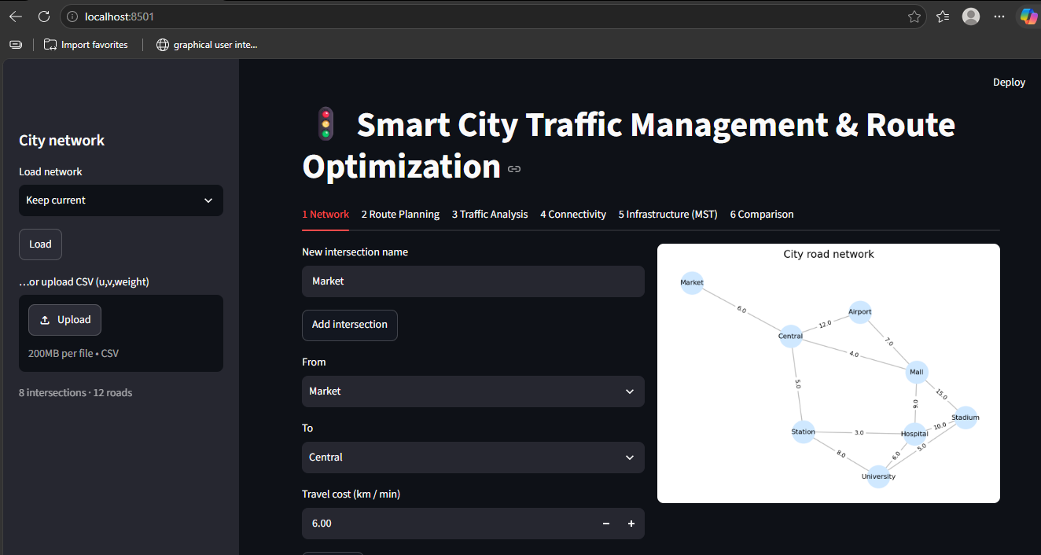
Figure 1: Network tab: add intersections and roads, city road network graph
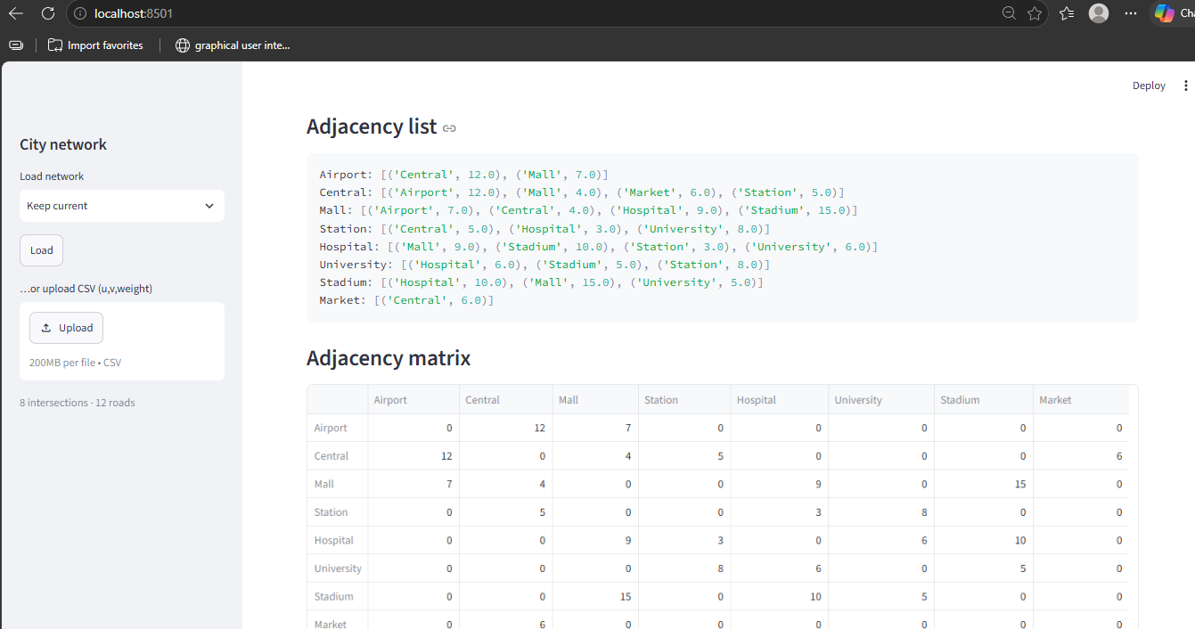
Figure 2: Adjacency list and adjacency matrix of the network

4.2 Route calculation (Dijkstra)
The shortest route from Airport to Stadium is Airport → Mall → Stadium with total cost 22. The step table shows how the tentative distances are updated at every visit.
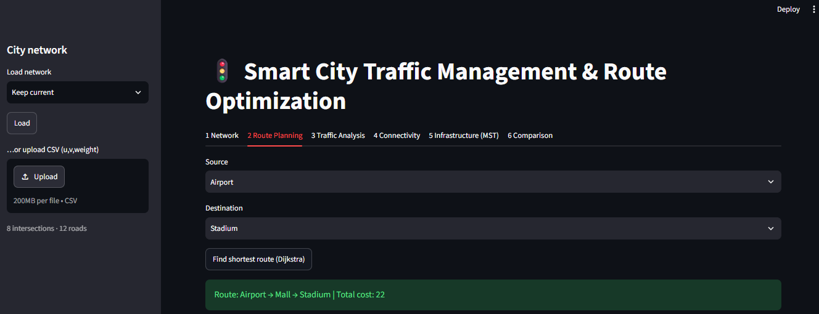
Figure 3: Route planning: shortest route found by Dijkstra
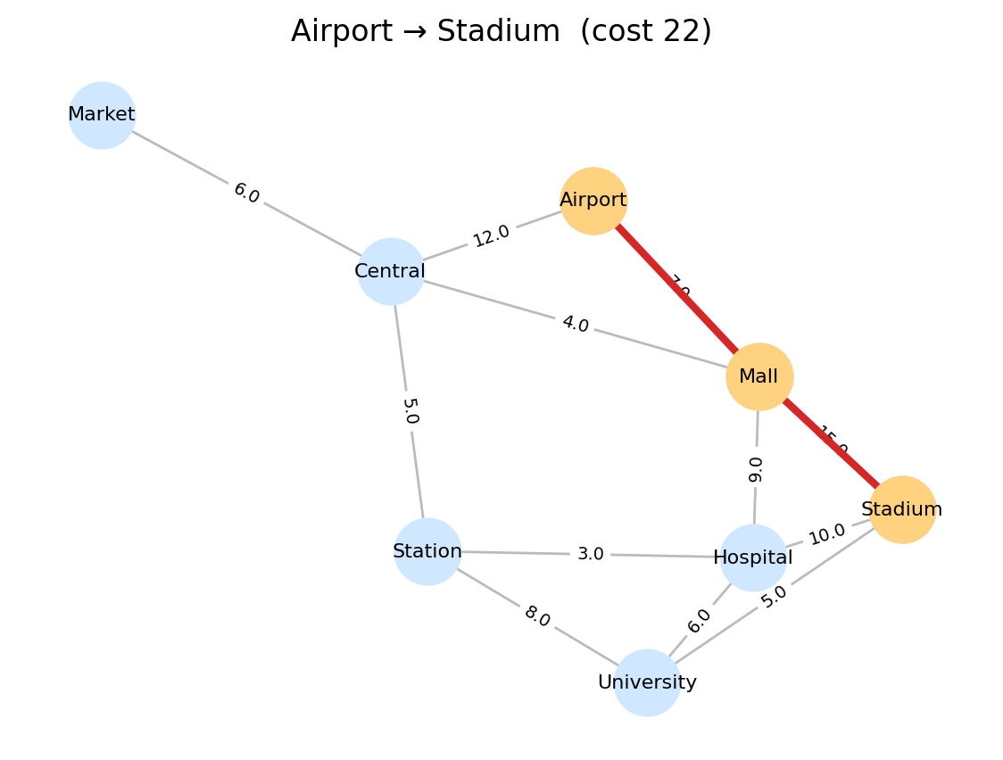
Figure 4: Shortest path highlighted on the city graph
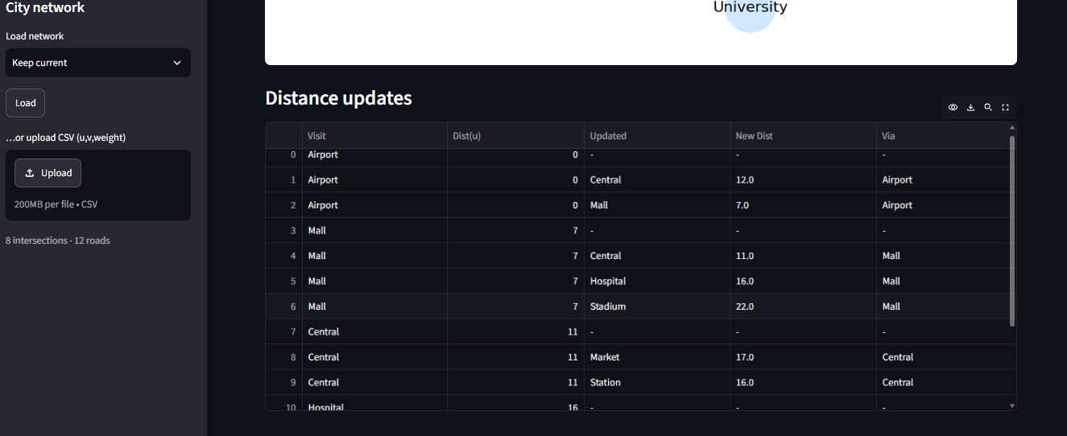
Figure 5: Dijkstra distance-update table

4.3 Traffic analysis (Bellman-Ford)
Congestion is applied to a chosen road (here Mall–Stadium with multiplier ×5). The original route cost was 22; after congestion the system reroutes through Airport → Mall → Hospital → Stadium with new cost 26, an increase of about 18%.
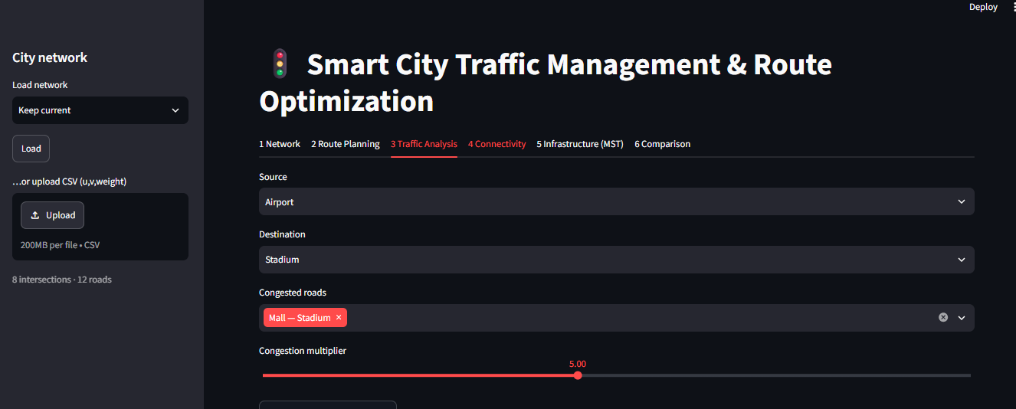
Figure 6: Traffic analysis: selecting congested road and multiplier
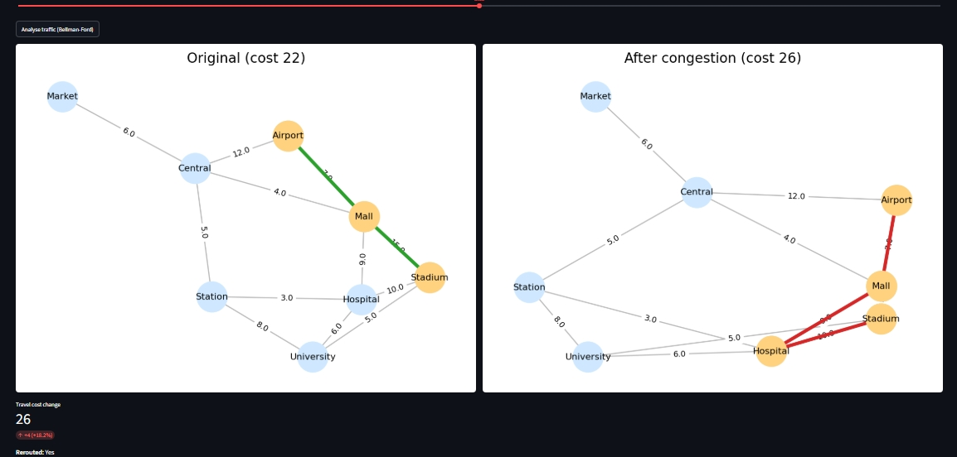
Figure 7: Original network (cost 22) versus congested network (cost 26)
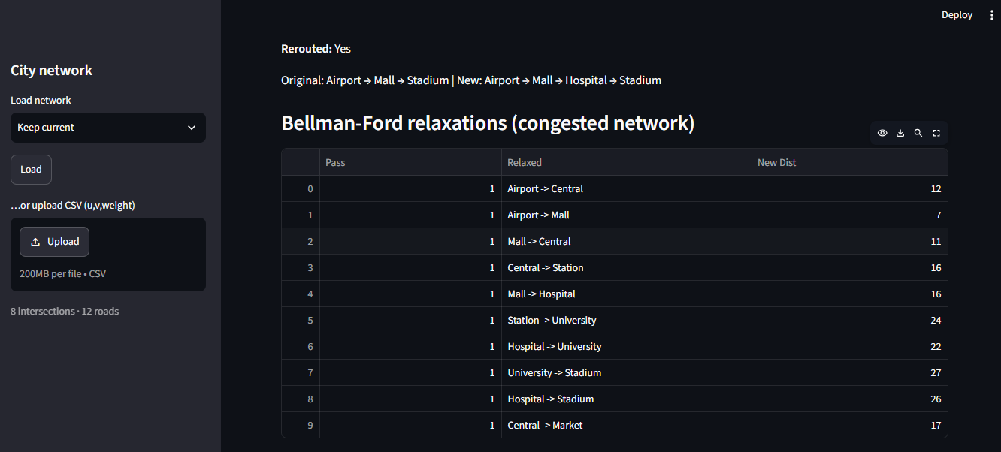
Figure 8: Bellman-Ford relaxation table for the congested network

4.4 Connectivity (BFS and DFS)
- BFS order: Airport, Central, Mall, Market, Station, Hospital, Stadium, University
- DFS order: Airport, Central, Mall, Hospital, Stadium, University, Station, Market
- Reachable: all 8 intersections; no unreachable area, so the network is fully connected.
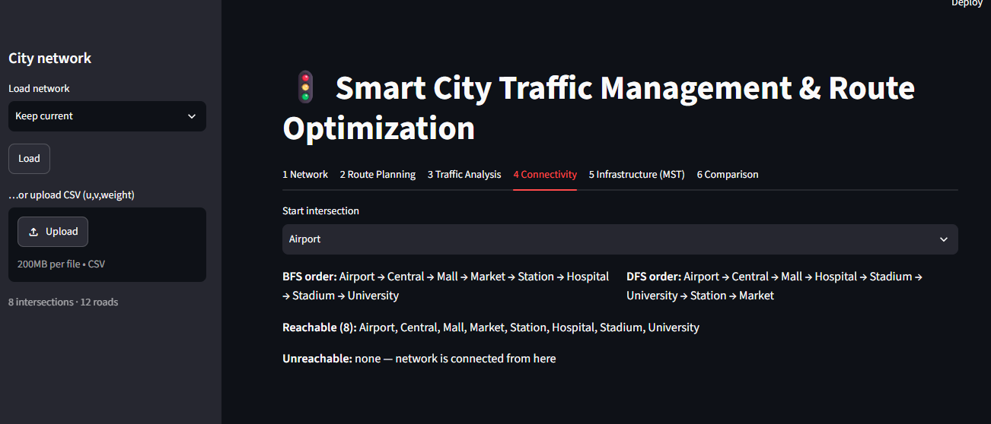
Figure 9: Connectivity tab: BFS and DFS traversal from Airport

4.5 Infrastructure planning (MST)
Prim and Kruskal both select the same minimum total infrastructure cost of 36. The MST connects all junctions at the lowest cost but has no redundancy.
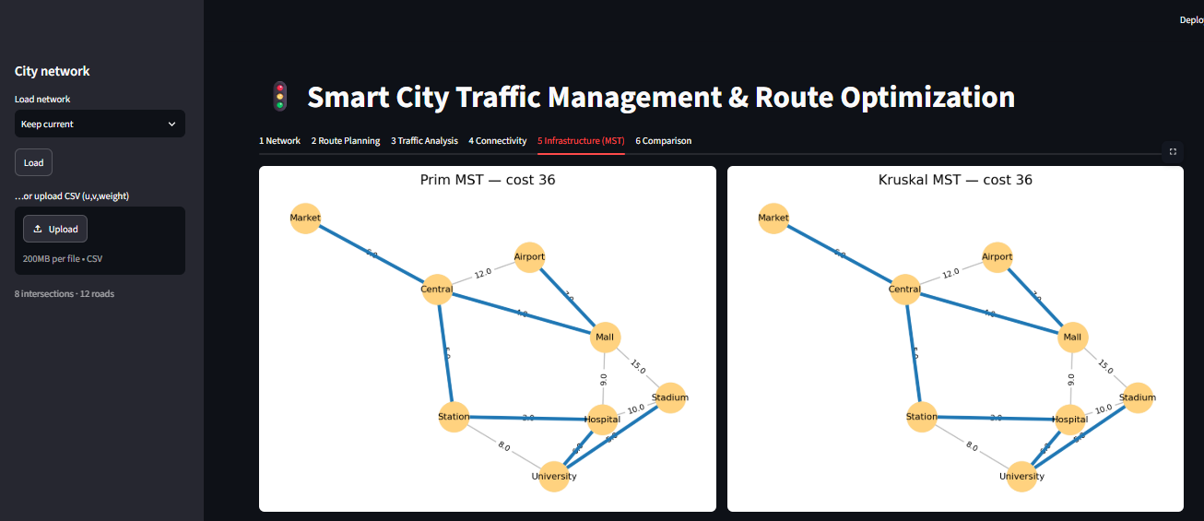
Figure 10: Prim MST and Kruskal MST (cost 36 each)
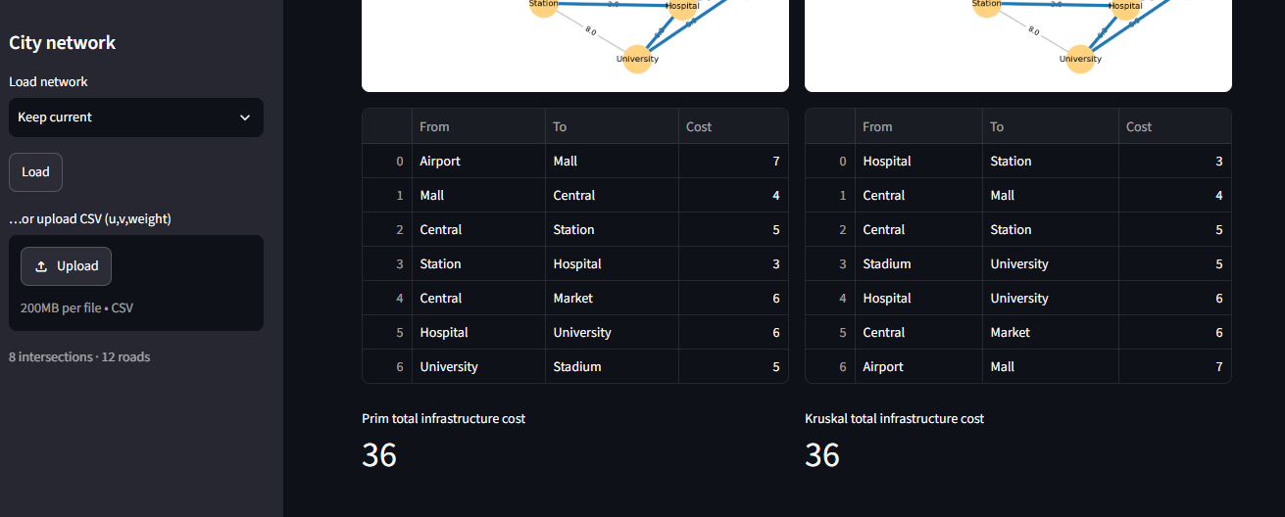
Figure 11: Roads selected by Prim and Kruskal

4.6 Performance comparison
The benchmark tab runs every algorithm on random networks of 10, 25, 50 and 100 intersections and records time and memory.
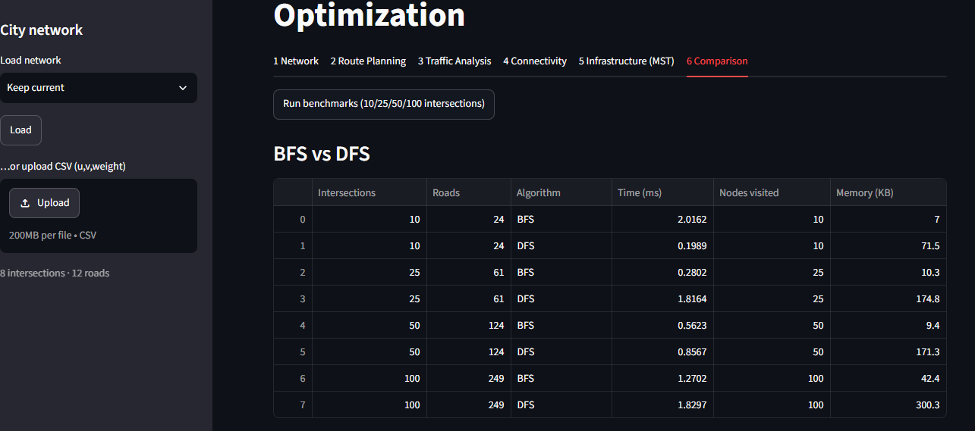
Figure 12: BFS versus DFS benchmark
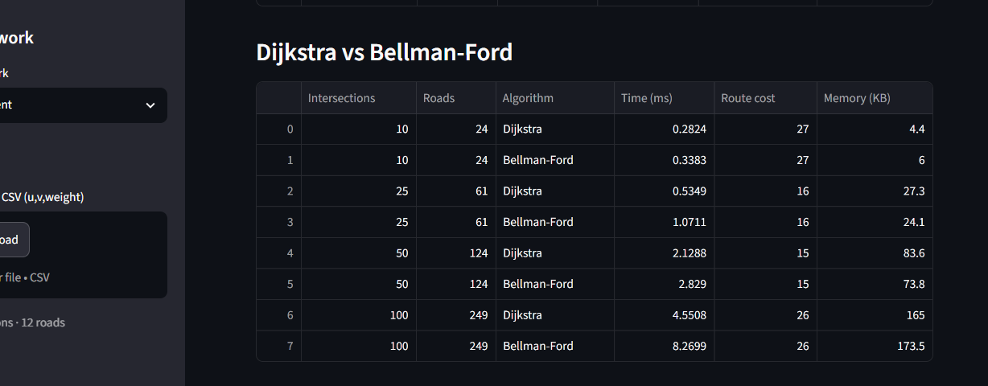
Figure 13: Dijkstra versus Bellman-Ford benchmark
Intersections | Roads | Dijkstra (ms) | Bellman-Ford (ms)
10 | 24 | 0.2824 | 0.3383
25 | 61 | 0.5349 | 1.0711
50 | 124 | 2.1288 | 2.8290
100 | 249 | 4.5508 | 8.2699

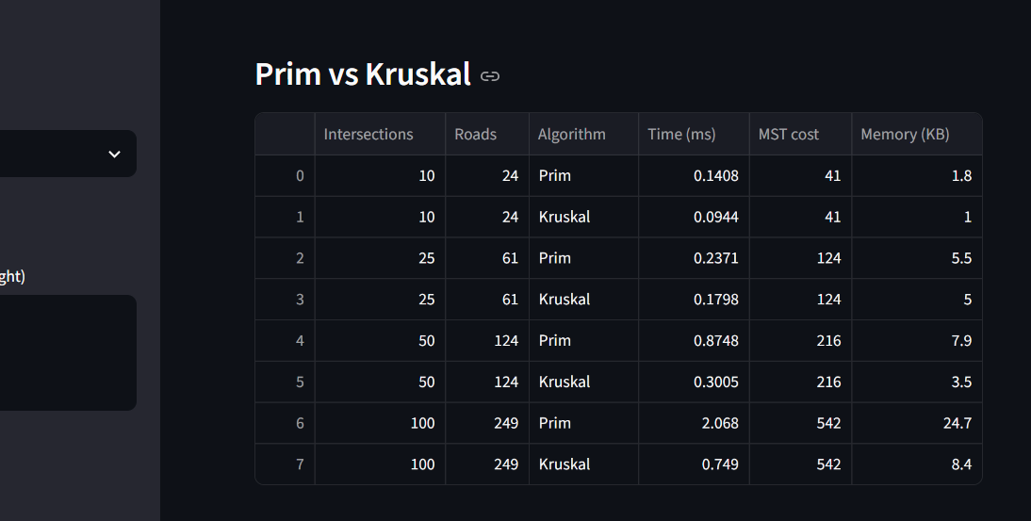
Figure 14: Prim versus Kruskal benchmark
Intersections | Roads | Prim (ms) | Kruskal (ms)
10 | 24 | 0.1408 | 0.0944
25 | 61 | 0.2371 | 0.1798
50 | 124 | 0.8748 | 0.3005
100 | 249 | 2.0680 | 0.7490

5. Analysis
- BFS vs DFS: both run in O(V+E). BFS uses a queue and finds the fewest-hop reachability, which suits “what is within N junctions” monitoring. DFS goes deep using recursion and suits exploring and connectivity checks.
- Dijkstra vs Bellman-Ford: Dijkstra, O((V+E) log V), was about twice as fast in the benchmark and is ideal for live navigation with non-negative weights. Bellman-Ford, O(VE), is slower but handles negative weights and detects negative cycles, so it suits what-if analysis.
- Prim vs Kruskal: both gave the same optimal cost on every network. Kruskal, O(E log E), was faster on these sparse graphs, while Prim is better for dense graphs.
- Traffic observations: increasing the weight of a main road either raises the cost of the same path or triggers an alternate route; the module reports the change in cost and percentage.
- Infrastructure insight: the MST is the cheapest way to connect all junctions, but with no redundancy it is a baseline rather than a final design.

6. Conclusion
Key findings: Dijkstra is best for routing, Bellman-Ford for flexible analysis, BFS/DFS for reachability, and Prim/Kruskal give equal-cost minimal networks.
Benefits: graph algorithms give fast, explainable and optimal decisions for navigation, rerouting and planning.
Future improvements: directed one-way roads, A* search, live traffic data, real map import (OpenStreetMap), time-dependent weights and MST with redundancy.

References
- Cormen, Leiserson, Rivest and Stein, Introduction to Algorithms.
- Kleinberg and Tardos, Algorithm Design.
- NetworkX and Streamlit documentation.

