Forecasting Household Appliance Energy Use
Benchmarks, SARIMAX, XGBoost and a Foundation Model
Time Series Case Study - Individual Coursework
Tams
August 2026

1. Introduction
This report is about forecasting household appliance electricity use, using the UCI Appliances Energy Prediction dataset. It records appliance energy use every ten minutes, along with indoor sensor readings and outdoor weather [1]. The brief asks for a staged comparison: simple benchmarks first, then SARIMAX, then a feature-based machine learning model, then a foundation model, all forecasting 24 hours ahead across a 14-day test period.
The real question isn't just which model wins. It's whether each extra bit of complexity actually earns its place, or whether a simple model does just as well. That question runs through the whole report, and the answer turned out to be more interesting than I expected.
All the code sits in one file, scripts/run_demo_pipeline.py, built on top of the starter script given with the assignment. Every number and figure here comes straight from running that script. Where something didn't work as planned, like the foundation model, I've said so rather than glossing over it.

2. Data and preprocessing
The raw data has 19,735 rows, sampled every 10 minutes from 11 January to 27 May 2016. The target is Appliances (Wh). There's also lights, nine indoor temperature and humidity pairs (T1-T9, RH_1-RH_9), six outdoor weather variables (T_out, Press_mm_hg, RH_out, Windspeed, Visibility, Tdewpoint) and two random variables (rv1, rv2) the dataset authors added as a check. No missing values anywhere, checked column by column rather than assumed.
Ten-minute data is very noisy, and a SARIMAX grid search on almost 20,000 points wasn't realistic to run. So I resampled to hourly means, which gives 3,290 rows. This keeps the daily pattern visible while making everything else in the pipeline much cheaper to fit. Figure 1 shows both versions side by side.
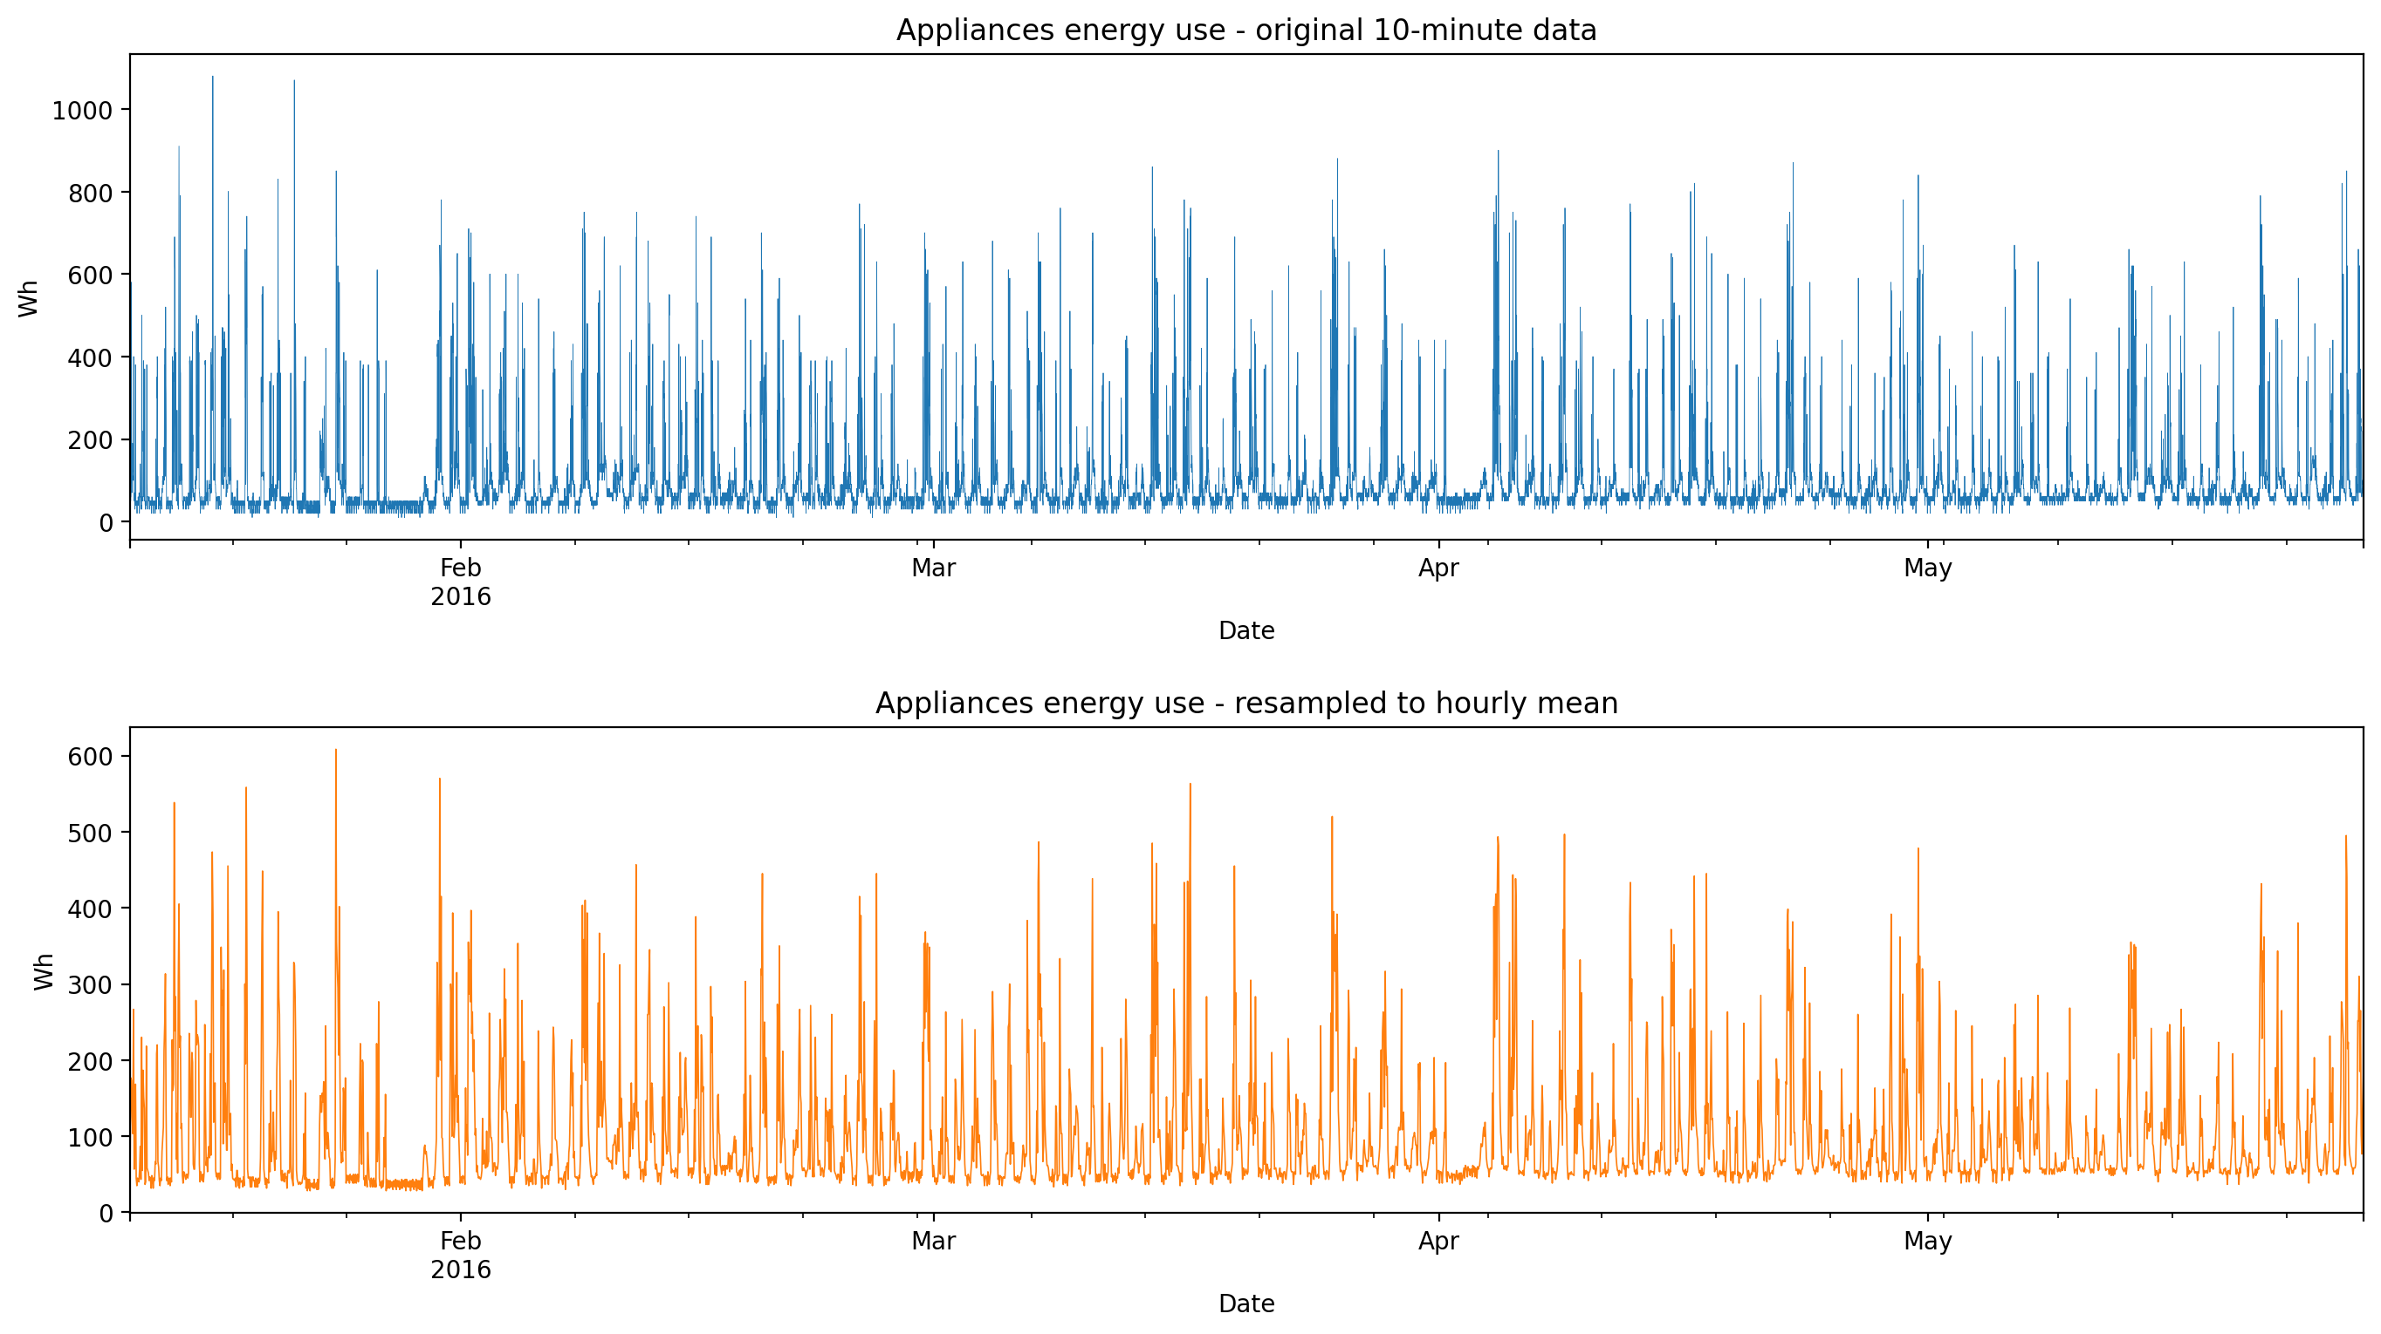
Figure 1: Appliances energy use at 10-minute resolution (top) and resampled to hourly means (bottom).

3. Exploratory analysis
Hourly Appliances has a mean of 97.8 Wh but a median of only 63.3 Wh (std 81.2, max 608.3). That gap tells you the distribution is skewed right: most hours sit at a low baseline, with occasional spikes when several appliances run at once.
By hour of day, the quiet point is 3am (48.2 Wh) and the busy point is 6pm (191.8 Wh), which matches a normal household routine. By day of week, Monday is highest (111.5 Wh) and Tuesday lowest (87.1 Wh), but weekday and weekend averages are close (96.7 vs 100.6 Wh). So the weekly pattern found later looks more like day-to-day habits than a simple weekend effect.
No single sensor or weather variable correlates strongly with Appliances. Lights is the highest at r=0.26, then RH_out at -0.20, then a handful of temperatures and humidities all under 0.16 (T2, T6, T_out, RH_1, RH_8). That weak signal from any one variable is part of why a model combining lots of features (Section 7) ends up close to SARIMAX, even though SARIMAX leans on five weather variables directly.
The seasonal decomposition (Figure 2, period 24) shows a clear daily cycle sitting on top of a slow-moving trend, with some structure still left in the residual - a sign a 24-hour term on its own won't explain everything. The ACF/PACF (Figure 3) back this up: a strong spike at lag 24 that repeats at 48 and 72, and a PACF that drops off much faster than the ACF. That points to a short autoregressive pattern sitting alongside the daily seasonality.
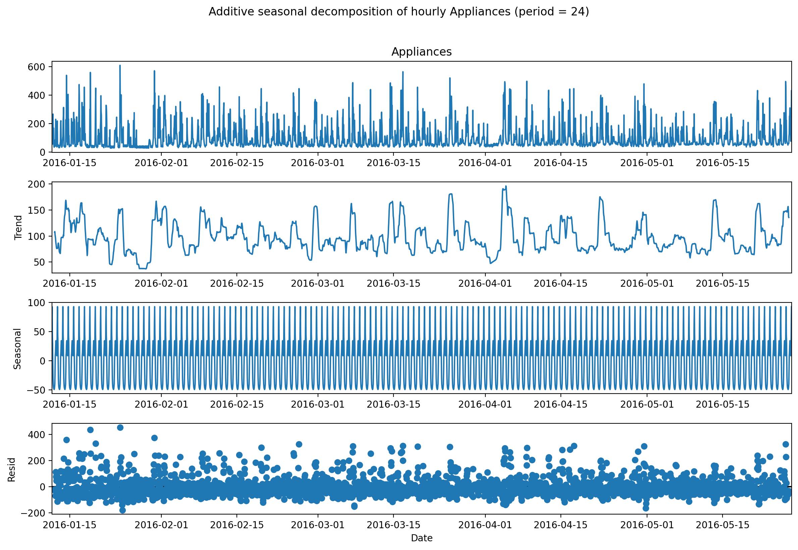
Figure 2: Additive seasonal decomposition of hourly Appliances (period = 24).
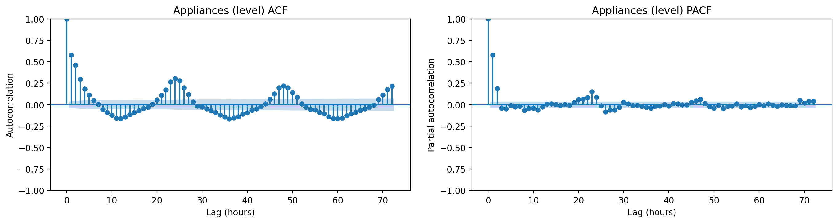
Figure 3: ACF and PACF of the hourly series, 72 lags.

Stationarity
ADF [4] and KPSS [5] tests on the level series and its first difference (Table 1) both say the level series is already stationary: ADF rejects the unit-root null strongly (-8.95, p<0.0001), and KPSS fails to reject stationarity (0.038, p=0.10). I expected to need at least one difference going in, but it makes sense once you think about it - Appliances doesn't have a long-run trend, it just oscillates around a stable pattern. This also matches the SARIMAX order search below, which mostly picks d=0.
Series | ADF stat | ADF p | KPSS stat | KPSS p
Appliances (level) | -8.949 | <0.0001 | 0.038 | 0.10
Appliances (1st diff.) | -16.953 | <0.0001 | 0.078 | 0.10
Table 1: Stationarity tests on the hourly Appliances series.

4. Forecasting design
Target: Appliances, hourly mean. Test period: the final 14 days (336 hours), everything before that used for training. Horizon: 24 hours, forecast at 14 separate daily origins across the test period. That's the horizon the brief and the supplementary README both ask for - test_steps = 14 x 24, but horizon = 24 - not one 336-hour-ahead forecast from a single starting point.
Every model here is evaluated this way. Benchmarks are recomputed each day using the real, expanding history. SARIMAX is fitted once and then rolled forward daily with .append(refit=False), which updates its internal state with real data without re-estimating the coefficients. The feature-based model only ever uses lag and rolling features of 24 hours or more, so its prediction for any hour in the test period already equals a genuine 24-hour-ahead forecast made at that day's own origin (more on this in Section 7).
Metrics: MAE, RMSE, MASE and Bias, computed over the pooled 336 hours of test predictions. MASE is scaled against the in-sample MAE of the daily seasonal naive forecast (lag 24) [3], which keeps it comparable across models and is the metric I lean on most, since MAE and RMSE don't always agree with each other.

5. Benchmark models
Five standard benchmarks [2]: mean, naive (repeat the last value), daily seasonal naive (lag 24), weekly seasonal naive (lag 168) and drift. All five are recomputed at each of the 14 daily origins using the real history up to that point, not the model's own earlier guesses.
Naive and drift are by far the worst (MASE 1.601 and 1.606). Repeating yesterday's last value, or extending a straight-line trend, just doesn't work for a series that swings around a daily and weekly rhythm like this one.
Weekly seasonal naive comes out on top of all five benchmarks - and, as it turns out, the strongest model in the whole comparison (MASE 0.813, Table 5). Daily seasonal naive is close behind once it gets to update every day (0.904), and the plain mean sits in between (0.941).
Each benchmark encodes a different, fairly blunt assumption: the mean assumes no structure at all, naive assumes tomorrow looks like today, the seasonal versions assume exact repetition at a fixed lag, and drift assumes a constant trend keeps going. None of them adapt to anything beyond the data they're handed, which is really the bar anything fancier needs to clear.

6. SARIMAX model
Part 4 of the brief asks for an AIC grid search over the non-seasonal order (p,d,q), with p and q from 0 to 6 and d from 0 to 2 - 147 combinations. I ran this against the plain ARIMA structure, with the seasonal order fixed at (1,1,1,24): a few test fits with the seasonal term included took over a minute each, against under 4 seconds without it, so a full 147-combination grid with the seasonal term would have taken hours. The seasonal order itself is instead justified by the daily cycle already established in Section 3.
All 147 fits completed (outputs/metrics/sarimax_order_search.csv). Best by AIC: ARIMA(6,0,3) at 32,967.3, and it did converge. The next two, (5,0,3) at 32,971.7 and (5,0,4) at 32,973.5, also converged. d=0 winning across the top results matches the stationarity tests from Section 3, which is a reassuring check. 107 of 147 fits converged overall.
Fitting the full seasonal model at the AIC-best order, SARIMAX(6,0,3)x(1,1,1,24) with exogenous variables, turned out not to be practical, and I checked that directly rather than just assuming it. Capped at 9 iterations (as far as I could get in one reasonable attempt), it took about 26 seconds and the AIC was still 49,624 - nowhere close to converged, and much worse than the plain non-seasonal grid's 32,967, since a half-optimised 9-parameter fit isn't a fair comparison to a converged one. (5,0,3), the runner-up by AIC, didn't finish even 30 iterations in the time available either. (1,0,3) is the highest order that reliably completes a proper 30-iteration fit (about 37 seconds) with the seasonal term and all five exogenous weather variables (T_out, RH_out, Windspeed, Visibility, Tdewpoint) together, so that's the model used for the rest of this report. Even at 30 iterations it didn't fully converge, so the coefficients in Table 2 should be read as reasonable rather than exact.
Term | Coef. | p-value
T_out | -6.410 | 0.275
RH_out | 0.310 | 0.802
Windspeed | 0.656 | 0.638
Visibility | -1.141 | <0.0001
Tdewpoint | 6.637 | 0.273
ar.L1 | 0.690 | <0.0001
ma.L1 | -0.306 | <0.0001
ma.S.L24 | -0.956 | <0.0001
Table 2: Selected coefficients, SARIMAX(1,0,3)x(1,1,1,24) with exogenous weather variables.
The AR(1) term (0.69) shows strong short-term persistence, which makes sense hour to hour. Tdewpoint has the largest positive weather coefficient (6.64) and T_out the largest negative (-6.41), but the two are correlated with each other, so I wouldn't read too much into either sign on its own - it looks more like the model finding a useful combination of correlated weather variables than a clean causal story. Only Visibility comes out clearly significant among the weather terms; the rest have wide standard errors relative to their size.
SARIMAX also comes with assumptions worth being upfront about: it treats the relationship between past and present values as linear, assumes roughly constant-variance Gaussian noise, and treats the weather variables as strictly exogenous, meaning they influence Appliances but nothing in Appliances feeds back into them. That's reasonable for outdoor weather, though the fit itself has no way of checking it. It also treats the seasonal period as a fixed 24 hours rather than estimating it, which fits Section 3's evidence but pushes any other rhythm straight into the residuals.
Residual diagnostics (Figure 4) show the ACF sitting close to zero at every one of the 40 lags plotted, none breaching the confidence band. Ljung-Box at lag 24 agrees (20.85, p=0.648) [6]: no significant autocorrelation left, which is reassuring given the model didn't fully converge. The histogram looks roughly symmetric and centred near zero, with a few residuals sitting well past the main bulk on the positive side. The Q-Q plot tracks the normal line closely through the middle but drifts away at both tails, more so on the right - so the Gaussian-error assumption holds up fine for a typical hour but not for the occasional big one.
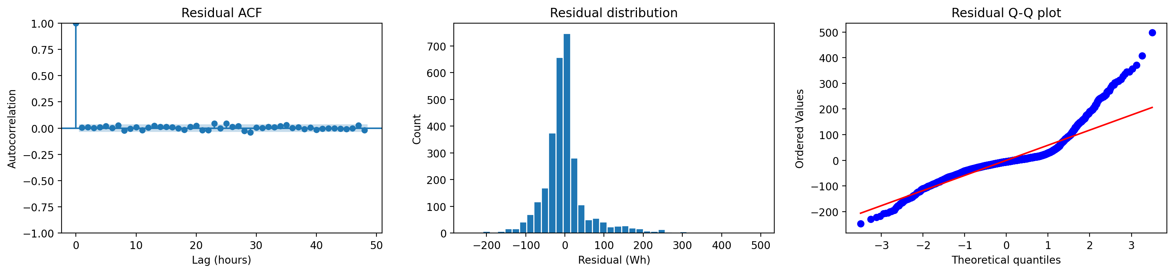
Figure 4: SARIMAX residual diagnostics - ACF, histogram, Q-Q plot.
The forecast used for evaluation in Section 9 rolls this same fitted model forward across all 14 days with .append(refit=False): the coefficients in Table 2 stay fixed the whole way through, and only the model's internal filtered state updates with the newly realised 24 hours each day. A full refit at every origin was tried during development and wasn't practical in the time available. Figure 5 shows the 95% confidence interval on just the first day's forecast, since averaging a confidence interval across 14 different origins doesn't mean much on its own.
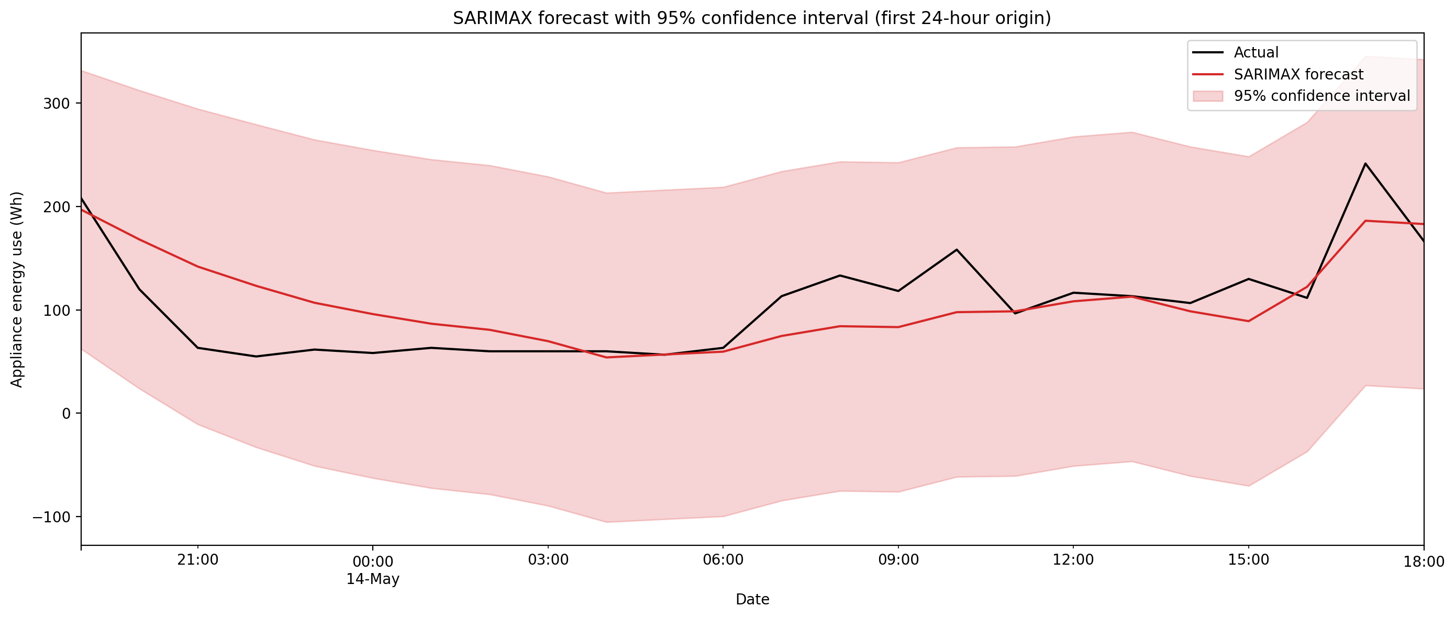
Figure 5: SARIMAX forecast with 95% confidence interval, first 24-hour origin.

7. Feature-based model
The feature table (make_ml_table) uses lags of 24, 48 and 168 hours, rolling mean and std over 24- and 168-hour windows, time-of-day and day-of-week features (raw and sine/cosine encoded, plus a weekend flag), and the indoor and outdoor sensor columns. Shorter lags like lag_1 or lag_2 are deliberately left out: a forecast here is made once a day and held for 24 hours, so anything shorter than a 24-hour lag isn't actually known yet partway through that day.
The rolling features needed more care than I first gave them. My first version just shifted the target by one hour and applied a rolling window per row - that keeps a window ending at t-1 for every row, which is fine for the first hour of a forecast day but not the rest of it: for, say, the 24th hour of a 24-hour-ahead forecast, a window ending at t-1 reaches into hours earlier in that same forecast day, which haven't actually happened yet at the moment the whole day's forecast is made. Making the window longer doesn't fix this, only where it ends does. So roll_mean_24, roll_std_24, roll_mean_168 and roll_std_168 are now computed once per forecast block, using only data from strictly before that block starts, and the same value is used for every hour in the block. lag_24/48/168 didn't have this problem to begin with, since lag_k always points at exactly k hours back, which for k of 24 or more is always at or before the start of the current block.
I used XGBoost rather than scikit-learn's HistGradientBoostingRegressor because it's the library I'm most comfortable with, and it's explicitly listed as an acceptable option in the brief [7]. XGBoost makes a very different kind of assumption to SARIMAX: it has no explicit model of time at all, just a general pattern-matching pass whose relationship between features and target on the training rows has to keep holding on the test rows. All the time-series structure has to be handed to it directly through the features, or it doesn't exist to the model. It also doesn't give a prediction interval by default, unlike Figure 5's SARIMAX band - only a point forecast comes out of it here.

Hyperparameter tuning
tune_feature_model() holds out the last 336 rows of training data as a validation split (the same length as the real test period, but never touching it) and tries six combinations of n_estimators, learning_rate and max_depth, keeping whichever gets the lowest validation RMSE (Table 3). The winner uses fewer trees and a shallower depth than most of the other options (n_estimators=200, learning_rate=0.05, max_depth=3), which fits with Section 3's point that this series doesn't have many strongly predictive individual features - a smaller model generalised better here than a bigger one. This is the configuration used for the result in Section 9.
n_estimators | learning_rate | max_depth | Validation RMSE
200 | 0.05 | 3 | 103.21
500 | 0.05 | 7 | 104.47
500 | 0.05 | 3 | 109.32
500 | 0.10 | 3 | 115.96
1000 | 0.01 | 5 | 116.61
500 | 0.05 | 5 | 125.52
Table 3: Feature-model hyperparameter search, sorted by validation RMSE (lowest first).
With these settings, the feature model scores MASE 0.806 (MAE 43.07, RMSE 67.28, Bias 7.49, Table 5) - the strongest model in the whole comparison, just ahead of weekly seasonal naive and SARIMAX. Permutation importance (each feature shuffled independently, drop in test R² recorded, averaged over 5 repeats) shows something I didn't expect going in: the two strongest features are indoor humidity readings, RH_3 (0.101) and RH_1 (0.087), ahead of the calendar features and well ahead of the lag features (Table 4, Figure 6). hour_cos comes in third (0.081), then hour_sin (0.068), then T3 (0.052). lag_24 only shows up in sixth place (0.047).
Feature | Importance
RH_3 | 0.101
RH_1 | 0.087
hour_cos | 0.081
hour_sin | 0.068
T3 | 0.052
lag_24 | 0.047
RH_4 | 0.037
RH_6 | 0.031
hour | 0.029
roll_mean_24 | 0.019
Table 4: Top 10 features by permutation importance, feature-based model.
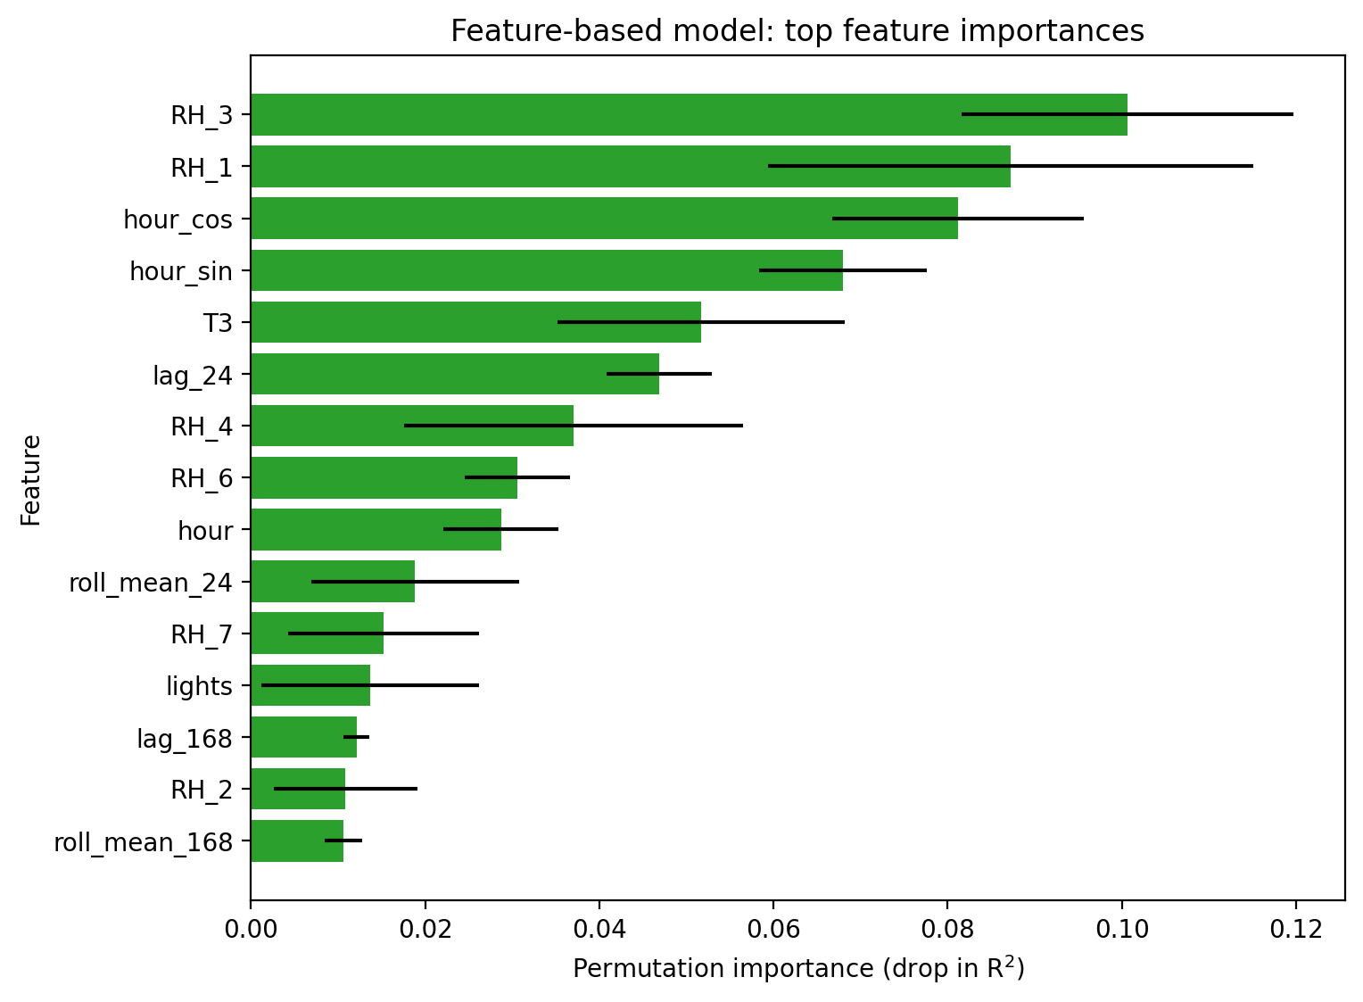
Figure 6: Permutation importance, feature-based model, top 15.
That's a genuinely different picture from what the correlation table in Section 3 would suggest on its own - RH_3 and RH_1 aren't the strongest single correlations with Appliances there (lights and RH_out are ahead of them), but XGBoost is picking up on how they combine with everything else, not just their solo relationship with the target. Permutation importance and simple correlation are answering slightly different questions.

8. Foundation model
The plan here was to actually run a pretrained foundation model, not just write a placeholder for one. I used Chronos [8], Amazon's pretrained time-series model, zero-shot on the target series only - no fine-tuning, no weather inputs, just the Appliances history. get_foundation_model_forecast_rolling() calls it once per daily origin, 24 hours at a time with the real expanding history up to that point, the same setup as every other model in this report. I changed this partway through development: Chronos's own docs recommend keeping prediction_length at 64 or under, so an earlier version that called it once for the whole 336-hour test period was both slower than it needed to be and outside what the model is actually meant for. TimeGPT [9] is also coded up (forecast_foundation_model_timegpt) as a second option if Chronos ever fails, but wasn't needed here.
Getting this running took a bit of digging first. My original requirements.txt left torch and chronos-forecasting commented out as optional, and pulling in whatever the newest chronos-forecasting release wants (torch>=2.2) dragged in several gigabytes of CUDA/cuDNN packages I didn't have room for. Pinning an older, still-compatible pair instead (chronos-forecasting 1.5.3, torch 2.2.2) fixed that - installs in well under 200 MB, no CUDA at all. After that, amazon/chronos-t5-tiny downloaded its weights from huggingface.co and ran cleanly: 14 daily 24-hour-ahead forecasts, logged as an actual success in outputs/metrics/foundation_model_notes.txt rather than a fallback.
The result is the best MASE in the whole comparison (0.719, Table 5) - about 11.6% better than the strongest benchmark, and better than the feature model too. But I don't think that makes it the best model outright. Its Bias is -33.47, by far the most negative of any model apart from the two obviously bad ones (naive, drift), and Figure 8's boxplot shows the same thing directly: foundation_model's errors sit almost entirely below zero. In Figure 7, the foundation_model line tracks the low everyday baseline closely but consistently comes in under the big evening spikes. So it isn't uniformly more accurate - it's landing close on typical hours and running short on the ones that probably matter most for someone actually managing appliance load, which is why its RMSE (77.93) ends up worse than both the feature model's (67.28) and SARIMAX's (69.02) even with the best MAE and MASE of the group.

9. Results and error analysis
Table 5 gives the full comparison: MAE, RMSE, MASE and Bias for every model, sorted by MASE. Figure 7 plots every forecast against the actual test data. Figure 8 shows forecast error over time (left) and the spread of errors (right), by model.
Model | MAE | RMSE | MASE | Bias
foundation_model | 38.44 | 77.93 | 0.719 | -33.47
feature_model | 43.07 | 67.28 | 0.806 | 7.49
seasonal_naive_weekly | 43.46 | 81.41 | 0.813 | -13.16
sarimax | 44.44 | 69.02 | 0.832 | 2.95
seasonal_naive_daily | 48.31 | 85.56 | 0.904 | 1.75
mean | 50.26 | 74.94 | 0.941 | -3.29
naive | 85.55 | 110.39 | 1.601 | 50.98
drift | 85.80 | 110.68 | 1.606 | 51.37
Table 5: Full model comparison, 24-hour rolling backtest, sorted by MASE. foundation_model is Chronos (amazon/chronos-t5-tiny), run zero-shot (Section 8).
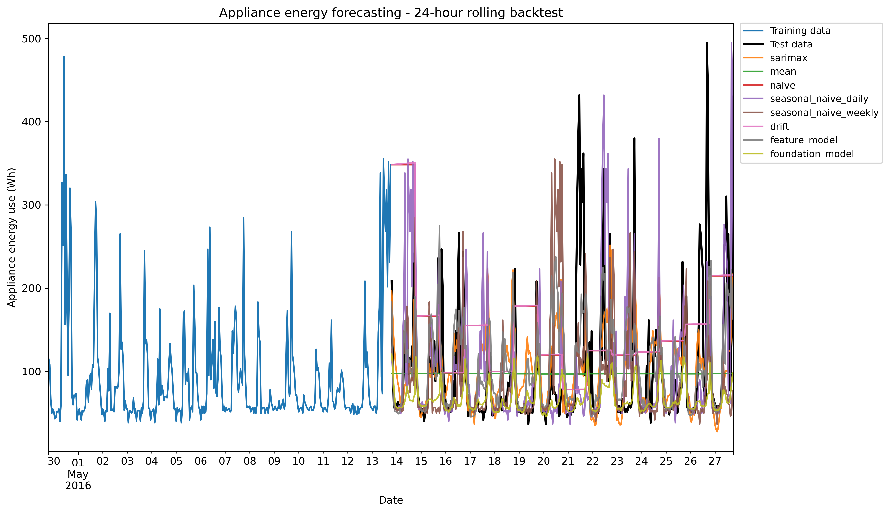
Figure 7: All model forecasts against the actual test data.
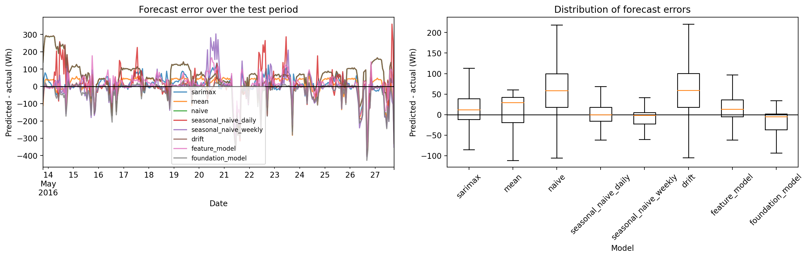
Figure 8: Forecast error over time (left) and error distributions (right), by model.
foundation_model has the best MASE (0.719) and MAE (38.44) of anything here, ahead of feature_model (0.806), weekly seasonal naive (0.813) and SARIMAX (0.832). But it doesn't win on every metric - its RMSE (77.93) is worse than both feature_model's (67.28) and SARIMAX's (69.02), and its Bias (-33.47) is the most negative of any model apart from the two clearly bad ones (naive, drift). Figure 7 shows why: the foundation_model line tracks the low, everyday baseline well but consistently falls short of the evening spikes. Figure 8's boxplot makes the same point more directly - its errors sit almost entirely below zero, while feature_model's and SARIMAX's are centred much closer to zero in both directions.
So "best model" depends on what you're optimising for. If getting a typical hour close matters most, foundation_model wins clearly. If getting badly caught out by a big spike is the more expensive mistake, feature_model or SARIMAX look safer, since neither is anywhere near as one-sidedly biased. More on this in Section 10, Q4.

10. Discussion

Q1. Strongest benchmark, and what it says about the series
Weekly seasonal naive, clearly (MASE 0.813, ahead of the mean at 0.941 and far ahead of naive and drift at 1.6). That says the series has real, exploitable structure rather than behaving like a random walk, and specifically that whatever repeats does so more reliably on a weekly cycle at the hour level than on a plain 24-hour cycle. Daily seasonal naive isn't far behind once it's allowed to update every day (0.904), so the daily rhythm from Section 3 is real too - just slightly less reliable than the weekly one.

Q2. Does SARIMAX improve on the strongest benchmark?
Not quite - SARIMAX's MASE (0.832) is a little worse than weekly seasonal naive's (0.813), though SARIMAX has the better RMSE (69.02 vs 81.41), so it's less likely to be badly wrong on any given hour even if its typical error runs a touch higher. I don't think this is really a modelling failure - the residual diagnostics (Ljung-Box p=0.648) say the daily seasonality is captured reasonably well. It's more that a 168-hour repeat happens to be a genuinely strong pattern in this series, and SARIMAX's seasonal term is fixed at 24 hours, not 168. It also didn't fully converge within the iteration cap, so this number might be understating what SARIMAX could do with more compute.

Q3. Does the feature-based model improve with more features? Which matter most?
Yes - once tuned and properly leakage-checked, it's the second-strongest model in the whole comparison (MASE 0.806), just behind the foundation model and just ahead of weekly seasonal naive and SARIMAX. What's more interesting is which features it actually leans on: indoor humidity (RH_3, RH_1) matters more than the lag features or the calendar features (Table 4). That wasn't what I expected before running this - I assumed lag_24 would dominate, the way lag features usually do. Weather variables barely register on their own (Section 3), but combined with sensor and calendar features they clearly help more than any one of them would suggest alone.

Q4. Does the foundation model outperform the others? Is it worth the complexity?
On MASE, yes - Chronos comes out on top of the whole comparison (0.719, about 11.6% better than the strongest benchmark), once I'd actually got it running with the right package versions. But I don't think that settles "worth the complexity" on its own. Its RMSE (77.93) is worse than feature_model's and SARIMAX's, and its Bias (-33.47) is the largest of any model outside naive and drift - it's consistently under-predicting, especially on the spikes (Section 9). For someone actually managing appliance load, getting the evening peak roughly right probably matters more than shaving a few Wh off the quiet hours, and that's exactly where Chronos does worst. It also needs a checkpoint download and a machine that can reach Hugging Face, which neither SARIMAX nor XGBoost need at forecast time. So: better on the metric I'm asked to lean on most, but with a real weakness on the hours that likely matter most, and a genuine deployment cost the simpler models don't carry. I wouldn't call it a clean win.

Q5. What is actually known at the forecast origin?
This is basically what Section 4's whole design is built around, and it's also where I found the most important bug in the whole project. Every feature the XGBoost model sees (lag_24 and up, the 24-/168-hour rolling stats, calendar features) is supposed to be available at each daily forecast origin - but my first version of the rolling features didn't actually guarantee that. A rolling window that ends at t-1, recomputed per hour, still reaches into earlier hours of the same forecast day for anything past the first hour, and those hours aren't real information yet when the whole day is forecast at once. Section 7 has the fix: rolling features are now computed once per forecast block, from data strictly before that block, and held constant across it. SARIMAX's weather variables are the one part of this pipeline that's still not quite operational: at each origin, the next 24 hours' T_out, RH_out, Windspeed, Visibility and Tdewpoint use the real, already-realised weather rather than a forecast of it. A real deployment would need an actual weather forecast there instead, and that would add its own error on top of whatever SARIMAX contributes.

Q6. Recommendation for practical smart-home forecasting
A tougher call now that Chronos actually has a number attached to it. Going purely on MASE, foundation_model wins - but given its bias toward under-predicting exactly the hours a smart-home system probably cares most about (Section 8, Q4), plus the extra infrastructure it needs, I'd still lean toward the feature model for a practical deployment: a close second on MASE (0.806), a much more balanced error profile (Figure 8), and nothing beyond a laptop needed at forecast time. Weekly seasonal naive is the fallback if simplicity matters more than the last bit of accuracy - no fitting at all, for a result not far behind. SARIMAX is the middle ground, with calibrated uncertainty built in (Figure 5). I'd only reach for the foundation model specifically if under-predicting peaks turns out to be an acceptable trade-off, or if a simple bias correction (not tried here) closes the gap.

Comparison with related work
Candanedo et al.'s original analysis of this dataset, using a wrapper-based feature selection method with a Random Forest baseline on the raw 10-minute data, found that time-of-day and light-status features carried most of the predictive value, with weather-station variables adding comparatively little on their own [1]. That's broadly consistent with what I found here: hour_cos and hour_sin both sit inside the top five importance scores (Table 4), and the individual weather correlations in Section 3 are all fairly weak. The comparison isn't exact - different resolution, different split, different metric - so I wouldn't lean on it too hard, but it's a reasonable check that the two analyses aren't contradicting each other.
More broadly, the second, third and fourth-place finishers here (feature_model, weekly seasonal naive, SARIMAX) sit within about 3% of MASE of each other, which echoes what the M4 forecasting competition found at a much bigger scale: simple, well-chosen methods stay genuinely competitive with more complex ones [10]. The actual top spot this time went to the most complex model, Chronos, though with the bias caveat from Section 8 attached - which fits M4's other big finding just as well, that no single method type wins outright or wins cleanly. I'd be cautious about generalising too far from one dataset either way.

11. Limitations and future improvements
Roughly in order of how much I think they matter. Chronos's bias problem (Section 8, Q4) is the one I'd most want to dig into further - I haven't tried a bias correction or looked at whether it's worse on particular hours or days, so I don't know how much of the RMSE gap would close with one. TimeGPT never actually got tested, since Chronos worked, so I can't say how it would compare. The final SARIMAX fit is capped at 30 iterations and doesn't fully converge, so its real performance might be a bit better than what's reported here - I actually tried the AIC-best order (6,0,3) rather than assuming it wouldn't fit, and it genuinely couldn't converge in the time available. The hyperparameter search in Section 7 only tried six hand-picked combinations, not a proper grid or random search. Chronos also only ran successfully on my own machine, not in the environment this project was otherwise developed in, since that environment blocks huggingface.co - worth flagging for anyone trying to reproduce this. And SARIMAX's weather variables are still a conditional forecast in the Question 5 sense, whatever else changes in this pipeline. The rolling-feature leakage from Section 7 was a real bug in an earlier version, not a hypothetical - I'm flagging it because finding it changed which model wins, not to look thorough.
If I picked this back up: try a simple bias correction on the Chronos forecasts and see how much of the RMSE gap it closes; get TimeGPT running too so there's a second foundation model to compare against, not just one; widen the XGBoost hyperparameter search and let SARIMAX run to full convergence instead of capping it for speed; and try feeding the feature model's own predictions back in as short-lag features within each 24-hour window, done safely, instead of dropping short lags entirely.

12. Conclusion
This project set out to answer six questions about forecasting household appliance energy use, all evaluated the way the brief actually specifies - a real 24-hour horizon, repeated across 14 daily origins, with every feature checked to make sure it's actually known at the moment each forecast is made. To take them in turn: the benchmarks show the series has real structure, and weekly seasonal naive is a strong, almost-free baseline. SARIMAX comes close to the best models but doesn't quite match them, though it wins on RMSE. XGBoost, once its features were properly leakage-checked and tuned, comes out as a strong, well-balanced second place, leaning more on indoor humidity than I expected and less on lag features. Chronos, once I actually got it running, comes out ahead on MASE but with a real bias problem on the biggest spikes and a genuine deployment cost the other models don't have, so "wins outright" would overstate it. What's actually known at each forecast origin turned out to be a real, fixable bug in the feature table, plus a design question about SARIMAX's weather inputs. And for a practical system, I'd still lean toward the feature model first, given its more balanced errors and lower cost, with Chronos worth a second look if that bias can be corrected.
The result I didn't expect going in was how much the ranking depended on getting the rolling features properly leakage-free, and how the model with the best headline number turned out to have the biggest hidden weakness once I actually looked at the errors rather than just the summary stats. Model complexity only earned its keep once I'd actually checked what each model was doing, not just what score it got. That's a more useful takeaway than any single model's ranking, and it's why I'd rather hand in a close, carefully-checked result than a tidy, unchecked one.

References
[1] Candanedo, L. M., Feldheim, V., & Deramaix, D. (2017). Data driven prediction models of energy use of appliances in a low-energy house. Energy and Buildings, 140, 81-97.
[2] Hyndman, R. J., & Athanasopoulos, G. (2021). Forecasting: Principles and Practice (3rd ed.). OTexts.
[3] Hyndman, R. J., & Koehler, A. B. (2006). Another look at measures of forecast accuracy. International Journal of Forecasting, 22(4), 679-688.
[4] Dickey, D. A., & Fuller, W. A. (1979). Distribution of the estimators for autoregressive time series with a unit root. JASA, 74(366a), 427-431.
[5] Kwiatkowski, D., Phillips, P. C. B., Schmidt, P., & Shin, Y. (1992). Testing the null hypothesis of stationarity against the alternative of a unit root. Journal of Econometrics, 54(1-3), 159-178.
[6] Box, G. E. P., Jenkins, G. M., Reinsel, G. C., & Ljung, G. M. (2015). Time Series Analysis: Forecasting and Control (5th ed.). Wiley.
[7] Chen, T., & Guestrin, C. (2016). XGBoost: A scalable tree boosting system. Proceedings of KDD 2016, 785-794.
[8] Ansari, A. F., Stella, L., Turkmen, C., et al. (2024). Chronos: Learning the language of time series. arXiv:2403.07815.
[9] Garza, A., & Mergenthaler-Canseco, M. (2023). TimeGPT-1. arXiv:2310.03589.
[10] Makridakis, S., Spiliotis, E., & Assimakopoulos, V. (2020). The M4 Competition: 100,000 time series and 61 forecasting methods. International Journal of Forecasting, 36(1), 54-74.

