Forecasting Household Appliance Energy Use
Benchmarks, SARIMAX, XGBoost and a Foundation Model
Tamanna Pathak
Repo: https://github.com/tamannapathak/appliance-energy-forecasting

1. Introduction
This report is about forecasting household appliance electricity use, using the UCI Appliances Energy Prediction dataset. It records appliance energy use every ten minutes, along with indoor sensor readings and outdoor weather [1]. The assignment asks for a staged comparison with simple benchmarks first, then SARIMAX, then a feature-based machine learning model, then a foundation model, all forecasting 24 hours ahead across a 14-day test period.
The real question isn't just which model wins. It's whether each extra bit of complexity actually earns its place, or whether a simple model does just as well. That question runs through the whole report, and the answer turned out to be more interesting than I expected.

2. Data and preprocessing
The original data consists of 19,735 rows, collected every 10 minutes from January 11 to May 27, 2016. The focus is on appliances (WH). The dataset includes lights, nine indoor temperature and humidity pairs, six outdoor weather factors, and two random variables included by the authors for validation. There are no missing values present, which was verified column-wise individually.
The ten-minute data is quite noisy, and conducting a SARIMAX grid search on nearly 20,000 points wasn't practical to perform. I therefore resampled to hourly averages, resulting in 3,290 rows. This maintains the visibility of the daily pattern while significantly reducing the cost of fitting everything else in the pipeline. Figure 1 displays both variants next to each other.

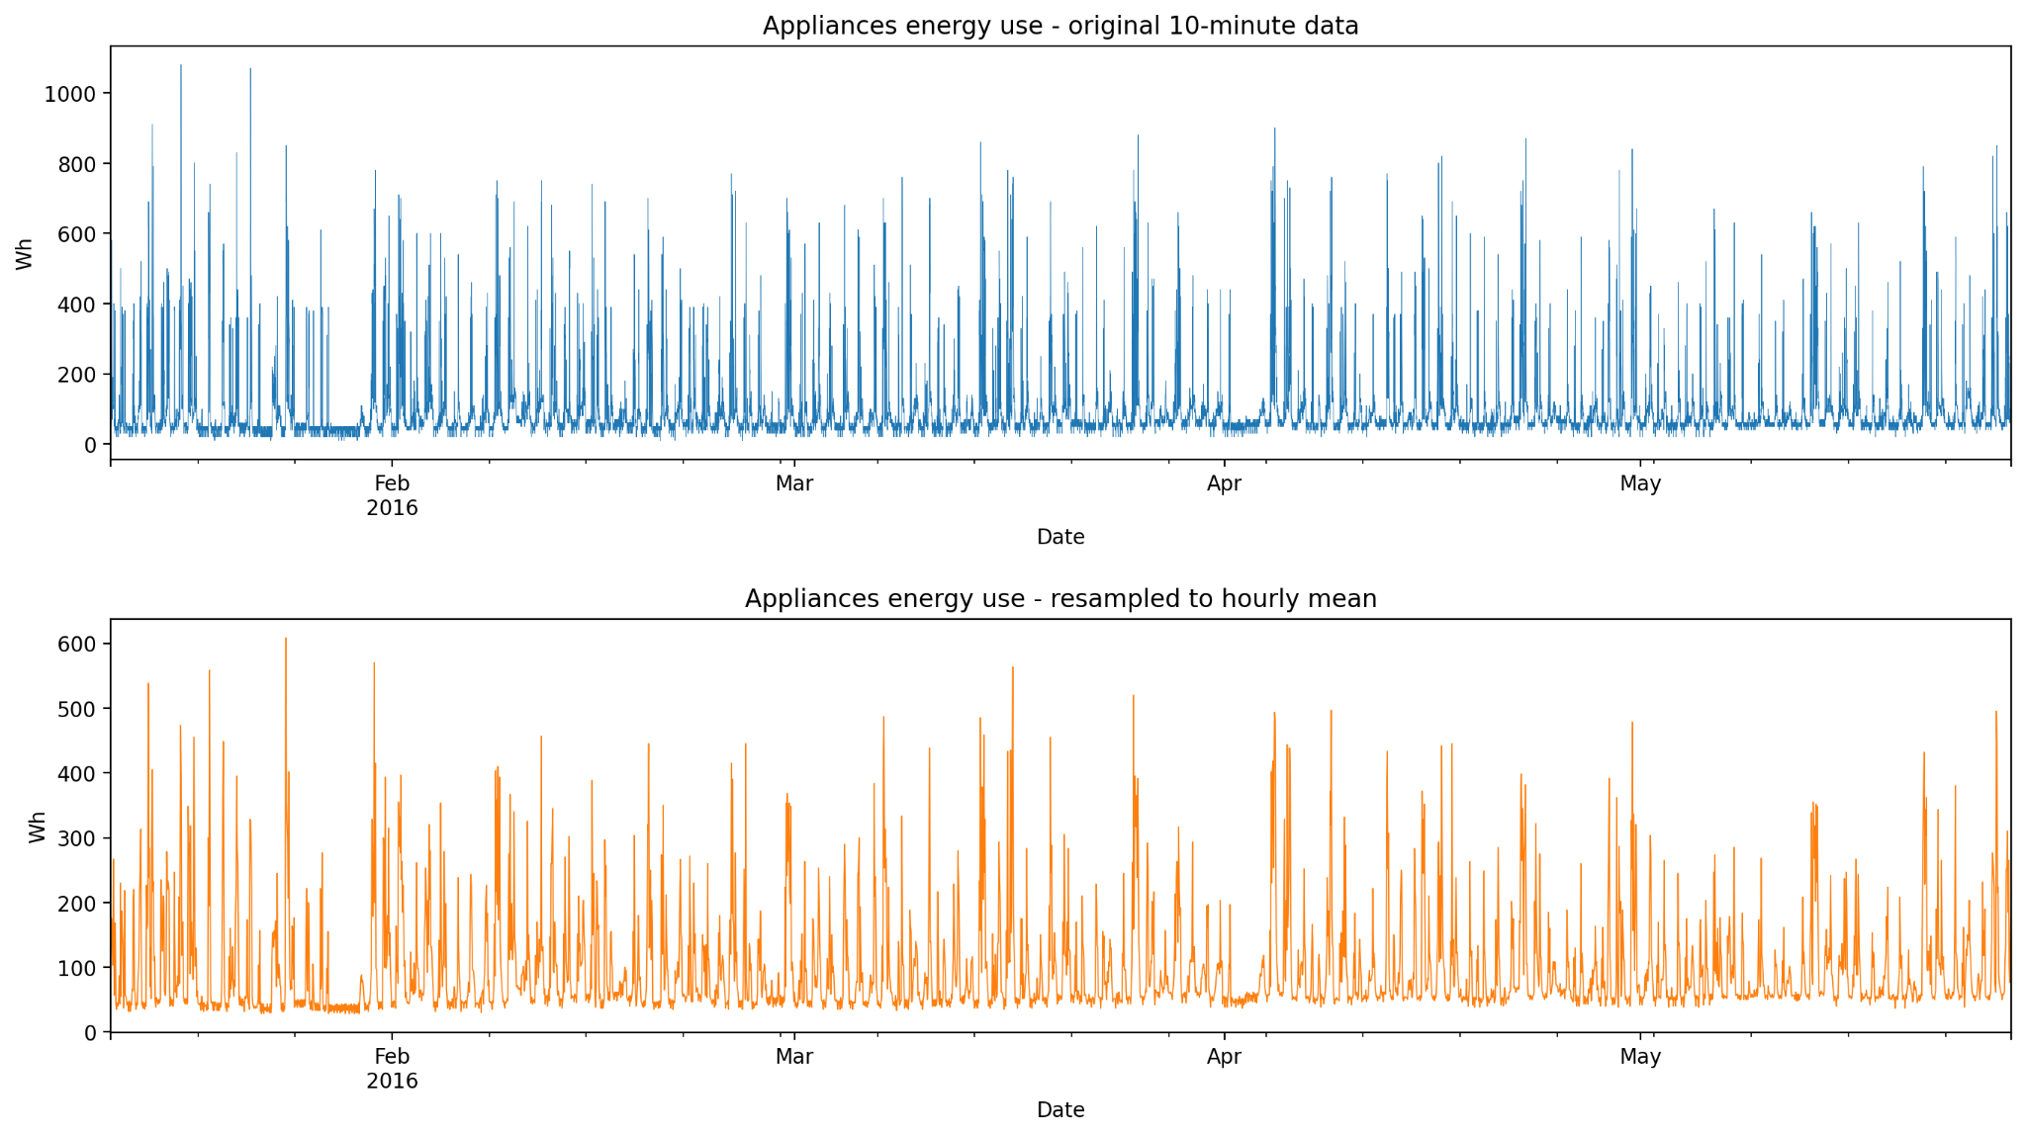
Figure 1: Appliances' energy use at 10-minute resolution (top) and resampled to hourly means (bottom).

3. Exploratory analysis
Hourly Appliances has an average of 97.8 Wh, while its median is just 63.3 Wh. That gap indicates a right-skewed distribution, which means the majority of hours are clustered around a low baseline, with periodic spikes when multiple appliances operate simultaneously.
According to the hour of the day, the calmest point occurs at 3am (48.2 Wh), while the busiest point is at 6pm (191.8 Wh), aligning with a typical household schedule. According to the day of the week, Monday peaks at 111.5 Wh, while Tuesday is at its lowest with 87.1 Wh; however, averages for weekdays and weekends are similar. Thus, the weekly trend discovered resembles daily routines more than just a straightforward weekend influence.
No individual sensor or weather factor shows a strong correlation with appliances. Lights have the highest correlation at r=0.26, followed by RH_out and several temperatures and humidities, all below 0.16. The weak signal from individual variables contributes to why a model that combines many features is similar to SARIMAX, despite SARIMAX relying directly on five weather variables.
The seasonal decomposition in Figure 2 reveals a distinct daily cycle overlaying a gradual trend, indicating that a 24-hour component won't account for everything. The ACF/PACF in Figure 3 also supports this, as we can see a significant spike at lag 24 that recurs at lags 48 and 72, along with a PACF that decreases much more rapidly than the ACF. This suggests a brief autoregressive pattern existing alongside the daily seasonal effects.

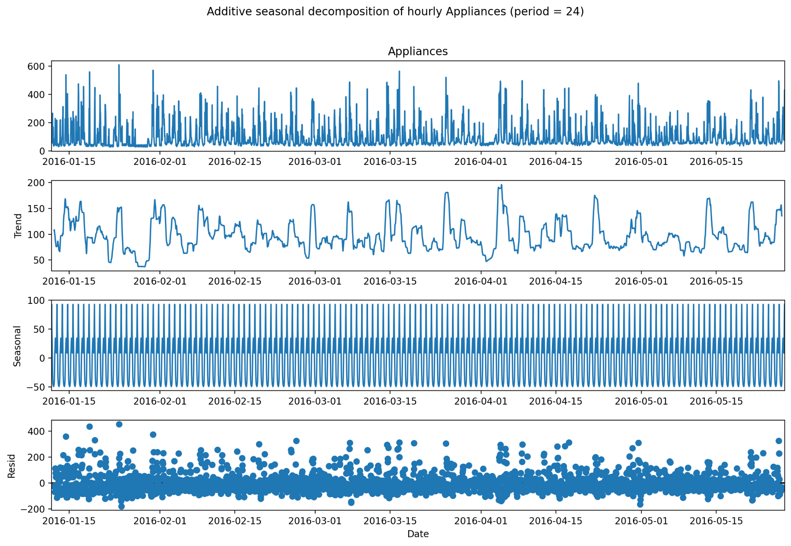
Figure 2: Additive seasonal decomposition of hourly appliances (period = 24).
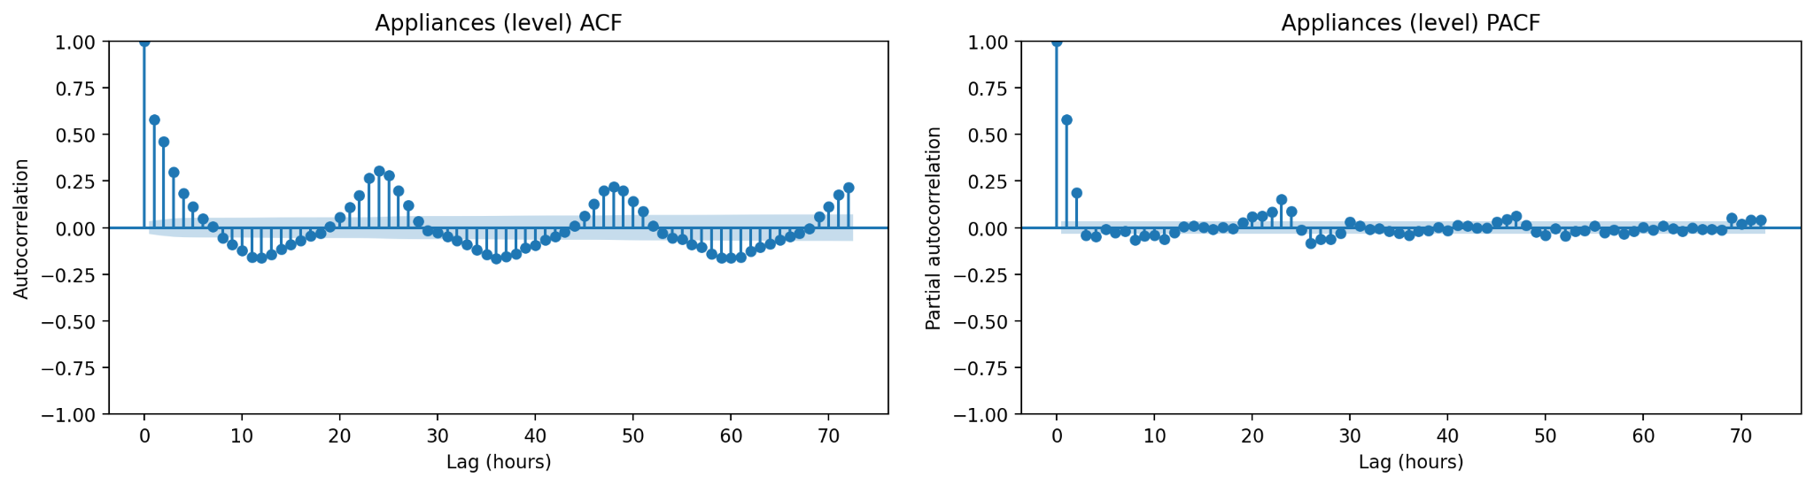
Figure 3: ACF and PACF of the hourly series, 72 lags.

Stationarity
ADF [4] and KPSS [5] tests on the level series and its first difference both say the level series is already stationary. ADF rejects the unit-root null strongly (-8.95, p<0.0001), and KPSS fails to reject stationarity (0.038, p=0.10). I expected to need at least one difference going in, but it makes sense once you think about it. Appliances don't have a long-run trend because they just oscillate around a stable pattern. This also matches the SARIMAX order search below, which mostly picks d=0.

4. Forecasting design
The target for this project is the range of appliances. I have selected a test period of the last 14 days (336 hours), and everything before that is used for training. The horizon is 24 hours, forecast at 14 daily origins across the test period.
Every model here is evaluated this way. Benchmarks are recomputed each day using the real expanding history. SARIMAX is fitted once. Then rolled forward daily with append(refit=False), which updates its state with real data without re-estimating the coefficients. The feature-based model always uses lag and rolling features of 24 hours or more, so its prediction for any hour in the test period already equals a genuine 24-hour-ahead forecast made at that day's own origin.
The metrics I have used are MAE, RMSE, MASE and bias computed over the 336 hours of test predictions. MASE is scaled against the in-sample MAE of the seasonal naive forecast (lag 24) [3], which keeps it comparable across models and is the metric I lean on most since MAE and RMSE don't always agree with each other.

5. Benchmark models
There are five benchmarks [2] that are used. These benchmarks are the mean, the method which repeats the last value, the daily seasonal naive method which looks at what happened 24 hours before; the weekly seasonal naive method which looks at what happened 168 hours before; and the drift method. Each of these five benchmarks is recalculated every day for 14 days using the history up to that point, not using any guesses made by the model earlier.
The naive and drift methods are the worst of the five benchmarks, with scores of 1.601 and 1.606. This is because repeating the value from yesterday or assuming that things will keep going in a straight line does not work well for a series that has a daily and weekly rhythm like this one. The weekly seasonal naive method is the best of the five benchmarks. It is actually the strongest model when you compare everything. It has a score of 0.813. The daily seasonal naive method is behind with a score of 0.904 once it gets updated every day. The mean method is in the middle with a score of 0.941.
Each of these benchmarks is based on an idea. The mean method assumes that there is no pattern, and the naive method assumes that tomorrow will be like today. The seasonal methods assume that things will happen exactly the same way at a fixed time, and the drift method assumes that things will keep going in a straight line. None of these methods can adapt to anything. They only use the data they have, which is the minimum that any more complex method should be able to do.

6. SARIMAX model
An AIC grid search was required for the non-seasonal order (p, d, q), where p and q ranged from 0 to 6 and d ranged from 0 to 2, totalling 147 combinations. I executed this using the basic ARIMA framework, maintaining the seasonal order at (1,1,1,24), and found out that several test fits with the seasonal component included required more than a minute each, compared to less than 4 seconds without it, so a complete grid of 147 combinations with the seasonal component would have consumed hours. The seasonal order is justified by the daily cycle outlined in Section 3.
All 147 fits are finished. The optimal model by AIC was ARIMA(6, 0, 3) at 32,967.3, and it did reach convergence. The subsequent pair, (5,0,3) at 32,971.7 and (5,0,4) at 32,973.5, also came together. The d=0 victory in the top results aligns with the stationarity tests from Section 3, providing a comforting verification. 107 out of 147 fits converged in total.
Applying the complete seasonal model at the AIC-optimal order, SARIMAX(6,0,3)x(1,1,1,24) with external variables proved to be impractical, and I verified this directly instead of merely assuming it. (5, 0, 3), the AIC second-place finisher, also failed to complete 30 iterations within the allotted time. (1,0,3) represents the highest order that consistently achieves a proper 30-iteration fit when including the seasonal term along with all five external weather variables. Thus, this model is employed for the remainder of this report.
The AR(1) term (0.69) indicates significant short-term persistence, which is logical on an hourly basis. Tdewpoint shows the highest positive weather coefficient (6.64), while T_out has the highest negative (-6.41); however, they are correlated, so I wouldn’t interpret either sign in isolation. It's more indicative of the model identifying a beneficial combination of related weather factors rather than a straightforward causal relationship. Visibility stands out as the only term with a clearly significant result among the weather variables; the others exhibit large standard errors compared to their values.
SARIMAX has certain assumptions that should be clearly stated. It views the connection between historical and current values as linear, presumes Gaussian noise with approximately constant variance, and considers weather factors as completely external, implying they affect appliances while no elements of appliances influence them in return. That’s sensible for outdoor conditions, although the fit itself cannot verify it. It additionally considers the seasonal interval as a constant 24 hours instead of estimating it. Residual diagnostics in Figure 4 illustrate the ACF remaining near zero across all 40 lags displayed, with none exceeding the confidence band. The Ljung-Box at lag 24 confirms (20.85, p = 0.648) [6]. No substantial autocorrelation remains, which is reassuring considering the model didn't completely converge. The histogram appears to be approximately symmetric and focused around zero, with a handful of residuals extending significantly beyond the main mass on the positive side. The Q-Q plot aligns well with the normal line in the centre but diverges at both ends, especially on the right, indicating that the Gaussian-error assumption is valid for an average hour but not for rare significant events.

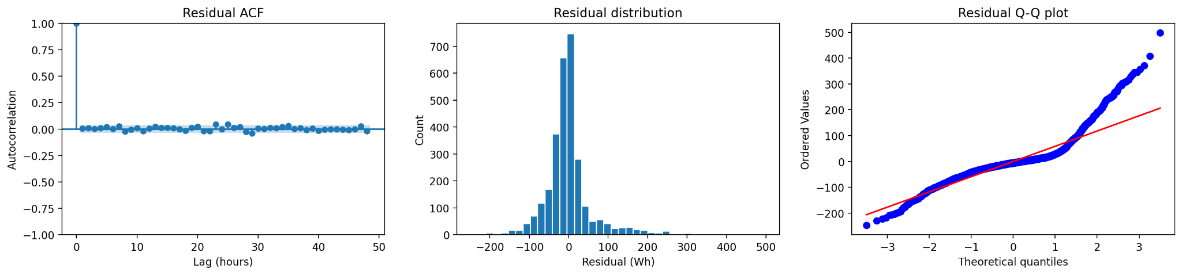
Figure 4: SARIMAX residual diagnostics – ACF, histogram, Q-Q plot.
The forecast used for evaluation rolls this same fitted model forward across all 14 days with .append(refit=False). The coefficients stay fixed the whole way through, and only the model's internal filtered state updates with the newly realized 24 hours each day. Figure 5 shows the 95% confidence interval on just the first day's forecast, since averaging a confidence interval across 14 different origins doesn't mean much on its own.
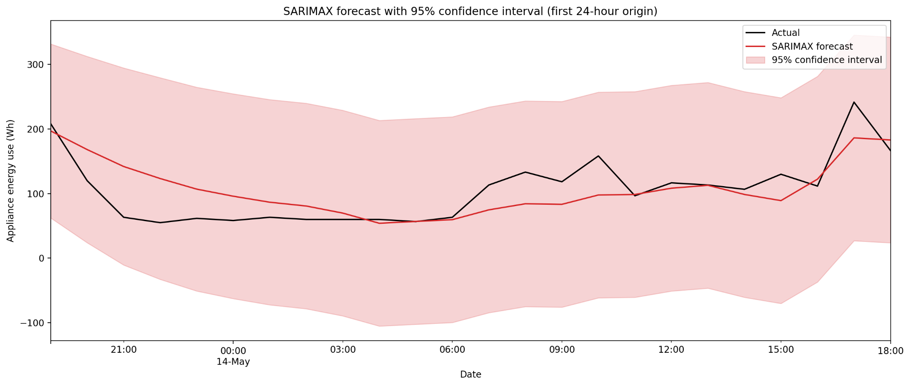
Figure 5: SARIMAX forecast with 95% confidence interval, first 24-hour origin.

7. Feature-based model
The feature table, which is made by the function, includes information from the past 24, 48 and 168 hours. It also includes the standard deviation of the data over 24 and 168 hours as well as information about the time of day and day of the week. The indoor and outdoor sensor data is included too. The feature table does not include data from the few hours like lag_1 or lag_2. This is because the forecast is made once a day and is used for the 24 hours. So any data from more than 24 hours ago is not available yet when the forecast is made.

At first I did not think enough about how to calculate the rolling average and standard deviation. My first attempt was to shift the target by one hour and apply the window to each row. This method had a problem. It worked for the hour of the forecast but not for the rest of the day. For example, if we are 24 hours into a 24-hour forecast, the rolling window would include data from earlier in the forecast day, which had not happened yet when the forecast was made. To fix this problem I now calculate the average and standard deviation once per forecast block. I only use data from before the block starts. I use the same value for every hour in the block. This way I avoid using data that has not happened yet. The lag_24, lag_48 and lag_168 features did not have this problem because they always point to a time in the past.
I chose to use the XGBoost library of the HistGradientBoostingRegressor from scikit-learn. This is because I am more familiar with XGBoost and it is listed as an option. XGBoost is different from the SARIMAX model. It does not have a built-in understanding of time. It needs the time-series structure to be included in the features. It only gives a forecast value, not a range of possible values, like the SARIMAX model does. The feature table made by the function is used by the XGBoost model to make forecasts.

Hyperparameter tuning
tune_feature_model() holds out the 336 rows of training data as a validation split , the same length as the real test period but never touching it and tries six combinations of n_estimators, learning_rate and max_depth keeping whichever gets the lowest validation RMSE (Table 3). The winner uses trees and a shallower depth than most of the other options (n_estimators=200, learning_rate=0.05, max_depth=3) which fits with Section 3s point that this series doesn't have many strongly predictive individual features. A smaller model generalised better here, than a bigger one. This is the configuration used for the result.

n_estimators | learning_rate | max_depth | Validation RMSE
200 | 0.05 | 3 | 103.21
500 | 0.05 | 7 | 104.47
500 | 0.05 | 3 | 109.32
500 | 0.10 | 3 | 115.96
1000 | 0.01 | 5 | 116.61
500 | 0.05 | 5 | 125.52
Table 3: Feature-model hyperparameter search, sorted by validation RMSE (lowest first).
With these settings the feature model scores MASE 0.806 (MAE 43.07, RMSE 67.28, Bias 7.49). The model in the whole comparison is just ahead of weekly seasonal naive and SARIMAX. Permutation importance (each feature shuffled drop in test R² recorded and averaged over 5 repeats) shows something I did not expect when I started: the two best features are indoor humidity readings, RH_3 (0.101) and RH_1 (0.087), ahead of the calendar features and well ahead of the lag features represented in Figure 6. Hour_cos comes in third (0.081), followed by hour_sin (0.068) and then T3 (0.052). Lag_24 only shows up in place (0.047).
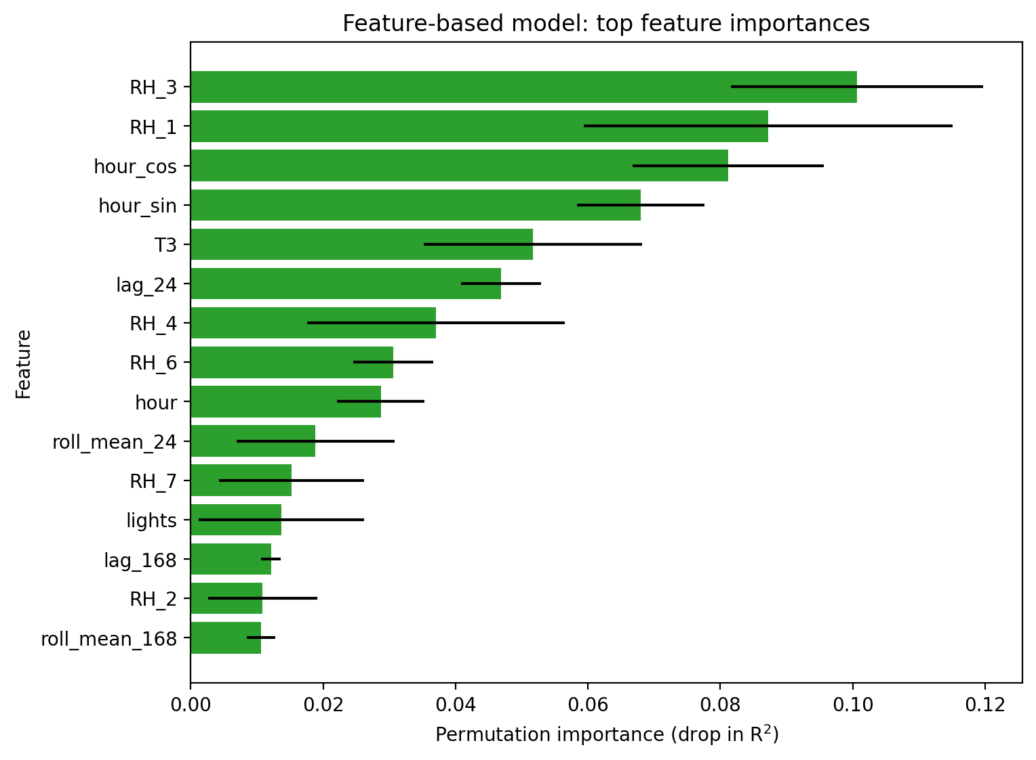
Figure 6: Permutation importance, feature-based model, top 15.
That's a genuinely different picture from what the correlation would suggest on its own. RH_3 and RH_1 aren't the strongest single correlations with appliances there, but XGBoost is picking up on how they combine with everything else, not just their solo relationship with the target. Permutation importance and simple correlation are answering slightly different questions.

8. Foundation model
The plan here was to actually run a pretrained foundation model, not just write a placeholder for one. I used Chronos [8], Amazon's pretrained time-series model, zero-shot on the target series only with no fine-tuning, no weather inputs, just the appliances' history. get_foundation_model_forecast_rolling() calls it once per daily origin, 24 hours at a time, with the real expanding history up to that point, the same setup as every other model in this report. I changed this partway through development. Chronos's own docs recommend keeping prediction_length at 64 or under, so an earlier version that called it once for the whole 336-hour test period was both slower than it needed to be and outside what the model is actually meant for. TimeGPT [9] is also coded up (forecast_foundation_model_timegpt) as a second option if Chronos ever fails, but it wasn't needed here.

The result is the best MASE in the whole comparison, about 11.6% better than the strongest benchmark and better than the feature model too. But I don't think that makes it the best model outright. Its bias is -33.47, by far the most negative of any model apart from the two obviously bad ones (naive, drift), and Figure 8's boxplot shows the same thing directly. foundation_model's errors sit almost entirely below zero. In Figure 7, the foundation_model line tracks the low everyday baseline closely but consistently comes in under the big evening spikes. So it isn't uniformly more accurate , it's landing close on typical hours and running short on the ones that probably matter most for someone actually managing appliance load, which is why its RMSE (77.93) ends up worse than both the feature model's (67.28) and SARIMAX's (69.02) even with the best MAE and MASE of the group.

9. Results and error analysis
Table 5 gives the full comparison: MAE, RMSE, MASE, and bias for every model, sorted by MASE. Figure 7 plots every forecast against the actual test data. Figure 8 shows forecast error over time (left) and the spread of errors (right), by model.
Model | MAE | RMSE | MASE | Bias
foundation_model | 38.44 | 77.93 | 0.719 | -33.47
feature_model | 43.07 | 67.28 | 0.806 | 7.49
seasonal_naive_weekly | 43.46 | 81.41 | 0.813 | -13.16
sarimax | 44.44 | 69.02 | 0.832 | 2.95
seasonal_naive_daily | 48.31 | 85.56 | 0.904 | 1.75
mean | 50.26 | 74.94 | 0.941 | -3.29
naive | 85.55 | 110.39 | 1.601 | 50.98
drift | 85.80 | 110.68 | 1.606 | 51.37
Table 5: Full model comparison, 24-hour rolling backtest, sorted by MASE. foundation_model is Chronos (amazon/chronos-t5-tiny), run zero-shot.
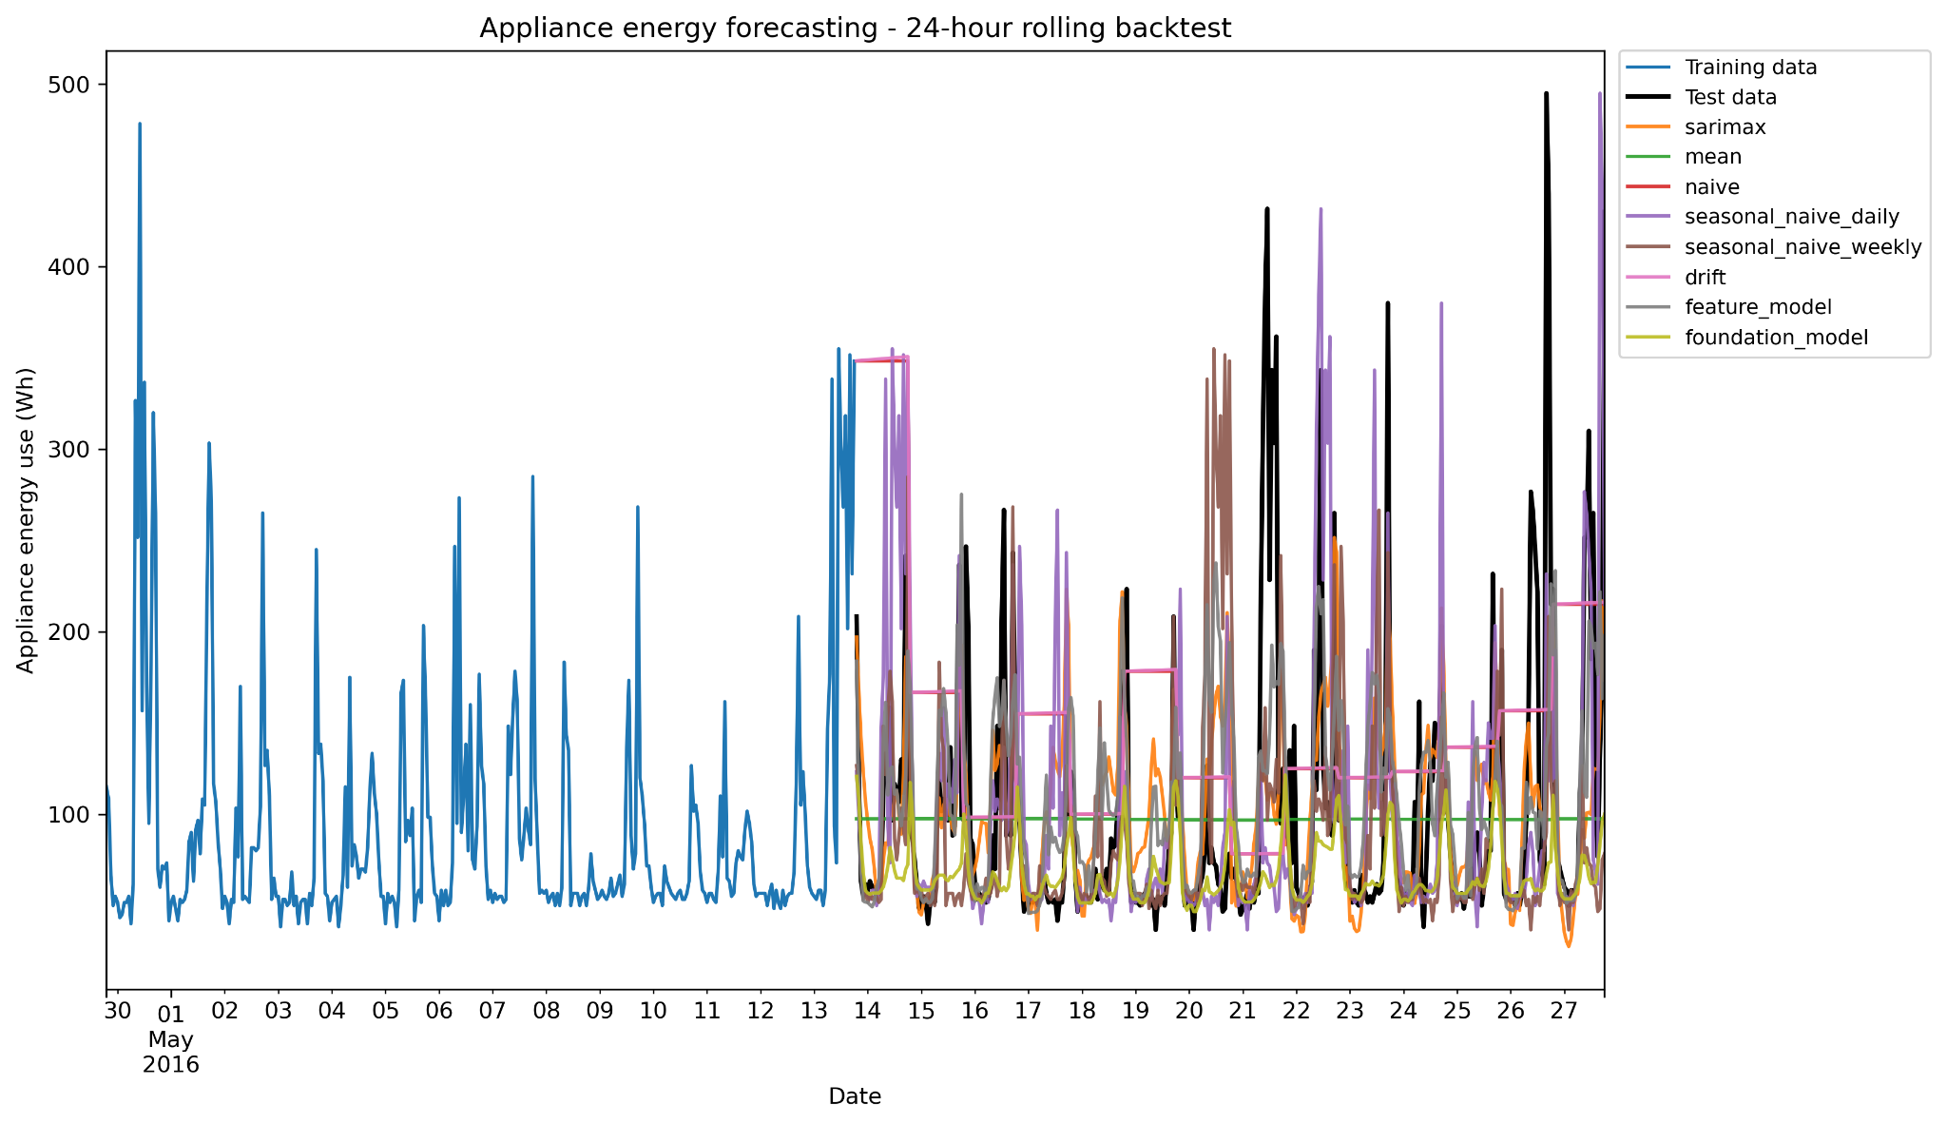
Figure 7: All model forecasts against the actual test data.
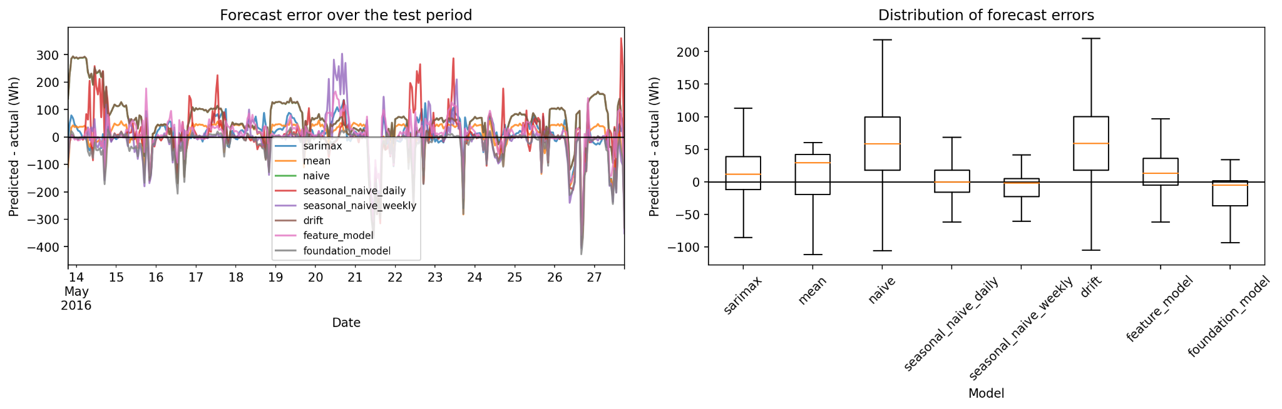
Figure 8: Forecast error over time (left) and error distributions (right), by model.

The foundation_model has the MASE 0.719 and MAE 38.44 of anything here ahead of feature_model 0.806, weekly seasonal naive 0.813, and SARIMAX 0.832. But it doesn't win on every metric; its RMSE 77.93 is worse than both feature_models 67.28 and SARIMAXs 69.02, and its bias -33.47 is the most negative of any model apart from the two clearly bad ones (naive drift). Figure 7 shows why , the foundation_model line tracks the everyday baseline well but consistently falls short of the evening spikes. Figure 8's boxplot makes the point more directly. Its errors sit almost entirely below zero, while feature_models and SARIMAXs are centered much closer to zero in both directions.

So "best model" depends on what you're optimizing for. If getting an hour close matters most, the foundation model wins clearly. If getting badly caught out by a spike is the more expensive mistake, feature_model or SARIMAX look safer since neither is anywhere near as one-sidedly biased. More on this, in Section 10 Q4.

10. Discussion
The weekly seasonal naive model is the strongest by far. It has a MASE of 0.813 which's better than the mean at 0.941 and much better than the naive and drift models at 1.6. This tells us that the series has a structure that we can use, rather than just being random. The weekly seasonal naive model is good at predicting what happens on a cycle at the hour level rather than just looking at a plain 24-hour cycle. The daily seasonal naive model is not far behind with a MASE of 0.904 once it is allowed to update every day. So the daily rhythm is too it is just a bit less reliable than the weekly one.

The SARIMAX model does not do better than the weekly seasonal naive model. Its MASE is 0.832 which is a bit worse than the seasonal naive model. However, it has a RMSE of 69.02 compared to 81.41 for the weekly seasonal naive model. This means that the SARIMAX model is less likely to be very wrong even if its typical error is a bit higher. I do not think this is a failure of the model. Rather that the daily seasonality is captured reasonably well. The problem is that the SARIMAX model has a fixed term of 24 hours rather than 168 hours, which is a strong pattern in this series.

The feature-based model does get better with features. Once it is tuned and checked for leakage, it is the strongest model, with a MASE of 0.806. This is behind the foundation model and just ahead of the weekly seasonal naive and SARIMAX models. What is interesting is that the feature-based model relies more on humidity, such as RH_3 and RH_1, than on lag features or calendar features. I did not expect this, as I thought lag_24 would be the important feature.

The foundation model, Chronos, does outperform the models on MASE with a score of 0.719. This is 11.6% better than the strongest benchmark. However, I do not think this means it is the model to use. Its RMSE is 77.93, which's worse than the feature-based model and the SARIMAX model. It also has a bias of -33.47, which means it is consistently under-predicting, especially on the spikes. For someone managing appliance load, getting the evening peak right is probably more important than saving a watt during quiet hours. The Chronos model does poorly on the hours that matter most. It also needs a checkpoint download and a machine that can reach Hugging Face, which the other models do not need.

What we actually know at the forecast origin is important. It is where I found the most important bug in the project. Every feature the XGBoost model sees is supposed to be available at each forecast origin, but my first version of the rolling features did not guarantee this. The fix is to compute the rolling features per forecast block from data strictly before that block and hold them constant across it. The SARIMAX models' weather variables are still not quite operational, as they use weather data rather than a forecast. A real deployment would need a weather forecast, which would add its own error on top of what the SARIMAX model contributes.

For smart-home forecasting, it is a tough call now that the Chronos model has a number attached to it. If we go purely on MASE, the foundation model wins. Given its bias toward underpredicting the hours that matter most plus the extra infrastructure it needs, I would still choose the feature-based model. It is a second on MASE with a much more balanced error profile, and it only needs a laptop at forecast time. The weekly seasonal naive model is a fallback if simplicity matters more than accuracy. The SARIMAX model is a ground, with calibrated uncertainty built in. I would only use the foundation model if under-predicting peaks is a trade-off or if a simple bias correction can close the gap.

Comparison with related work
Candanedo et al.'s original analysis of this dataset, using a wrapper-based feature selection method with a Random Forest baseline on the raw 10-minute data, found that time-of-day and light-status features carried most of the predictive value, with weather-station variables adding comparatively little on their own [1]. That's broadly consistent with what I found here. hour_cos and hour_sin both sit inside the top five importance scores, and the individual weather correlations are all fairly weak. The comparison isn't exact; there are different resolutions, different splits, and different metrics, so I wouldn't lean on it too hard, but it's a reasonable check that the two analyses aren't contradicting each other.

More broadly, the second, third and fourth-place finishers here (feature_model, weekly seasonal naive, and SARIMAX) sit within about 3% of MASE of each other, which echoes what the M4 forecasting competition found at a much bigger scale, so that simple, well-chosen methods stay genuinely competitive with more complex ones [10].

11. Limitations and future improvements
Chronos's bias problem is the one I'd most want to dig into further. I haven't tried a bias correction or looked at whether it's worse on particular hours or days, so I don't know how much of the RMSE gap would close with one. TimeGPT never actually got tested, since Chronos worked, so I can't say how it would compare. The final SARIMAX fit is capped at 30 iterations and doesn't fully converge, so its real performance might be a bit better than what's reported here. I actually tried the AIC-best order (6, 0, 3) rather than assuming it wouldn't fit, and it genuinely couldn't converge in the time available. The hyperparameter search only tried six hand-picked combinations, not a proper grid or random search. SARIMAX's weather variables are still a conditional forecast in the Question 5 sense, whatever else changes in this pipeline. The rolling-feature leakage was a real bug in an earlier version, not a hypothetical one. I'm flagging it because finding it changed which model wins, not to look thorough.
If I picked this back up, I would try a simple bias correction on the Chronos forecasts and see how much of the RMSE gap it closes; get TimeGPT running too so there's a second foundation model to compare against, not just one; widen the XGBoost hyperparameter search and let SARIMAX run to full convergence instead of capping it for speed; and try feeding the feature model's own predictions back in as short-lag features within each 24-hour window, done safely, instead of dropping short lags entirely.

12. Conclusion
This project was done to answer six questions about forecasting the energy use of household appliances. We looked at the energy use over a 24-hour period, and we did this for 14 different days. We made sure that every feature we used was actually known at the time we made each forecast.

To look at the results, the benchmarks showed that the series has a pattern, and a weekly seasonal naive approach is a strong baseline that is almost free. SARIMAX is close to the models, but it does not quite match them, although it wins when it comes to RMSE. XGBoost is in second place once its features are properly checked and tuned, and it relies more on indoor humidity than I thought it would and less on lag features.

Chronos comes out ahead when it comes to MASE. It has a real problem with bias on the biggest spikes, and it has a deployment cost that the other models do not have. So saying it wins outright would be an overstatement. What we actually know at each forecast origin turned out to be a bug in the feature table that we could fix and a design question about the weather inputs for SARIMAX.

For a system I would still choose the feature model first because it has more balanced errors and a lower cost, and Chronos is worth a second look if we can correct that bias. The result that I did not expect was how much the ranking of the models depended on getting the rolling features properly free of leakage and how the model with the headline number turned out to have the biggest hidden weakness once I actually looked at the errors rather than just the summary statistics.

The complexity of the models only made a difference once I had actually checked what each model was doing, not what score it got. This is a more useful thing to learn than the ranking of any single model, and it is why I would rather have a close and carefully checked result than a tidy but unchecked one. The forecasting of household appliance energy use is what this project is about, and the forecasting of household appliance energy use is what we need to focus on.

References
[1] Candanedo, L. M., Feldheim, V., & Deramaix, D. (2017). Data driven prediction models of energy use of appliances in a low-energy house. Energy and Buildings, 140, 81-97.
[2] Hyndman, R. J., & Athanasopoulos, G. (2021). Forecasting: Principles and Practice (3rd ed.). OTexts.
[3] Hyndman, R. J., & Koehler, A. B. (2006). Another look at measures of forecast accuracy. International Journal of Forecasting, 22(4), 679-688.
[4] Dickey, D. A., & Fuller, W. A. (1979). Distribution of the estimators for autoregressive time series with a unit root. JASA, 74(366a), 427-431.
[5] Kwiatkowski, D., Phillips, P. C. B., Schmidt, P., & Shin, Y. (1992). Testing the null hypothesis of stationarity against the alternative of a unit root. Journal of Econometrics, 54(1-3), 159-178.
[6] Box, G. E. P., Jenkins, G. M., Reinsel, G. C., & Ljung, G. M. (2015). Time Series Analysis: Forecasting and Control (5th ed.). Wiley.
[7] Chen, T., & Guestrin, C. (2016). XGBoost: A scalable tree boosting system. Proceedings of KDD 2016, 785-794.
[8] Ansari, A. F., Stella, L., Turkmen, C., et al. (2024). Chronos: Learning the language of time series. arXiv:2403.07815.
[9] Garza, A., & Mergenthaler-Canseco, M. (2023). TimeGPT-1. arXiv:2310.03589.
[10] Makridakis, S., Spiliotis, E., & Assimakopoulos, V. (2020). The M4 Competition: 100,000 time series and 61 forecasting methods. International Journal of Forecasting, 36(1), 54-74.

