Exp. 1 Design an LED Flasher

Circuit Diagram:

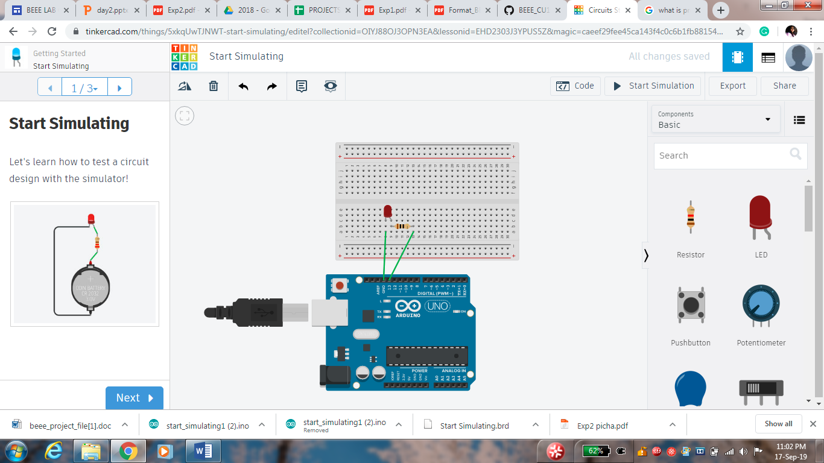

**Theory:**

Concept Used:

* Ohm’s law

**Learning & Observations:**

* Working of Arduino
* Coding for Arduino using C language

**Problems & Troubleshooting:**

* Port selection
* Loose connections
* Error in coding

**Precautions:**

* Connections should be tight
* Port and board selection should be correct
* Code should be written properly

**Learning Outcomes:**

Blinking of LED was verified after uploading the program.