Exp. 2 Design an LED Chaser

Circuit Diagram:

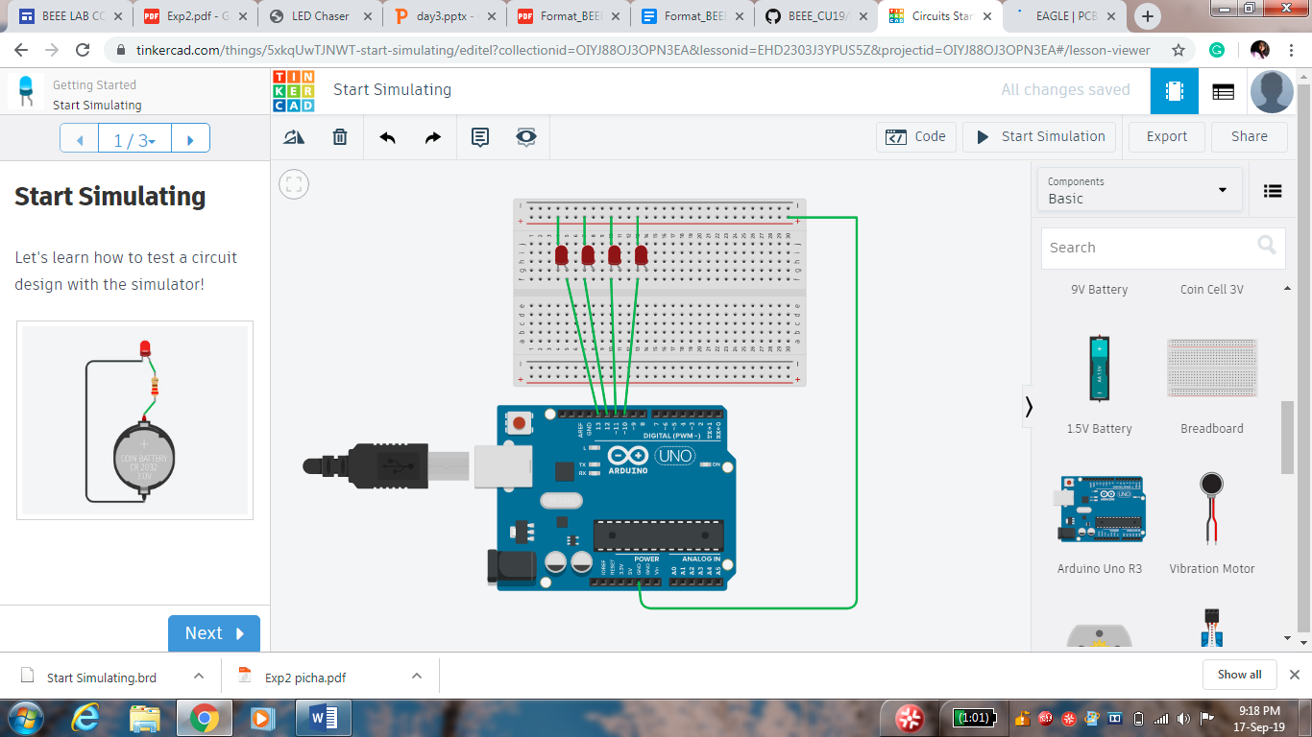

**Theory:**

Concept Used:

* Ohm’s law
* Kirchhoff’s rule
* For loop

**Learning & Observations:**

* Working of Arduino
* Using for loop
* Different LED patterns
* Application of Ohm’s law and Kirchhoff’s rule

**Problems & Troubleshooting:**

* Port selection
* Loose connections
* Error in coding

**Precautions:**

* Connections should be tight
* Port and board selection should be correct
* Code should be written properly

**Learning Outcomes:**

Chasing of LED was verified after uploading the program.