Business Template

Subject areas
Logo / Image

Contents
1 Business Description 3
1.1 Business background 3
1.2 Problems. Current Situation 3
1.3 The benefits of implementing a database. Project Vision 3
2 Model description 3
2.1 Definitions & Acronyms 3
2.2 Logical Scheme 3
2.3 Objects 3

Business Description

Business background
The auction house specializes in selling antiques and artwork through auctions. Sellers submit their items to the company, which then decides the best auction to present them. With company employees, each item is assigned to a lot number before the auction. Buyers bid on items, and the final sale price is recorded with the starting price. Time of the sales is also recorded. Both buyers and sellers can participate in multiple auctions, and the same person or a company can participate both as a seller or as a buyer.

Problems. Current Situation
Currently, auction records are managed manually, leading to inefficiencies, data loss, and errors. Tracking transactions, bids, and item histories is cumbersome. The absence of a centralized database makes it difficult to retrieve past auction details and verify sales records.

the Benefits of implementing a database. Project Vision
A database system will improve efficiency, accuracy, and accessibility of auction data. It will enable easy tracking of items, bids, and final sale prices while ensuring data integrity. The system will allow auction house employees to access and update auction details quickly, improving the overall auction process.

Model description

Definitions & Acronyms
Lot Number: A unique identifier assigned to each auctioned item (referenced in the Items table).
Seller: The person or entity providing an item for auction (referenced in the Sellers table).
Buyer: The person or entity purchasing an item at auction (referenced in the Buyers table).
Auction: An event where items are bid on and sold to the highest bidder (referenced in the Auctions table).
Final Sale Price: The price at which an item is sold after bidding (stored in the Sales table).

Logical Scheme
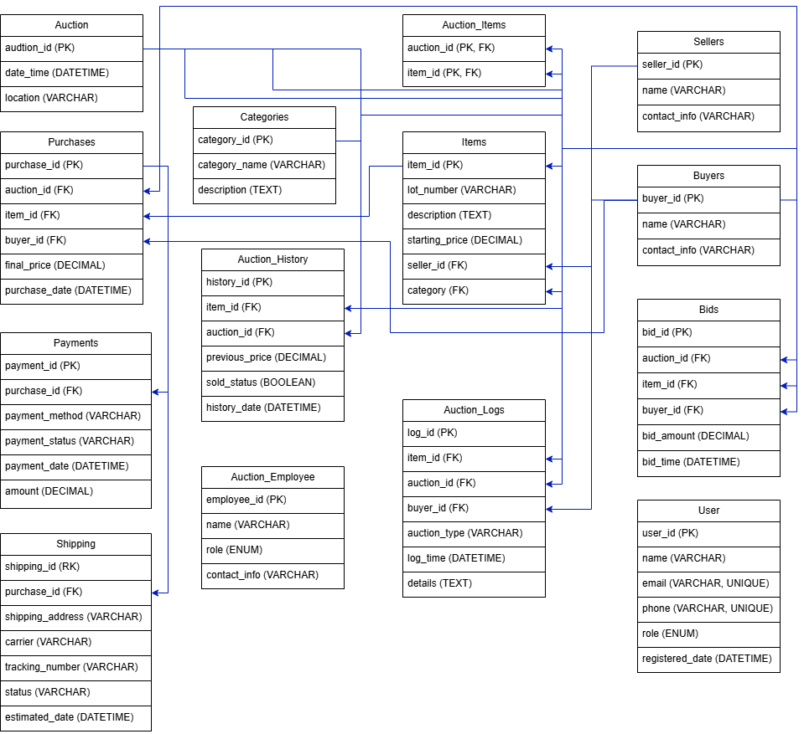

Objects

- Auction
Table Auction contains all information for the auction date and location.

Table Name | Field name | Field Description | Data Type
Auction | auction_id | Public key, PK | INT
 | Date_time | Date and time for the auction | DATETIME
 | location | Location of the auction | VARCHAR

- Auction Items
Table Auction items contain item identification and auction identification.

Table Name | Field name | Field Description | Data Type
Auction Items | auction_id | PK, FK | INT
 | item_id | PK, FK | INT

- Auction History
Table Auction History contains all information about date and time of auction and sold status.

Table Name | Field name | Field Description | Data Type
Auction History | history_id | Public key, PK | INT
 | item_id | FK | INT
 | auction_id | FK | INT
 | previous_price | Previous price of an item | DECIMAL
 | sold_status | Status of an item, can be true or false | BOOLEAN
 | history_date | Date and time of arrival | DATETIME

- Auction Employees
Table Auction Employees contain all information about employees.

Table Name | Field name | Field Description | Data Type
Auction Employees | employee_id | Public key, PK | INT
 | name | Name of the employee | VARCHAR
 | role | Role of the employee, can be “Manager”, “Auctioneer”, “Marketing”, “Legal Advisor”, “Valuer” | ENUM

- Auction Logs
Table Auction Logs contain all information about item, auction, buyer, and all the logs and details.

Table Name | Field name | Field Description | Data Type
Auction Logs | log_id | Public key, PK | INT
 | item_id | FK | INT
 | auction_id | FK | INT
 | buyer_id | FK | INT
 | auction_type | Type of auction | VARCHAR
 | log_time | Date and time of log | DATETIME
 | details | Description | TEXT

- Categories
Table Categories contain descriptions of item categories.
Table Name | Field name | Field Description | Data Type
Categories | category_id | PK | INT
 | category_name | Item category name | VARCHAR
 | description | Category description | TEXT
- Items
Table Items contain all information about items, their seller, category and price.

Table Name | Field name | Field Description | Data Type
Items | item_id | Public key, PK | INT
 | lot_number | Number in the auction | VARCHAR
 | description | Description of the item | TEXT
 | starting_price | Starting price of the item | DECIMAL
 | seller_id | FK | INT
 | category_id | FK | INT

- Sellers
Table Sellers contain all contact info about seller.

Table Name | Field name | Field Description | Data Type
Sellers | seller_id | PK | INT
 | name | Seller name information | VARCHAR
 | contact_info | Contact of the seller | VARCHAR

- Buyers
Table Buyers contain all contact info about buyers.

Table Name | Field name | Field Description | Data Type
Buyers | buyer_id | PK | INT
 | name | Buyer name information | VARCHAR
 | contact_info | Contact of the seller | VARCHAR

- Users
Table Users contain all the information about registration of users.

Table Name | Field name | Field Description | Data Type
Users | user_id | Public key, PK | INT
 | name | Username | VARCHAR
 | email | Email of user | VARCHAR, UNIQUE
 | phone | Phone number of the user | VARCHAR, UNIQUE
 | role | Role of the user, can be “Employee”, “Buyer”, “Seller”, “Guest” | ENUM
 | registered_date | Date of registration | DATETIME

- Bids
Table Bids contain all the information about buyers and all the bids amount and time.

Table Name | Field name | Field Description | Data Type
Bids | bid_id | Public key, PK | INT
 | auction_id | FK | INT
 | item_id | FK | INT
 | buyer_id | FK | INT
 | bid_amount | Last price on the item | DECIMAL
 | bid_time | Time of the bidding | DATETIME

- Purchases
Table Purchases contain all the information about prices and buyers and sellers.

Table Name | Field name | Field Description | Data Type
Purchases | purchase_id | Public key, PK | INT
 | auction_id | FK | INT
 | item_id | FK | INT
 | buyer_id | FK | INT
 | final_price | Last price on the item | DECIMAL
 | purchase_date | Date of the purchase | DATETIME

- Payments
Table Payments contain all the information about payment history, method etc.

Table Name | Field name | Field Description | Data Type
Payments | payment_id | Public key, PK | INT
 | purchase_id | FK | INT
 | payment_method | Method of the payment | VARCHAR
 | payment_status | Status of the payment | VARCHAR
 | amount | Payment amount | DECIMAL
 | payment_date | Date of the payment | DATETIME

- Shipping
Table Shipping contains all the information about shipping addresses etc.

Table Name | Field name | Field Description | Data Type
Shipping | shipping_id | Public key, PK | INT
 | purchase_id | FK | INT
 | shipping_address | Address on the shipping label | VARCHAR
 | carrier | Who carries the shipping | VARCHAR
 | tracking_number | Number for the tracking of the package | VARCHAR
 | status | Status of the shipping | VARCHAR
 | estimated_date | Estimated date of arrival | DATETIME

