**# Project README**

This project is a full-stack application with the server-side implemented in Java Spring and the client-side implemented in React with the Material-UI design library.

For the project's functionality, Redux and React Router DOM libraries were utilized.

## Project Setup

1. **Clone the Repository**:

```bash

git clone <repository_url>

```

### Server-side Setup (Java Spring)

To set up the server-side environment, follow these steps:

1. **Install IntelliJ IDEA**: Download and install IntelliJ IDEA from the [official website](https://www.jetbrains.com/idea/download/).

2. **Open Server Project "sampleProject" in IntelliJ IDEA**: Open IntelliJ IDEA and import the server project by selecting "Open" from the File menu and navigating to the server directory.

3. **Install Dependencies**: IntelliJ IDEA will automatically handle the dependencies specified in the `pom.xml` file. Make sure Maven is properly configured in IntelliJ IDEA.

4. **Run the Server**: Run the server by executing the main Spring Boot application class.

### Client-side Setup (React with Material-UI)

To set up the client-side environment, follow these steps:

1. **Install Visual Studio Code**: Download and install Visual Studio Code from the [official website](https://code.visualstudio.com/download).

2. **Open Client Project in Visual Studio Code**: Open Visual Studio Code and open the client project directory.

3. **Install Dependencies**: Open the integrated terminal in Visual Studio Code and run `npm install` to install all the dependencies specified in the `package.json` file.

4. **Run the Client**: Run the client by executing `npm run dev` in the integrated terminal. This will start the development server and open the project in your default web browser.

## Additional Information

- Make sure you have Node.js and npm installed on your system to work with React and Node.js dependencies.

- For detailed instructions on setting up IntelliJ IDEA and Visual Studio Code, refer to their respective documentation.

- Feel free to modify and distribute the project according to the terms of the [MIT License](LICENSE).

## Project Structure

- **server/**: Contains the server-side code implemented in Java Spring.

- **client/**: Contains the client-side code implemented in React with Material-UI.

- **README.md**: This file, providing instructions and information about the project.

## Dependencies

### Server-side Dependencies (Java Spring)

- **Spring Boot**: Framework for creating stand-alone, production-grade Spring-based applications.

- *(Add any other dependencies specific to your server-side implementation)*

### Client-side Dependencies (React with Material-UI)

- **React**: JavaScript library for building user interfaces.

- **Material-UI**: React components that implement Google's Material Design.

- **Redux**: Predictable state container for JavaScript apps.

- **React Router DOM**: Declarative routing for React.

- *(Add any other dependencies specific to your client-side implementation)*

## Usage

In this application, you can manage your list of members efficiently. Here's how you can interact with the system:

1. **View Members**: Upon accessing the application, you will see a list of existing members. You can click on each member to view their details.

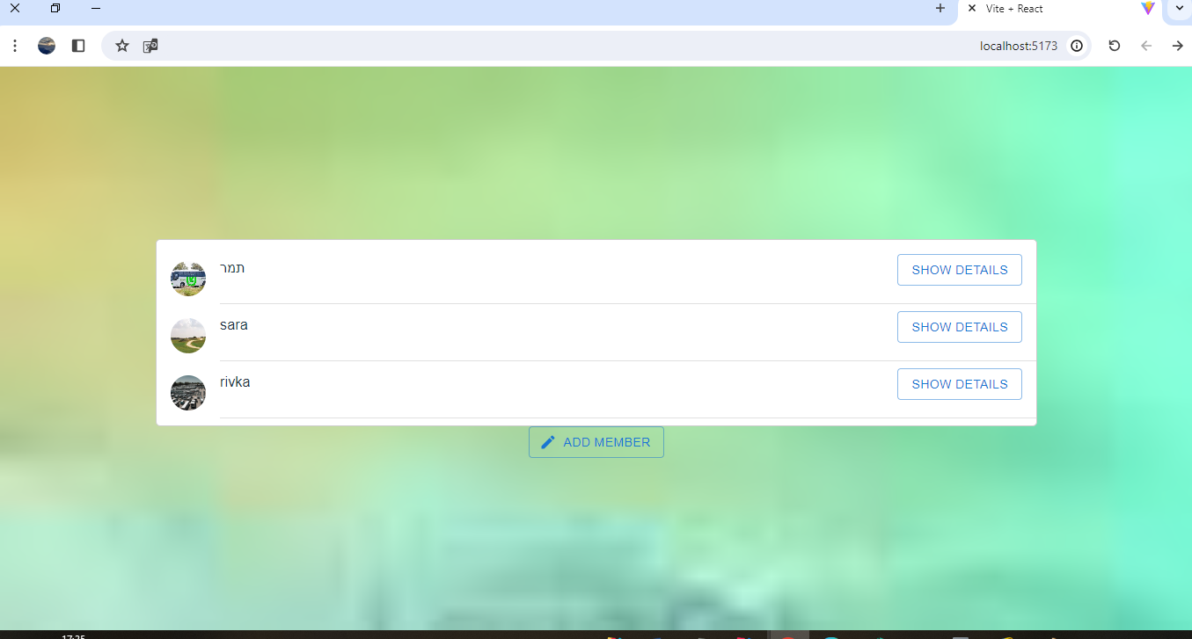

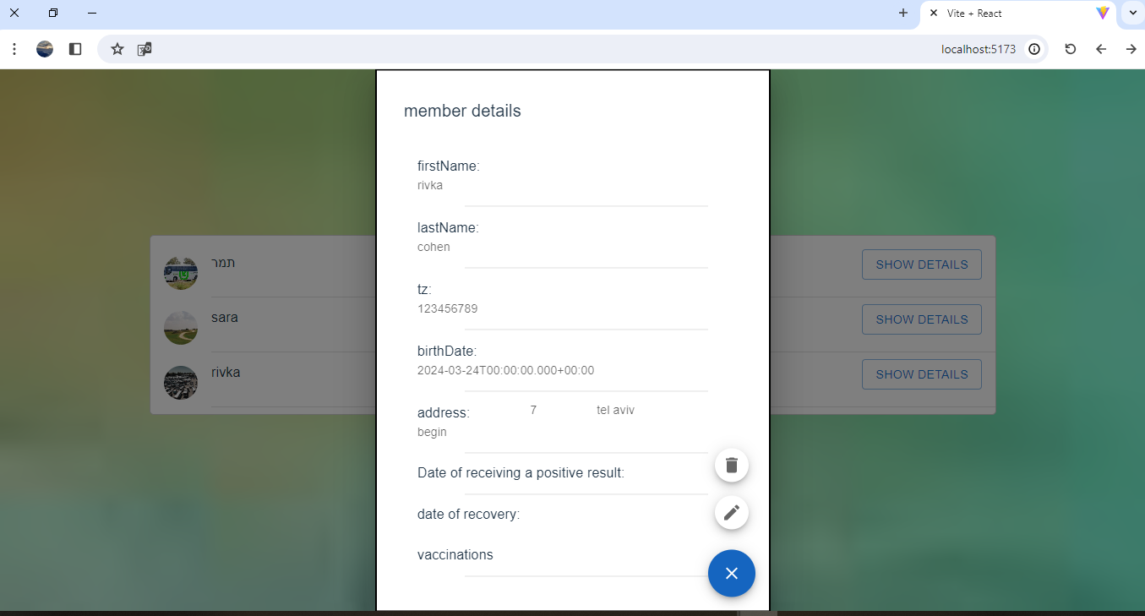

2. **Add Member**: To add a new member, click on the "Add Member" button. Fill in the required information in the form and click "Save Member" to add the member to the list.

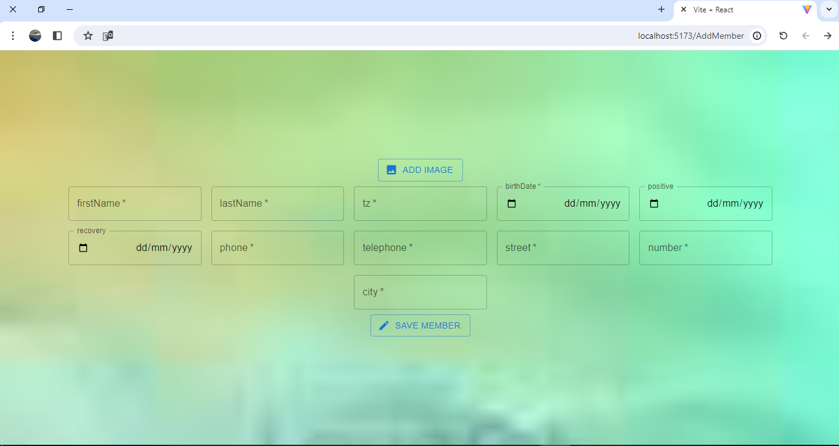

3. **Update Member**: If you need to update the details of an existing member, click on the member's name in the list to view their details. Then, click on the "Edit" button to modify the information as needed. After making the changes, click "Save" to update the member's details.

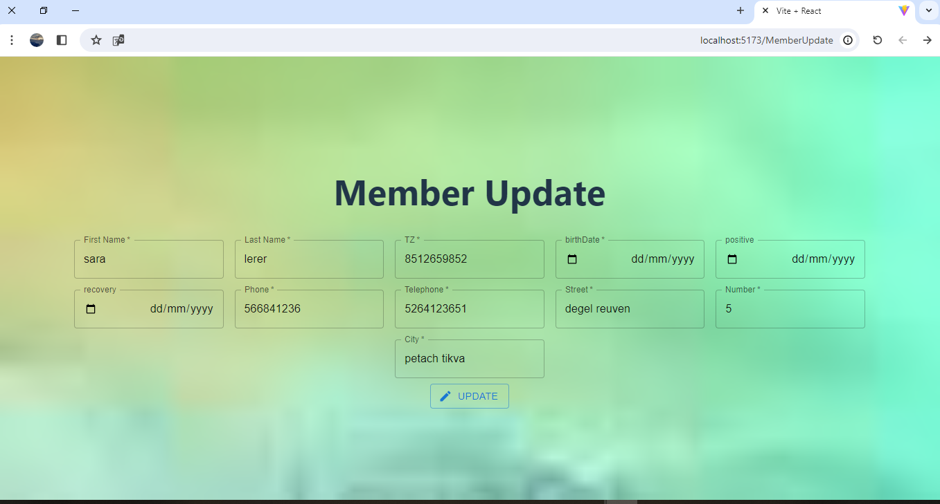

4. **Delete Member**: To remove a member from the list, navigate to the member's details page by clicking on their name in the list. Then, click on the "Delete" button to permanently remove the member from the system.

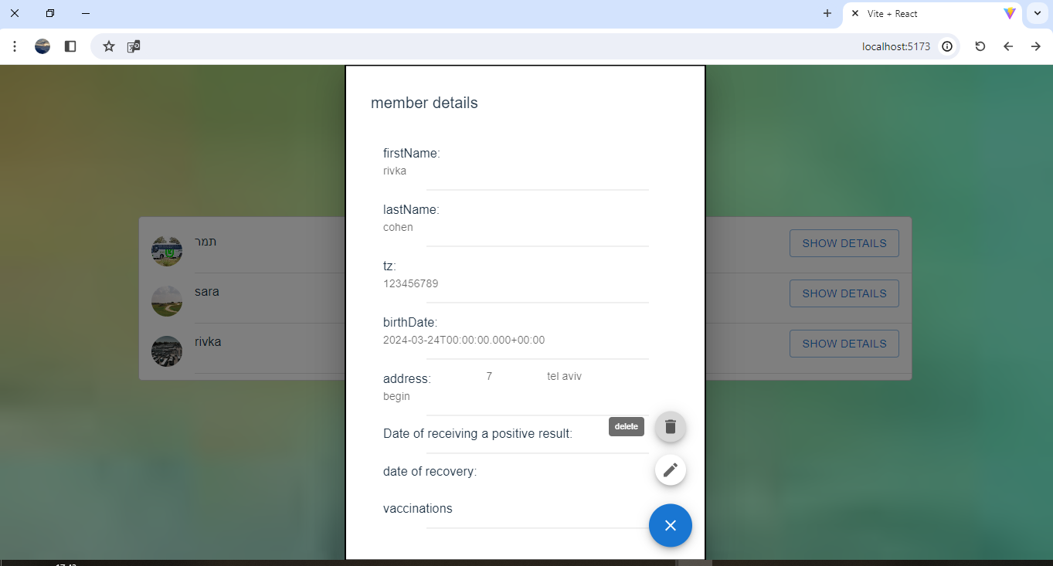

5. **Add Vaccination**: If a member receives a vaccination, you can add the vaccination details by clicking on the "Add Vaccination" button on their details page. Fill in the vaccination details such as the type of vaccine, date of vaccination, and any additional notes, then click "Save" to update the member's record with the new vaccination information.

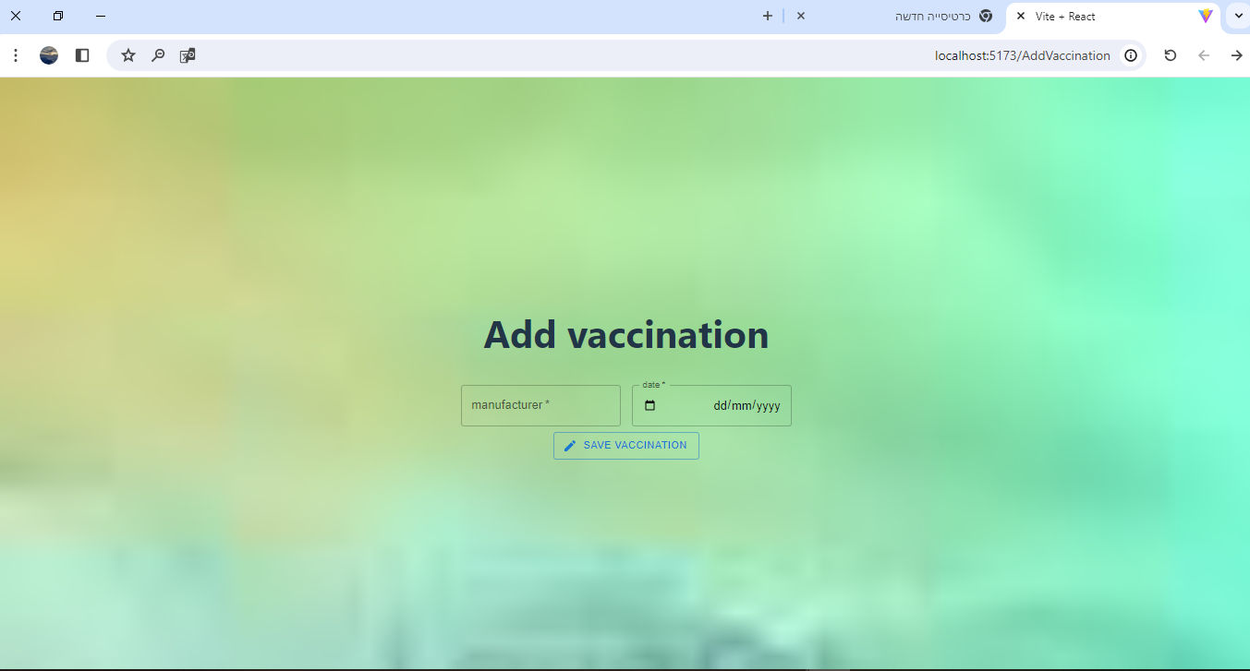

By following these steps, you can effectively manage your list of members and keep their information up-to-date.