Part A Report

Name: Tatsuhiko Araki

Assignment 6: Perceptron Classification and Training

CSE 415 Introduction to Artificial Intelligence, Autumn 2022, University of Washington

Please answer each question using text in Blue, so your answers stand out from the questions.

Note: If not otherwise specified, use the default parameters present in the starter code to answer the questions.

A1. How many epochs were required to train your perceptron on the 2-class Iris data having 2 features? What was the performance of your perceptron on the test data?

4 epochs were required to train my perceptron on the 2-class iris data having 2 features. By repeating the number of epochs, the line for linear separation gradually rises, and the plotted points can be linearly separated by the line with the number of epochs of 4. There are 2 errors on the test data, out of 80.

A2. Include a graphic produced using matplotlib that shows both the training data points (in separate colors) and the “separating” lines implied by the weights at the end of each training epoch.” (Reduce the graphic as necessary to make it fit here without taking up more than half the page.)

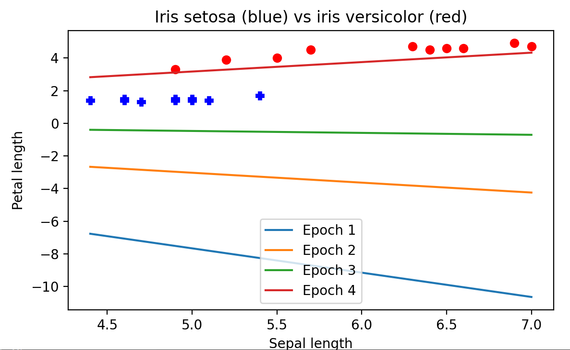

A3. In the above plot, was there any thrashing (oscillation in the separator, such as flipping slope back and forth between positive and negative values, or having its y intercept jumping up and down as epochs proceed? How would you describe the progress of the learning, on the basis of the plot?

If the data isn’t separable, weights might thrash. However, in this case, as you can see the graph above, thrashing did not occur because the line at the epoch number of 4 was able to perform clean linear separation.

A4. After plotting the ring data, describe its distribution in words.

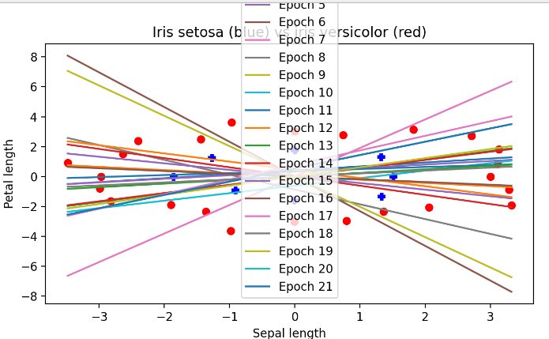

It can be seen that the plotted points are scattered and the red and blue points cannot be separated.　In addition, it can be seen that the number of epochs was specified 20 times, but it was repeated 20 times and did not converge.

A5. Describe the sequence of separators obtained when training your perceptron for 25 epochs using the ring data. Is there any thrashing? To what extent did it achieve convergence? And finally, do you think if the model is run for more epochs it will eventually fully converge?

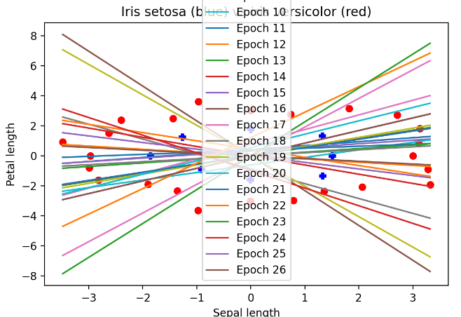

　Likewise epoch number 20, the plotted points are not linearly separated and thrashing occurs. Remapping needs to be done to converge. If you increase the number of epochs too much, the line will overfit the plotted points, resulting in an overfitted line. In short, more epochs don’t make the model converge.

A6. After you have re-mapped the ring data with the provided non-linear mapping function, plot the data and describe the distribution.

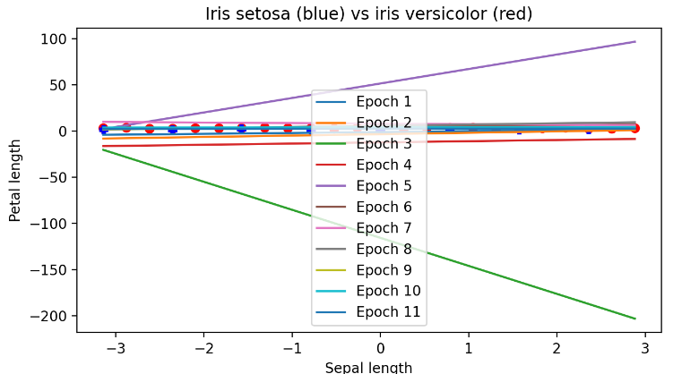

Although it is difficult to judge from this figure, it can be seen that the model converges at 11 epochs. In addition, the plotted points are neatly linearly separated from the lower figure without lines.

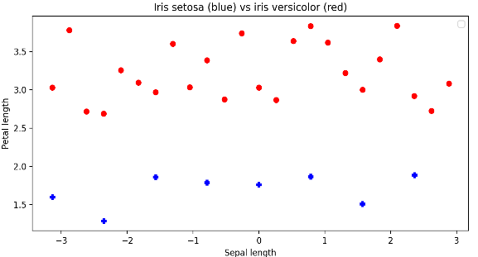

A7. After training your perceptron on the re-mapped ring data, did it achieve convergence, and if so, how many epochs were used?

As you can see from the above figure, we can see that this model converges by remapping. And 11 epochs are needed to converge.

A8. What do these results suggest about the power of perceptrons to classify data that may consist of clusters that cannot be separated by a linear manifold (such as a line or plane)?

　It turns out that in perceptron classification some processing (such as remapping) needs to be applied to the plotted points if they are not linearly separated.