The focus of this thesis project is to explore visual themes of different scripts. The word script is used to refer to the character set used by different writing systems to encode spoken language; i.e. the Latin alphabet, is a script used by many different writing systems to express languages such as English, German, French and Malay. In the field of linguistics some research exists in the development of specific scripts (see related work section xx). However the goal of this project is not to explore the evolution from past to present, but to compare different current scripts in light of their historical connections.

Background

The visual aspect of written language played an important role in the history of writing. Before written language as we know it today was *proto-writing*, a picture writing system*.* Proto-writing uses ideograms or pictograms - graphic symbols that represent ideas or objects respectively - and does not directly translate to specific words from spoken language. The shape of the symbols conveyed the information and a reader would not necessarily need to know the spoken language of the writer in order to gather the information contained in the symbols. When most *true-writing* evolved (true-writing being a system in which the entire content of spoken language can be encoded), symbols that represent whole words were used to encode information (logograms). Again the shape of the symbol was related to the information, but unlike in picture-writing systems, they represented specific words of the writer’s language. From there, the phonetic system stemmed, in which symbols represent sounds that are combined to phonetically construct words from spoken language. The shape of the symbol no longer has a specific meaning; rather it can be combined to create many different words. Some scripts, such as the chinese characters or egyptian hieroglyphs, preserved both systems such that symbols can function both as logograms and as phonemes. In general, most scripts lost the connection that used to exist between the visual shape and the meaning. However the visual aspect of the scripts we use today stemmed from a long history of evolution.

Previous projects

The next section describes two projects, *letters space distribution* and *the origin of languages and their scripts*. These projects were done as part of the visualization class with professor Hanspeter Pfister and together they form the groundwork that led to this thesis project.

Letters space distribution is a project that aims to explore the distribution in space of glyphs in text segments of varying languages. It allows for the exploration of the space distribution for a writing system used by a specific language and a comparison between the different languages. The space distribution is obtained based on text segments which provide sets of characters from each language. The bitmap, the image of the character as a 2D array of pixels, is retrieved for each character. Then the bitmaps of all the characters are overlayed, counting the number of times each pixel is visited. This generates a grey scale “heat map” showing how often a pixel is used by the characters in the given text segment and provides a visual insight into how the characters of that writing system are distributed in space. Note that all characters in given text segments were used, therefore if a character repeated multiple times it had a stronger impact on the resulting space distribution. For example Hindi’s space distribution (Figure 1) shows almost all characters have a line across the top, since these pixels are most strongly colored.

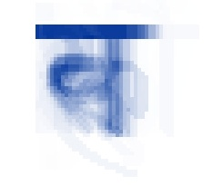

**Figure 1: Hindi’s space distribution**

The first part of this visualization (Figure 2) contains a small multiple showing the space distribution derived from 10 different languages, on the first row - English, Portuguese, German, French and Malay which all use a latin derived alphabet; on the second row - Hebrew, Arabic, Hindi, Thai and Chinese which each use their own distinct writing system.

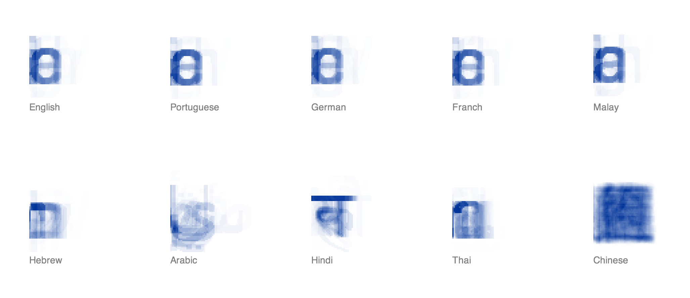

**Figure 2: space distributions of 10 selected languages**

Selecting a specific language brings up a page that displays a larger interactive version of the space distribution for that language on the left, all the characters that appear in the text as a bubble chart on the right, and the original text at the bottom of the page (Figure 3). The size of the bubble corresponds to the number of time that character appears in the text which is displayed at the bottom. Hovering over a pixel in the space distribution section on the left highlights that pixel in orange as well as the corresponding letters (i.e. letters that occupy the highlighted pixel) in the bubble chart on the right (Figure 4).

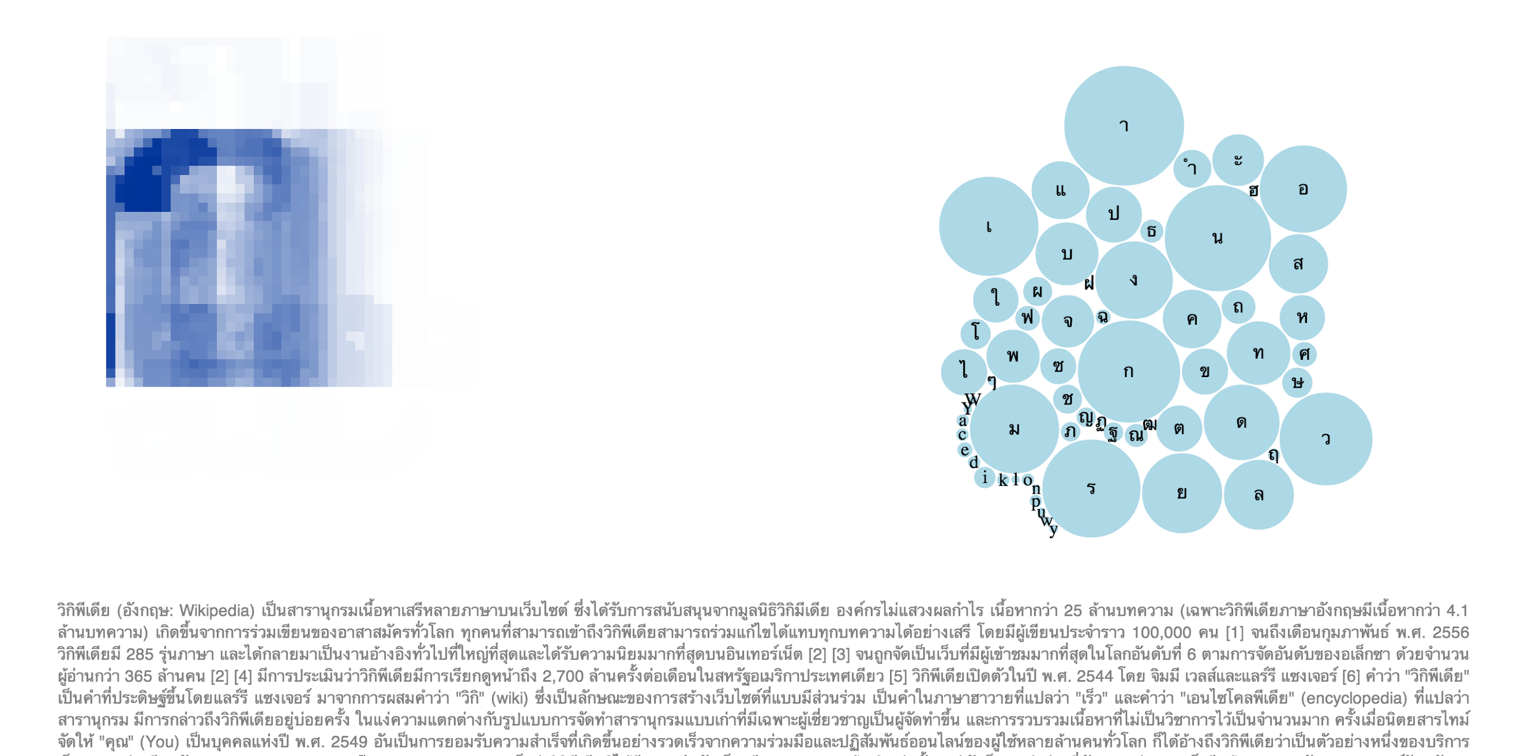

**Figure 3: the page for Thai showing the space distribution on the left and the bubble chart on the right**

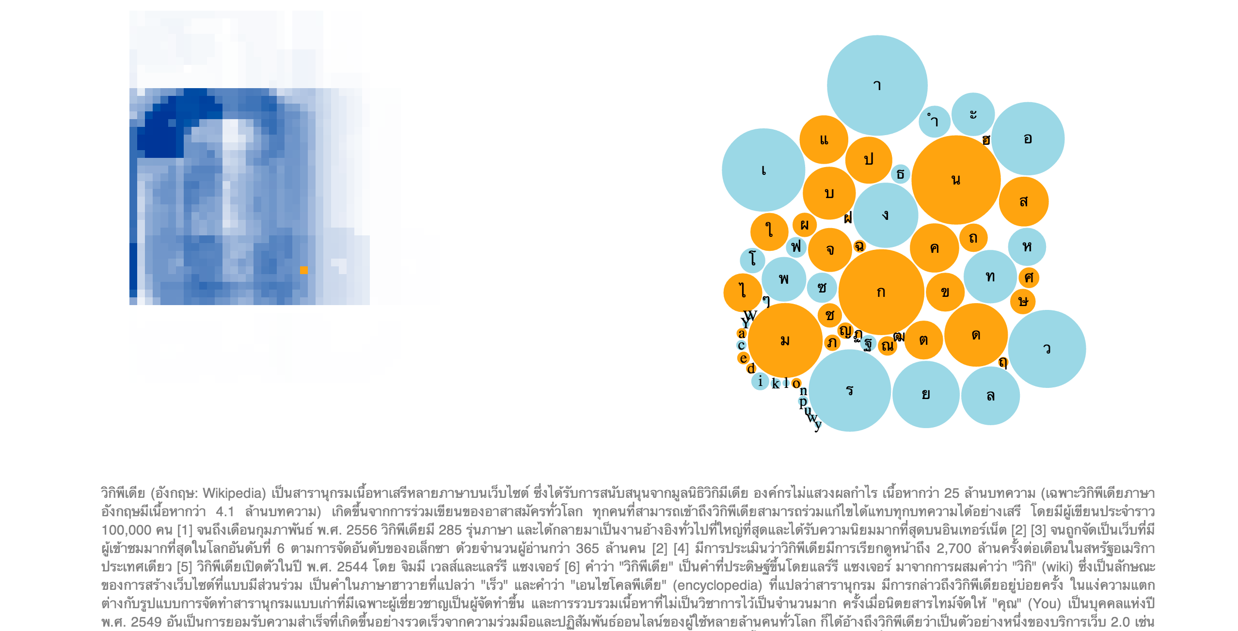

**Figure 4: space distribution and characters of Thai with a specific pixel and corresponding letters highlighted**

Since the space distribution is based on the frequency and use of specific characters, we expected to find a greater difference between the languages that use a latin derived alphabet, however this visualization shows that the space distribution of these languages is remarkably similar. The Malay text is slightly different as it seems to use the letter *a* more heavily than *e*, unlike the other latin derived languages. This slight difference as well as the high similarity of the other latin derived scripts may be explained by the fact that the spoken languages English, Portuguese, German and French all have a common Indo-European origin and share a closer history than Malay. Chinese (Figure 5) was probably the most interesting to note as it was the most distinctly different - it showed very dense characters with even distribution over a square, and a significantly higher amount of characters used with a smaller occurrences rate.

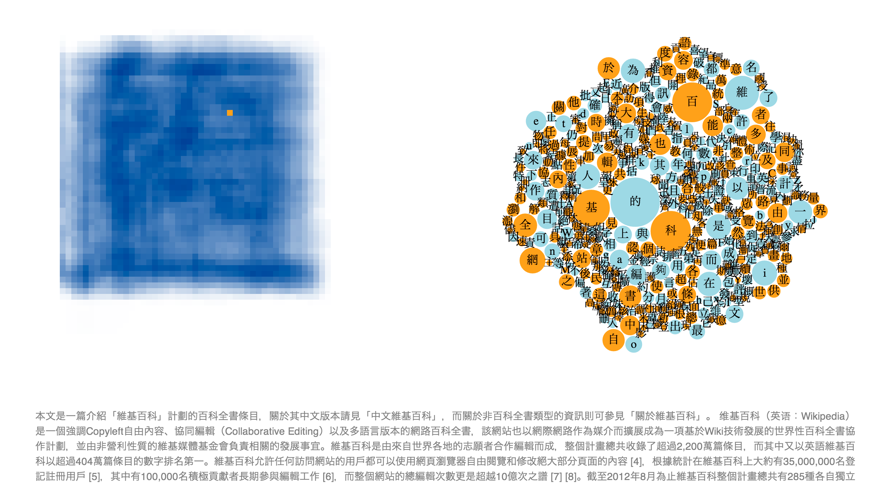

**Figure 5: space distribution and characters of Chinese with a specific pixel and corresponding letters highlighted**

The origin of languages and their scripts is a project that aims to collect and visualize the evolution tree of different languages and their writing systems. Origins of spoken languages are displayed on the left and origins of writing systems are displayed on the right. Clicking on a language family brings up the tree for that family (Figure 6). Languages that have an alphabet connected to it are larger and in full color. Selecting one of those nodes displays the alphabet node at the same level, connected to it’s origin. The selected node is highlighted while the rest are greyed out (Figure 7). At the bottom there are details on demand - a frame displaying the wikipedia article about the language or the alphabet (Figure 8). Selecting the alphabet will open the writing system tree, with that node already selected. When a script tree is open, selecting one of the selectable scripts will present a list of all languages that use that alphabet.

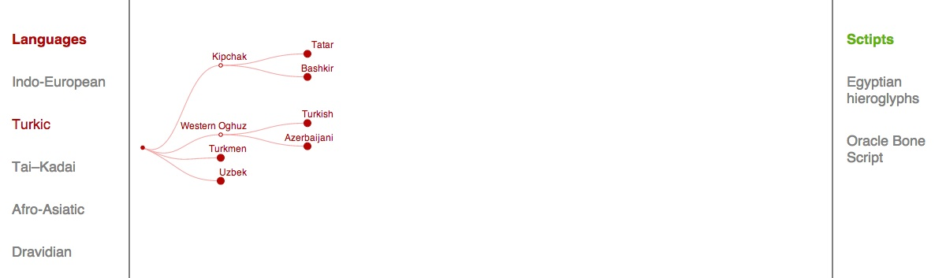

**Figure 6: the Turkic origin evolution tree**

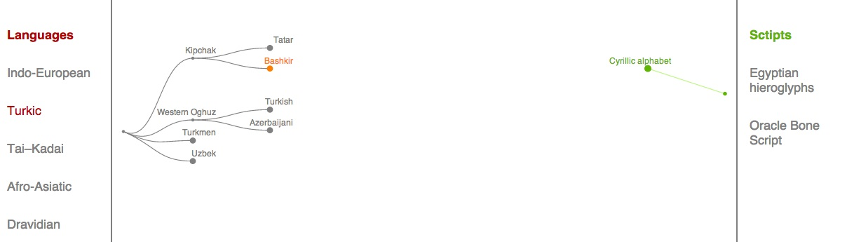

**Figure 7: the language Bashkir is selected and the corresponding alphabet is displayed**

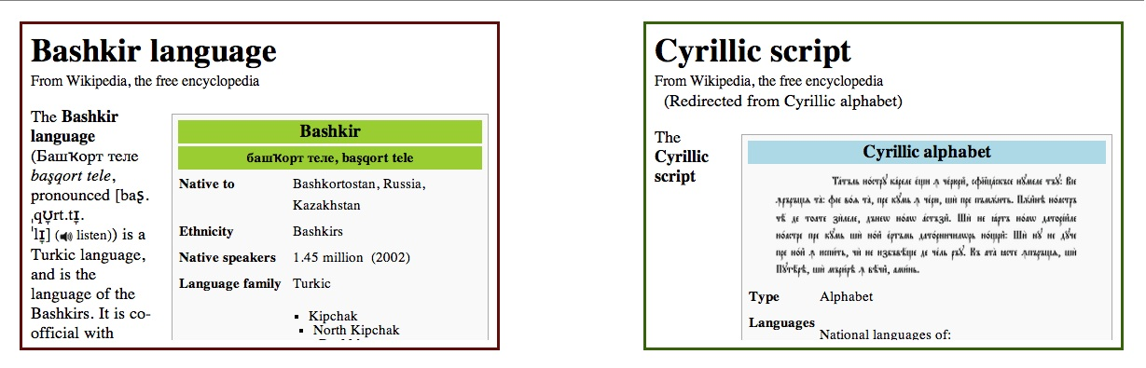

**Figure 8: additional information from Wikipedia on the selected language and script**

Result

The end result of this project is a web based interactive visualization that compares 11 scripts that are in use today, all of which stemmed from the Egyptian Hieroglyph origin. The visualization displays the evolutionary tree of the scripts on the left (as scraped from Wikipedia in the previously described project), followed by a heatmap mapping the similarity between all scripts (see figure 9). Each character of each script was analyzed to compiled and an average was created to achieve a numerical representation of the scripts based on its lines and curves. The similarity score between scripts was calculated as a distance between the scripts with axes of lines and curves.

The heatmap diagonal is the intersection of scripts itself (identity) therefore we chose to use them in order to show a small scatter plot of the letters distribution. For each character set we used a bi kmeans algorithm to find 3 clusters based on the same distance function described above. The central letter of each cluster was chosen as a representative character for the script. All scripts are similarly scaled so this small multiple can also be used to compare scripts by letters distribution.

Selecting one of the rectangles representing the similarity between two scripts highlights the two scripts, displays an extra data section and shows a larger version of the scatter plots (see figure 10) (TBD). The extra data section shows the full character set, the similarity score on a scale and a world map with current script distribution (*add reference*).

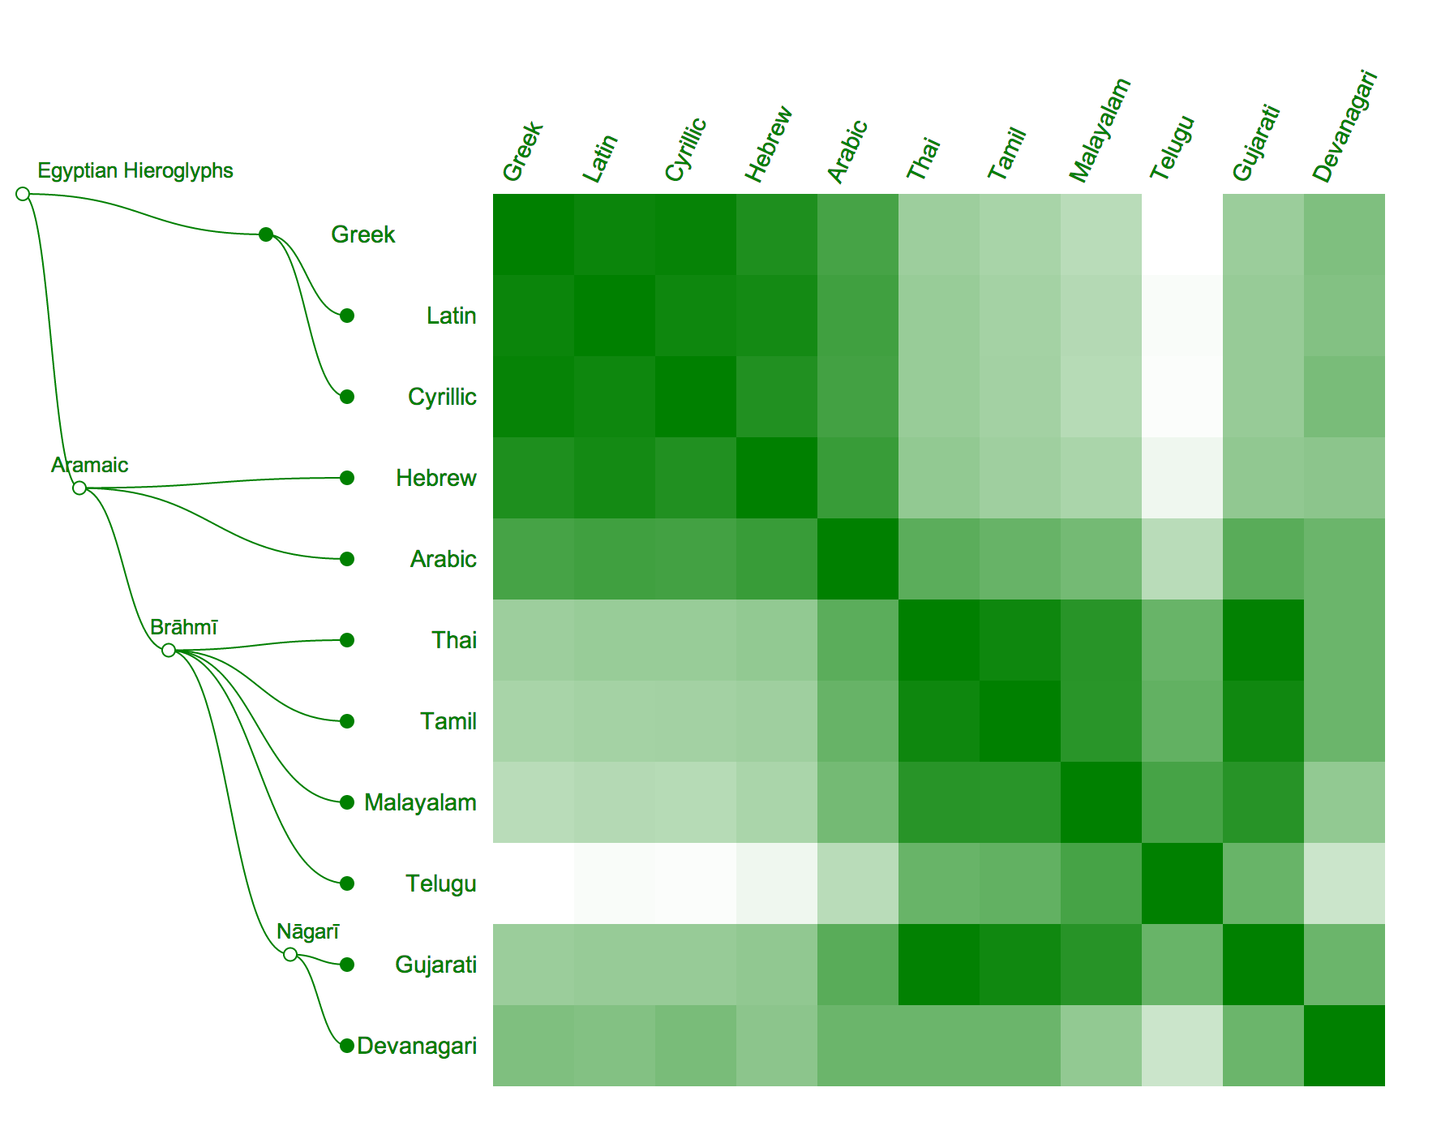

**Figure 9: script evolution tree on the left leading to the comparison heatmap**

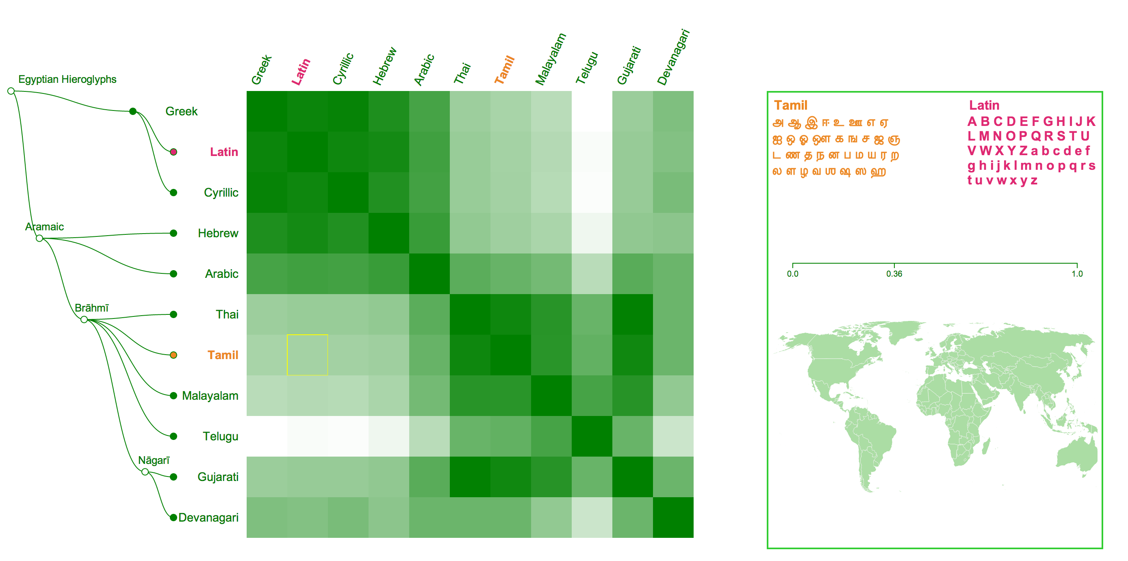

**Figure 10: Tamil and Latin comparison selected with extra data on the right**

Organization of this document

The related work in chapter 2 covers work done both in the field of linguistics and in the field of data visualization. Chapter 3 describes initial work, which includes two projects relating to letters space distribution and mapping of spoken languages and scripts. Chapter 4 will detail the data collection algorithm and analysis, including the validation procedure. The visualization design and implementation will be discussed in chapter 5.