FindMyCells Handbook

Written by: Tamas Balassa  
Last updated: Nov 27th, 2017

**Install / requirements[1]:**

* Python 2.7+
* Python packages:
  + PyQt5
  + Numpy
  + Scipy
  + PIL (Python Imaging Library)
  + Protobuf
  + Caffe

**Running the software:**

To run the software, the user has to run the Graphics/main_window.py file.

**User Interface:**

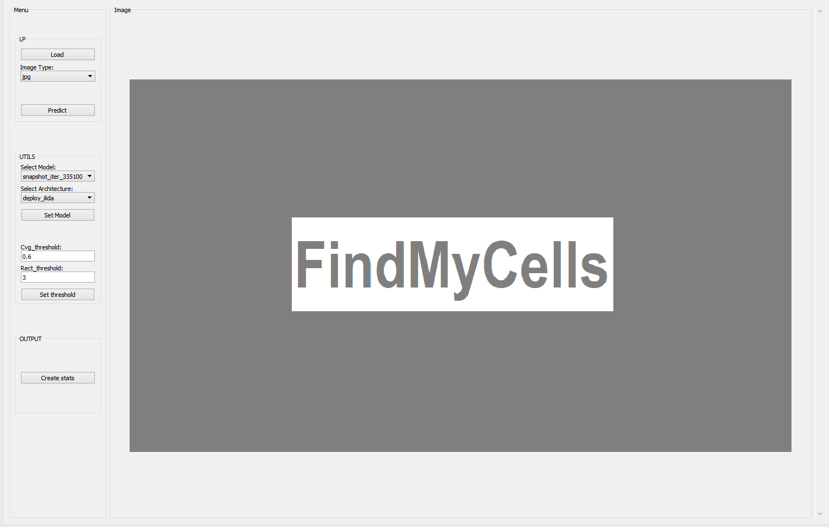

**Load button:**For the initial dataset, the image files has to be in a folder. To load them, the folder has to be selected. The correct image types should be set before loading the images.

**Predict button:**With the predict button a user can predict for the current image. By scrolling, the bounding boxes will be removed.

**Dataset scrollbars:**The pre-trained model and its corresponding architecture can be selected here.

**Cvg_threshold:**Can be a double number. It defines the threshold for recognizing an object.

**Rect_threshold:**Has to be an integer number. It defines the threshold for the overlapping bounding boxes.

**Output:**Creates a report file results.csv in Graphics folder.

1. NVIDIA GPU is highly recommended for the best effectiveness, if the user wants to turn off the GPU mode, he should switch the *True* to *False* in Graphics/main_window.py 219th and 226th rows