FindMyCells Handbook

**LINUX**

Written by: Tamas Balassa

Last updated: Oct 19th, 2018

**Requirements:**

Linux >17.04 is **highly** recommended. The reason is that *caffe* must be built on your machine otherwise, which is a complicated task. In case if You have <17.04 Linux, please visit <https://github.com/BVLC/caffe> for further instructions.

The following software components are required to run the software:

* *sudo apt install caffe-gpu,* if You want to use the GPU version, or
* *sudo apt install caffe-cpu* otherwise
* Required (and unusual) Python packages (*pip install*):
  + PyQt5
  + PIL

**Running the software:**

To run the software from terminal:

* Go to the root directory
* Run the software with the simple *./run.sh* command (You might need to give permission to this file: *chmod a+x run.sh*)

**User Interface:**

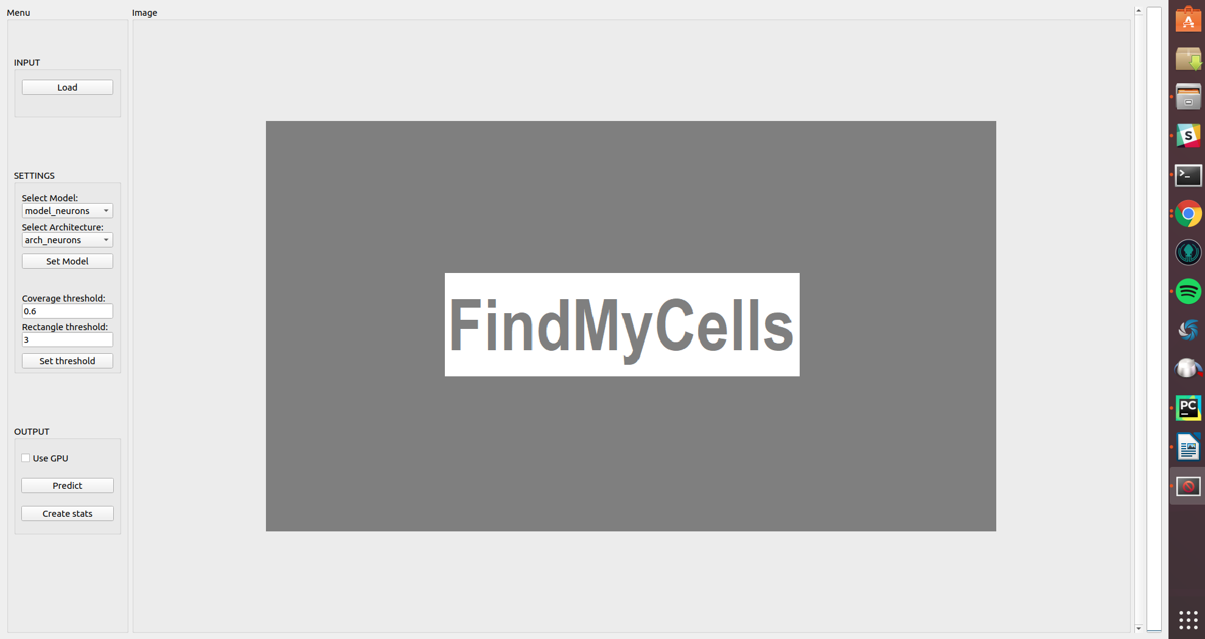

**Load button:**

FindMyCells (FMC) loads in the selected images. The currently supported file formats are: jpg, jpeg, png, tif and tiff. By mouse scrolling the previous/next image will be shown.

**Network scrollbars:**

FMC uses *caffe****[1]*** based network model. In case of a new detection task, a trained *caffe* network architecture file (*prototxt*) and model/weights file (*caffemodel*) should be copied into **AI/models/**. These files can then be selected in the dropdown menus.

**Coverage threshold:**

A real number (between 0 and 1). It defines the threshold for recognizing an object. Larger number results more conservative detection.

Note: A negative threshold value will automatically be set back to the default value (0.6).

**Rectangle threshold:**

An integer number defining the threshold for the overlapping bounding boxes. Clustering grouped rectangles.

Note: If the number is lower than zero, then it will be set back to the default value (3).

**Use GPU checkbox:**

Check this box if You are using GPU (*caffe-gpu*), otherwise leave it unchecked. This will handle if the predictions are calculated on cpu or on gpu.

**Predict button:**

With the predict button the user can predict objects on the current image. Using the middle (scroll) button will reset the bounding boxes.

**Output stat:**

Creates a statistical report file results.csv in **graphics/** folder.

The fields in this report file contain six values, which are the following:

· Image Name: this filed will contain the full path to the predicted image

· Cell ID: each identified cell has a unique number as ID (it resets at each image)

· X1 & Y1: starting X and Y coordinates of the predicted bounding box

· X2 & Y2: ending X and Y coordinates of the predicted bounding box

1. Caffe is a deep learning framework, made by BAIR - http://caffe.berkeleyvision.org/