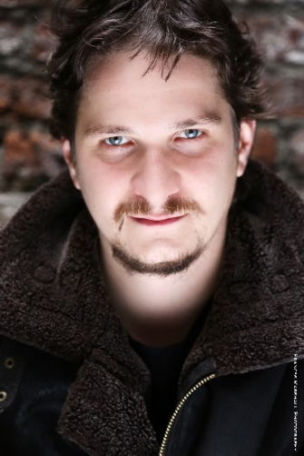
GYULA NAGY
Baritone

gyula.nagy.baritone@gmail.com
Hungarian (EU citizen)

Upcoming Engagements:

2016 September- 2018 June: Young Artist at Jette Parker Young Artists Programme at the Royal Opera House, Covent Garden

Belcore (Cover) L'elisir d'amore ROH
Baron Douphol La Traviata ROH
Flemish Deputy Don Carlos ROH
Sharpless (Cover) Madama Butterfly ROH
Imperial Commissioner Madama Butterfly ROH
Nachtigall Meistersinger ROH
Paul Les Enfants Terribles (Philip Glass) The Royal Ballet
Filotete Oreste (Handel) ROH - JPYAP
Fiorello Il barbiere di Siviglia ROH

Recent Engagements:
2016
WNO Associate Artist:
Silvio Pagliacci Welsh National Opera C: C. Rizzi, D: E. Moshinsky
Count Almaviva (Cover) The Marriage of Figaro Welsh National Opera C: Koenigs-Philippo, D: T. Richter
Count Almaviva (Cover) Figaro Gets a Divorce Welsh National Opera C: J. Brown, D: D. Pountney

2015
Escamillo (Cover) Carmen Scottish Opera C: Parry-Clark, D: Caurier-Leiser
Baritone Carmina Burana Surrey Festival Choir and Orchestra C: Marcus Pashley
Punch (H. Birtwistle) Unhappy Families (Scenes) National Opera Studio C: M. Shanahan, D: Keith Warner
Eisenstein/Figaro (Rossini) Opera Scenes Scottish Opera-NOS C: Derek Clark, D: Elaine Kidd

2014
Don Giovanni/Papageno Opera Gala Welsh National Opera-NOS C: Mark Shanahan
Onegin/Don Giovanni Opera Scenes National Opera Studio D: Gilles Rico, C: M. Shanahan
Tarquinius The Rape of Lucretia Irish Youth Opera D: M. Barker-Caven, C: S. Barlow
Rodrigo/Prince Igor/Count (Mozart) Baritone Brilliance RTÉ National Symphony Orchestra C: Colman Pearce
Morales Carmen in Concert RTÉ Concert Orchestra C: J. Wilson, Carmen: P. Bardon
Escamillo Live on RTE Lyric FM RTÉ National Symphony Orchestra C: Gavin Maloney
Forester The Cunning Little Vixen Royal Irish Academy of Music C: David Adams, D: Lynne Parker

2013:
Baritone Messiah Irish Baroque Orchestra-Resurgam C: John Butt
Don Giovanni Mozart: Don Giovanni Zezere Arts Festival D: R. Recchia, Rep: J. O’Shea

Education:
2014-2015 National Opera Studio, London,
Supported by the Royal Opera House and the International Opera Awards
2013-2014 Opera Theatre Company, Dublin, Young Associate Artists’ Programme
2010-2014 Royal Irish Academy of Music, BA in Music Performance
Teacher: Philip O’Reilly
Vocal coaches: Brenda Hurley, Andrew Synnott
Prizes and Awards:
2016 Recipient of Chris Ball Bursary, Cardiff
2015 Recipient of the International Opera Awards Foundation Bursary, London
2014 Recipient of the International Opera Awards Foundation Bursary, London
2014 Supported by Tudás a Jövőnkért Foundation, Hungary
2013 Feis Ceoil, Dublin: Winner of the Dermot Troy Trophy for oratorio singing
2013 Recipient of the John McCormack Society Bursary, Dublin
2011 Recipient of the Gaiety Bursary, Dublin

