Name: Nguyen Trung Tam

Code: B1910697

Course: CT313H – M02

# REPORT LAB

## Step 0: Install node and git

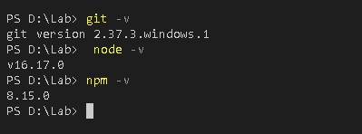

## Step 1: Setup project

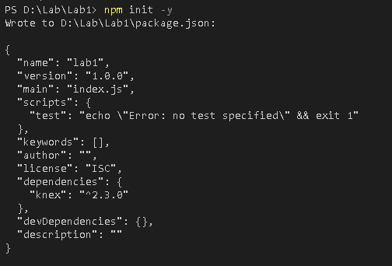

## Step 2: Manage source code with git and github

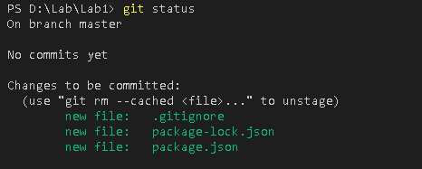

Verify code published

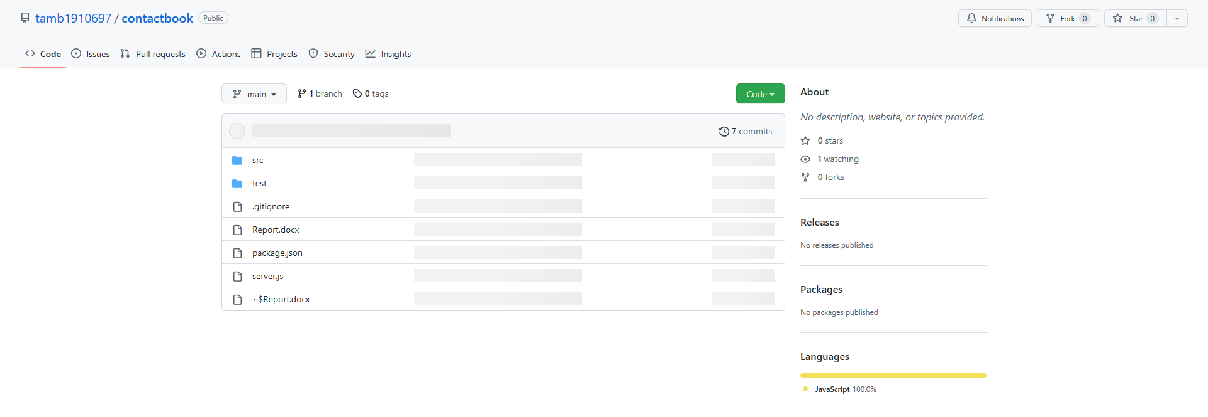

## Step 3: Install express

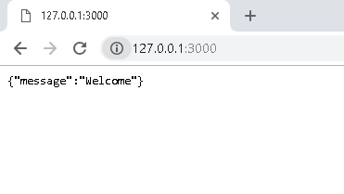

## Step 4: Define controller and routes

# Test contacts list

GET http://localhost:3000/api/contacts HTTP/1.1

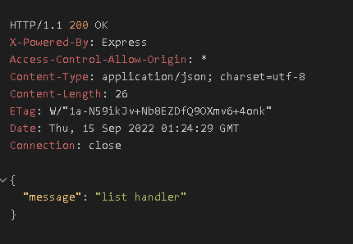

# Test contacts create

POST [http://localhost:3000/api/contacts HTTP/1.1](http://localhost:3000/api/contacts%20HTTP/1.1)

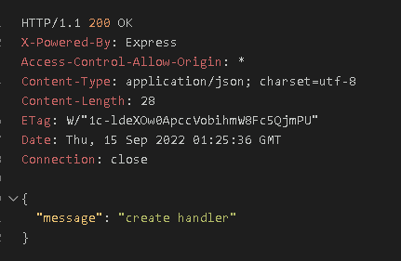

# Test contacts delete all

DELETE [http://localhost:3000/api/contacts HTTP/1.1](http://localhost:3000/api/contacts%20HTTP/1.1)

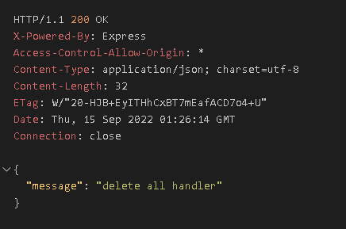

# Test contacts favorite

GET [http://localhost:3000/api/contacts/favorite HTTP/1.1](http://localhost:3000/api/contacts/favorite%20HTTP/1.1)

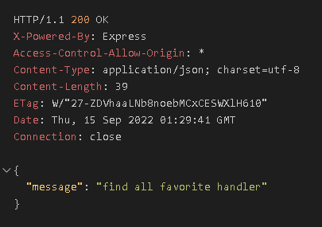

# Test contacts read

GET http://localhost:3000/api/contacts/1 HTTP/1.1

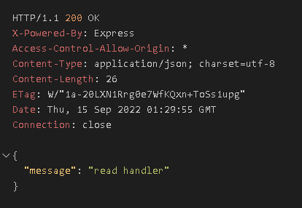

# Test contacts update

PUT http://localhost:3000/api/contacts/1 HTTP/1.1

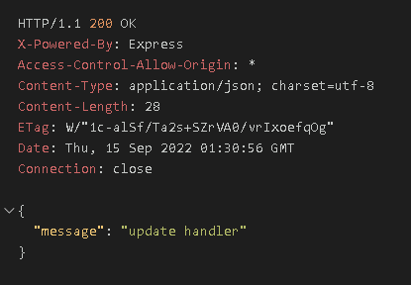

# Test contacts delete

DELETE [http://localhost:3000/api/contacts/1 HTTP/1.1](http://localhost:3000/api/contacts/1%20HTTP/1.1)

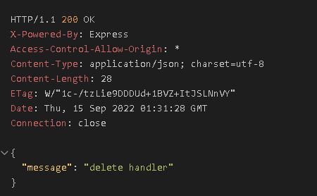

## Step 5: Implement error handling

# Test contacts not found 404

GET [http://localhost:3000/api/unknown HTTP/1](http://localhost:3000/api/unknown%20HTTP/1).1

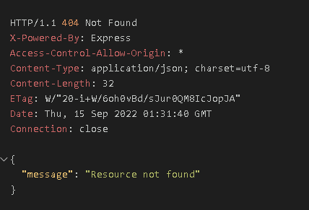

Github: <https://github.com/tamb1910697/contactbook>

# Test create contact with json

POST http://localhost:3000/api/contacts HTTP/1.1

Content-Type: application/json

{

    "name": "Long Tran",

    "email": "longtran@gmail.com",

    "address": "Vinh Long",

    "phone": "09832738518"

}

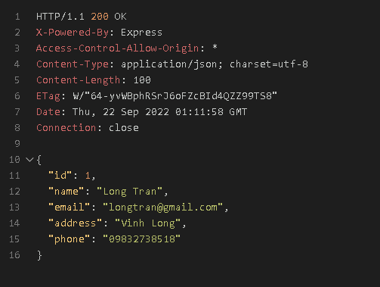

# Test contacts list

GET http://localhost:3000/api/contacts HTTP/1.1

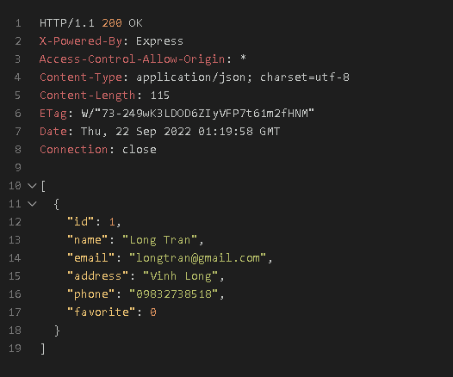

# Test contacts read

GET http://localhost:3000/api/contacts/1 HTTP/1.1

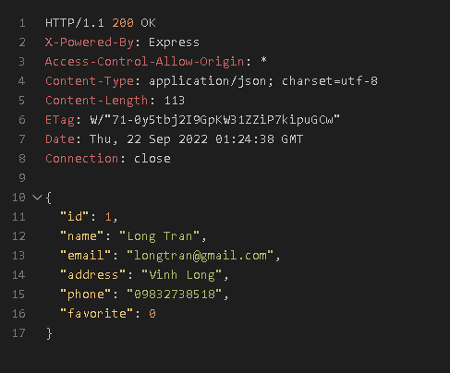

###

# Test contacts update

PUT http://localhost:3000/api/contacts/1 HTTP/1.1

Content-Type: application/json

{

    "name": "Nguyen Long Tran",

    "email": "longtran@gmail.com",

    "address": "Vinh Long",

    "phone": "0987665432"

}

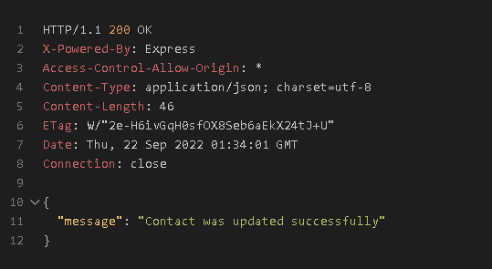

###

# Test contacts favorite

GET http://localhost:3000/api/contacts/favorite HTTP/1.1

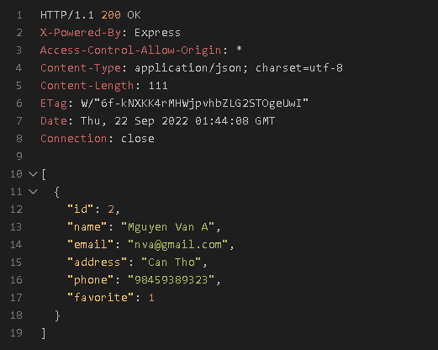

###

# Test contacts delete

DELETE http://localhost:3000/api/contacts/3 HTTP/1.1

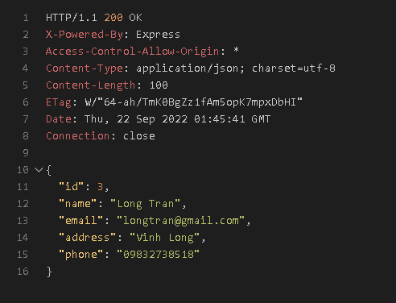

###

# Test contacts delete all

DELETE  http://localhost:3000/api/contacts HTTP/1.1

