TB Adaptive Model™

Adaptive Executive Control Framework
For Dynamic Systems, Operations & Strategic Execution
White Paper – Integrated Draft Version 2.2
Prepared by:
Dr. Tariq Mohana Bahwini
Developed through THE MULIS

Executive Summary
Modern organizations increasingly operate in environments characterized by uncertainty, operational pressure, organizational complexity, and continuous change (Senge, 2006; Sterman, 2000).
TB Adaptive Model™ introduces an adaptive executive control framework designed to improve execution responsiveness, governance adaptability, and organizational stability in dynamic operational environments.
The framework integrates concepts from systems thinking, adaptive control logic, governance dynamics, and strategic execution disciplines. Rather than treating organizations as static administrative structures, the framework approaches them as dynamic systems requiring continuous sensing, diagnosis, adaptation, stabilization, and learning.

The Executive Challenge
Organizations across both public and private sectors continue to face persistent execution challenges, particularly within large-scale operational and strategic environments. Common issues include delayed initiatives, operational bottlenecks, governance congestion, fragmented accountability structures, and slow decision-making cycles (Turner & Müller, 2003).
In many cases, these issues are not caused by technical limitations alone, but by the inability of existing governance and execution systems to respond effectively to changing operational conditions.
Traditional management models were largely developed under assumptions of relative stability and predictable execution environments. However, modern organizations increasingly operate within dynamic and nonlinear conditions characterized by uncertainty, interdependencies, and continuous operational pressure (Sterman, 2000).
As organizational complexity increases, the gap between strategic intent and execution capability becomes more difficult to manage using static governance and control structures.
The central insight behind TB Adaptive Model™ is that many organizations continue to manage dynamic operational environments using governance and execution mechanisms originally designed for relatively stable systems.
From this perspective, the issue is not solely execution failure, but rather the growing mismatch between:
• dynamic operational conditions,
• and static executive control structures.
TB Adaptive Model™ therefore proposes an adaptive executive control approach that emphasizes:
• continuous operational sensing,
• governance responsiveness,
• adaptive decision behavior,
• and execution stabilization under changing conditions.

Dynamic Systems Perspective
TB Adaptive Model™ is based on the assumption that organizations should be understood as dynamic systems rather than static administrative structures.
In practice, organizational environments are continuously influenced by interconnected operational, strategic, financial, regulatory, and human factors. As these variables evolve, the overall behavior of the system also changes over time.
Operational conditions rarely remain stable for extended periods. Changes in stakeholder priorities, governance structures, resource availability, regulatory requirements, market conditions, technological developments, and external pressures can all significantly influence execution performance and organizational stability (Dooley, 1997).
Within dynamic environments, organizational behavior is often nonlinear. Small operational issues may escalate into larger execution failures if response mechanisms are delayed, while relatively small governance adjustments may sometimes produce significant stabilization effects across the system.
This perspective differs from traditional management assumptions that often treat execution environments as predictable and controllable through fixed planning structures alone.
Under static management approaches:
• governance pathways are typically rigid,
• escalation mechanisms are slow,
• leadership responses are standardized,
• and operational control structures may struggle to adapt when conditions change rapidly.
As organizational complexity increases, the limitations of static control structures become more visible, particularly in:
• large infrastructure programs,
• healthcare operations,
• transformation initiatives,
• and high-dependency operational systems.
TB Adaptive Model™ therefore proposes a shift from static management toward adaptive executive control.
The framework assumes that executive systems should continuously:
• sense operational conditions,
• detect instability signals,
• diagnose underlying system behavior,
• adjust governance and leadership responses,
• and stabilize execution performance dynamically, as illustrated in Figure 1.
From this perspective, leadership is not viewed as a fixed administrative function, but as an adaptive control mechanism responsible for maintaining organizational responsiveness and strategic stability under changing conditions.
The framework is conceptually influenced by systems thinking and adaptive control logic, where system performance is continuously monitored and control behavior is adjusted in response to environmental variation and operational feedback (Sterman, 2000).
Accordingly, organizational stability is not achieved by eliminating change, but by improving the organization’s ability to adapt effectively while maintaining operational alignment, governance responsiveness, and execution continuity.

Adaptive Executive Control Cycle
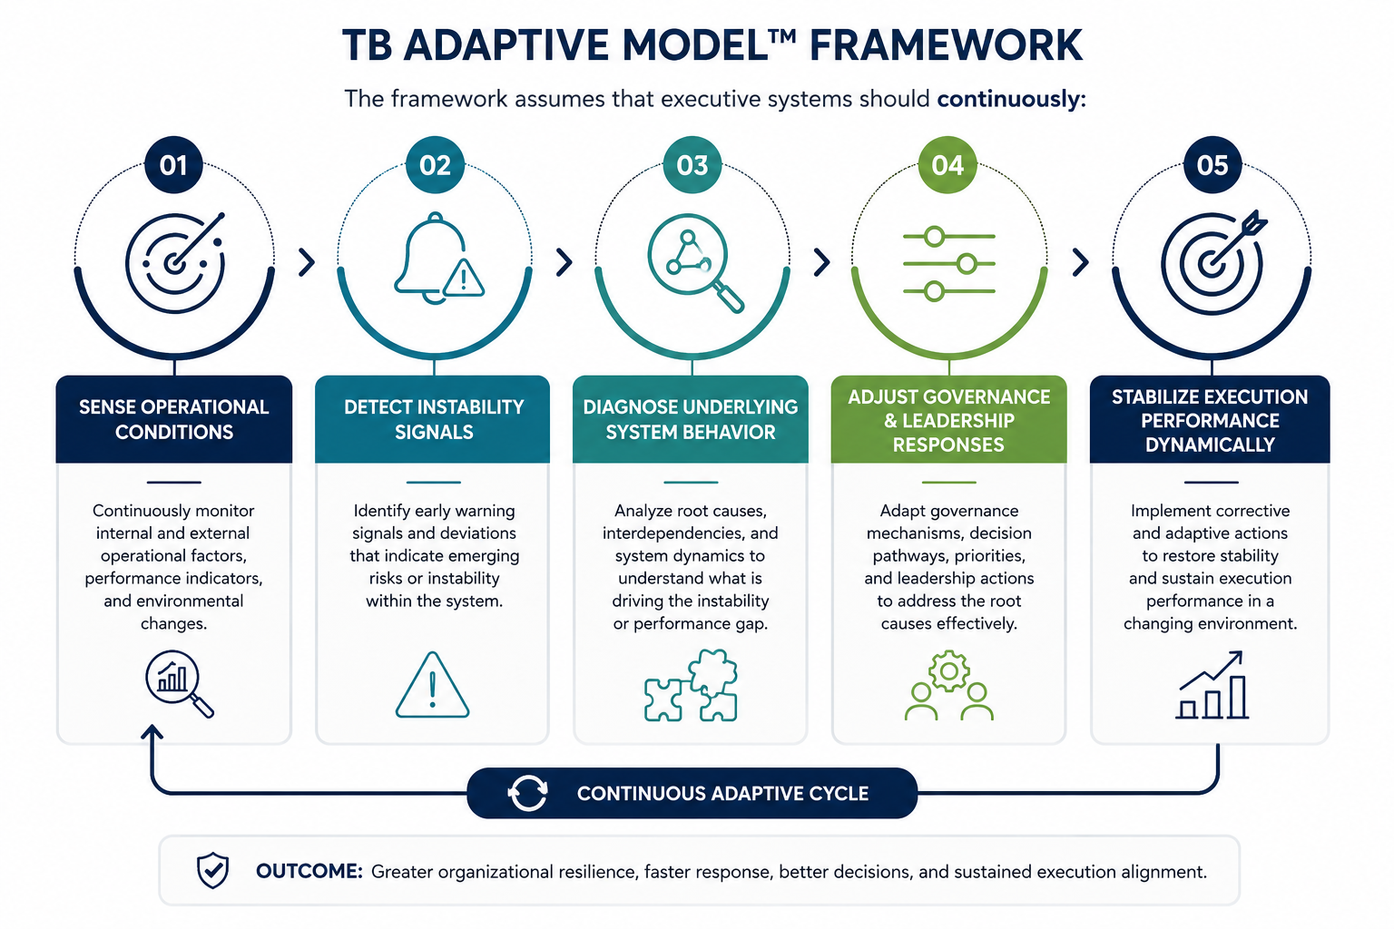
Figure 1. Adaptive Executive Control Cycle within TB Adaptive Model™

Core Framework Principles
Dynamic Systems Principle™
Organizations and projects should be understood as evolving systems operating within interconnected and continuously changing environments. This principle is conceptually aligned with systems thinking literature, which emphasizes that organizational behavior emerges through interactions between multiple dynamic variables rather than isolated activities (Senge, 2006; Sterman, 2000).
Control Before Expansion Principle™
Operational expansion should not exceed the organization’s ability to maintain governance visibility, execution control, and coordination effectiveness. Research in organizational complexity and project governance demonstrates that scaling systems without proportional control capability often increases instability and execution risk (Turner & Müller, 2003).
Governance Latency Principle™
Delays between issue detection, decision-making, and executive response can significantly affect execution stability and operational performance. This principle is influenced by governance and control system literature emphasizing the importance of responsiveness and timely intervention in dynamic organizational environments (Dooley, 1997).
Adaptive Leadership Gain Principle™
Leadership behavior should adapt according to the degree of uncertainty, instability, and operational pressure within the system. Dynamic capability theory supports the view that organizations must continuously adjust leadership and organizational responses to sustain effectiveness under changing conditions (Teece, Pisano, & Shuen, 1997).
Strategic Alignment Stability Principle™
Long-term operational stability depends on maintaining alignment between strategic objectives and execution activities. Misalignment between strategy and operational execution often contributes to performance degradation and governance fragmentation (Kaplan & Norton, 2006).
Recovery Through Reconfiguration Principle™
In distressed operational environments, recovery may require redesigning governance structures, execution pathways, and decision mechanisms rather than relying solely on additional resources. Organizational recovery literature suggests that adaptive restructuring is often necessary to restore execution stability within complex systems (Weick & Sutcliffe, 2007).
Continuous Learning Loop Principle™
Organizations should continuously convert operational experience into institutional learning and adaptive capability. This principle is grounded in organizational learning theory, which emphasizes continuous feedback, learning, and system adaptation as essential components of long-term organizational resilience (Argyris & Schön, 1978; Senge, 2006).

Framework Architecture
TB Adaptive Model™ consists of five interconnected executive layers that operate as a continuous adaptive cycle:
• Strategic Reference Layer
• Sensing Layer
• Diagnosis Engine
• Adaptive Control Layer
• Learning Loop
The architecture is designed to support adaptive executive decision-making in complex and continuously changing operational environments.
The framework cycle operates as follows:
Sense → Diagnose → Adapt → Stabilize → Learn
Each layer performs a specific executive function while remaining interconnected with the overall adaptive system architecture.

Enhanced Framework Architecture
Figure 2 illustrates the TB Adaptive Model™ framework architecture.
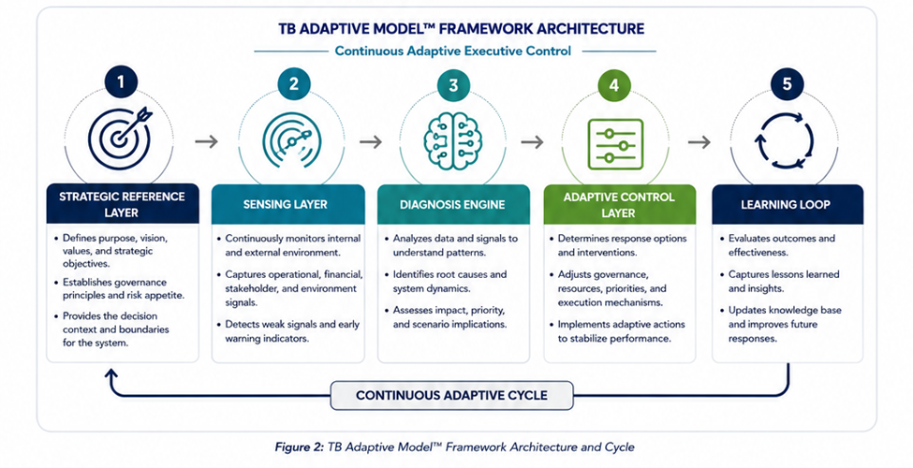
Figure 2. TB Adaptive Model™ Framework Architecture

1. Strategic Reference Layer
This layer establishes the strategic foundation and executive direction for the system. It defines organizational purpose, strategic objectives, governance principles, decision boundaries, and operational priorities.
The layer provides alignment between executive intent and operational execution, reducing ambiguity and supporting strategic consistency across the organization (Kaplan & Norton, 2006; Hambrick & Fredrickson, 2001).

2. Sensing Layer
This layer continuously monitors internal and external operational conditions to identify relevant signals, performance shifts, risks, and emerging instability indicators.
The sensing process includes operational metrics, stakeholder feedback, environmental conditions, governance signals, and execution performance indicators. The objective is to detect both strong and weak signals before instability escalates (Choo, 2011; Daft & Lengel, 1986).

3. Diagnosis Engine
The diagnosis layer transforms operational data and observed signals into actionable executive understanding. It identifies root causes, analyzes interdependencies, evaluates system behavior, and assesses the potential operational impact of identified conditions.
The diagnosis process supports informed executive decision-making through analytical interpretation of system dynamics and operational patterns (Sterman, 2000; Richmond, 1993).

4. Adaptive Control Layer
Based on diagnostic insights, this layer determines the most appropriate executive response and adaptive intervention strategy.
Adaptive actions may include governance restructuring, escalation redesign, resource reallocation, decision acceleration, leadership adjustment, or execution pathway modification. The purpose is to stabilize organizational performance while preserving strategic alignment and responsiveness (Dooley, 1997; Galbraith, 1977).

5. Learning Loop
This layer evaluates outcomes, captures lessons learned, and converts operational experience into institutional knowledge and future adaptive capability.
Continuous organizational learning improves future sensing accuracy, executive responsiveness, and system resilience under changing conditions (Argyris & Schön, 1978; Senge, 2006; Nonaka & Takeuchi, 1995).

Related Work & Literature Positioning
TB Adaptive Model™ draws conceptual influence from several established disciplines and research areas related to systems thinking, adaptive control, organizational governance, strategic execution, and dynamic capabilities.
Rather than positioning itself as a replacement for existing management or organizational theories, the framework builds upon multiple research streams and integrates them into a unified adaptive executive control perspective for dynamic operational environments.
Systems Thinking in Project Management
Systems thinking literature views organizations and projects as interconnected systems rather than isolated operational activities. This perspective emphasizes that organizational behavior emerges through relationships, feedback loops, interdependencies, and dynamic interactions between multiple variables (Sterman, 2000; Senge, 2006).
Within project management environments, systems thinking improves understanding of complexity, operational dependencies, delayed effects, and unintended consequences. TB Adaptive Model™ extends this perspective by introducing an adaptive executive response structure that continuously adjusts governance and operational control behavior according to changing environmental conditions.
Dynamic Capabilities Theory
Dynamic capabilities theory focuses on the organization’s ability to sense environmental changes, seize opportunities, and continuously reconfigure organizational capabilities in response to uncertainty and evolving market conditions (Teece, Pisano, & Shuen, 1997).
The theory emphasizes adaptability as a strategic capability rather than a temporary operational reaction.
TB Adaptive Model™ aligns with this perspective by treating executive adaptability as a continuous governance function embedded within the operational system itself. The framework expands this logic into day-to-day executive execution environments, where adaptive behavior becomes part of governance operations rather than solely strategic repositioning.
Complex Adaptive Systems
Complex adaptive systems literature describes organizations as evolving systems characterized by nonlinear behavior, distributed interactions, feedback effects, and continuous adaptation (Dooley, 1997).
Within such systems, small operational changes may generate disproportionately large organizational effects, while rigid control mechanisms may reduce overall adaptability and responsiveness.
TB Adaptive Model™ adopts this perspective by assuming that organizational environments continuously evolve and therefore require adaptive executive control mechanisms capable of sensing instability, interpreting system behavior, and dynamically stabilizing execution performance.
Organizational Learning and Governance
Organizational learning theory emphasizes the importance of continuous learning, feedback interpretation, knowledge creation, and institutional adaptation as mechanisms for improving long-term organizational performance and resilience (Argyris & Schön, 1978; Senge, 2006; Nonaka & Takeuchi, 1995).
Governance literature similarly emphasizes the importance of decision quality, accountability structures, coordination mechanisms, and executive responsiveness within complex organizational systems.
TB Adaptive Model™ integrates organizational learning directly into its executive control cycle through the Learning Loop layer, where operational experience continuously improves future sensing accuracy, adaptive response quality, governance responsiveness, and institutional resilience.
Positioning of TB Adaptive Model™
Unlike traditional project management and governance frameworks that primarily emphasize planning stability, procedural compliance, and fixed control structures, TB Adaptive Model™ focuses on adaptive executive behavior under dynamic operational conditions.
The framework positions governance not as a static administrative process, but as a continuously adaptive executive control system capable of:
• sensing operational instability,
• interpreting dynamic system behavior,
• adapting executive responses,
• stabilizing organizational execution,
• and continuously learning from operational feedback.
From this perspective, TB Adaptive Model™ bridges the gap between:
• systems thinking,
• adaptive control theory,
• executive governance,
• and strategic execution management.
Expected Contribution and Future Impact
The expected contribution of TB Adaptive Model™ extends beyond traditional project management methodologies by introducing an integrated adaptive executive framework specifically designed for high-complexity and high-uncertainty environments.
The framework may contribute to future research and executive practice in several areas, including:
• adaptive governance systems,
• dynamic executive control,
• organizational resilience,
• transformation management,
• healthcare operational systems,
• capital project execution,
• and AI-supported governance environments.
From a practical perspective, the framework aims to improve:
• governance responsiveness,
• execution stability,
• strategic alignment,
• adaptive capability,
• and institutional learning performance.
The long-term vision of TB Adaptive Model™ is to support the evolution of executive systems from static governance structures toward continuously adaptive organizational control architectures capable of operating effectively under uncertainty, complexity, and continuous change.

Governance Dynamics
Governance Friction™
Governance friction refers to the operational resistance created by excessive procedural complexity, fragmented authority structures, unclear accountability, and bureaucratic inefficiencies. High governance friction often slows execution responsiveness and reduces organizational agility in dynamic operational environments (Galbraith, 1977; Daft & Lengel, 1986).
Governance Latency™
Governance latency describes the delay between identifying operational issues and implementing executive decisions or corrective actions. Prolonged latency can amplify operational instability, increase escalation frequency, and weaken execution performance in fast-changing environments (Dooley, 1997).
Control Drift™
Control drift refers to the gradual deviation between intended strategic control and actual operational behavior over time. This condition may emerge when executive oversight mechanisms fail to adapt to evolving environmental conditions, resulting in reduced alignment and weakened execution discipline (Sterman, 2000).
Organizational Inertia™
Organizational inertia describes the tendency of institutions to resist structural, operational, or governance changes despite environmental shifts or performance pressures. Organizational theory literature suggests that inertia can significantly limit adaptive capability and reduce responsiveness during periods of transformation or instability (Senge, 2006; Weick & Sutcliffe, 2007).
Collectively, these governance dynamics directly influence organizational responsiveness, execution stability, strategic alignment, and the overall adaptive capacity of executive systems.

Measurement & Operational Indicators
Governance Latency Index™ (GLI)
The Governance Latency Index™ measures the average time required for governance systems to respond to operational issues, escalation signals, or executive decisions.
The purpose of the index is to evaluate governance responsiveness and identify delays affecting execution stability and organizational agility.
A simplified conceptual equation may be expressed as:
GLI = Total Governance Response Time / Number of Governance Decisions
Where:
• Governance Response Time includes escalation review, decision processing, approval duration, and implementation initiation.
• Lower GLI values indicate faster governance responsiveness.
This concept is aligned with governance responsiveness and organizational control literature emphasizing the importance of timely executive intervention in dynamic systems (Dooley, 1997; Galbraith, 1977).
Strategic Alignment Score™ (SAS)
The Strategic Alignment Score™ measures the degree of alignment between operational activities and organizational strategic objectives.
The indicator evaluates whether projects, operational decisions, and resource allocation remain connected to defined executive priorities.
A simplified conceptual equation may be expressed as:
SAS = (Aligned Operational Activities / Total Operational Activities) × 100
Where:
• Higher percentages indicate stronger strategic alignment.
• Lower values may indicate governance fragmentation or operational drift.
This concept is influenced by strategic performance management and balanced scorecard literature (Kaplan & Norton, 2006).
Adaptive Response Rate™ (ARR)
The Adaptive Response Rate™ measures the organization’s ability to implement corrective or adaptive actions in response to changing operational conditions.
The objective is to assess organizational responsiveness under dynamic and uncertain environments.
A simplified conceptual equation may be expressed as:
ARR = (Successful Adaptive Responses / Total Detected Operational Changes) × 100
Where:
• Successful responses include interventions that stabilize performance or reduce execution risk.
• Higher ARR values indicate stronger adaptive capability.
The concept aligns with dynamic capabilities theory and adaptive organizational systems research (Teece, Pisano, & Shuen, 1997).
Executive Stability Index™ (ESI)
The Executive Stability Index™ measures the overall operational stability of the executive system by integrating multiple execution variables into a unified stability indicator.
The indicator may combine:
• governance responsiveness,
• execution consistency,
• escalation frequency,
• operational variance,
• and strategic alignment.
A simplified conceptual structure may be expressed as:
ESI = (SAS + ARR – Governance Friction – Governance Latency Variance) / Operational Variability
Where:
• Higher ESI values indicate stronger executive stability.
• Lower ESI values may indicate instability, governance overload, or execution drift.
This concept is influenced by systems stability theory and organizational resilience literature (Sterman, 2000; Weick & Sutcliffe, 2007).
Analytical Application of Indicators
The combined use of these indicators allows executive systems to:
• identify instability trends early,
• measure governance responsiveness,
• evaluate adaptive capability,
• monitor strategic alignment,
• and support data-driven executive decision-making.
Within TB Adaptive Model™, these indicators are not intended as purely reporting metrics, but as adaptive executive sensing mechanisms that support continuous stabilization and organizational learning.

Example Application
A large operational program experienced recurring delays, increasing escalation activity, and inconsistent execution performance.
Further analysis identified governance-related issues including delayed approvals, overlapping escalation channels, and slow executive response cycles.
An adaptive restructuring approach improved execution responsiveness and operational stability.

Future Direction
Future executive systems will increasingly rely on predictive analytics, operational sensing, governance intelligence, and AI-supported decision environments.
TB Adaptive Model™ views artificial intelligence as a support mechanism for executive awareness and adaptive responsiveness rather than a replacement for leadership.

Conclusion
Modern organizations operate in increasingly dynamic and demanding environments.
TB Adaptive Model™ proposes an adaptive executive approach focused on operational sensing, governance responsiveness, strategic alignment, and continuous stabilization.
The framework builds upon concepts related to systems thinking, adaptive systems, organizational learning, and dynamic capabilities (Senge, 2006; Teece et al., 1997).

About the Author
Dr. Tariq Mohana Bahwini is an engineering consultant and healthcare operations leader specializing in complex project recovery, operational execution, healthcare infrastructure, and adaptive governance environments.
Currently developing executive concepts related to adaptive systems and strategic execution through THE MULIS.

References (APA Style)
Dooley, K. (1997). A complex adaptive systems model of organization change. Nonlinear Dynamics, Psychology, and Life Sciences, 1(1), 69–97.
Senge, P. M. (2006). The fifth discipline: The art and practice of the learning organization. New York, NY: Doubleday.
Sterman, J. D. (2000). Business dynamics: Systems thinking and modeling for a complex world. Boston, MA: Irwin/McGraw-Hill.
Teece, D. J., Pisano, G., & Shuen, A. (1997). Dynamic capabilities and strategic management. Strategic Management Journal, 18(7), 509–533.
Turner, J. R., & Müller, R. (2003). On the nature of the project as a temporary organization. International Journal of Project Management, 21(1), 1–8.
Argyris, C., & Schön, D. A. (1978). Organizational learning: A theory of action perspective. Reading, MA: Addison-Wesley.
Kaplan, R. S., & Norton, D. P. (2006). Alignment: Using the balanced scorecard to create corporate synergies. Boston, MA: Harvard Business School Press.
Weick, K. E., & Sutcliffe, K. M. (2007). Managing the unexpected: Resilient performance in an age of uncertainty (2nd ed.). San Francisco, CA: Jossey-Bass.
Choo, C. W. (2011). Environmental scanning as information seeking and organizational learning. Information Research, 7(1).
Daft, R. L., & Lengel, R. H. (1986). Organizational information requirements, media richness and structural design. Management Science, 32(5), 554–571.
Galbraith, J. R. (1977). Organization design. Reading, MA: Addison-Wesley.
Hambrick, D. C., & Fredrickson, J. W. (2001). Are you sure you have a strategy? Academy of Management Executive, 15(4), 48–59.
Nonaka, I., & Takeuchi, H. (1995). The knowledge-creating company. New York, NY: Oxford University Press.
Richmond, B. (1993). Systems thinking: Critical thinking skills for the 1990s and beyond. System Dynamics Review, 9(2), 113–133.

