Offers Project

Contents

Offers project : a re-marketing tool 2

Actants & General Workflow: 2

Front-end workflow: 2

Back-end workflow: (UI: http://blackrockdigital.github.io/startbootstrap-sb-admin/index.html) 3

System-Admin workflow: 3

Technical Requirements 3

Platform: 3

Notes: 3

# Offers project : a re-marketing tool

This is a tool which allows a business (say a hotel) to re-market to website visitors if they visit the hotel site but do not book. Eg. if a user visits the site he’s asked for his email address. If he enters it and later he does not book, the offers system will email him to offer him a special offer. If he does not sign up then next time he visits the site the user will see a popup with a special offer.

Hotels can sign up to the offers system after paying, and can then login to define the content of the popup/email to be presented to users, define their goal URL, and copy the auto-generated javascript which the hotel needs to place on its website so that the popup/email functionality can work.

## Actants & General Workflow:

### Front-end workflow:

1. A user visits website of (say) Hotel X
2. Website shows popup (<http://www.cssscript.com/categories/modal-popup/>) asking user to enter his email address, via a form (which exists in the popup) or via using his facebook or google account.

-Load form from 3rd party resource

-Facebook and Google authentication services

1. **If the user registers (or is already registered)** and proceeds with going to the booking system/page but does not book, 30min later the system will send him an email with a special offer to entice him to return to the site and make the booking.

- So we should have a different tracking script on thank you or order confirmation page when user already place an order.

1. **If the user does not register**, then the next time the user visits the site he’ll see a popup with a special offer. The popup appears only once a day, every day but only within 1 week of his first visit. The popup may also show to users who did register too, if the hotel wishes for this to happen.

- We will have cookie on first visit. Cookie if already register.

### Back-end workflow: (UI: <http://blackrockdigital.github.io/startbootstrap-sb-admin/index.html>)

1. **Signup**
   1. The hotel visits the Offers System signup page, selects a Package (packages are based on the number of pageviews. Ie. How many times the Offers System is called from the hotel’s website).

- How should we count the number of times the offers system is called. Base on the number of popup was showed or the times users access to the client's website.

* 1. The hotel then registers to use the service (registration form (email + password + agreement to terms and conditions) + subscription payment using Worldpay).
     1. The subscription payment should be charged on the 1st of each month. Eg. if the monthly payment is $10 and it’s now the 15th of May, then the first payment is $5 and then on the 1st of every month the hotel is charged $10. Or it could be that nothing is charged until the 1st of the next month, in which case the hotel is charged $15 the first month and then $10 on the 1st of every month.

- Subscription world pay payment processing.

* 1. A confirmation email is sent to the hotel with their username and password.

1. **Login**
   1. The hotel visits the Offers System login page, from where he can also be reminded his password , via email, he’s forgotten it. Ie. Form: username, password (forgot password).

- Login page, forgot password feature. Do we need captcha?

* 1. Hotel logs in using registered username and password, and is able to view a dashboard where they can:
     1. View the number of Popups shown , Emails sent, and how many times the Offers System/Script has been triggered/called this month. (these could potentially exist as columns in the table holding the hotel information. A cron job could potentially reset the script-called counter each month)
        1. Seeing the same figures between 2 dates would be ideal, but perhaps there is an easier way to achieve this by letting the hotel’s Google Analytics log such information? This could be combined with measuring Bookings within Google Analytics. Ie. Compare the number of emails sent and number of bookings made as a result of the offer emails and popups.

- How we could let GA log those information and how we could get them. Clarify more detail about “Compare the number of emails sent and number of bookings made as a result of the offer emails and popups.”

* + 1. Define the content of the Email (subject+content) & Popup(title+content) (as described above) using a rich text editor (eg. ckeditor.com): All links in the editor should be customised automatically so that they include a “?from=OffersSystem” in the URL or “&from=OffersSystem” depending on the number of querystring parameters already potentially contained in links.

- What are “all links”? What will be they used for? Where will those link will be pointed to?

* + 1. Define the “goal/booking URL”

- So that we no need a different tracking code for goal page.

* + 1. Copy-paste the System’s auto-generated Javascript code which they need to put onto their site so that visitors are tracked.
    2. Select whether whether popups should appear to non-registered users only or also to registered users.
    3. *Optional Future Feature/Requires discussion*: How do you suggest we could structure the database to enable hotels to automatically upgrade/change packages, in an easy way, if there is one.

**DASHBOARD Layout**

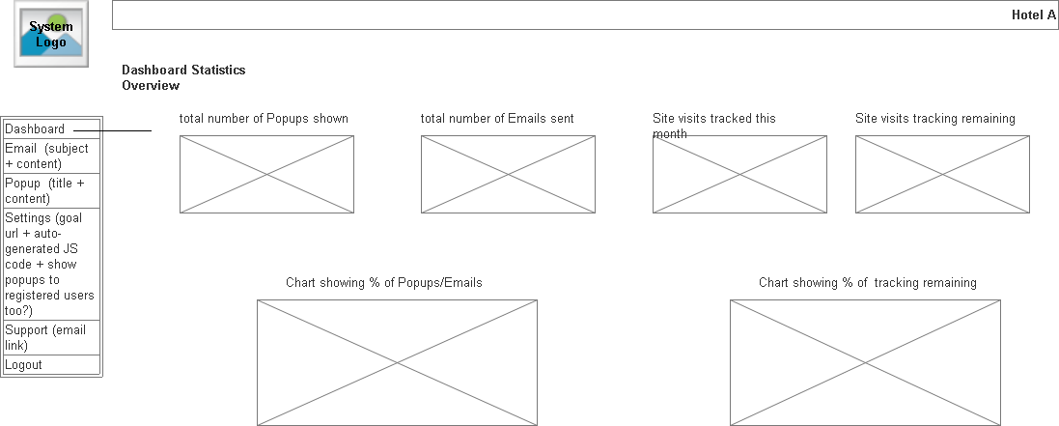

### System-Admin workflow:

1. No system-admin system required
2. System Administrator creates packages directly in the database eg. packages table with columns: packageID, NoOfVisitsAllowed, price
3. *Cron jobs*:
   1. an ASP page runs every 30min and sends the emails to visitors. They should be emailed only once . (suggested database fields: “1stEmailSent (y/n), 1stEmailSentDateTime”)
   2. an ASP page runs every 1 day and if a hotels quota (NoOfVisitsAllowed) is more than 90% it sends an email to let them know that. This is sent only once that month to each hotel.
   3. Potentially an ASP page runs on the 1st of each month to reset the number of times the Offers JS has been called.

**- Technial detail**

1. **DB Design, review and understanding specification, giving estimation: 6 hours 80$**
2. **BACK END**
   1. Sign up: Display packages, Payment processing, validate sign up information, payment cron job. 10 **hours. 150$**
      * Worldpay (refer food ordering) : 5 hours 75$
      * Basic layout, display package: 2 hours 30$
      * Signup, validate, intergate Worldpage: 2 hours 30$

2. Login form: 7$

3. Dashboard with GA intergation: 75$

* Layout: 30$ 2Hours
* GA research and integrate: 30$ 2 hours

4. Email and popup content editor: 4 hours 60$

- Richtext editor: 2 hours 30$

- Form save, validating: 2 hours 30$

5. Other setting: 3 hours 45 $

6. Cron jobs: 30$

## Technical Requirements

### Platform:

Classic ASP / MS-Access / Bootstrap

## Notes:

1. The system should utilize client-side code as much as possible and minimize interactions with the server-side.
2. Take into account that later the system could be upgrading to SQL Server. With that in mind, ensure that you treat dates appropriately. Eg.
   * Although session.LCID=2057 could be used, several articles suggest that “even though #literal# is always USA format, CDate does work as expected. “  &   “and try FormatDateTime to get the dates back out in correct format. “
   * See<http://stackoverflow.com/questions/12891588/date-format-in-ms-access>
   * See<http://www.4guysfromrolla.com/webtech/051601-1.shtml>
3. Tooltips and validation should be placed in all forms to assist users.
4. It is suggested that cookies (local storage is probably better) are used to track visitor activity:

suggested:

*visitor-status: visited/interested/booked  
 registered: [yes/no]* (expires after 1 year?) *first-visited: [ date-time]* (expires after 7 days?) *last-visited: [ date-time]* (expires after 7 days?) *visit-count: [number]*

1. All the above may require further discussion with the developer in order to find the best way of implementation.