**SonarQube Eclipse Plugin Installation and configuration**

Download the [SonarQube](https://www.sonarqube.org/downloads/) software to host a local server.

* Run “StartSonar.bat” in \bin folder to start the SonarQube server.

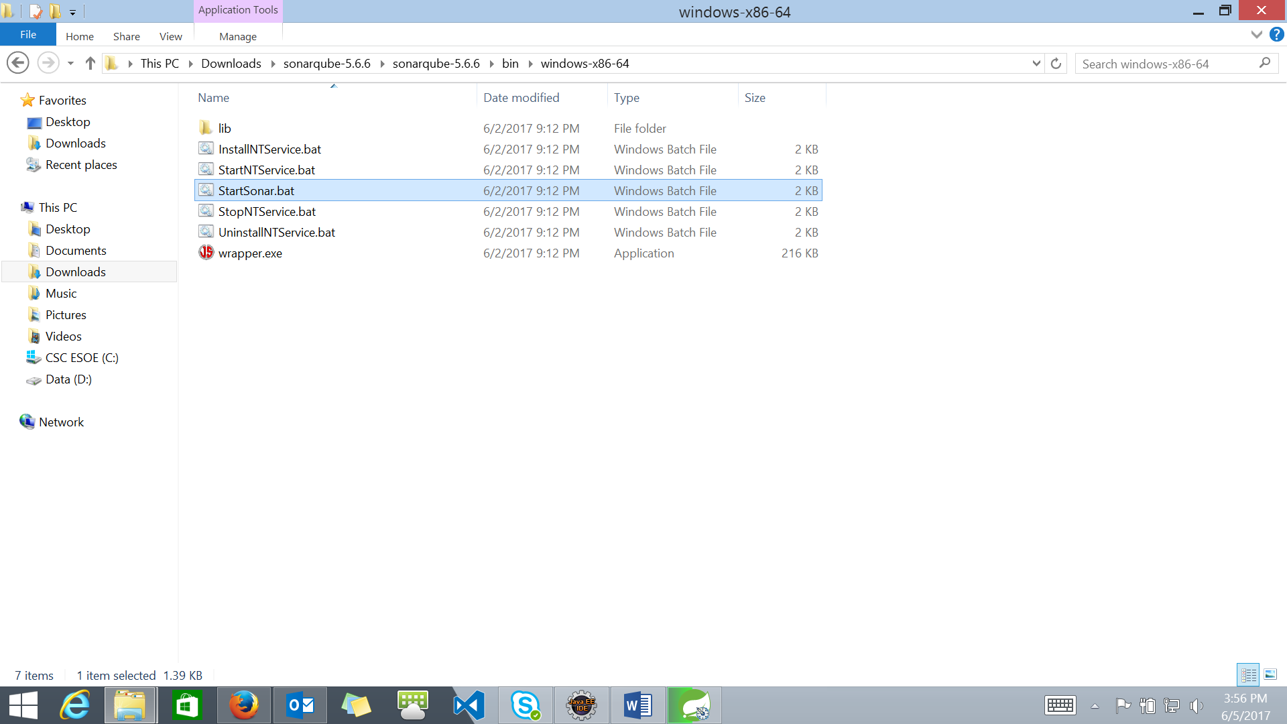

* Hit “ [http://localhost:9000/](http://localhost:9000/%20) ” in browser to view the dashboard.

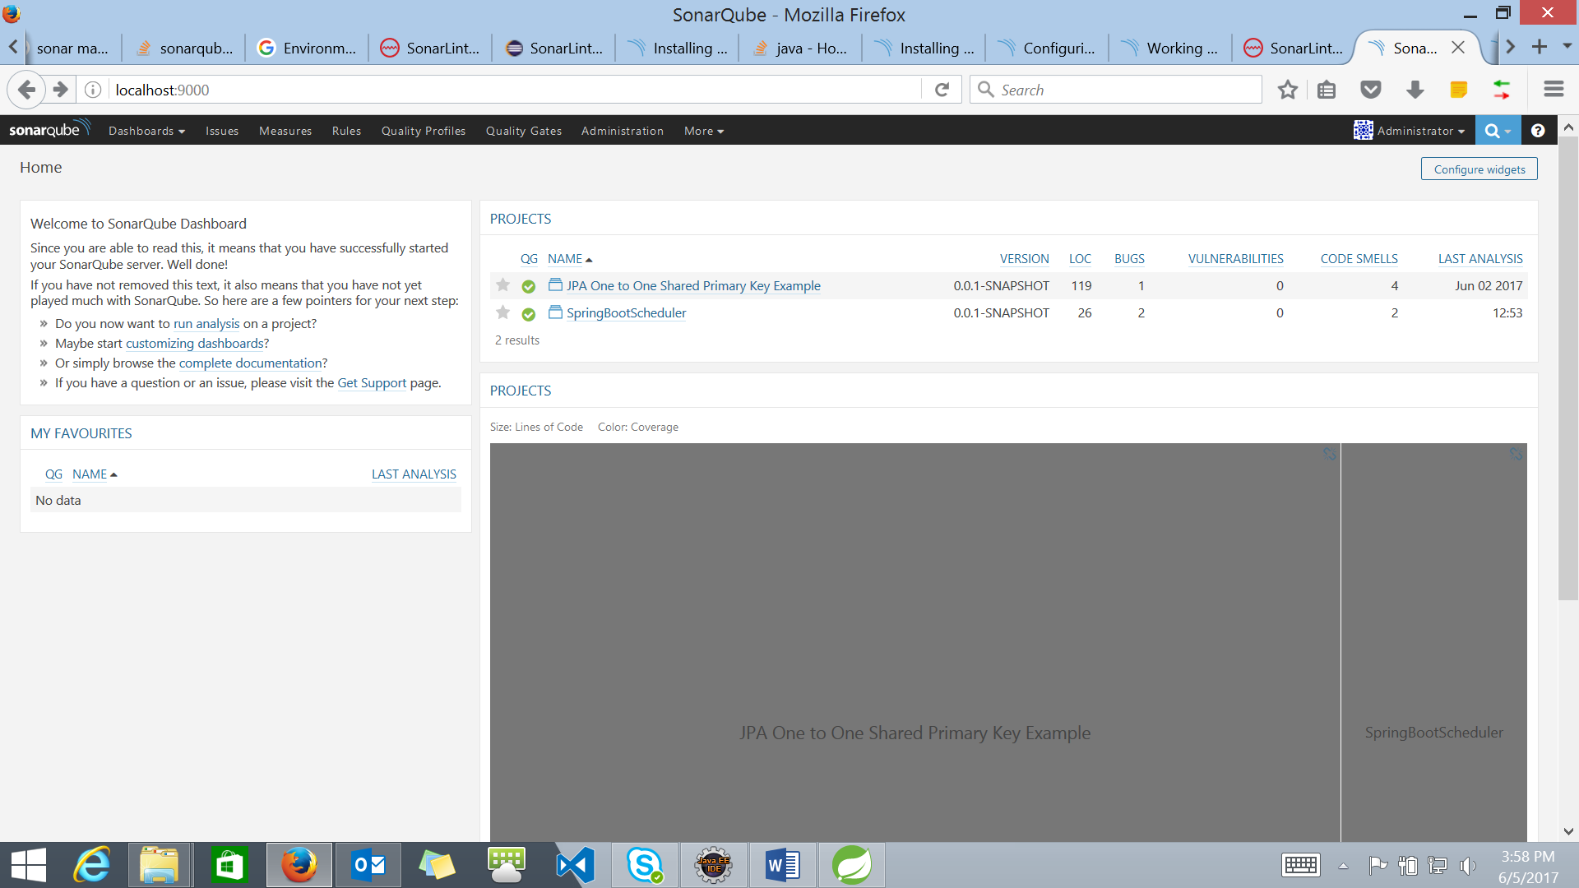

Binding sonar analyzer to a project.

* Through Maven property.

Add this property entry to the projects **pom.xml .**

<properties>

<!-- SERVER ON A REMOTE HOST -->

<sonar.host.url>http://localhost:9000/</sonar.host.url>

</properties>

Run maven build – “**mvn sonar:sonar**”

On successful build, refresh “ [http://localhost:9000/](http://localhost:9000/%20) ” to see the analyzed report/bugs.

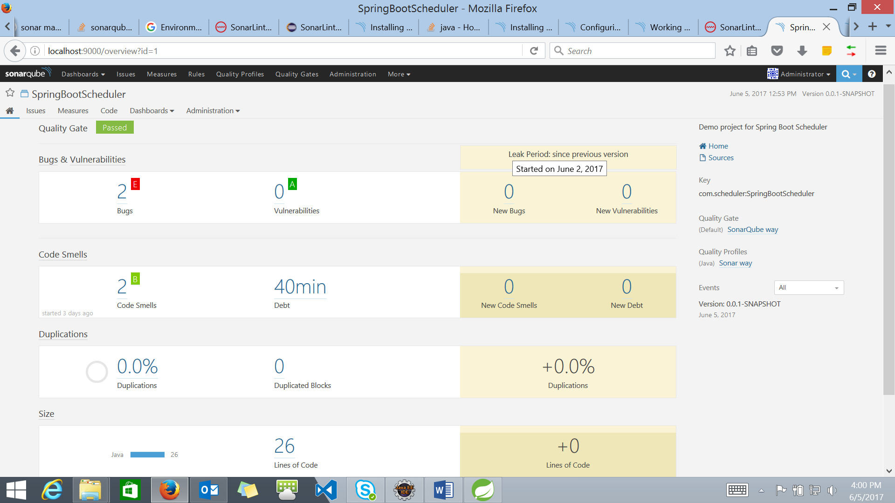

* Through eclipse plugin.

1. Install [SonarLint](https://marketplace.eclipse.org/content/sonarlint) plugin from the eclipse marketplace to the IDE (STS/Eclipse).
2. Configure the server in IDE – **Window > Show view > Other > SonarQube Servers.**

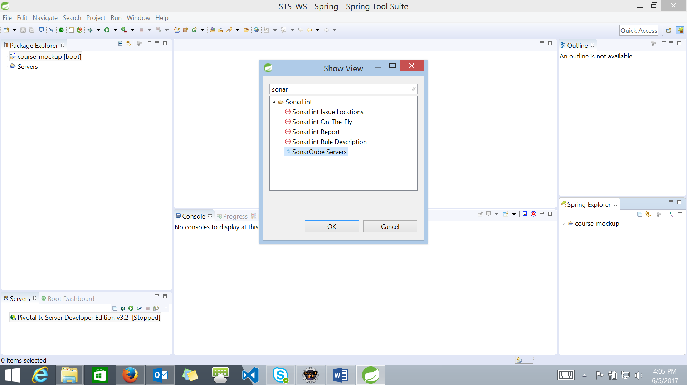

1. Under **SonarQube Servers** view tab -

Click Connect to a SonarQube server > set URL to <http://localhost:9000/> > Test connection > should get ‘successfully connected’ (if the local server is up and running) > Finish.

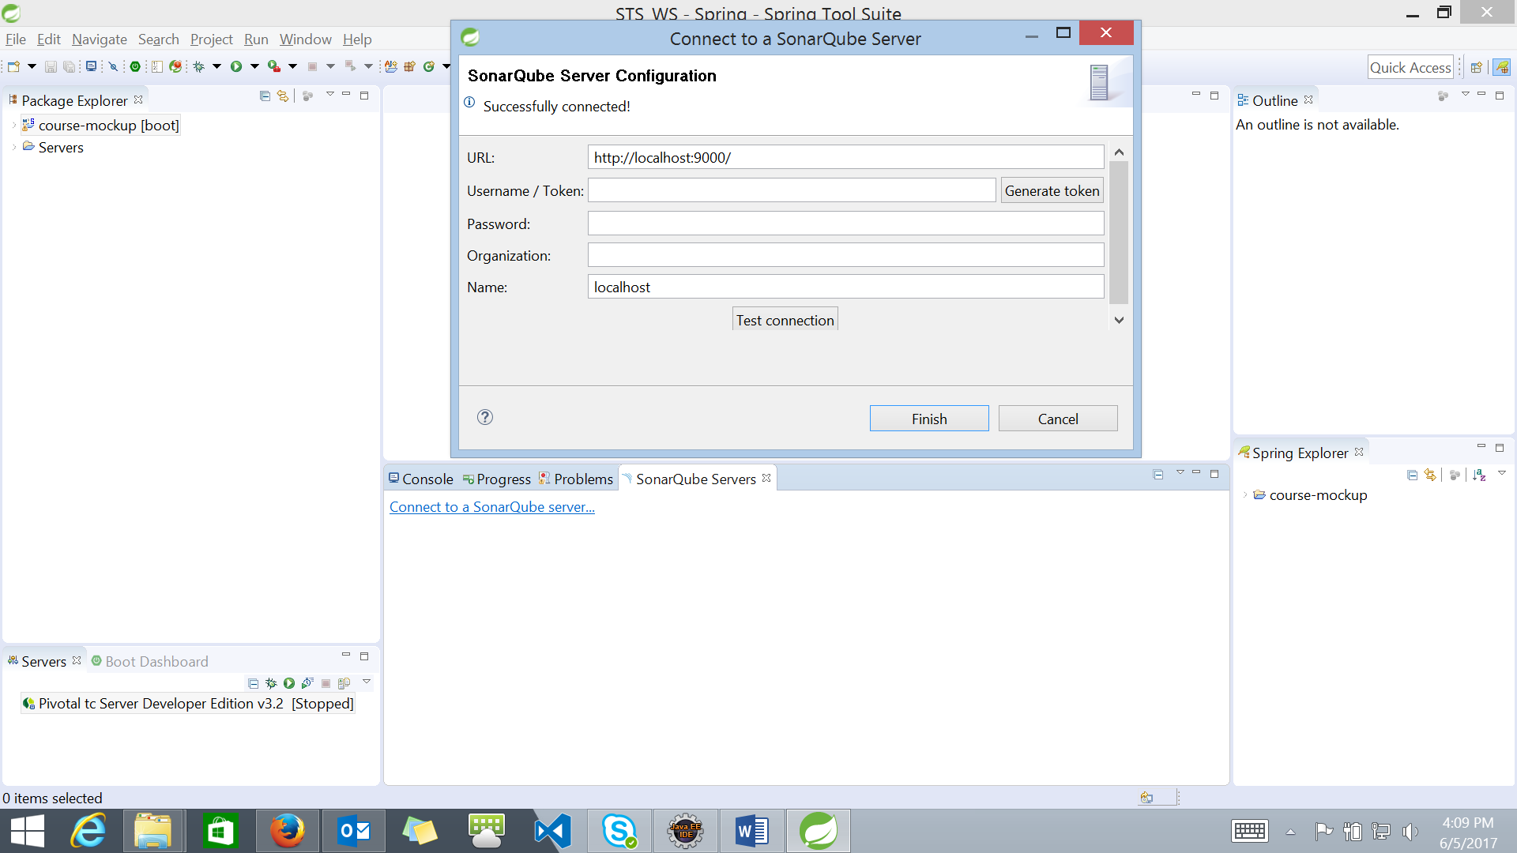

On successfully configuring server.

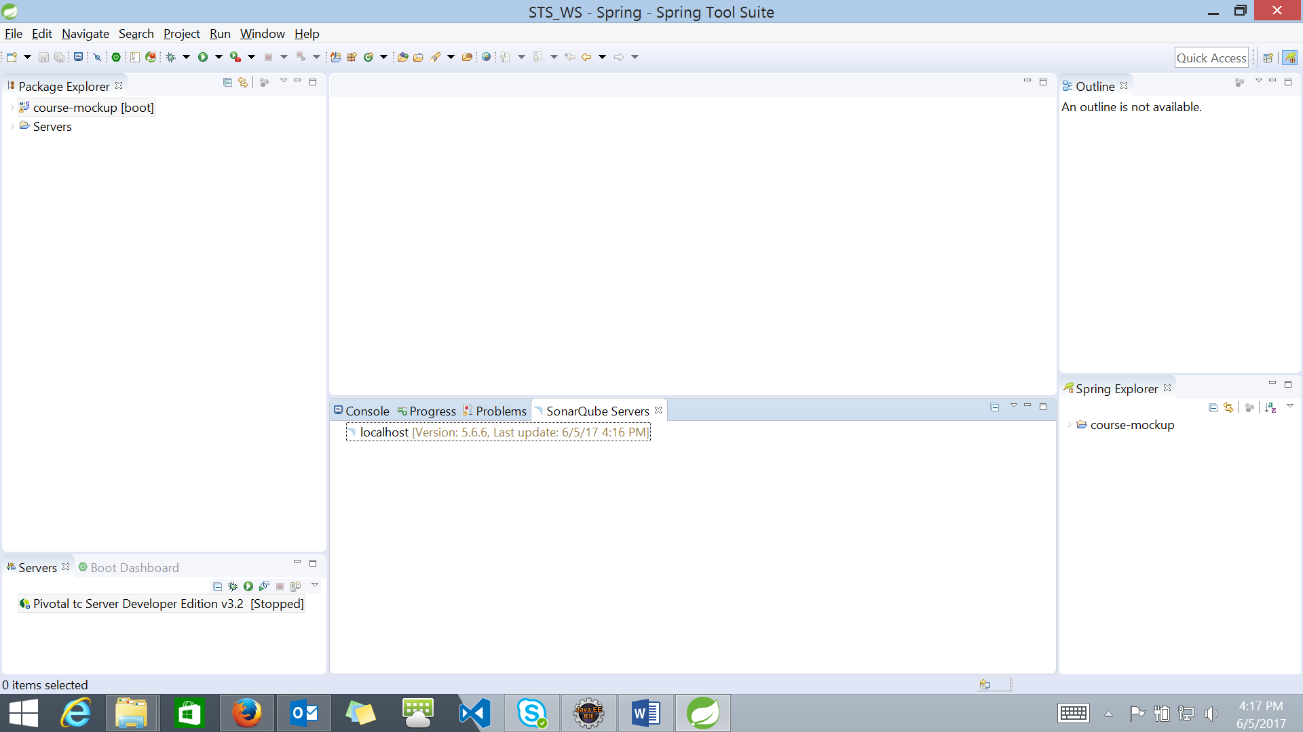

1. Add the other SonarLint views -

Window > Show view > Other > **SonarLint On-The-Fly.**

Window > Show view > Other > **SonarLint Rule Description.**



Start coding, SonarLint will analyses the current working file and update the report under **SonarLint On-The-Fly** tab and click on the listed bugs to get a brief description under **SonarLint Rule Description.**

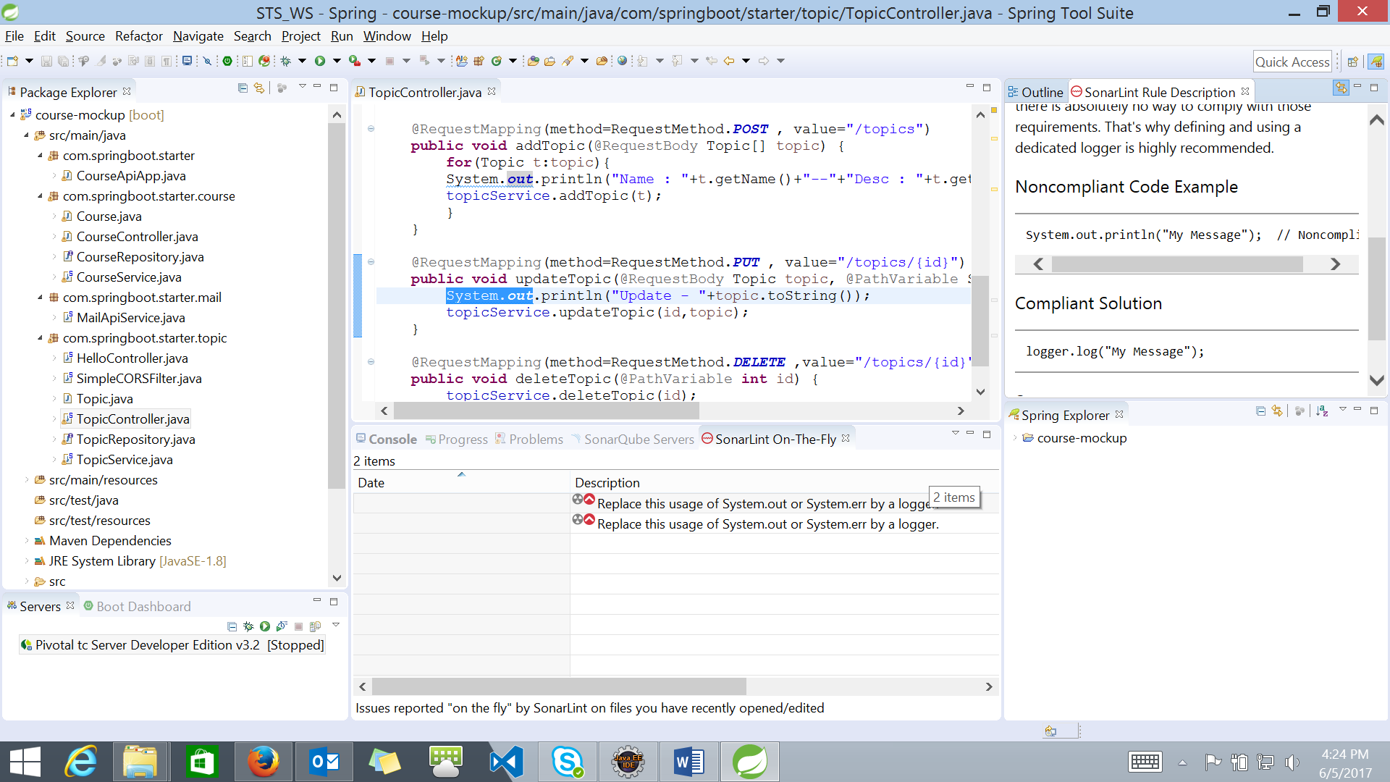

**Optional (Report generation)**:

Complete analysis in [preview mode](https://docs.sonarqube.org/display/SONARQUBE51/Getting+Issues+Report+in+Preview+Mode) by generating a HTML report.

Maven goal:

sonar:sonar -Dsonar.analysis.mode=preview -Dsonar.issuesReport.html.enable=true

Generated reports -

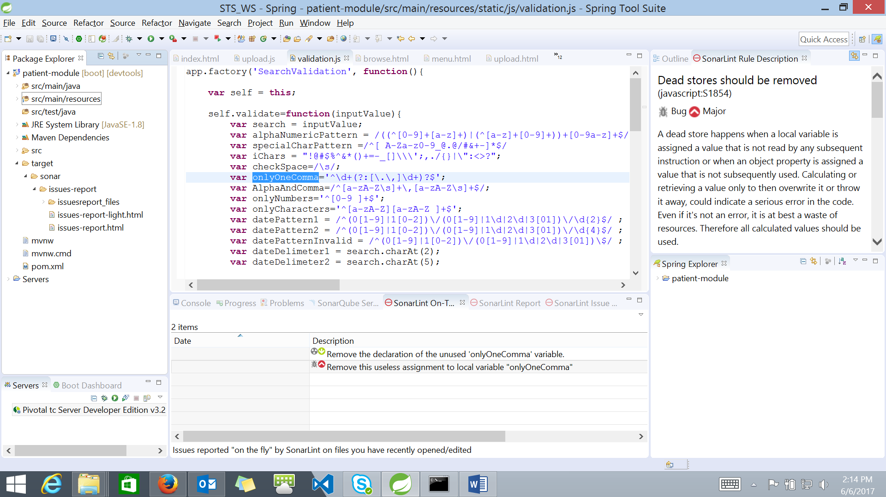

Issues-report.html

