<$Scr_H::2><$Scr_Ps::0>Why doesn't this project use other modeling approaches
<!$Scr_Ps::0>There are approaches which focus on the predictive modeling such as the predictive modeling approach used by Max Kuhn. This approach focuses in detail how a machine learning pipeline works, and will dive deep into the details of the decisions in modeling. Though this approach has certain benefits in helping us detailing the decisions made when conducting models, we instead use a more business-oriented framework, which is called the CRISP Framework.
<$Scr_Ps::0>Benefits of the CRISP Framework
<!$Scr_Ps::0>CRISP helps to build a data science project based on business results and financial benefits. I will follow this framework since it combines both the data science approach and the evaluation of the project. It connects the models with the return on investment to show the value or impact from the business. The reasons we also use CRISP is because:
- <!$Scr_H::2><$Scr_H::2> • It's an agile method: it implements data science projects iteratively, helping us to overcome common sense thinking and help us to adjust to unexpected issues quickly.
- It's data science for business's sake. It focuses on the ROI of the project, helping us to evaluate KPIs and potential economic impact if the model is implemented. It also ensures that we always iterate our projects to meet the business goal.
<!$Scr_H::2><$Scr_H::2>In terms of churn, ROI is one of the most critical metrics in which we want to know besides the technical aspect of data science. Follow this framework step-by-step helps us to make sure we don't miss any important steps during the processIt allows us to focus on processes that require human involvement that requires creativity and intelligence, parts that have not been automated by machines.

<!$Scr_H::2>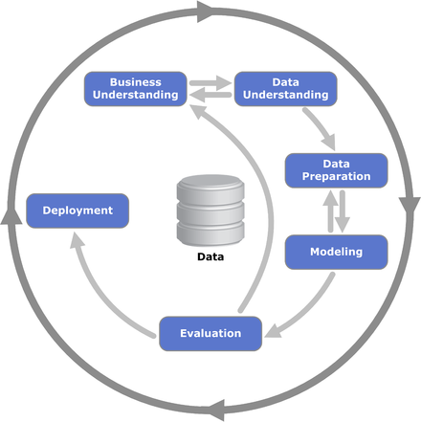
<$Scr_H::2><$Scr_Cs::1>The CRISP Framework<!$Scr_Cs::1>
<!$Scr_H::2>

