Helios 1D Laser–Target Coupling:
Calibration Analysis for PDD Wetted-Foam Targets
Benchmarked Against Olson et al. 2D HYDRA Reference (Phys. Plasmas 28, 122704, 2021)
T. Mehlhorn | Xcimer Energy | April 2026
helios_postprocessor v3.0 | github.com/tamehlhorn/helios_postprocessor

1. Executive Summary
A systematic calibration study was conducted to assess the ability of the Helios 1D spherical radiation-hydrodynamics code to reproduce published 2D HYDRA results for NIF polar direct-drive (PDD) wetted-foam capsule implosions. The reference target is the Olson et al. 2021 design (Phys. Plasmas 28, 122704) driven at 235 TW peak / 23 TW foot, with 1.44 MJ absorbed and peak implosion velocity 370 km/s.
The study identifies the root cause of Helios over-drive as a fundamental geometric limitation of the 1D spherical model and proposes four specific code modifications that would correct it, ranging from a simple empirical correction to a self-consistent ray-trace fix.

Key findings:
- Helios over-drives the capsule by +10% in peak velocity (409 vs 370 km/s) despite absorbing 4% less total energy than HYDRA (1.39 vs 1.44 MJ).
- LaserPwrOnTarget / LaserPwrDelivered = 1.0000 at every timestep throughout the simulation. Helios 1D sees zero geometric miss — every watt of delivered power illuminates the target regardless of capsule radius.
- In 3D HYDRA, fixed-pointing NIF PDD beams illuminate a decreasing solid angle as the capsule shrinks below the aim-point radius at late drive times. This time-dependent geometric miss effect is absent from Helios by construction.
- Laser energy deposits correctly at the ablation surface throughout the implosion (Figure 1). The over-drive is not caused by wrong deposition location.
- The fuel adiabat history (Figure 2) shows nearly isentropic compression (α ≈ 0.3 at peak velocity vs reference 7.4), consistent with excess ablation efficiency rather than insufficient shock heating.
- Four code modification options are identified, ranging from a pre-processing power table correction to a self-consistent per-ray intercept check inside the existing ray-trace loop.

2. Target and Simulation Setup

2.1 Reference Target
The Olson 2021 PDD wetted-foam target is a 4-region spherical capsule:

Region | Material | Zones | Role
1 | DT Vapor | 0–150 | Hot spot
2 | DT Ice | 151–280 | Cold cryo fuel — sets adiabat
3 | DT-CH foam | 281–410 | Wetted foam ablator
4 | CH Skin | 411–440 | Outer ablator

Laser pulse: 23 TW foot (0–5 ns), linear ramp (5–9 ns), 235 TW flat top (9–12.7 ns). Wavelength 0.351 μm (NIF Nd:glass). Helios geometry: half-cone angle 20°, spot radius 0.16 cm (Gaussian), focus position d = 0.20 cm, power multiplier 1.0. EOS: SESAME for DT vapor and DT ice; PROPACEOS for DT-CH foam and CH skin. Alpha transport: non-local.

2.2 Published Reference Values (Olson 2021, Table I)

Metric | Published value | Notes
Laser energy absorbed | 1.44 MJ | 99% of delivered energy
Peak implosion velocity | 370 μm/ns | Mass-weighted average of density peaks
In-flight kinetic energy | 120 kJ | Sum of inward-moving zone KE
Hydrodynamic efficiency | 8.3% | KE at peak velocity / absorbed energy
Fuel adiabat at peak v | 7.4 | DT+CH mixed EOS, mass-weighted peak-density zones
In-flight aspect ratio | 18 | R_a,2/3 / Δ_2/3 definition
Fuel mass at stagnation | 1.68 mg | Unablated DT mass
Hot spot CR | 15 | R_inner-foam / R_hs at ignition (T > 5.2 keV)
Effective areal density | 1.10 g/cm² | Volume-equivalent radius
Total thermonuclear yield | 62 MJ | 2D HYDRA; 14 MeV neutron yield 2.2×10¹⁹

3. Calibration Results

3.1 Best-Match Simulation (Olson_PDD_2021_01a)

Metric | Helios | HYDRA ref | Δ (%) | Status
Peak velocity (km/s) | 409 | 370 | +10.5% | Close
Absorbed energy (MJ) | 1.388 | 1.440 | −4% | Good
Absorption fraction (%) | 91.2 | 99.0 | −7.8% | Systematic gap
In-flight KE (kJ) | 152 | 120 | +27% | Over-driven
Hydro efficiency (%) | 11.0 | 8.3 | +32% | Over-efficient
Imploded DT mass (mg) | 0.65 | 1.68 | −61% | Over-ablated
ρR_cf (g/cm²) | 0.73 | 1.10 | −34% | Over-ablated
Yield (MJ) | 3.7 | 62 | −94% | No ignition
Stagnation time (ns) | 14.33 | ∲13.5 | +6% | Late

The primary deficits — over-driven velocity, over-ablated fuel mass, and low ρR_cf — are all causally linked to the root mechanism described in section 4.

3.2 Parameter Scan Summary
- Absorption fraction is insensitive to cone angle and spot size (87–91% across all runs). Refraction in the Helios 1D model controls coupling, not beam geometry.
- Hydro efficiency is locked at 9–11% regardless of laser geometry. The excess drive is in the ablation physics, not the ray-trace.
- LaserPwrOnTarget / LaserPwrDelivered = 1.0000 at every timestep in every run.
- SESAME DT EOS raises the adiabat by approximately 0.3–0.5 relative to PROPACEOS but does not close the gap to α = 7.4.

4. Root Cause Analysis

4.1 Geometric Coupling Efficiency is Unity Throughout
The Helios EXODUS output includes LaserPwrOnTargetForBeam, representing power geometrically intercepting the target at each timestep. For all 425 timesteps across the full 12.7 ns drive:

LaserPwrOnTarget / LaserPwrDelivered = 1.0000 (every timestep, every run)

This is definitive evidence that the Helios 1D model sees no geometric miss. In 3D HYDRA with fixed-pointing NIF PDD beams, the illuminated fraction decreases as R(t) falls below the beam aim-point radius at late drive times. This reduction simultaneously: (a) reduces total energy delivered to the corona, decreasing peak velocity; (b) shifts the foot/peak energy ratio, raising the effective adiabat; and (c) reduces ablation rate, preserving more unablated fuel.

4.2 Deposition Location is Correct (Figure 1)
The LaserEnTimeIntg spatial profile (Figure 1, top panel) confirms that energy deposits at the ablation surface throughout the drive. The peak deposition radius tracks inward from ~2300 μm at 2 ns to ~1200 μm at 12.5 ns, following the ablation front. All energy is deposited within the foam and CH skin ablator — the DT ice and hot spot receive essentially zero direct laser energy. This is physically correct behavior.
The instantaneous power density (Figure 1, bottom-left) shows a broad deposition profile spanning ~500–1000 μm radially at any given time. The absorption fraction (Figure 1, bottom-right) falls monotonically from 99.3% to 91% due to increasing corona refraction — not geometric miss.

4.3 Fuel Adiabat History (Figure 2)
The mass-averaged adiabat in the DT ice (Figure 2) shows nearly isentropic compression throughout the implosion. The adiabat rises from α ≈ 0 at 4 ns (undisturbed ice) to α ≈ 0.3 during the foot shock transit (5–6 ns), then to α = 1.49 at peak implosion velocity (13.45 ns). The reference value of 7.4 is not reached until stagnation onset. In HYDRA, the foot shock deposits more entropy because the geometric miss effect attenuates the main drive relative to the foot — raising the foot/peak energy ratio and setting the cold fuel on a higher adiabat before the main drive arrives.

4.4 Absorption Drop is Refraction, Not Geometry
The absorption history (Figure 1, bottom-right) starts at 99.3% and falls to 91.1% by pulse end. This monotonic decrease is caused by increasing refraction loss as the corona density profile steepens — it is not geometric miss. The early-time match of 99.3% to the published 99% confirms the Helios refraction model is physically consistent.

5. Recommended Calibration Path

5.1 Flux Limiter Scan (near-term, no code change)
The thermal conduction flux limiter f is the primary empirical lever controlling ablation efficiency. Recommended scan:

Run | f | Expected effect
Olson_PDD_2021_01a | 0.06 | Baseline (409 km/s, α ≈ 1.5)
Olson_PDD_2021_f08 | 0.08 | Moderate reduction in ablation efficiency
Olson_PDD_2021_f10 | 0.10 | Stronger suppression, lower velocity
Olson_PDD_2021_f12 | 0.12 | Upper bound

5.2 Geometric Power Correction (empirical, no code change)
A time-dependent power multiplier based on the geometric coupling efficiency:
f_geom(t) = ∫₀^α_c(t) G(α) dα / ∫₀^θ G(α) dα
α_c(t) = arcsin(R(t)/d) G(α) = exp(−d²tan²(α)/2σ²)

R(t) is obtained from a no-burn Helios run; the corrected pulse P_eff(t) = P(t) × f_geom(t)/f_geom(0) is then substituted in the RHW power table. This correction should be anchored to the HYDRA absorbed-energy history once available from the Olson group (LANL).

6. Code Modification Options for Helios Developers

Option | Code change required | Physical fidelity | Recovers adiabat?
1: Pre-processing multiplier | None (external script) | Low | Partial
2: View-factor multiplier | ~3 lines in power-setting routine | Medium | Yes if foot/peak also corrected
3: Per-ray intercept check | ~15 lines in ray-trace loop | High — self-consistent | Yes
4: Multi-angle beam model | New ray-trace module | Highest; enables CBET | Yes

Option 2: View-factor multiplier (recommended minimal fix)
Apply a time-dependent multiplier to the laser power at each timestep based on the solid angle subtended by the capsule:
Ω(t) = 2π(1 − cos(arcsin(R(t)/d)))
P_eff(t) = P_delivered(t) × Ω(t) / Ω(0)
R(t) is the outermost zone boundary, already available in the ray-trace context. Estimated change: 3 lines.

Option 3: Per-ray intercept check (recommended self-consistent fix)
Inside the existing ray-trace loop, add a geometric intercept condition for each ray at angle α:
if ( |sin(α)| > R(t) / d ) then ray_weight = 0 // geometric miss
else ray_weight = G(α) // normal Gaussian weight
As R(t) decreases during the implosion, the critical miss angle α_c = arcsin(R(t)/d) decreases, automatically cutting off an increasing fraction of the outer cone rays. The absorbed power is then computed from the reduced ray bundle using the existing absorption physics. Estimated change: ~15 lines. No empirical anchoring required.

Verification diagnostic: after implementing Options 2 or 3, the LaserPwrOnTargetForBeam / LaserPwrDeliveredForBeam ratio should decrease monotonically from 1.0 at t=0 as the capsule implodes. This variable is already written to the EXODUS output and provides a direct built-in check of the geometric correction.

7. Note on Cross-Beam Energy Transfer
CBET is absent from Helios. For the Olson 2021 design, the authors note that the quarter-critical radius does not shrink below the original capsule radius during the pulse, so CBET effects are modest and were excluded from the published HYDRA simulations. CBET is therefore not the primary calibration target for this design. For higher-power or faster-imploding designs, CBET would need to be addressed, and Option 4 (multi-angle model) is the only modification that opens the possibility of including CBET physics.

8. Recommendations

For Xcimer design work
- Run the flux limiter scan (f = 0.06, 0.08, 0.10, 0.12) to identify the calibrated f value for the Olson 2021 target class.
- Request the HYDRA absorbed-energy history from the Olson group (LANL). This single dataset enables anchored empirical calibration without code modification.
- Apply the calibrated f value and Option 2 view-factor correction to the Xcimer HDD VI_6 target as a starting point, noting that the geometric miss effect is smaller for symmetric HDD than for PDD.
- Use the adiabat history and laser deposition diagnostics from helios_postprocessor to validate corrected runs.

For Helios code developers
- Option 3 (per-ray intercept check, ~15 lines in the ray-trace loop) is the recommended minimal modification for PDD geometry. It requires only R(t) and d, both already available in the ray-trace context, and is verifiable via the LaserPwrOnTargetForBeam EXODUS variable.
- Option 4 (multi-angle model) is the preferred long-term path if CBET modeling is also desired.
- The LaserPwrOnTargetForBeam / LaserPwrDeliveredForBeam ratio provides a built-in verification diagnostic: it should fall below 1.0 at late times after any geometric miss correction is implemented.

9. References
- R. E. Olson et al., Phys. Plasmas 28, 122704 (2021). [Primary reference: 230 TW pulse, Table I]
- R. E. Olson, C. A. Thomas, B. M. Haines, M. J. Schmitt, Nucl. Fusion 66, 026002 (2026). [Igniting PDD design: 329 TW, 2.15 MJ]
- G. E. Kemp et al., Phys. Plasmas 32, 022702 (2025). [Xcimer hybrid HDD target]
- M. Hohenberger et al., Phys. Plasmas 22, 056308 (2015). [NIF PDD illumination geometry]
- helios_postprocessor v3.0, T. Mehlhorn, github.com/tamehlhorn/helios_postprocessor (2026).

Appendix: Diagnostic Figures

Figure 1 — Laser Deposition Spatial Profile

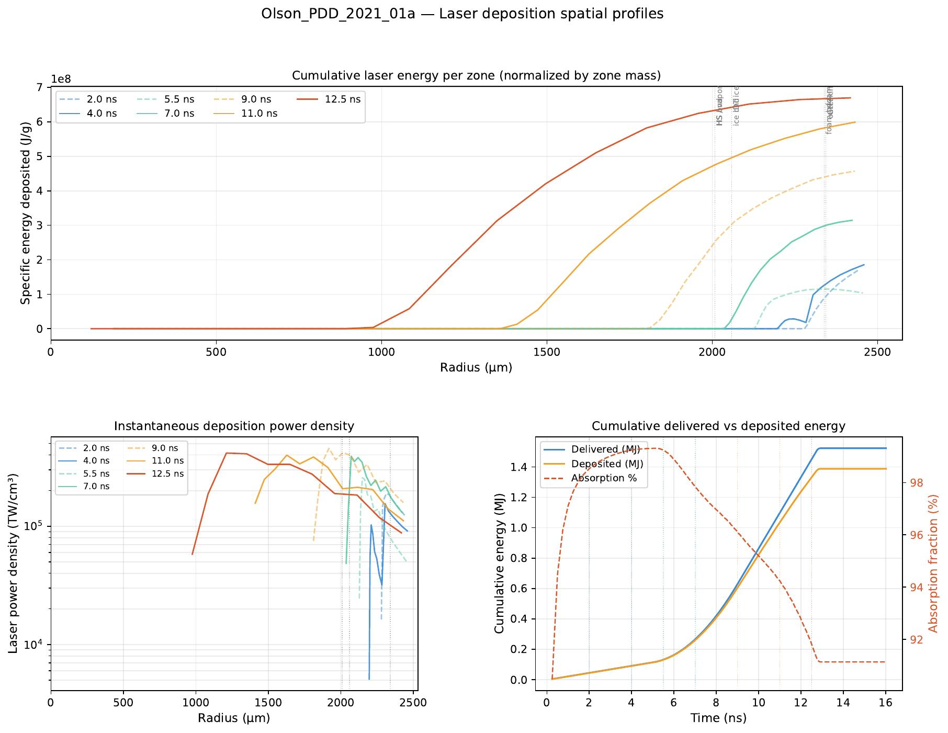
Figure 1. Laser deposition spatial profiles — Olson_PDD_2021_01a — Top: cumulative specific energy deposited per zone (J/g) vs radius at seven timesteps from 2 ns (foot) through 12.5 ns (end of pulse). Energy deposits entirely within the foam and CH skin ablator; the DT ice receives negligible direct laser energy. Bottom-left: instantaneous power density (TW/cm³) on log scale, showing the deposition zone tracking the ablation front inward. Bottom-right: cumulative delivered vs deposited energy with absorption fraction (%), starting at 99.3% and falling to 91% due to increasing corona refraction.

Figure 2 — Fuel Adiabat History

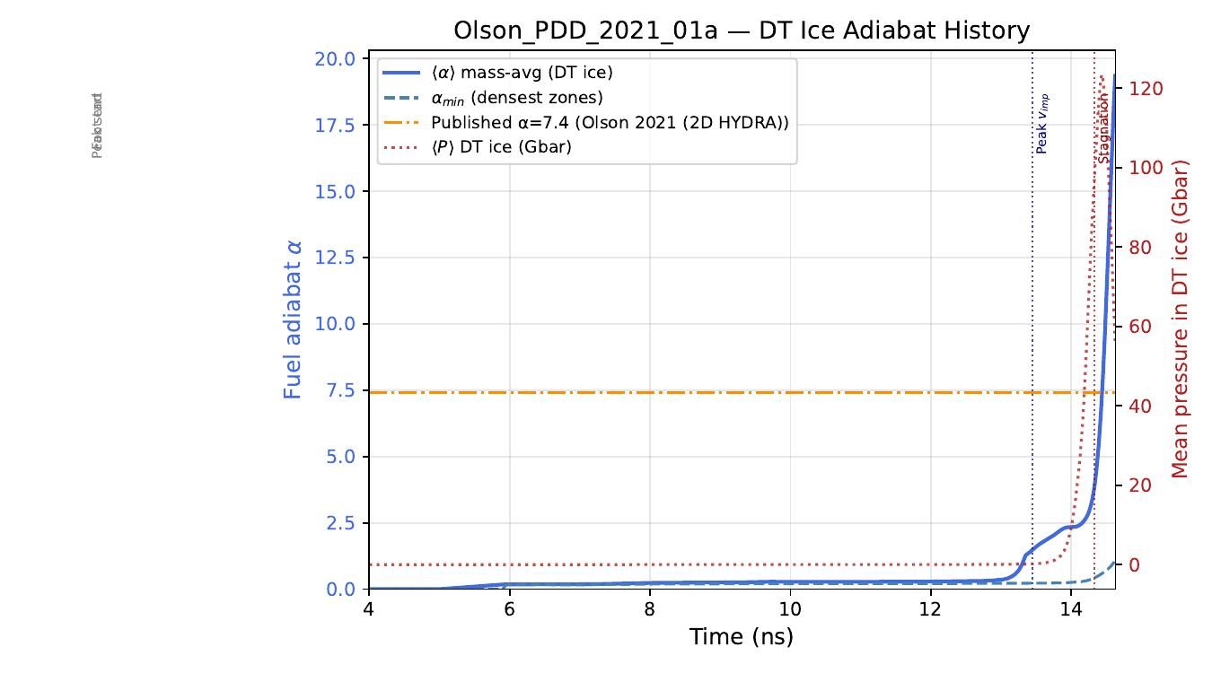
Figure 2. DT ice adiabat history α(t) — Olson_PDD_2021_01a — Mass-averaged adiabat α = P/P_Fermi (solid blue, left axis) and minimum zone adiabat (dashed blue) in the DT ice layer vs time, with mean DT ice pressure (red dotted, right axis). The orange reference line marks the published HYDRA value of 7.4. The foot shock (5–6 ns) deposits only α ≈ 0.2–0.18; the main drive raises α to 1.5 at peak velocity (13.45 ns). The factor-of-5 deficit relative to HYDRA is consistent with the absence of geometric miss in Helios, which would normally attenuate the main drive relative to the foot and raise the effective adiabat.

Figure 3 — First Shock in DT Ice

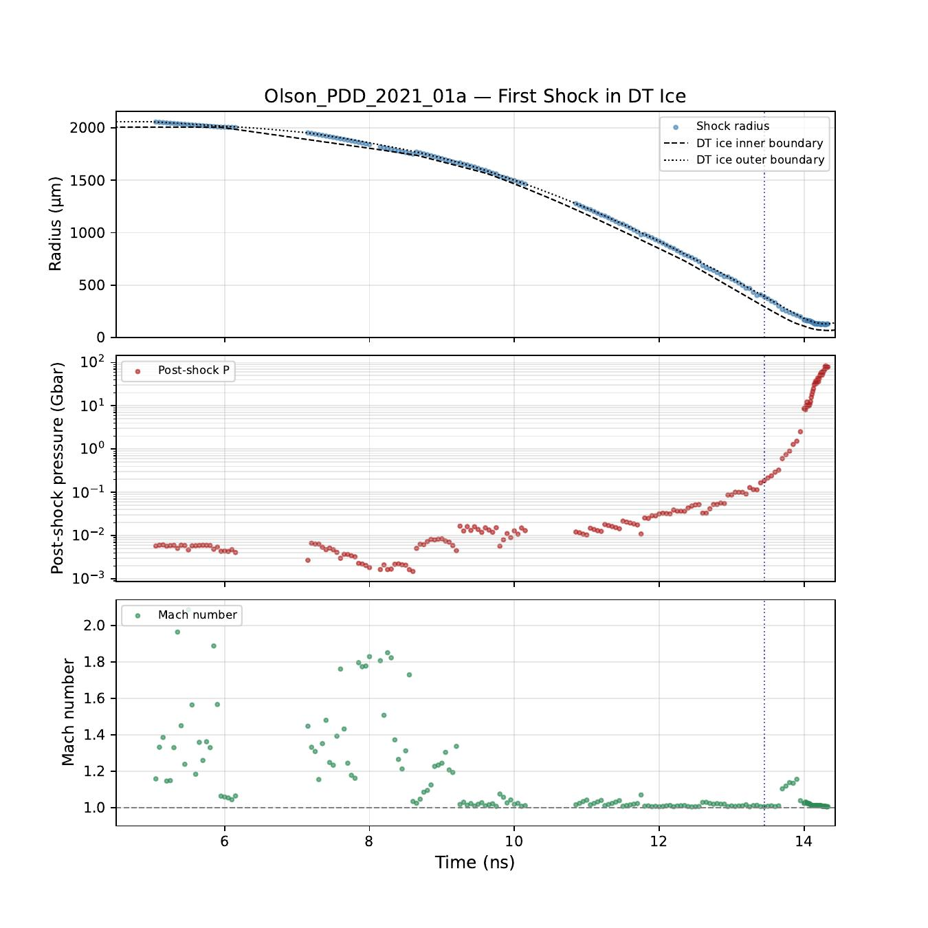
Figure 3. First shock diagnostics in DT ice — Olson_PDD_2021_01a — Top: shock radius (blue dots) vs DT ice inner and outer boundaries (dashed/dotted lines). The shock tracks the outer ice boundary throughout compression. Middle: post-shock pressure on log scale, rising from ~0.005 Gbar during the foot phase to ~100 Gbar at stagnation. Bottom: Mach number, showing weak shocks (M ≈ 1.0–1.8) throughout the foot and ramp phases — consistent with the low adiabat (α ≈ 0.2) set during foot transit. Reference vertical lines mark foot end, peak start, and peak velocity time.

Xcimer Energy — Target Design Group | April 2026 | For distribution to collaborators and Helios code developers

