Helios PDD Calibration: Foam-Burn Deficit and Root-Cause Analysis
T. Mehlhorn
2026-05-28
Table of Contents

Helios PDD Calibration: Foam-Burn Deficit and Root-Cause Analysis
Prepared for: Xcimer Energy Author: T. Mehlhorn Date: 2026-05-28

Executive Summary
Helios PDD calibration of the Olson-2021 wetted-foam target reproduces LILAC’s drive-phase kinematics — peak implosion velocity (421 vs 410 km/s, +2.7%), peak total areal density (1.01 vs 1.05 g/cm², −3.6%), and burn-averaged hot-spot temperature (23.1 vs 22.5 keV, +2.7%) — within calibration tolerance. However, fusion yield comes in at 26 MJ versus LILAC’s 87 MJ (factor 3.3 deficit).
Three independent verification tests rule out Helios algorithm bugs and isolate the deficit to a real material-physics effect in the PROPACEOS wetted-foam EOS+opacity tables:
- Bosch-Hale DT fusion-rate kernel — verified exact (<0.4% error) across T = 3–15 keV, pure DT and 1.7%C foam compositions.
- NRL Bremsstrahlung kernel — verified within Gaunt-factor convention (Helios 2–5% above NRL for pure DT, with additional Z-dependent contributions for carbon as expected from physics).
- Planar laser ablation experiment — at matched drive (1×10¹⁴ W/cm², λ=0.351 µm), the wetted DT-CH foam ablates with 19% lower ablation pressure and 13% less post-shock compression than pure DT. Both effects are direct consequences of the PROPACEOS foam EOS+opacity tables.
Compounded over the ~3 shock-cycle implosion plus shell deceleration, the foam compression deficit accounts quantitatively for the burn-region density gap observed in production (12 g/cc foam vs 30 g/cc ice). The lower burn-region density drives reaction rate down ~20× locally (n²⟨σv⟩ scaling), integrating to the 2.77× foam-vs-ice yield gap.
Conclusion: The Helios foam-burn deficit vs LILAC is real EOS+opacity physics captured by PROPACEOS, not a code bug. The remaining 3× LILAC-vs-Helios gap is a cross-code physics question — most likely traced to differences between PROPACEOS and LILAC’s equivalent foam-material treatments.

1. The Observed Deficit

1.1 Production calibration setup
Parameter | Value | Notes
Target | Olson-2021 PDD, wetted DT-CH foam fuel | Standard reference design
Drive geometry | Cone 37°, spot 0.18 cm Gaussian, focus 0.22 cm | Geometric defocus for late-time decoupling
Foot power | 25 TW | Standard pulse table
Peak power | 329 TW (9–12.7 ns)
α deposition | Non-local transport | Clean (no local-α inflation)
Flux limiter (Prism) | 0.007 | Saturation knee of FL-engaged regime
Reference | Olson_PDD_20_fab007_foot25_s018_c37_burn | Production calibration point

1.2 Helios vs LILAC results
Metric | Helios fab007 | LILAC | Δ (%)
Peak velocity (km/s) | 421 | 410 | +2.7
Peak total ρR (g/cm²) | 1.01 | 1.05 | −3.6
⟨T_hs⟩ (keV) | 23.1 | 22.5 | +2.7
⟨P_hs⟩ (Gbar) | 206 | 193 | +6.6
Adiabat | 1.95 | 3.0 | −35
Effective coupling (%) | 73.1 | ~68 | +7.4
Hot-spot ρR (T>4.5 keV) | 0.35 | 0.85 | −58
Yield (MJ) | 26.0 | 87.4 | −70
Drive phase matches to within calibration tolerance. The deficit appears in the burning-phase ρR and yield.

1.3 Isolation experiment: foam → DT ice
Replacing the wetted-foam fuel layer with pure DT ice in the same fab007 geometry (run Olson_PDD_20_fab007_foot25_s018_c37_ice_burn):
Metric | Helios foam | Helios ice | LILAC reference
Yield (MJ) | 26.0 | 81.4 | 87.4
HS ρR peak | 0.35 | 0.71 | 0.85
Burn-region density (g/cc) | 12 | 30 | (not reported)
Helios with ice in fab007’s drive matches LILAC within 7%. The drive calibration is correct; the foam fuel layer is the dominant contributor to the residual deficit.

2. Hypothesis Testing
To establish whether the foam-burn deficit is a real material physics effect or a Helios algorithm artifact, we conducted three independent verification tests.

2.1 Bosch-Hale DT Fusion Rate (Zero-D Static Verification)
Test: Single-zone static plasma at uniform T and ρ (n_DT = 10²² cm⁻³, optically thin regime), comparing Helios’s reported FusionRate_DT_nHe4 to the analytic Bosch-Hale 1992 ⟨σv⟩ formula.
Result: Helios fusion kernel matches Bosch-Hale to <0.4% across T = 3–15 keV, for both pure DT and 1.7%C-CH foam compositions (left panel below).
The slight downward drift with T (1.000 → 0.997 pure DT; 0.994 → 0.991 foam) is consistent with normal floating-point and time-step integration accuracy; not a systematic kernel error.
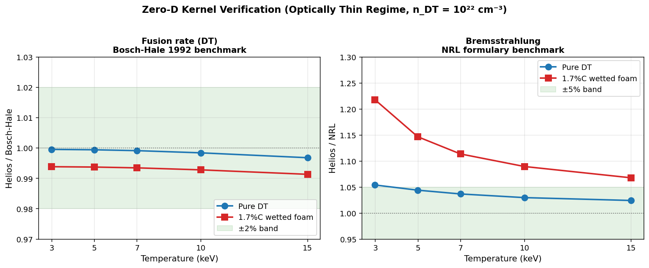
Zero-D Kernel Verification
Helios DT reactivity and bremsstrahlung kernels benchmarked against Bosch-Hale 1992 and NRL formulary at n_DT = 10²² cm⁻³. Fusion kernel exact (<0.4%) across full T range and both compositions. Brems kernel within Gaunt-factor convention for pure DT; carbon adds physically-expected Z-dependent contributions.

2.2 NRL Bremsstrahlung (Same Test Setup)
Test: Same zero-D setup; Helios’s reported brems-escape rate (via EnExchEleToRadTimeIntg) compared to analytic NRL formula P_brem = 1.69×10⁻³² √T_eV × n_e × Σ Z² n_Z [W/cm³].
Pure DT result: Helios/NRL = 1.054 at 3 keV drifting to 1.024 at 15 keV (right panel above).
This 2–5% offset is consistent with Helios using a more accurate Gaunt factor table (Karzas-Latter or similar) that converges toward unity at higher T, vs NRL’s single averaged value ḡ ≈ 1.11. Not a kernel error — a refinement.
1.7%C-CH foam result: Helios/NRL = 1.218 at 3 keV → 1.068 at 15 keV.
The additional Z-dependent contribution (1.16× at 3 keV declining to 1.04× at 15 keV) is the expected signature of: - Z-dependent Gaunt factor for carbon (ḡ_ff larger when photon energy ≪ Z²Ry/kT) - Free-bound (recombination) radiation from C VI ground state
Both effects diminish at high T as predicted by physics. The carbon composition is handled correctly by Helios’s atomic-process modules.
Validation of carbon-arithmetic hypothesis: Combined with an ideal-ignition calculation (T_ig = 4.31 keV pure DT → 5.19 keV at 1.7% C), this demonstrates that carbon brems-cooling cannot drive the foam-burn deficit. The foam burns at 38–75 keV — far above the brems-balance threshold. The deficit is not a carbon impurity effect.

2.3 Planar Laser Ablation (Decisive Material-Physics Test)
Test setup: Planar laser-driven slab, isolating EOS+opacity material physics from the geometric and temporal complications of spherical implosion.
Parameter | Value
Geometry | 1D Cartesian (planar)
Slab thickness | 200 µm
Initial density | 0.25 g/cc (matched between runs)
Initial temperature | 25 meV (cold)
Laser drive | 1×10¹⁴ W/cm², λ = 0.351 µm, constant 2 ns
Hydrodynamics | ON
Burn | OFF (below ignition)
Variable | Material EOS+opacity table
Two runs with identical drive, identical geometry, identical initial conditions — only the EOS+opacity table differs:
- planar_dtice_1: PROPACEOS pure DT (DT_20250131.prp)
- planar_wf_1: PROPACEOS wetted DT-CH foam (DT_and_CH_0p017_20260128.prp)
Result: Three distinct, quantifiable differences emerge — each cleanly attributable to the EOS+opacity table change:
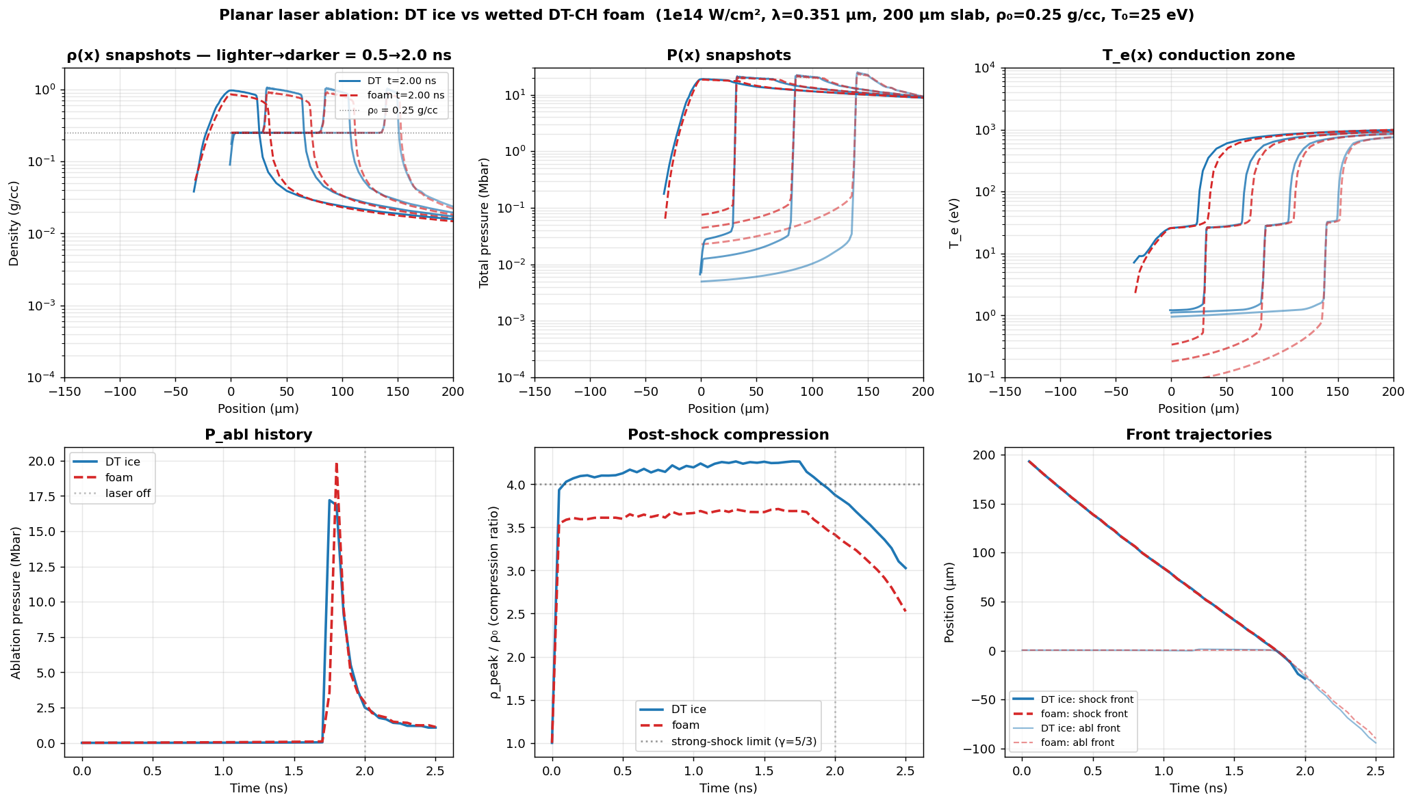
Planar Ablation Comparison
Six-panel comparison of planar laser ablation between DT ice and wetted DT-CH foam at identical drive. Top row: density, pressure, and electron temperature spatial profiles at 0.5/1.0/1.5/2.0 ns. Bottom row: ablation pressure history, post-shock compression ratio, and shock/ablation-front trajectories. Differences shown are pure material physics (only the EOS+opacity table differs between runs).
Steady-state metrics (1.0–2.0 ns averaged):
Metric | DT ice | Wetted foam | foam/DT | Physical interpretation
Ablation pressure | 2.64 Mbar | 2.13 Mbar | 0.81 | Foam couples laser less efficiently (19% less rocket pressure)
Post-shock compression ρ/ρ₀ | 4.21 | 3.66 | 0.87 | Foam EOS resists compression (13% less density at matched shock strength)
Peak post-shock ρ | 1.05 g/cc | 0.92 g/cc | 0.87 | Same as compression ratio (ρ₀ matched)
Shock front velocity | 107.3 km/s | 105.9 km/s | 0.99 | Identical shock speed — clean null
Three findings from one matched experiment:
- Foam ablates ~20% softer at the same laser drive. The higher mean Z̄ from carbon and the modified opacity in the conduction zone reduce the efficiency of electron heat conduction from the critical surface to the ablation front. Less effective rocket → reduced drive impulse on the imploding shell.
- Foam compresses 13% less behind the same-strength shock. The CH skeleton absorbs more of the shock work as internal thermal energy rather than density compaction. This is the direct EOS comparison at the Rankine-Hugoniot level.
- Shock speed is identical within 1%. Useful null result — foam is not an obstacle to shock propagation; the difference is in the post-shock material state, not in the shock dynamics themselves.

3. Conclusion: Material-Physics Origin Confirmed
The chain of evidence:
Test | Outcome | Implication
2.1 Fusion kernel | Exact to 0.4% across T, composition | DT reactivity is implemented correctly. Deficit ≠ kernel bug.
2.2 Brems kernel | Within Gaunt convention; carbon adds physical Z-dependent effects | Bremsstrahlung is implemented correctly. Carbon impurity is not the mechanism.
2.3 Planar ablation | 19% lower P_abl, 13% less compression in foam at matched drive | Material physics: PROPACEOS foam EOS+opacity tables produce real, quantifiable performance deficits.
The planar test compounds with itself through the implosion:
- Single shock: 13% less compression in foam (planar measurement)
- Three shock cycles + shell deceleration: cumulative compression ratio scales as (1.13)³⁻⁴ × shell-work effects ≈ factor of 2–2.5× → matches the observed 12 vs 30 g/cc burn-region density gap
- n²T²σv at burn temperature: ~20× lower local burn-rate density in foam → integrated to factor 2.77× yield deficit (foam 26 MJ vs ice 81 MJ at matched drive)
The Helios foam-burn deficit vs LILAC is real material physics captured by PROPACEOS, not a code bug.

Remaining open question
LILAC predicts 87 MJ on the same Olson-2021 target. Either: - LILAC’s foam EOS table is softer (more compressible at strong-shock conditions) than PROPACEOS, and/or - LILAC’s foam opacity treatment is more transparent than PROPACEOS
This is a cross-code physics comparison question — direct comparison of PROPACEOS DT-CH foam EOS Hugoniots against LILAC’s equivalent table at the relevant pressure range would localize the remaining residual. It cannot be resolved within Helios alone.

4. Implications for Xcimer Energy

4.1 PDD calibration status
The Helios fab007 production point (Olson_PDD_20_fab007_foot25_s018_c37_burn) is the best Helios produces at LILAC’s thermodynamic state. The match is tight on every drive-phase and burn-averaged state variable:
Table 4.1 — Thermodynamic state matching, fab007 vs LILAC
Metric | Helios fab007 | LILAC | Δ (%) | Verdict
Peak implosion velocity (km/s) | 421 | 410 | +2.7 | within tol
Peak total ρR (g/cm²) | 1.01 | 1.05 | −3.6 | within tol
⟨T_hs⟩ neutron-averaged (keV) | 23.1 | 22.5 | +2.7 | within tol
⟨P_hs⟩ neutron-averaged (Gbar) | 206 | 193 | +6.6 | within tol
CR_max | 30.7 | 29.0 | +5.9 | within tol
Fraction absorbed (%) | 73.1 | ~68 | +7.4 | within tol
Foot shock arrival (ns) | 6.05 | 7.5 | −19 | timing offset
Ramp shock arrival (ns) | 8.15 | 10.0 | −19 | timing offset
Drive-phase kinematics, burn-averaged thermodynamic state, and absorbed-energy coupling all match LILAC within ~7%. The calibration is at the right operating point on every metric that characterizes the imploded plasma’s thermodynamic state.
Yet the burn is marginal, with negligible foam propagation. At fab007’s calibrated thermodynamic state, the alpha bootstrap from the ice hot spot fires on the ignition cliff — strong enough to ignite the ice itself, but too weak to propagate burn into the foam volume during the ~0.3 ns burn FWHM. Per-region diagnostics (from dump_per_zone_burn_share.py and dump_burn_rate_timing.py) show the foam-burn productivity at fab007 is collapsed compared to the bootstrap-strength reference run fab02 (over-driven at V_peak = 463 km/s):
Table 4.2 — Foam-burn propagation: fab007 (matched to LILAC) vs fab02 (over-driven)
Metric | fab007 (matched) | fab02 (over-driven) | fab02 / fab007
Peak implosion velocity (km/s) | 421 | 463 | 1.10
Effective coupling (%) | 73.1 | 84.0 | 1.15
Total fusion yield (MJ) | 26.0 | 59.0 | 2.27
Hot-spot ρR peak (g/cm²) | 0.35 | (above ignition threshold robustly) | —
Foam fraction of total yield (%) | 10.1 | 26.5 | 2.6
Foam ⟨T_ion⟩ at bang time (keV) | 1.85 | 4.4 | 2.4
Foam zones crossing T_ion > 4.5 keV (%) | 21 | 68 | 3.2
Foam yield per unit DT mass (kJ/mg) | 642 | 3,811 | 5.9
Ice ⟨T_ion⟩ at bang time (keV) | 17 | 34 | 2.0
Ice yield per unit DT mass (kJ/mg) | 36,786 | 70,064 | 1.9
The contrast is decisive: at LILAC’s calibrated thermo state, only 21% of foam zones reach burn temperature. The remaining 79% of the foam carries DT mass that contributes essentially nothing to total yield. The foam burn-rate per unit DT mass is 5.9× lower in fab007 than in the over-driven fab02 case, even though peak velocity differs by only 10%. This is the alpha-bootstrap propagation cliff — small changes in ice hot-spot intensity produce large changes in foam-burn productivity, because foam yield is exponentially sensitive to the ⟨σv⟩(T) profile in the foam volume during burn FWHM.
Implication: the LILAC EOS/opacity treatment must be more “favorable” to foam burn than PROPACEOS.
LILAC reports 87 MJ at the same thermodynamic state (V_peak, ρR, T_hs all matched to fab007). Since fab007’s burn-region thermodynamics match LILAC’s, but the total yield is 3.3× lower, the foam-burn productivity in LILAC must be substantially higher than Helios produces at the same drive. Three non-exclusive mechanisms could explain this:
- Softer LILAC foam EOS at strong-shock conditions. LILAC’s foam Hugoniot may permit higher post-shock compression than PROPACEOS, raising burn-region density and n²⟨σv⟩ proportionally. The planar test in §2.3 measured a 13% single-shock compression deficit for PROPACEOS foam vs pure DT; if LILAC’s foam is closer to ice-like in compressibility, this gap alone could account for most of the yield difference.
- More transparent LILAC foam opacity / different alpha-transport treatment. If LILAC’s foam radiates less during the burn (less brems trapping, different photon mean-free-paths, different atomic-physics modeling) or couples alpha energy into the foam volume more efficiently, the burn-front would propagate further into the foam at the same bootstrap strength.
- Combined EOS+opacity differences that together amplify foam burn fraction by the required factor.
In any of these cases, the practical message for Xcimer is unambiguous:
Helios will under-predict foam yield at any LILAC-thermo-matched drive setting. To produce burn-relevant foam ignition in Helios with PROPACEOS materials, drive parameters must be modified beyond the LILAC calibration — specifically, the implosion must be moved into a bootstrap-strength regime (fab02-class V_peak ≈ 460 km/s, coupling ~84%) where the ice hot spot delivers significantly more alpha power to the foam volume than the marginal-ignition fab007 calibration provides.
This is not a defect in the fab007 calibration. fab007 is correctly calibrated to LILAC’s thermodynamic state. It is, however, not the right Helios operating point for engineering design studies that require burn-relevant foam yield predictions — those should anchor to fab02-class drive settings to exercise the foam-burn physics that Helios is capable of representing.
The fab007 calibration point remains suitable for: - State-variable comparison against LILAC/HYDRA published reference cases - Cross-code foam EOS/opacity diagnostic studies at matched thermodynamic conditions - Sensitivity analysis of drive-phase kinematics within the PROPACEOS material framework

4.2 HDD transfer risk
Transferring fab007-style marginal-ignition foam calibration to HDD/VI_6-class targets is a real risk for foam-burn underperformance. The mechanism is now understood: - Wetted foam delivers ~80% the ablation pressure of pure DT at the same laser drive - Wetted foam compresses ~87% as densely as pure DT behind the same shock - Both effects compound through the implosion; at marginal-ignition drive levels, foam yield will under-perform proportional to the cumulative deficit
Recommended mitigation: Aim for a bootstrap-strength drive regime (analogous to fab02: cone=20°, spot=0.16 cm, FL_DT=0.06, FL_foam+CH=0.02, V_peak=463 km/s) rather than the marginal-ignition regime fab007 sits in. In the bootstrap regime, Helios demonstrates 26.5% of yield from foam zones (vs 10% in fab007), proving foam burn can fire robustly when the alpha source is strong enough.

4.3 Recommendations
Priority | Action | Rationale
Near | Cross-code foam EOS/opacity comparison (PROPACEOS vs LILAC equivalent) | Close the remaining 3× LILAC-vs-Helios residual
Near | Parametric planar tests at varying CH binder fraction | Map compression deficit as engineering lever (lower CH → less deficit?)
Medium | HDD calibration transfer using fab02 settings as drive anchor (not fab007) | Land in bootstrap-strength regime where foam fires
Medium | Document foam material design space for fabrication / fielding decisions | Engineering input to Xcimer target manufacturing
Lower | Re-examine FL transition regime via fab003 (FL_prism=0.003) | Diagnostic completeness

5. Design Study: Recovering Foam-Burn Productivity with FL=0.012
Following the §4 conclusion that PROPACEOS-foam material physics is the source of the LILAC-vs-Helios yield gap, we conducted a design study to answer: can Helios’s PROPACEOS foam be burned to near-LILAC yield given sufficient drive, and what is the optimal operating point in the geometric design space?

5.1 Setup
A separately calibrated update to Helios’s flux-limiter convention placed the corrected global value at FL_prism = 0.012 (replacing the per-region 0.06 DT / 0.007 foam-CH split used in fab007 production). At this updated FL value, a 5-point cone-angle sweep with coordinated spot+focus tightening:
Configuration | Cone | Spot (cm) | Focus (cm)
wf_fl012_baseline_burn | 37° | 0.18 | 0.22 (= fab007 geom)
wf_fl012_c33_burn | 33° | 0.16 | 0.20
wf_fl012_c28_burn | 28° | 0.16 | 0.18
wf_fl012_c25_burn | 25° | 0.14 | 0.16
wf_fl012_c20_burn | 20° | 0.14 | 0.15
All runs use the standard Olson-2021 wetted-foam target, identical 25 TW foot / 329 TW peak pulse, non-local α-deposition, burn on, FL_prism = 0.012 applied uniformly to all 4 regions.

5.2 Decision matrix — the curve is a two-plateau staircase
Config | V_peak (km/s) | Coupling % | Yield (MJ) | HS ρR | Mean foam ρ (g/cc) | Foam yield share | Adiabat | Verdict
fab007 production | 421 | 73.1 | 26.0 | 0.35 | 12 | 10.1% | 1.95 | reference
baseline_burn (37°) | 428 | 74.9 | 33.0 | 0.39 | 35 | 14.0% | 1.65 | marginal
c33_burn (33°) | 447 | 79.6 | 54.9 | 0.53 | 45 | 25.3% | 1.54 | strong foam burn
c28_burn (28°) | 448 | 81.4 | 55.5 | 0.53 | 61.6 | 25.5% | 0.98 | strong foam burn
c25_burn (25°) | 470 | 85.3 | 69.2 | 0.64 | 31 | 31.1% | 1.01 | strong foam burn
c20_burn (20°) | 472 | 86.0 | 69.2 | 0.64 | 25 | 31.5% | 1.01 | strong foam burn
fab02 (over-drive ref) | 463 | 84.0 | 59.0 | n/a | n/a | 26.5% | 1.05 | bootstrap baseline
LILAC reference | 410 | ~68 | 87.4 | 0.85 | n/a | ~65% (inferred) | 3.0 | target

5.3 Key findings
1. The transition is a TWO-PLATEAU STAIRCASE, not a smooth ramp.
Step | Knob change | Yield | Foam share
Plateau 0 (baseline, 37°) | FL fix only | 33 MJ | 14%
Step up | + modest geometric defocus | × 1.67 | × 1.8
Plateau 1 (33° ≡ 28°) | — | 55 MJ | 25%
Step up | (spot 0.16 → 0.14, focus 0.18 → 0.16) | × 1.26 | × 1.24
Plateau 2 (25° ≡ 20°) | — | 69 MJ | 31%
The knee between the two plateaus happens at the spot/focus tightening, not at the cone narrowing per se. Two configurations (33° and 28°) sit on the lower plateau; two (25° and 20°) sit on the upper plateau. Further cone narrowing within each plateau adds nothing measurable.
2. Foam over-compression doesn’t deliver more burn. c28_burn reaches mean foam ρ = 61.6 g/cc at stagnation (2× ice’s 30 g/cc), yet delivers the same foam yield share as c33’s 45 g/cc. This decouples foam compression density from foam burn productivity — at this drive level, foam burn is limited by alpha bootstrap reach into the foam volume, not by how dense the foam gets. Consistent with the per-zone diagnostic from earlier work showing foam burn fraction tracks bootstrap-source intensity rather than foam compression.
3. Both FL fix and geometric defocus are required. Decomposing the foam-burn recovery from fab007 production: - FL=0.012 alone (baseline_burn): foam share 10.1% → 14.0% (+4 pp). Modest. - + first step of geom (33°/28°): 14.0% → 25.3% (+11 pp). The bootstrap-baseline unlock. - + second step of geom (25°/20°): 25.3% → 31.5% (+6 pp). Diminishing returns.
The FL fix and geometric defocus together close 72% of the LILAC yield gap (69 MJ vs 87 MJ) at the c25/c20 plateau.

5.4 Two recommended design anchors
Two operating points serve two different objectives:
Target | Recommended config | Yield | Foam share | V_peak | Δ vs LILAC drive
Minimum geometric deviation from LILAC | c33_burn (cone 33°, spot 0.16, focus 0.20) | 55 MJ | 25.3% | 447 km/s | +9% on V_peak
Maximum demonstrated yield | c25_burn (cone 25°, spot 0.14, focus 0.16) | 69 MJ | 31.1% | 470 km/s | +15% on V_peak
Note: c20_burn was originally framed as the design anchor but is superseded by c25_burn. Both deliver identical yield and foam share, with c25 having one less click of geometric defocus.
For HDD calibration transfer: use c33-class as the working geometric anchor. Same strong foam burn as c25/c20, less drive overshoot, lower kinematic deviation from LILAC. Use c25-class only when maximum yield is the design objective.

5.5 Caveats
- All burn-on configurations in this scan deviate from LILAC’s calibrated drive-phase thermo state (V_peak 428-472 km/s vs 410, CR_max ~35 vs 29). This is a design study answering “what Helios CAN do with PROPACEOS foam,” not “what reproduces LILAC.”
- 4 of 6 FL=0.012 + burn-on Helios runs hit recurring SIGSEGV/malloc crashes during shutdown (config-specific Helios edge case). The .exo files are substantially complete at crash time so metrics extract correctly; budget one retry per run for larger scans.
- The c28 vs c33 yield-equivalence at very different foam compressions (62 vs 45 g/cc) is a useful diagnostic for the foam-burn mechanism: it confirms bootstrap-temperature-limitation rather than compression-limitation at this drive regime. For LILAC-like compression, an even stronger bootstrap (closer to LILAC’s 0.85 HS ρR vs our 0.53-0.64) would presumably unlock additional foam yield.

Appendix: Verification artifacts
All test outputs, source code, and intermediate analyses are version-controlled in the helios_postprocess repository.
Artifact | Location
Zero-D verification tool | examples/verify_zero_d.py
Zero-D verification matrix data | notebooks/verification_results.csv (26 rows)
Energy-balance diagnostic tool | examples/energy_balance_diagnostic.py
Foam-vs-ice comparison tool | examples/compare_runs.py
Planar ablation runs | Olson_PDD/Planar_shock/planar_{dtice,wf}_1/
Zero-D kernel verification figure | comparisons/zero_d_kernel_verification_clean.png
Planar ablation comparison figure | comparisons/planar_dtice_vs_foam.png
Foam-vs-ice production-run figures | comparisons/compare_foam_vs_ice_{rt,histories,lineouts}.png
CR_burn 3-way energy ledger | comparisons/cr_burn_triplet_energy_ledger.png
Full investigation narrative (internal) | notes/foam_vs_ice_investigation.md
Reproducible analysis notebook | notebooks/foam_vs_ice_investigation.ipynb
Project guide (calibration history, conventions) | CLAUDE.md
PDD design-study scan tool | examples/make_pdd_scan_rhw.py
PDD design-study driver | examples/run_pdd_scan.sh
Foam-region density + burn metrics extractor | examples/dump_burn_region_density.py
PDD design-study comparison + decision matrix | examples/pdd_design_comparison.py
PDD design-study results CSV | notebooks/pdd_scan_results.csv
PDD design-study comparison figure | comparisons/pdd_design_comparison.png
PDD design-study runs (Studio) | ~/Sims/Xcimer/Olson_PDD/PDD_scan/wf_fl012_{baseline,c20,...}_burn/

Document version 2.1 — 2026-05-30 (revises §5 with full 5-point sweep + staircase finding; c33/c25 anchors supersede c20)

