Smart Campus Assistant
Software Requirements Specification

Version | 1.0
Date | March 2026
Project | Capstone Project

Table of Contents

1. Project Overview | 3
2. Stakeholders | 3
3. Functional Requirements | 4
4. Non-Functional Requirements | 4
5. Use Cases | 5
6. Edge Cases Summary | 9
7. UML Diagrams | 10

1. Project Overview

1.1 Purpose of the System
The Smart Campus Assistant is a lightweight web application designed to allow students to ask questions about campus information — such as reception hours, exam schedules, room locations, and general FAQs — in natural language and receive instant answers powered by Artificial Intelligence.

1.2 System Goals
- Provide immediate, accurate, and 24/7 answers to students' campus-related queries.
- Reduce the manual workload on campus administration and support staff.
- Ensure AI responses are strictly bounded to campus context to prevent hallucinations.

1.3 System Architecture Overview
The system consists of three integrated components:

- Frontend — Responsive Web UI where students submit questions and view answers.
- Backend — FastAPI server that handles routing, input validation, question classification, and communication with the AI service.
- AI Service — External LLM (Gemini that processes the classified prompt and generates a context-aware response.

2. Stakeholders

Stakeholder | Role | Key Interests
Student | Primary End User | Fast, accurate answers; friendly UI; 24/7 availability
Developer | Builder & Maintainer | Clean architecture, testability, scalability
AI Service (OpenAI/Claude) | External Processing System | Receives well-formed prompts; returns structured responses
Campus Administrator | Data Owner | Easy database updates; accurate information reflected in real-time

3. Functional Requirements
These are the core actions the system MUST support:

ID | Description | Priority | Source
FR-01 | The system must allow users to submit text-based queries through a web interface. | High | UC-01–06
FR-02 | The backend must automatically classify incoming questions into at least three categories: Schedule, General Info, and Technical Issue. | High | UC-01–05
FR-03 | The system must retrieve context-specific information from a structured database to assist the AI in generating accurate responses. | High | UC-01–04
FR-04 | The system must trigger a predefined fallback response when the AI cannot confidently answer or when the question is out of scope. | High | UC-05
FR-05 | Campus administrators must be able to update database records (exam rooms, times, office hours) through a dedicated interface. | Medium | UC-06
FR-06 | The system must validate all admin input before saving — required fields cannot be left empty. | Medium | UC-06

4. Non-Functional Requirements
These define how well the system performs, using measurable metrics:

Category | Requirement | Quantitative Metric | Measurement Method
Performance | Response Time | AI response displayed within 3 seconds of clicking Send, on a standard internet connection (>10 Mbps) | Pytest + time.time(); manual stopwatch test
Security | API Key Protection | API keys must never appear in source code or Git history. Managed exclusively via .env files excluded from version control. | GitHub secret scan; .gitignore audit
Reliability | Uptime | Backend server must maintain ≥ 99% uptime during active hours (08:00–22:00). Equals < 9 minutes downtime per day. | Health check endpoint; server logs
Usability | Responsiveness | Frontend must render correctly on screens ≥ 375px wide (mobile-first). All core features accessible without horizontal scrolling. | Chrome DevTools device emulation
Scalability | Concurrent Load | System must handle 50 simultaneous users without response time exceeding 5 seconds | Locust load test
Maintainability | Test Coverage | AI service module must have ≥ 70% code coverage | pytest-cov report

5. Use Cases
The system supports the following core interactions:

UC-01: Query Exam Schedule (Main Scenario)
Actor | Student
Goal | Find out when and where a specific exam takes place.
Precondition | Student is connected to the web interface. The exam exists in the campus database.
Main Flow | 1. The user asks: "When is the SQL exam?" 2. The backend classifies the query as "Schedule". 3. The system retrieves the exam record from the database. 4. The AI formats and returns the response: "The SQL exam is on Feb 25 in Room 401." 5. The answer is displayed in the chat interface with the category label "Schedule".
Postcondition | Student has received the exam date, time, and location.
Edge Case | The user asks about a course that does not exist in the database. The AI responds: "I couldn't find an exam for that course in our system. Please double-check the course name."

UC-02: Real-Time Technical Issue Reporting
Actor | Student
Goal | Get immediate help or a workaround for a campus technical issue.
Precondition | Student is experiencing a technical problem on campus.
Main Flow | 1. The user types: "The library Wi-Fi is down." 2. The backend classifies the query as "Technical Issue". 3. The AI provides an immediate workaround: "I see there's a network issue in the library. Please try connecting to 'Campus-Guest' or contact support at *1234." 4. The response is displayed with the category label "Technical Issue".
Postcondition | Student received an actionable workaround or contact information.
Edge Case | The user types only "broken" insufficient context. The AI asks for clarification: "I'd love to help! Which system or building is experiencing the issue?"

UC-03: General Information Query (Foreign Language Support)
Actor | Student
Goal | Get campus information in a non-native language (English).
Precondition | Student is connected to the interface and asks in English or Hebrew.
Main Flow | 1. The user asks: "Where is the main library located?" 2. The backend classifies as "General Info". 3. The AI retrieves the location from the database and replies: "The main library is located in Building 4, on the second floor." 4. The response is displayed with the category label "General Info".
Postcondition | Student received the requested campus information.
Edge Case | The user types random gibberish (e.g., "asdfgh"). The AI triggers a fallback: "I didn't quite catch that. Could you please rephrase your question?"

UC-04: Combo Query (Schedule + Facilities)
Actor | Student
Goal | Find a location that satisfies multiple conditions simultaneously.
Precondition | Student needs a study space and has specific requirements.
Main Flow | 1. The user asks: "Where is an empty study room near a coffee machine?" 2. The backend classifies as "Schedule" + "General Info" (multi-intent). 3. The AI processes both conditions, queries the database for room availability and facility proximity. 4. The AI suggests the best match: "Room 205 is currently free and is located next to the coffee station on Floor 2."
Postcondition | Student received a room recommendation satisfying both conditions.
Edge Case | No matching room exists. The AI suggests the closest alternative: "There are no empty rooms with a coffee machine right now, but Room 102 is empty and there's a cafeteria one floor down."

UC-05: Out-of-Scope Query (Mandatory Fallback)
Actor | Student
Goal | The system refuses to answer non-campus questions to prevent AI hallucinations.
Precondition | User attempts to use the assistant for a purpose outside its defined scope.
Main Flow | 1. The user tries to trick the AI: "Write a Python script to calculate an average." 2. The backend classifies the query as "Out of Scope". 3. The system triggers the mandatory fallback response: "I am the Smart Campus Assistant. I can only help with campus schedules, services, and technical issues." 4. No AI API call is made — the fallback is served directly from the backend.
Postcondition | User is informed of the system's scope. No irrelevant content is generated.
Edge Case | The external AI API goes down during a valid request. The backend catches the error and displays: "The AI service is currently unavailable. Please try again later." The error is logged server-side.

UC-06: Campus Admin Updates Critical Information
Actor | Campus Administrator
Goal | Update database records so the AI provides real-time, accurate answers.
Precondition | Admin is authenticated and has edit permissions on the campus database.
Main Flow | 1. The Admin logs into the admin panel. 2. The Admin navigates to the exam schedule section. 3. The Admin changes the SQL exam room from 302 to 401 and clicks Save. 4. The system validates all required fields. 5. The database is updated and the Admin sees: "Information updated successfully." 6. All subsequent student queries now return the updated room number.
Postcondition | Database reflects the updated information. AI responses are immediately accurate.
Edge Case | The Admin accidentally leaves the "Time" field empty. The system blocks the save and shows: "The 'Time' field cannot be empty. Please correct it and try again."

6. Edge Cases Summary
The following table consolidates all identified edge cases and their handling strategies:

ID | Source | Trigger | System Response
EC-01 | UC-01 | Student queries a course not in the database | AI responds: "I couldn't find an exam for that course. Please check the course name."
EC-02 | UC-02 | User sends vague input ('broken') with no context | AI asks for clarification: "Which system or building is experiencing the issue?"
EC-03 | UC-03 | User inputs gibberish or nonsensical text | AI triggers fallback: "I didn't quite catch that. Could you rephrase your question?"
EC-04 | UC-04 | No room matches both conditions (availability + proximity) | AI suggests the closest alternative: available room + nearby cafeteria
EC-05 | UC-05 | User asks an off-topic question (coding, weather, etc.) | Backend serves fixed fallback without calling AI API. Scope message returned.
EC-06 | UC-05 | External AI API is down or returns HTTP 500 | Backend catches exception, returns: "AI service unavailable. Try again later." Error logged.
EC-07 | UC-06 | Admin submits form with empty required field | System blocks save, highlights the empty field, shows validation error message.

7. UML Diagrams

7.1 Use Case Diagram
The diagram below presents all system actors and their associated use cases. Relationships between use cases are shown using standard UML notation (<<include>>, <<extend>>).

Actor | Associated Use Cases
Student | UC-01: Query Exam Schedule, UC-02: Report Technical Issue, UC-03: General Info Query, UC-04: Combo Query, UC-05: Out-of-Scope (fallback triggered)
Campus Administrator | UC-06: Update Campus Information
AI Service (External) | Processes prompts <<include>> in UC-01 through UC-04; bypassed in UC-05 (fallback)
IT Team | Monitor server uptime; manage API keys and .env configuration

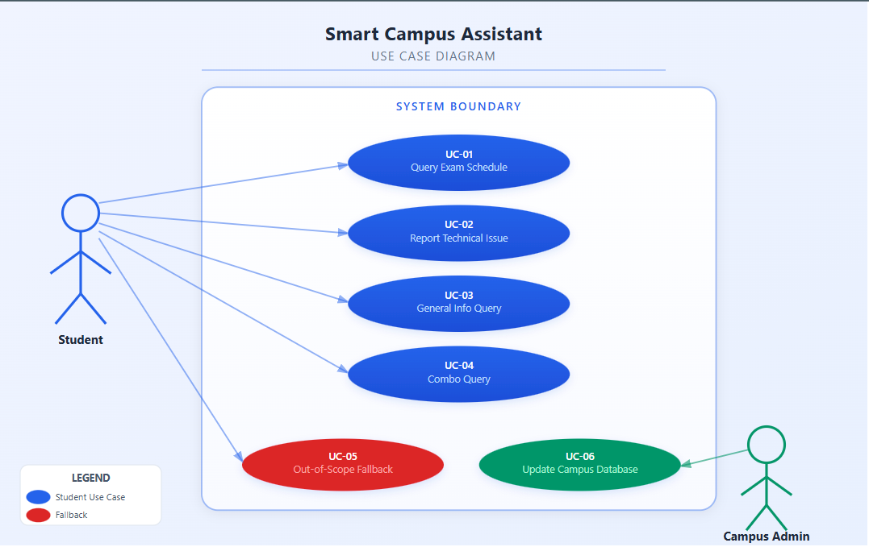

7.2 Sequence Diagram — Main Flow (UC-01)
The sequence diagram below illustrates the asynchronous flow for the primary scenario: a student submits a question, the backend classifies and enriches it, the AI service processes it asynchronously, and a structured response is returned to the user.

Step | Action | Between | Description
1 | Submit Question | Student → Frontend | Student types "When is the SQL exam?" and clicks Send.
2 | POST /ask | Frontend → Backend | Frontend sends: { "question": "When is the SQL exam?" }
3 | Validate Input | Backend (internal) | Check: length > 2, not empty, no injection attempts.
4 | Classify Question | Backend (internal) | Category assigned: "Schedule".
5 | Fetch DB Context | Backend → Database | Query campus DB for matching exam records.
6 | Build Prompt | Backend (internal) | Construct system prompt with campus context + user question.
7 | Async API Call | Backend → AI Service | Send enriched prompt to LLM. Timeout: 10 seconds.
8 | AI Processing | AI Service (internal) | LLM generates response. Server does not block — async/await.
9 | Return Answer | AI Service → Backend | Response: { answer: "SQL exam: Feb 25, Room 401.", confidence: 0.95 }
10 | Fallback Check | Backend (internal) | confidence ≥ 0.7 → use AI answer. Otherwise → serve fallback message.
11 | JSON Response | Backend → Frontend | { answer, category: "schedule", response_time: "1.3s" }
12 | Display Answer | Frontend → Student | Answer shown with category badge and response time.
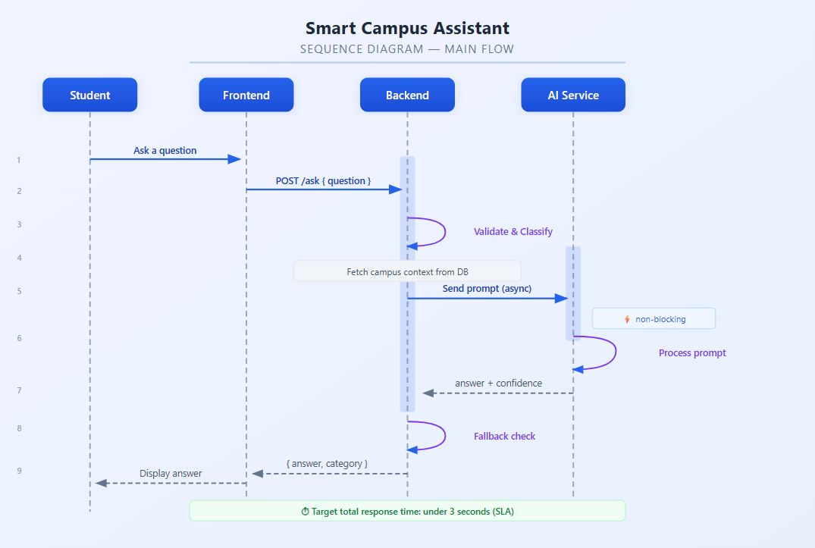

7.3 Async Flow Note
Steps 7–9 execute asynchronously using Python's async/await pattern in FastAPI. This ensures the server remains non-blocking and can handle multiple concurrent requests simultaneously. In the event of a timeout (> 10 seconds), the backend's exception handler intercepts the error, logs it server-side, and returns a pre-defined fallback message to the user — preventing any unhandled crash or blank response.

