**Creating Static Linked Library**

Consider the Project Structure

Configuration Type

Static lib

Configuration Type

Application .exe

Configuration Type

Static lib

**How to link the above projects to get an .exe file ?**

We need to provide the appropriate directory to the Demo project of Demo1 and Demo2 projects so that it can the appropriate files.

**For project 🡪 Demo 1**

Projects default-> Configuration Type-> Static Library (.lib)

After this refer to the Output directory -> $(SolutionDir )\$(Configuration) here the generated .lib will be saved.

Now build this project and will notice that .lib will saved to the location $(SolutionDir)\$(Configuration) Where ,

$(Configuaration)=Debug or Release whatever mode we choose .

**Note:-**

Debug has all the files and infact some other files which has some indexes to refer the actual codes and also help in debugging the code.

Release has less files hence small in size code executes directly and no debugging is possible, code crash means crash.

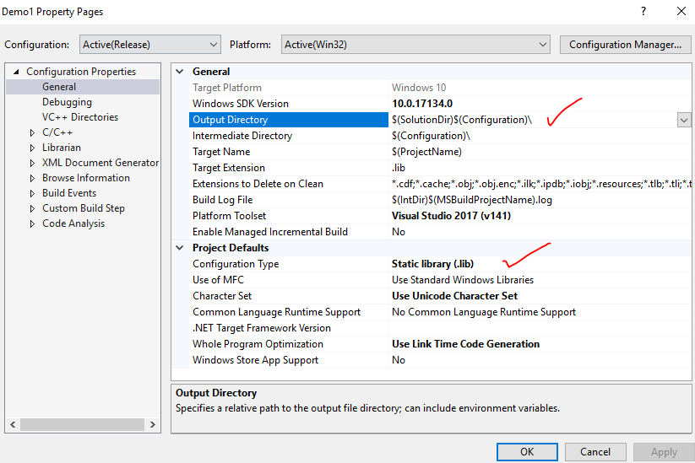

Similarly,

**For Project 🡪 Demo2**

Projects default-> Configuration Type-> Static Library (.lib)

See -> Output directory -> $(SolutionDir )\$(Configuration) here the generated .lib will be saved.

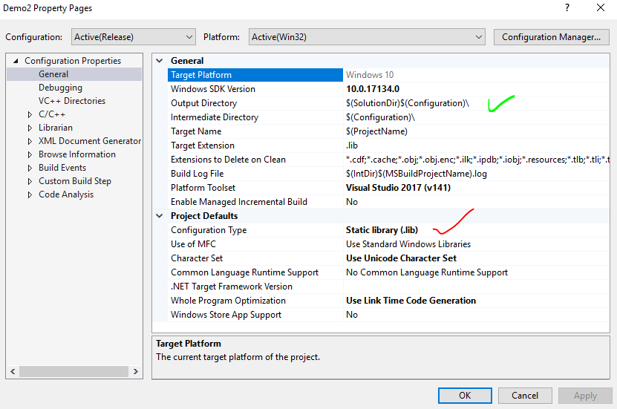

Till now we have complied and generated .lib files for the individual projects VIZ Demo1 and Demo2 . But now we have to link these small projects to main project so here we go.

**For Project 🡪 Demo**

Properties

1. Configuration Properties🡪 1.General

Check Output directory where final solution file will be generated and Project Defaults/ Configuration Type as Application type (.exe)

1. C/C++ 🡪 Provide the directory of header files which are to be used.
2. Linker-> Finally Link the individual Projects with the main project(whose configuration type is .exe)

Source and Destination has to be specified

So Input are Demo1.lib and Demo2.lib so give these inputs as Additional Dependencies .

NEXT

In general OPTION of linker provide the target location where the final build is to be form usually Debug folder of the solution.

Note:-

SolutionDir= F:\CmakeTutorials\Demo

TargerDir= F:\CmakeTutorials\Demo\(Release or Debug)

SolutionDir\Demo1= F:\CmakeTutorials\Demo\Demo1

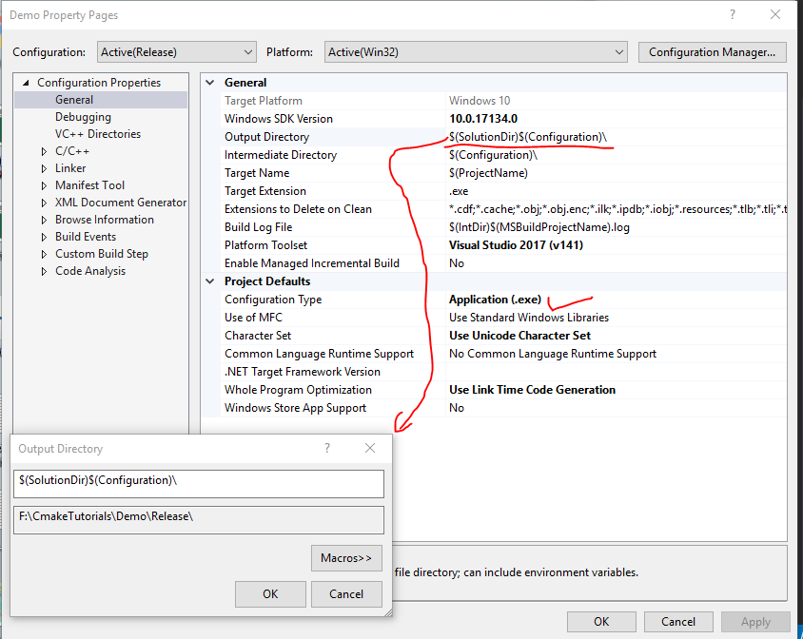

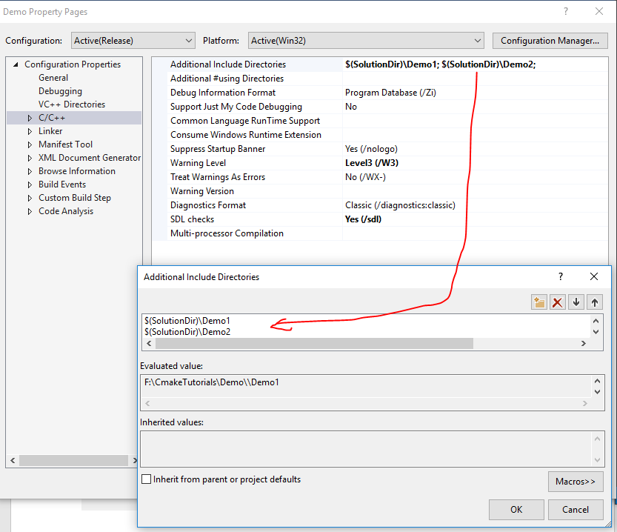

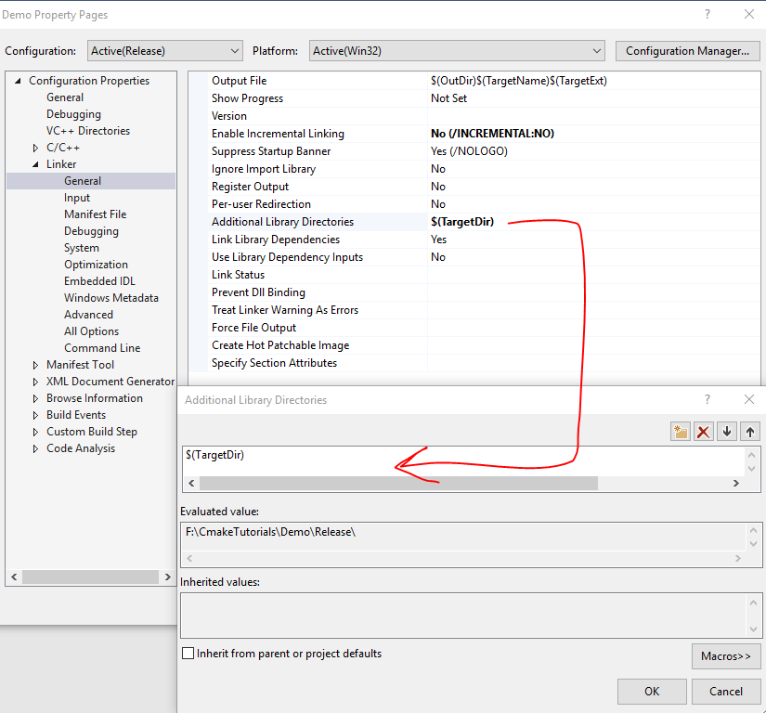

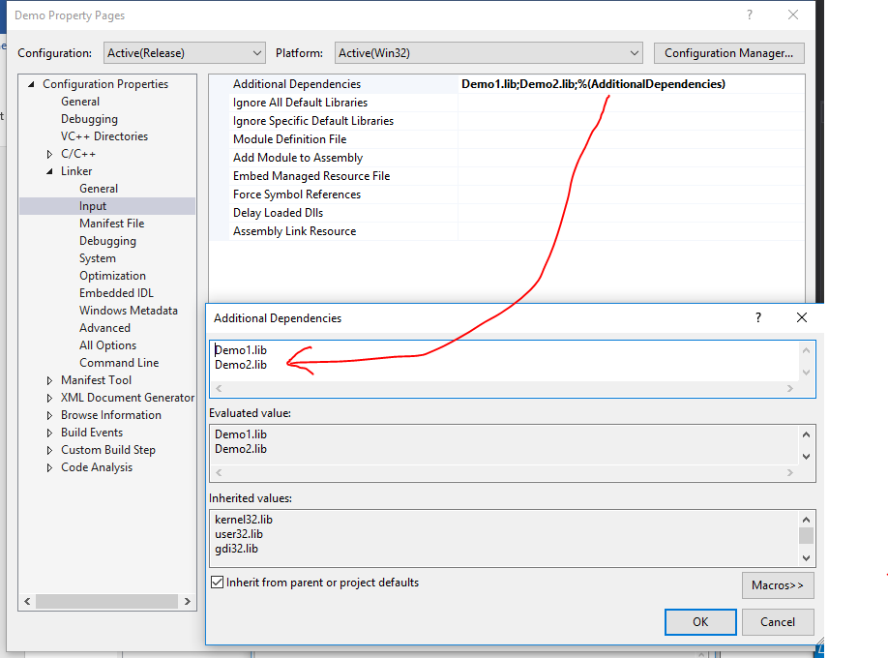

And finally do this

