**MIDTERM**

**MOBILE PROGRAMMING**

**REPORT**

**Project Name:** WHERE AM I

**Authors:**

**Name:** Tamer

**Surname:** KARALÜRT

**Student Number:** 155050010

**Name:** Atacan

**Surname:** GÜLER

**Student Number:** 155050041

Login Page: Register Page:

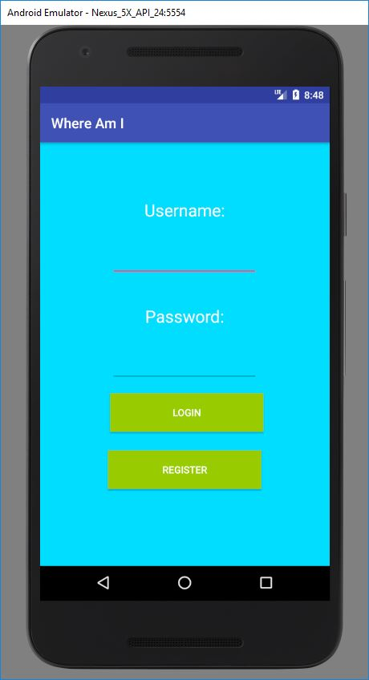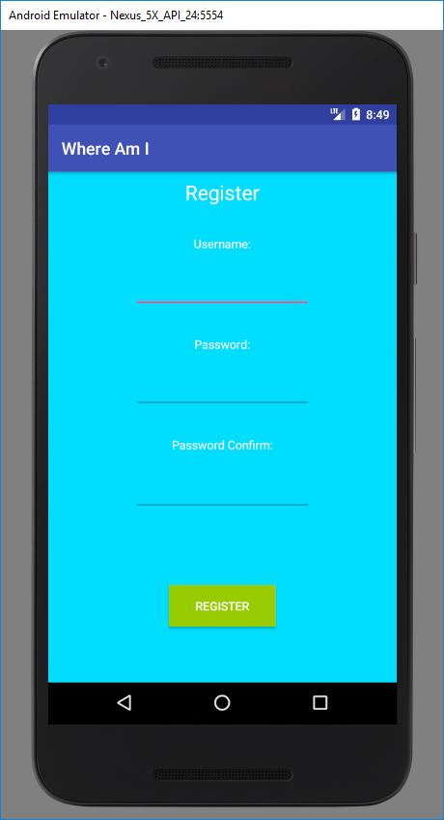

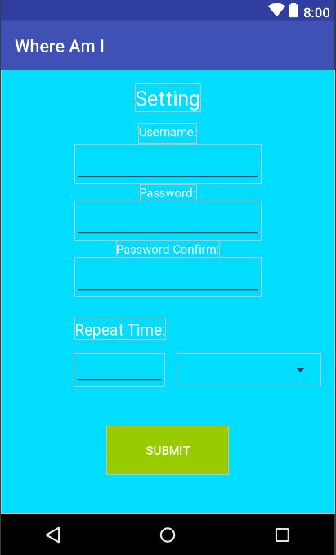Settings Page:

# Reporting

Part of the design is finished. Coding is done according to prepared designs. Location is get and the location saving in text document like member registration. We are going to prepare homepage respect to database, show location on google maps and more.