  - WEB TECHNOLOGIES

Assignment 3

Night Tokyo
  - Responsive Web Design
Media Queries + Bootstrap Grid
An English-language editorial website about Tokyo after dark, its districts, and Japanese car culture.
Submission detail | Value
Student | Tamerlan Aitpayev
Group | SE-2401
GitHub repository | https://github.com/TamerlanAitpayev/web3
Source files | index.html · style.css · assets/ (Pure HTML5 & CSS3, Zero Custom JavaScript)
Required viewport widths | 375px · 768px · 1280px

Project overview and setup
The page combines an atmospheric Tokyo night theme with two approaches to responsive layout. The district cards use a custom CSS Grid. The hero, story, garage, and field notes use Bootstrap containers, rows, columns, components, and utilities.
Section | Purpose | Layout approach
#home | Opening title, night-city visual, section links | Bootstrap
#districts | Three places to explore after dark | Custom CSS Grid + min-width media queries
#about | Editorial text and a supporting image | Bootstrap columns + responsive ordering
#garage | Three Japanese car cards | Bootstrap responsive columns + cards
#field-notes | Expandable practical notes | Bootstrap grid + accordion

Bootstrap 5.3.8 is connected through its CDN. The local style.css is linked after Bootstrap, allowing the custom colors, typography, and surfaces to override its defaults. The Bootstrap JavaScript bundle appears before the closing body tag and natively powers the collapsible navbar, accordion, and garage modals.
<meta name="viewport" content="width=device-width, initial-scale=1">
<!-- Bootstrap CSS is loaded first, then style.css. -->
<link rel="stylesheet" href="style.css">
The viewport tag makes the browser use the device width for layout. Both approaches start with the phone layout and add wider-screen changes. The layout does not depend on floats, fixed card widths, or absolute positioning.

Task 1 — Media queries by hand
The #districts section contains three repeated district cards. All classes inside this section are custom classes. The section does not use Bootstrap containers, rows, columns, cards, or utility classes for its layout.
The base .district-grid rule creates one flexible column. At 768px, a min-width media query changes the grid to two columns. At 992px, a second query changes it to three. The tablet breakpoint also changes the heading size and section spacing, so the queries adjust more than the number of columns.
.district-grid {
display: grid;
grid-template-columns: minmax(0, 1fr);
}
@media (min-width: 768px) {
.district-grid { grid-template-columns: repeat(2, minmax(0, 1fr)); }
/* The district heading and spacing also change here. */
}
@media (min-width: 992px) {
.district-grid { grid-template-columns: repeat(3, minmax(0, 1fr)); }
}
This excerpt shows the layout logic; style.css contains the complete rules. minmax(0, 1fr) lets each column share the available space and shrink without forcing a horizontal overflow. Card images scale with their card, so the layout can adapt between the three required test widths.
Viewport | Columns | Reason
375px | 1 | Only the mobile base rule applies.
768px | 2 | The first min-width query applies.
1280px | 3 | Both queries apply; the 992px rule sets three columns.

Task 1 evidence — Districts at 375px
Section / interaction capture • capture size: 375 × 1785px • source: districts-375.png
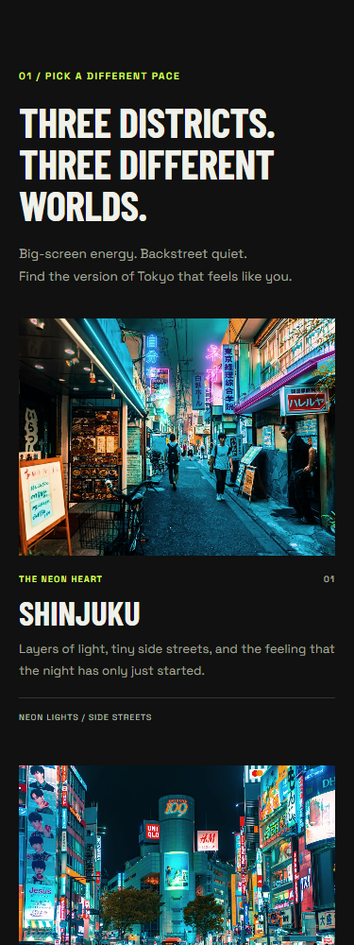  Pixels 0–999 | 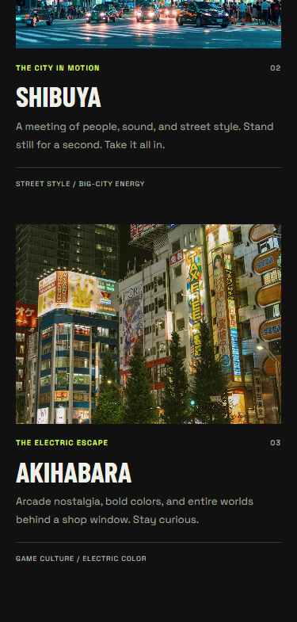  Pixels 1000–1784
Read consecutive panels from left to right, then continue on the next sheet. No page content is omitted.

Task 1 evidence — Districts at 768px — sheet 1/2
Section / interaction capture • capture size: 768 × 1313px • source: districts-768.png
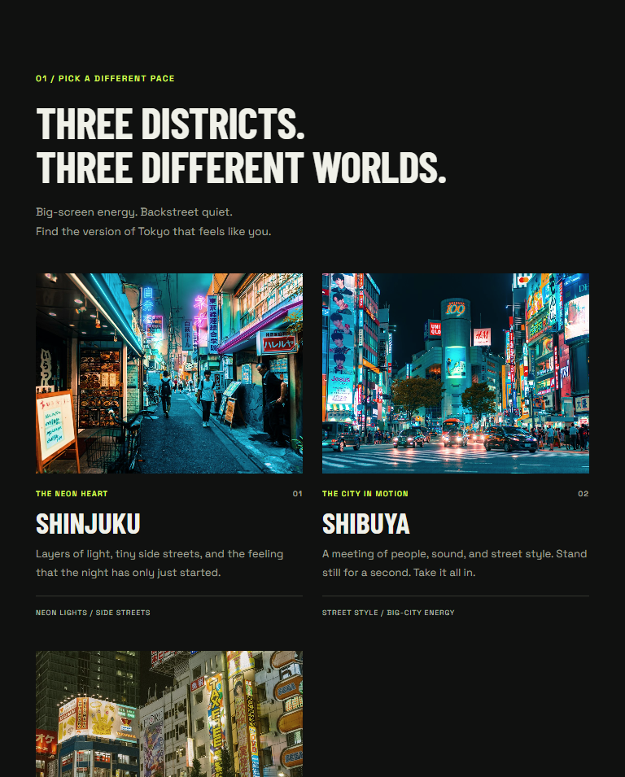
Vertical pixels 0–954 of 1313.
Read consecutive panels from left to right, then continue on the next sheet. No page content is omitted.

Task 1 evidence — Districts at 768px — sheet 2/2
Section / interaction capture • capture size: 768 × 1313px • source: districts-768.png

Vertical pixels 955–1312 of 1313.

Task 1 evidence — Districts at 1280px — sheet 1/2
Section / interaction capture • capture size: 1280 × 815px • source: districts-1280.png
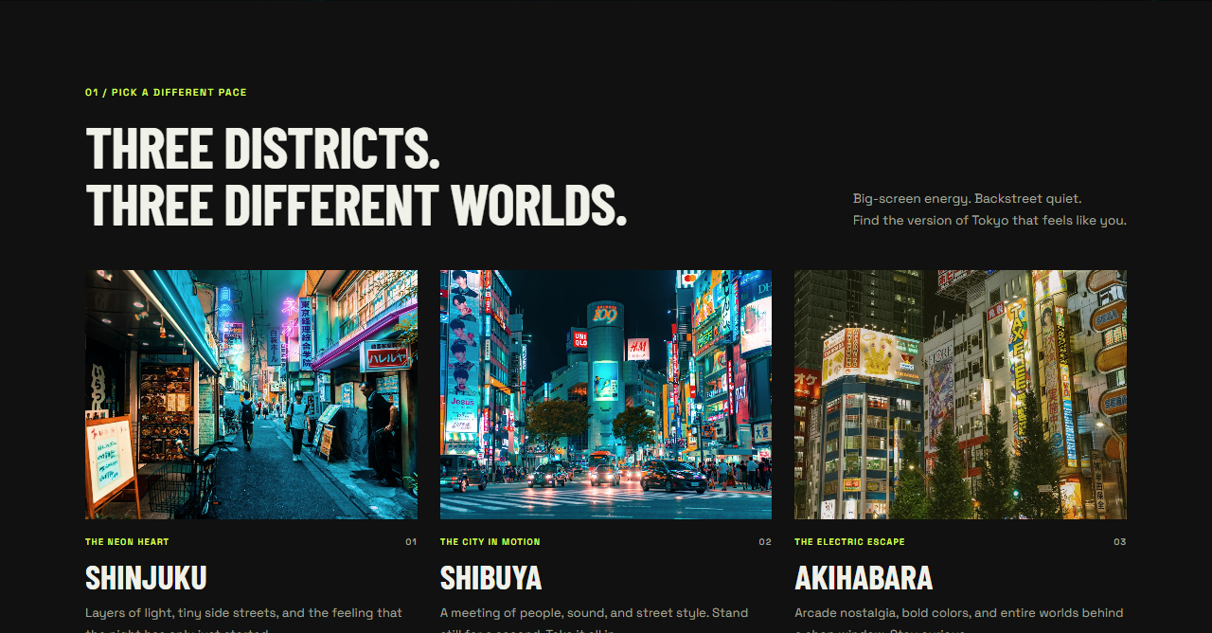
Vertical pixels 0–667 of 815.
Read consecutive panels from left to right, then continue on the next sheet. No page content is omitted.

Task 1 evidence — Districts at 1280px — sheet 2/2
Section / interaction capture • capture size: 1280 × 815px • source: districts-1280.png

Vertical pixels 668–814 of 815.

Task 2 — Bootstrap grid and components
The remaining sections use Bootstrap's container → row → column structure. The garage repeats col-12 col-md-6 col-lg-4 on each card wrapper: twelve of twelve grid units on a phone, six of twelve from 768px, and four of twelve from 992px. This produces the same 1 → 2 → 3 card arrangement as the custom district grid.
<div class="container">
<div class="row">
<div class="col-12 col-md-6 col-lg-4">
<article class="card">...</article>
</div>
<!-- Repeat the card column for the other two cars. -->
</div>
</div>
The #about section has a text column and an image column. The text uses order-1 order-lg-2; the image uses the opposite order. On phones, the text is first and the image follows below. At the large breakpoint the columns sit next to each other, with the image on the left. The text remains first in the source order so the main explanation is encountered before the image.
The desktop status label uses d-none d-md-inline-flex, so it is hidden below 768px. A separate phone hint uses d-md-none, so it appears only below 768px. Bootstrap spacing, flex, and text utilities handle recurring alignment and spacing around these sections.
The navbar uses navbar-expand-lg. Below 992px, its navigation links collapse into a menu controlled by the menu button; at larger widths, the links are displayed inline. Each link targets a real section ID. The page also includes Bootstrap cards and an accordion. The accordion lets the reader expand a field note without displaying all of its content at once.
The garage buttons open dedicated Bootstrap modals with rich editorial stories for each vehicle. The modals and all other interactive components (collapsible navbar and accordion) operate 100% natively via Bootstrap 5.3 data attributes (data-bs-toggle, data-bs-target, data-bs-dismiss) and the official CDN bundle. In accordance with assignment requirements, the project uses zero custom JavaScript, preserving strict separation of concerns and robust standard-compliant behavior.
Requirement | Implementation on this page
Responsive card grid | #garage: col-12 col-md-6 col-lg-4
Stacked columns + priority | #about: text first on phones; responsive order-* classes
Responsive visibility | d-none d-md-inline-flex and d-md-none
Responsive navigation | navbar-expand-lg + Bootstrap collapse
Additional components | Garage cards, the field-notes accordion, and the garage modals
Utilities | Responsive display, order, spacing, flex, and text classes
Architecture | Pure HTML5 & CSS3 with Bootstrap 5.3 CDN bundle (Zero custom JS)

Task 2 evidence — Garage at 375px
Section / interaction capture • capture size: 375 × 1781px • source: garage-375.png
  Pixels 0–999 | 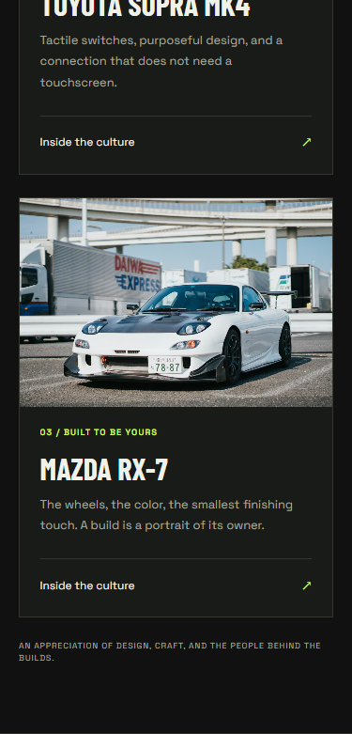  Pixels 1000–1780
Read consecutive panels from left to right, then continue on the next sheet. No page content is omitted.

Task 2 evidence — Garage at 768px — sheet 1/2
Section / interaction capture • capture size: 768 × 1320px • source: garage-768.png
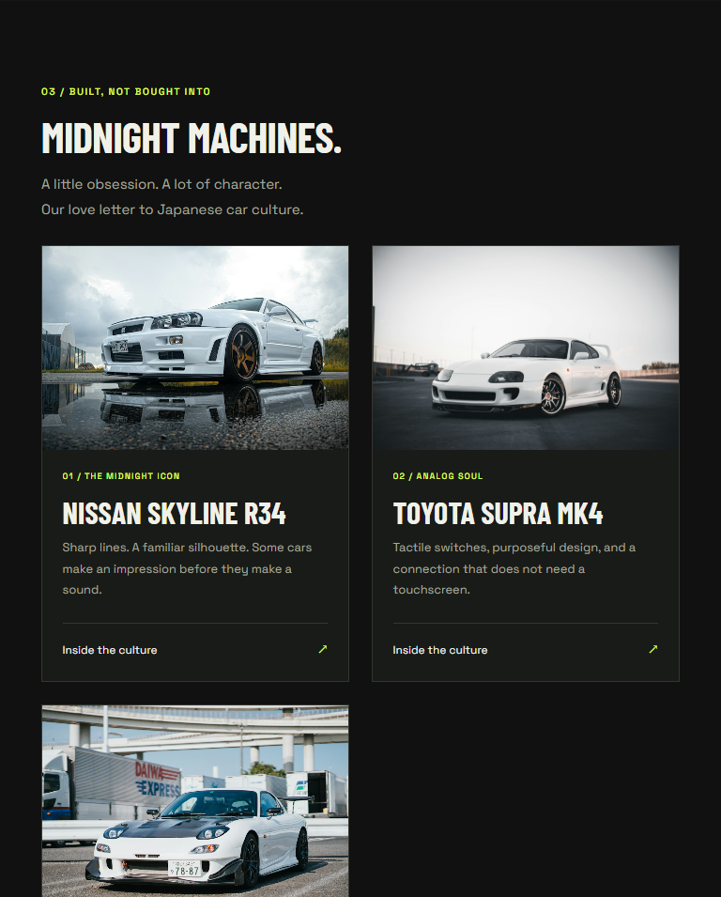
Vertical pixels 0–954 of 1320.
Read consecutive panels from left to right, then continue on the next sheet. No page content is omitted.

Task 2 evidence — Garage at 768px — sheet 2/2
Section / interaction capture • capture size: 768 × 1320px • source: garage-768.png

Vertical pixels 955–1319 of 1320.

Task 2 evidence — Garage at 1280px — sheet 1/2
Section / interaction capture • capture size: 1280 × 824px • source: garage-1280.png
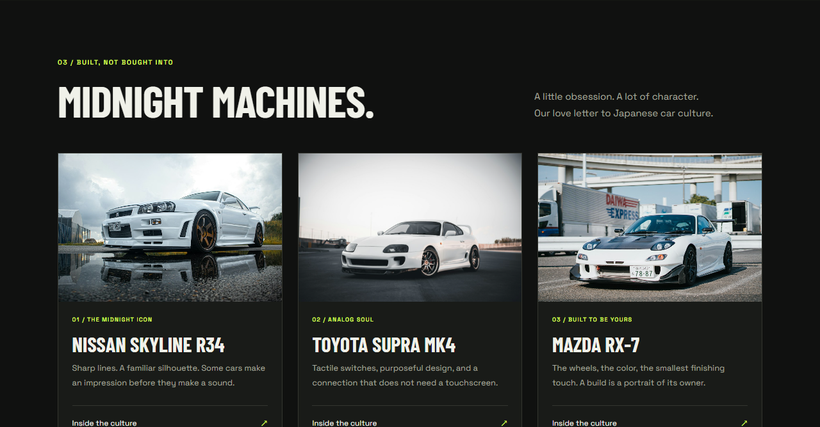
Vertical pixels 0–667 of 824.
Read consecutive panels from left to right, then continue on the next sheet. No page content is omitted.

Task 2 evidence — Garage at 1280px — sheet 2/2
Section / interaction capture • capture size: 1280 × 824px • source: garage-1280.png

Vertical pixels 668–823 of 824.

Task 2 evidence — Text comes first on phones
Section / interaction capture • capture size: 375 × 995px • source: about-mobile.png

Pixels 0–994

Task 2 evidence — Two columns and desktop ordering — sheet 1/2
Section / interaction capture • capture size: 1280 × 759px • source: about-desktop.png

Vertical pixels 0–667 of 759.
Read consecutive panels from left to right, then continue on the next sheet. No page content is omitted.

Task 2 evidence — Two columns and desktop ordering — sheet 2/2
Section / interaction capture • capture size: 1280 × 759px • source: about-desktop.png
Vertical pixels 668–758 of 759.

Task 2 evidence — Expanded mobile menu
Section / interaction capture • capture size: 375 × 900px • source: navbar-mobile.png
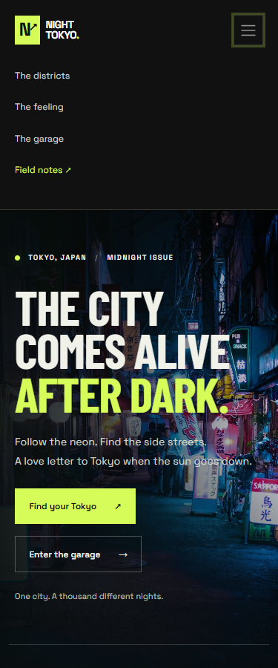
Pixels 0–899

Task 2 evidence — Expanded field note
Section / interaction capture • capture size: 375 × 819px • source: accordion-open.png
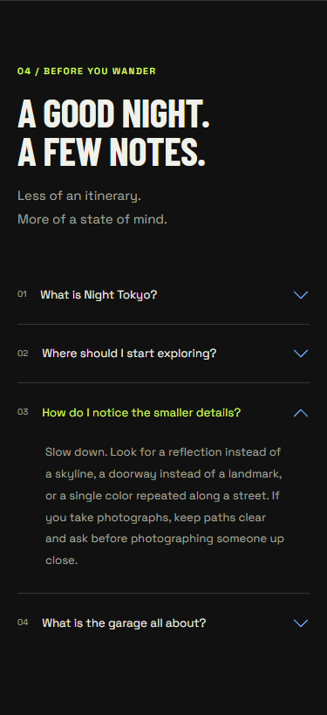
Pixels 0–818

Task 2 evidence — Native Bootstrap modal window
Section / interaction capture • capture size: 375 × 900px • source: garage-modal.png
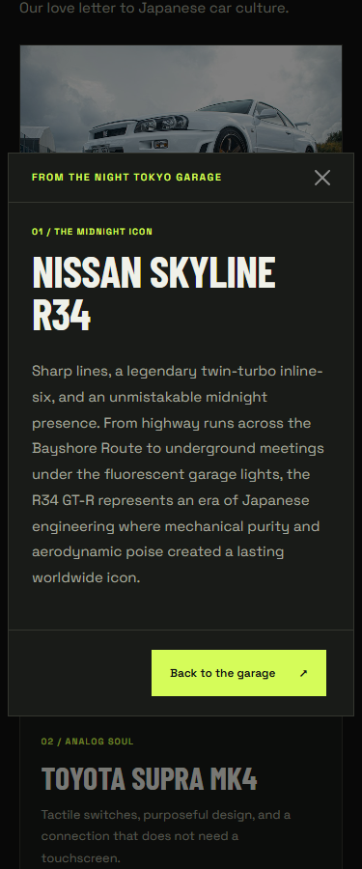
Pixels 0–899

Task 3 — Comparing the two approaches
Aspect | Custom media queries: districts | Bootstrap grid: garage / other sections
Layout code | The district grid needs a base grid rule and two min-width rules in style.css. | Each garage column uses col-12 col-md-6 col-lg-4 in the HTML; Bootstrap supplies the breakpoint rules.
Design control | District heading size, card spacing, and the grid can be tuned together in a section-specific query. | Bootstrap handles column widths and gutters; local CSS adds the Tokyo colors, borders, and typography.
Changing the layout | Changing the laptop district count means editing grid-template-columns in the 992px query. | Changing the garage to four cards per row would use col-lg-3 on each wrapper.
Speed and reuse | The repeated district layout is small, but its responsive rules must be written and maintained. | The same responsive column pattern can be reused across sections; collapse and accordion already provide interaction.
Ordering and visibility | Equivalent behavior would require additional custom order and display rules. | The about section uses order-*; the status label and phone hint use d-* utilities.

I would choose custom media queries for a distinctive section such as the districts, where the spacing and heading need to change together with the card layout. I would choose Bootstrap for repeated card layouts and page structure, especially when the page also needs a responsive navbar or accordion. Combining both approaches keeps the district design flexible while making the rest of this page quicker to maintain.

Conclusion
I learned how to build a mobile-first layout with both CSS Grid media queries and Bootstrap's responsive columns. I learned how breakpoints produce one, two, and three cards per row, and how ordering and display utilities help prioritize content on smaller screens. I also learned why checking several viewport widths matters: a layout can look correct on a laptop and still overflow or become difficult to read on a phone.

Defense Guide & Theoretical Answers
The practical defense accounts for 70 of the 100 total evaluation points. Below are the key theoretical concepts, code justifications, and answers to questions commonly asked during laboratory defense:
Q: What does responsive design mean?
A: A design approach where the layout automatically adapts to the available viewport width while preserving visual hierarchy, readability, and interaction usability across mobile, tablet, and desktop devices.
Q: What is the layout viewport and why is the meta tag mandatory?
A: <meta name="viewport" content="width=device-width, initial-scale=1"> instructs mobile browsers to set the layout viewport width to the device's physical screen width (in CSS pixels) and sets the initial zoom scale to 1. Without it, mobile browsers assume a desktop page, render at a virtual 980px width, and scale down, breaking media queries and the Bootstrap grid.
Q: Why is this architecture strictly mobile-first?
A: Base CSS rules define styles for narrow phone screens without any media query wrappers. Progressive min-width media queries (@media (min-width: 768px), @media (min-width: 992px)) layer on multi-column layouts and larger typography for wider viewports. This ensures fast rendering on mobile devices and eliminates redundant desktop overrides.
Q: Why is style.css linked after Bootstrap CSS in the head?
A: In CSS, when rules have equal specificity, the cascade gives priority to the rule defined latest in document order. Linking style.css after the Bootstrap stylesheet allows custom theme tokens, typography, and handmade grid styles to cleanly override Bootstrap defaults.
Q: Why does the project use zero custom JavaScript?
A: The assignment curriculum focuses strictly on CSS media queries and Bootstrap's responsive grid system. By relying exclusively on standard HTML5 data-attributes (data-bs-toggle, data-bs-target, data-bs-dismiss) and the official Bootstrap CDN bundle, all interactive components (mobile menu toggler, accordion panels, and car modals) operate declaratively and reliably with zero runtime errors, zero custom scripts, and clean separation of concerns.
Q: How does the handmade section change at breakpoints?
A: At 375px: 1 column (minmax(0, 1fr)). At 768px: 2 columns (repeat(2, minmax(0, 1fr))), heading font-size grows from 2.75rem to 3.35rem, and card gap changes. At 992px: 3 columns (repeat(3, minmax(0, 1fr))), heading layout switches to flex-direction: row and font-size reaches 3.8rem.
Q: How do Bootstrap columns stack and reorder in Task 2?
A: The garage cards use col-12 col-md-6 col-lg-4, creating 1 column on phones (12/12), 2 columns on tablets (6/12), and 3 columns on laptops (4/12). In the About section, the text column has order-1 order-lg-2 while the image has order-2 order-lg-1; this ensures the important editorial text appears first on phones and swaps to the right side on laptops.

Verification evidence
Browser verification passed.
These results are read from docs/verification.json. The original JSON and scripts/verify_site.py provide the complete measurements and reproducible checks.
Viewport | District columns | Garage columns | Horizontal overflow | District heading
375px | 1 | 1 | No | 44px
768px | 2 | 2 | No | 53.6px
1280px | 3 | 3 | No | 60.8px

Viewport | Story order | Phone hint | Edition label | Menu button
375px | Text above image | Visible | Hidden | Visible
768px | Text above image | Hidden | Visible | Visible
1280px | Image left; text right | Hidden | Visible | Hidden

Interaction / feature | Recorded result
Mobile navigation | Passed: collapses on small screens, toggles open/close, and links navigate to sections.
Field-notes accordion | Passed: panels open and close; only one panel is open at a time.
Garage modals | Passed: all three buttons open the corresponding modal natively.
Keyboard interaction | Passed: Escape dismisses the modal and returns keyboard focus.
Architecture (Zero custom JS) | Passed: Zero custom JavaScript; all components work via standard HTML and Bootstrap data-attributes.

All page images loaded at each of the three required widths.
The local fonts loaded at each of the three required widths.
All tested in-page navigation targets exist.
The verification recorded no page JavaScript errors or failed project-resource requests.
Additional widths checked without horizontal overflow: 320px, 360px, 576px, 991px, 992px, 1440px.

References
The assignment specification and the following technical references support the implementation and its explanation:
Bootstrap 5.3: Getting started
https://getbootstrap.com/docs/5.3/getting-started/introduction/
Bootstrap 5.3: Grid system
https://getbootstrap.com/docs/5.3/layout/grid/
Bootstrap 5.3: Display utilities
https://getbootstrap.com/docs/5.3/utilities/display/
Bootstrap 5.3: Navbar
https://getbootstrap.com/docs/5.3/components/navbar/
Bootstrap 5.3: Accordion
https://getbootstrap.com/docs/5.3/components/accordion/
Bootstrap 5.3: Modals
https://getbootstrap.com/docs/5.3/components/modal/
MDN: Using media queries
https://developer.mozilla.org/en-US/docs/Web/CSS/CSS_media_queries/Using_media_queries

Appendix — The complete page at three widths
The following evidence includes the complete page captured at 375px, 768px, and 1280px. Tall screenshots are divided into consecutive panels for readability; the pixel ranges show where each panel belongs. Together, the panels reproduce the full original screenshot without omitting content.
The original PNG files remain available in docs/screenshots/full-375.png, full-768.png, and full-1280.png. Use those files to inspect the captures at their original resolution.

Complete page — 375px — sheet 1/4
Complete page capture • capture size: 375 × 6427px • source: full-375.png
  Pixels 0–999 | 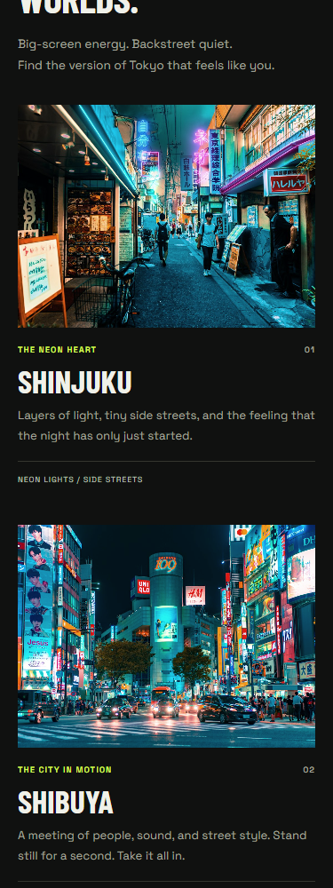  Pixels 1000–1999
Read consecutive panels from left to right, then continue on the next sheet. No page content is omitted.

Complete page — 375px — sheet 2/4
Complete page capture • capture size: 375 × 6427px • source: full-375.png
  Pixels 2000–2999 |   Pixels 3000–3999

Complete page — 375px — sheet 3/4
Complete page capture • capture size: 375 × 6427px • source: full-375.png
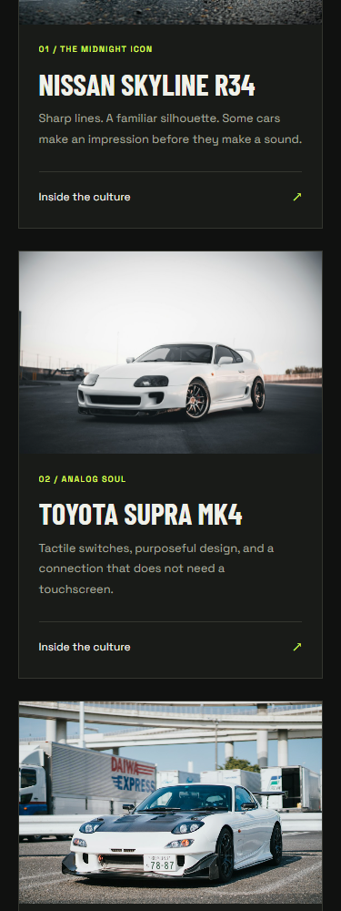  Pixels 4000–4999 | 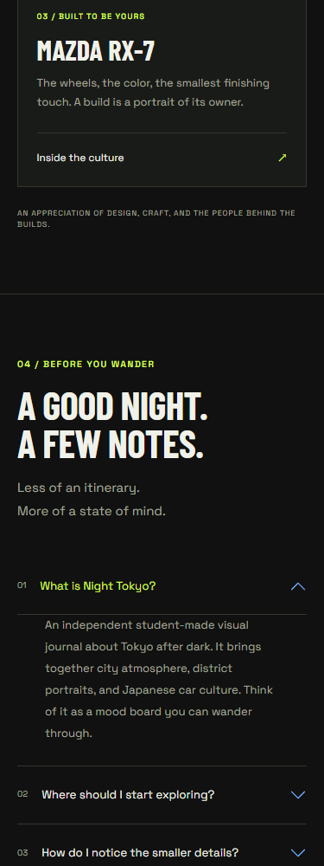  Pixels 5000–5999

Complete page — 375px — sheet 4/4
Complete page capture • capture size: 375 × 6427px • source: full-375.png
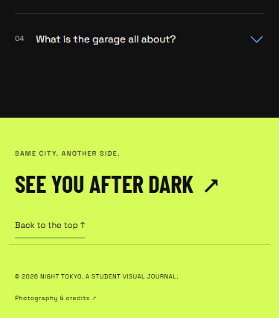
Pixels 6000–6426

Complete page — 768px — sheet 1/6
Complete page capture • capture size: 768 × 5637px • source: full-768.png
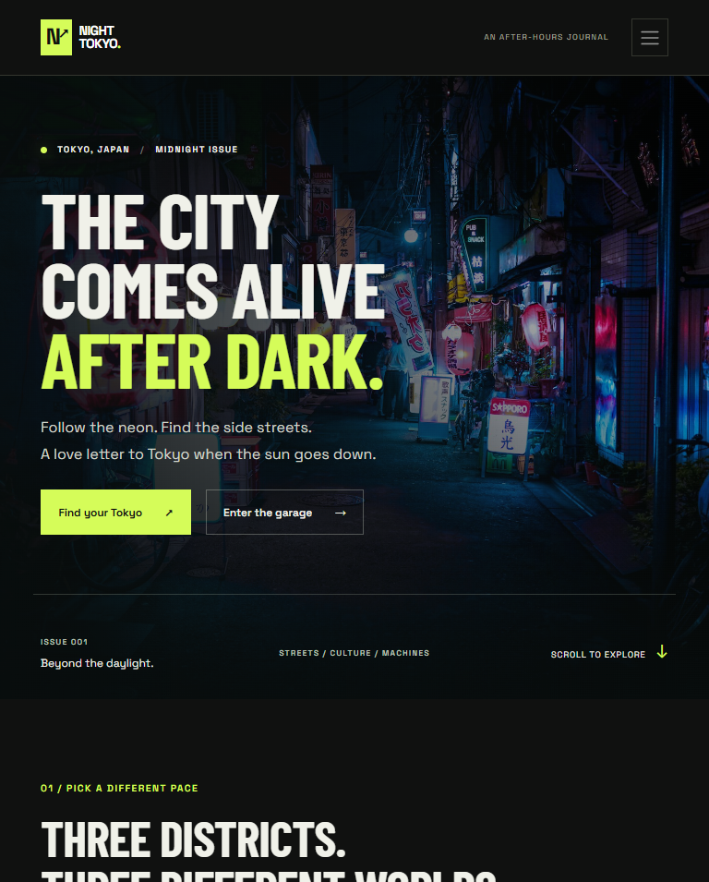
Vertical pixels 0–954 of 5637.
Read consecutive panels from left to right, then continue on the next sheet. No page content is omitted.

Complete page — 768px — sheet 2/6
Complete page capture • capture size: 768 × 5637px • source: full-768.png
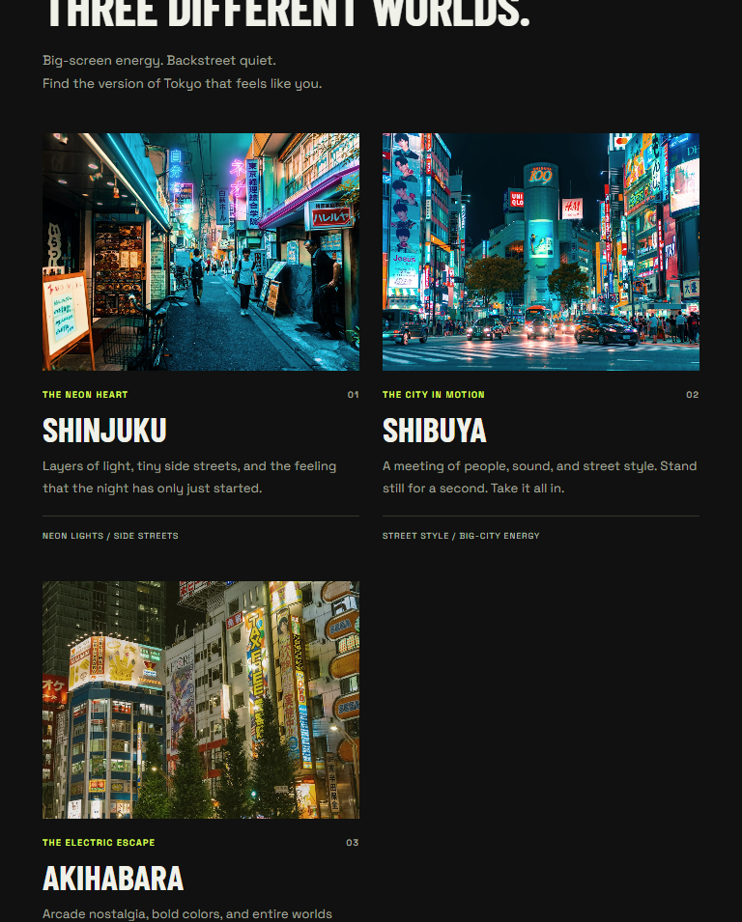
Vertical pixels 955–1909 of 5637.

Complete page — 768px — sheet 3/6
Complete page capture • capture size: 768 × 5637px • source: full-768.png
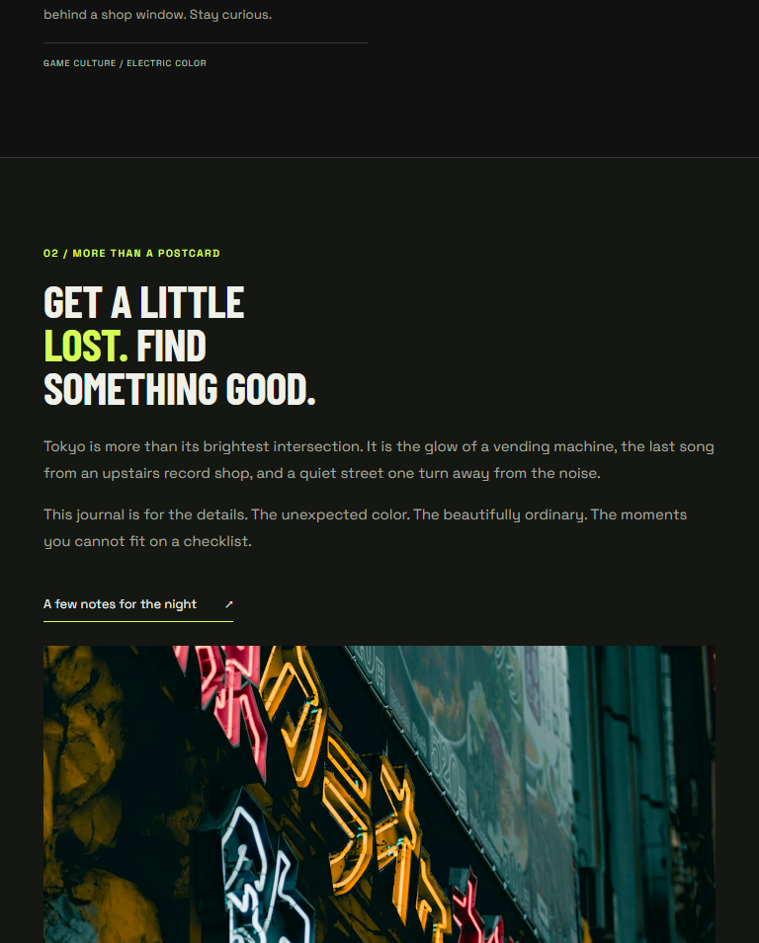
Vertical pixels 1910–2864 of 5637.

Complete page — 768px — sheet 4/6
Complete page capture • capture size: 768 × 5637px • source: full-768.png
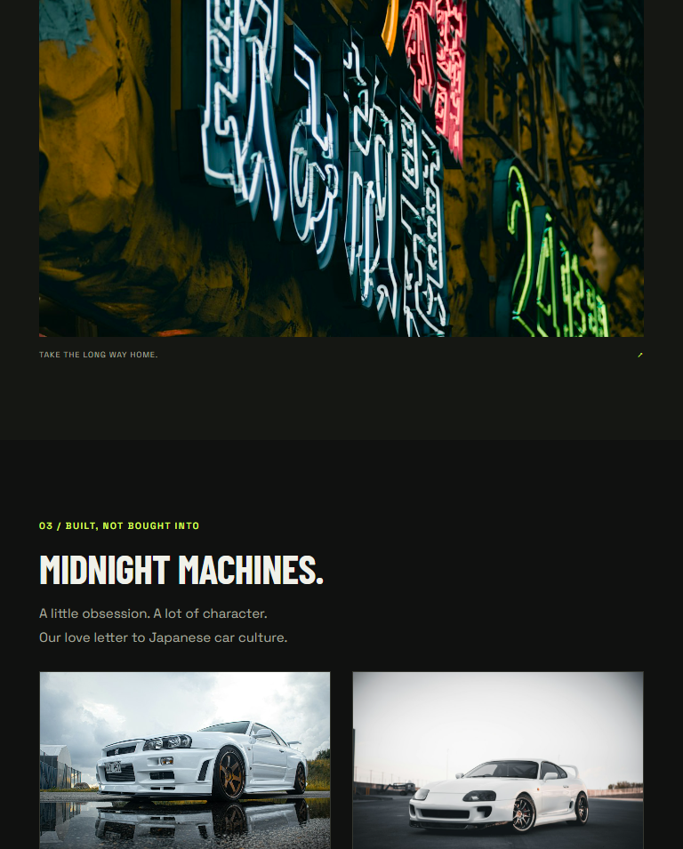
Vertical pixels 2865–3819 of 5637.

Complete page — 768px — sheet 5/6
Complete page capture • capture size: 768 × 5637px • source: full-768.png
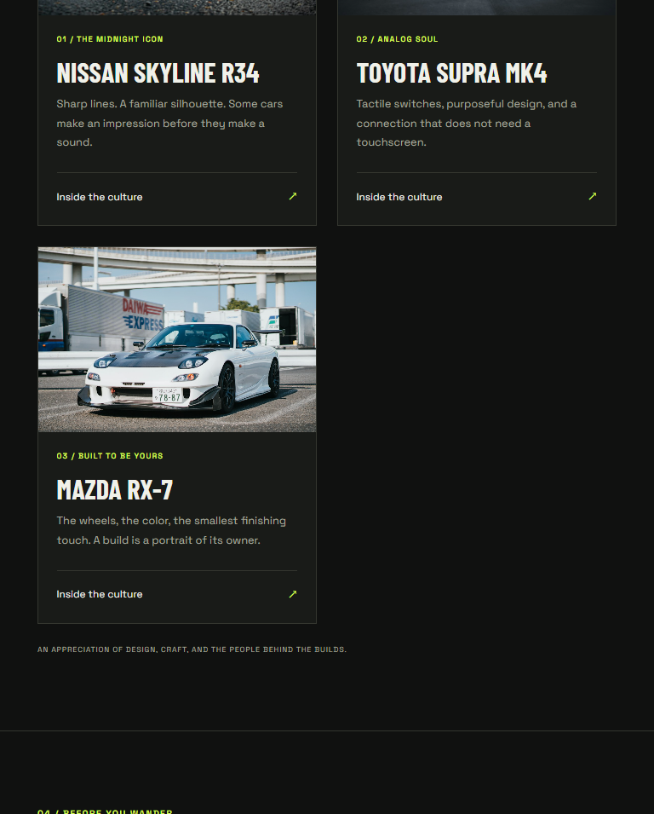
Vertical pixels 3820–4774 of 5637.

Complete page — 768px — sheet 6/6
Complete page capture • capture size: 768 × 5637px • source: full-768.png
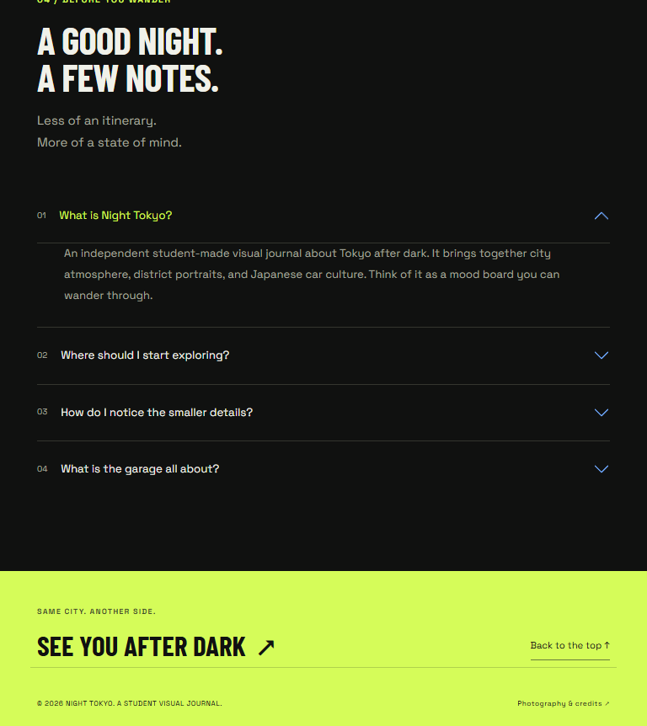
Vertical pixels 4775–5636 of 5637.

Complete page — 1280px — sheet 1/7
Complete page capture • capture size: 1280 × 4079px • source: full-1280.png
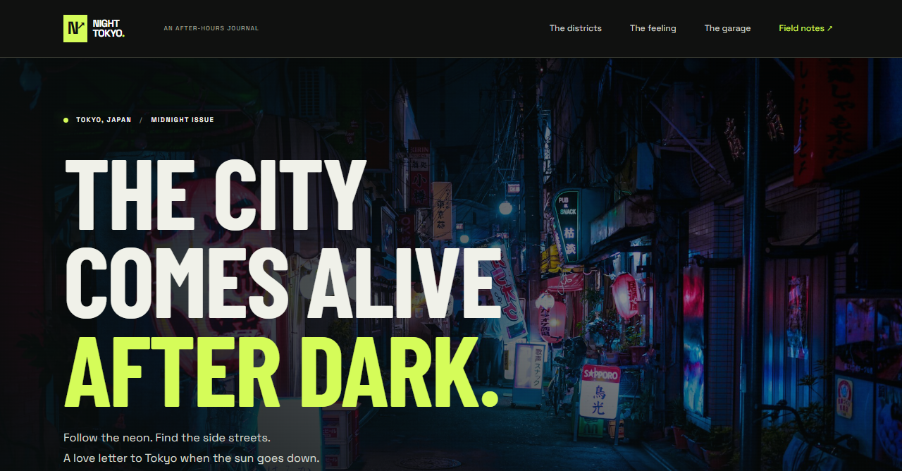
Vertical pixels 0–667 of 4079.
Read consecutive panels from left to right, then continue on the next sheet. No page content is omitted.

Complete page — 1280px — sheet 2/7
Complete page capture • capture size: 1280 × 4079px • source: full-1280.png

Vertical pixels 668–1335 of 4079.

Complete page — 1280px — sheet 3/7
Complete page capture • capture size: 1280 × 4079px • source: full-1280.png
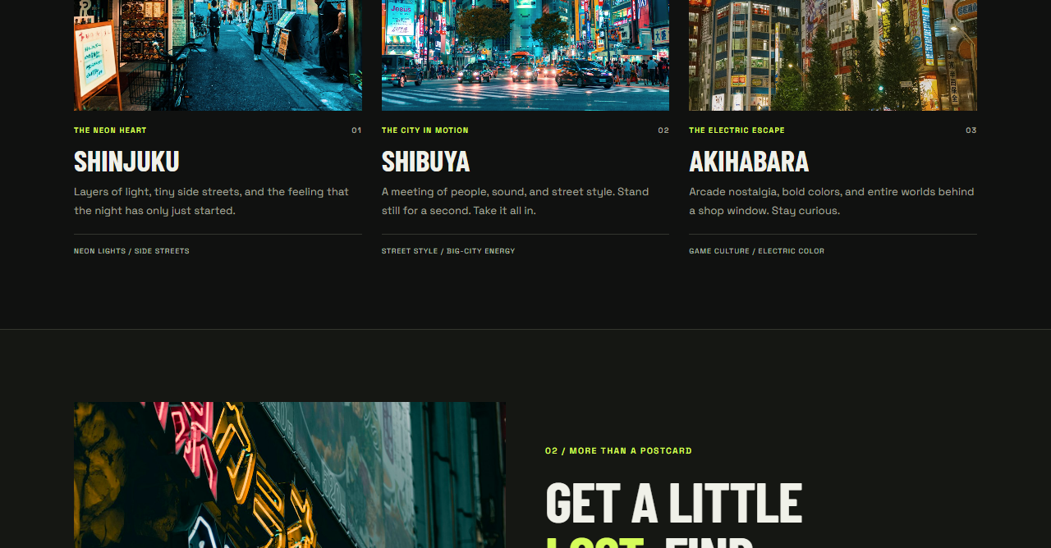
Vertical pixels 1336–2003 of 4079.

Complete page — 1280px — sheet 4/7
Complete page capture • capture size: 1280 × 4079px • source: full-1280.png

Vertical pixels 2004–2671 of 4079.

Complete page — 1280px — sheet 5/7
Complete page capture • capture size: 1280 × 4079px • source: full-1280.png
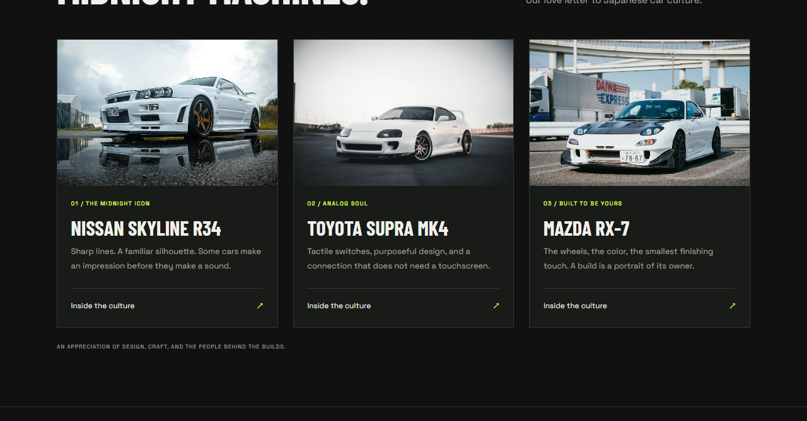
Vertical pixels 2672–3339 of 4079.

Complete page — 1280px — sheet 6/7
Complete page capture • capture size: 1280 × 4079px • source: full-1280.png
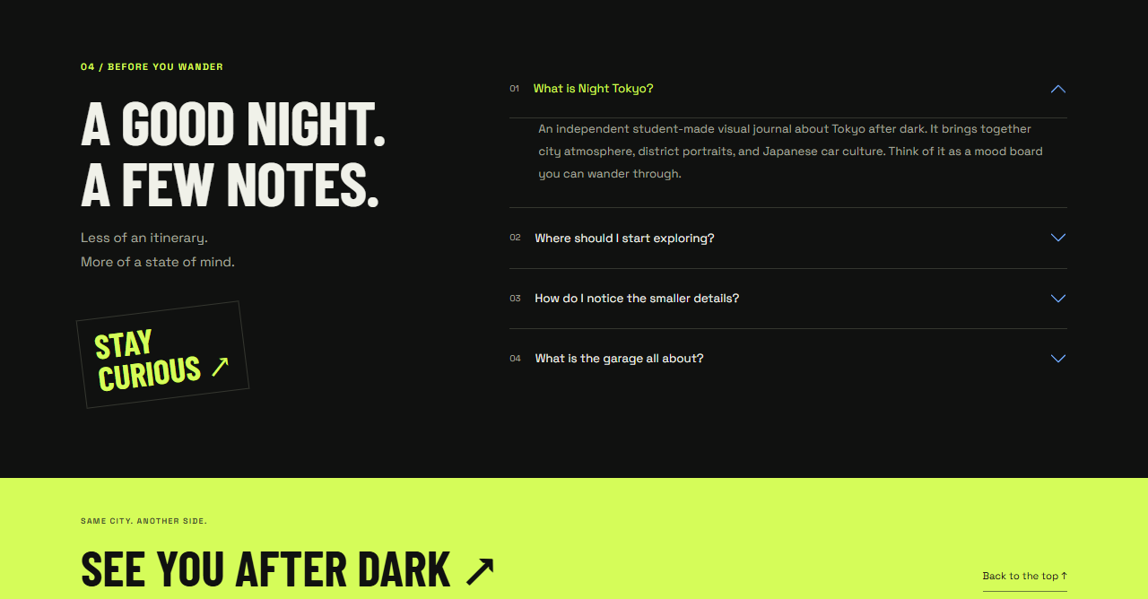
Vertical pixels 3340–4007 of 4079.

Complete page — 1280px — sheet 7/7
Complete page capture • capture size: 1280 × 4079px • source: full-1280.png
Vertical pixels 4008–4078 of 4079.

