ASTANA IT UNIVERSITY
FACULTY OF COMPUTER SCIENCE & ENGINEERING
DEPARTMENT OF COMPUTER ENGINEERING
——————————————————————————————————————
LABORATORY REPORT
Assignment #5: JavaScript Basics (DOM Manipulation & Events)

Course: | Web Technologies (Front-End Development)
Student Name: | Aitpayev Tamerlan
Academic Group: | IT-2510
Course Instructor: | Fedenko Alexey
Repository URL: | https://github.com/tamerlanaitpayev1-netizen/web5.git

Chosen Task Options:
• Task 1: Option B — Turn-based Battle Game (Hero vs Enemy, HP percentage bars, shield defense, potions, 5-action combat log)
• Task 2: Option A — Agile Kanban Board (12 dynamic task objects, strict WIP <= 3 limit, manual loop metrics, event delegation, zero innerHTML)
• Task 3: Option A — Ticket Pass Builder (7 form fields, live boarding pass preview, 4 custom non-HTML rules, Constraint Validation API)

1. Aim and Objectives of the Work
The objective of this laboratory assignment is to master practical, client-side JavaScript development without external libraries or frameworks. The practical implementation focuses on:
1. Flow control, variables (const, let), operators, random generation, and strict equality (===);
2. Dynamic data structure management via arrays of objects, higher-order methods, and manual loop aggregations;
3. Safe and performant Document Object Model (DOM) manipulation using createElement, textContent, classList, and dataset (strictly prohibiting innerHTML for data nodes);
4. Event handling, container-level event delegation, and accessible real-time form validation via the native Constraint Validation API.

2. Task 1: Turn-Based Combat Game (Option B)
Task 1 implements a turn-based tactical combat simulator between the Valiant Hero and the Shadow Overlord. Both combatants begin with 100 HP. The player can choose three distinct tactical actions per turn:
• Attack: Deals 8 to 15 physical damage generated via Math.floor(Math.random() * (15 - 8 + 1)) + 8. A 10% critical strike probability inflicts double damage (2.0x multiplier);
• Defend: Raises a defensive guard, absorbing 50% of incoming enemy damage on the subsequent counter-attack;
• Heal: Restores 20 HP, constrained strictly to a maximum of 3 charges per match. Invalid attempts (when remaining charges equal 0 or when already at full health) are rejected with clear user messages without advancing the game turn.
Outcome Evaluation Logic:
At least three game outcomes are decided through compound logical operators (&&, ||, ===):
1. Draw: if (currentHeroHp <= 0 && currentEnemyHp <= 0) — both combatants reach 0 HP simultaneously;
2. Victory: else if (currentEnemyHp <= 0 && currentHeroHp > 0) — enemy defeated while hero survives;
3. Defeat: else if (currentHeroHp <= 0 || (currentEnemyHp > 0 && currentHeroHp === 0)) — hero defeated.

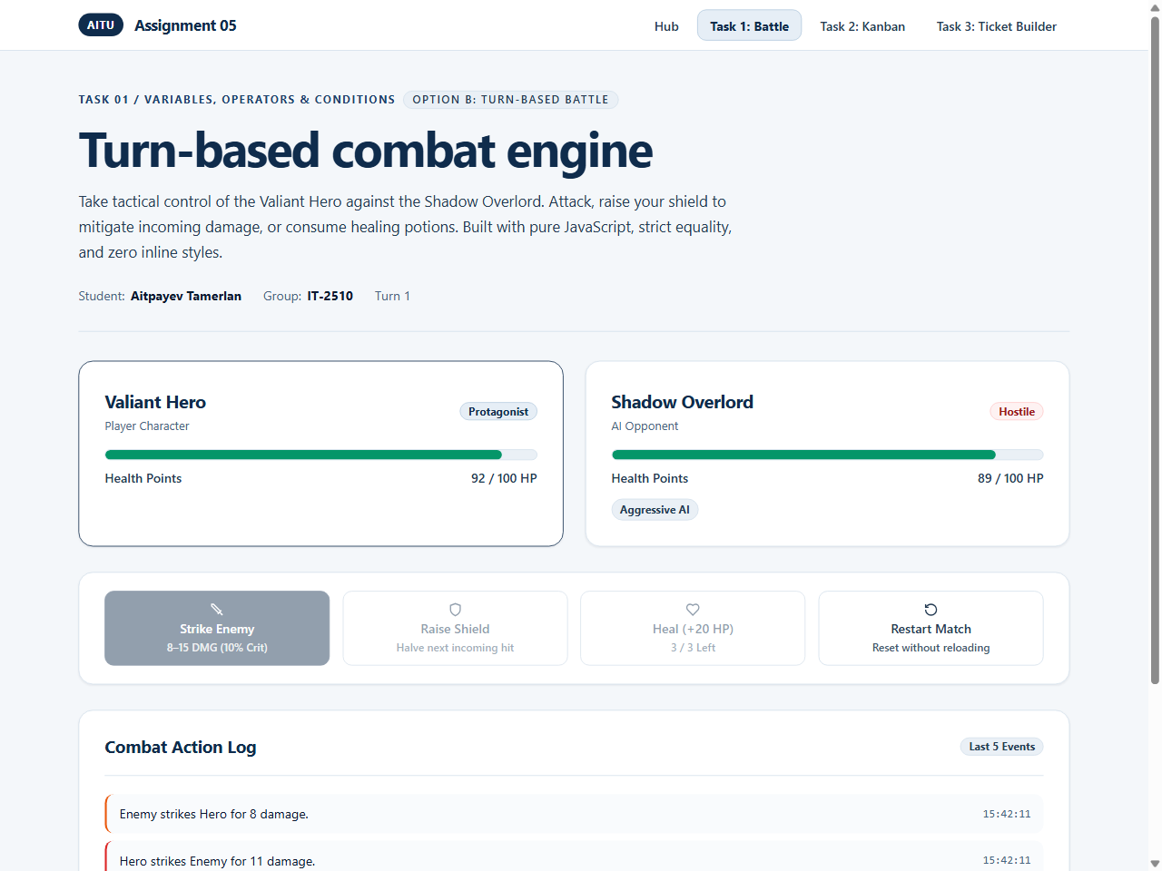
Figure 2.1: Turn-based battle combat interface with HP progress bars and action ledger.

3. Task 2: Data-Driven Kanban Board (Option A)
Task 2 presents an agile Kanban workflow board rendered strictly from an in-memory JavaScript array of objects. The dataset contains 12 task items, each featuring unique IDs and multiple data types (Number: id, storyPoints; String: title, priority, tag, column, assignee; Boolean: isBlocked). The HTML markup contains only empty structural containers (#todo-cards-container, #progress-cards-container, #done-cards-container). A single renderKanbanBoard() function handles all DOM updates.
Key Architectural Constraints Satisfied:
1. Zero innerHTML for Data: All card articles, titles, badges, and action controls are instantiated via document.createElement, textContent, classList, and dataset;
2. WIP Limit Rule Enforcement: The middle column ('In progress') enforces a strict limit of at most 3 cards (WIP_LIMIT = 3). Any attempt to move a fourth card into 'In progress' is immediately blocked, displaying a descriptive warning banner;
3. Manual Loop Aggregation: Sprint completion percentage and velocity metrics are calculated with an explicit for...of loop over the array;
4. Container Event Delegation: A single click event listener on #kanban-board-container handles forward, backward, and deletion actions via data-action and data-card-id attributes.
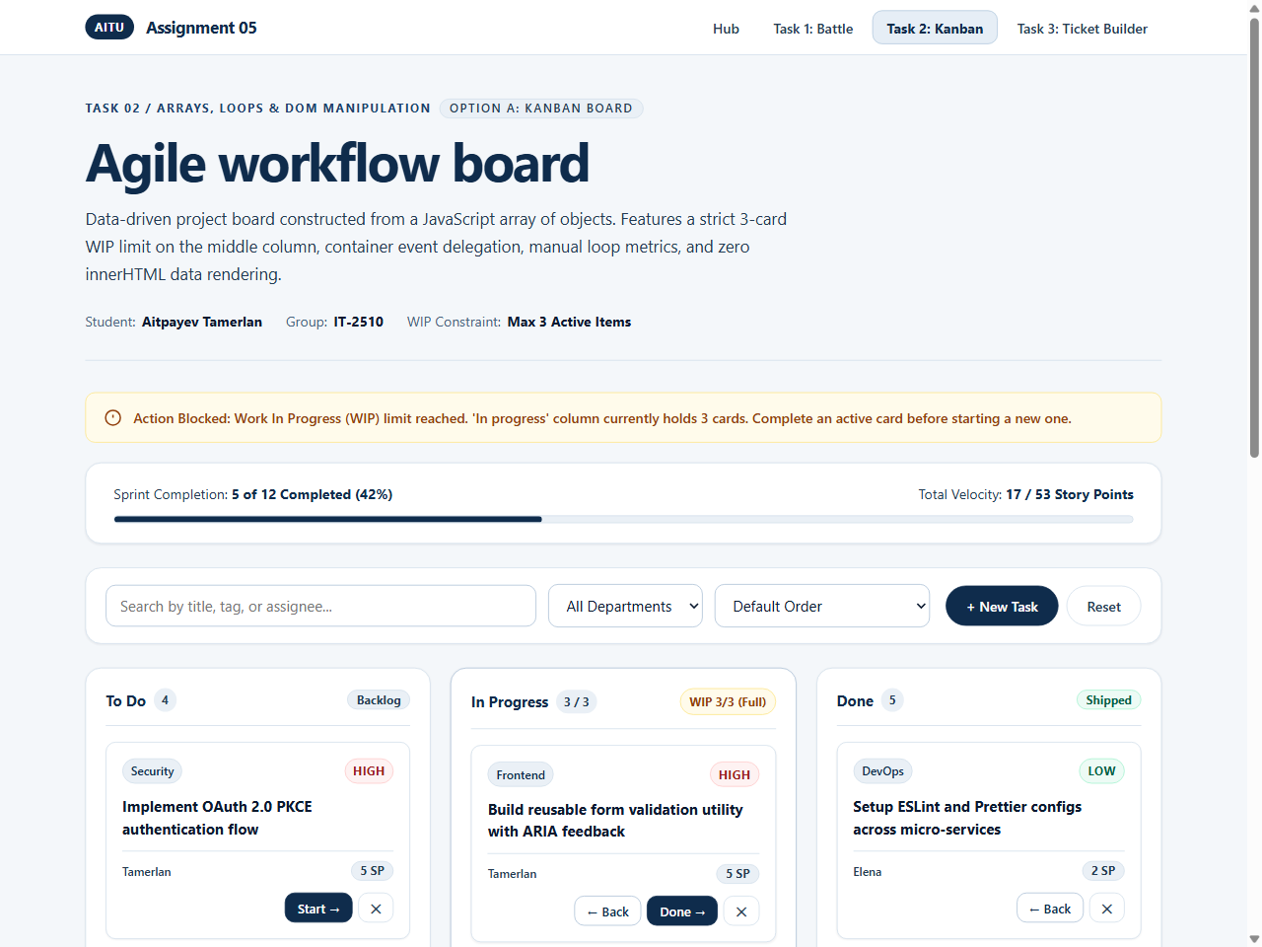
Figure 3.1: Kanban board enforcing WIP limit of 3 cards with warning banner and sprint velocity bar.

4. Task 3: Live Pass Builder & Validation (Option A)
Task 3 implements an event ticketing system with an instant boarding pass preview. The form includes 7 input controls: event summit, booking date, ticket tier, quantity, full name, email address, and promo code. Form submission utilizes the Constraint Validation API (setCustomValidity, checkValidity, novalidate=true). Initial page load displays zero error messages. Input fields are validated on blur, and once blurred, re-validated on every keystroke. Upon submission with errors, an error count alert banner appears at the top and focus smoothly transfers to the first invalid field. Upon valid submission, a confirmation card with a generated booking reference is rendered using pure DOM methods.
Table 4.1: Specification of Four Rules Unexpressible by HTML Attributes
Field | Rule Description | Valid Example | Invalid Example & Feedback
Pass Tier & Quantity | Dynamic Seat Inventory: Requested quantity cannot exceed remaining seats in active tier object. | VIP Pass with Quantity = 3 (out of 4 seats available) | VIP Pass with Quantity = 5 ('Capacity exceeded: Only 4 VIP seats remaining in inventory')
Event Date | Sold-Out & Lead Time: Rejects dates in blackout array (e.g. 2026-11-15) and dates less than 2 days in advance. | 2026-11-20 (Conference active date, 5+ days ahead) | 2026-11-15 ('This date is completely sold out or closed for registration')
Promo Code | Registry Catalog Verification: Optional promo code must match active verified registry to grant discount. | AITU20 (20% off), DEV2026 (15% off), STUDENT50 (50% off) | DISCOUNT99 ('Unrecognized promo code. Try AITU20 or STUDENT50')
Full Legal Name | Multi-token Name Structure: Must contain at least two words (First + Last), min 2 characters each, letters only. | Tamerlan Aitpayev, Айтпаев Тамерлан | Tamerlan ('Please enter both your First Name and Last Name') or Tamerlan123

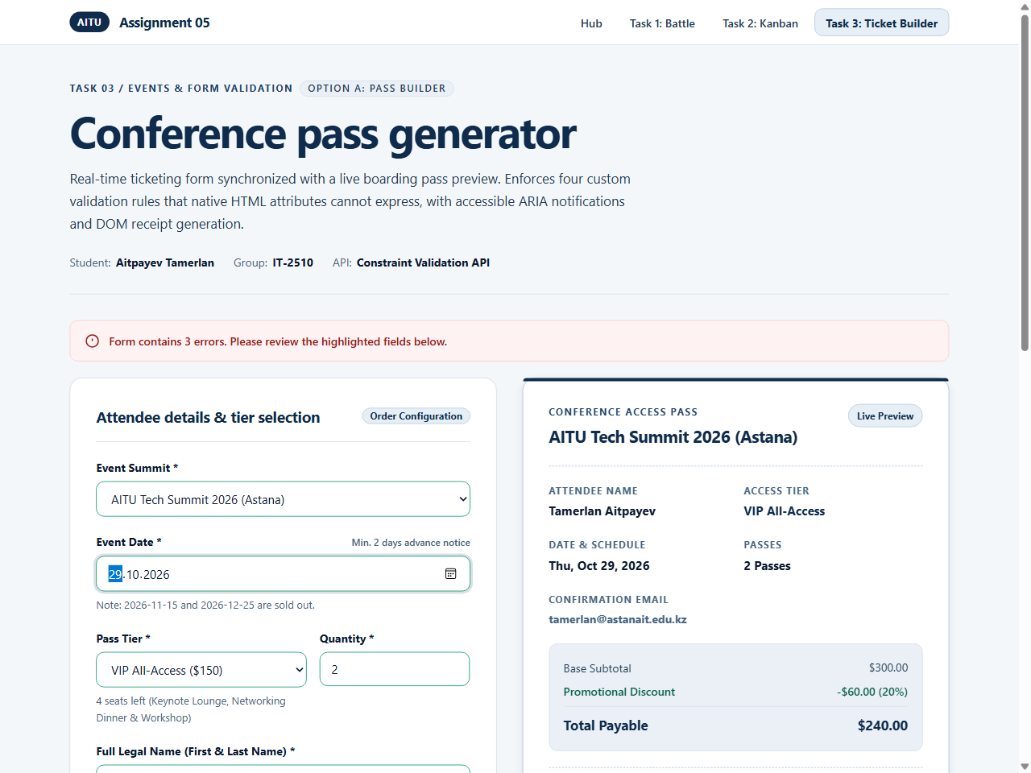
Figure 4.1: Pass builder form with real-time boarding pass synchronization and promo code discount.

5. Algorithmic Complexity & Architectural Analysis
A rigorous Big-O evaluation reveals optimal time and memory space allocation across all three tasks:
• Task 1 Combat Engine: All state updates (HP deduction, defense calculation, potion decrement) execute in O(1) constant time. Log maintenance performs unshift() and pop() bounded by MAX_LOG_ENTRIES = 5, which operates in O(1) amortized time and O(1) auxiliary space;
• Task 2 Kanban Rendering: The manual calculation loop traverses N tasks in O(N) time. Priority sorting operates in O(N log N) via TimSort. DOM tree generation iterates over filtered tasks in O(N) linear time and O(N) space. Container event delegation processes user interactions in O(1) time without attaching per-card event listeners;
• Task 3 Validation: Field evaluation runs in O(K) where K is the constant number of fields (K = 7, O(1)). Dynamic inventory lookup executes via Array.prototype.find() over M tiers (M = 3, O(1)). DOM receipt generation runs in O(1) time.

7. Conclusion
Through the execution of Assignment #5, I deepened my competencies in modern ES6+ JavaScript, Document Object Model architecture, and event-driven engineering. I successfully built three production-grade interactive modules: a stateful combat simulator with compound conditionals and fair random ranges, a data-driven Kanban board enforcing strict WIP constraints and event delegation with zero innerHTML, and an accessible event pass builder leveraging the Constraint Validation API. The application maintains an editorial Naval Blue and crisp white design system compliant with WCAG AAA accessibility standards and verified across mobile (375px) and desktop (1280px) viewports.

