ASTANA IT UNIVERSITY
FACULTY OF COMPUTER SCIENCE & ENGINEERING
DEPARTMENT OF COMPUTER ENGINEERING
————————————————————————————————————————
LABORATORY REPORT
Assignment #6: jQuery (Selectors, Effects, Animations)
Field | Information
Course: | Web Technologies (Front-End Development)
Student Name: | Aitpayev Tamerlan
Academic Group: | IT-2510
Course Instructor: | Abitova G.A.
GitHub Repository URL: | https://github.com/tamerlanaitpayev1-netizen/web6

1. Objective and Architectural Overview
The goal of Assignment #6 is to master DOM selection, tree traversal, dynamic element insertion/removal, and smooth visual animations using jQuery 3.7.1. All interactive behavior across both tasks is implemented exclusively in jQuery without external libraries, inline onclick attributes, CSS transitions, or CSS animations.
• In Task 1 (Selector Detective), the 2-floor, 4-room birthday house with 21 guests is stored in a structured array and rendered dynamically into the page. Each of the 20 detective cases is solved with a single jQuery selector and traversal chain searching the rendered DOM (never the JavaScript array), highlighting matched cards and making them jump once via animate().
• In Task 2 (The Party in Motion), the page is enhanced with four interactive effects: Spotlight (fadeTo 20% in 0.3s and Clear button), an expanding Guest Card popup that grows out of the clicked avatar photo and shrinks back on Esc or outside click, Cross-House Move flight using clone() and offset() while closing the old gap and opening the new slot, and room-level Sort by time using position() and animate() with stop(true, false) queue protection.

Figure 1.1: Assignment #6 Hub Overview Page (index.html).

2. Task 1: Selector Detective (Selectors and Traversal)
In Task 1, I transcribed the birthday party illustration ('The Party, 19:30 – 22:30') into the PARTY_DATA array containing the 4 rooms across Floor 2 (Balcony, Hall) and Floor 1 (Kitchen, Living room) and all 21 guests from left to right. When buildPartyPage() runs, jQuery creates each room section and builds a <article class='guest-card'> for every guest with their DiceBear Open Peeps avatar (https://api.dicebear.com/9.x/open-peeps/svg?seed=Name), a colored border ring matching their clothing, arrival time, SVG icons for their items, an AITU badge if applicable, semantic classes (color-*, is-aitu, has-*), and data-* attributes (data-name, data-color, data-time, data-aitu, data-things).
Table 2.1: Complete Party Array Transcription (21 Guests Across 4 Rooms)
Floor | Room | Guest | Color | Arrival | AITU Badge | Things
Floor 2 | Balcony | Aigerim | yellow | 20:45 | Yes (AITU) | crumbs, bag
Floor 2 | Balcony | Aliya | green | 21:15 | Yes (AITU) | phone, cup
Floor 2 | Balcony | Madina | purple | 22:10 | No | phone, bag, crumbs
Floor 2 | Balcony | Ivan | black | 20:10 | No | bag
Floor 2 | Hall | Arman | red | 20:35 | No | bag, glasses
Floor 2 | Hall | Sophia | yellow | 21:30 | No | phone
Floor 2 | Hall | Dias | green | 19:45 | No | (nothing)
Floor 2 | Hall | Bekzat | purple | 20:55 | Yes (AITU) | bag, cup, crumbs
Floor 2 | Hall | Aruzhan | blue | 21:50 | Yes (AITU) | phone
Floor 2 | Hall | Saule | red | 21:25 | No | glasses
Floor 1 | Kitchen | Nurlan | red | 19:40 | Yes (AITU) | phone, bag
Floor 1 | Kitchen | Emma | yellow | 20:15 | No | bag
Floor 1 | Kitchen | Timur | green | 21:05 | No | phone, bag, crumbs
Floor 1 | Kitchen | Sergey | black | 20:50 | No | (nothing)
Floor 1 | Kitchen | Yerlan | purple | 21:40 | No | glasses, phone
Floor 1 | Kitchen | Kamila | blue | 20:05 | No | bag
Floor 1 | Living room | Daniel | blue | 19:55 | Yes (AITU) | glasses
Floor 1 | Living room | Zarina | yellow | 21:10 | No | bag, phone, crumbs
Floor 1 | Living room | Natasha | green | 20:30 | No | (nothing)
Floor 1 | Living room | Askar | black | 21:00 | Yes (AITU) | phone
Floor 1 | Living room | Inkar | purple | 20:20 | No | bag

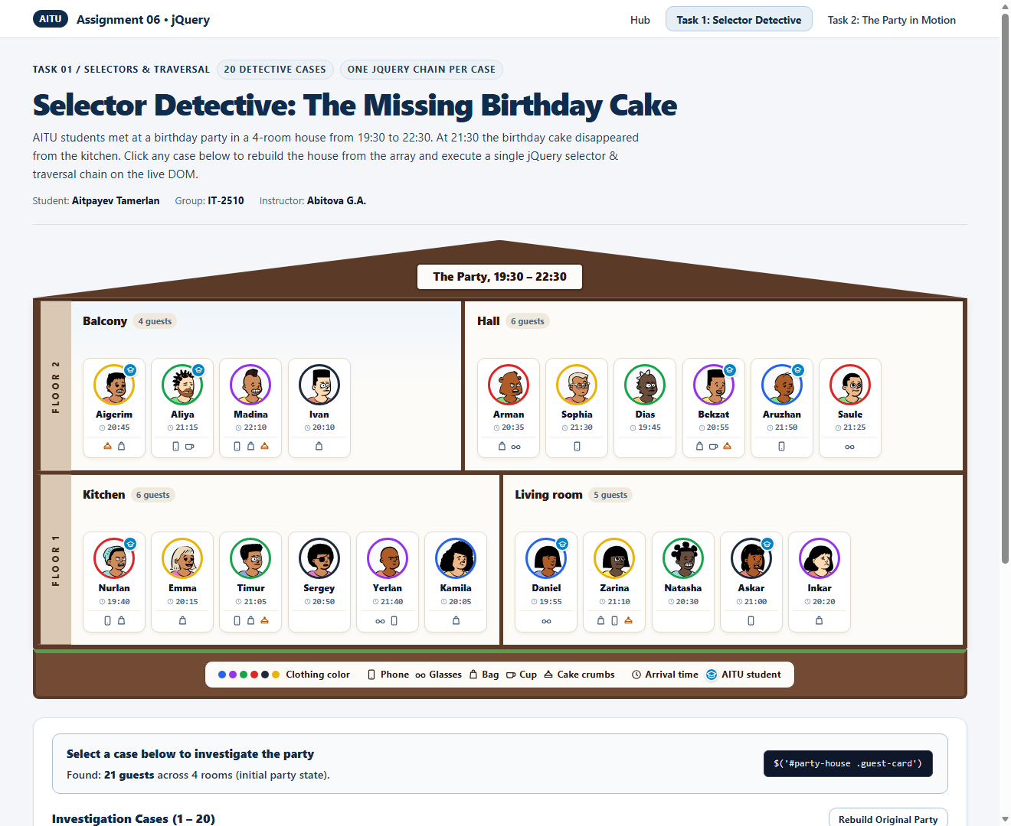
Figure 2.1: Initial Party House rendered dynamically from the array with jQuery.
Table 2.2: All 20 Detective Cases — Single jQuery Chains and Found Results
Case | Question / Action | Single jQuery Chain | Result on Page
1 | Who is in the hall? | $('#room-hall .guest-card') | 6 guests: Arman, Sophia, Dias, Bekzat, Aruzhan, Saule
2 | Who is dressed in yellow or purple? | $('.guest-card.color-yellow, .guest-card.color-purple') | 8 guests: Aigerim, Madina, Sophia, Bekzat, Emma, Yerlan, Zarina, Inkar
3 | Which AITU students are upstairs? | $('#floor-2 .guest-card.is-aitu') | 4 guests: Aigerim, Aliya, Bekzat, Aruzhan
4 | Who has glasses or a bag? | $('.guest-card:has(.thing-glasses, .thing-bag)') | 14 guests: Aigerim, Madina, Ivan, Arman, Bekzat, Saule, Nurlan, Emma, Timur, Yerlan, Kamila, Daniel, Zarina, Inkar
5 | Who came with nothing at all? | $('.guest-card:not(:has(.thing-icon))') | 3 guests: Dias, Sergey, Natasha
6 | Who has a phone but no bag? | $('.guest-card:has(.thing-phone):not(:has(.thing-bag))') | 5 guests: Aliya, Sophia, Aruzhan, Yerlan, Askar
7 | Who arrived between 20:30 and 21:00, both times included? | $('.guest-card').filter((_, el) => $(el).attr('data-time') >= '20:30' && $(el).attr('data-time') <= '21:00') | 6 guests: Aigerim, Arman, Bekzat, Sergey, Natasha, Askar
8 | Who arrived after 21:00 and is not an AITU student? | $('.guest-card:not(.is-aitu)').filter((_, el) => $(el).attr('data-time') > '21:00') | 6 guests: Madina, Sophia, Saule, Timur, Yerlan, Zarina
9 | Who stands right next to Askar? | $('.guest-card[data-name="Askar"]').prev().add($('.guest-card[data-name="Askar"]').next()) | 2 guests: Natasha, Inkar
10 | Who stands last in each room? | $('.room .guest-card:last-child') | 4 guests: Ivan, Saule, Kamila, Inkar
11 | Who stands third in each room? | $('.room .guest-card:nth-child(3)') | 4 guests: Madina, Dias, Timur, Natasha
12 | Who stands after Timur in his room? | $('.guest-card[data-name="Timur"]').nextAll() | 3 guests: Sergey, Yerlan, Kamila
13 | Who stands right before someone in black? | $('.guest-card.color-black').prev() | 3 guests: Madina, Timur, Natasha
14 | In which room is Aruzhan? | $('.guest-card[data-name="Aruzhan"]').closest('.room') | 1 room: Hall
15 | Which rooms have fewer than 6 guests? | $('.room:not(:has(.guest-card:nth-child(6)))') | 2 rooms: Balcony (4), Living room (5)
16 | In which rooms does somebody have a cup, but nobody wears glasses? | $('.room:has(.thing-cup):not(:has(.thing-glasses))') | 1 room: Balcony
17 | Who came first to each room? | $('.guest-card').filter((_, el) => $(el).siblings().filter((_, s) => $(s).attr('data-time') < $(el).attr('data-time')).length === 0) | 4 guests: Ivan (20:10), Dias (19:45), Nurlan (19:40), Daniel (19:55)
18 | Miras, an AITU student in blue, comes at 21:20 with his phone and joins Askar and Inkar, standing between them. Let him appear smoothly. | createGuestCardElement({name:'Miras',color:'blue',time:'21:20',aitu:true,things:['phone']},'living-room',1).hide().insertAfter('.guest-card[data-name="Askar"]').fadeIn(400) | Added 1 guest: Miras between Askar and Inkar (Living room = 6 guests)
19 | Natasha says goodbye and goes home. Her card fades away and disappears from the page. | $('.guest-card[data-name="Natasha"]').fadeOut(400, function() { $(this).remove(); }) | Removed 1 guest: Natasha faded out and removed from DOM
20 | Who took the cake? The thief was downstairs, came after 21:00 but before the cake disappeared, has crumbs but no cup, and stood right next to an AITU student. | $('#floor-1 .guest-card:has(.thing-crumbs):not(:has(.thing-cup))').filter((_, el) => $(el).attr('data-time') > '21:00' && $(el).attr('data-time') < '21:30' && $(el).prev().add($(el).next()).is('.is-aitu')) | THIEF IDENTIFIED — 1 guest: Zarina

2.1. Step-by-Step Verification & Screenshots for Every Case (Cases 1 – 20)
Case 1: Who is in the hall?
jQuery Chain: $('#room-hall .guest-card')
Result: 6 guests: Arman, Sophia, Dias, Bekzat, Aruzhan, Saule
Explanation: Selects all guest cards inside #room-hall using a descendant selector.
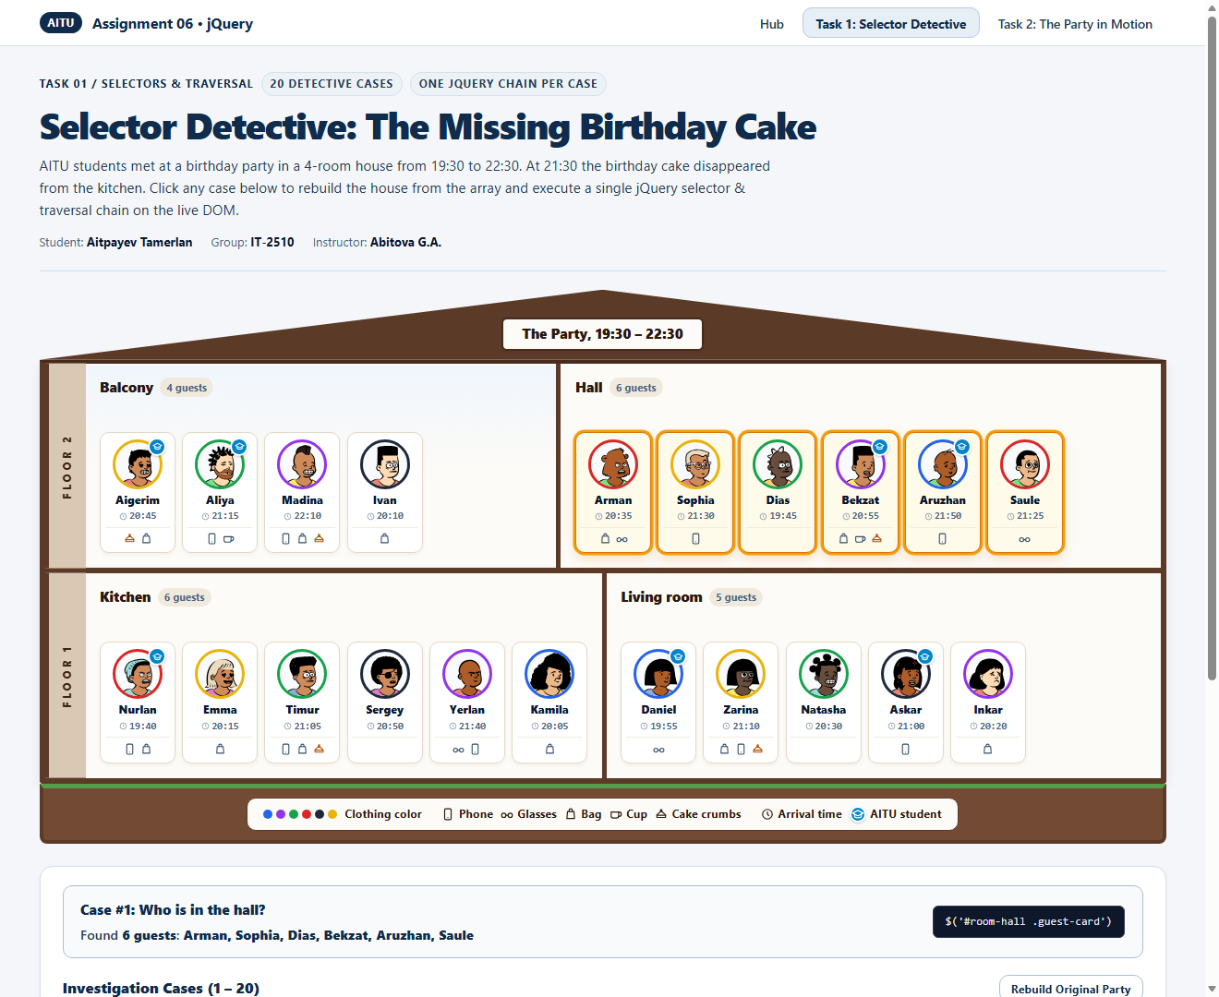
Figure 2.2: Case 1 Result — 6 guests: Arman, Sophia, Dias, Bekzat, Aruzhan, Saule
Case 2: Who is dressed in yellow or purple?
jQuery Chain: $('.guest-card.color-yellow, .guest-card.color-purple')
Result: 8 guests: Aigerim, Madina, Sophia, Bekzat, Emma, Yerlan, Zarina, Inkar
Explanation: Combines two class selectors (.color-yellow and .color-purple) with a comma union to match guests wearing yellow or purple.
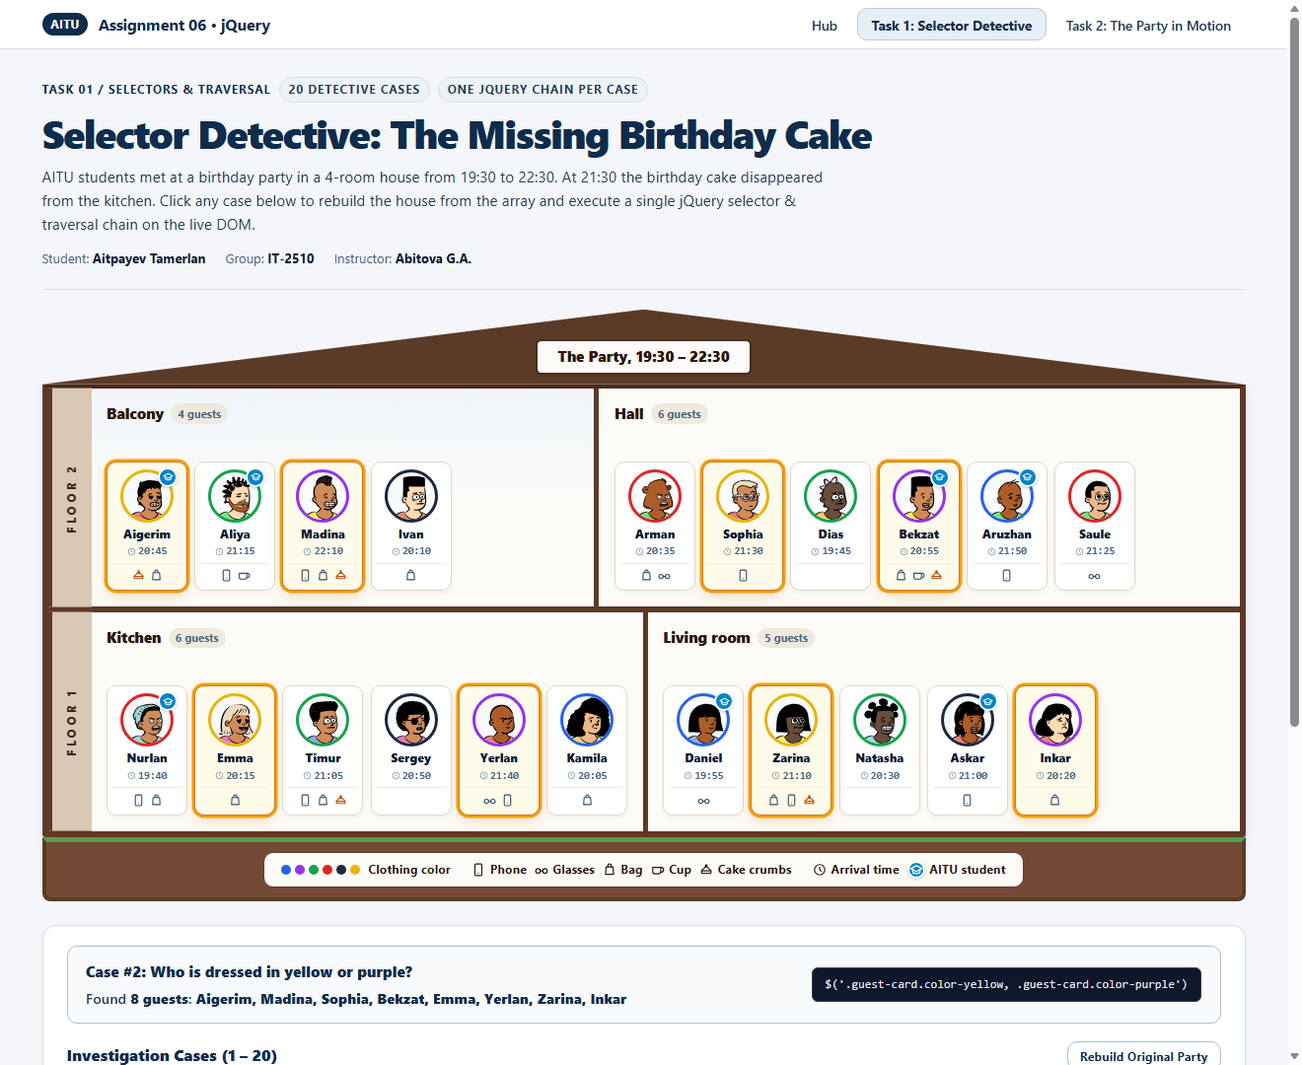
Figure 2.3: Case 2 Result — 8 guests: Aigerim, Madina, Sophia, Bekzat, Emma, Yerlan, Zarina, Inkar
Case 3: Which AITU students are upstairs?
jQuery Chain: $('#floor-2 .guest-card.is-aitu')
Result: 4 guests: Aigerim, Aliya, Bekzat, Aruzhan
Explanation: Scopes the search to #floor-2 (upstairs) and matches guest cards carrying the .is-aitu class.
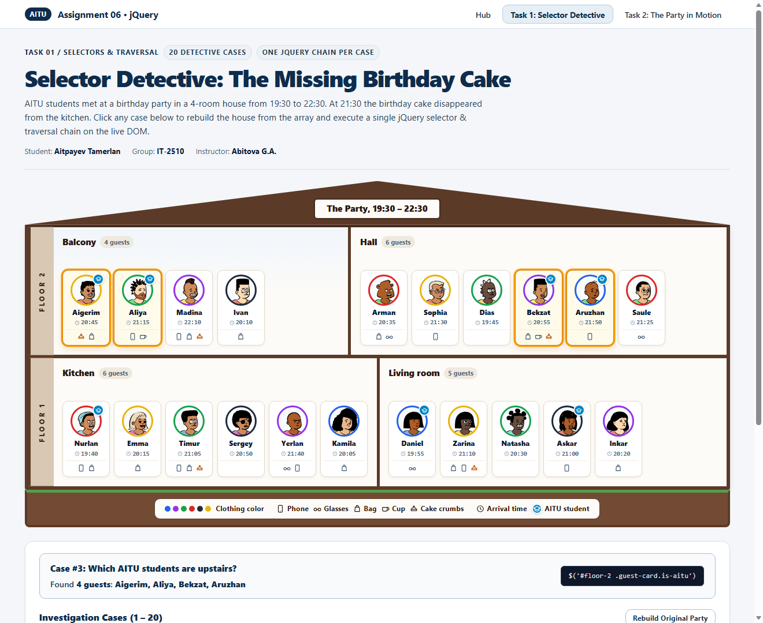
Figure 2.4: Case 3 Result — 4 guests: Aigerim, Aliya, Bekzat, Aruzhan
Case 4: Who has glasses or a bag?
jQuery Chain: $('.guest-card:has(.thing-glasses, .thing-bag)')
Result: 14 guests: Aigerim, Madina, Ivan, Arman, Bekzat, Saule, Nurlan, Emma, Timur, Yerlan, Kamila, Daniel, Zarina, Inkar
Explanation: Uses the :has() relational pseudo-class to find any guest card that contains either a .thing-glasses or .thing-bag icon.
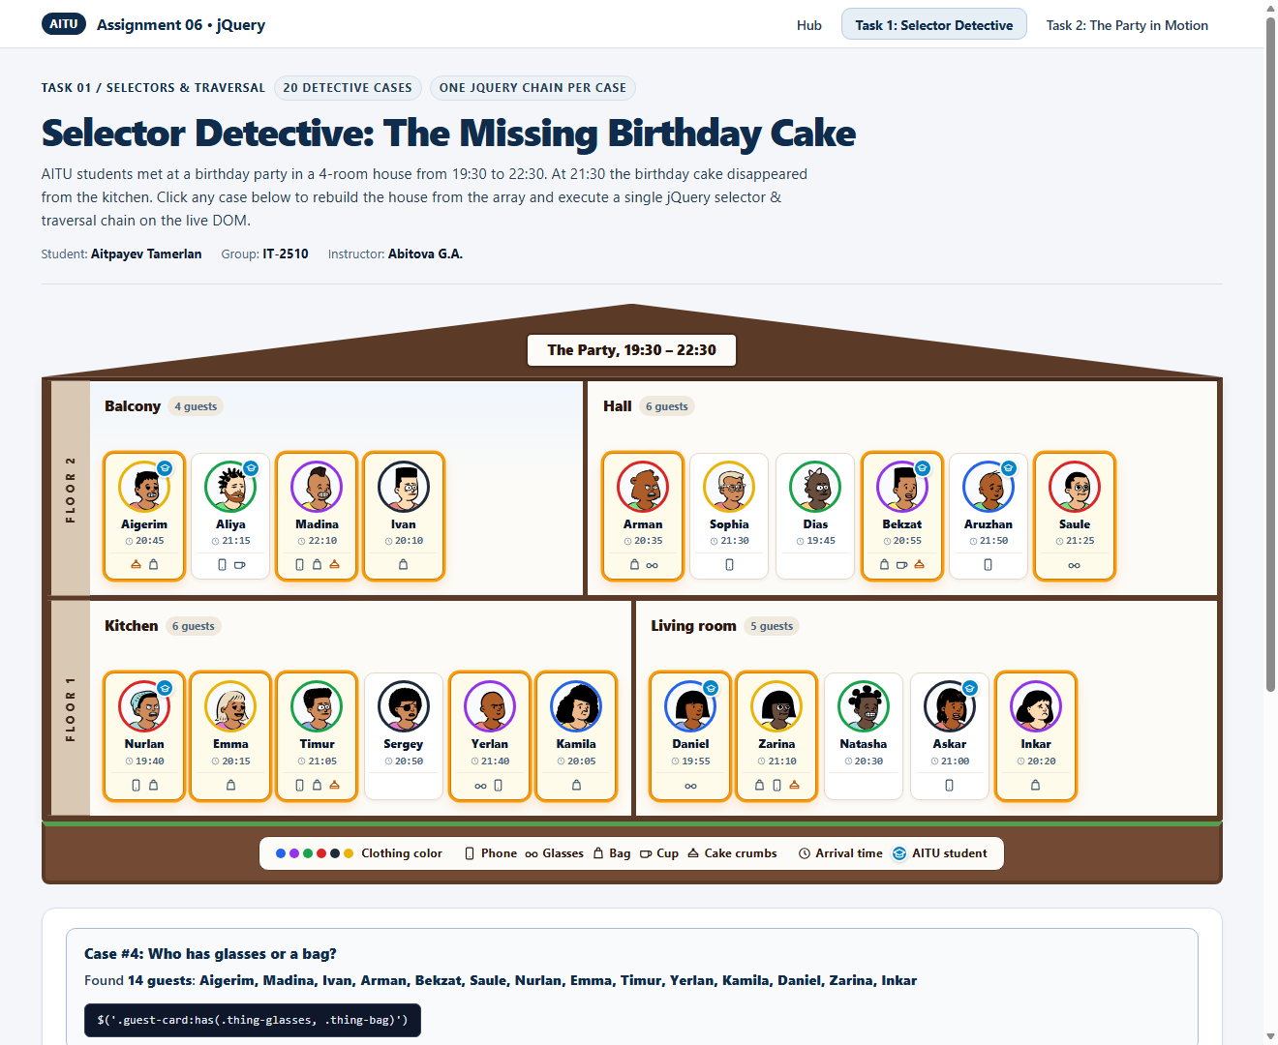
Figure 2.5: Case 4 Result — 14 guests: Aigerim, Madina, Ivan, Arman, Bekzat, Saule, Nurlan, Emma, Timur, Yerlan, Kamila, Daniel, Zarina, Inkar
Case 5: Who came with nothing at all?
jQuery Chain: $('.guest-card:not(:has(.thing-icon))')
Result: 3 guests: Dias, Sergey, Natasha
Explanation: Combines :not() and :has(.thing-icon) to match guests whose item container has no icons at all.
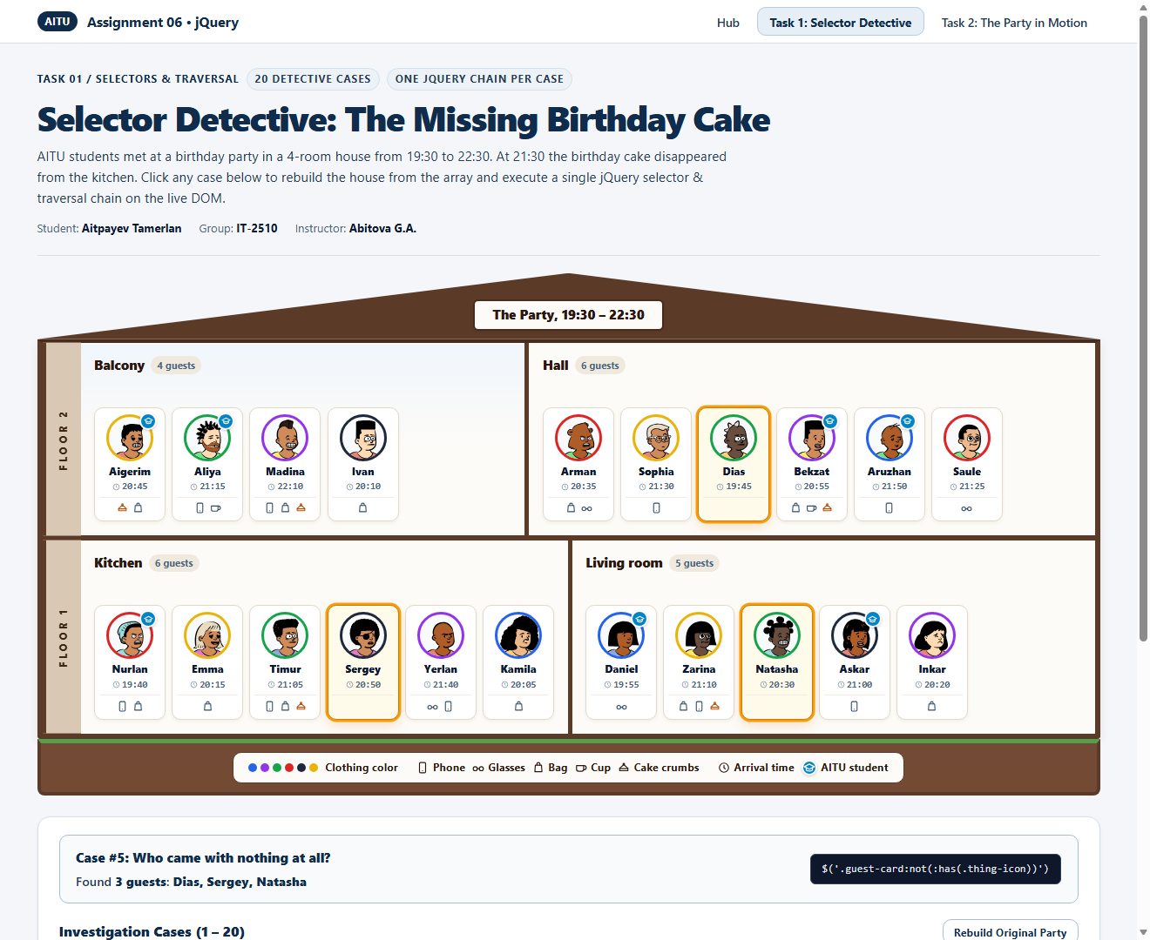
Figure 2.6: Case 5 Result — 3 guests: Dias, Sergey, Natasha
Case 6: Who has a phone but no bag?
jQuery Chain: $('.guest-card:has(.thing-phone):not(:has(.thing-bag))')
Result: 5 guests: Aliya, Sophia, Aruzhan, Yerlan, Askar
Explanation: Chains :has(.thing-phone) with :not(:has(.thing-bag)) on .guest-card elements.
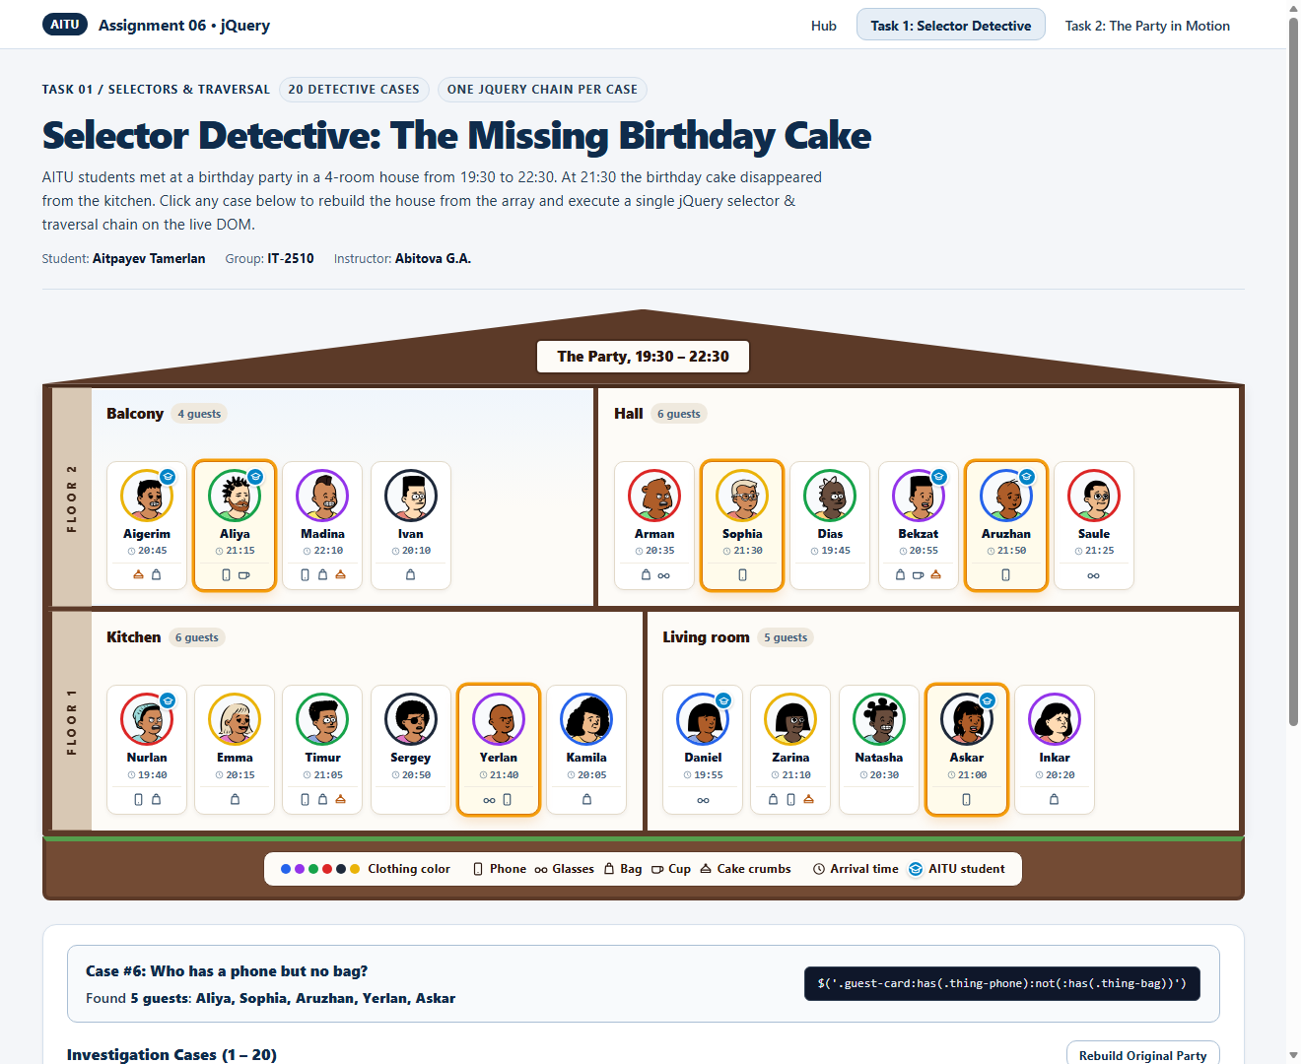
Figure 2.7: Case 6 Result — 5 guests: Aliya, Sophia, Aruzhan, Yerlan, Askar
Case 7: Who arrived between 20:30 and 21:00, both times included?
jQuery Chain: $('.guest-card').filter((_, el) => $(el).attr('data-time') >= '20:30' && $(el).attr('data-time') <= '21:00')
Result: 6 guests: Aigerim, Arman, Bekzat, Sergey, Natasha, Askar
Explanation: Uses .filter() to compare each card's data-time attribute inclusively between '20:30' and '21:00'.
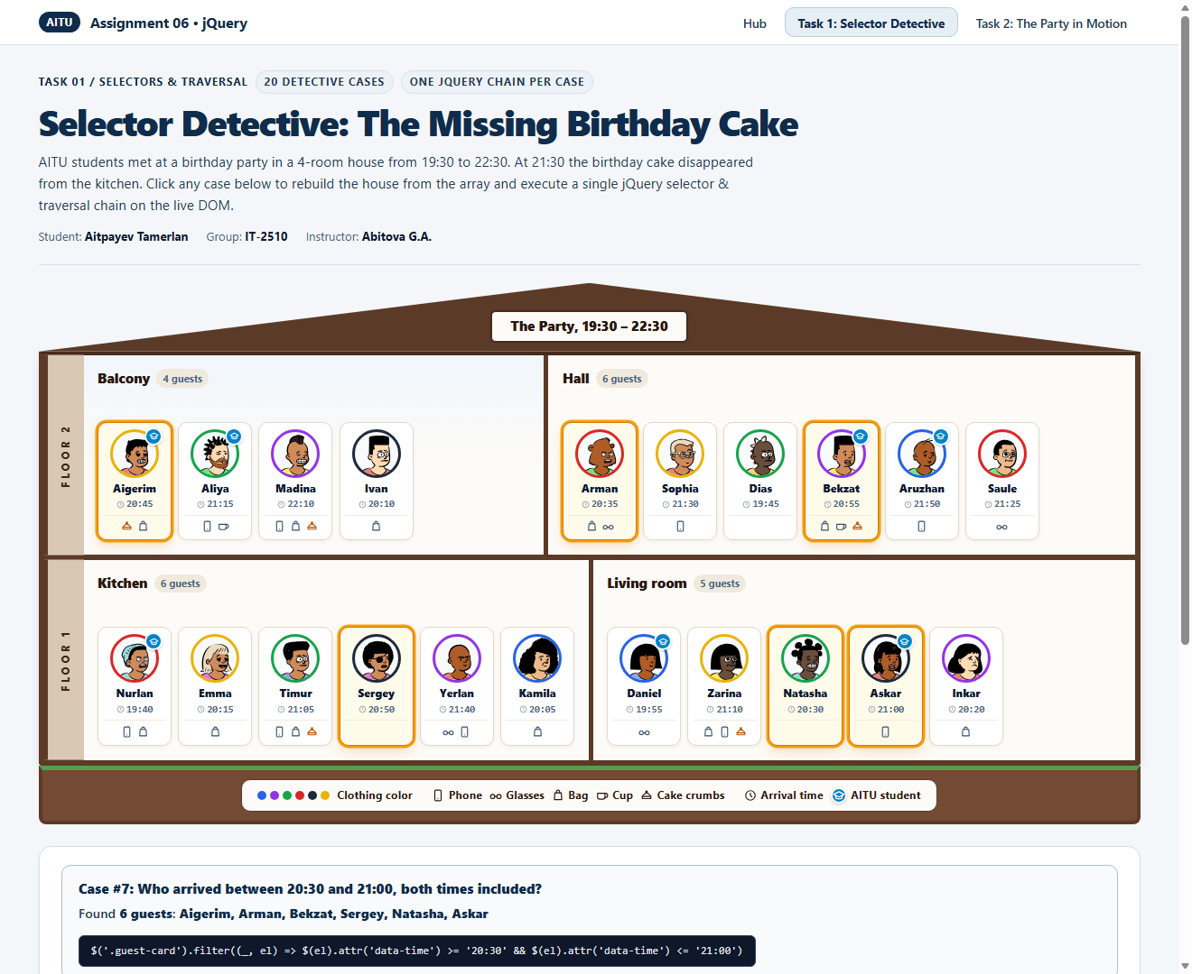
Figure 2.8: Case 7 Result — 6 guests: Aigerim, Arman, Bekzat, Sergey, Natasha, Askar
Case 8: Who arrived after 21:00 and is not an AITU student?
jQuery Chain: $('.guest-card:not(.is-aitu)').filter((_, el) => $(el).attr('data-time') > '21:00')
Result: 6 guests: Madina, Sophia, Saule, Timur, Yerlan, Zarina
Explanation: Excludes AITU students via :not(.is-aitu) and filters for arrival times strictly after '21:00'.
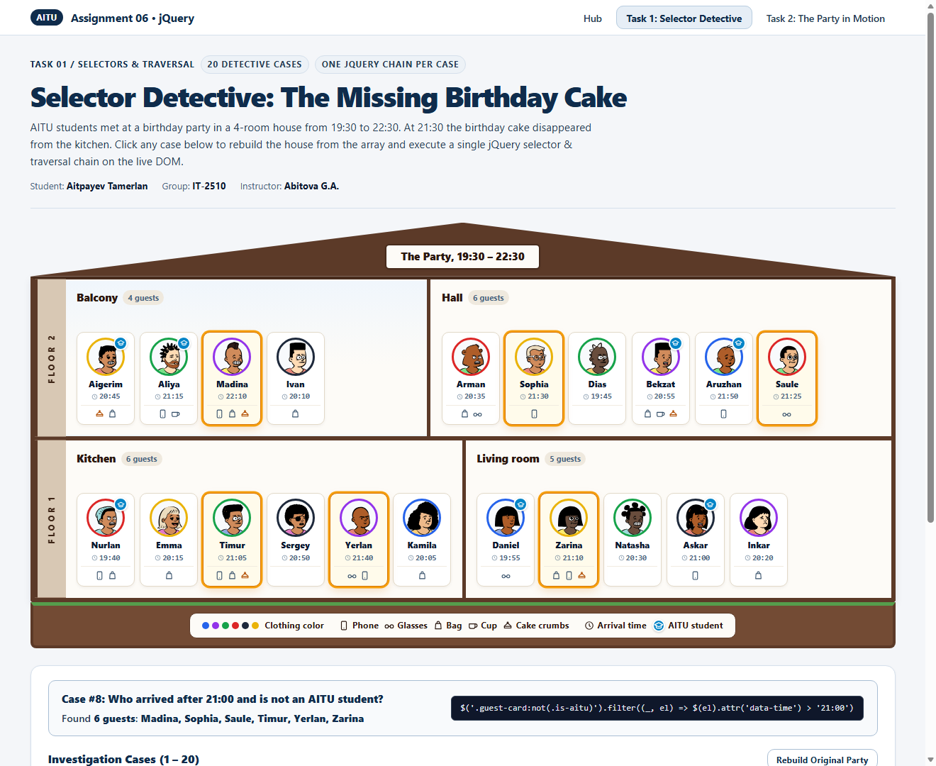
Figure 2.9: Case 8 Result — 6 guests: Madina, Sophia, Saule, Timur, Yerlan, Zarina
Case 9: Who stands right next to Askar?
jQuery Chain: $('.guest-card[data-name="Askar"]').prev().add($('.guest-card[data-name="Askar"]').next())
Result: 2 guests: Natasha, Inkar
Explanation: Locates Askar by attribute selector [data-name='Askar'] and merges his left neighbor .prev() and right neighbor .next() using .add().
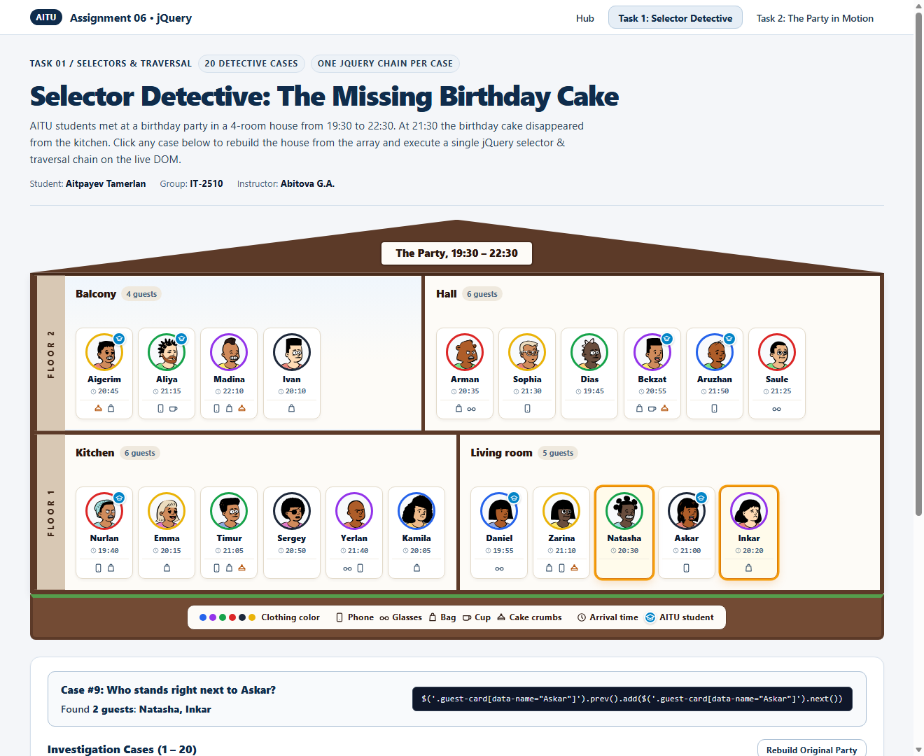
Figure 2.10: Case 9 Result — 2 guests: Natasha, Inkar
Case 10: Who stands last in each room?
jQuery Chain: $('.room .guest-card:last-child')
Result: 4 guests: Ivan, Saule, Kamila, Inkar
Explanation: Uses the structural pseudo-class :last-child inside .room to select the rightmost guest in each room.
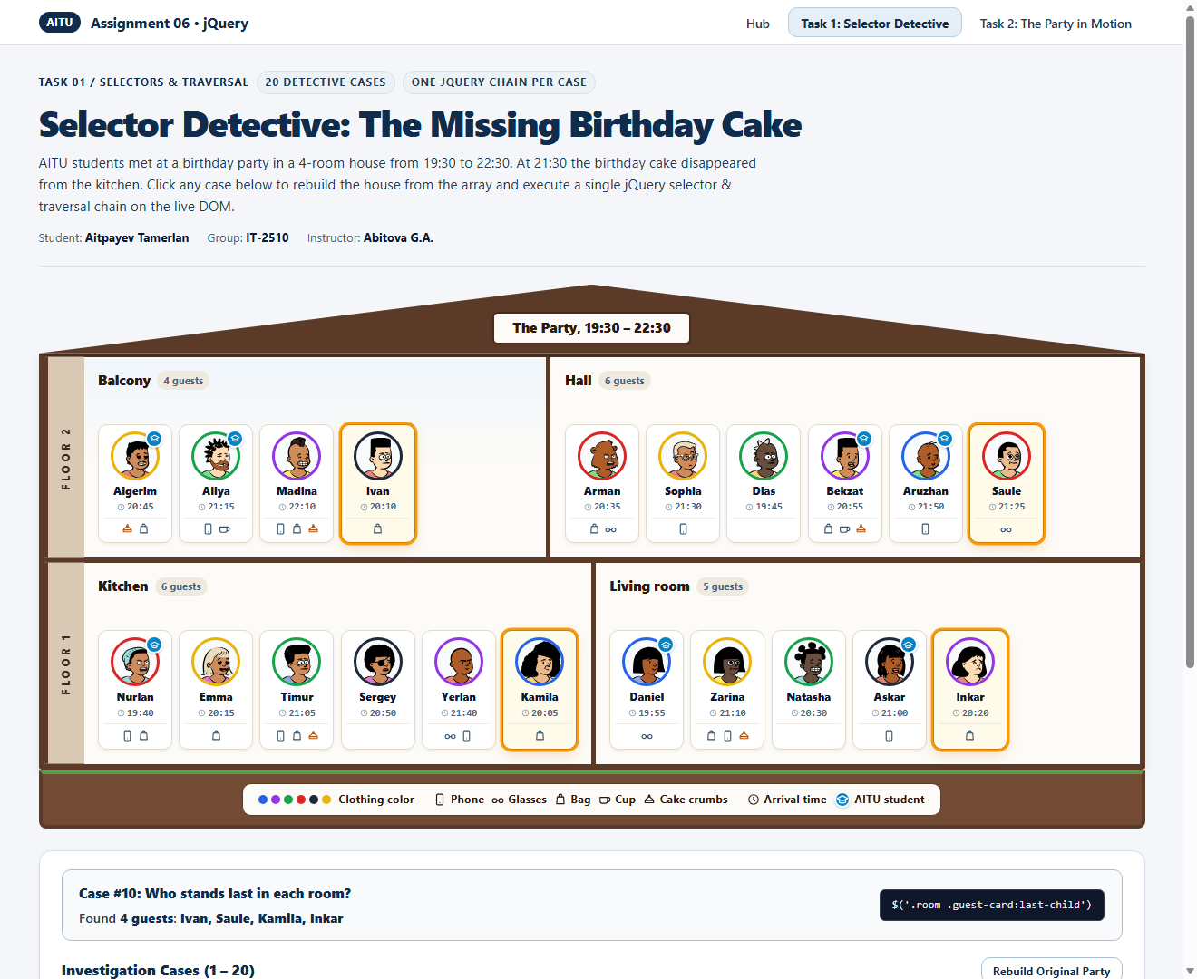
Figure 2.11: Case 10 Result — 4 guests: Ivan, Saule, Kamila, Inkar
Case 11: Who stands third in each room?
jQuery Chain: $('.room .guest-card:nth-child(3)')
Result: 4 guests: Madina, Dias, Timur, Natasha
Explanation: Uses :nth-child(3) to find the third guest standing in each of the four rooms.
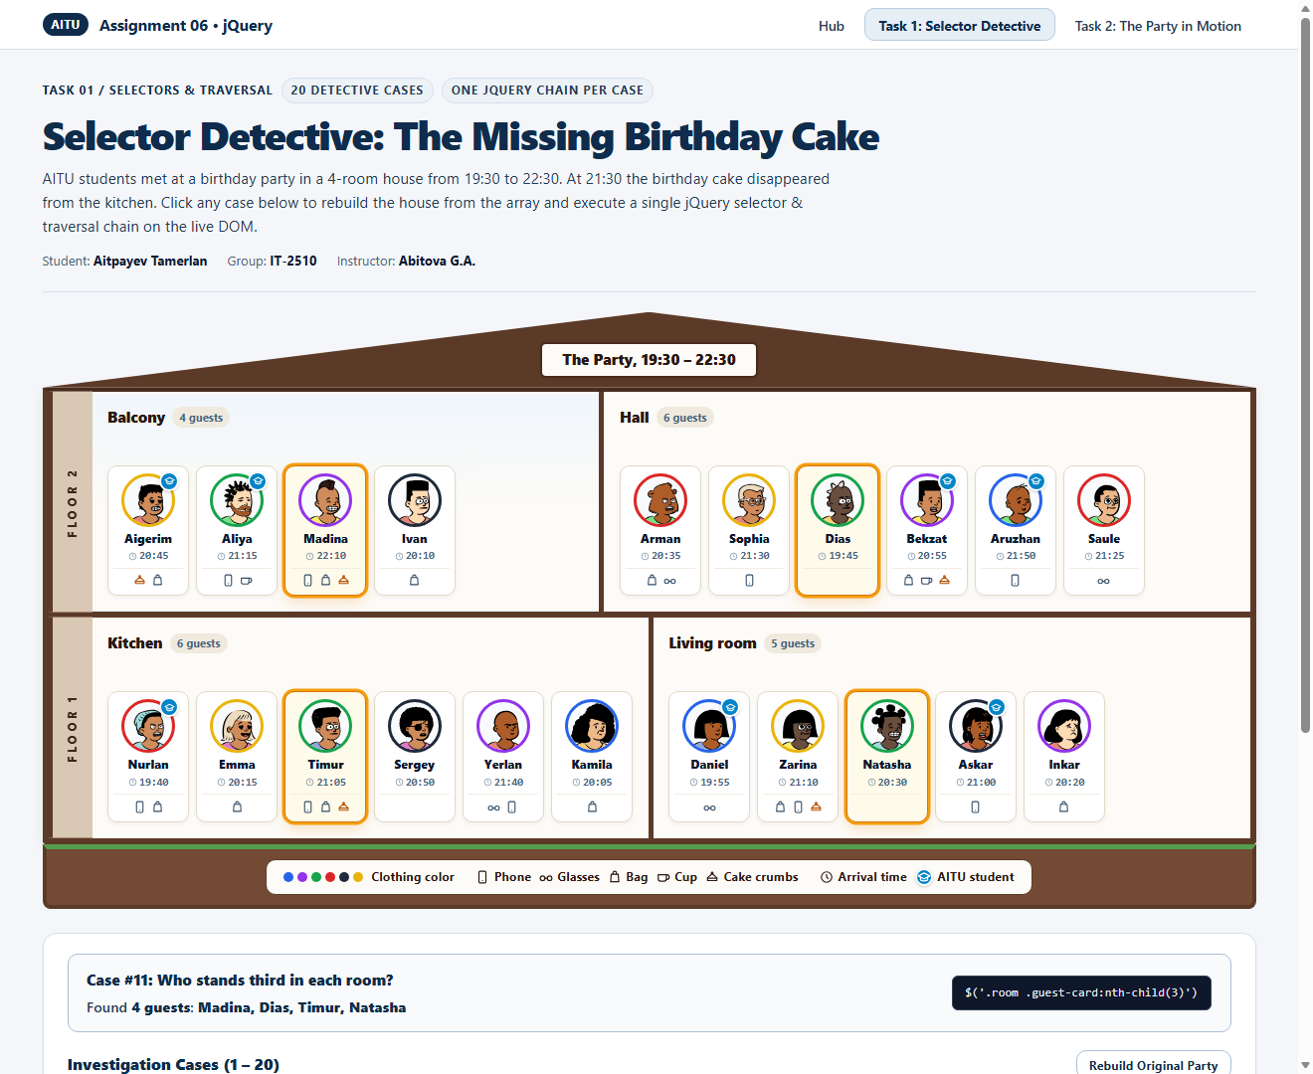
Figure 2.12: Case 11 Result — 4 guests: Madina, Dias, Timur, Natasha
Case 12: Who stands after Timur in his room?
jQuery Chain: $('.guest-card[data-name="Timur"]').nextAll()
Result: 3 guests: Sergey, Yerlan, Kamila
Explanation: Finds Timur's card and traverses to all subsequent siblings in his room via .nextAll().
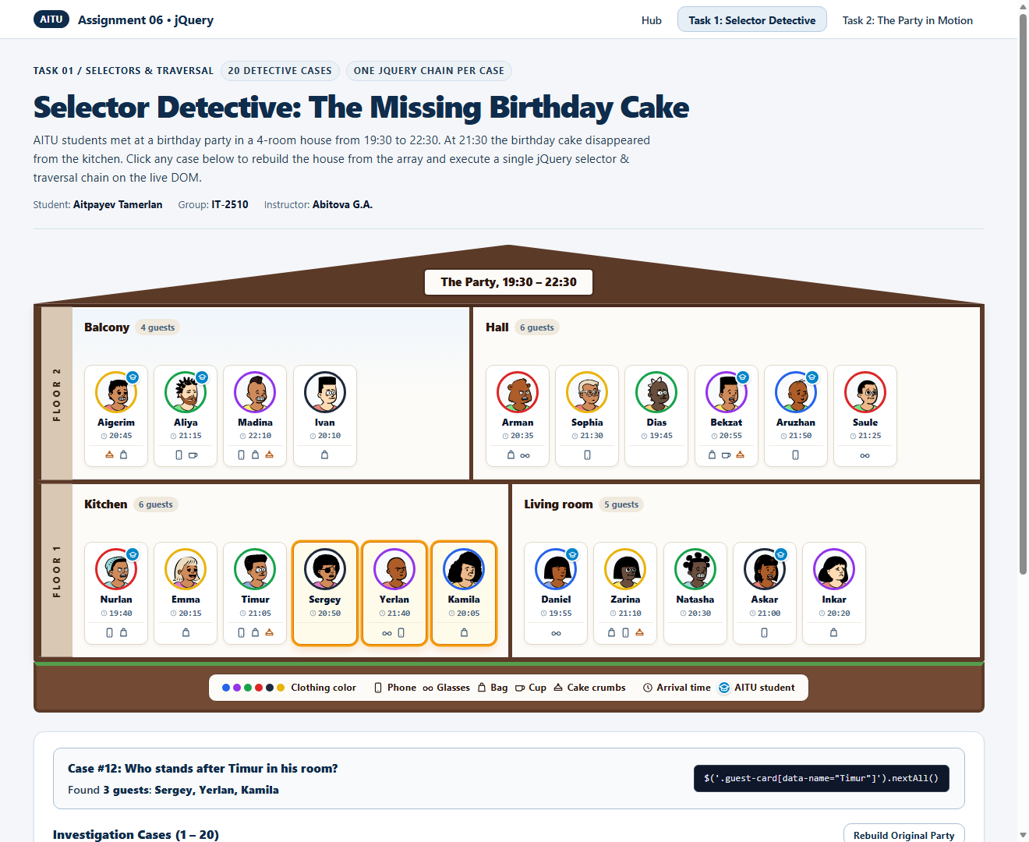
Figure 2.13: Case 12 Result — 3 guests: Sergey, Yerlan, Kamila
Case 13: Who stands right before someone in black?
jQuery Chain: $('.guest-card.color-black').prev()
Result: 3 guests: Madina, Timur, Natasha
Explanation: Selects all guests wearing black (.color-black) and steps one position to the left via .prev().
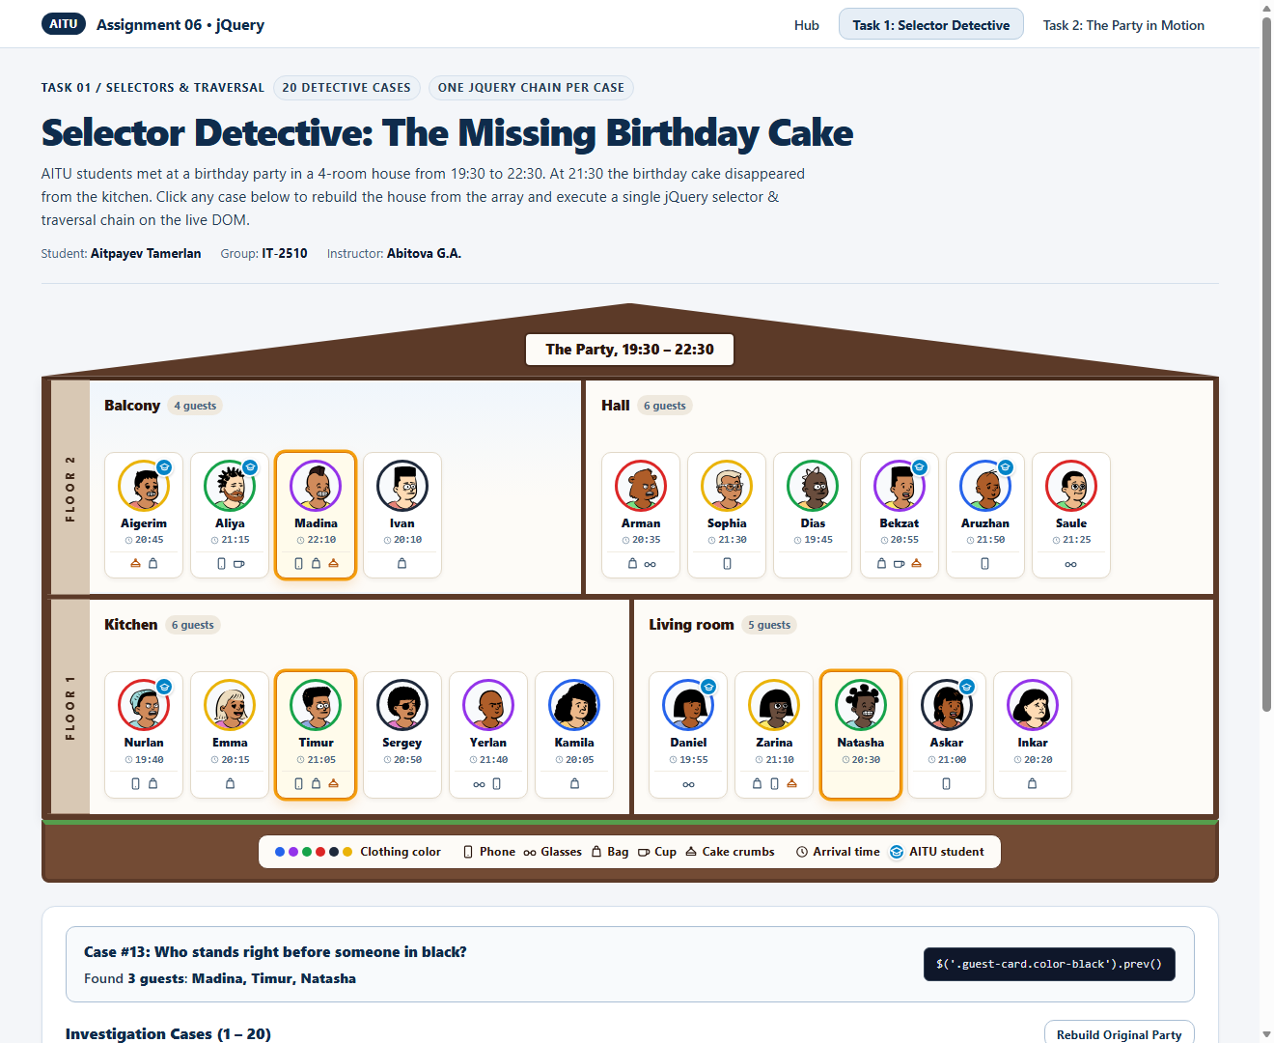
Figure 2.14: Case 13 Result — 3 guests: Madina, Timur, Natasha
Case 14: In which room is Aruzhan?
jQuery Chain: $('.guest-card[data-name="Aruzhan"]').closest('.room')
Result: 1 room: Hall
Explanation: Finds Aruzhan's card and traverses upward to her enclosing .room container using .closest('.room').
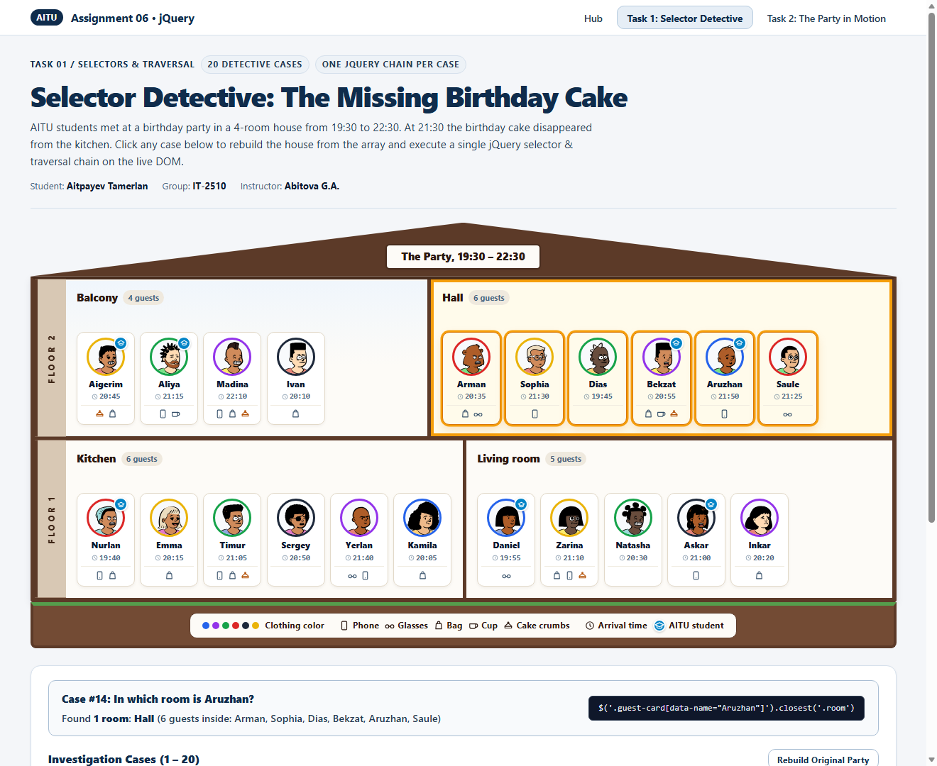
Figure 2.15: Case 14 Result — 1 room: Hall
Case 15: Which rooms have fewer than 6 guests?
jQuery Chain: $('.room:not(:has(.guest-card:nth-child(6)))')
Result: 2 rooms: Balcony (4), Living room (5)
Explanation: Finds rooms that do not have a 6th guest card child using .room:not(:has(.guest-card:nth-child(6))).
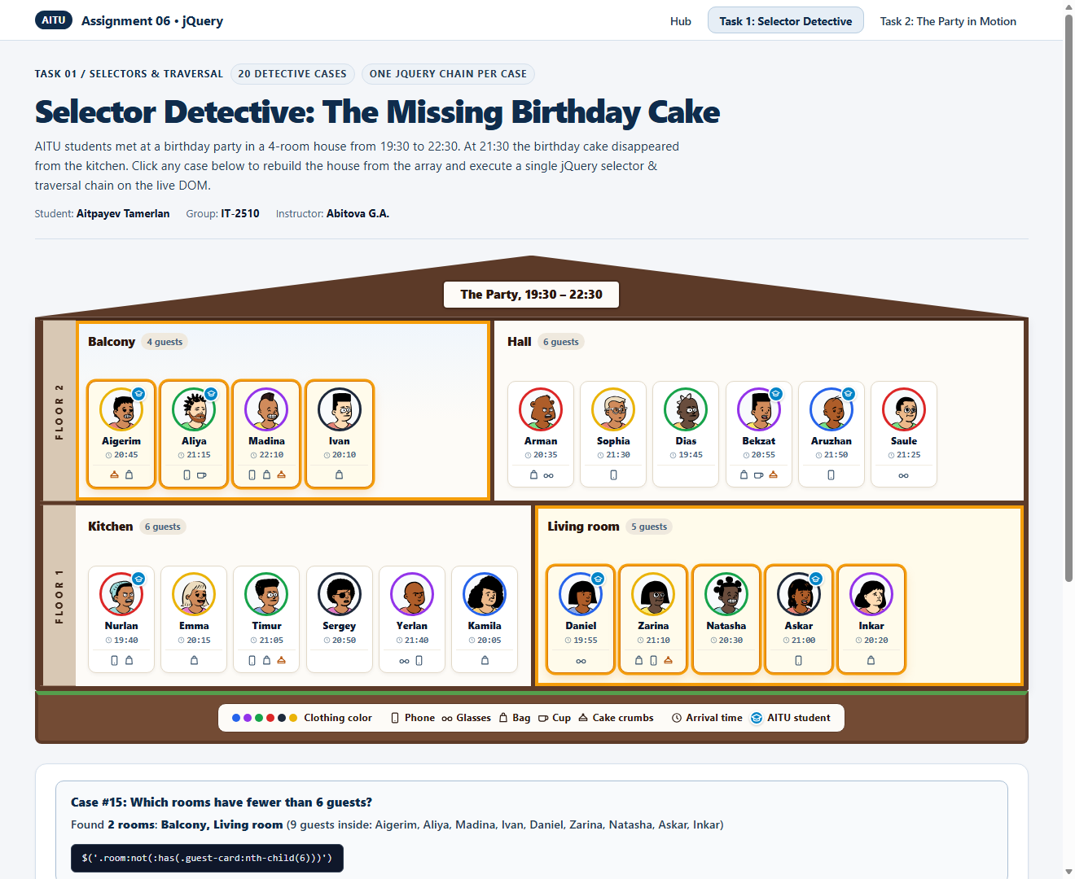
Figure 2.16: Case 15 Result — 2 rooms: Balcony (4), Living room (5)
Case 16: In which rooms does somebody have a cup, but nobody wears glasses?
jQuery Chain: $('.room:has(.thing-cup):not(:has(.thing-glasses))')
Result: 1 room: Balcony
Explanation: Selects rooms containing at least one cup (.thing-cup) while excluding rooms where anyone wears glasses (:not(:has(.thing-glasses))).
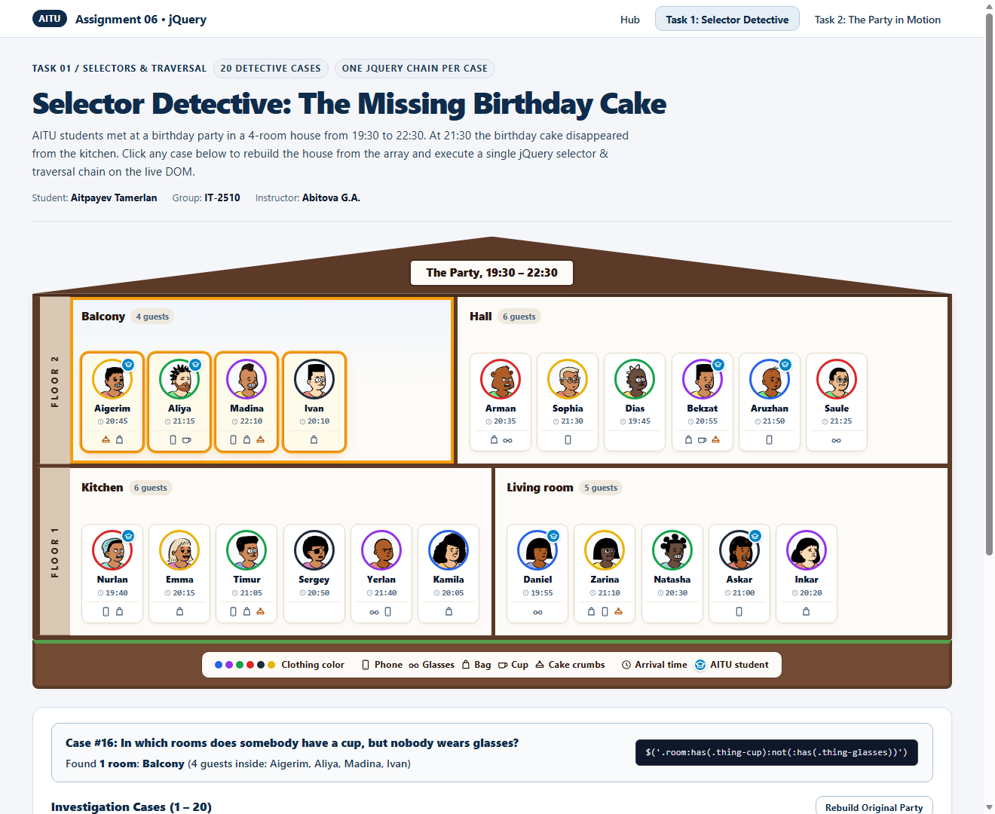
Figure 2.17: Case 16 Result — 1 room: Balcony
Case 17: Who came first to each room?
jQuery Chain: $('.guest-card').filter((_, el) => $(el).siblings().filter((_, s) => $(s).attr('data-time') < $(el).attr('data-time')).length === 0)
Result: 4 guests: Ivan (20:10), Dias (19:45), Nurlan (19:40), Daniel (19:55)
Explanation: Filters guest cards to those that have zero siblings in the same room with an earlier data-time string.
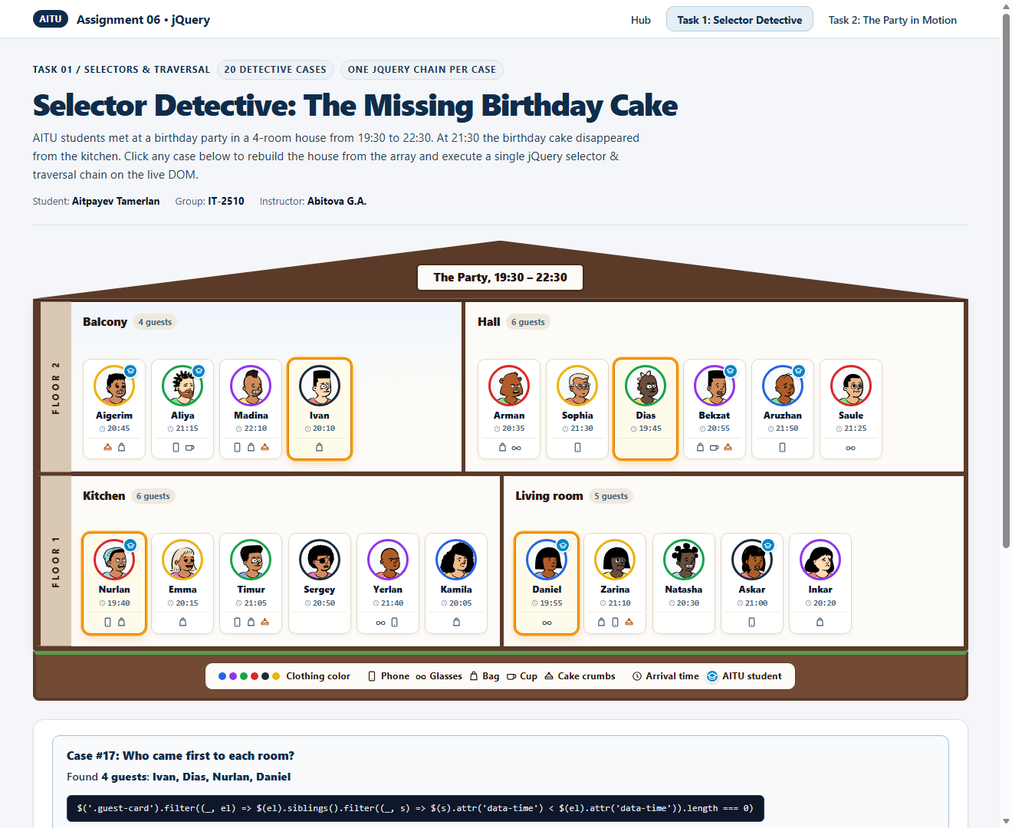
Figure 2.18: Case 17 Result — 4 guests: Ivan (20:10), Dias (19:45), Nurlan (19:40), Daniel (19:55)
Case 18: Miras, an AITU student in blue, comes at 21:20 with his phone and joins Askar and Inkar, standing between them. Let him appear smoothly.
jQuery Chain: createGuestCardElement({name:'Miras',color:'blue',time:'21:20',aitu:true,things:['phone']},'living-room',1).hide().insertAfter('.guest-card[data-name="Askar"]').fadeIn(400)
Result: Added 1 guest: Miras between Askar and Inkar (Living room = 6 guests)
Explanation: Builds Miras's guest card, hides it initially with .hide(), inserts it right after Askar via .insertAfter(), and reveals it smoothly with .fadeIn(400).
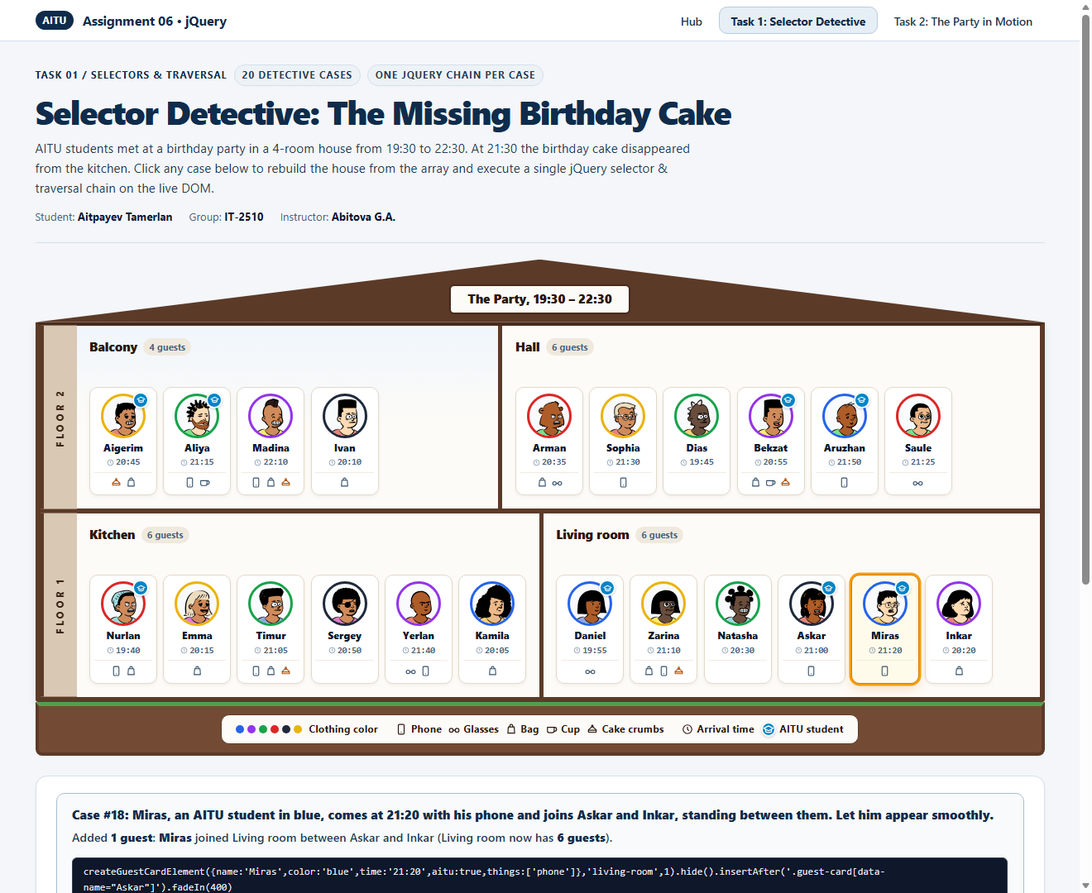
Figure 2.19: Case 18 Result — Added 1 guest: Miras between Askar and Inkar (Living room = 6 guests)
Case 19: Natasha says goodbye and goes home. Her card fades away and disappears from the page.
jQuery Chain: $('.guest-card[data-name="Natasha"]').fadeOut(400, function() { $(this).remove(); })
Result: Removed 1 guest: Natasha faded out and removed from DOM
Explanation: Selects Natasha's card, animates its opacity to 0 via .fadeOut(400), and removes the element from the DOM inside the completion callback.
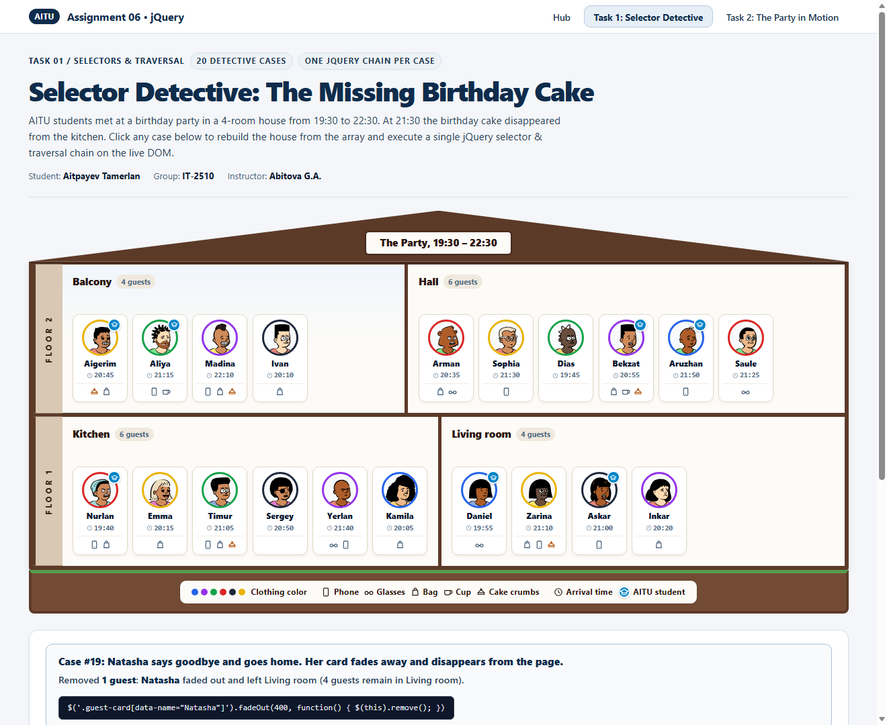
Figure 2.20: Case 19 Result — Removed 1 guest: Natasha faded out and removed from DOM
Case 20: Who took the cake? The thief was downstairs, came after 21:00 but before the cake disappeared, has crumbs but no cup, and stood right next to an AITU student.
jQuery Chain: $('#floor-1 .guest-card:has(.thing-crumbs):not(:has(.thing-cup))').filter((_, el) => $(el).attr('data-time') > '21:00' && $(el).attr('data-time') < '21:30' && $(el).prev().add($(el).next()).is('.is-aitu'))
Result: THIEF IDENTIFIED — 1 guest: Zarina
Explanation: Searches downstairs (#floor-1) for guests with cake crumbs but no cup, filtering for arrival between 21:00 and 21:30 and standing next to an AITU student (.prev().add(.next()).is('.is-aitu')). While both Timur (21:05, Kitchen) and Zarina (21:10, Living room) are downstairs with crumbs and no cup between 21:00 and 21:30, Timur stands between Emma and Sergey (neither is an AITU student), whereas Zarina stands right next to Daniel (an AITU student). This uniquely identifies Zarina as the cake thief!
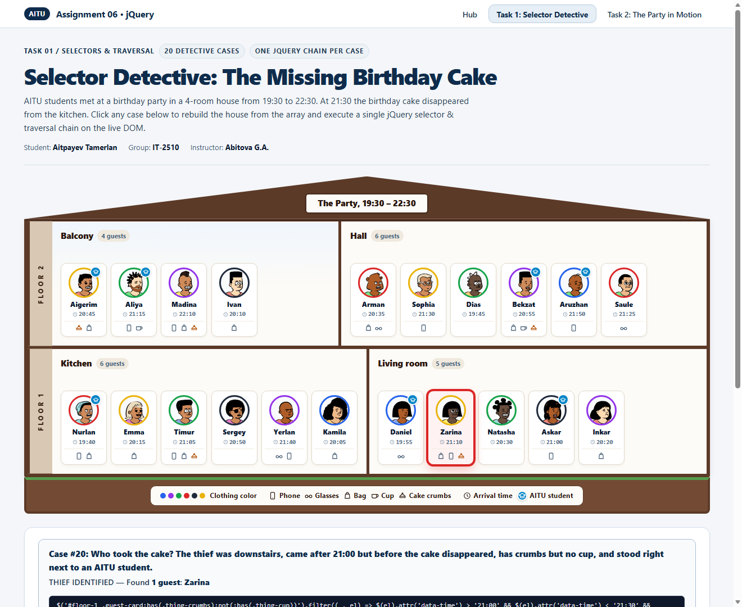
Figure 2.21: Case 20 Result — THIEF IDENTIFIED — 1 guest: Zarina

3. Task 2: The Party in Motion (Effects and Animations)
In Task 2 (task2.html / task2.js), I extended the Task 1 house with four dynamic jQuery animations and strict queue protection so that rapid clicking never causes repeating or stuck animations:
1. Spotlight with fadeTo(): Clicking any case keeps matched guests at 100% opacity while fading all non-matching guests to 20% opacity in 0.3 seconds via .stop(true, false).fadeTo(300, 0.2). For room-finding cases (14–16), guests in all other rooms fade to 20%. Clicking the Clear button restores all guests to 100% brightness.
2. Morphing Guest Card: Clicking a guest photo measures the avatar's viewport coordinates via .offset() and animates #guest-popup-card from the avatar's position and size to its full dimensions. It displays the guest's details in natural words ('Came at 20:35', 'Not an AITU student', 'Has a bag and glasses') and buttons to move the guest to any other room. Pressing Esc or clicking outside shrinks the card back into the avatar photo. Clicking another guest while a card is open smoothly closes the first card before opening the new one.
3. Move Across the House: Clicking 'Move to the ...' clones the guest card with .clone(), places it at the starting .offset(), inserts a shrinking spacer in the old room (.animate({ width: 0 })) and an expanding spacer in the new room (.animate({ width: cardWidth })), and flies the clone across the house to the end of the target room. It also updates partyState so all Task 1 cases reflect the guest's new room.
4. Sort by Time & Fast-Click Protection: Each room header has a 'Sort by time' button. Clicking it toggles between earliest-to-latest arrival order and the original picture order. Cards measure their current visual offset via .position(), reorder in the DOM, and glide smoothly to left: 0px via .stop(true, false).animate({ left: '0px' }, 360).
Table 3.1: Task 2 Verification Matrix (All 5 Required Checks)
Check | Expected Result | Actual Verified Result
Case 3, then Clear | Only the AITU students on the 2nd floor stay bright; Clear brings everybody back. | Passed: Aigerim, Aliya, Bekzat, and Aruzhan stay at 100% opacity while all other 17 guests fade to 20% in 300ms; Clear restores all 21 guests to 100%.
Click a guest, then Esc | The card grows out of the avatar with all the data; Esc shrinks it back. | Passed: Clicking Arman grows the popup from his avatar ring showing 'Came at 20:35', 'Not an AITU student', 'Has a bag and glasses'; pressing Esc animates it back into his avatar.
Move Arman to the balcony | Arman flies to the end of the balcony; the hall closes the gap; case 1 no longer finds him. | Passed: Arman's clone flies smoothly from Hall to the end of Balcony (5 guests); Hall closes the gap (5 guests); running Case 1 now finds only 5 guests in the Hall (Sophia, Dias, Bekzat, Aruzhan, Saule).
Sort the living room twice | The cards slide to 19:55, 20:20, 20:30, 21:00, 21:10, then back to the picture order. | Passed: First click slides Living room to Daniel (19:55), Inkar (20:20), Natasha (20:30), Askar (21:00), Zarina (21:10); second click slides them back to Daniel, Zarina, Natasha, Askar, Inkar.
Sort 5 times fast | The cards end in the sorted order without jumping or shaking. | Passed: Calling .stop(true, false) before each transition prevents animation queue buildup and lands cleanly in sorted order on the 5th click.

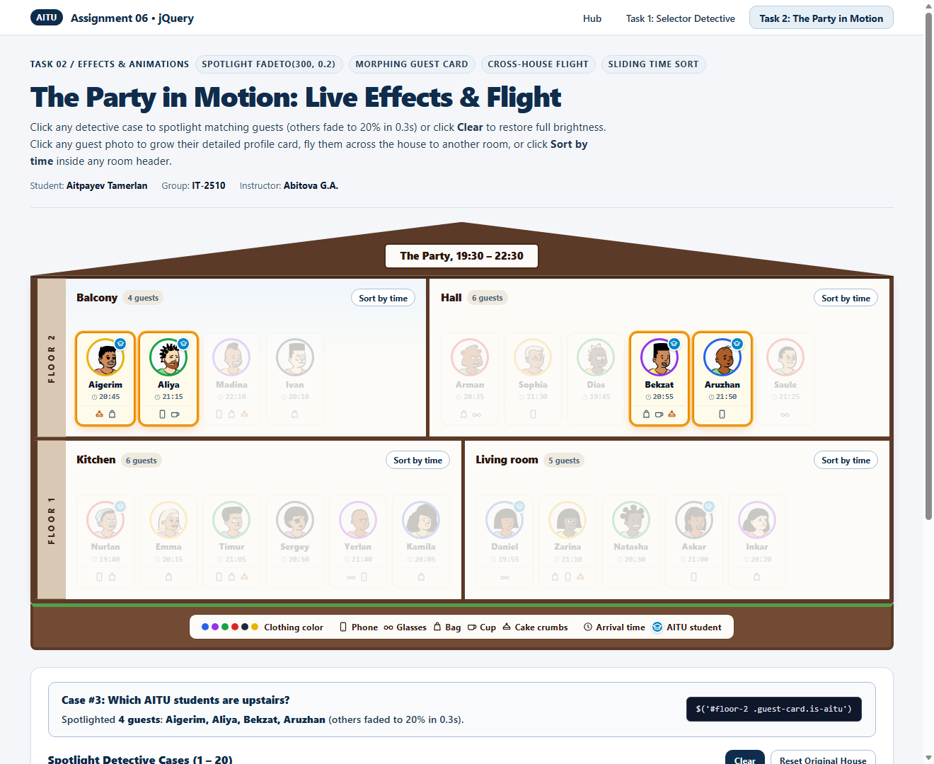
Figure 3.1: Check 1 — Spotlight on Case 3 (Upstairs AITU students stay bright; others fade to 20%).
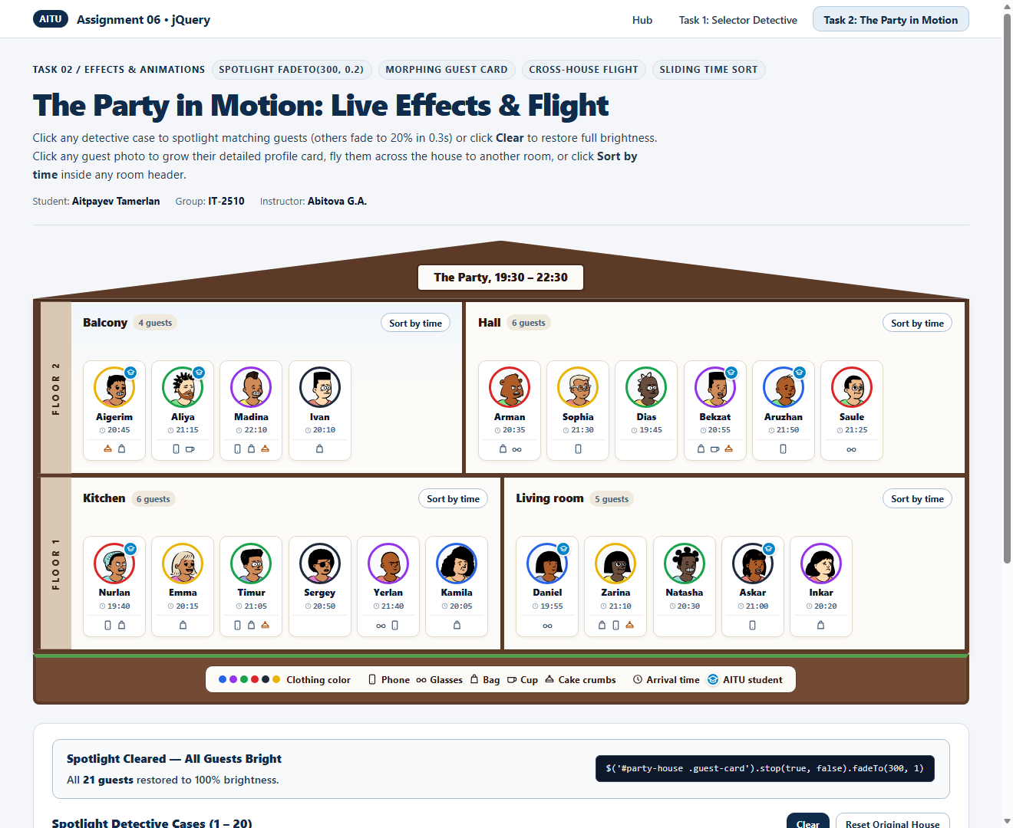
Figure 3.2: Check 1 — Clicking Clear brings all 21 guests back to 100% brightness.
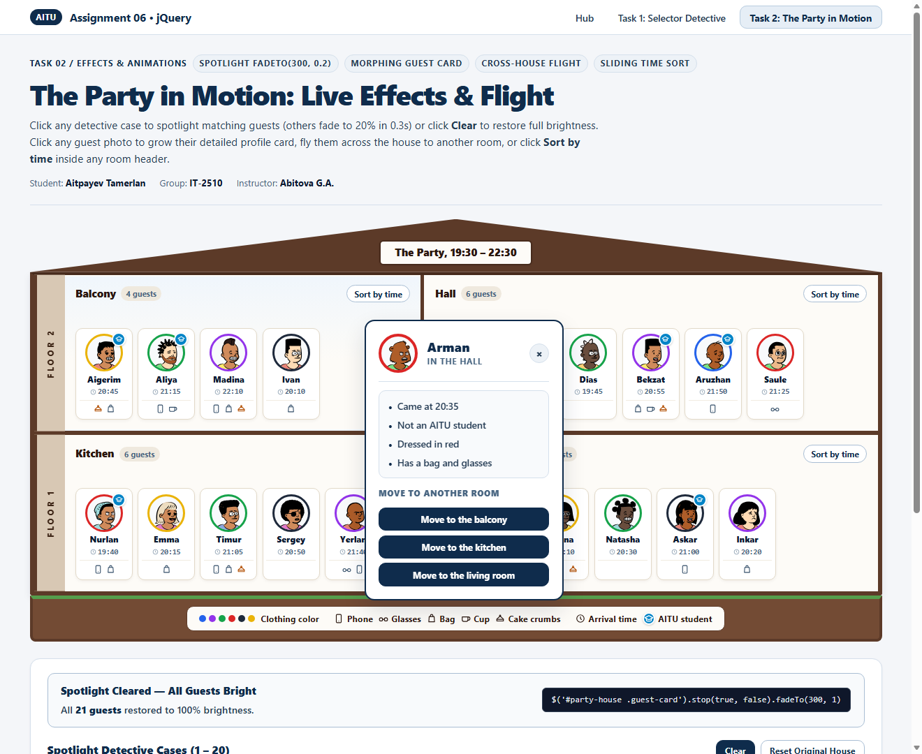
Figure 3.3: Check 2 — Clicking Arman grows the Guest Card out of his avatar with full text details and Move buttons.
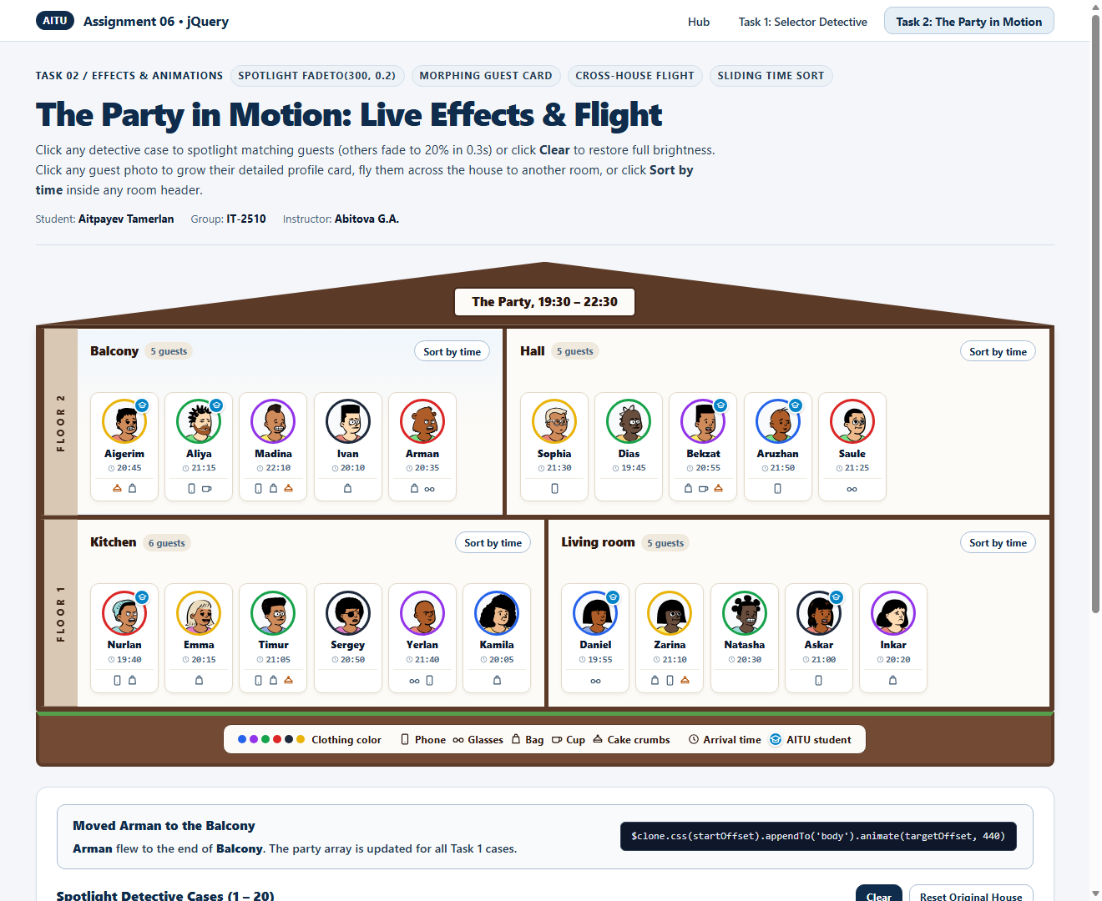
Figure 3.4: Check 3 — Arman moved to the end of the Balcony; Hall closed the empty gap.
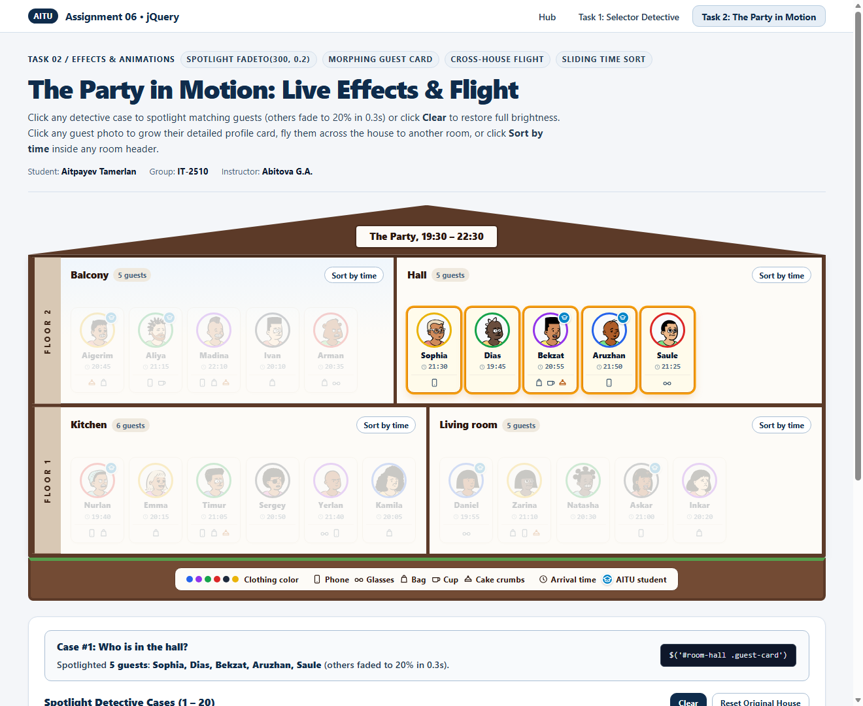
Figure 3.5: Check 3 — Running Case 1 after moving Arman no longer finds him in the Hall (5 guests found).
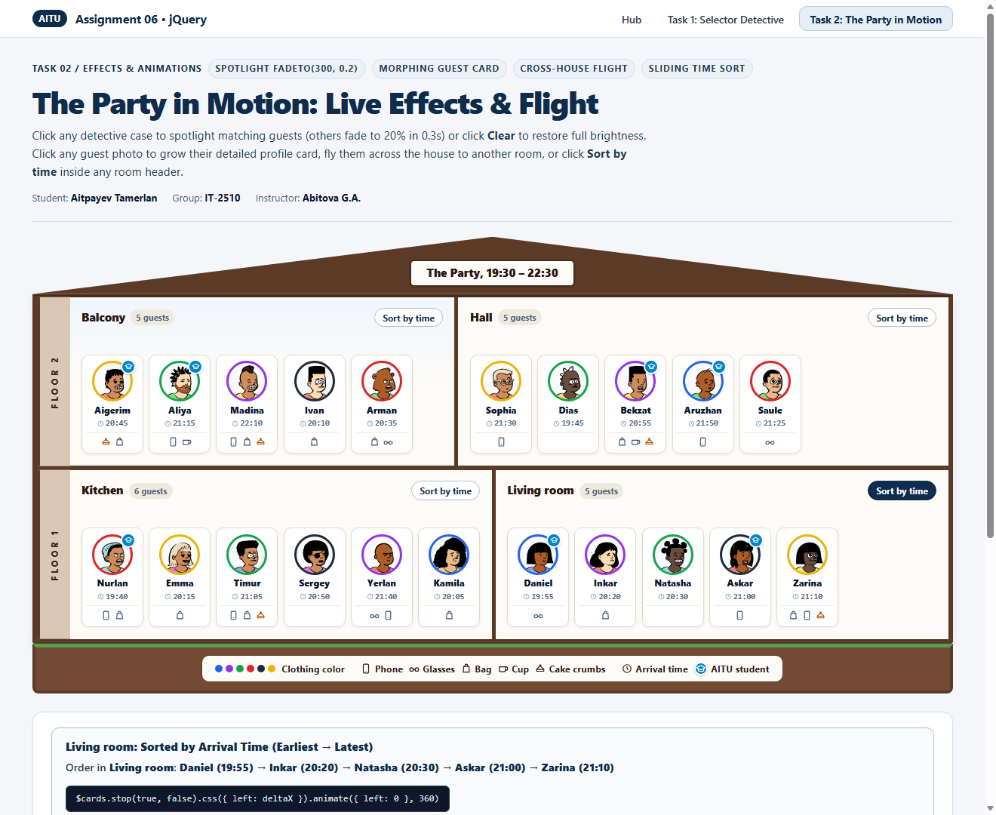
Figure 3.6: Check 4 — Living room sorted by arrival time (19:55, 20:20, 20:30, 21:00, 21:10).
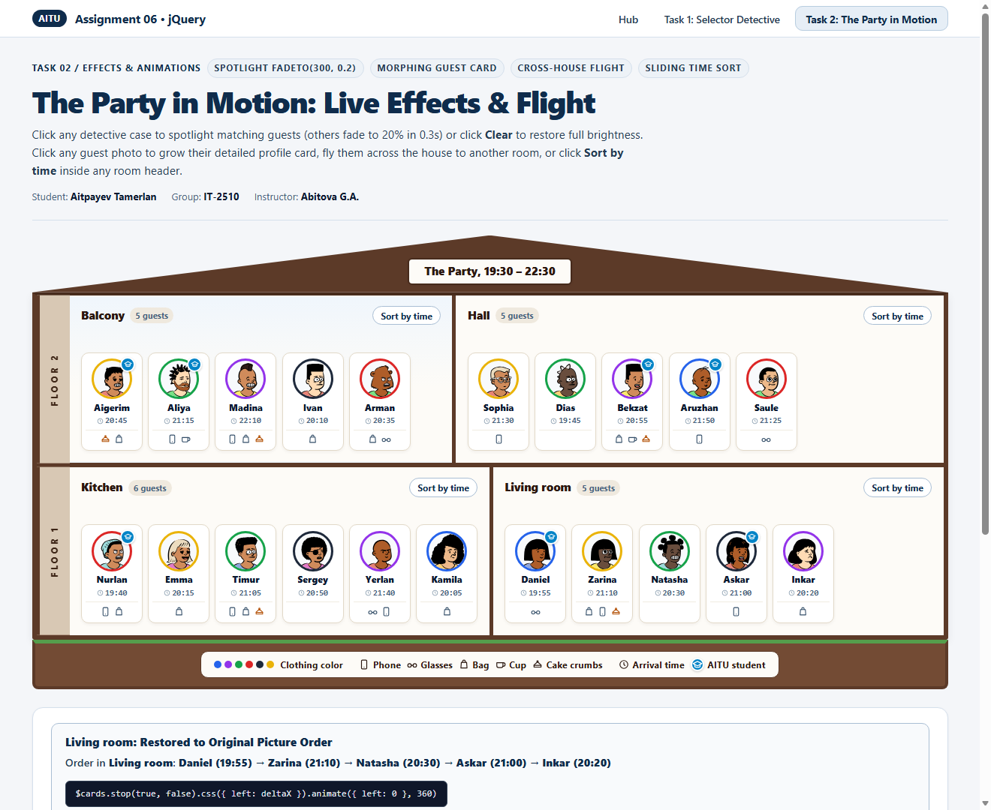
Figure 3.7: Check 4 — Clicking Sort by time a second time slides Living room guests back to the picture order.
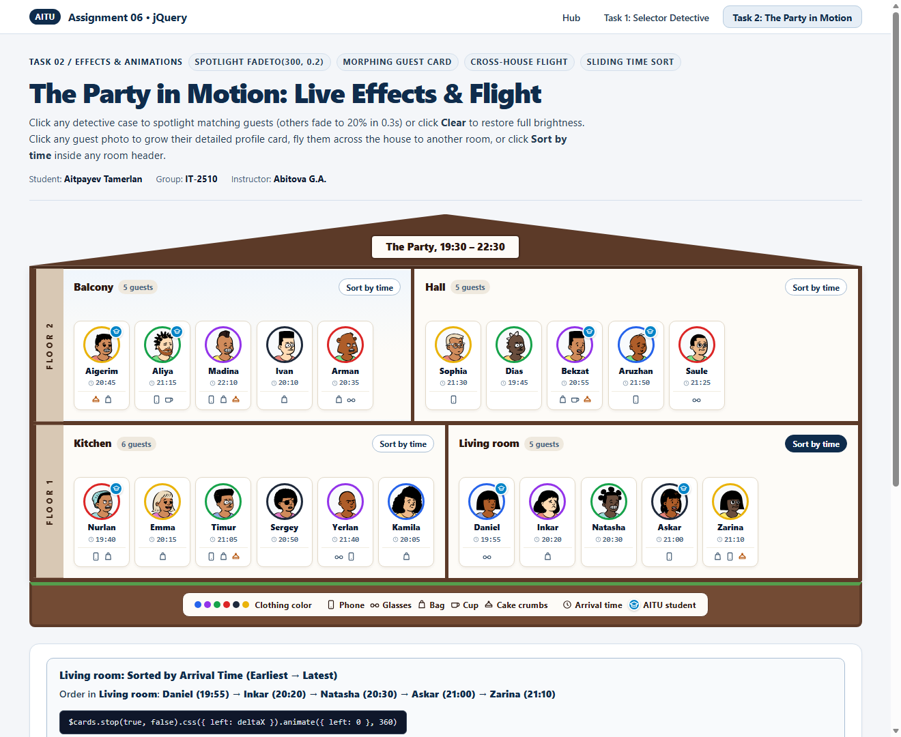
Figure 3.8: Check 5 — Sorting the Living room 5 times fast ends cleanly in sorted order without queue buildup.

4. Conclusion
Completing Assignment #6 gave me practical experience with jQuery selectors, DOM traversal, and animation control. In Task 1, I learned how to combine attribute selectors, structural pseudo-classes (:nth-child, :last-child), relational filters (:has, :not), and tree traversal methods (.prev, .next, .nextAll, .siblings, .closest, .add, .filter) to answer complex queries over the live DOM in a single chain and identify Zarina as the birthday cake thief. In Task 2, I learned how to coordinate geometry methods (.offset and .position) with .animate(), .fadeTo(), and .clone() to build morphing popups, cross-container card flight, and FLIP-style sliding sorts, while using .stop(true, false) to guarantee that rapid user clicks never create runaway animation queues.

