**Content of the website**

1. Main page, index.html

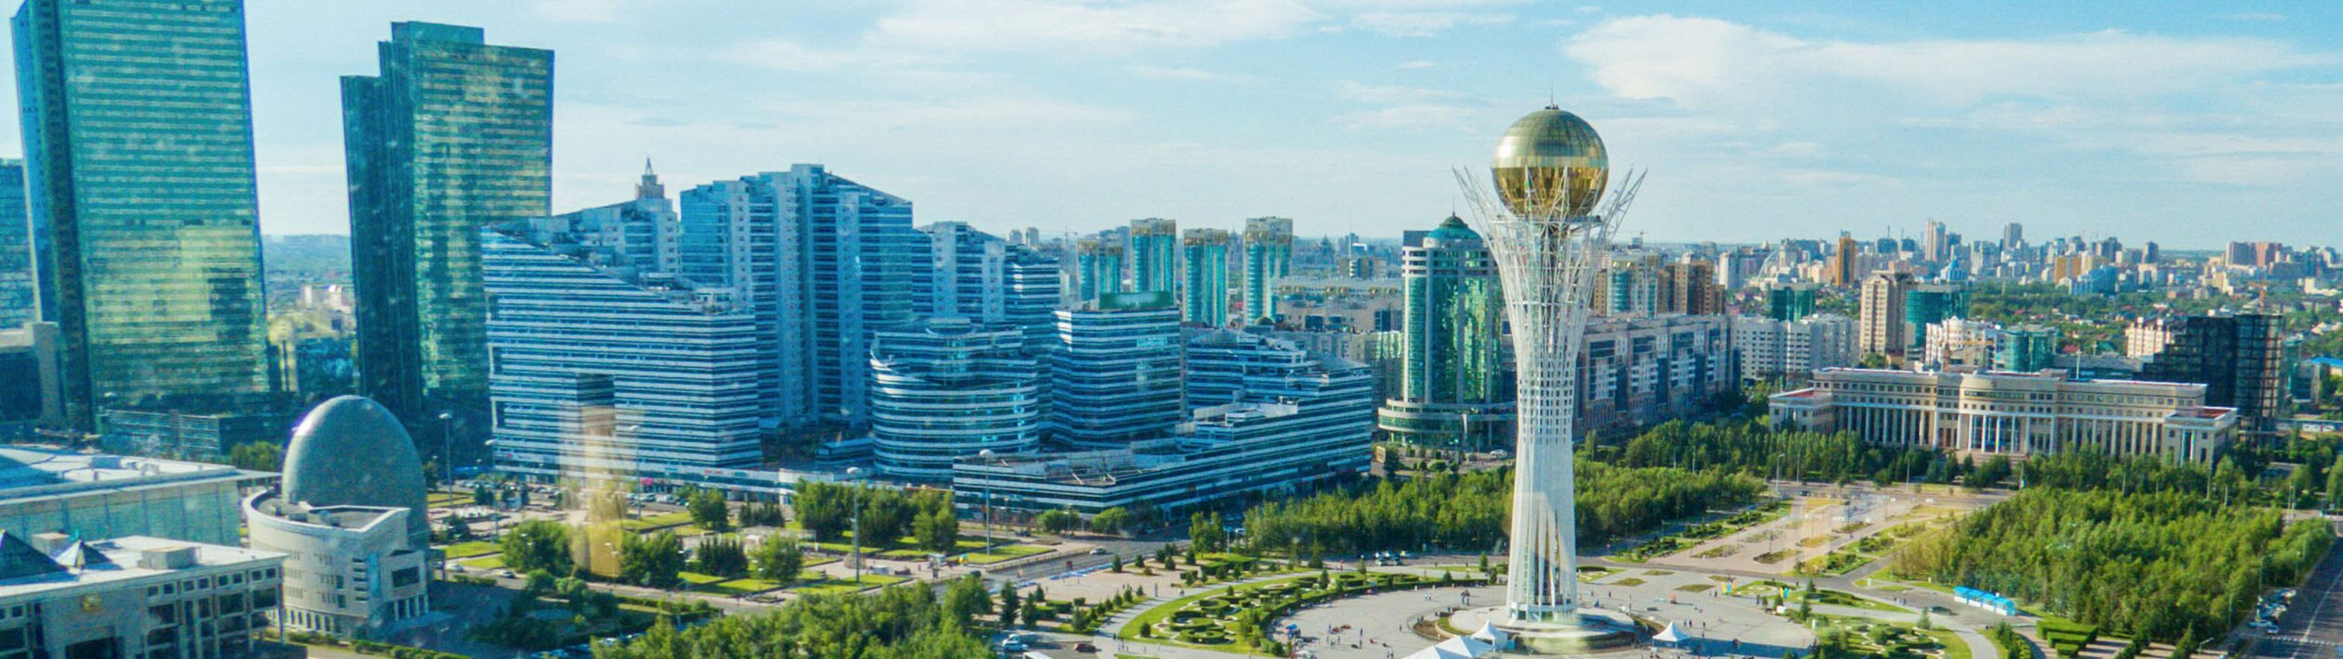

Kazakhstan is the largest country in the world which has no access to the World Ocean, however the territory of Kazakhstan is washed by land-locked seas: the Caspian and Aral. Major part of the country are horizonless steppes, deserts and mountains that house thousands of species of animals and birds. The nature of Kazakhstan is beautiful in its own way. It is severe, since the majority of the territory consists of deserts (44%) and semi-deserts (14%). Only 26% of the territory is occupied by steppe zones and 5.5% by forest. More than six thousand of plant species vegetate in Kazakhstan, about 500 species of birds, 178 species of animals, 49 species of reptiles, 12 species of amphibians may be encountered in its spaciousness and about 100 species of fishes – in the rivers and lakes. The nature of Kazakhstan is various, its desert massive is immense and its mountain peaks are high and harsh. The country’s flora and fauna are represented by various species of rare and unique animals and plants, many of which are entered in the Red Book.

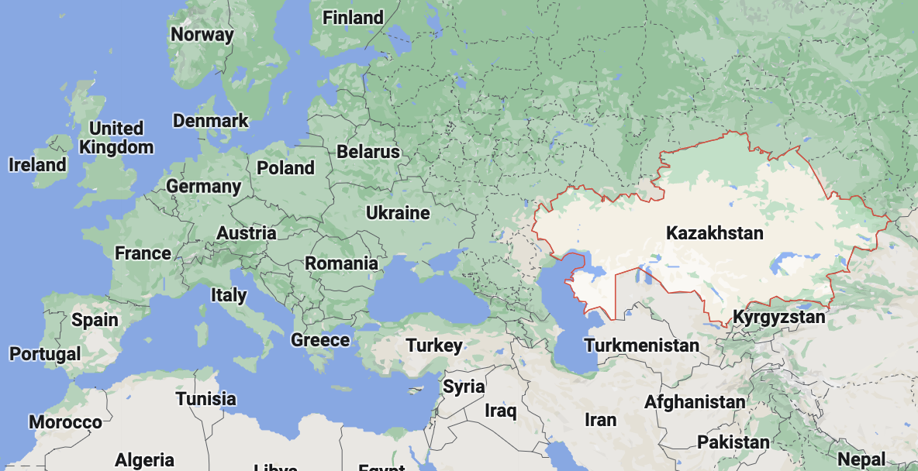

*(borderless table)*

|  |  |
| --- | --- |
| Capital city: | Nur-Sultan |
| Currency: | Tenge (1 HUF ≈ 1.3 tenge) |
| Official languages: | Kazakh, Russian |
| Population: | ≈ 19,200,000 |
| Area: | 2,724,900 km2 |

**Nur-Sultan.**

New center with wide avenues and unusual buildings was built from scratch on the left bank of the Ishim River; whereas the right bank of the river is calm and cozy atmosphere, still preserves the memory of the past.

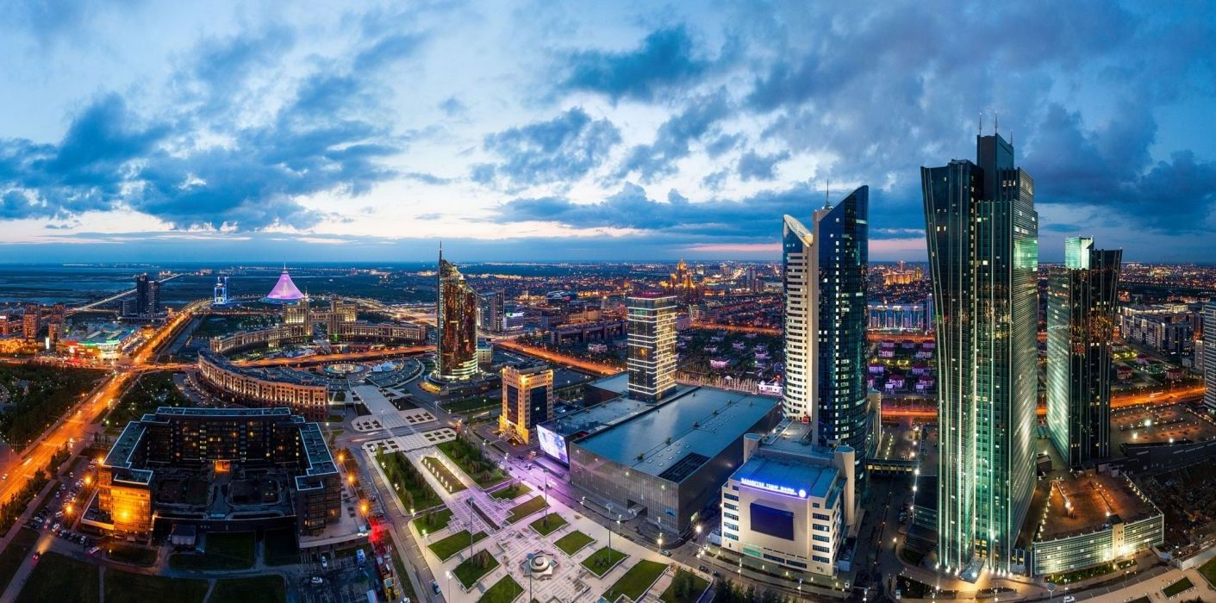

**Almaty.**

The city is framed by snowcapped mountains covered with spruces creating a stunning scenery year-round. The world-class ski resort can be reached in just 30 minutes from the city center Shymkent.

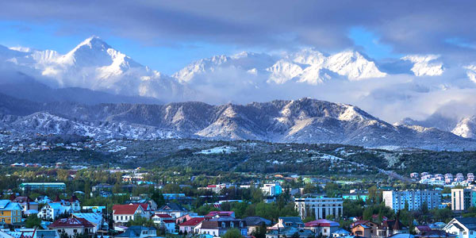

**Shymkent.**

Nowadays Shymkent is the largest city in Kazakhstan in terms of area. Known from ancient times as a flourishing city on the Great Silk Road. The city’s name is translated as a ‘garden city’

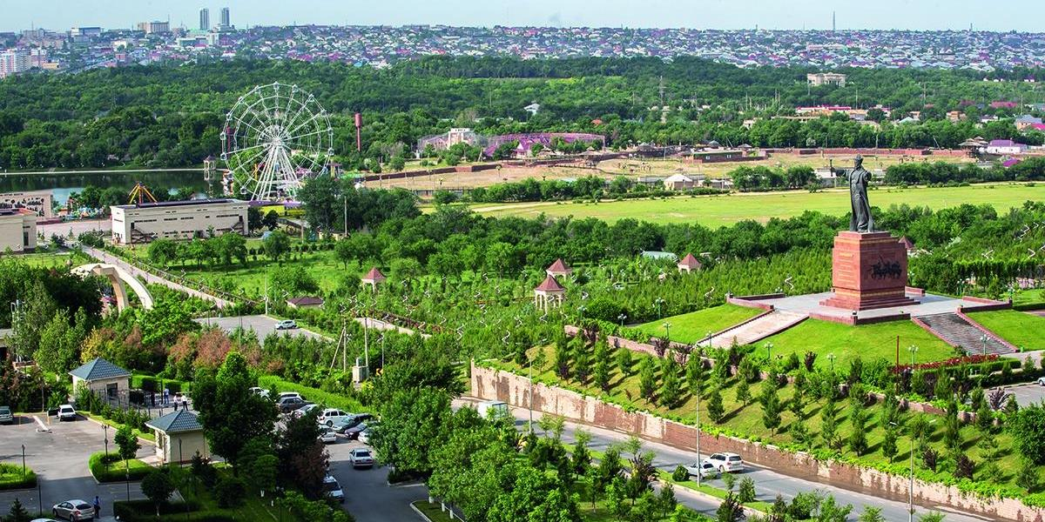

2. Places to visit, visit.html

[ Select: Nur-Sultan; Almaty; Shymkent; More… ]

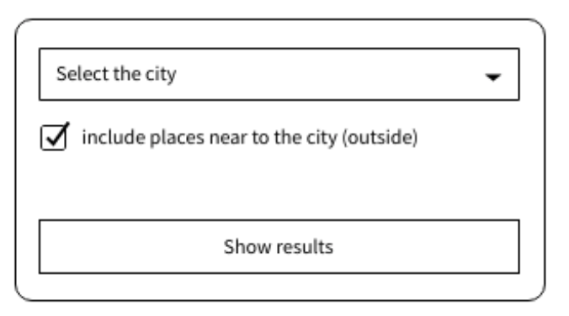

[ Table: city ; number of places (in) ; number of places (out) ; month of update ]

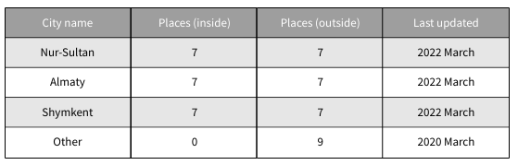

**Nur-Sultan**: Bayterek, Khazret Sultan Mosque, EXPO (future energy), National Museum, Astana Opera, Khan-Shatyr, Mega “Silk Way”, City park, Embankment, (…) and descriptions per each place

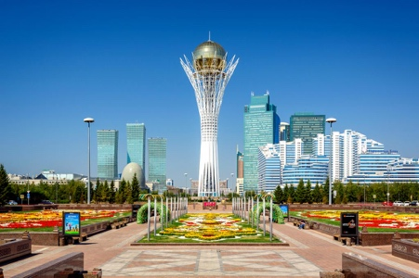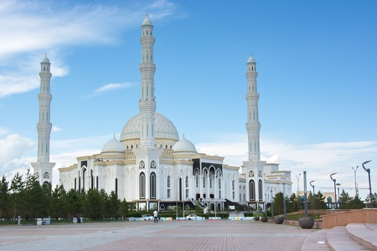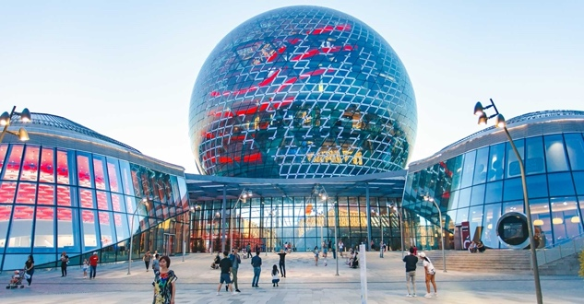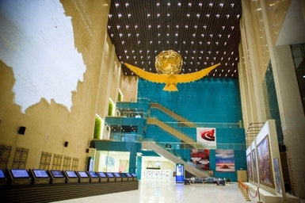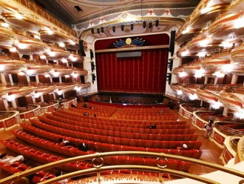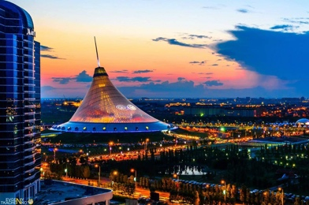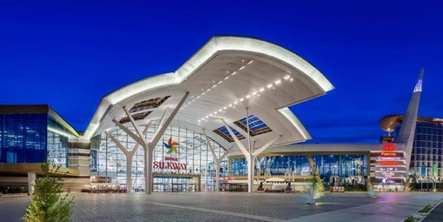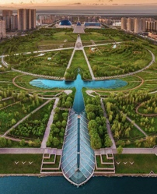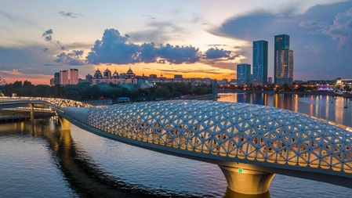

**Almaty**: Big Almaty Lake, Kok-tobe, Medeo, Shymbulak, Opera & Ballet, Green Bazaar, Central Mosque, Botanical Garden, (…) and descriptions per each place

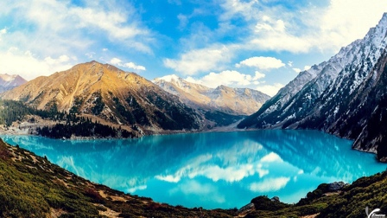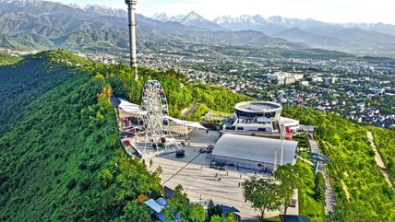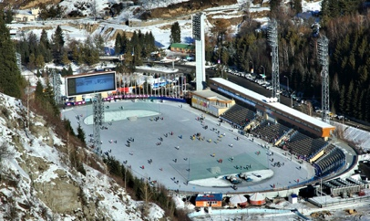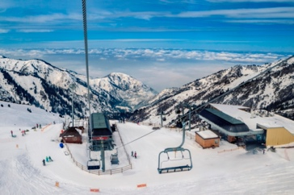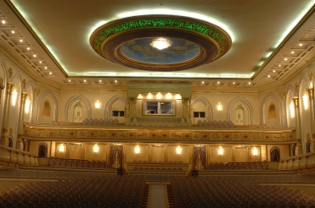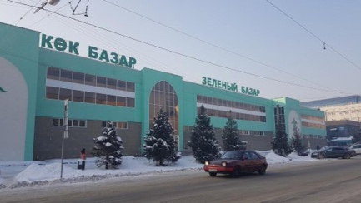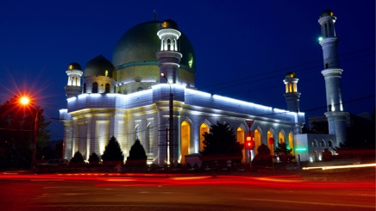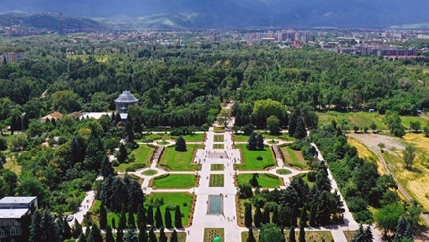

**Shymkent**: Central park, Zoo, Dendropark, Arystan Bab, Ugam, Burgulyuk, Ancient citadel, Aksu Canyon, Sayramsu, Turkistan, (…) and descriptions per each place

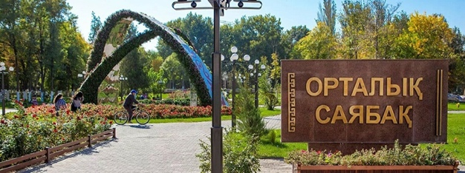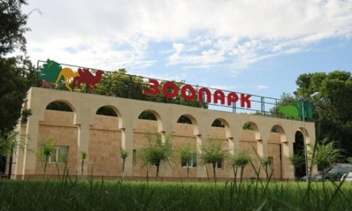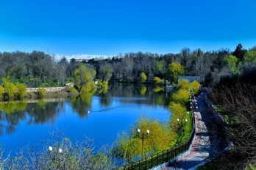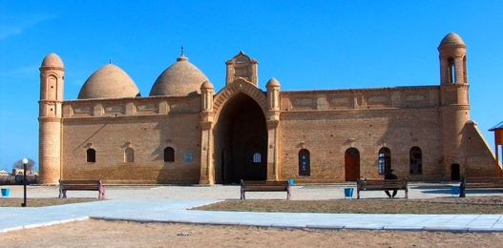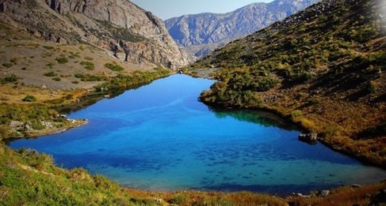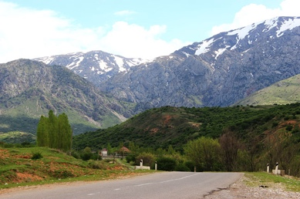

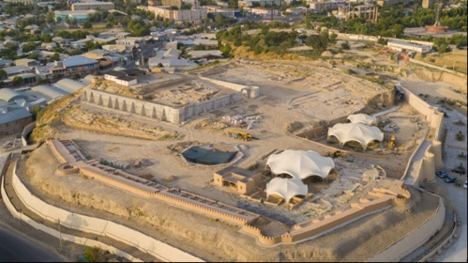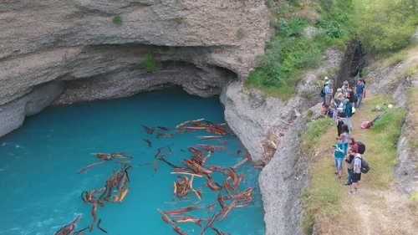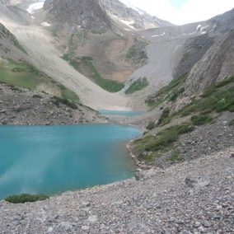

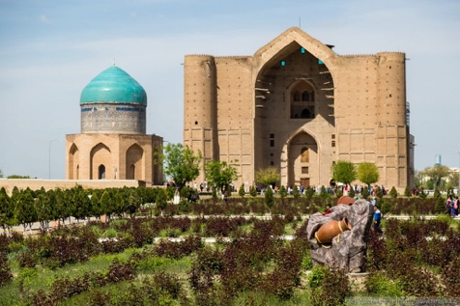

3. Gallery, media.html

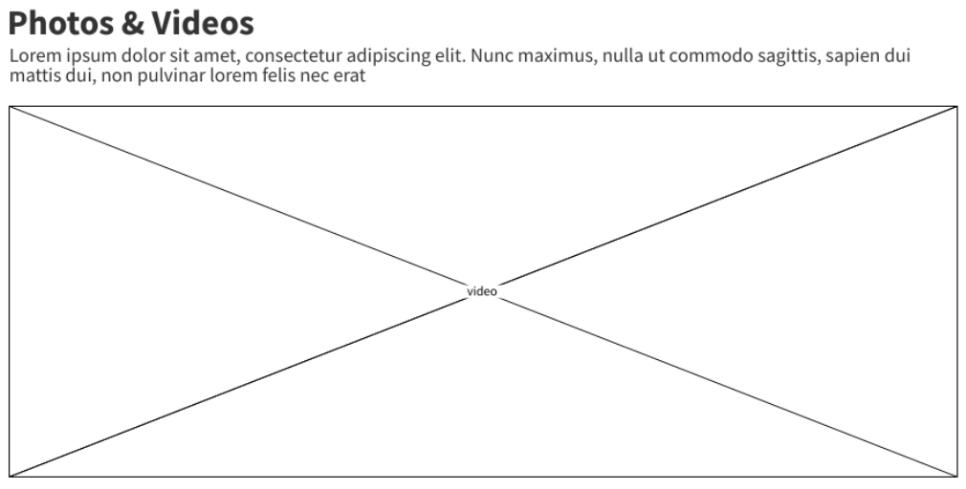

(^ place for video above ^) video link: <https://youtu.be/9_DFSppBKFM>

and shuffled photos from page 2 (visit.html)

4. Contact information, contacts.html

Surname Name

[email@somewhere.kz](mailto:email@somewhere.kz)

+7 700 XXX XXXX and/or +36 70 XXX XXXX

|  |  |
| --- | --- |
| t.me/user | telegram link (button) |
| wa.me/3670XXXXXXX | whatsapp link (button) |

4. Feedback, message.html

