SALES PERFORMANCE & PROFITABILITY ANALYSIS

An integrated approach to statistical analysis and interactive visualization



Prepared by

Tamiah Mwangi

Data Analyst

EXCEL · SQL · STATA · TABLEAU

1.INTRODUCTION
Sales performance is influenced by various factors, including product categories, geographical regions, pricing, discounts, and customer purchasing patterns. Understanding these factors is essential for evaluating business performance and identifying opportunities to improve profitability.
This project analyzes sales data consisting of 1,000 observations to examine sales trends, profitability, and relationships among key business variables. SQL was used to query and explore the dataset, while Stata was used for statistical analysis, including correlation, regression, and analysis of variance (ANOVA). Tableau was used to develop an interactive dashboard for visualizing key performance indicators and comparing sales and profit across categories and regions.
The findings provide insights into sales performance and profitability, demonstrating the application of data analysis, statistical techniques, and visualization tools to support data-driven business decision-making.

2.DATA DESCRIPTION
The dataset used in this project consists of 1,000 observations and 15 variables covering sales transactions, product information, customer characteristics, and profitability. The dataset provides information on sales amounts, quantities sold, product categories, geographical regions, sales representatives, costs, prices, discounts, payment methods, and sales channels.
The key variables include Sales Amount, which measures the value of sales; Quantity Sold, which records the number of units sold; and Total Profit, which measures the profit generated. Other variables, such as Unit Cost, Unit Price, Discount Percentage, Product Category, and Region, were used to examine factors associated with sales performance and profitability.
The dataset was prepared for analysis by organizing variables into appropriate data types and cleaning inconsistencies to facilitate statistical analysis and visualization.

3.METHODOLOGY

The project followed a quantitative data analysis approach involving data preparation, querying, statistical analysis, and visualization.
Excel was used to calculate and prepare selected variables, including discount percentage. SQL was then used to query and explore the dataset, while Stata was used to conduct exploratory data analysis, correlation analysis, multiple regression, and analysis of variance (ANOVA). These techniques helped examine relationships among sales variables and assess differences in sales performance across regions.
Finally, Tableau was used to develop an interactive dashboard presenting key performance indicators, including total sales, total profit, and profit margin, alongside visualizations comparing sales and profitability across product categories and regions.

4. RESULTS AND INTERPRETATION

4.1 Correlation Analysis
The correlation analysis revealed a strong positive relationship between sales amount and quantity sold, with a correlation coefficient of 0.7037. This suggests that transactions involving larger quantities tended to have higher sales amounts. Discount percentage had a moderate negative relationship with total profit (-0.4584), indicating that higher discounts were associated with lower profitability. Unit cost and unit price were also highly correlated, with a coefficient of 0.9951, suggesting a potential multi collinearity problem in the regression model.

4.2 Multiple Regression Analysis
A multiple linear regression model was estimated to examine the relationship between total profit and five explanatory variables: sales amount, quantity sold, unit cost, unit price, and discount percentage. The original model achieved an R-squared of 0.7244, indicating that the explanatory variables accounted for approximately 72.44% of the variation in total profit. The model was statistically significant overall.
Following the diagnostic tests, heteroskedasticity-robust standard errors were used. The robust regression results showed that quantity sold, unit cost, unit price, and discount percentage were statistically significant at the 5% level. Sales amount was not statistically significant (p = 0.126). The negative coefficient for discount percentage suggests an inverse association between discounts and total profit, holding the other variables constant.

4.3 Analysis of Variance (ANOVA)
A one-way ANOVA was conducted to determine whether mean sales amounts differed across the four regions. The results showed no statistically significant difference in mean sales amounts across regions (F = 0.39, p = 0.7568). Since the p-value exceeded the 5% significance level, the null hypothesis was not rejected. The R-squared value of 0.0012 indicates that region accounted for approximately 0.12% of the variation in sales amount in this analysis.

4.4 Regression Diagnostic Tests
The Variance Inflation Factor (VIF) results indicated severe multi collinearity between unit cost and unit price. Their VIF values were approximately 101.96 and 103.23, respectively, suggesting that these variables contain highly overlapping information. Therefore, their individual regression coefficients should be interpreted cautiously.
The Breusch–Pagan/Cook–Weisberg test for heteroskedasticity produced a chi-square statistic of 51.68 and a p-value below 0.001. The null hypothesis of constant error variance was rejected, providing evidence of heteroskedasticity. To address this issue in statistical inference, the regression was re-estimated using heteroskedasticity-robust standard errors. This adjustment does not eliminate the multicollinearity problem, which remains a limitation of the model.

5. TABLEAU DASHBOARD INSIGHTS
The interactive Tableau dashboard provides an overview of sales performance and profitability across product categories, regions, and sales representatives. The business recorded total sales of 68.46 million, total profit of 4.62 million, and 25,355 units sold. The dashboard also displays a profit margin of 6.75%.
The category comparisons show that Clothing generated the highest sales, while Furniture recorded the highest profit. These findings illustrate that the category generating the most sales does not necessarily generate the highest profit.
The monthly sales and profit visualizations allow users to examine changes in business performance over time. The sales representative chart compares the contribution of individual representatives, while the discount and profit visualization helps explore how profitability varies with discount levels.
Overall, the dashboard presents key performance indicators and visual comparisons in an accessible format, supporting the identification of sales patterns and areas that may require further investigation.
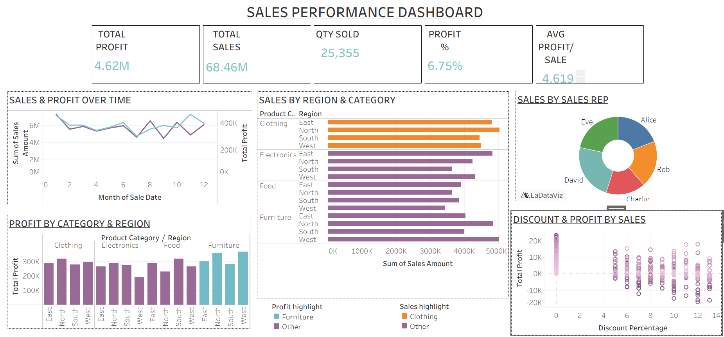

6. CONCLUSION
This project used Excel, SQL, Stata, and Tableau to analyze sales data comprising 1,000 observations and 15 variables. The regression model explained 72.44% of the variation in total profit, with quantity sold, unit cost, unit price, and discount percentage being statistically significant when robust standard errors were used. The ANOVA results showed no statistically significant differences in mean sales across the four regions.
The diagnostic tests revealed heteroskedasticity and severe multi collinearity between unit cost and unit price, highlighting limitations in interpreting individual regression coefficients. The Tableau dashboard complemented the statistical analysis by presenting key performance indicators and identifying differences in sales and profitability across product categories. Overall, the project demonstrates how statistical analysis and data visualization can generate useful insights to support informed business decision-making.

7. RECOMMENDATIONS
Based on the findings of the analysis, the following recommendations are proposed:
- Optimize discount strategies: Since discount percentage was negatively associated with total profit, the business should review its discounting policies to ensure that promotions support sales without unnecessarily reducing profitability.
- Prioritize product profitability: Management should investigate why Clothing generated the highest sales while Furniture recorded the highest profit. This could help inform product pricing, inventory allocation, and marketing decisions.
- Monitor regional performance: Although the analysis found no statistically significant differences in mean sales across the four regions, management should continue monitoring regional performance to identify emerging trends and opportunities for growth.
- Evaluate sales representative performance: The dashboard can help management compare sales representatives' contributions and identify practices that may be worth sharing across the sales team.
- Use data for continuous decision-making: Management should regularly review sales, profit margins, and monthly performance trends through the Tableau dashboard to support informed pricing, sales, and inventory decisions.

8. LIMITATIONS
The analysis was limited to 1,000 observations, and the findings may not represent sales performance beyond the dataset. The regression model also showed severe multicollinearity between unit cost and unit price, limiting the interpretation of their individual effects on total profit. Although robust standard errors were used to address heteroskedasticity, other model limitations may remain. Additionally, the findings indicate associations rather than causation and should be interpreted cautiously.

