16423 – Designing Computer Vision App

Alvin Chou

Project CheckPoint

The goal of this project is to implement a mobile application for gaze detection using the iPad’s camera. In addition, I am also working on how to frame the project of gaze detection in an application unique to the mobile platform. Over the past week, I have completed working on importing a 3D modeling of the face using a CANDIDE library provided by Tastenkunst (<http://www.tastenkunst.com/#/brf>). The result is shown in Figure 1. Since the focus of the project is not on creation of the model, but rather using the model as a reference frame to calculate the geometry of gaze estimation, the next step is to evaluate different methods in extracting the centroid of the Iris given the existing face model. I am looking into blob detections, correlation filters, and feature extraction methods to detect the spherical iris and perform the centroid calculation. I’d like to look into a method in which mobile performance is optimized. Over the next few weeks, I will be working on Iris extraction and gaze estimation using geometrical properties. Finally, I am currently brainstorming ideas on how gaze estimation can be used in an application unique to the mobile platform. Some thoughts include looking at where people spend the most time staring at mobile screens, taking pictures through gaze, scrolling reading materials using gaze detection, or some other application where gaze is useful on a mobile platform.

For this projects, the goals include:

* Create a 3D face model using NXT-BRF library.
* Create an eye gaze estimation of an individual based on the 3D face model
* Create an application of the eye gaze estimation for a purpose unique to mobile platforms.

Deliverables:

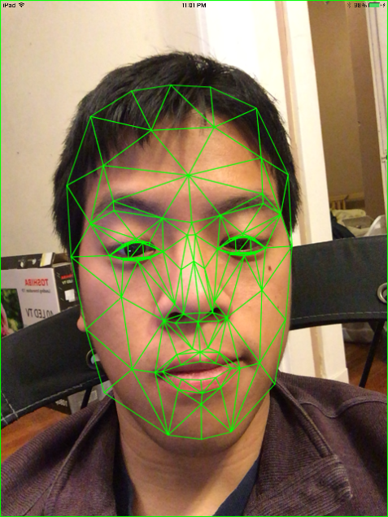The primary success metrics of this project is to demo a working App. The app should be able to accurately create and track a 3D model face, then identify the eyeballs, and finally create a gaze estimation. The deliverable for the project would be a video of a working example. As a nice to have, the project would be able to work in real-time in class.

Schedule:

|  |  |
| --- | --- |
| 11/22-11/25 | 11/26-11/28 |
| Finalized 3D Face modeling | Work on Iris centroid detection and extraction |
| 11/29-12/2 | 12/3-12/5 |
| Work on Iris centroid detection and extraction | Work on final application |
| 12/6-12/8 | 12/9-12/11 |
| Work on final application and testing | Work on Final Presentation & Report |

Figure 1. CANDIDE face model