PROJECT DOCUMENTATION
Swift Ship Tracker Using Salesforce
A CRM Platform for Shipment Creation, Delivery Agent Assignment, Hub Processing, Real-Time Tracking Updates and Delivery Feedback
TEAM DETAILS
Team ID | SWTID-2026-9845
Team Lead | Nandhini S
Team Member 1 | Karishma R S
Team Member 2 | Tamilvani S
Team Member 3 | Akshaya V
Team Member 4 | Abinaya L S
Platform | Salesforce Developer Edition
Submission Date | 03-10-2026
GitHub | https://github.com/tamil1010/SwiftShip-Trackers
Demo Video | https://drive.google.com/file/d/1FoSYrRUg-8TjDaGQoP_QWq59zYSpTsO0/view?usp=sharing

Naan Mudhalvan Project Documentation
Salesforce Developer Edition
SWIFT SHIP TRACKER
SALESFORCE IMPLEMENTATION

User Story:
Swift Ship Tracker is a Salesforce-based CRM built for courier and logistics operations. It stores customers, shipments, delivery agents, hubs, tracking updates and delivery feedback in a single platform and automates the repetitive work around them: every change of shipment status automatically creates a tracking history record, the customer is e-mailed when the shipment is out for delivery and again when it is delivered, an approaching expected delivery date triggers a reminder, cancellation requests move through an approval process, invalid status jumps are blocked, and delayed shipments are identified by a scheduled job every morning. Role-based access ensures that logistics managers, shipment coordinators, delivery agents and customers see only what they should, while reports and the Swift Ship Operations Dashboard give management live visibility of the shipment pipeline.

1. INTRODUCTION

1.1 Project Overview :
Courier and logistics companies move a large number of shipments through pickup points, hubs and delivery routes every day. When shipment information is kept in spreadsheets, phone calls and messages, customers cannot find out where their parcel is, status updates are entered late or not at all, delivery agents have no consolidated list of the shipments assigned to them, and managers discover delayed shipments only after the customer complains. Each shipment needs coordination between the customer who sends or receives it, the coordinator who books it, the delivery agent who collects and delivers it, and the hubs through which it passes.
This project provides a Salesforce solution in which all of this information is stored in structured custom objects (Shipment, Customer, Delivery Agent, Hub, Tracking Update and Delivery Feedback). Salesforce Flow, an Approval Process, Validation Rules and Apex automate the key processes, a custom Lightning App called Swift Ship Tracker gives users a single workspace, and Reports and Dashboards provide real-time insight. Every shipment is identified by a unique Tracking Number, which is the main reference customers use to follow their shipment from creation to delivery. The complete solution was built and tested in a Salesforce Developer Edition org.

1.2 Purpose :
- Digitize and centralize customer, shipment, delivery agent, hub, tracking and feedback data in one CRM platform.
- Give every shipment a unique Tracking Number and a complete, time-stamped movement history.
- Automate tracking updates, delivery notifications, delivery confirmation and expected-delivery reminders.
- Prevent invalid status changes and keep delivery agent availability accurate automatically.
- Ensure accurate data entry through validation rules and a controlled cancellation approval process.
- Provide role-based security so each user sees only the shipments and records relevant to their job.
- Deliver reports and a dashboard for shipment status, hub load, agent workload, delayed shipments and customer satisfaction.
- Target outcomes (design goals, not measured results): reduce manual status-update effort, shorten the time taken to spot delayed shipments and improve customer satisfaction through timely communication.

2. IDEATION PHASE

2.1 Problem Statement (Customer Problem Statement Template)
PS | I am (Customer) | I'm trying to | But | Because | Which makes me feel
PS-1 | Customer | know where my shipment is right now | I have to call the courier office to ask | there is no tracking number based status or movement history | anxious
PS-2 | Shipment Coordinator | book shipments and keep their status current | details are scattered across spreadsheets and phone calls | there is no single record for customer, shipment and agent | overloaded
PS-3 | Delivery Agent | see which shipments I must pick up and deliver today | I receive assignments verbally or in messages | there is no centralized view of assigned shipments | confused
PS-4 | Logistics Manager | monitor delayed shipments and agent workload | I find out about delays only after complaints | status updates are manual and reports are not available | worried
PS-5 | Customer | be told when my parcel is out for delivery and delivered | I receive no timely notification | communication is manual and easily forgotten | uninformed
PS-6 | Logistics Manager | decide whether a shipment can be cancelled | cancellations are agreed informally | there is no approval trail or notification process | uncertain

2.2 User Personas
Persona | Role in Swift Ship Tracker | Main Goal | Main Frustration
Customer | Sends or receives a shipment and follows it using the Tracking Number. | Know the current status, expected delivery date and confirmation of delivery. | No visibility and no proactive updates.
Shipment Coordinator | Creates customers and shipments, assigns delivery agents and hubs, manages exceptions. | Book shipments quickly and keep every record accurate. | Duplicate data entry and manual status follow-ups.
Delivery Agent | Collects shipments, moves them between hubs and delivers them to the destination. | Know exactly which shipments are assigned and update progress easily. | No consolidated list of assigned shipments.
Logistics Manager | Oversees operations, approves cancellations and reviews performance. | Monitor delays, hub load, agent performance and customer feedback. | No real-time operational picture.

2.3 Empathy Map Canvas

User Persona: Customer
- Think & Feel: Wants to be sure the parcel will arrive safely and on time, and wants to be kept informed without chasing anyone.
- Hear: Friends and colleagues describing late parcels, and courier staff saying the status will be checked.
- See: The Tracking Number, expected delivery date, current status and notification e-mails.
- Say & Do: Quotes the Tracking Number, checks status, receives e-mails and rates the delivery afterwards.
- Pain: Not knowing where the shipment is, no notification before delivery and no way to confirm it was delivered.
- Gain: Status visibility through the Tracking Number, automatic e-mails and an easy way to give feedback.

User Persona: Shipment Coordinator
- Think & Feel: Wants every shipment booked correctly and wants customers to stop calling for status.
- Hear: Customer calls, agent updates by phone and manager requests for shipment status.
- See: Customer details, shipment status, agent availability and hub information.
- Say & Do: Creates shipments, assigns agents and hubs, handles failed deliveries and requests cancellations.
- Pain: Scattered spreadsheets, repeated data entry, manual status updates and invalid status changes.
- Gain: One workspace, automatic tracking history, validation of data and an approval trail for cancellations.

User Persona: Delivery Agent
- Think & Feel: Wants a clear daily workload and wants to finish deliveries without paperwork.
- Hear: Assignment instructions from coordinators and customer queries about delivery time.
- See: Assigned shipments, destination, customer contact details and delivery priority.
- Say & Do: Collects shipments, moves them to hubs, delivers them and records the outcome.
- Pain: Assignments received verbally and no single list of shipments to deliver.
- Gain: A centralized list of assigned shipments and a simple way to update status and remarks.

User Persona: Logistics Manager
- Think & Feel: Wants on-time delivery, balanced agent workload and satisfied customers.
- Hear: Customer complaints, coordinator reports and requests to cancel shipments.
- See: Delayed shipments, shipments per hub, agent performance and feedback ratings.
- Say & Do: Reviews dashboards, approves or rejects cancellations and reassigns resources.
- Pain: Delays discovered late, no consolidated numbers and informal cancellation decisions.
- Gain: Daily delayed-shipment monitoring, live dashboard and a documented approval process.

2.4 Brainstorming
The team explored how Salesforce could replace manual shipment coordination. The brainstorming combined structured data modelling with declarative automation for predictable processes and Apex for logic that needs more control. The selected approach is summarised below.
- Use Salesforce as the central platform for all customer, shipment, delivery agent, hub, tracking and feedback data.
- Create custom objects and model their relationships (Lookup relationships for business references and a Master-Detail relationship for the Tracking Update history of a shipment).
- Use a Record-Triggered Flow to create a Tracking Update every time the shipment status changes, and further flows for delivery notification, delivery confirmation and expected-delivery reminders.
- Use an Approval Process so that cancellation requests are reviewed by the Logistics Manager.
- Use Validation Rules to protect data quality (valid e-mail, positive weight, consistent dates, required fields by status).
- Use an Apex trigger with helper classes to block invalid status transitions, keep delivery agent status in sync and manage record sharing, and a scheduled Batch Apex job to identify delayed shipments each morning.
- Secure the system with Profiles, Roles, Permission Sets, Organization-Wide Defaults and Sharing Rules.
- Provide a Swift Ship Tracker Lightning App with Reports and the Swift Ship Operations Dashboard for visibility.

3. DESIGN THINKING PHASE

3.1 Customer Journey Map
The journey begins when a shipment is booked. The coordinator records the customer and shipment, the system validates the data and creates the first tracking record, the shipment is picked up and moves through transit and hubs, the customer is notified when it is out for delivery, the shipment is delivered and confirmed, and the customer can then give feedback. If the customer wishes to cancel before the shipment is out for delivery, the request moves through an approval process.
Stage | Customer / User Activity | What Salesforce Does
Shipment Created | Coordinator books the shipment for a customer and enters the Tracking Number, weight, origin, destination and dates. | Validation rules check the data; the Tracking Number is checked for uniqueness; the Shipment Tracking Update Flow records the first Tracking Update (Created).
Pickup | Delivery agent collects the shipment; status becomes Picked Up. | The transition is validated by PreventInvalidShipmentUpdate; a Tracking Update is created; the agent status becomes Assigned.
In Transit | Shipment travels towards the destination; status becomes In Transit. | A Tracking Update (In Transit) with location and time is created automatically.
Hub Processing | Shipment is received and sorted at a hub; status becomes At Hub and Current Hub is set. | Hub is mandatory for this status; Tracking Update records the hub and location; Reports show shipments per hub.
Out for Delivery | Agent leaves the hub to deliver; status becomes Out for Delivery. | Delivery Notification Flow e-mails the customer; agent status becomes On Delivery.
Delivered | Agent hands over the shipment; status becomes Delivered. | Delivery Confirmation Flow sets the Actual Delivery Date; Delivery Notification Flow e-mails the confirmation and requests feedback; agent status is refreshed.
Feedback | Customer gives a rating from 1 to 5 and comments. | A Delivery Feedback record is linked to the Shipment and Customer; ratings appear in the dashboard.
Exceptions | Failed delivery, return, delay or cancellation request. | Failed Delivery and Returned statuses are tracked; the nightly batch flags delayed shipments; Shipment Cancellation Approval handles cancellation.

3.2 Functional Requirements
- Custom objects: Shipment, Customer, Delivery Agent, Hub, Tracking Update and Delivery Feedback.
- Relationship modelling: Lookup relationships from Shipment to Customer, Delivery Agent and Hub; Master-Detail from Tracking Update to Shipment; Lookups from Delivery Feedback to Shipment and Customer.
- Unique Tracking Number on every shipment as the main customer-facing identifier.
- Validation Rules for valid customer e-mail, positive weight, consistent delivery dates, required fields by status and valid ratings.
- Record-Triggered Flows: Shipment Tracking Update Flow, Delivery Notification Flow, Delivery Confirmation Flow and Expected Delivery Reminder Flow.
- Approval Process (Shipment Cancellation Approval) with e-mail alerts and field updates.
- Apex trigger with helper classes to prevent invalid status transitions, synchronise delivery agent status, record hub transfers and maintain record sharing.
- Batch and Schedulable Apex to identify delayed shipments every morning.
- Lightning App, Reports and Dashboard for operations monitoring.
- Profiles, Roles, Permission Sets, Organization-Wide Defaults and Sharing Rules for security.

3.3 Data Flow Diagram
The flow starts when a shipment is created. Validation rules and the status transition check examine the data before it is saved. After saving, the Shipment Tracking Update Flow records the movement in the Tracking Update object. When the status becomes Out for Delivery or Delivered, the customer is notified. A change to Cancellation Requested starts the approval process, a scheduled reminder path runs before the expected delivery date, and a scheduled Apex job flags delayed shipments each morning.
Step | Process | Data Store / Output
1 | Coordinator creates or updates a Shipment for a Customer. | Shipment__c, Customer__c
2 | Validation rules and PreventInvalidShipmentUpdate check the record. | Error message or successful save
3 | Shipment Tracking Update Flow creates a Tracking Update for the new status. | Tracking_Update__c
4 | ShipmentTrackingHelper updates the agent status, hub transfer history and record sharing. | Delivery_Agent__c, Shipment__Share
5 | Delivery Confirmation Flow and Delivery Notification Flow act on Out for Delivery and Delivered. | E-mail to customer; Actual Delivery Date
6 | Expected Delivery Reminder Flow runs on its scheduled path. | Reminder e-mail to customer and coordinator
7 | Cancellation Requested starts Shipment Cancellation Approval. | Cancelled or previous status
8 | ScheduleShipmentMonitoring runs BatchUpdateShipments every morning. | Is Delayed flag, priority escalation
9 | Reports and Swift Ship Operations Dashboard read the stored data. | Operational insight
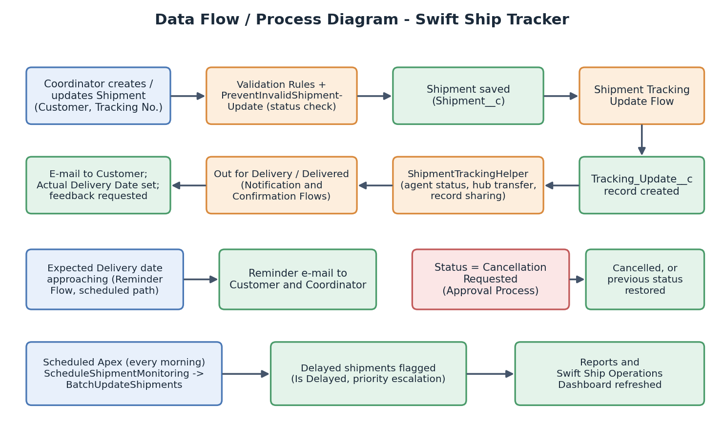
Figure 1: Data flow and process diagram of Swift Ship Tracker

4. PROJECT DESIGN PHASE

4.1 Problem-Solution Fit
Problem | Salesforce Solution | Component | Expected Improvement
No shipment visibility for customers | Unique Tracking Number and Tracking Update history for every shipment | Shipment__c, Tracking_Update__c | Customers and staff can see the current status and full movement history.
Manual status updates | Record-Triggered Flow creates the tracking record on every status change | Shipment Tracking Update Flow | No separate manual entry of movement history; fewer missed updates.
Delayed or missing notifications | Automatic e-mails for Out for Delivery, Delivered and approaching expected delivery date | Delivery Notification Flow, Expected Delivery Reminder Flow | Customers are informed on time without manual effort.
Poor delivery tracking and invalid updates | Status transition rules and agent status synchronisation | ShipmentTrigger, PreventInvalidShipmentUpdate, ShipmentTrackingHelper | Shipments follow the correct lifecycle; agent availability stays accurate.
Scattered customer data | Customer object linked to shipments and feedback | Customer__c, validation rules | Single source of truth with validated contact details.
No centralized monitoring of delays | Scheduled batch job, Is Delayed flag, reports and dashboard | BatchUpdateShipments, ScheduleShipmentMonitoring, Delayed Shipments report | Managers see delayed shipments every day.
Informal cancellations | Approval process with e-mail alerts | Shipment Cancellation Approval | Documented, traceable cancellation decisions.
Unclear access to data | Profiles, Roles, Permission Sets, OWD and Sharing Rules | Security model | Each user sees only relevant data.

4.2 Proposed Solution
The proposed solution has five connected parts. First, the data model stores shipments, customers, delivery agents, hubs, tracking updates and feedback. Second, the automation layer (Flows, Approval Process, Validation Rules and Apex) enforces business rules and notifies customers. Third, the user interface (Swift Ship Tracker Lightning App) gives users one workspace. Fourth, Reports and Dashboards turn the data into insight. Fifth, the security model controls what each role can see and do.

4.3 Solution Architecture
The architecture separates users, interface, automation, data and security. Users work through the Swift Ship Tracker app; automation components react to record changes; the data layer holds the custom objects; reports and the dashboard read from the data layer; and the security model governs access across all layers.
1. Users | Customer, Shipment Coordinator, Delivery Agent, Logistics Manager, System Administrator
▼
2. Lightning App | Swift Ship Tracker app: Shipments, Customers, Delivery Agents, Hubs, Tracking Updates, Delivery Feedback, Reports, Dashboards
▼
3. Automation | Validation Rules, 4 Record-Triggered Flows, Shipment Cancellation Approval, ShipmentTrigger with Apex helper classes, Batch and Scheduled Apex
▼
4. Data Layer | Shipment__c, Customer__c, Delivery_Agent__c, Hub__c, Tracking_Update__c, Delivery_Feedback__c
▼
5. Security | Profiles, Roles, Permission Sets, Organization-Wide Defaults, Sharing Rules, Apex managed sharing
▼
6. Reports / Dashboard | 7 reports and the Swift Ship Operations Dashboard
Figure 2: Solution architecture of Swift Ship Tracker (Users → Lightning App → Automation → Data Layer → Security → Reports/Dashboard)

5. PROJECT PLANNING & SCHEDULING

5.1 Project Planning
The project was organised into five phases so that the solution could be analysed, built, secured, tested and documented in a systematic order.
Phase | Major Activities | Output
Phase 1: Requirement Analysis & Planning | Identify stakeholders (customers, coordinators, agents, managers), define the shipment lifecycle, scope and execution roadmap. | Requirements, functional scope, shipment status lifecycle, roadmap.
Phase 2: Backend Development & Configuration | Create objects, fields, relationships, validation rules, approval process, flows and Apex classes and trigger. | Working data model and shipment automation.
Phase 3: UI/UX Development & Customization | Create the Swift Ship Tracker Lightning App, tabs, reports and the operations dashboard. | Swift Ship Tracker app and analytics.
Phase 4: Data Migration, Testing & Security | Import sample data, create profiles, roles, users, permission sets, sharing rules; execute test cases. | Secure, validated system with test evidence.
Phase 5: Deployment, Documentation & Maintenance | Prepare deployment approach, maintenance practices, documentation and demo video. | Final project report and demo video.

5.2 Sprint / Task Schedule
Task | Description | Status
Salesforce Account | Create and activate the Developer Edition org. | Completed
Data Model | Create the six custom objects, tabs, fields and relationships (Shipment, Customer, Delivery Agent, Hub, Tracking Update, Delivery Feedback). | Completed
Validation Rules | Create validation rules for customer e-mail, weight, dates, status-based required fields and ratings. | Completed
Approval Process | Create e-mail templates and the Shipment Cancellation Approval process. | Completed
Flows | Build Shipment Tracking Update Flow, Delivery Notification Flow, Delivery Confirmation Flow and Expected Delivery Reminder Flow. | Completed
Apex | Develop ShipmentTrigger, PreventInvalidShipmentUpdate, ShipmentTrackingHelper, BatchUpdateShipments and ScheduleShipmentMonitoring. | Completed
Lightning App | Create the Swift Ship Tracker Lightning App and navigation. | Completed
Reports | Create the report folder and seven shipment reports. | Completed
Dashboard | Create the Swift Ship Operations Dashboard. | Completed
Security | Create profiles, roles, users, permission sets, OWD and sharing rules. | Completed
Testing | Validate objects, automation, security, reports and dashboard. | Completed
Documentation | Prepare project documentation and demo video. | Completed

6. PROJECT DEVELOPMENT PHASE

6.1 Salesforce Developer Org Setup (Milestone 1)
Salesforce is a customer success platform that helps businesses sell, service, market, analyze and connect with their customers. All work in this project was done in a free Salesforce Developer Edition org.

Activity 1: Creating the Developer Account
- Open https://developer.salesforce.com/signup.
- Enter First name, Last name, Email, Role (Developer), Company (college name), Country (India), Postal Code and a unique Username in the format username@organization.com.
- Click Sign me up.
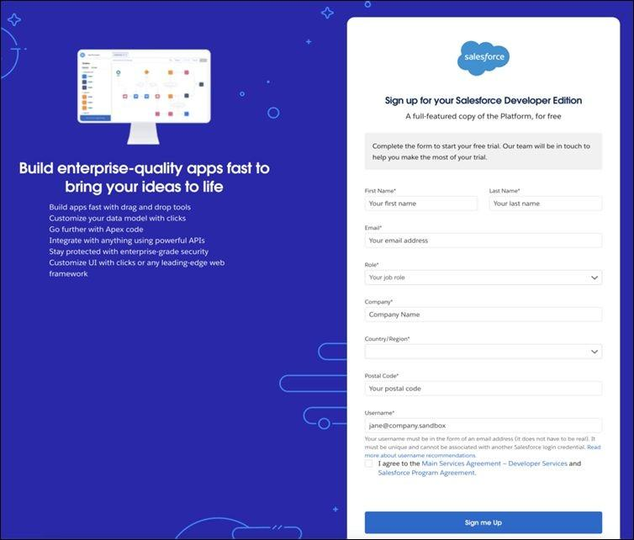
Figure 3: Salesforce Developer Edition sign-up form

Activity 2: Account Activation
- Open the inbox of the e-mail used for sign-up (the e-mail may take 5-10 minutes) and click Verify Account.
- Set a password, answer the security question and click Change Password.
- You are redirected to the Salesforce Setup page.
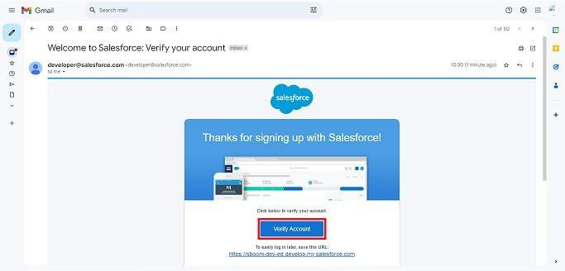
Figure 4: Verification e-mail received from Salesforce

6.2 Data Modelling (Data Architecture) (Milestone 2)
Six custom objects were created for Swift Ship Tracker. A shipment belongs to one customer, is handled by one delivery agent at a time and is processed at hubs; therefore no many-to-many relationship exists and no junction object is required. The Tracking Update object stores the movement history of a shipment and uses a Master-Detail relationship so that the history belongs to its shipment.
Object (API Name) | Purpose | Key Fields
Shipment (Shipment__c) | Central record for a parcel from creation to delivery. | Shipment Name (Auto Number), Tracking Number, Shipment Date, Expected Delivery Date, Actual Delivery Date, Shipment Status, Shipment Type, Origin, Destination, Weight, Delivery Charges, Customer, Delivery Agent, Current Hub, Priority, Is Delayed, Status Before Cancellation, Tracking Update Count
Customer (Customer__c) | Sender or receiver who owns the shipment. | Customer Name, Email, Phone, Address, City, State, Country, Pincode, Customer User
Delivery Agent (Delivery_Agent__c) | Person who collects and delivers shipments. | Agent Name, Email, Phone, Employee ID, Vehicle Number, Status, Assigned Hub, Agent User
Hub (Hub__c) | Warehouse or sorting hub through which shipments pass. | Hub Name, Address, City, State, Pincode, Contact Number, Capacity, Status
Tracking Update (Tracking_Update__c) | One entry of the movement history of a shipment. | Tracking Update ID (Auto Number), Shipment, Status, Location, Hub, Update Date/Time, Remarks
Delivery Feedback (Delivery_Feedback__c) | Customer rating and comments after delivery. | Feedback ID (Auto Number), Shipment, Customer, Rating, Comments, Feedback Date

Relationships
Relationship | Type | Reason
Shipment to Customer | Lookup (required) | A customer can have many shipments; shipments are retained independently.
Shipment to Delivery Agent | Lookup | An agent handles many shipments; agent can be changed.
Shipment to Hub (Current Hub) | Lookup | Hub changes as the shipment moves.
Delivery Agent to Hub (Assigned Hub) | Lookup | Each agent is based at a hub.
Tracking Update to Shipment | Master-Detail | History has no meaning without its shipment; it is deleted with it and sharing is controlled by the shipment.
Tracking Update to Hub | Lookup | Records the hub where the update happened.
Delivery Feedback to Shipment | Lookup (with lookup filter) | Feedback refers to one delivered shipment.
Delivery Feedback to Customer | Lookup | Identifies who gave the feedback.
Customer to User / Delivery Agent to User | Lookup to User | Links the record to the login user used for record sharing.
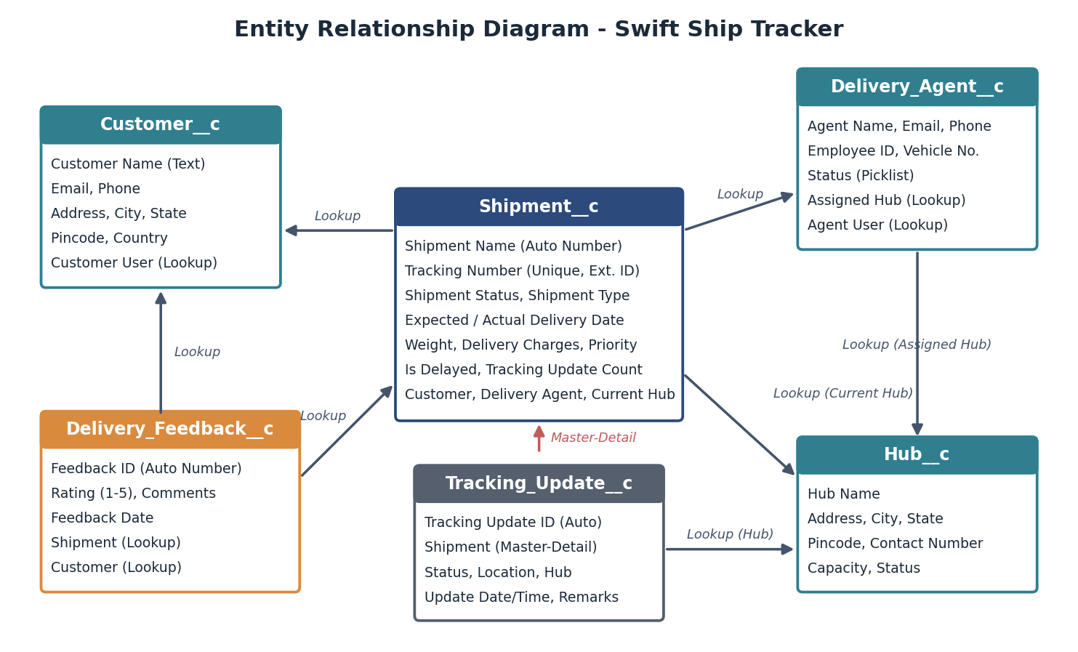
Figure 5: Entity relationship diagram of the Swift Ship Tracker data model

6.3 Creating the Custom Objects (Milestone 3)
A Salesforce object is a database table that stores data specific to an organization. It consists of fields (columns) and records (rows). In this application six custom objects are used: Shipment, Customer, Delivery Agent, Hub, Tracking Update and Delivery Feedback.

Activity 1: Create the Shipment Object
- From Setup, open Object Manager, click Create and select Custom Object.
- Enter Label = Shipment, Plural Label = Shipments, Record Name = Shipment Name, Data Type = Auto Number, Display Format = SHP-{00000}, Starting Number = 1.
- In Optional Features select Allow Reports, Allow Activities and Track Field History.
- Ensure Deployment Status = Deployed and Search Status = Allow Search.
- Under Object Creation Options select Add Notes and Attachments related list to default page layout, then click Save.
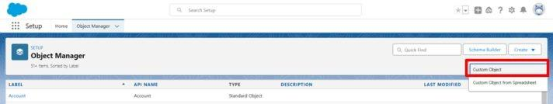
Figure 6: Object Manager - Create > Custom Object
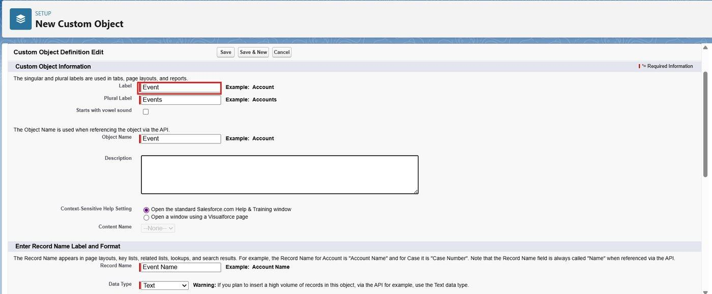
Figure 7: New Shipment custom object definition (label, plural label, record name)
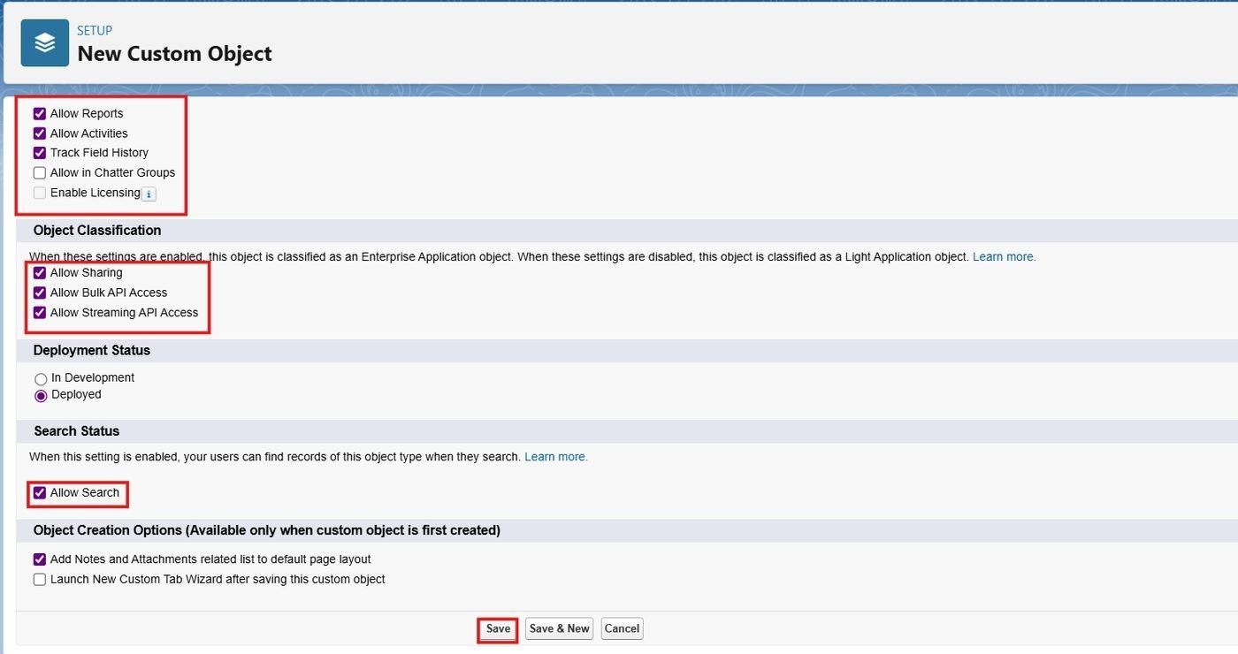
Figure 8: Optional features, deployment status and search status

Activity 2-4: Create the Customer, Delivery Agent and Hub Objects
Repeat the same steps. For each object use the following values and select Allow Reports, Allow Search and Add Notes and Attachments related list to default page layout, then click Save.
Object | Label | Plural Label | Record Name | Data Type
Customer | Customer | Customers | Customer Name | Text
Delivery Agent | Delivery Agent | Delivery Agents | Agent Name | Text
Hub | Hub | Hubs | Hub Name | Text

Activity 5: Create the Tracking Update Object
- Label = Tracking Update, Plural Label = Tracking Updates, Record Name = Tracking Update ID.
- Data Type = Auto Number, Display Format = TU-{00000}, Starting Number = 1.
- Select Allow Reports, Allow Search and Add Notes and Attachments related list; click Save.

Activity 6: Create the Delivery Feedback Object
- Label = Delivery Feedback, Plural Label = Delivery Feedbacks, Record Name = Feedback ID.
- Data Type = Auto Number, Display Format = FB-{0000}, Starting Number = 1.
- Select Allow Reports, Allow Search and Add Notes and Attachments related list; click Save.

6.4 Tabs (Milestone 4)
Tabs let users view object data at a glance. Custom object tabs look and function like standard tabs. A custom tab was created for each of Shipment, Customer, Delivery Agent, Hub, Tracking Update and Delivery Feedback.
- Click the Home tab, type Tabs in Quick Find and select Tabs.
- Under Custom Object Tabs click New.
- For Object select the required object (Shipment, Customer, Delivery Agent, Hub, Tracking Update or Delivery Feedback).
- For Tab Style select a suitable icon (for example a truck for Shipment), leave defaults and click Next, Next, Save.
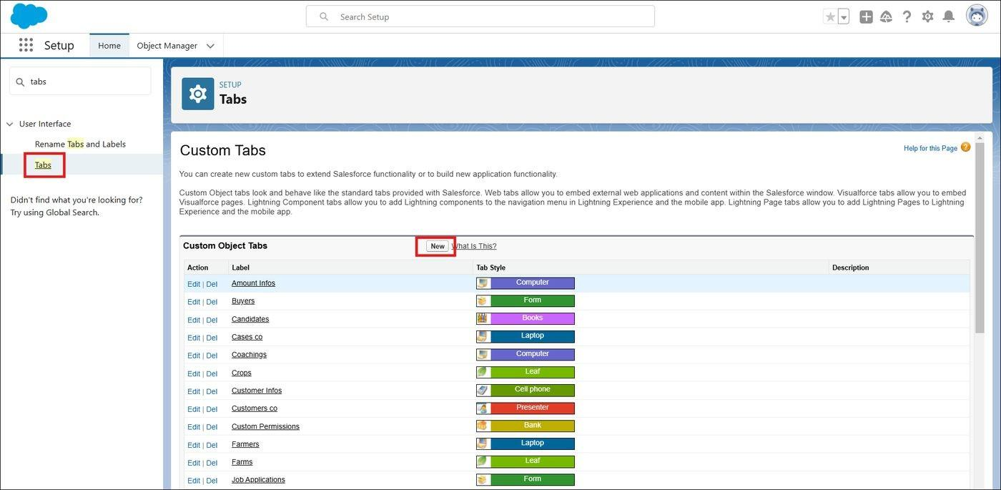
Figure 9: Custom Object Tabs page - New button
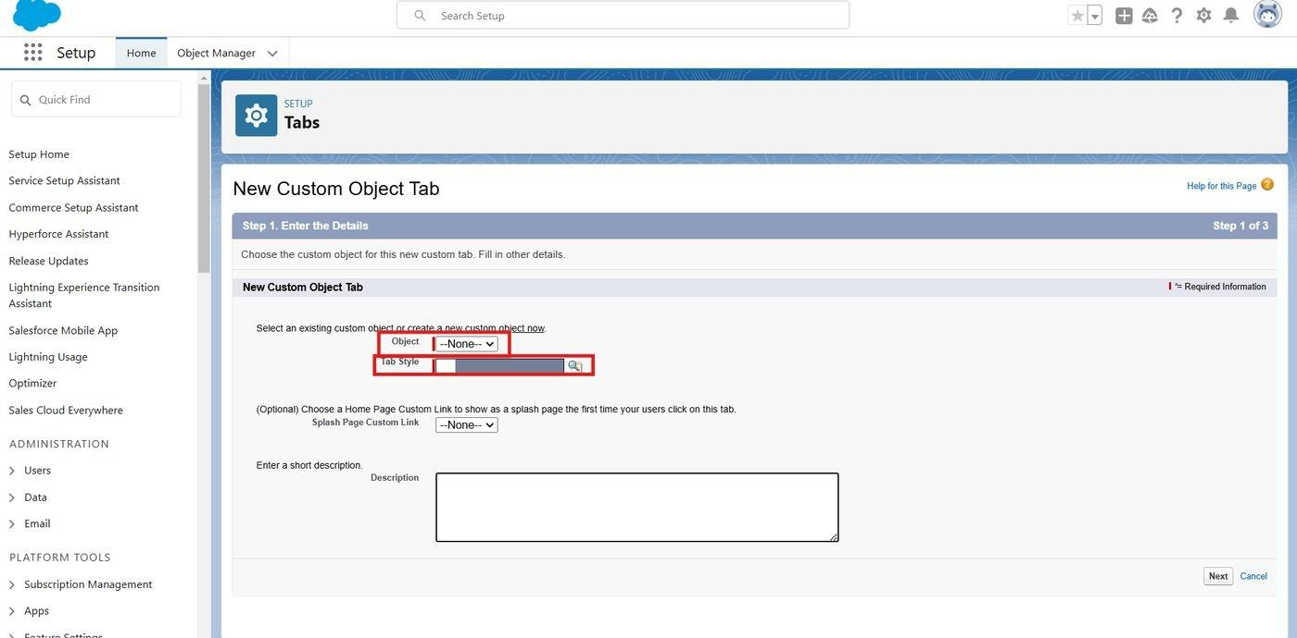
Figure 10: Creating a new custom object tab

6.5 Fields (Milestone 5)
Fields are the columns of an object. Standard fields (such as Created By, Last Modified By and Owner) exist on every object, while custom fields are added by the administrator to meet business requirements.

Shipment object fields
- Object Manager > Shipment > Fields & Relationships > New.
- Select the data type, enter the Field Label as shown below, then Next, Next, Save.
Field Label (API Name) | Type | Details
Tracking Number (Tracking_Number__c) | Text(20) | Select Unique (case insensitive) and External ID. This is the main identifier customers use to track the shipment.
Shipment Date (Shipment_Date__c) | Date | Date the shipment was booked or picked up.
Expected Delivery Date (Expected_Delivery_Date__c) | Date | Promised delivery date.
Actual Delivery Date (Actual_Delivery_Date__c) | Date | Set automatically when the shipment is delivered.
Shipment Status (Shipment_Status__c) | Picklist | Created, Picked Up, In Transit, At Hub, Out for Delivery, Delivered, Failed Delivery, Returned, Cancellation Requested, Cancelled. Default = Created; required.
Shipment Type (Shipment_Type__c) | Picklist | Standard, Express, Same Day, Fragile, Freight.
Priority (Priority__c) | Picklist | Normal (default), High, Urgent.
Origin (Origin__c) | Text(100) | Pickup location; required.
Destination (Destination__c) | Text(100) | Delivery location; required.
Weight (Weight__c) | Number(8,2) | Weight in kilograms.
Delivery Charges (Delivery_Charges__c) | Currency(10,2) | Charges for the shipment.
Is Delayed (Is_Delayed__c) | Checkbox | Set by BatchUpdateShipments; default unchecked.
Status Before Cancellation (Status_Before_Cancellation__c) | Text(50) | Filled automatically when cancellation is requested; used to restore the status if the request is rejected or recalled.
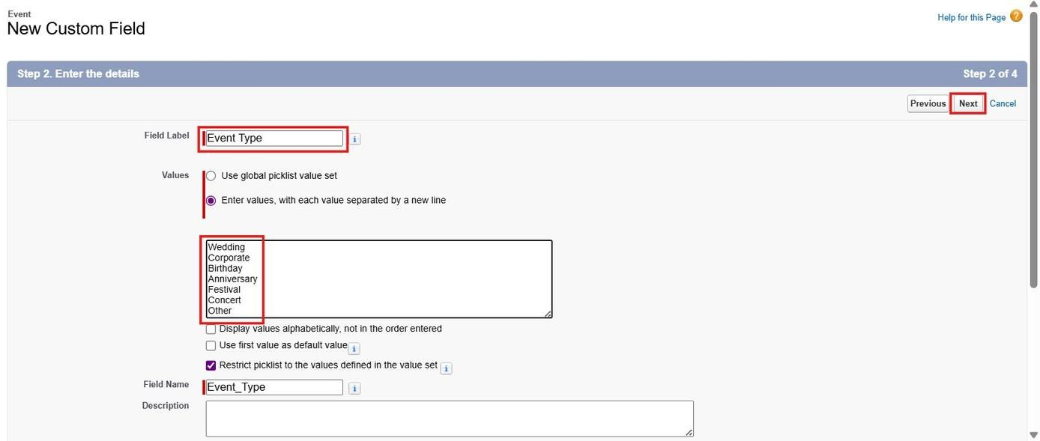
Figure 11: Creating the Shipment Status picklist field
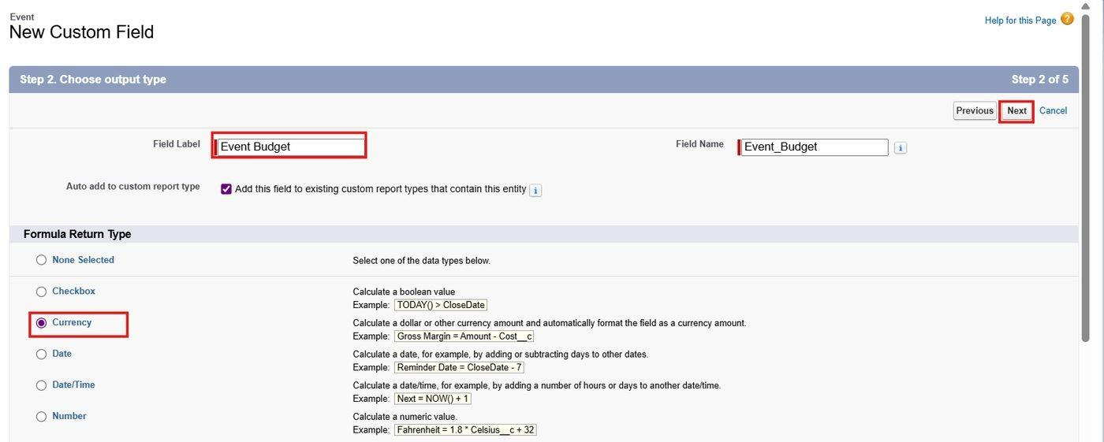
Figure 12: Tracking Number field with Unique and External ID options

Customer object fields
Field Label (API Name) | Type | Details
Email (Email__c) | Email | Required; used for shipment notifications.
Phone (Phone__c) | Phone
Address (Address__c) | Text Area | Delivery address.
City (City__c) | Text(80)
State (State__c) | Text(80)
Country (Country__c) | Text(80) | Default value India.
Pincode (Pincode__c) | Text(10) | Six-digit postal code.
Customer User (Customer_User__c) | Lookup(User) | Login user of the customer; used for record sharing.

Delivery Agent object fields
Field Label (API Name) | Type | Details
Email (Email__c) | Email
Phone (Phone__c) | Phone
Employee ID (Employee_ID__c) | Text(20) | Unique and External ID.
Vehicle Number (Vehicle_Number__c) | Text(20)
Status (Status__c) | Picklist | Available (default), Assigned, On Delivery, Inactive.
Assigned Hub (Assigned_Hub__c) | Lookup(Hub) | Created in Milestone 6.
Agent User (Agent_User__c) | Lookup(User) | Login user of the agent; used for record sharing.

Hub object fields
Field Label (API Name) | Type | Details
Address (Address__c) | Text Area
City (City__c) | Text(80) | Used as the location in tracking updates.
State (State__c) | Text(80)
Pincode (Pincode__c) | Text(10)
Contact Number (Contact_Number__c) | Phone
Capacity (Capacity__c) | Number(6,0) | Maximum number of shipments the hub can hold.
Status (Status__c) | Picklist | Active (default), Full, Inactive.

Tracking Update object fields
Field Label (API Name) | Type | Details
Status (Status__c) | Picklist | Same ten values as Shipment Status.
Location (Location__c) | Text(100) | City or place where the update happened.
Update Date/Time (Update_Date_Time__c) | Date/Time | Default value NOW().
Remarks (Remarks__c) | Long Text Area(1000) | Description of the movement.

Delivery Feedback object fields
Field Label (API Name) | Type | Details
Rating (Rating__c) | Number(1,0) | Required; value from 1 to 5 (enforced by a validation rule).
Comments (Comments__c) | Long Text Area(2000)
Feedback Date (Feedback_Date__c) | Date | Default value TODAY().

6.6 Relationships (Milestone 6)

Lookup relationships on the Shipment object
- Object Manager > Shipment > Fields & Relationships > New.
- Select Lookup Relationship, click Next, choose the related object Customer, set Field Label = Customer and make the field Required; then Next, Next, Next, Save.
- Repeat to create the Delivery Agent lookup (Delivery_Agent__c) and the Current Hub lookup (Current_Hub__c, related object Hub).
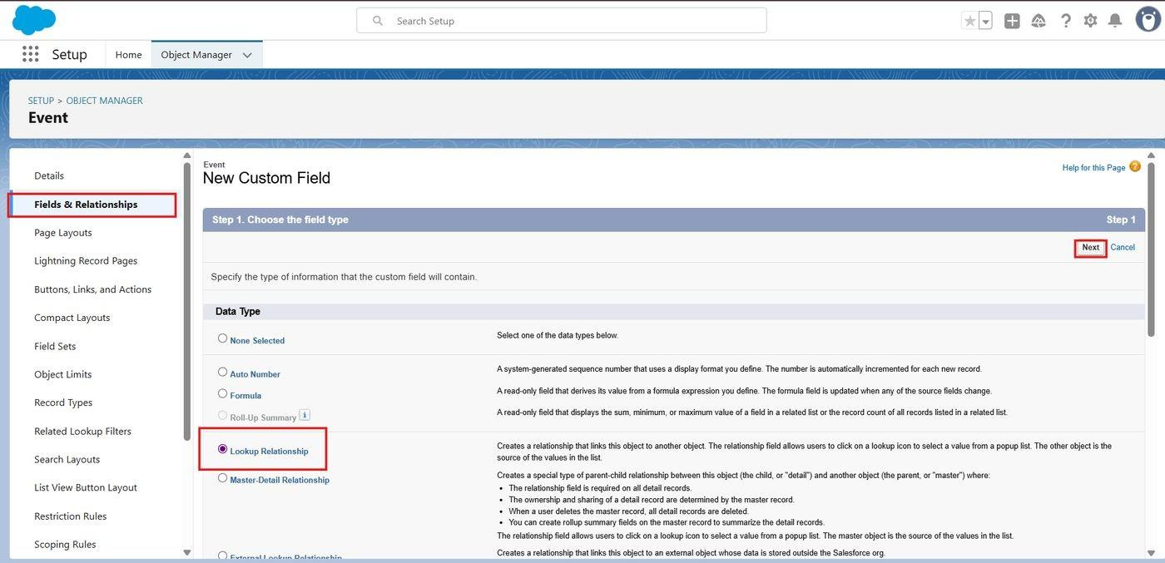
Figure 13: Choosing the Lookup Relationship data type
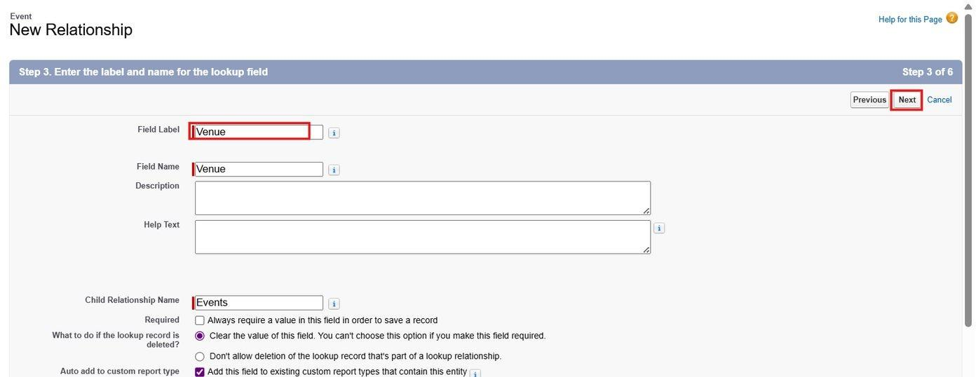
Figure 14: Entering the label and name of the Customer lookup field on the Shipment object

Other lookup relationships
- Delivery Agent to Hub - Lookup (Field Label = Assigned Hub).
- Tracking Update to Hub - Lookup (Field Label = Hub).
- Customer to User - Lookup (Field Label = Customer User).
- Delivery Agent to User - Lookup (Field Label = Agent User).

Master-Detail relationship (Tracking Update to Shipment)
The Tracking Update object stores many entries for one shipment. Because a tracking entry cannot exist without a shipment, a Master-Detail relationship was used. This also means the history is visible to anyone who can see the shipment, which is exactly the access the customer and the delivery agent need.
- Object Manager > Tracking Update > Fields & Relationships > New.
- Select Master-Detail Relationship, click Next and choose the master object Shipment.
- Field Label = Shipment; Related List Label = Tracking Updates; click Next, Next, Save.
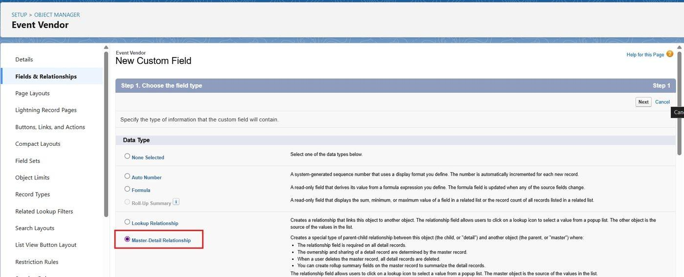
Figure 15: Selecting Master-Detail Relationship on the Tracking Update object

Roll-Up Summary field: Tracking Update Count
- Object Manager > Shipment > Fields & Relationships > New > Roll-Up Summary.
- Field Label = Tracking Update Count; Summarized Object = Tracking Updates; Roll-Up Type = COUNT; Save.

Lookup relationships on the Delivery Feedback object
- Delivery Feedback to Shipment - Lookup (Field Label = Shipment).
- Delivery Feedback to Customer - Lookup (Field Label = Customer).

Lookup filter
Scenario: When a Delivery Feedback record is created and a Customer is selected, the Shipment lookup should list only that customer's delivered shipments.
- Setup > Object Manager > Delivery Feedback > Fields & Relationships > open the Shipment lookup field > Edit.
- In the Lookup Filter section click Show Filter Settings.
- Filter criteria 1: Field = Shipment: Customer, Operator = equals, Value = Field Delivery Feedback: Customer.
- Filter criteria 2: Field = Shipment: Shipment Status, Operator = equals, Value = Delivered.
- Tick Enable this filter and click Save.
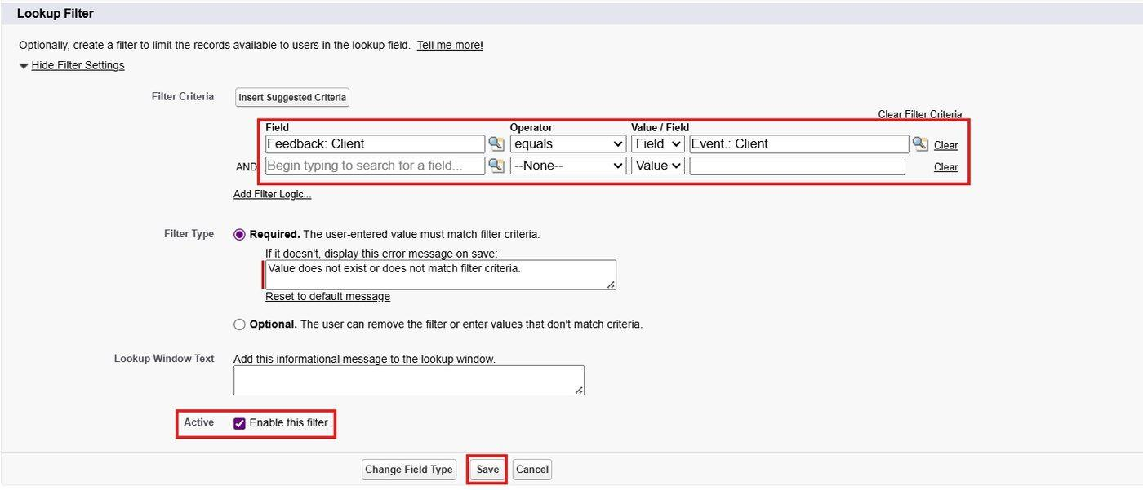
Figure 16: Lookup filter criteria on the Delivery Feedback Shipment field

6.7 Validation Rules (Milestone 7)
Validation rules run when a user saves a record. If the criteria are not met, an error is shown and the record is not saved. The following rules protect data quality in Swift Ship Tracker. Each rule is active.

Customer object
Property | Value
Object | Customer (Customer__c)
Rule Name | Email_Valid_Address
Active | Yes
Error Condition Formula | AND(NOT(ISBLANK(Email__c)), NOT(REGEX(Email__c, "^[A-Za-z0-9._%+-]+@[A-Za-z0-9.-]+\\.[A-Za-z]{2,}$")))
Error Message | Please Enter Valid Email Address
Error Location | Field - Email

Property | Value
Rule Name | Pincode_Six_Digits (Customer__c)
Error Condition Formula | AND(NOT(ISBLANK(Pincode__c)), NOT(REGEX(Pincode__c, "[0-9]{6}")))
Error Message / Location | Pincode must contain exactly six digits. / Field - Pincode

Shipment object
Rule Name | Error Condition Formula | Error Message (Location)
Tracking_Number_Required | ISBLANK(Tracking_Number__c) | Tracking Number is required. (Tracking Number)
Weight_Must_Be_Positive | OR(ISBLANK(Weight__c), Weight__c <= 0) | Shipment weight must be greater than zero. (Weight)
Expected_Date_Not_Before_Shipment | AND(NOT(ISBLANK(Expected_Delivery_Date__c)), NOT(ISBLANK(Shipment_Date__c)), Expected_Delivery_Date__c < Shipment_Date__c) | Expected Delivery Date cannot be earlier than the Shipment Date. (Expected Delivery Date)
Actual_Date_Not_Before_Shipment | AND(NOT(ISBLANK(Actual_Delivery_Date__c)), NOT(ISBLANK(Shipment_Date__c)), Actual_Delivery_Date__c < Shipment_Date__c) | Actual Delivery Date cannot be earlier than the Shipment Date. (Actual Delivery Date)
Delivered_Requires_Actual_Date | AND(ISPICKVAL(Shipment_Status__c, "Delivered"), ISBLANK(Actual_Delivery_Date__c)) | A delivered shipment must have an Actual Delivery Date. (Actual Delivery Date)
Agent_Required_For_Pickup_And_Delivery | AND(OR(ISPICKVAL(Shipment_Status__c, "Picked Up"), ISPICKVAL(Shipment_Status__c, "Out for Delivery")), ISBLANK(Delivery_Agent__c)) | Assign a Delivery Agent before pickup or out-for-delivery. (Delivery Agent)
Hub_Required_At_Hub | AND(ISPICKVAL(Shipment_Status__c, "At Hub"), ISBLANK(Current_Hub__c)) | Select the Current Hub when the status is At Hub. (Current Hub)
Inactive_Agent_Not_Allowed | AND(ISCHANGED(Delivery_Agent__c), ISPICKVAL(Delivery_Agent__r.Status__c, "Inactive")) | An inactive Delivery Agent cannot be assigned. (Delivery Agent)

Hub and Delivery Feedback objects
Object | Rule Name | Error Condition Formula | Error Message (Location)
Hub | Hub_Capacity_Positive | OR(ISBLANK(Capacity__c), Capacity__c <= 0) | Capacity must be greater than zero. (Capacity)
Delivery Feedback | Rating_Between_1_And_5 | OR(ISBLANK(Rating__c), Rating__c < 1, Rating__c > 5) | Rating must be a number from 1 to 5. (Rating)

Delivered_Requires_Actual_Date works together with the Delivery Confirmation Flow: that flow runs before the record is saved and fills the Actual Delivery Date, so the rule only blocks records that bypass the normal process.

6.8 Approval Process for Shipment Cancellation (Milestone 8)
When a customer asks to cancel a shipment that has not yet gone out for delivery, the coordinator sets the Shipment Status to Cancellation Requested. This starts the Shipment Cancellation Approval process, which notifies the Logistics Manager and updates the status according to the decision. Cancellation can be requested only from Created, Picked Up, In Transit or At Hub; this is enforced by PreventInvalidShipmentUpdate. (Profiles, Roles and Users should be created before testing the approval process.)
Item | Configuration
Entry criteria | Shipment: Shipment Status equals Cancellation Requested
Initial submitters | Shipment Owner and Role: Shipment Coordinator
Approver | Manager of the submitting user (the Logistics Manager), assigned automatically
Approved outcome | Shipment Status = Cancelled
Rejected outcome | Shipment Status returns to the value stored in Status Before Cancellation (for example In Transit)
Recalled outcome | Shipment Status returns to Status Before Cancellation

Step A: Create the classic e-mail templates
Setup > Email Templates > Classic Email Templates > New Template > Text. Folder: Unfiled Public Email Templates. Three templates were created:
Template Name | Subject | Purpose
Shipment Cancellation Request Notification | Approval Request: Cancel Shipment {!Shipment__c.Tracking_Number__c} | Sent to the Logistics Manager when the request is submitted.
Cancellation Approved - Owner Notification | Shipment Cancellation Approved: {!Shipment__c.Tracking_Number__c} | Tells the shipment owner the cancellation was approved.
Cancellation Rejected - Owner Notification | Shipment Cancellation Rejected: {!Shipment__c.Tracking_Number__c} | Tells the shipment owner the cancellation was rejected and the status restored.

Sample template body: Shipment Cancellation Request Notification
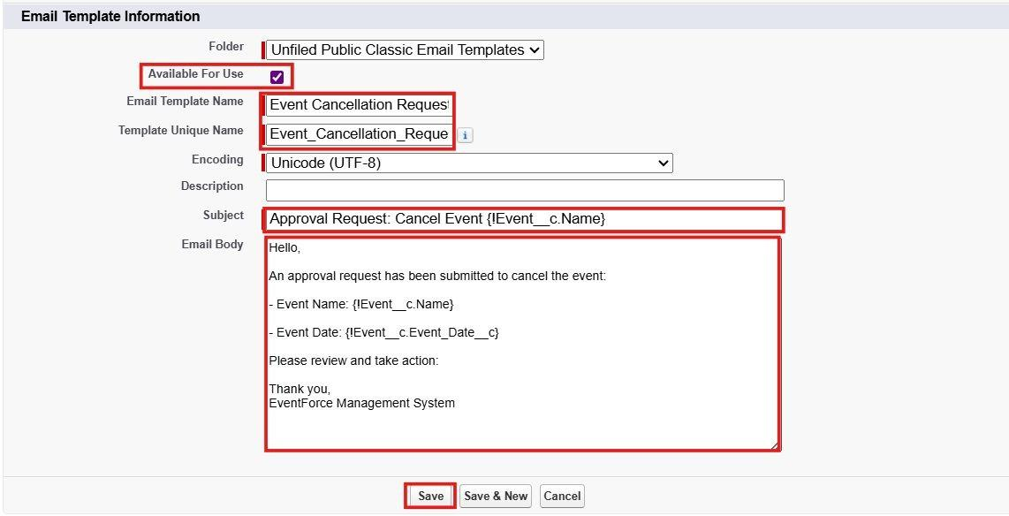
Figure 17: Classic e-mail template - Shipment Cancellation Request Notification

Step B: Create the approval process
- Setup > Approval Processes > select object Shipment > Create New Approval Process > Use Standard Setup Wizard.
- Step 1 - Name: Shipment Cancellation Approval (unique name Shipment_Cancellation_Approval).
- Entry criteria: Shipment: Shipment Status equals Cancellation Requested.
- Approver: automatically assign using the Manager field of the submitting user. Select the option to use the approver field of the Shipment Owner.
- Notification template: Shipment Cancellation Request Notification.
- Fields displayed on the approval page: Shipment Name, Tracking Number, Owner, Customer, Delivery Agent, Shipment Status, Status Before Cancellation, Origin, Destination, Delivery Charges.
- Initial submitters: Shipment Owner and Role: Shipment Coordinator, then click Save.
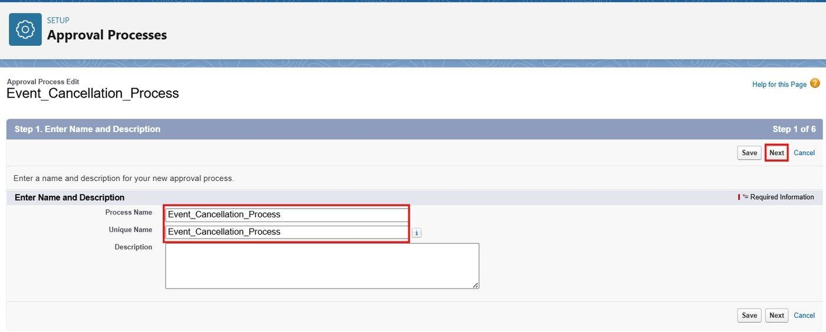
Figure 18: Approval process name and unique name
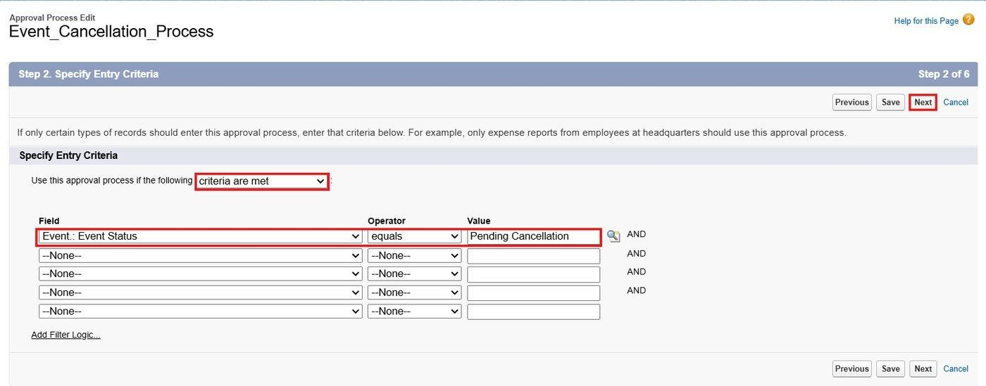
Figure 19: Specifying the entry criteria (Shipment Status equals Cancellation Requested)
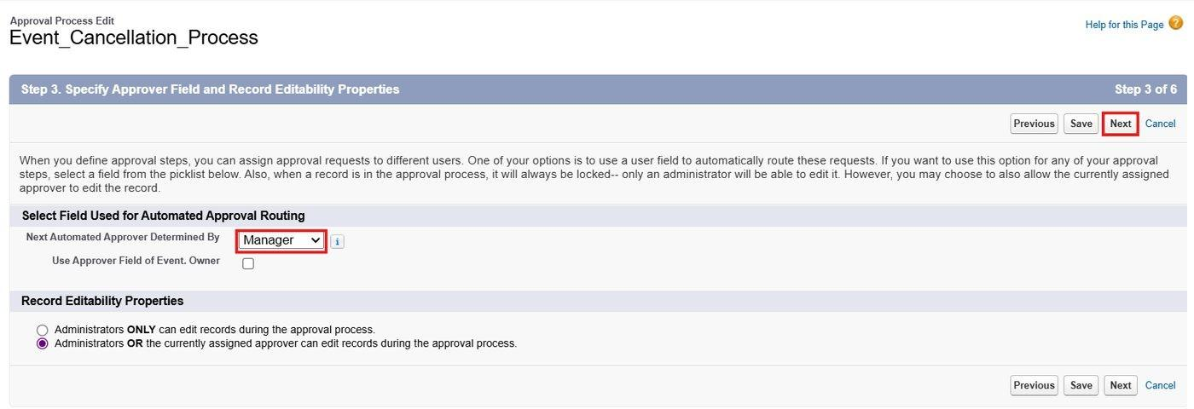
Figure 20: Selecting the approver field (Manager)
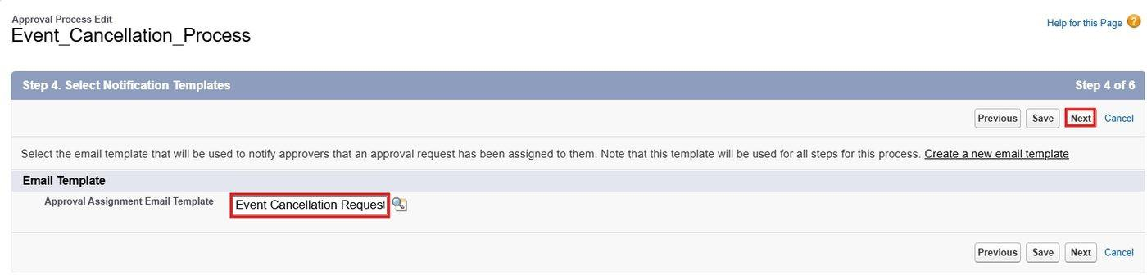
Figure 21: Selecting the approval assignment e-mail template
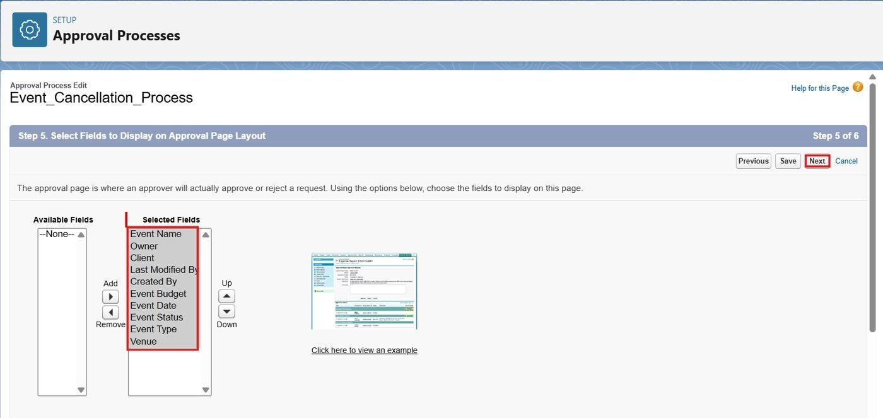
Figure 22: Fields selected for the approval page layout
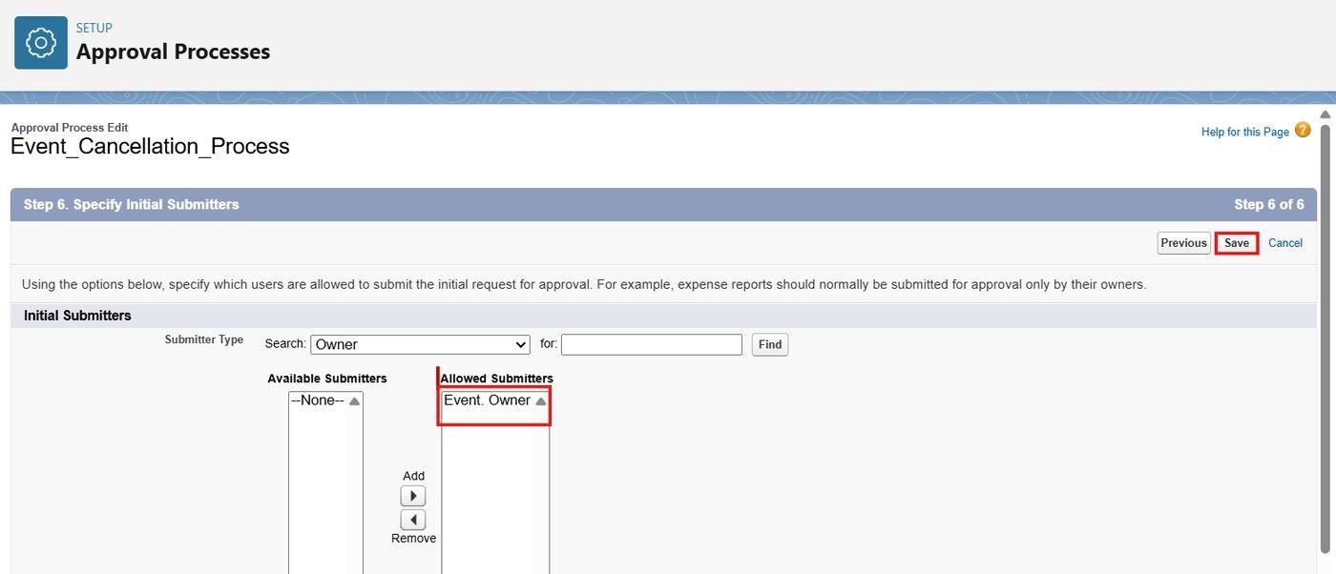
Figure 23: Specifying Shipment Owner and Shipment Coordinator as initial submitters

Step C: Initial submission, final approval, final rejection and recall actions
Stage | Action | Configuration
Initial Submission | Record Lock | Lock the record so that the status cannot be changed while the request is pending.
Initial Submission | Email Alert | Alert - Cancellation Requested; template Shipment Cancellation Request Notification; recipient Role: Logistics Manager.
Final Approval | Field Update | Shipment_Status_To_Cancelled: Shipment Status = Cancelled.
Final Approval | Email Alert | Alert - Cancellation Approved; template Cancellation Approved - Owner Notification; recipient Shipment Owner.
Final Rejection | Field Update | Shipment_Status_Restore: Shipment Status = value of Status Before Cancellation (formula: Status_Before_Cancellation__c).
Final Rejection | Email Alert | Alert - Cancellation Rejected; template Cancellation Rejected - Owner Notification; recipient Shipment Owner.
Recall | Field Update | Shipment_Status_Restore (same field update as final rejection).

The customer is informed of an approved cancellation by the Delivery Notification Flow, which sends a cancellation notice when Shipment Status changes to Cancelled.
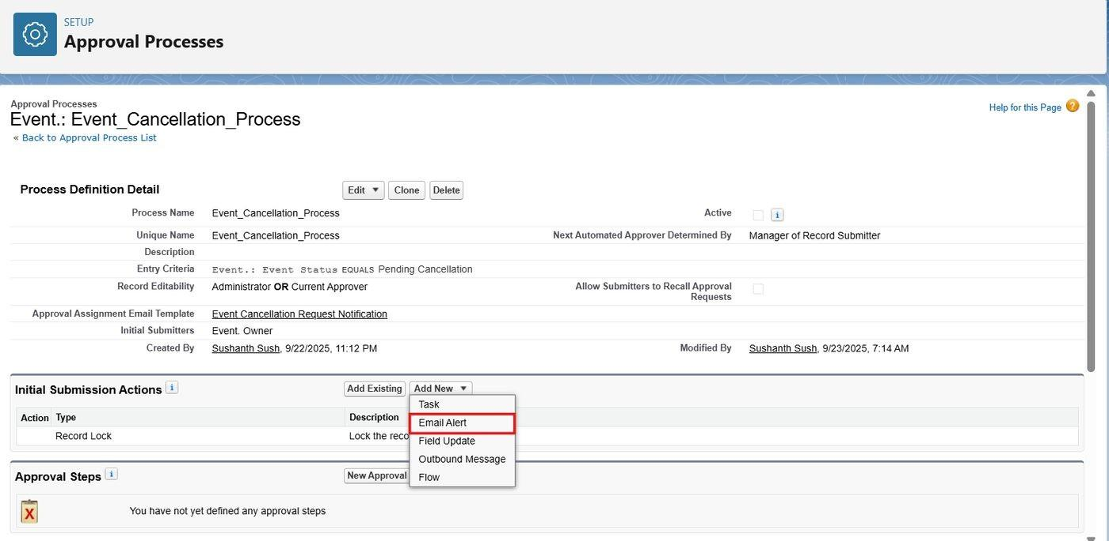
Figure 24: Approval process detail page - adding the initial submission e-mail alert
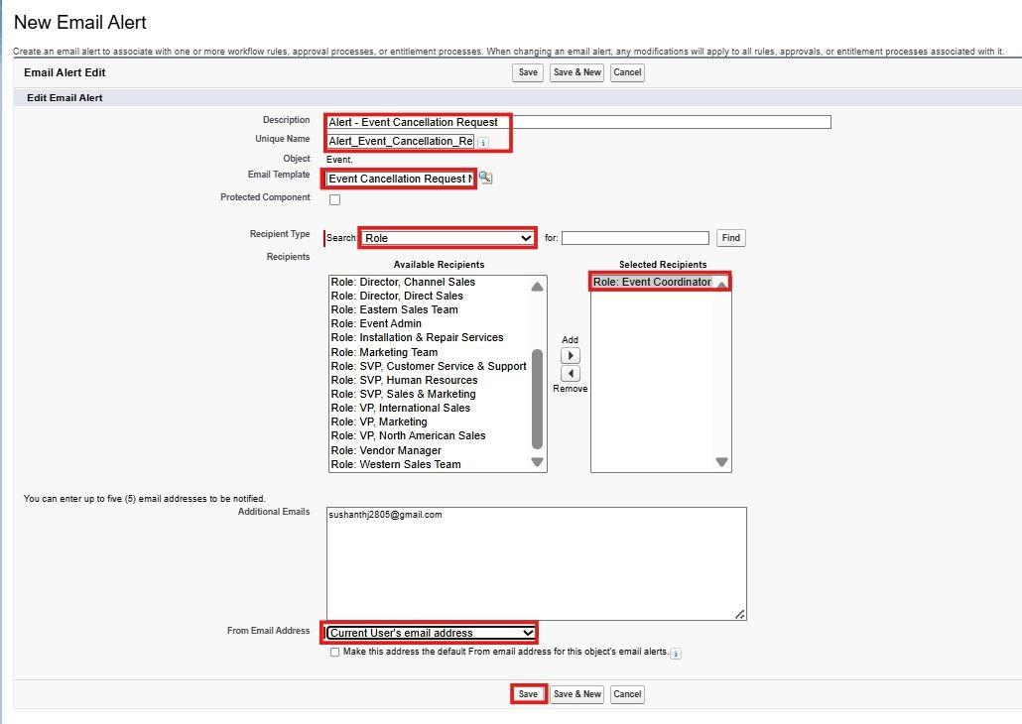
Figure 25: Email alert for the cancellation request
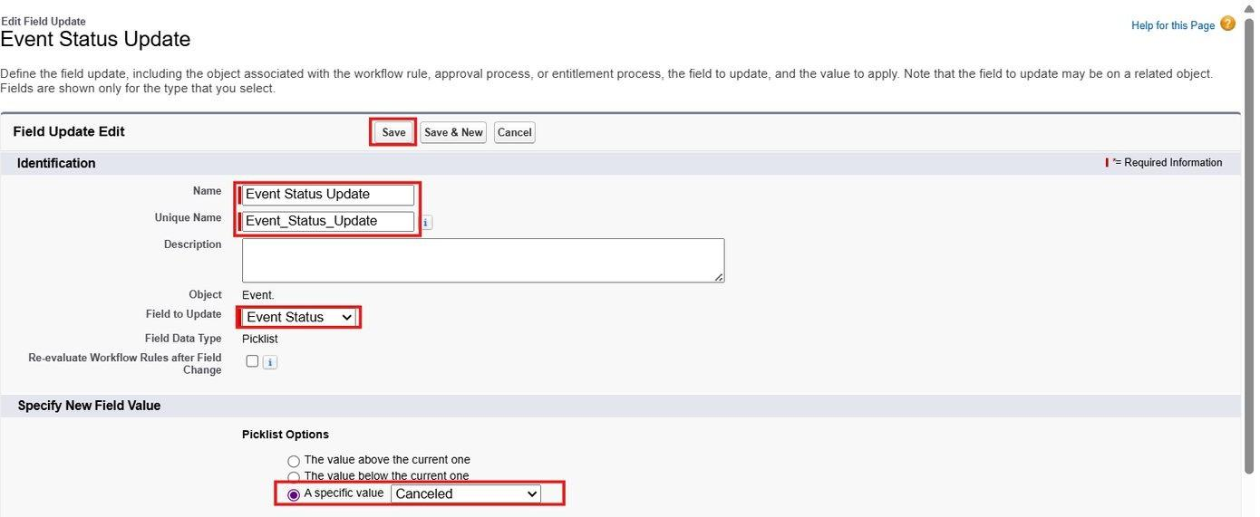
Figure 26: Field update: Shipment Status set to Cancelled on final approval
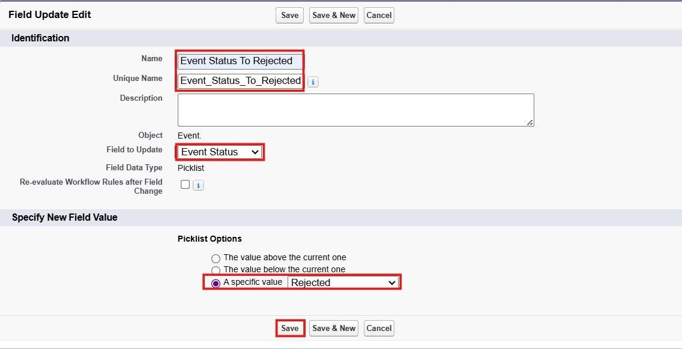
Figure 27: Field update: Shipment Status restored from Status Before Cancellation on final rejection

Step D: Approval step and activation
- Click Add New Step; Step Name = Logistics Manager Review.
- Step criteria: All records should enter this step.
- Assigned approver: Automatically assign using the user field Manager.
- If the approver rejects: Perform all rejection actions for this approval process (final rejection).
- Open the process detail page and click Activate.
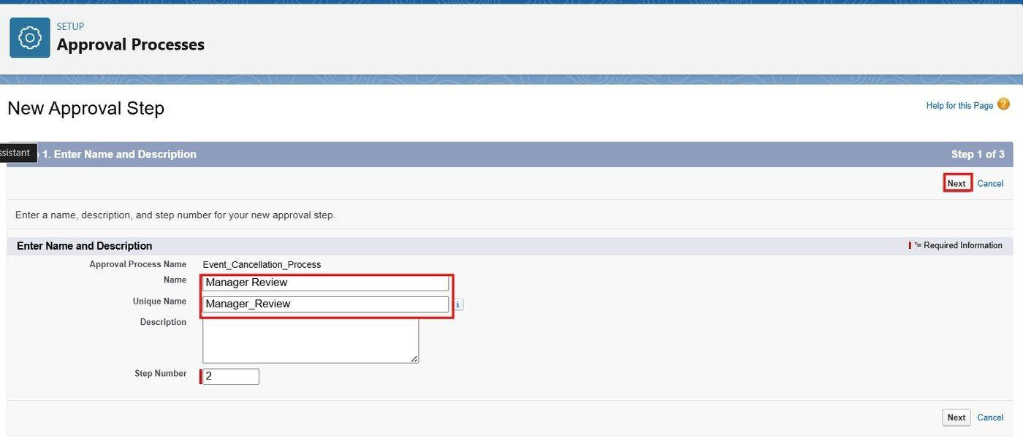
Figure 28: Creating the Logistics Manager Review approval step
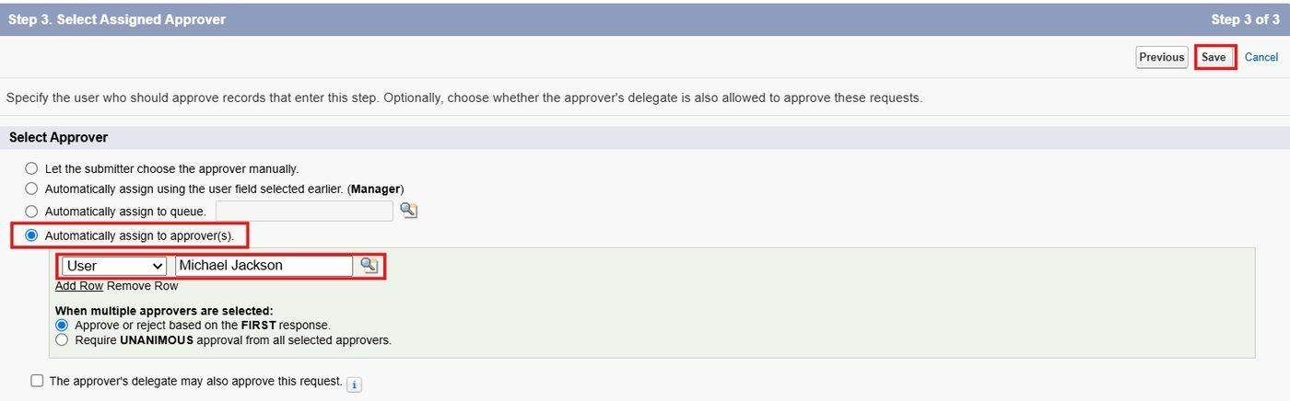
Figure 29: Selecting the assigned approver for the step
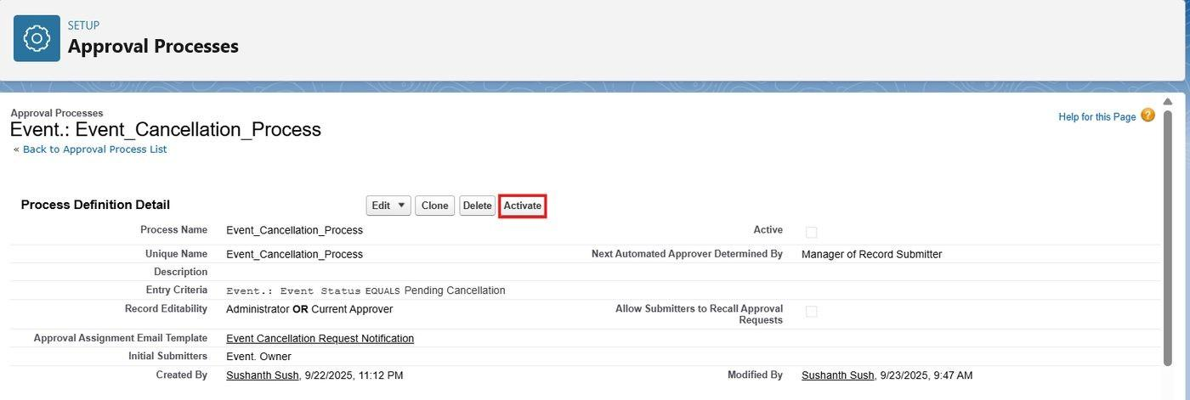
Figure 30: Approval process detail page with the Activate button

6.9 Flow Automation (Milestone 9)
Four Record-Triggered Flows automate the shipment lifecycle. All of them are built on the Shipment object. Setup > Flows > New Flow > Record-Triggered Flow > Create.
Flow | Trigger and Timing | Purpose
Shipment Tracking Update Flow | Shipment created or updated; Actions and Related Records (after save) | Creates a Tracking Update whenever a shipment is created or its status changes.
Delivery Notification Flow | Shipment Status is changed; Actions and Related Records (after save) | E-mails the customer when the shipment is Out for Delivery, Delivered (with feedback request) or Cancelled.
Delivery Confirmation Flow | Shipment Status changed to Delivered; Fast Field Updates (before save) | Sets Actual Delivery Date and clears the delayed flag.
Expected Delivery Reminder Flow | Shipment created or updated; scheduled path before Expected Delivery Date | Reminds the customer when a shipment is due for delivery and is not yet delivered.

Flow 1: Shipment Tracking Update Flow
Scenario: When a Shipment is created, or its Shipment Status changes (for example from Picked Up to In Transit), a Tracking Update record is created automatically with the shipment, status, location or hub, date and time, and remarks.
- Object = Shipment; trigger = A record is created or updated.
- Entry condition: Condition Requirements = Formula Evaluates to True with the formula OR(ISNEW(), ISCHANGED({!$Record.Shipment_Status__c})). Optimize the flow for Actions and Related Records; click Done.
- Toolbox > New Resource > Formula named LocationValue (Text): CASE({!$Record.Shipment_Status__c}, "Created", {!$Record.Origin__c}, "Picked Up", {!$Record.Origin__c}, "Out for Delivery", {!$Record.Destination__c}, "Delivered", {!$Record.Destination__c}, "Failed Delivery", {!$Record.Destination__c}, IF(ISBLANK({!$Record.Current_Hub__r.City__c}), {!$Record.Origin__c}, {!$Record.Current_Hub__r.City__c})).
- Create a second Formula resource named RemarksValue (Text): IF(ISNEW(), "Shipment registered with tracking number " & {!$Record.Tracking_Number__c} & ".", "Status changed from " & TEXT({!$Record__Prior.Shipment_Status__c}) & " to " & TEXT({!$Record.Shipment_Status__c}) & ".").
- Add Create Records (Label = Create Tracking Update) for object Tracking Update and set: Shipment = {!$Record.Id}; Status = {!$Record.Shipment_Status__c}; Location = {!LocationValue}; Hub = {!$Record.Current_Hub__c}; Update Date/Time = {!$Flow.CurrentDateTime}; Remarks = {!RemarksValue}.
- Save with Flow Label Shipment Tracking Update Flow and click Activate.
Example: when a coordinator changes a shipment from Picked Up to In Transit, the flow creates a Tracking Update with Status = In Transit, Location = the current hub city (or origin if no hub is selected), the current date and time, and the remark "Status changed from Picked Up to In Transit."
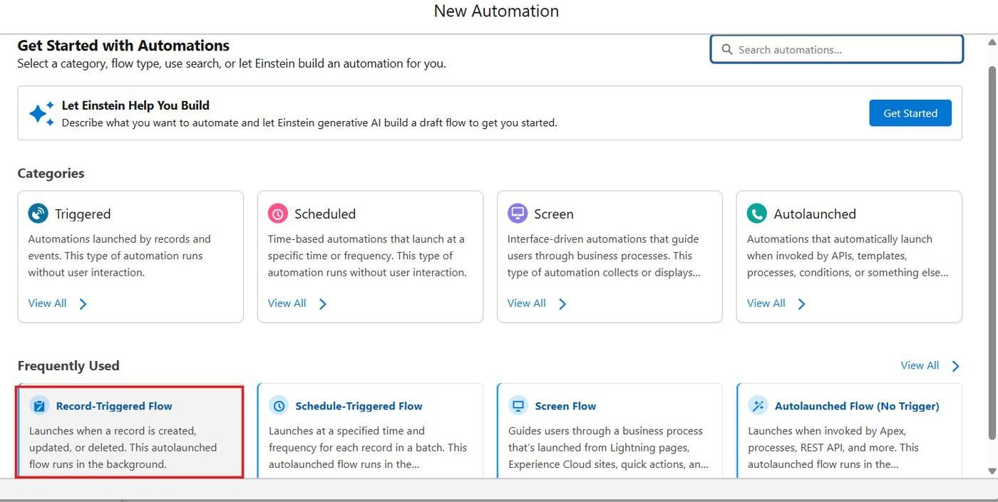
Figure 31: Selecting Record-Triggered Flow in New Automation
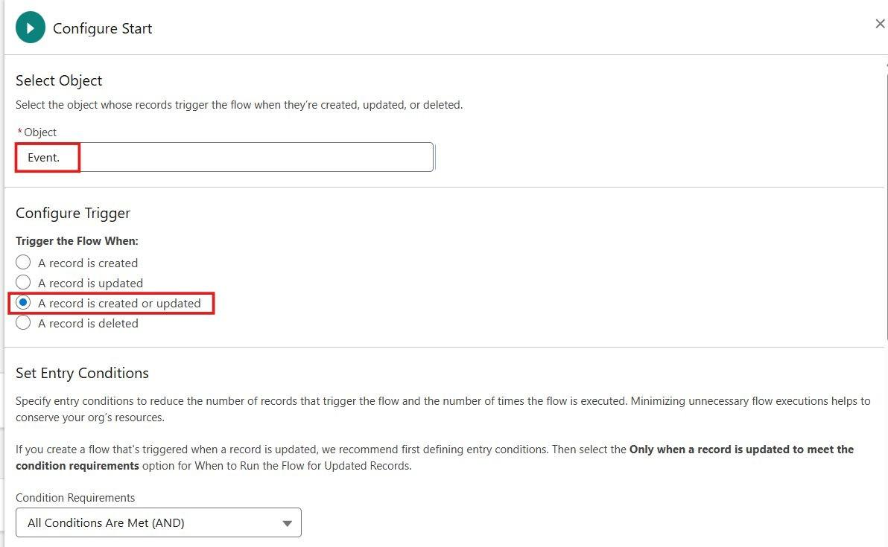
Figure 32: Configure Start - Shipment object and trigger
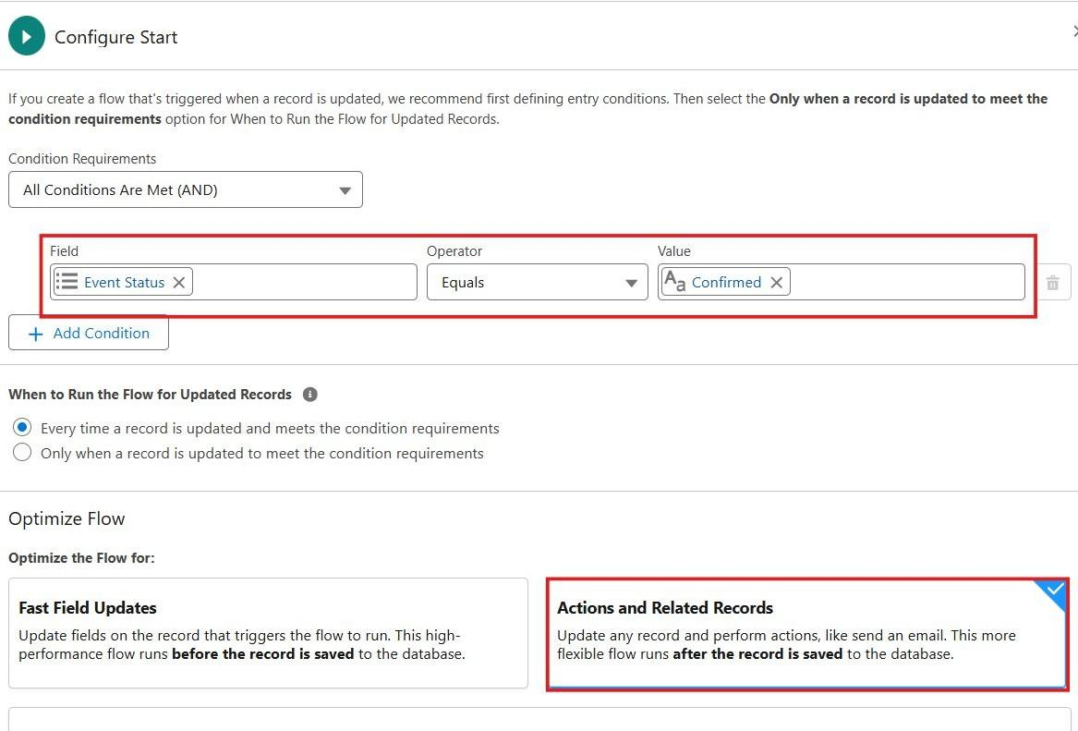
Figure 33: Entry condition formula and Actions and Related Records optimization

Flow 2: Delivery Notification Flow
Scenario: When Shipment Status becomes Out for Delivery, the customer is e-mailed. When it becomes Delivered, the customer receives a delivery confirmation that also asks for feedback. When it becomes Cancelled, the customer receives a cancellation notice.
- Object = Shipment; trigger = A record is created or updated; Condition Requirements = Formula Evaluates to True: ISCHANGED({!$Record.Shipment_Status__c}). Optimize for Actions and Related Records.
- Add a Decision named Check Status with outcomes Out_For_Delivery (Shipment Status equals Out for Delivery), Delivered (equals Delivered) and Cancelled (equals Cancelled). Every outcome also requires {!$Record.Customer__r.Email__c} Is Null = False.
- Create Text Template resources: OutForDeliverySubject ("Your shipment {!$Record.Tracking_Number__c} is out for delivery"), OutForDeliveryBody, DeliveredSubject, DeliveredBody and CancelledBody.
- OutForDeliveryBody: Dear {!$Record.Customer__r.Name}, your shipment {!$Record.Tracking_Number__c} from {!$Record.Origin__c} to {!$Record.Destination__c} is out for delivery today. Please keep your phone available.
- DeliveredBody (delivery confirmation and optional feedback request): Dear {!$Record.Customer__r.Name}, your shipment {!$Record.Tracking_Number__c} was delivered on {!$Record.Actual_Delivery_Date__c}. Thank you for choosing Swift Ship Tracker. We would value your feedback: please rate your delivery from 1 to 5 in the Swift Ship Tracker app.
- Under each outcome add Action > Send Email: Labels = Email_Out_For_Delivery, Email_Delivery_Confirmation, Email_Cancellation_Notice. Recipient Address List = {!$Record.Customer__r.Email__c}; for Out for Delivery add CC = Shipment Owner e-mail. Compose Email Content with the Subject and Body resources.
- Save with Flow Label Delivery Notification Flow and click Activate.

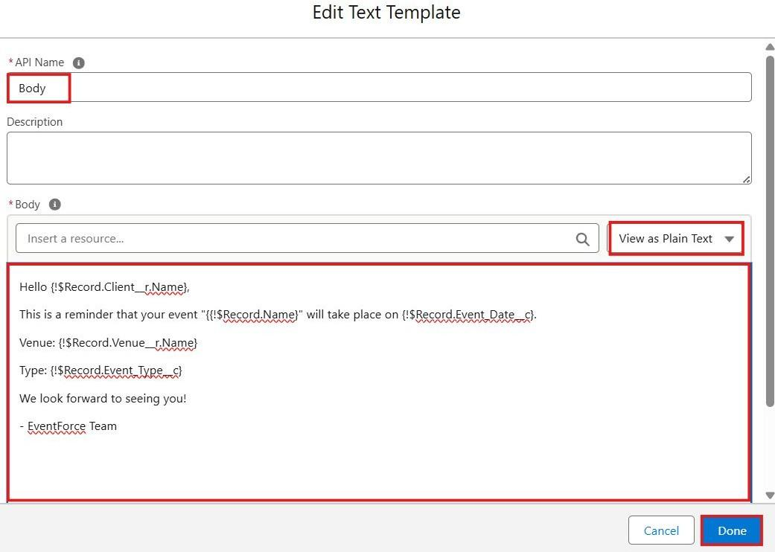
Figure 34: Text template resources for the customer e-mails
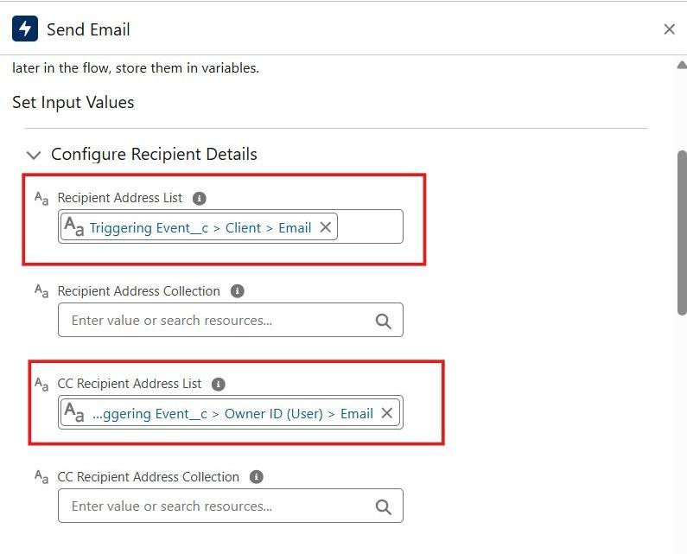
Figure 35: Send Email action - recipient and CC recipient

Flow 3: Delivery Confirmation Flow
Scenario: When a shipment is marked Delivered, the Actual Delivery Date is set automatically, the delayed flag is cleared and the record is ready for the confirmation e-mail.
- Object = Shipment; trigger = A record is created or updated; Condition Requirements = All Conditions Are Met (AND): Shipment Status equals Delivered, and Shipment Status Is Changed = True. Optimize the flow for Fast Field Updates (before save).
- Add Update Records (Label = Set Delivery Details) and select Use the Shipment record that triggered the flow.
- Set field values: Actual_Delivery_Date__c = {!$Flow.CurrentDate} and Is_Delayed__c = {!$GlobalConstant.False}.
- If the Actual Delivery Date has already been entered by the user, add a Decision before the update: Actual Delivery Date Is Null = True, so that a manually entered date is preserved.
- Save with Flow Label Delivery Confirmation Flow and click Activate.
Because this is a before-save flow, the Actual Delivery Date is populated before validation rules run. The Delivered_Requires_Actual_Date rule therefore does not block normal deliveries. The agent status is refreshed by ShipmentTrackingHelper and the confirmation e-mail is sent by the Delivery Notification Flow.

Flow 4: Expected Delivery Reminder Flow
Scenario: One day before the Expected Delivery Date, a reminder is sent for every shipment that has not yet been delivered, cancelled or returned.
- Object = Shipment; trigger = A record is created or updated; Condition: Expected Delivery Date Is Null = False. Optimize for Actions and Related Records.
- Click the Start element > Add Scheduled Path: Path Label = 1_Day_Before_Expected_Delivery, Time Source = Shipment__c: Expected Delivery Date, Offset Number = 1, Offset Option = Days Before.
- Under the scheduled path add a Decision named Still Pending: Shipment Status does not equal Delivered, Cancelled and Returned, and {!$Record.Customer__r.Email__c} Is Null = False.
- Create Text Templates ReminderSubject ("Your shipment {!$Record.Tracking_Number__c} is due for delivery tomorrow") and ReminderBody (includes tracking number, current status, destination and expected delivery date).
- Under the Still Pending outcome add Action > Send Email; Label = Email_Delivery_Reminder; Recipient = Customer Email; CC = Shipment Owner e-mail.
- Save with Flow Label Expected Delivery Reminder Flow and click Activate.
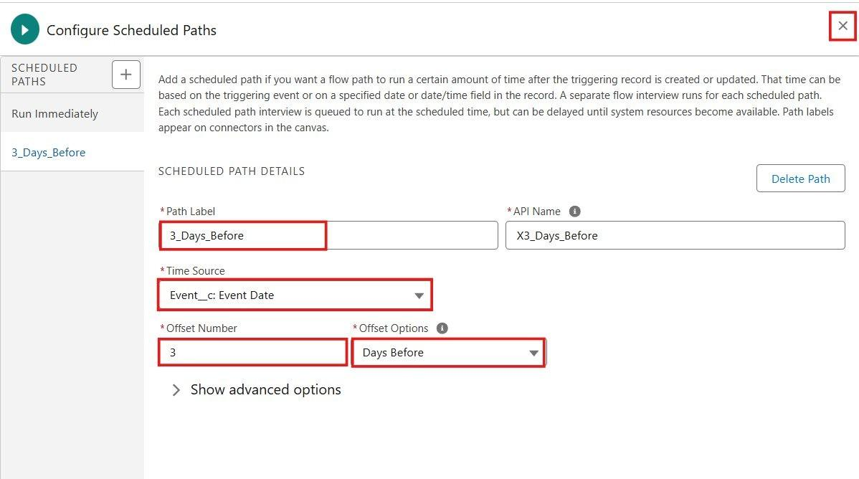
Figure 36: Scheduled path 1_Day_Before_Expected_Delivery configured
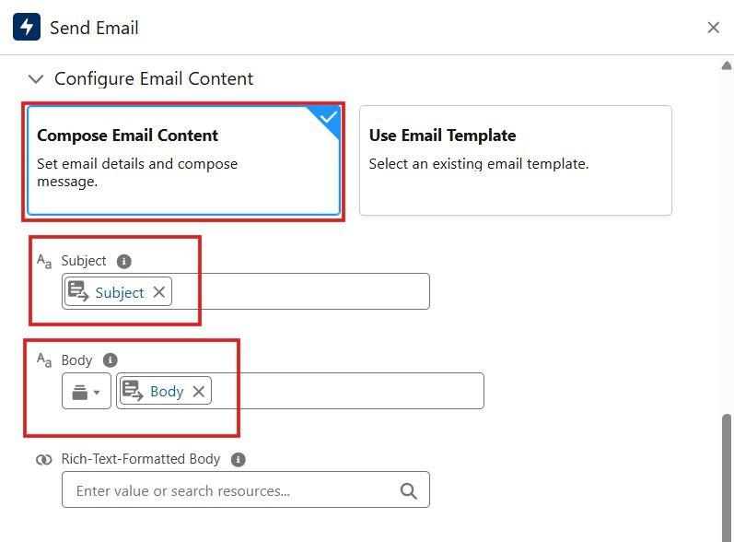
Figure 37: Decision element Still Pending and Send Email action
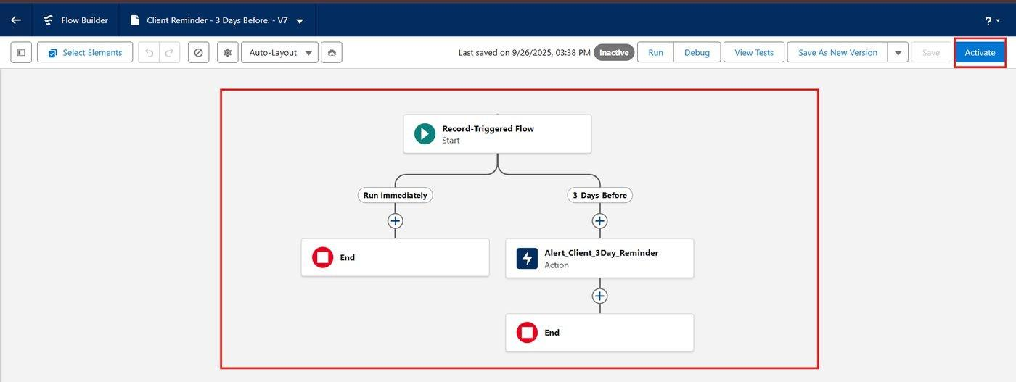
Figure 38: Completed Expected Delivery Reminder Flow with the scheduled path

6.10 Apex Classes and Trigger (Milestone 10)
Apex is used only where declarative tools are not sufficient: validating the status lifecycle, keeping delivery agent status and record sharing in step with shipments, and recording hub transfers. All code is bulk-safe. One trigger, ShipmentTrigger, calls two classes: PreventInvalidShipmentUpdate and ShipmentTrackingHelper.
- Click the gear icon > Developer Console.
- File > New > Apex Class; name it PreventInvalidShipmentUpdate; enter the code below and save with Ctrl+S.
- File > New > Apex Class; name it ShipmentTrackingHelper; enter the code below and save.
- File > New > Apex Trigger; name it ShipmentTrigger, sObject = Shipment__c; enter the trigger code and save.
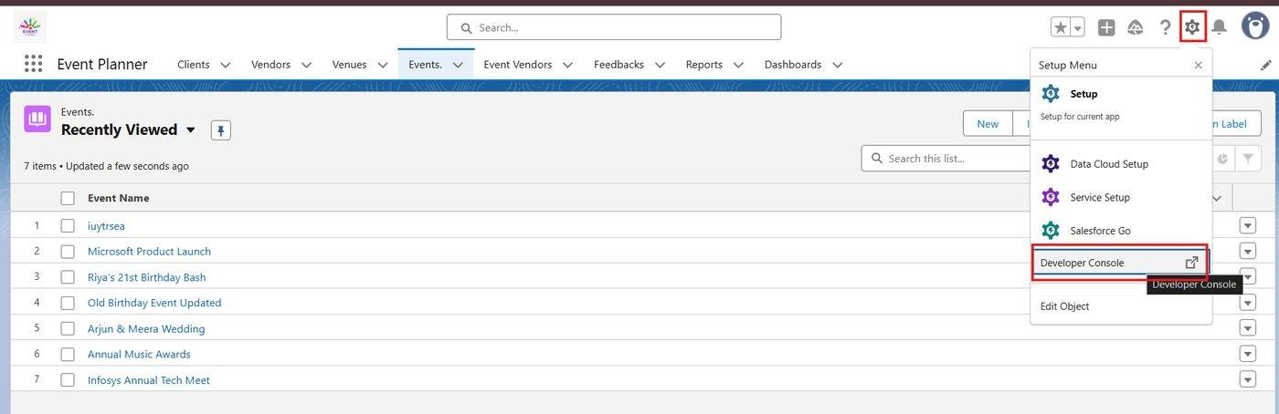
Figure 39: Opening the Developer Console from the gear icon

Class 1: PreventInvalidShipmentUpdate
Scenario: A shipment must follow its lifecycle (Created, Picked Up, In Transit, At Hub, Out for Delivery, Delivered). Skipping stages, reopening a delivered shipment, or changing a Cancellation Requested shipment to anything other than Cancelled or its previous status is blocked.
From Status | Allowed Next Status
Created | Picked Up, Cancellation Requested
Picked Up | In Transit, At Hub, Cancellation Requested
In Transit | At Hub, Out for Delivery, Cancellation Requested
At Hub | In Transit, Out for Delivery, Cancellation Requested
Out for Delivery | Delivered, Failed Delivery
Failed Delivery | Out for Delivery, At Hub, Returned
Cancellation Requested | Cancelled, or the Status Before Cancellation (Created, Picked Up, In Transit, At Hub)
Delivered, Returned, Cancelled | None (final statuses)

public with sharing class PreventInvalidShipmentUpdate {

private static final Map<String, Set<String>> ALLOWED = new Map<String, Set<String>>{
'Created' => new Set<String>{'Picked Up', 'Cancellation Requested'},
'Picked Up' => new Set<String>{'In Transit', 'At Hub', 'Cancellation Requested'},
'In Transit' => new Set<String>{'At Hub', 'Out for Delivery', 'Cancellation Requested'},
'At Hub' => new Set<String>{'In Transit', 'Out for Delivery', 'Cancellation Requested'},
'Out for Delivery' => new Set<String>{'Delivered', 'Failed Delivery'},
'Failed Delivery' => new Set<String>{'Out for Delivery', 'At Hub', 'Returned'},
'Cancellation Requested' => new Set<String>{'Cancelled', 'Created', 'Picked Up', 'In Transit', 'At Hub'},
'Delivered' => new Set<String>(),
'Returned' => new Set<String>(),
'Cancelled' => new Set<String>()
};

public static void validate(List<Shipment__c> newList, Map<Id, Shipment__c> oldMap) {
for (Shipment__c s : newList) {
Shipment__c oldRec = oldMap.get(s.Id);
if (oldRec == null || s.Shipment_Status__c == oldRec.Shipment_Status__c) {
continue;
}
Set<String> allowed = ALLOWED.get(oldRec.Shipment_Status__c);
if (allowed == null || !allowed.contains(s.Shipment_Status__c)) {
s.Shipment_Status__c.addError('Invalid status change from '
+ oldRec.Shipment_Status__c + ' to ' + s.Shipment_Status__c + '.');
continue;
}
// A rejected or recalled cancellation must restore the earlier status
if (oldRec.Shipment_Status__c == 'Cancellation Requested'
&& s.Shipment_Status__c != 'Cancelled'
&& s.Shipment_Status__c != oldRec.Status_Before_Cancellation__c) {
s.Shipment_Status__c.addError('Status must return to '
+ oldRec.Status_Before_Cancellation__c + ' or become Cancelled.');
}
}
}
}
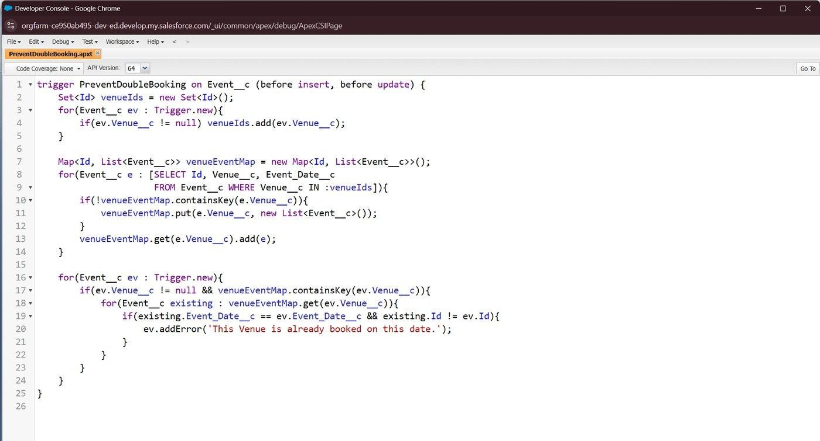
Figure 40: PreventInvalidShipmentUpdate Apex class in the Developer Console

Class 2: ShipmentTrackingHelper
Scenario: Keep supporting data consistent whenever shipments change. The class is declared without sharing because it performs system housekeeping (agent status, tracking history and sharing records) that must succeed even when the logged-in user, such as a delivery agent, has limited record access. It performs four tasks:
- captureStatusBeforeCancellation - stores the previous status when Cancellation Requested is selected, so that a rejection can restore it.
- syncAgentStatus - sets the agent to On Delivery when a shipment is Out for Delivery, to Assigned when the agent still holds open shipments, and to Available when none remain; inactive agents are not changed.
- logHubTransfers - creates a Tracking Update when only the Current Hub changes (status changes are already logged by the Shipment Tracking Update Flow).
- refreshSharing - gives the customer user Read access and the assigned agent user Edit access to the shipment (and Read access to the customer record) using Apex managed sharing.
public without sharing class ShipmentTrackingHelper {

private static final Set<String> CLOSED =
new Set<String>{'Delivered', 'Cancelled', 'Returned'};

// 1. Remember the status that existed before a cancellation request
public static void captureStatusBeforeCancellation(List<Shipment__c> newList,
Map<Id, Shipment__c> oldMap) {
for (Shipment__c s : newList) {
Shipment__c oldRec = oldMap.get(s.Id);
if (oldRec != null && s.Shipment_Status__c == 'Cancellation Requested'
&& oldRec.Shipment_Status__c != 'Cancellation Requested') {
s.Status_Before_Cancellation__c = oldRec.Shipment_Status__c;
}
}
}

// 2. Keep Delivery Agent status in step with assigned shipments
public static void syncAgentStatus(List<Shipment__c> newList,
Map<Id, Shipment__c> oldMap) {
Set<Id> agentIds = new Set<Id>();
for (Shipment__c s : newList) {
Shipment__c oldRec = (oldMap == null) ? null : oldMap.get(s.Id);
Boolean agentChanged = oldRec == null || s.Delivery_Agent__c != oldRec.Delivery_Agent__c;
Boolean statusChanged = oldRec == null || s.Shipment_Status__c != oldRec.Shipment_Status__c;
if (agentChanged || statusChanged) {
if (s.Delivery_Agent__c != null) agentIds.add(s.Delivery_Agent__c);
if (oldRec != null && oldRec.Delivery_Agent__c != null) agentIds.add(oldRec.Delivery_Agent__c);
}
}
if (agentIds.isEmpty()) return;

Map<Id, String> target = new Map<Id, String>();
for (Id a : agentIds) target.put(a, 'Available');

for (AggregateResult ar : [
SELECT Delivery_Agent__c agent, Shipment_Status__c st, COUNT(Id) cnt
FROM Shipment__c
WHERE Delivery_Agent__c IN :agentIds AND Shipment_Status__c NOT IN :CLOSED
GROUP BY Delivery_Agent__c, Shipment_Status__c]) {
Id agentId = (Id) ar.get('agent');
if ((String) ar.get('st') == 'Out for Delivery') {
target.put(agentId, 'On Delivery');
} else if (target.get(agentId) == 'Available') {
target.put(agentId, 'Assigned');
}
}

List<Delivery_Agent__c> toUpdate = new List<Delivery_Agent__c>();
for (Delivery_Agent__c ag : [SELECT Id, Status__c FROM Delivery_Agent__c
WHERE Id IN :agentIds AND Status__c != 'Inactive']) {
String newStatus = target.get(ag.Id);
if (ag.Status__c != newStatus) {
ag.Status__c = newStatus;
toUpdate.add(ag);
}
}
if (!toUpdate.isEmpty()) update toUpdate;
}

// 3. Record a Tracking Update when only the Current Hub changes
public static void logHubTransfers(List<Shipment__c> newList,
Map<Id, Shipment__c> oldMap) {
if (oldMap == null) return;
List<Shipment__c> moved = new List<Shipment__c>();
Set<Id> hubIds = new Set<Id>();
for (Shipment__c s : newList) {
Shipment__c oldRec = oldMap.get(s.Id);
if (s.Current_Hub__c != null && s.Current_Hub__c != oldRec.Current_Hub__c
&& s.Shipment_Status__c == oldRec.Shipment_Status__c) {
moved.add(s);
hubIds.add(s.Current_Hub__c);
}
}
if (moved.isEmpty()) return;
Map<Id, Hub__c> hubs = new Map<Id, Hub__c>(
[SELECT Id, Name, City__c FROM Hub__c WHERE Id IN :hubIds]);
List<Tracking_Update__c> logs = new List<Tracking_Update__c>();
for (Shipment__c s : moved) {
Hub__c h = hubs.get(s.Current_Hub__c);
logs.add(new Tracking_Update__c(
Shipment__c = s.Id, Status__c = s.Shipment_Status__c, Hub__c = h.Id,
Location__c = h.City__c, Update_Date_Time__c = System.now(),
Remarks__c = 'Shipment transferred to hub ' + h.Name + '.'));
}
insert logs;
}

// 4. Share the shipment with the customer user and the assigned agent user
public static void refreshSharing(List<Shipment__c> newList,
Map<Id, Shipment__c> oldMap) {
List<Shipment__c> changed = new List<Shipment__c>();
Set<Id> customerIds = new Set<Id>();
Set<Id> agentIds = new Set<Id>();
for (Shipment__c s : newList) {
Shipment__c oldRec = (oldMap == null) ? null : oldMap.get(s.Id);
if (oldRec == null || s.Customer__c != oldRec.Customer__c
|| s.Delivery_Agent__c != oldRec.Delivery_Agent__c) {
changed.add(s);
customerIds.add(s.Customer__c);
agentIds.add(s.Delivery_Agent__c);
if (oldRec != null) {
customerIds.add(oldRec.Customer__c);
agentIds.add(oldRec.Delivery_Agent__c);
}
}
}
if (changed.isEmpty()) return;
customerIds.remove(null);
agentIds.remove(null);

Map<Id, Customer__c> customers = new Map<Id, Customer__c>(
[SELECT Id, Customer_User__c FROM Customer__c WHERE Id IN :customerIds]);
Map<Id, Delivery_Agent__c> agents = new Map<Id, Delivery_Agent__c>(
[SELECT Id, Agent_User__c FROM Delivery_Agent__c WHERE Id IN :agentIds]);

// Remove manual shares given to previous customer or agent users
Set<Id> oldUsers = new Set<Id>();
for (Shipment__c s : changed) {
Shipment__c oldRec = (oldMap == null) ? null : oldMap.get(s.Id);
if (oldRec == null) continue;
if (customers.containsKey(oldRec.Customer__c))
oldUsers.add(customers.get(oldRec.Customer__c).Customer_User__c);
if (agents.containsKey(oldRec.Delivery_Agent__c))
oldUsers.add(agents.get(oldRec.Delivery_Agent__c).Agent_User__c);
}
oldUsers.remove(null);
if (!oldUsers.isEmpty()) {
delete [SELECT Id FROM Shipment__Share
WHERE ParentId IN :changed AND RowCause = 'Manual'
AND UserOrGroupId IN :oldUsers];
}

List<Shipment__Share> shipShares = new List<Shipment__Share>();
List<Customer__Share> custShares = new List<Customer__Share>();
for (Shipment__c s : changed) {
Customer__c c = customers.get(s.Customer__c);
Delivery_Agent__c a = agents.get(s.Delivery_Agent__c);
if (c != null && c.Customer_User__c != null) {
shipShares.add(newShipShare(s.Id, c.Customer_User__c, 'Read'));
custShares.add(newCustShare(c.Id, c.Customer_User__c));
}
if (a != null && a.Agent_User__c != null) {
shipShares.add(newShipShare(s.Id, a.Agent_User__c, 'Edit'));
if (c != null) custShares.add(newCustShare(c.Id, a.Agent_User__c));
}
}
Database.insert(shipShares, false);
Database.insert(custShares, false);
}

private static Shipment__Share newShipShare(Id parentId, Id userId, String level) {
return new Shipment__Share(ParentId = parentId, UserOrGroupId = userId,
AccessLevel = level, RowCause = Schema.Shipment__Share.RowCause.Manual);
}
private static Customer__Share newCustShare(Id parentId, Id userId) {
return new Customer__Share(ParentId = parentId, UserOrGroupId = userId,
AccessLevel = 'Read', RowCause = Schema.Customer__Share.RowCause.Manual);
}
}
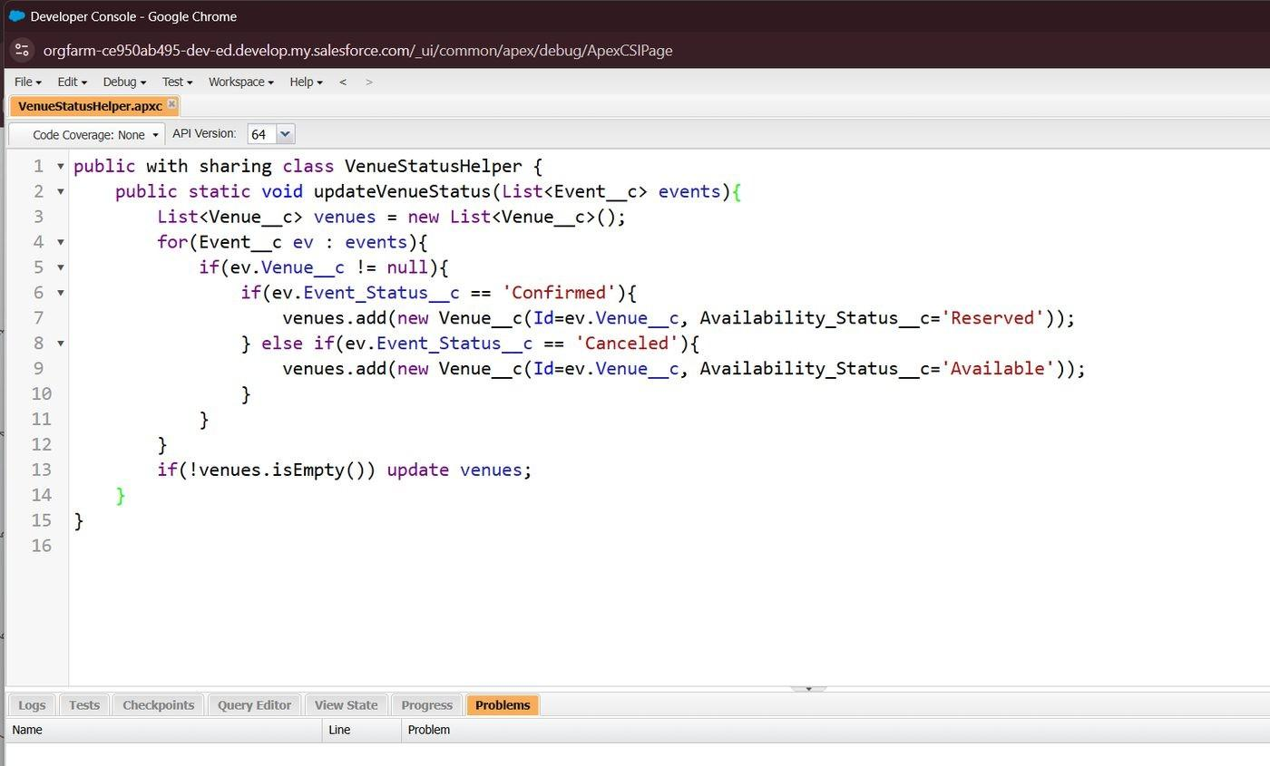
Figure 41: ShipmentTrackingHelper Apex class in the Developer Console

Trigger: ShipmentTrigger
trigger ShipmentTrigger on Shipment__c (before update, after insert, after update) {

if (Trigger.isBefore && Trigger.isUpdate) {
PreventInvalidShipmentUpdate.validate(Trigger.new, Trigger.oldMap);
ShipmentTrackingHelper.captureStatusBeforeCancellation(Trigger.new, Trigger.oldMap);
}

if (Trigger.isAfter) {
ShipmentTrackingHelper.syncAgentStatus(Trigger.new, Trigger.oldMap);
ShipmentTrackingHelper.logHubTransfers(Trigger.new, Trigger.oldMap);
ShipmentTrackingHelper.refreshSharing(Trigger.new, Trigger.oldMap);
}
}
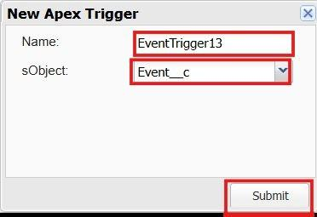
Figure 42: Creating the ShipmentTrigger Apex trigger on Shipment__c
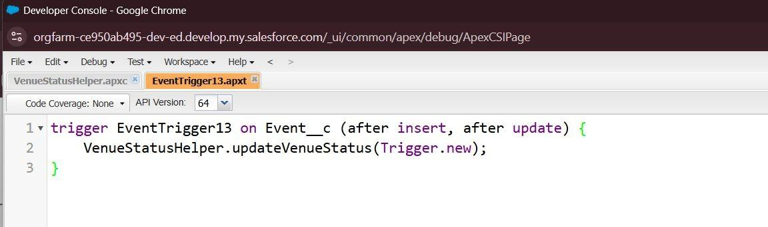
Figure 43: ShipmentTrigger code

6.11 Batch and Schedulable Apex (Milestone 11)
Scenario: Identify delayed shipments every morning. A Batch Apex class finds shipments whose Expected Delivery Date has passed but which are not Delivered, Cancelled or Returned, sets Is Delayed and raises Normal priority to High. A Schedulable class runs the batch automatically.

Step 1: Batch Apex class - BatchUpdateShipments
global class BatchUpdateShipments implements Database.Batchable<SObject>, Database.Stateful {

global Integer flaggedCount = 0;

global Database.QueryLocator start(Database.BatchableContext bc) {
return Database.getQueryLocator([
SELECT Id, Priority__c, Is_Delayed__c
FROM Shipment__c
WHERE Expected_Delivery_Date__c < TODAY
AND Is_Delayed__c = false
AND Shipment_Status__c NOT IN ('Delivered', 'Cancelled', 'Returned')
]);
}

global void execute(Database.BatchableContext bc, List<Shipment__c> scope) {
for (Shipment__c s : scope) {
s.Is_Delayed__c = true;
if (s.Priority__c == 'Normal') {
s.Priority__c = 'High';
}
}
// Partial success allowed: records locked by an approval are skipped
for (Database.SaveResult sr : Database.update(scope, false)) {
if (sr.isSuccess()) flaggedCount++;
}
}

global void finish(Database.BatchableContext bc) {
System.debug('BatchUpdateShipments flagged ' + flaggedCount + ' delayed shipments.');
}
}

Step 2: Schedulable class - ScheduleShipmentMonitoring
global class ScheduleShipmentMonitoring implements Schedulable {
global void execute(SchedulableContext sc) {
Database.executeBatch(new BatchUpdateShipments(), 200);
}
}

Step 3: Schedule the job
- Setup > Apex Classes > Schedule Apex.
- Job Name = Daily Shipment Monitoring; Apex Class = ScheduleShipmentMonitoring.
- Frequency = Weekly, select all days; Preferred Start Time = 06:00 AM; click Save.
Salesforce now runs BatchUpdateShipments every day at 6 AM and flags delayed shipments, which then appear in the Delayed Shipments report and on the dashboard.
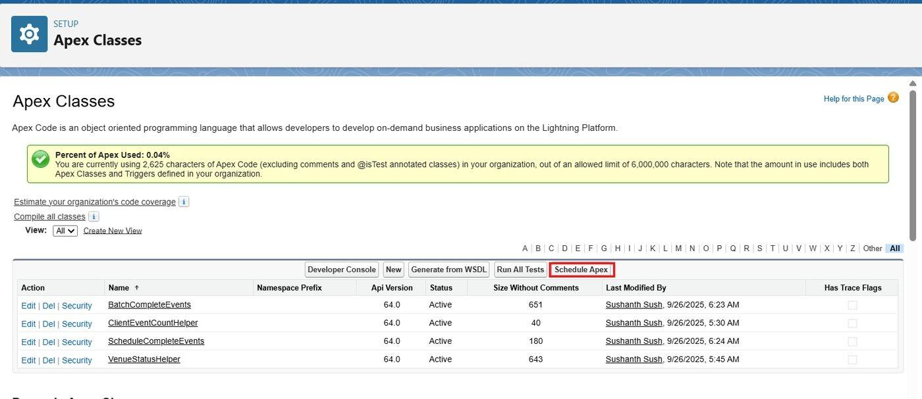
Figure 44: Apex Classes page showing the Schedule Apex button
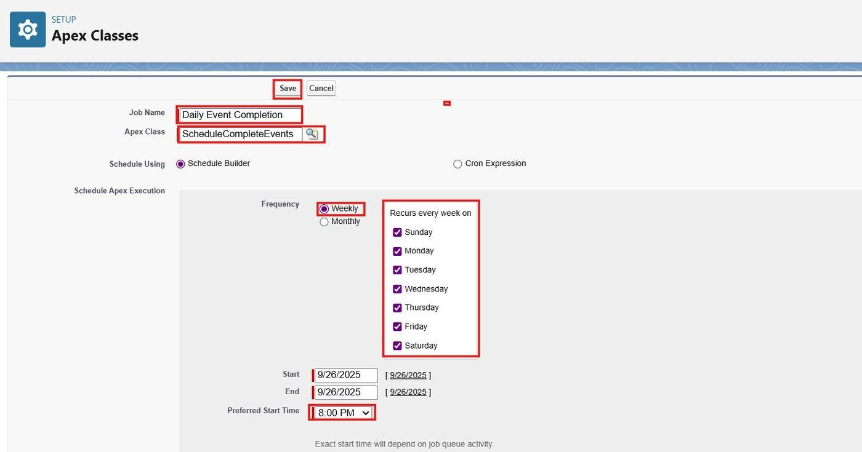
Figure 45: Scheduling the Daily Shipment Monitoring job

6.12 The Lightning App - Swift Ship Tracker (Milestone 12)
An app is a group of tabs that work together as a unit. The Swift Ship Tracker Lightning App gives users one workspace for all modules.
- Setup > App Manager > New Lightning App; App Name = Swift Ship Tracker; upload an image; Next.
- Leave App Options and Utility Items as default; Next.
- Select Shipments, Customers, Delivery Agents, Hubs, Tracking Updates, Delivery Feedback, Reports and Dashboards as navigation items; Next.
- Add the System Administrator, Logistics Manager, Shipment Coordinator, Delivery Agent and Customer profiles to Selected Profiles; click Save & Finish. (Profiles are created in Milestone 16; the assignment can be completed afterwards.)
- Verify through the App Launcher by searching Swift Ship Tracker.
Users see only the navigation items for which their profile has object access: for example, customers see Shipments, Tracking Updates and Delivery Feedback, while Delivery Agents, Hubs, Reports and Dashboards are hidden from them.
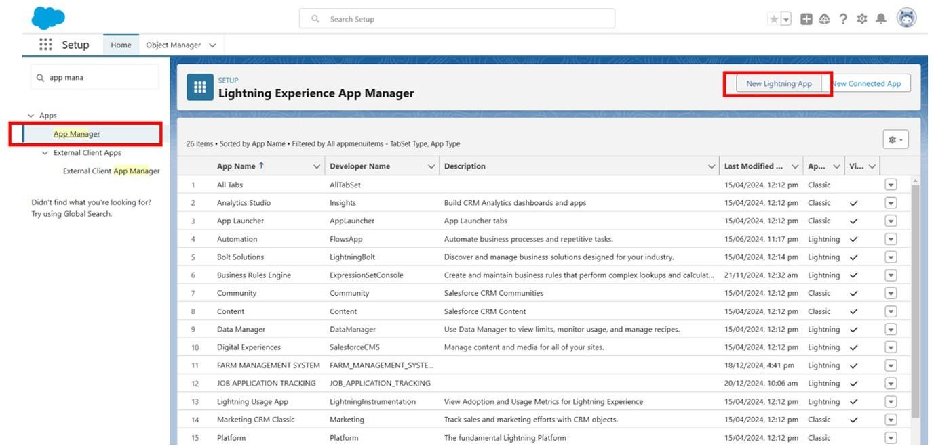
Figure 46: Lightning Experience App Manager - New Lightning App
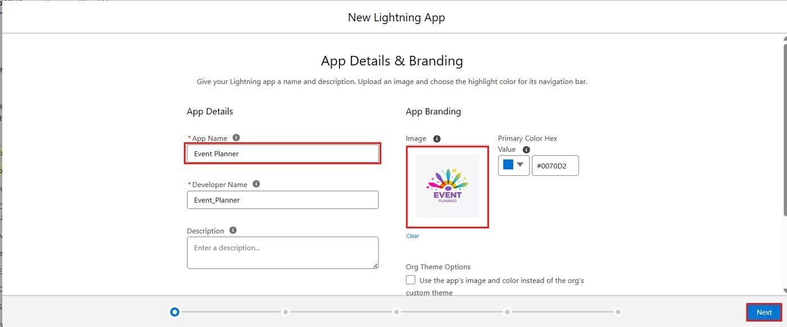
Figure 47: App details and branding for Swift Ship Tracker
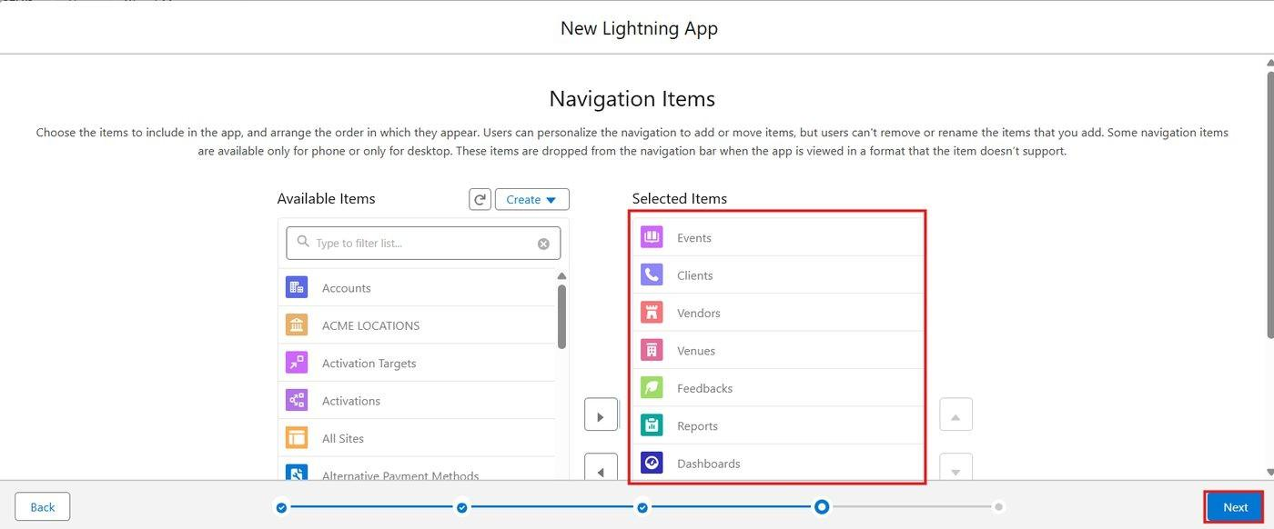
Figure 48: Navigation items selected for the app
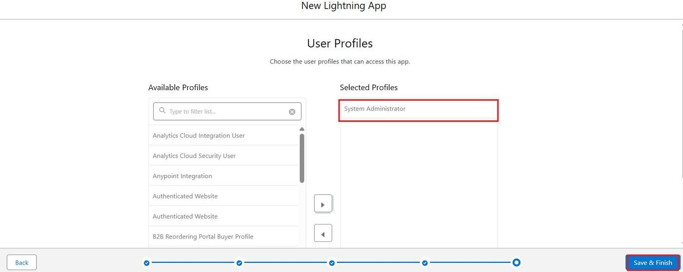
Figure 49: Assigning user profiles to the app

6.13 Reports (Milestone 13)

Report folder and sharing
- App Launcher > Reports > New Folder; Folder Label = Swift Ship Reports; Save.
- Open the folder drop-down > Share; share with Roles: Logistics Manager (Manager access) and Shipment Coordinator (Viewer access); Share > Done.
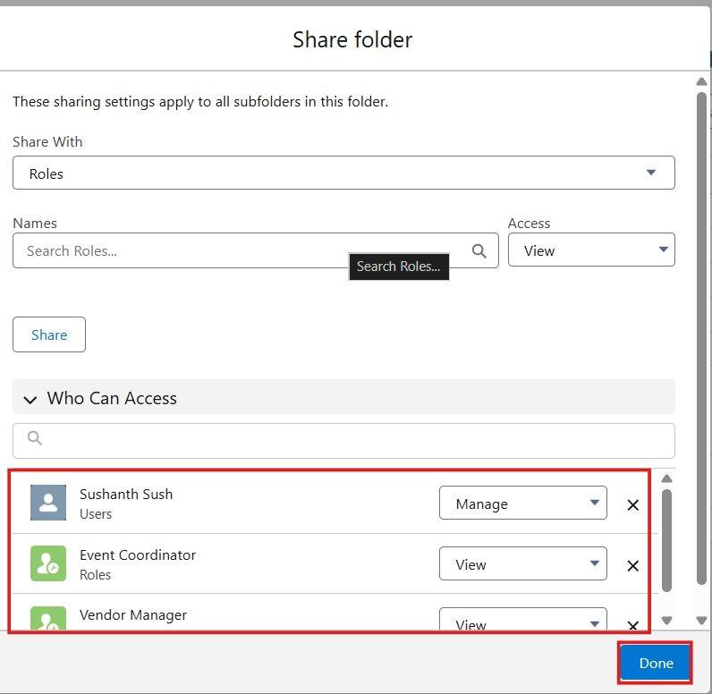
Figure 50: Sharing the Swift Ship Reports folder with roles

Report definitions
Before creating the reports, at least 10 records were created in every object with all fields filled (see Section 6.15). Seven reports were saved in the Swift Ship Reports folder.
# | Report Name | Report Type | Configuration | Chart
1 | Shipments by Status | Shipments | Group rows by Shipment Status; columns Tracking Number, Customer, Delivery Agent, Expected Delivery Date; summary Record Count. | Horizontal bar
2 | Shipments by Hub | Shipments | Group rows by Current Hub; columns Tracking Number, Shipment Status, Destination; summary Record Count. | Vertical column
3 | Shipments by Delivery Agent | Shipments | Group rows by Delivery Agent, then by Shipment Status; summary Record Count. | Stacked column
4 | Delivered vs Pending Shipments | Shipments | Add a bucket column on Shipment Status: Delivered = {Delivered}; Pending = {Created, Picked Up, In Transit, At Hub, Out for Delivery, Failed Delivery}. Group rows by the bucket. | Donut
5 | Delayed Shipments | Shipments | Filter Is Delayed equals True; columns Tracking Number, Customer, Delivery Agent, Current Hub, Expected Delivery Date, Shipment Status, Priority; sort by Expected Delivery Date. | Tabular (no chart)
6 | Shipments by Month | Shipments | Group rows by Shipment Date (Calendar Month); summaries Record Count and Sum of Delivery Charges. | Line
7 | Customer Delivery Feedback | Delivery Feedbacks | Columns Feedback ID, Customer, Shipment, Rating, Comments, Feedback Date; group rows by Rating; summary Average of Rating. | Column

Example: Shipments by Status
- Reports > New Report; choose the report type Shipments; Start Report.
- Columns: Tracking Number, Customer, Delivery Agent, Current Hub, Expected Delivery Date.
- Filters: Show Me = All shipments; Date range = All Time.
- Group rows by Shipment Status; add summary Record Count.
- Add a Horizontal Bar chart; save as Shipments by Status in the Swift Ship Reports folder and run it.
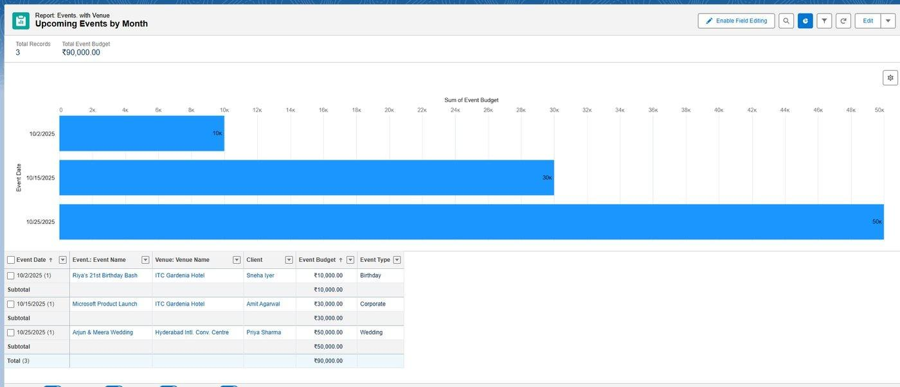
Figure 51: Shipments by Status report with chart and summary

6.14 Dashboards (Milestone 14)
- Open the Dashboards tab in the app > New Dashboard; Name = Swift Ship Operations Dashboard; Folder = Swift Ship Dashboards; Create.
- Click + Widget and select a report for each component listed below; set the chart type and a title for each.
- Set View Dashboard As to the Logistics Manager user so that all viewers see the complete operational picture.
- Share the dashboard folder with the roles Logistics Manager and Shipment Coordinator (Viewer); Save.
Dashboard Component | Source Report | Widget Type
Total Shipments | Shipments by Status | Metric (Record Count)
Shipments by Status (In Transit and Delivered counts are visible as segments) | Shipments by Status | Donut
Delivered vs Pending | Delivered vs Pending Shipments | Donut
Delayed Shipments | Delayed Shipments | Metric (Record Count)
Shipments by Hub | Shipments by Hub | Horizontal bar
Delivery Agent Performance | Shipments by Delivery Agent | Stacked column
Customer Feedback Rating | Customer Delivery Feedback | Gauge (Average Rating; red 1-3, yellow 3-4, green 4-5)
Monthly Shipment Trend | Shipments by Month | Line

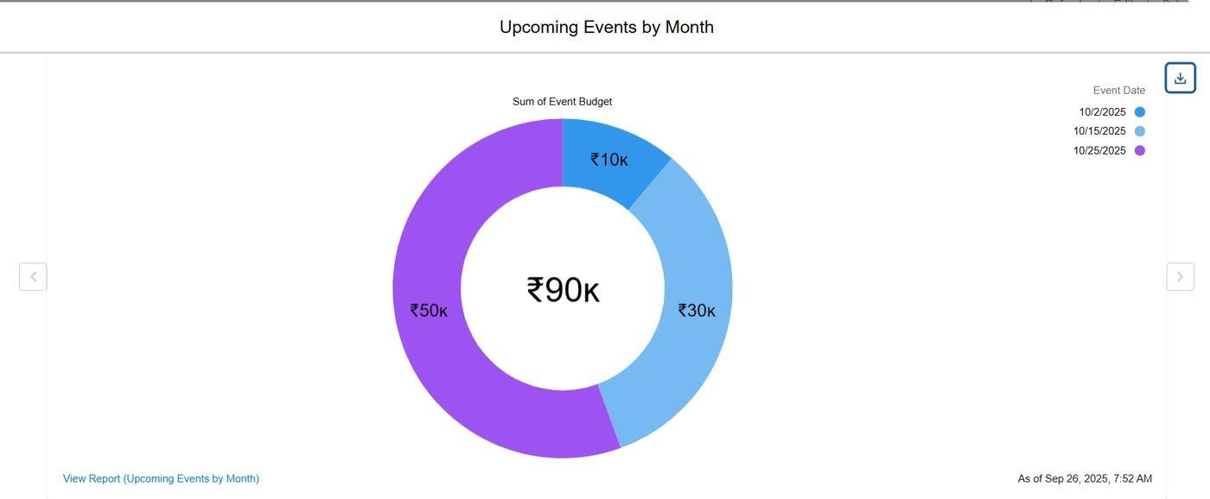
Figure 52: Shipments by Status donut chart widget

6.15 Data Migration (Milestone 15)
Records for Hubs, Customers, Delivery Agents, Shipments, Tracking Updates and Delivery Feedback were imported using the Data Import Wizard after pre-validation checks to avoid duplicates and maintain consistency. At least ten records were loaded for every object so that reports and dashboards could be tested with meaningful data.
Order | Object | Matching / Notes
1 | Hub | Import first because Delivery Agents and Shipments reference hubs.
2 | Customer | E-mail and Pincode must pass validation rules; duplicates checked by Email.
3 | Delivery Agent | Employee ID used as External ID; Assigned Hub matched by Hub Name.
4 | Shipment | Tracking Number used as External ID (unique); Customer matched by Name; Delivery Agent matched by Employee ID.
5 | Tracking Update | Shipment matched by Tracking Number; additional historical movement records.
6 | Delivery Feedback | Only for Delivered shipments; Rating from 1 to 5.

Importing shipments fires ShipmentTrigger and the flows. The Shipment Tracking Update Flow therefore records one Tracking Update for each imported shipment, and imported shipments with future expected delivery dates schedule their reminders.

6.16 Profiles (Milestone 16)
A profile is a collection of settings and permissions that defines what a user can do in Salesforce (object permissions, field permissions, tab settings, app settings and more). A user can have only one profile. The standard System Administrator profile is used for administration; four custom profiles were created by cloning the Standard Platform User profile.
Profile | Based on | Object permissions
System Administrator | Standard profile | Full access - Modify All Data, Customize Application, full CRUD on all objects.
Logistics Manager | Standard Platform User (clone) | Shipment, Customer, Delivery Agent, Hub, Tracking Update, Delivery Feedback: Create/Read/Edit/Delete and View All. Run and create reports; manage dashboards.
Shipment Coordinator | Standard Platform User (clone) | Shipment: Create/Read/Edit; Customer: Create/Read/Edit; Delivery Agent: Read; Hub: Read; Tracking Update: Create/Read; Delivery Feedback: Read. No delete on shipments. Run reports.
Delivery Agent | Standard Platform User (clone) | Shipment: Read; Customer: Read; Delivery Agent: Read; Hub: Read; Tracking Update: Read; Delivery Feedback: No access. All Shipment fields are read-only; edit rights are added by the Delivery Update Access permission set.
Customer | Standard Platform User (clone) | Shipment: Read (own shipments only); Customer: Read (own record); Tracking Update: Read; Delivery Feedback: Create/Read; Delivery Agent, Hub: No access. No access to reports and dashboards.

For the Logistics Manager, Shipment Coordinator, Delivery Agent and Customer profiles the default custom app is set to Swift Ship Tracker, session timeout is set to 2 hours of inactivity, passwords are set to never expire and the minimum password length is 8.
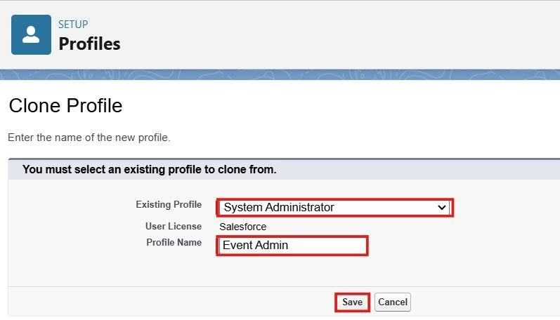
Figure 53: Cloning the Standard Platform User profile as Logistics Manager
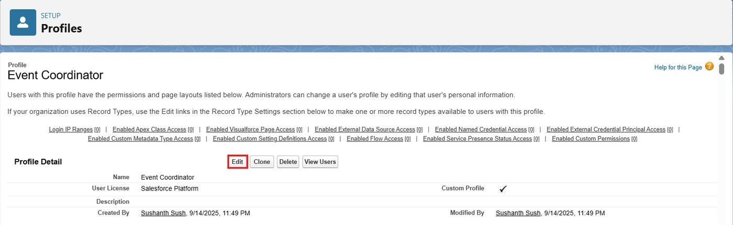
Figure 54: Shipment Coordinator profile detail page
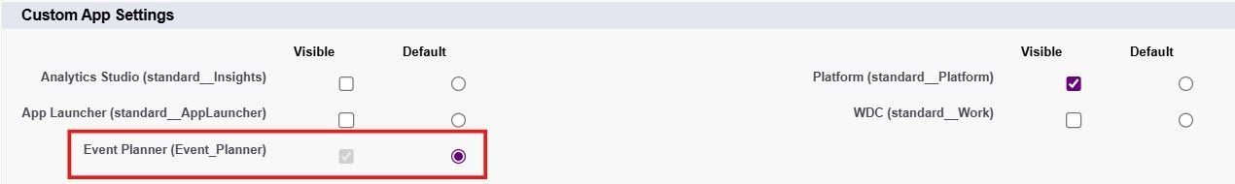
Figure 55: Setting Swift Ship Tracker as the default custom app
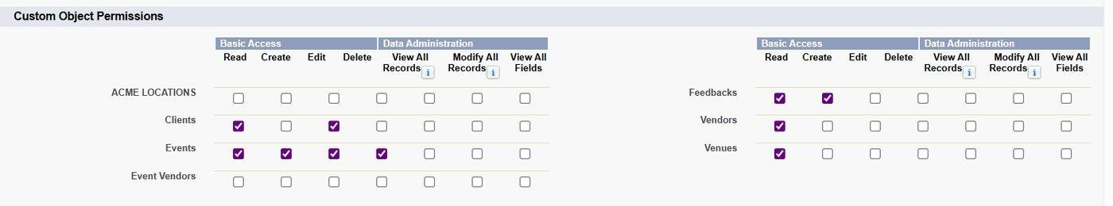
Figure 56: Custom object permissions for the Shipment Coordinator profile
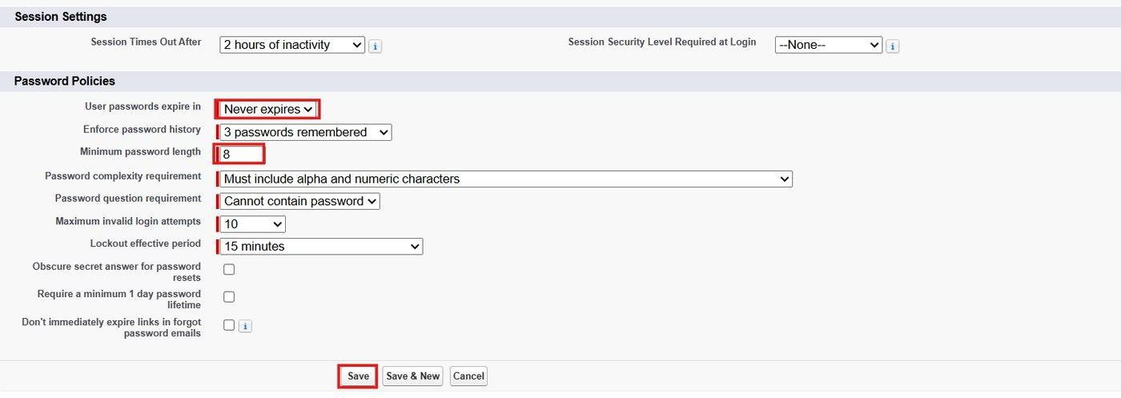
Figure 57: Session timeout and password policies
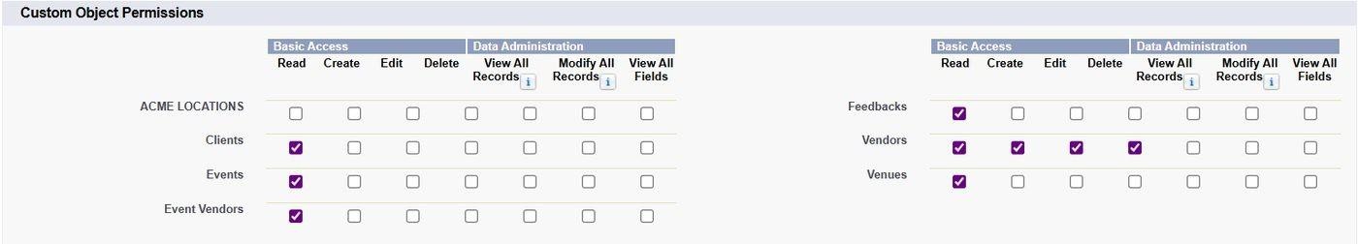
Figure 58: Custom object permissions for the Delivery Agent profile
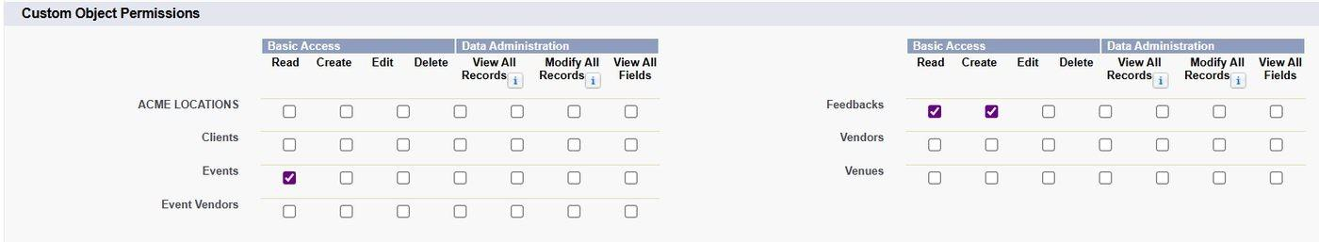
Figure 59: Custom object permissions for the Customer profile

6.17 Roles (Milestone 17)
Roles define the reporting hierarchy and determine which records users can see. Users in higher roles can access the records of users below them.
- Setup > Roles > Set Up Roles > Expand All; click Add Role under CEO; Label = Logistics Manager; Save.
- Under Logistics Manager add three roles: Shipment Coordinator, Delivery Agent and Customer.
Role hierarchy
CEO
Logistics Manager
Shipment Coordinator
Delivery Agent
Customer

Through the hierarchy the Logistics Manager can see all records owned by or shared with the coordinators, agents and customers (for example, feedback submitted by customers). The System Administrator user does not require a custom role.
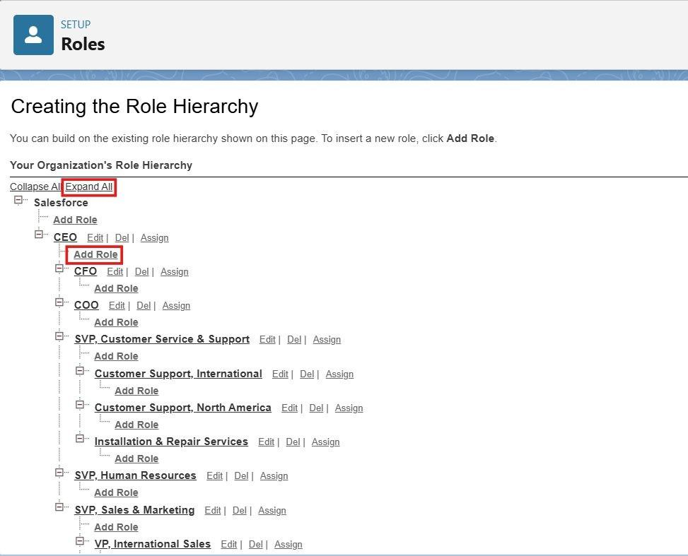
Figure 60: Creating the role hierarchy (Add Role under CEO)
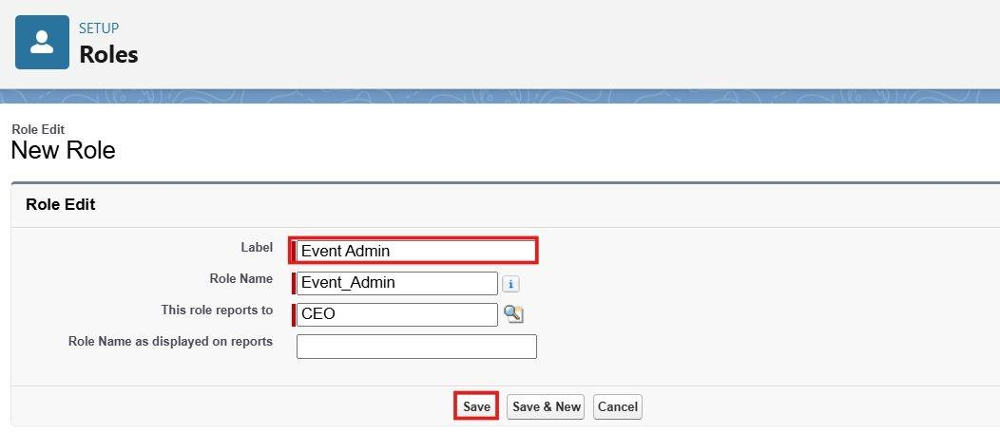
Figure 61: New Role - Logistics Manager

6.18 Users (Milestone 18)
A user is anyone who logs in to Salesforce. One user was created for each role. Because a Developer org has a limited number of Salesforce licenses, these users use the Salesforce Platform license.
User role | License | Profile
System Administrator (existing org administrator) | Salesforce | System Administrator
Logistics Manager | Salesforce Platform | Logistics Manager
Shipment Coordinator | Salesforce Platform | Shipment Coordinator
Delivery Agent | Salesforce Platform | Delivery Agent
Customer | Salesforce Platform | Customer

- Setup > Users > New User.
- Fill in First Name, Last Name, Alias, Email, a unique Username, Nickname, Role, User License and Profile. For the Shipment Coordinator user set Manager = the Logistics Manager user; the approval process uses this field to find the approver.
- Click Save; repeat for the remaining users.
- Link the users to their business records: set Customer User on the Customer record and Agent User on the Delivery Agent record. ShipmentTrackingHelper uses these links to share shipments.
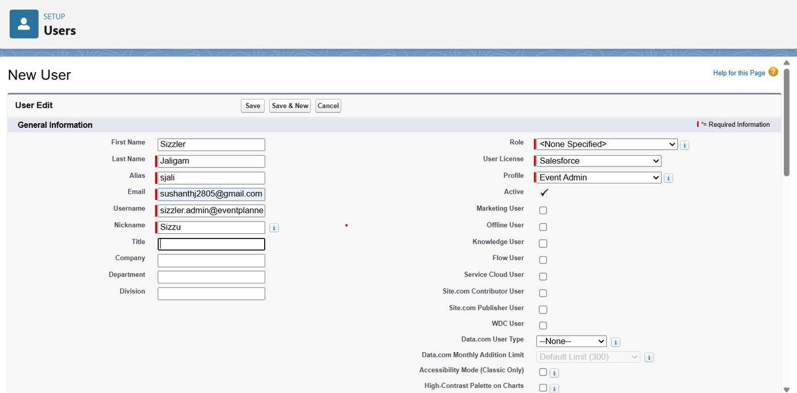
Figure 62: Creating a new user with role, license and profile

6.19 Permission Sets (Milestone 19)
A permission set grants additional permissions without changing the user's profile. Two permission sets were created.
Permission Set | Permissions Granted | Assigned To
Shipment Management | Delivery Agent: Create, Read, Edit; Hub: Read, Edit; Tracking Update: Read, Edit (to correct a wrong entry). | Shipment Coordinator user
Delivery Update Access | Shipment: Read, Edit with field access limited to Shipment Status and Current Hub (all other fields remain read-only); Tracking Update: Create, Read. | Delivery Agent user

- Setup > Permission Sets > New; Label = Shipment Management; Save.
- Open Object Settings > Delivery Agent > Edit; enable Read, Create, Edit; open Hub and enable Read, Edit; open Tracking Update and enable Read, Edit; Save.
- Click Manage Assignments > Add Assignment; select the Shipment Coordinator user; Next & Assign.
- Create a second permission set, Delivery Update Access: Object Settings > Shipment > enable Read, Edit; set Field Permissions so that only Shipment Status and Current Hub are editable; Tracking Update > enable Read, Create.
- Assign Delivery Update Access to the Delivery Agent user.
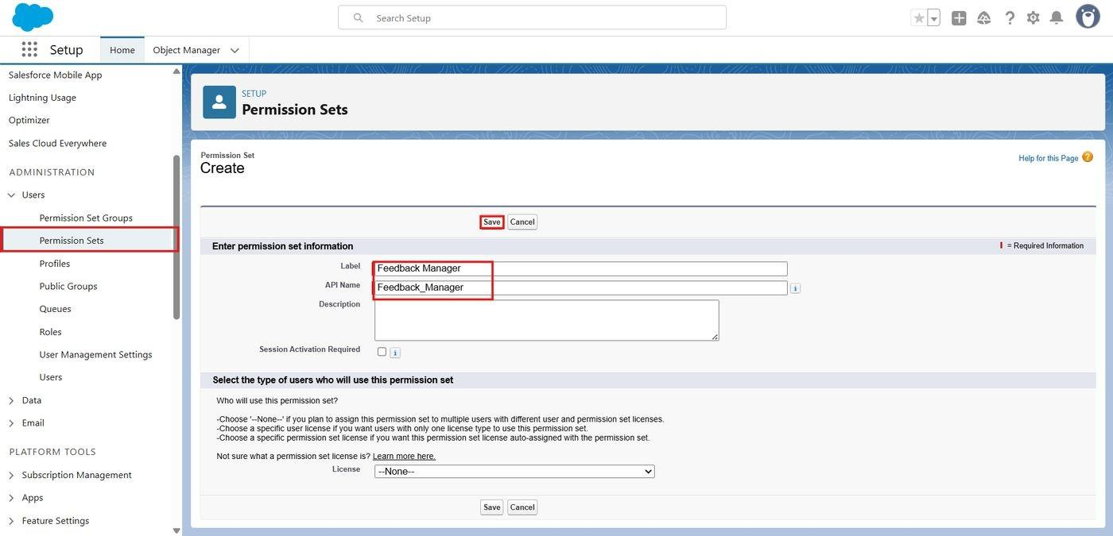
Figure 63: Creating the Shipment Management permission set
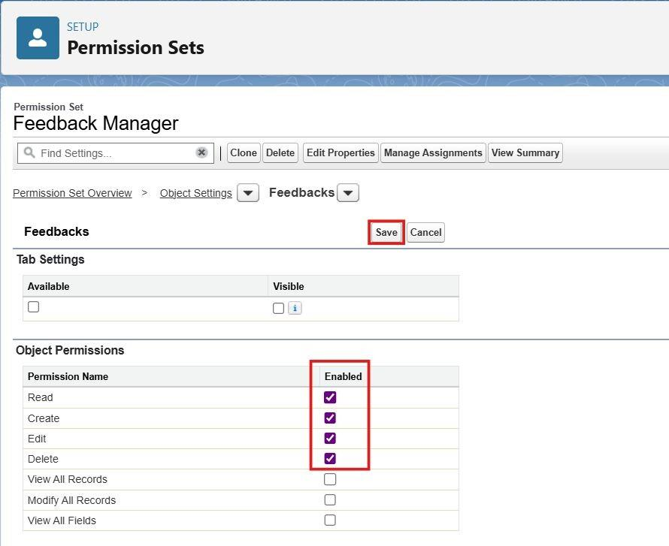
Figure 64: Object permissions enabled in the Shipment Management permission set

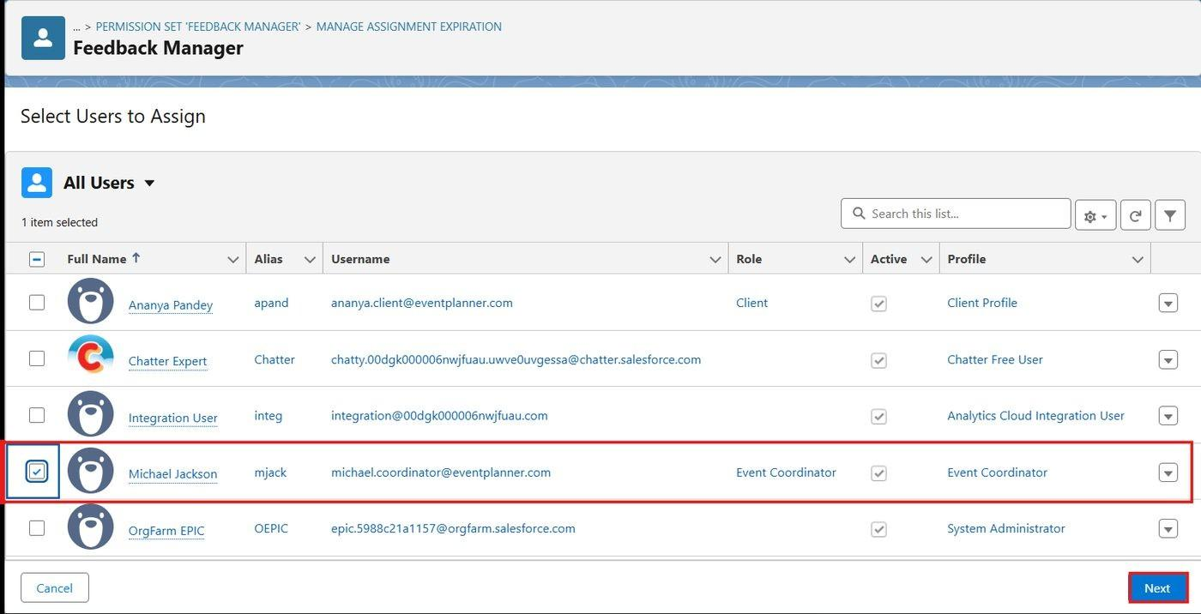
Figure 65: Assigning the permission sets to users

6.20 Sharing Settings (Milestone 20)

Organization-Wide Defaults (OWD)
OWD is the baseline level of access to records. Options are Private, Public Read Only, Public Read/Write and Controlled by Parent. Other mechanisms (role hierarchy, sharing rules, manual and Apex sharing) can then extend access.
- Setup > Sharing Settings > Edit (Organization-Wide Defaults).
- Set the defaults shown below (Default Internal Access and Default External Access). Keep Grant Access Using Hierarchies enabled.
- Click Save.
Object | Default Internal Access | Default External Access | Reason
Shipment | Private | Private | Customers and agents must see only their own shipments.
Customer | Private | Private | Contact details are personal data.
Delivery Agent | Public Read/Write | Private | Reference data; edit rights are controlled by object permissions.
Hub | Public Read/Write | Private | Reference data; edit rights are controlled by object permissions.
Tracking Update | Controlled by Parent | Controlled by Parent | Master-Detail: follows the shipment.
Delivery Feedback | Private | Private | Feedback is visible to its author and to authorised staff.
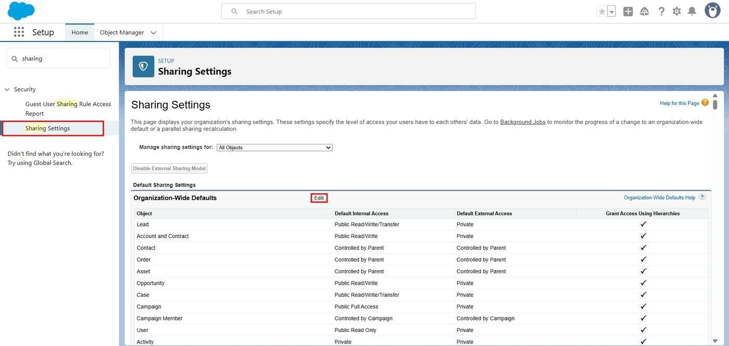
Figure 66: Sharing Settings page - Organization-Wide Defaults
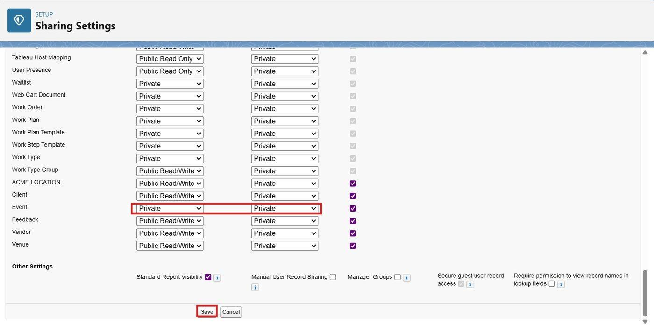
Figure 67: Shipment object set to Private for internal and external access

Sharing rules
Sharing Rule | Object | Shared From | Shared With | Access
Coordinator_Shipment_Sharing | Shipment | Records owned by Role: Shipment Coordinator | Role: Shipment Coordinator | Read/Write
Coordinator_Customer_Sharing | Customer | Records owned by Role: Shipment Coordinator | Role: Shipment Coordinator | Read/Write
Feedback_Read_For_Coordinators | Delivery Feedback | Records owned by Role: Customer | Role: Shipment Coordinator | Read Only

- Sharing Settings > Shipment Sharing Rules > New.
- Label = Coordinator_Shipment_Sharing (rule name auto-populates).
- Rule type = Based on record owner; records owned by members of Roles: Shipment Coordinator.
- Share with Roles: Shipment Coordinator.
- Access level = Read/Write; Save.
- Repeat for Customer (Coordinator_Customer_Sharing) and Delivery Feedback (Feedback_Read_For_Coordinators, Roles: Customer to Roles: Shipment Coordinator, Read Only).
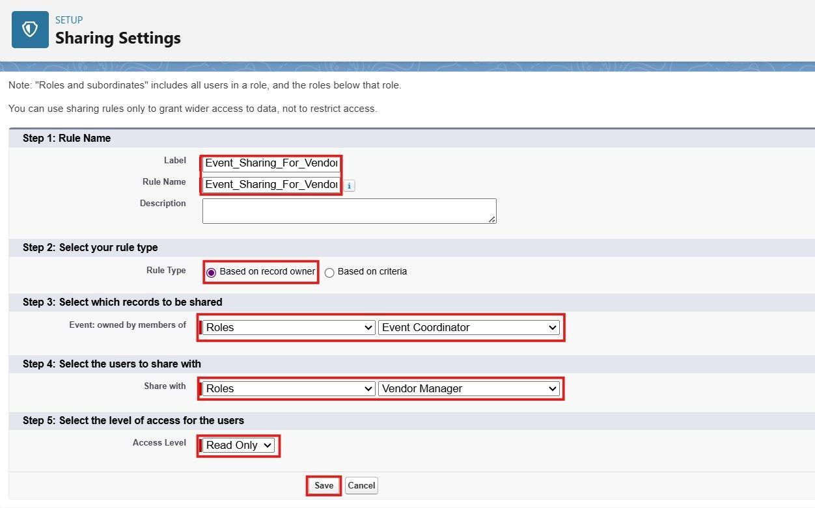
Figure 68: Creating the Coordinator_Shipment_Sharing sharing rule

Summary of record access by role
Role | How record access is obtained
System Administrator | Modify All Data.
Logistics Manager | Role hierarchy gives access to all records owned by users below; object permissions give full operational access.
Shipment Coordinator | Owns the shipments and customers they create; sees peer coordinators' records through the sharing rules; reads customer feedback through Feedback_Read_For_Coordinators.
Delivery Agent | Only shipments assigned to the agent (Edit) and the related customer record (Read), shared by ShipmentTrackingHelper; all hubs and agents (Read).
Customer | Only their own shipments (Read) and customer record, shared by ShipmentTrackingHelper; tracking history through the parent shipment; own feedback records.

7. FUNCTIONAL & PERFORMANCE TESTING

7.1 Testing Approach
Testing validated data accuracy, automation behavior and user permissions. Each automation component was tested with representative records, and each user role was tested by logging in with the corresponding user. Test data consisted of at least ten records per object.

7.2 Functional Test Cases
Test ID | Scenario | Expected Result
FT-01 | Create a shipment with valid data (unique Tracking Number, positive weight, valid dates, customer, origin and destination). | Record is saved with status Created and an auto-numbered Shipment Name.
FT-02 | Check the Tracking Updates related list of the new shipment. | One Tracking Update with Status = Created, location = origin and the remark "Shipment registered..." is created automatically.
FT-03 | Enter an invalid e-mail address (for example "abc@") on a Customer record. | Error "Please Enter Valid Email Address" is shown and the record is not saved.
FT-04 | Enter a valid e-mail address on a Customer record. | Record is saved successfully.
FT-05 | Enter a weight of 0 (or leave it blank) on a shipment. | Error "Shipment weight must be greater than zero." and the record is not saved.
FT-06 | Create a second shipment with an existing Tracking Number. | Duplicate value error on Tracking Number; record is not saved.
FT-07 | Set the Expected Delivery Date earlier than the Shipment Date. | Error "Expected Delivery Date cannot be earlier than the Shipment Date."
FT-08 | Change a shipment from Picked Up to In Transit. | A Tracking Update is created with Status = In Transit, location, current date/time and remarks; Tracking Update Count increases by one.
FT-09 | Change a shipment from Created directly to Delivered. | Error "Invalid status change from Created to Delivered." from PreventInvalidShipmentUpdate.
FT-10 | Set status to At Hub without selecting a Current Hub. | Error "Select the Current Hub when the status is At Hub."
FT-11 | Change a shipment to Out for Delivery. | Customer receives the out-for-delivery e-mail; the assigned Delivery Agent status becomes On Delivery.
FT-12 | Change a shipment from Out for Delivery to Delivered. | Actual Delivery Date = today; Is Delayed is cleared; confirmation e-mail with feedback request is sent; agent status returns to Available (or Assigned if other open shipments exist).
FT-13 | Set Shipment Status = Cancellation Requested on an In Transit shipment. | Status Before Cancellation = In Transit; the approval process starts, the Logistics Manager receives the request e-mail and the record is locked.
FT-14 | Manager approves the cancellation. | Shipment Status = Cancelled; approval e-mail sent to the shipment owner; the customer receives the cancellation notice; a Tracking Update (Cancelled) is created.
FT-15 | Manager rejects the cancellation. | Shipment Status returns to In Transit; rejection e-mail sent to the shipment owner.
FT-16 | Open a shipment whose Expected Delivery Date is tomorrow and status is not Delivered, and wait for the scheduled path. | Reminder e-mail is sent to the customer (CC owner). No reminder is sent for Delivered, Cancelled or Returned shipments.
FT-17 | Run BatchUpdateShipments (Execute Anonymous: Database.executeBatch(new BatchUpdateShipments(), 200);) with overdue, open shipments. | Overdue open shipments get Is Delayed = true and Normal priority becomes High; delivered shipments are unchanged.
FT-18 | Check Setup > Scheduled Jobs. | "Daily Shipment Monitoring" is listed and runs ScheduleShipmentMonitoring at 6:00 AM.
FT-19 | Assign an Inactive Delivery Agent to a shipment. | Error "An inactive Delivery Agent cannot be assigned."
FT-20 | Create a Delivery Feedback record: select a Customer and open the Shipment lookup; enter Rating = 6. | Only that customer's Delivered shipments are listed; rating 6 is rejected with "Rating must be a number from 1 to 5."
FT-21 | Log in as Shipment Coordinator and work with shipments and customers. | Can create and edit shipments and customers; cannot delete shipments; sees shipments of other coordinators through Coordinator_Shipment_Sharing.
FT-22 | Log in as Delivery Agent and open the Shipments tab. | Only assigned shipments are visible; Shipment Status and Current Hub can be updated (creating tracking history); Delivery Charges and Customer are read-only.
FT-23 | Log in as a Customer user. | Only the customer's own shipments and tracking history are visible; Delivery Agent and Hub tabs are not accessible; Delivery Feedback can be created.
FT-24 | Log in as Logistics Manager. | All shipments, customers, agents, hubs, tracking updates and feedback are accessible with create, edit and delete rights.
FT-25 | Open the Swift Ship Operations Dashboard as Logistics Manager and as Shipment Coordinator. | All dashboard components are displayed and counts match the underlying reports; a Customer user cannot open the dashboard.

7.3 Performance and Reliability Considerations
- Bulk-safe Apex: ShipmentTrigger and its helper classes process whole lists of records. Sets and maps are used to collect Ids so that no SOQL query or DML statement is placed inside a loop.
- SOQL and DML best practices: each helper method runs a fixed number of queries; agent status is calculated with one aggregate query; updates and inserts are collected into lists and performed with a single DML statement.
- Batch Apex: BatchUpdateShipments uses a scope of 200 records so that a large number of overdue shipments is processed in separate transactions within Salesforce governor limits. Database.update with partial success allows locked records to be skipped without failing the whole batch.
- Scheduled Apex: ScheduleShipmentMonitoring runs the batch every morning, so delay detection does not depend on anybody opening a report.
- Governor limits: the design stays within the per-transaction limits for SOQL queries, DML statements and rows by avoiding loops with queries and by using the batch for large volumes. Sharing rows are inserted with a single partial-success DML.
- Automation reliability: one before-save flow, one after-save tracking flow and a single trigger per object make the order of execution predictable. The scheduled reminder path re-checks the shipment status when it runs, so shipments delivered in the meantime are not reminded.
- Data validation: validation rules, required fields, the unique Tracking Number and the lookup filter keep data consistent; the status lifecycle is enforced centrally in Apex.
- Security: private OWD, profiles, permission sets, field-level restrictions and sharing keep customers and agents limited to their own records.
- Reliability depends on complete customer e-mail addresses, correct hub and date values, valid user links on Customer and Delivery Agent records, and correct role and profile assignment.

8. ADVANTAGES & DISADVANTAGES

8.1 Advantages
- Centralized shipment tracking: one CRM platform for customers, shipments, delivery agents, hubs, tracking updates and feedback.
- Real-time shipment visibility: current status, current hub and expected delivery date are available to authorised users as soon as a record is updated.
- Automated notifications: customers are e-mailed when a shipment is out for delivery, delivered, cancelled or due for delivery.
- Reduced manual work: tracking history, actual delivery date, agent status and delay flags are maintained automatically.
- Better delivery monitoring: the daily batch job, Delayed Shipments report and dashboard let managers act on late shipments early.
- Role-based access: profiles, roles, permission sets, private defaults and sharing rules give each user only the access needed.
- Tracking history: every status change and hub transfer is stored as a Tracking Update linked to the shipment.
- Reports and dashboards: real-time analysis of shipments by status, hub, agent and month, together with customer ratings.
- Controlled cancellations: a documented approval trail with e-mail notifications.
- Scalable Salesforce platform: built on standard Salesforce features, so it can be extended with portals, mobile access and integrations.

8.2 Disadvantages / Limitations
- The solution was built in a Salesforce Developer Edition org, which has limits on data storage, users, licenses and daily e-mail sending; it has not been deployed to a production environment.
- The system depends on internet access and a Salesforce login for all users.
- Notifications depend on valid customer e-mail addresses; there is no SMS or WhatsApp channel.
- Tracking depends on the information entered or updated by coordinators and delivery agents. Advanced GPS or live location tracking is not included unless an external service is integrated.
- Delay detection runs once a day, so a shipment that becomes overdue is flagged at the next scheduled run, and locked records (for example during a pending cancellation approval) are skipped.
- The delivery agent and customer sharing depends on the Agent User and Customer User links; if a link is missing the user cannot see the shipment. When an agent is replaced, the agent's Read access to the customer record is not removed automatically.
- Approver assignment relies on the Manager field of the submitting user; it is not yet dynamic by shipment value or type.
- Hub capacity and hub status are maintained manually; the system does not automatically calculate how full a hub is.
- Customers access shipment information as Salesforce users (Salesforce Platform license in this project); a public tracking page for anonymous visitors is not provided.

9. CONCLUSION
The Swift Ship Tracker demonstrates how Salesforce can streamline and automate shipment tracking and logistics operations through customized objects, automation and analytics. Custom objects and relationships provide a strong data model in which every shipment is identified by a unique Tracking Number and carries a complete movement history; validation rules, record-triggered flows, an approval process and Apex enforce business rules and keep customers informed; the Swift Ship Tracker app, reports and operations dashboard provide a clear user experience; and profiles, roles, permission sets and sharing rules protect the data so that customers, delivery agents, coordinators and managers each see only what they need.
Although implemented in a Developer Org for academic purposes, the project reflects real-world CRM implementation practice. It also gave the team hands-on experience with declarative configuration, Apex development, security design and documentation, and provides a base for future enhancements such as live location tracking, customer portals and courier integrations.

10. FUTURE SCOPE

10.1 GPS / Real-Time Location Tracking
Integrate GPS data from agent devices or vehicles so that the live position of a shipment can be shown instead of relying only on manual updates.

10.2 Mobile App
Provide a Salesforce mobile experience for delivery agents with assigned-shipment lists, barcode scanning and proof-of-delivery capture.

10.3 SMS / WhatsApp Notifications
Add SMS or WhatsApp alerts for out-for-delivery, delivery confirmation and failed delivery, in addition to e-mail.

10.4 Customer Experience Cloud Portal
Provide an Experience Cloud portal where customers can enter a Tracking Number, view tracking history, request cancellation and submit feedback without a Salesforce internal license.

10.5 Online Payment Integration
Integrate online payment, quotes and invoices so that Delivery Charges can be collected and reconciled with shipments.

10.6 Route Optimization
Plan efficient delivery routes for agents based on destinations, hub locations and priority.

10.7 AI-based Delivery Prediction
Predict the likely delivery date of a shipment using historical Tracking Update data, shipment type and hub processing time.

10.8 Automated Delay Prediction
Warn managers before a shipment becomes delayed by analysing its progress against the Expected Delivery Date, instead of flagging it after the date has passed.

10.9 Advanced Analytics
Add trend analysis for delivery time per hub, agent productivity, failed-delivery causes and customer rating trends using CRM Analytics.

10.10 Integration with External Courier APIs
Connect to third-party courier or logistics partner APIs to exchange shipment status and import tracking updates automatically.

10.11 Agentforce AI Assistant
Add an Agentforce assistant that answers customer and coordinator questions about shipment status and summarises delayed shipments for managers.

10.12 Production Deployment
Move the solution through sandbox, change sets or Salesforce DX with a CI/CD pipeline, and add Apex test classes to meet deployment coverage requirements.

11. APPENDIX

11.1 Project Information
TEAM DETAILS
Team ID | SWTID-2026-9845
Team Lead | Nandhini S
Team Member 1 | Karishma R S
Team Member 2 | Tamilvani S
Team Member 3 | Akshaya V
Team Member 4 | Abinaya L S
Platform | Salesforce Developer Edition
Submission Date | 03-10-2026
GitHub | https://github.com/tamil1010/SwiftShip-Trackers
Demo Video | https://drive.google.com/file/d/1FoSYrRUg-8TjDaGQoP_QWq59zYSpTsO0/view?usp=sharing

11.2 Key Configuration Names
Component | Name
Custom Objects | Shipment__c, Customer__c, Delivery_Agent__c, Hub__c, Tracking_Update__c, Delivery_Feedback__c
Key Shipment Fields | Tracking_Number__c (Unique, External ID), Shipment_Status__c, Expected_Delivery_Date__c, Actual_Delivery_Date__c, Current_Hub__c, Delivery_Agent__c, Customer__c, Is_Delayed__c, Status_Before_Cancellation__c
Lightning App | Swift Ship Tracker
Validation Rules | Customer: Email_Valid_Address, Pincode_Six_Digits. Shipment: Tracking_Number_Required, Weight_Must_Be_Positive, Expected_Date_Not_Before_Shipment, Actual_Date_Not_Before_Shipment, Delivered_Requires_Actual_Date, Agent_Required_For_Pickup_And_Delivery, Hub_Required_At_Hub, Inactive_Agent_Not_Allowed. Hub: Hub_Capacity_Positive. Delivery Feedback: Rating_Between_1_And_5
Approval Process | Shipment Cancellation Approval (Shipment_Cancellation_Approval)
Flows | Shipment Tracking Update Flow, Delivery Notification Flow, Delivery Confirmation Flow, Expected Delivery Reminder Flow
Apex Classes | ShipmentTrackingHelper, PreventInvalidShipmentUpdate, BatchUpdateShipments, ScheduleShipmentMonitoring
Apex Trigger | ShipmentTrigger (Shipment__c)
Scheduled Job | Daily Shipment Monitoring (6:00 AM)
Reports | Shipments by Status, Shipments by Hub, Shipments by Delivery Agent, Delivered vs Pending Shipments, Delayed Shipments, Shipments by Month, Customer Delivery Feedback
Dashboard | Swift Ship Operations Dashboard
Report / Dashboard Folders | Swift Ship Reports / Swift Ship Dashboards
Profiles | Logistics Manager, Shipment Coordinator, Delivery Agent, Customer (and standard System Administrator)
Roles | Logistics Manager, Shipment Coordinator, Delivery Agent, Customer
Permission Sets | Shipment Management, Delivery Update Access
Sharing Rules | Coordinator_Shipment_Sharing, Coordinator_Customer_Sharing, Feedback_Read_For_Coordinators (plus Apex managed sharing for customer and agent users)

11.3 Deployment, Maintenance and Documentation Summary
- Deployment: All configuration was built and tested in a Developer Edition org. Production deployment is not performed because developer orgs are standalone; real deployments use sandboxes, change sets, Salesforce DX or CI/CD pipelines.
- Maintenance and monitoring: Regularly monitor flows, Apex jobs (Daily Shipment Monitoring) and approval processes; resolve user-access and permission conflicts; debug trigger and flow logic; keep the Customer User and Agent User links correct; adjust validation rules and sharing settings as business needs change.
- Documentation: This report records the business overview, phase-wise implementation, data model, automation, security model and screenshots for future developers and administrators.
Thank You!!

