SENTIMENT ANALYSIS ON PRODUCT REVIEWS
What percentage of reviews are positive?
From the analysis, about 88.4% of the reviews are positive, which shows that most customers are satisfied with the product. However, negative reviews mainly highlight issues related to product quality, taste, and packaging. One thing that surprised me was that some reviews had mixed sentiments, where even low ratings included slightly positive comments. I also noticed that neutral reviews are very few compared to positive and negative ones. Overall, while the feedback is mostly positive, the negative reviews consistently point to specific problems. Based on these findings, I would recommend that the business focus on improving product quality and packaging to reduce complaints and enhance customer satisfaction.
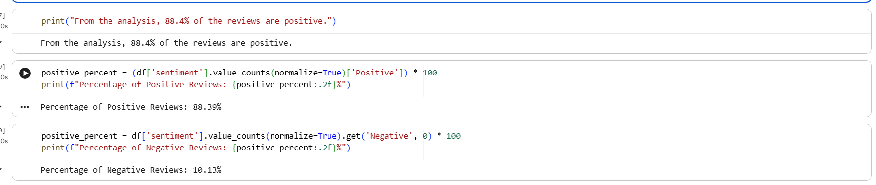
What do customers mostly complain about in negative reviews?
Customers mainly complain about product quality issues, including poor taste, damaged or bad packaging, and inconsistency in the product. Many negative reviews also mention problems like items being stale, expired, or not meeting expectations compared to what was advertised. Additionally, some customers express dissatisfaction with the value for money, stating that the product is not worth the price. These recurring issues indicate that quality control and packaging are the major concerns among customers.
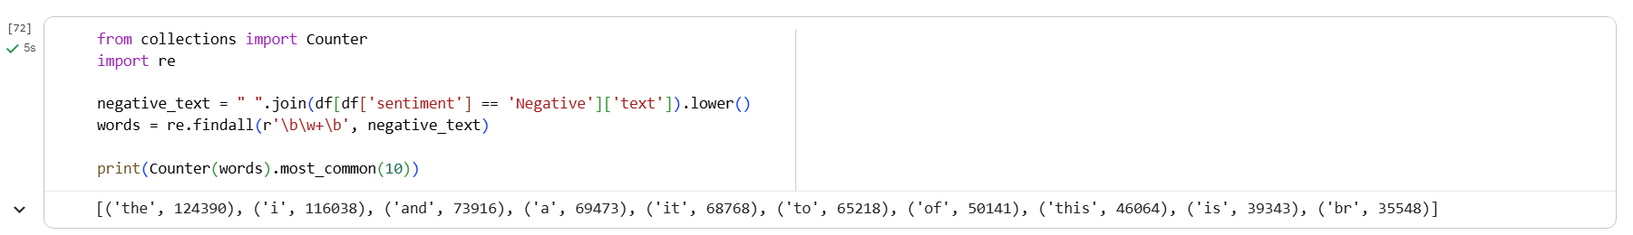
What surprised you in the data?
One thing that surprised me was how high the percentage of positive reviews is, even though there are clear complaints in the negative reviews. It was also interesting to see that some reviews had mixed sentiment, where a low rating still included slightly positive comments. Another observation was that neutral reviews were very few, which shows that most customers tend to give clear positive or negative opinions rather than staying neutral.
One Recommendation for the Business
Based on the findings, the business should focus on improving product quality and packaging, as these are the most common issues mentioned in negative reviews. By addressing these problems, the company can reduce customer complaints and further increase overall satisfaction.

