# Load necessary libraries  
library(readxl)

## Warning: package 'readxl' was built under R version 4.4.1

library(ggplot2)

## Warning: package 'ggplot2' was built under R version 4.4.1

library(dplyr)

## Warning: package 'dplyr' was built under R version 4.4.1

##   
## Attaching package: 'dplyr'

## The following objects are masked from 'package:stats':  
##   
## filter, lag

## The following objects are masked from 'package:base':  
##   
## intersect, setdiff, setequal, union

# Load the data from the Excel file  
file_path <- "C:/Users/ASUS/Downloads/bikes.xlsx"  
data <- read_excel(file_path)

# Display summary statistics  
summary(data)

## bike.id model category1 category2   
## Min. : 1 Length:97 Length:97 Length:97   
## 1st Qu.:25 Class :character Class :character Class :character   
## Median :49 Mode :character Mode :character Mode :character   
## Mean :49   
## 3rd Qu.:73   
## Max. :97   
## frame price   
## Length:97 Min. : 415   
## Class :character 1st Qu.: 1950   
## Mode :character Median : 3200   
## Mean : 3954   
## 3rd Qu.: 5330   
## Max. :12790

# Filter the top 10 bikes by price  
top_10_bikes <- data %>%  
 arrange(desc(price)) %>%  
 head(10)

# Bar diagram of the top 10 bikes by price  
ggplot(top_10_bikes, aes(x = reorder(model, price), y = price)) +  
 geom_bar(stat = "identity", fill = "blue") +  
 coord_flip() +  
 labs(title = "Top 10 Bikes by Price", x = "Model", y = "Price") +  
 theme_minimal()

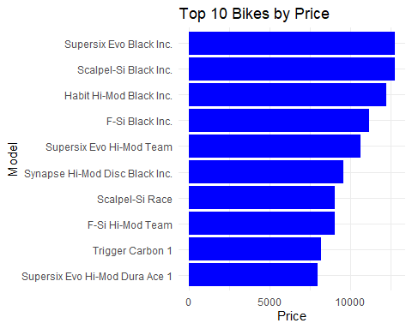

# Pie chart of the distribution of bikes by category1  
category1_distribution <- data %>%  
 group_by(category1) %>%  
 summarize(count = n()) %>%  
 mutate(percentage = count / sum(count) * 100)

ggplot(category1_distribution, aes(x = "", y = percentage, fill = category1)) +  
 geom_bar(stat = "identity", width = 1) +  
 coord_polar(theta = "y") +  
 labs(title = "Distribution of Bikes by Category1", x = "", y = "") +  
 theme_minimal()

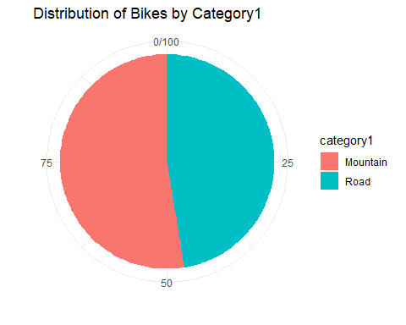

# Save the plots  
ggsave("top_10_bikes_bar.png")

## Saving 5 x 4 in image

ggsave("category1_distribution_pie.png")

## Saving 5 x 4 in image