# FitFlex

## Introduction

* + Project Title: Fit Flex
  + Project ID: SWTID1741244102154020
  + Team Leader: MANICKAM R
  + Team Member: TAMIL ARASAN D[25-APR-2005]
  + Team Member: TAMIL ARASAN D[26-DEC-2004]
  + Team Member: PREM A
  + Team Member: GOPI KRISHNAN P

## Project Overview

FitFlex is a modern fitness application designed to provide users with an extensive range of workout routines, exercise categories, and a personalized fitness experience. Built using React.js, it ensures a seamless user interface, dynamic search, and structured exercise management.

## Key Features

* Access to exercises from a reputable fitness API.
* Dynamic search functionality to find exercises based on categories.
* Interactive UI with high-quality images and workout instructions.
* Personalized exercise recommendations.
* Seamless navigation using React Router.
* Subscription-based newsletter for fitness tips.
* Fetching and displaying related workout videos from YouTube.

## Architecture

FitFlex follows a modular component structure in React. The main architecture includes:

1. Component Structure: UI components are separated into reusable elements for efficiency.

2. State Management: Utilizes React's Context API for global state management.

3. Routing: Uses React Router for seamless page navigation.

## Setup Instructions

**Prerequisites**

Ensure you have the following installed:

* - Node.js and npm (for package management).
* - React.js for frontend development.
* - Git for version control.
* - A code editor such as Visual Studio Code.

**Installation Steps**

* - Clone the repository: `git clone [repository_link]`
* - Navigate to the project directory: `cd fitness-app-react`
* - Install dependencies: `npm install`
* - Start the development server: `npm start`
* - Access the application at `http://localhost:3000`.

## Folder Structure

fit-flex-app/

src/

│── assets/

│ ├── about-img (image)

│ ├── bg_img (image)

│ ├── bg_vid (video)

│

│── components/

│ ├── About.js

│ ├── Footer.js

│ ├── Hero.js

│ ├── HomeSearch.js

│ ├── Navbar.js

│

│── pages/

│ ├── BodyPartsCategory.js

│ ├── EquipmentCategory.js

│ ├── Exercise.js

│ ├── Home.js

│

│── styles/

│ ├── About.css

│ ├── Categories.css

│ ├── Exercise.css

│ ├── Footer.css

│ ├── Hero.css

│ ├── Home.css

│ ├── HomeSearch.css

│ ├── Navbar.css

│

│── App.js

│── App.test.js

│── index.js

│── reportWebVitals.js

│── setupTests.js

## Running the Application

To start the development server, use the command:

`npm start`

## Component Documentation

**Key Components**

Navbar Component: Provides navigation links to different pages.

Hero Component: Displays featured fitness content and trending exercises.

Search Component: Allows users to search for exercises based on categories.

Exercise Page: Displays detailed information on selected workouts.

## State Management

FitFlex uses React Context API for global state management, ensuring smooth data flow between components. Each exercise fetched from the API is stored in a state variable, and UI updates are handled efficiently.

## User Interface

The UI follows a clean and modern approach with easy navigation. Some features include:

- Responsive design for desktop and mobile users.

- Intuitive UI with interactive elements for a seamless experience.

## Styling

The application uses Tailwind CSS for styling. It ensures modular and reusable design components for a consistent layout.

## Testing

The application follows unit testing with Jest and React Testing Library. Test cases ensure

## Screenshots

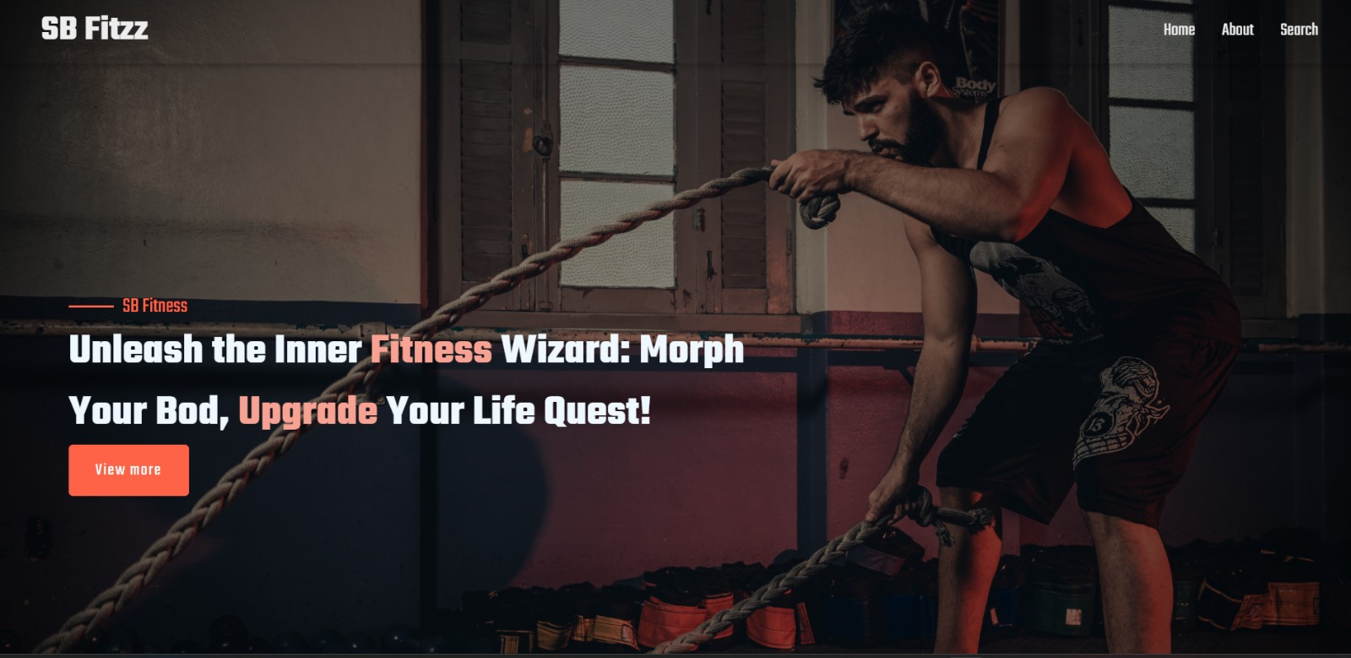

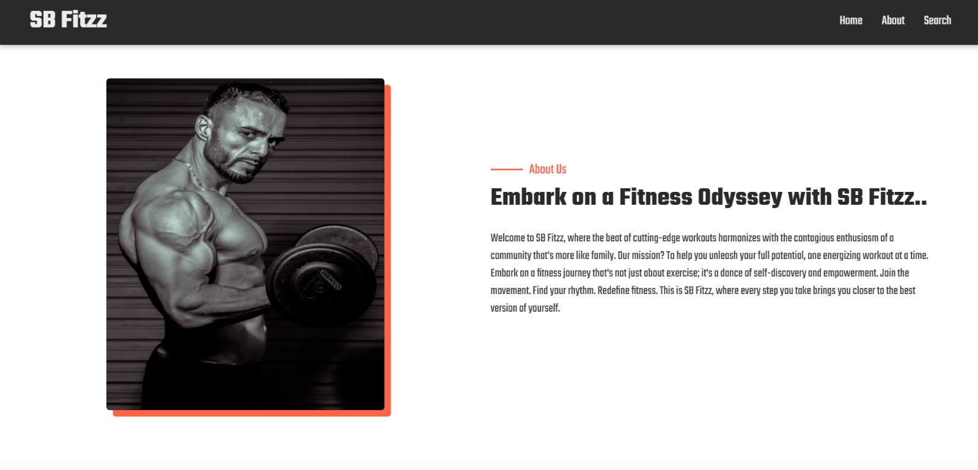

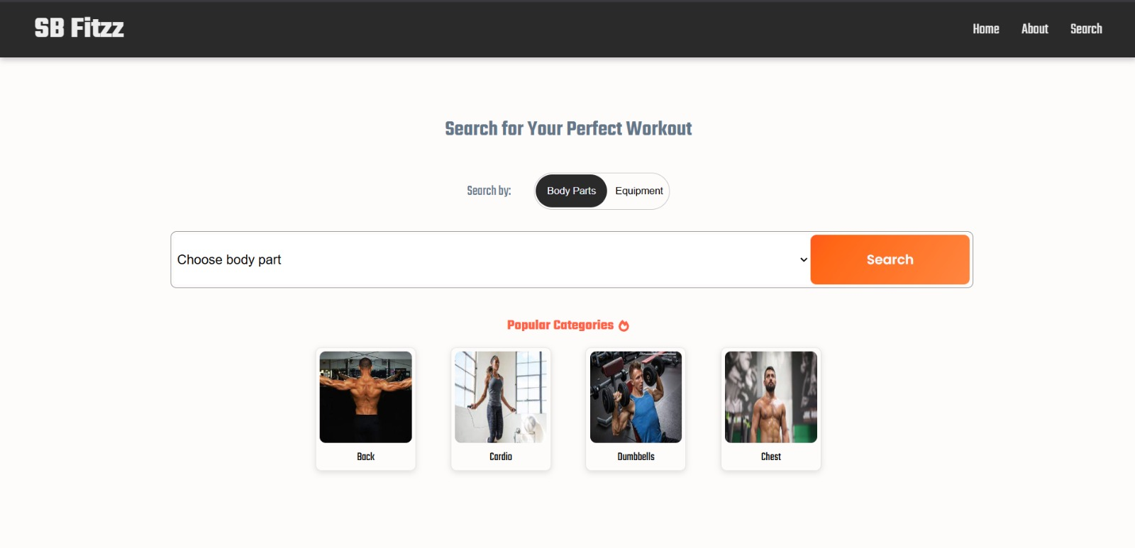

## Known Issues

Currently, there are minor issues related to API rate limits when fetching exercises. Future optimizations will include caching mechanisms to reduce API calls.

## Future Enhancements

* - Integration with wearable fitness trackers.
* - AI-based personalized workout recommendations.
* - Social media integration for sharing fitness progress.
* - Enhanced animations and UI improvements.