Mesh-SOS: Priority-Aware Delay-Tolerant Disaster Mesh Network

Abstract
When cellular infrastructure fails during disasters, victims cannot request help. Mesh-SOS is a zero-cost, delay-tolerant (store-carry-forward) network built from ordinary laptops and Android phones. Nodes discover each other with UDP broadcast, exchange messages with a summary-vector anti-entropy protocol over TCP, store them persistently in SQLite, and upload them through any node that reaches the internet to a rescue dashboard. We propose PriorityAware-DTN, a routing scheme that orders by urgency, scales the copy budget by urgency and battery, weights copy splitting by PRoPHET delivery predictability, and purges delivered copies with ACKs. In simulation with 50–200 nodes it delivers 93–100% of SOS messages at 2–5x lower overhead than Epidemic flooding, at the cost of lower delivery of non-urgent messages.

1. Problem
In the December 2015 Chennai floods and Cyclone Michaung (December 2023) mobile towers lost power and backhaul; large areas had no voice or data for days while people were trapped on rooftops. Phones still had batteries and Wi-Fi radios, but no tool turned them into a rescue network that prioritises life-threatening requests and conserves battery.

2. Related work
- FireChat (Open Garden): Wi-Fi/Bluetooth mesh chat, used in 2014 Hong Kong protests; discontinued around 2018. General chat, no SOS priority.
- Bridgefy: Bluetooth mesh messenger; academic analyses (e.g. Albrecht et al., 2021) reported serious security flaws.
- Briar: secure peer-to-peer messenger over Bluetooth/Wi-Fi/Tor; strong security but designed for messaging between contacts, not urgency triage or rescue upload.
- Serval Project: mesh telephony for disaster relief; Wi-Fi ad-hoc often required rooted phones or extra hardware.
- Meshtastic / goTenna: long-range LoRa mesh; needs purchased radios.
- Classical DTN routing: Epidemic (Vahdat & Becker 2000), Spray-and-Wait (Spyropoulos et al. 2005), PRoPHET (Lindgren et al. 2003; RFC 6693).

3. Novelty
- Routing that jointly uses urgency, battery level and delivery predictability (PriorityAware-DTN).
- Priority-based buffer management (drop lowest priority, not oldest) and per-contact priority ordering.
- End-to-end ACK propagation to purge copies and save battery.
- Signed messages end-to-end and a rescue-side triage dashboard (dedup, urgency ranking, map).
- Zero hardware cost: runs on Windows laptops and Android (Termux) with one hotspot as the shared medium.

4. System design
Node = discovery (UDP beacons every 2 s on ports 47000-47009), exchange server (TCP, JSON lines), SQLite store, routing module, gateway uploader, Flask UI. Dashboard = Flask + SQLite + Leaflet. Message = id, origin, type (SOS/INFO/ACK), urgency 1-5, people count, lat/lon, text, TTL, creation time, public key, Ed25519 signature, hop list (unsigned).

5. Protocol
- Encounter: initiator sends HELLO{ids, acks, battery, P-table, gateway flag}; responder replies HELLO; both send the messages the peer lacks, SOS first.
- Copy budget L = base(SOS 16, ACK 8, INFO 4) x (0.6+0.2*urgency) x (0.5 if battery<30%).
- Weighted spray: give w*L copies, w = P_peer/(P_peer+P_self) clipped to [0.2,0.8], reduced for low-battery peers.
- Battery gate: peers <15% accept only SOS, <5% accept nothing.
- Last copy: forwarded only to a peer with higher predictability; SOS keeps an insurance copy.
- Gateway uploads; the dashboard verifies the signature; acked IDs spread in HELLOs and delete copies.

6. Results
Simulator: 3 km x 3 km, 4 static gateways, 60 m radio range, 10 s step, 5 h, finite buffer (40 msgs), 4 messages per contact per step, 25% of messages SOS, random battery 10-100%, 3 seeds, community and random-waypoint mobility.
Mobility | Nodes | Protocol | SOS deliv. | All deliv. | SOS latency (min) | Tx / delivered
community | 50 | epidemic | 0.70 | 0.71 | 61.5 | 39.6
community | 50 | priority | 0.93 | 0.67 | 71.8 | 9.8
community | 50 | prophet | 0.68 | 0.70 | 84.4 | 22.7
community | 50 | spray_wait | 0.82 | 0.81 | 87.9 | 7.9
community | 100 | epidemic | 0.99 | 0.99 | 36.7 | 22.9
community | 100 | priority | 0.93 | 0.75 | 45.7 | 11.8
community | 100 | prophet | 0.97 | 0.96 | 47.4 | 14.4
community | 100 | spray_wait | 0.90 | 0.91 | 52.9 | 8.0
community | 200 | epidemic | 0.99 | 1.00 | 33.4 | 89.1
community | 200 | priority | 0.97 | 0.63 | 47.1 | 19.4
community | 200 | prophet | 1.00 | 0.99 | 41.0 | 70.6
community | 200 | spray_wait | 0.77 | 0.77 | 60.4 | 11.2
random_waypoint | 50 | epidemic | 0.87 | 0.86 | 61.4 | 20.4
random_waypoint | 50 | priority | 0.96 | 0.80 | 63.3 | 6.6
random_waypoint | 50 | prophet | 0.80 | 0.78 | 82.0 | 10.6
random_waypoint | 50 | spray_wait | 0.83 | 0.84 | 72.3 | 7.6
random_waypoint | 100 | epidemic | 0.99 | 0.99 | 35.7 | 31.8
random_waypoint | 100 | priority | 0.98 | 0.74 | 43.6 | 10.7
random_waypoint | 100 | prophet | 0.95 | 0.97 | 60.5 | 21.1
random_waypoint | 100 | spray_wait | 0.92 | 0.90 | 55.7 | 8.0
random_waypoint | 200 | epidemic | 0.99 | 0.99 | 27.1 | 65.9
random_waypoint | 200 | priority | 1.00 | 0.81 | 33.9 | 12.4
random_waypoint | 200 | prophet | 0.99 | 0.99 | 36.3 | 38.5
random_waypoint | 200 | spray_wait | 0.92 | 0.95 | 45.4 | 8.4
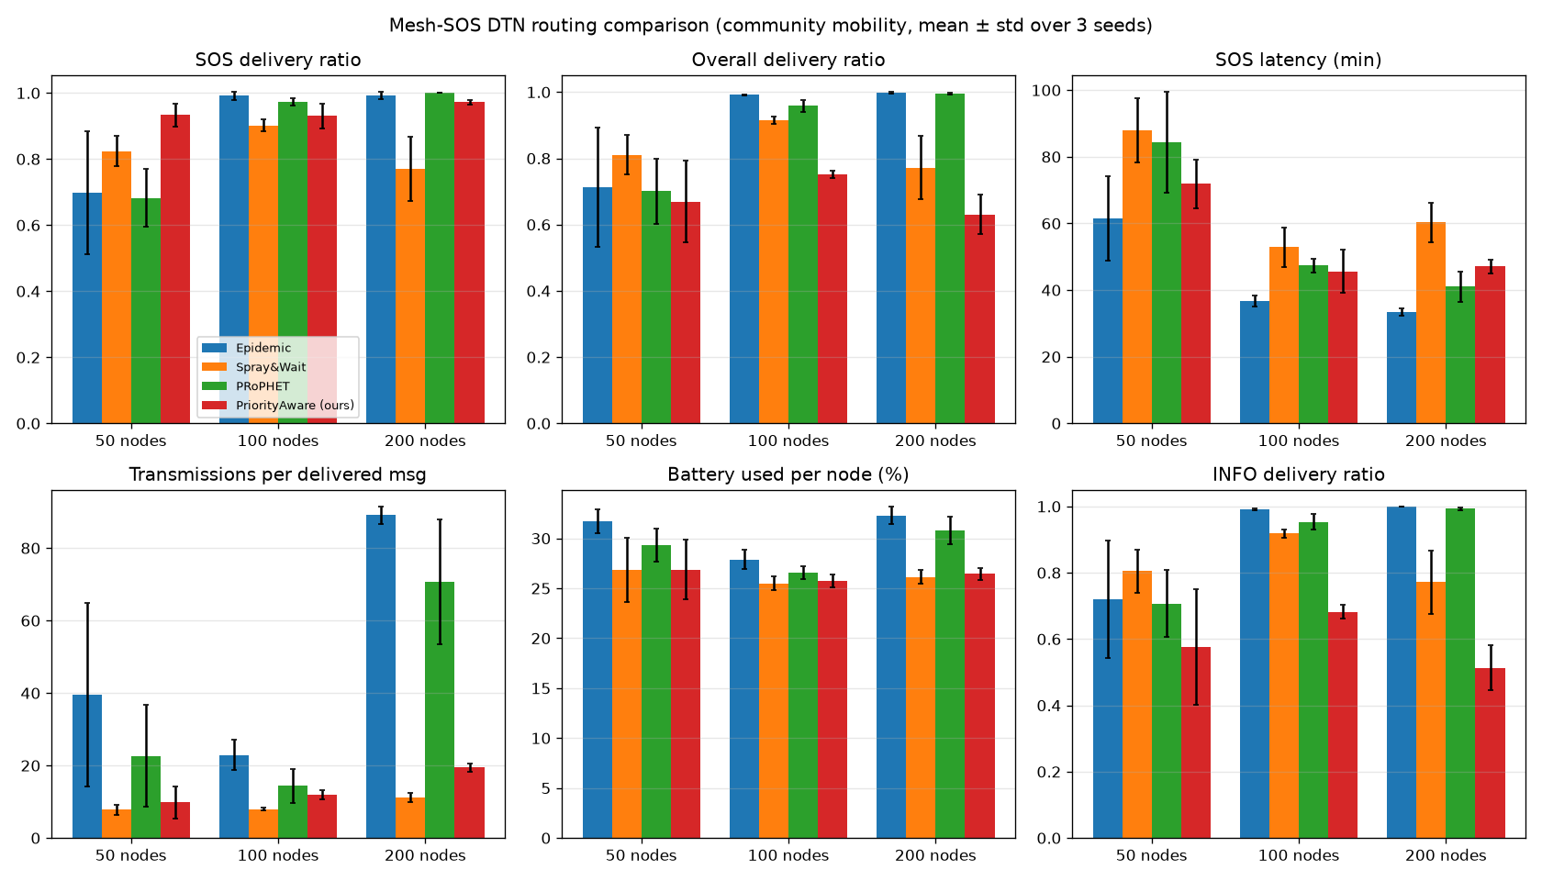
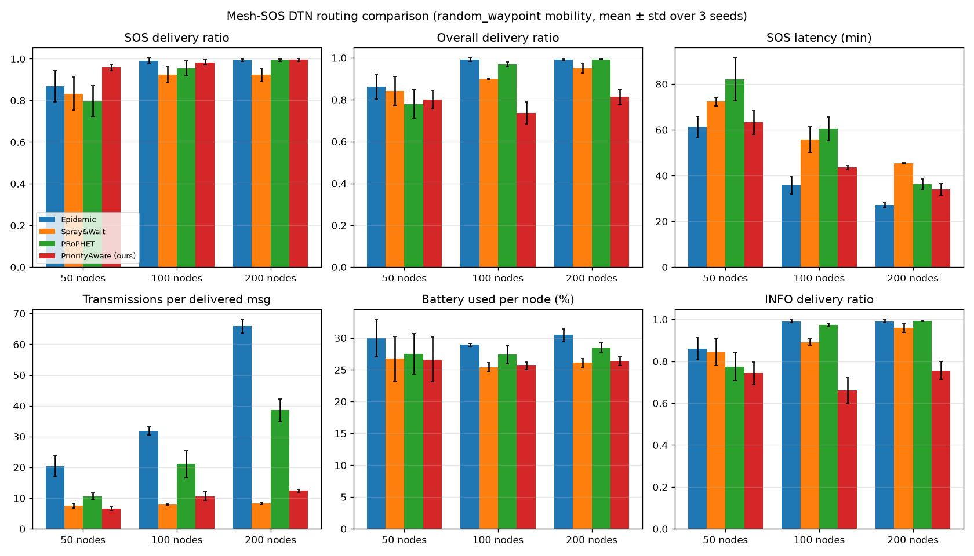
Interpretation (honest): PriorityAware-DTN wins clearly in sparse networks (50 nodes: SOS delivery 0.93-0.96 vs 0.70-0.87 for Epidemic) and always uses far fewer transmissions than Epidemic and PRoPHET. In dense networks (100-200 nodes) Epidemic and PRoPHET match or slightly beat it on SOS delivery and latency, but with 2-5x the transmissions and more battery. It deliberately sacrifices INFO messages (overall delivery 0.63-0.81). Spray-and-Wait has the lowest overhead but lower SOS delivery.
Prototype test (one machine, 4 processes, line topology A-B-C-D): an SOS from A reached the dashboard through 3 hops in about 9 s; ACK returned to A; with the gateway switched off the SOS was stored on A, B and C and was delivered about 4 s after the gateway returned.

7. Limitations
- Simulation uses synthetic mobility and an energy proxy (fixed cost per transmission and per time unit), not real traces or measured power.
- The prototype uses a shared Wi-Fi hotspot as the link layer; true infrastructure-less Wi-Fi Direct/BLE needs a native Android app.
- No PKI: signatures prove integrity, not real-world identity; SOS spam from new keys is possible.
- Real multi-device field tests must be done by the team; numbers above are from simulation and localhost.

8. Conclusion and future work
Mesh-SOS shows that urgency- and battery-aware DTN routing can get SOS messages out of a disconnected disaster zone using only existing phones. Future work: native Android Wi-Fi Direct/BLE, LoRa relays, real mobility traces from campus tests, and rescue-agency key distribution.

