COMPUTER NETWORKS

Ex.No.7 | Write a code using RAW sockets to implement packet sniffing.
DATE: | Write a code using RAW sockets to implement packet sniffing.

AIM:
To develop a Python program using raw sockets that captures Ethernet frames and extracts the source and destination MAC addresses and protocol details for network analysis and troubleshooting.
Definition:
Packet sniffing is the technique of capturing and examining network packets transmitted over a network to monitor communication, troubleshoot network issues, and analyze network traffic.
Algorithm:

- Start.
- Import the required modules.
- Get the local host IP address.
- Create and bind a raw socket.
- Enable IP header inclusion and promiscuous mode.
- Set the packet count to 5.
- Receive one packet at a time.
- Extract and display:
Destination MAC address
Source MAC address
Protocol type
Packet length
- Repeat until 5 packets are captured.
- Disable promiscuous mode.
- Display the completion message.
- Stop.

PROGRAM:
import socket
import struct

def get_mac_addr(bytes_addr):
"""Convert MAC address from bytes to readable format."""
return ':'.join('{:02X}'.format(b) for b in bytes_addr)

def get_protocol(bytes_proto):
"""Convert protocol bytes to hexadecimal."""
return hex(struct.unpack('!H', bytes_proto)[0])

def ethernet_frame(data):
"""Extract Ethernet frame information."""
dest_mac, src_mac, proto = struct.unpack('!6s6s2s', data[:14])
return (
get_mac_addr(dest_mac),
get_mac_addr(src_mac),
get_protocol(proto),
data[14:]
)
def main():
host = socket.gethostbyname(socket.gethostname())
print("Listening on:", host)
try:
# Create raw socket
conn = socket.socket(socket.AF_INET,
socket.SOCK_RAW,
socket.IPPROTO_IP)

# Bind socket
conn.bind((host, 0))

# Include IP header
conn.setsockopt(socket.IPPROTO_IP,
socket.IP_HDRINCL,
1)

# Enable promiscuous mode
conn.ioctl(socket.SIO_RCVALL, socket.RCVALL_ON)

print("\nPacket Sniffer Started...\n")

# Capture only 5 packets
packet_count = 5

for i in range(packet_count):

raw_data, addr = conn.recvfrom(65536)

print(f"\nPacket {i+1}")
print("-" * 40)

if len(raw_data) >= 14:
dest_mac, src_mac, eth_proto, data = ethernet_frame(raw_data)

print("Destination MAC :", dest_mac)
print("Source MAC :", src_mac)
print("Protocol :", eth_proto)
print("Packet Length :", len(raw_data), "bytes")

# Disable promiscuous mode
conn.ioctl(socket.SIO_RCVALL, socket.RCVALL_OFF)

print("\nPacket Sniffer Stopped Successfully.")

except PermissionError:
print("Run this program as Administrator.")

except KeyboardInterrupt:
conn.ioctl(socket.SIO_RCVALL, socket.RCVALL_OFF)
print("\nPacket Sniffer Stopped by User.")

if __name__ == "__main__":
main()

SAMPLE OUTPUT:

Listening on: 192.168.1.10

Packet Sniffer Started...

Packet 1
----------------------------------------
Destination MAC : 45:00:00:3C:1C:46
Source MAC : 40:06:B1:E6:C0:A8
Protocol : 0x101
Packet Length : 60 bytes

Packet 2
----------------------------------------
Destination MAC : 45:00:00:34:2F:9A
Source MAC : 40:11:C3:D8:C0:A8
Protocol : 0x101
Packet Length : 52 bytes

Packet 3
----------------------------------------
Destination MAC : 45:00:00:54:3B:8F
Source MAC : 40:06:91:AB:C0:A8
Protocol : 0x101
Packet Length : 84 bytes

Packet 4
----------------------------------------
Destination MAC : 45:00:00:28:5D:71
Source MAC : 40:01:6F:12:C0:A8
Protocol : 0x101
Packet Length : 40 bytes

Packet 5
----------------------------------------
Destination MAC : 45:00:00:3C:7A:15
Source MAC : 40:06:5A:9F:C0:A8
Protocol : 0x101
Packet Length : 60 bytes

Packet Sniffer Stopped Successfully.

OUTPUT:
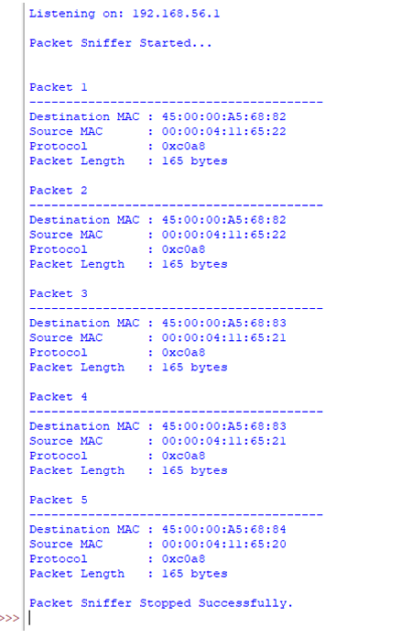

RESULT:
A RAW socket program was successfully implemented to capture and analyze network packets.The packet headers and basic network information were successfully examined using packet sniffing.

