COMPUTER NETWORKS

Ex.No.8 | Develop a simple calculator using XMLRPC
DATE | Develop a simple calculator using XMLRPC

AIM:
To develop a simple calculator using XMLRPC using Python.

Introduction: XML-RPC:
XML-RPC is a protocol that uses XML to encode remote procedure calls (RPC) and HTTP as a transport mechanism, allowing a client to call functions on a remote server over a network.

ALGORITHM:

CLIENT:
- Start the program.
- Import the xmlrpc.client module.
- Create a connection to the XML-RPC server using ServerProxy.
- Display the calculator menu:
  - Addition
  - Subtraction
  - Multiplication
  - Division
  - Exit
- Read the user's choice.
- If the user selects Exit, terminate the program.
- Otherwise, read two input numbers.
- Send the selected operation and the two numbers to the server.
- Receive the result from the server.
- Display the result.
- Repeat Steps 4–10 until the user chooses Exit.
- End the program.
SERVER:
- Start the program.
- Import the SimpleXMLRPCServer module.
- Define the calculator functions:
Addition
Subtraction
Multiplication
Division (check for division by zero).
- Create an XML-RPC server on localhost with port 8000.
- Register all the calculator functions with the server.
- Display the message "XML-RPC Server is Running on Port 8000...".
- Wait for client requests.
- When a client sends a request:
- Execute the requested arithmetic operation.
- Return the result to the client.
- Continue serving requests until the server is manually stopped.
- End the program.

PROGRAM CODE:

SERVER:

from xmlrpc.server import SimpleXMLRPCServer
# Calculator Functions
def add(a, b):
return a + b

def sub(a, b):
return a - b

def mul(a, b):
return a * b

def div(a, b):
if b == 0:
return "Error! Division by Zero"
return a / b

# Create XML-RPC Server
server = SimpleXMLRPCServer(("localhost", 8000))
print("XML-RPC Server is Running on Port 8000...")

# Register Functions
server.register_function(add, "add")
server.register_function(sub, "sub")
server.register_function(mul, "mul")
server.register_function(div, "div")

# Keep Server Running
server.serve_forever()

CLIENT:
import xmlrpc.client
# Connect to Server
proxy = xmlrpc.client.ServerProxy("http://localhost:8000/")
while True:
print("\n------ XML-RPC Calculator ------")
print("1. Addition")
print("2. Subtraction")
print("3. Multiplication")
print("4. Division")
print("5. Exit")

choice = int(input("Enter your Choice: "))

if choice == 5:
print("Calculator Closed.")
break

a = float(input("Enter First Number: "))
b = float(input("Enter Second Number: "))

if choice == 1:
print("Result =", proxy.add(a, b))

elif choice == 2:
print("Result =", proxy.sub(a, b))

elif choice == 3:
print("Result =", proxy.mul(a, b))

elif choice == 4:
print("Result =", proxy.div(a, b))

else:
print("Invalid Choice")

SAMPLE OUTPUT:
SERVER:
XML-RPC Server is Running on Port 8000...

127.0.0.1 - - [09/Jul/2026 11:05:10] "POST /RPC2 HTTP/1.1" 200 -
127.0.0.1 - - [09/Jul/2026 11:05:24] "POST /RPC2 HTTP/1.1" 200 -
127.0.0.1 - - [09/Jul/2026 11:05:38] "POST /RPC2 HTTP/1.1" 200 -
127.0.0.1 - - [09/Jul/2026 11:05:52] "POST /RPC2 HTTP/1.1" 200 -

CLIENT:
------ XML-RPC Calculator ------
1. Addition
2. Subtraction
3. Multiplication
4. Division
5. Exit

Enter your Choice: 1
Enter First Number: 15
Enter Second Number: 10
Result = 25.0

------ XML-RPC Calculator ------
1. Addition
2. Subtraction
3. Multiplication
4. Division
5. Exit
Enter your Choice: 2
Enter First Number: 15
Enter Second Number: 10
Result = 5.0

------ XML-RPC Calculator ------
1. Addition
2. Subtraction
3. Multiplication
4. Division
5. Exit

Enter your Choice: 3
Enter First Number: 15
Enter Second Number: 10
Result = 150.0

------ XML-RPC Calculator ------
1. Addition
2. Subtraction
3. Multiplication
4. Division
5. Exit

Enter your Choice: 4
Enter First Number: 15
Enter Second Number: 10
Result = 1.5

------ XML-RPC Calculator ------
1. Addition
2. Subtraction
3. Multiplication
4. Division
5. Exit

Enter your Choice: 4
Enter First Number: 15
Enter Second Number: 0
Result = Error! Division by Zero

------ XML-RPC Calculator ------
1. Addition
2. Subtraction
3. Multiplication
4. Division
5. Exit

Enter your Choice: 5
Calculator Closed.

OUTPUT:

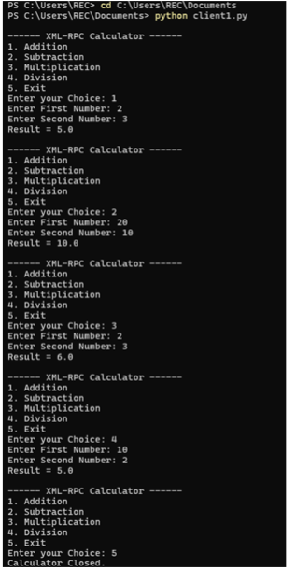

RESULT:
Thus a simple calculator was developed using xmlrpc in python.

