EX.NO:05 REG.NO:210701290

DATE:

**PUBLIC CLOUD CREATING AN INSTANCE IN IBM CLOUD**

**AIM:**

Develop a simple application to understand the concept of PAAS using IBM CLOUD.

**PROCEDURE:**

1. In the IBM Cloud console, go to Menu icon Menu icon > VPC Infrastructure > Compute > Virtual server instances.

2. Click Create and enter the information required.

3. Click Create virtual server instance when you are ready to provision.

**OUTPUT:**

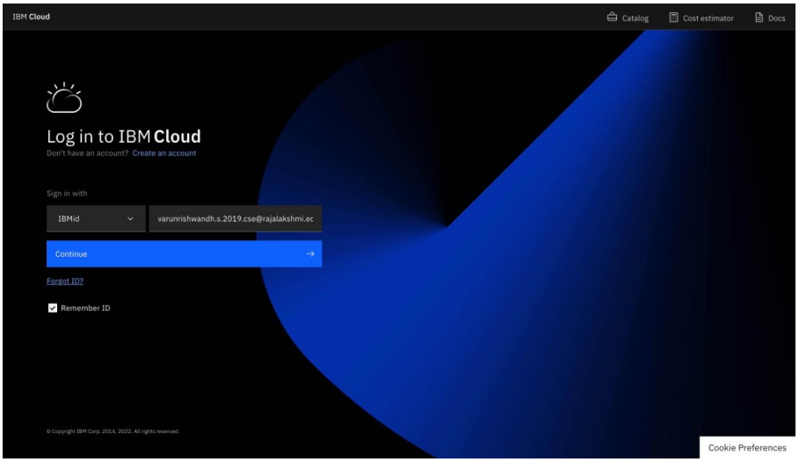

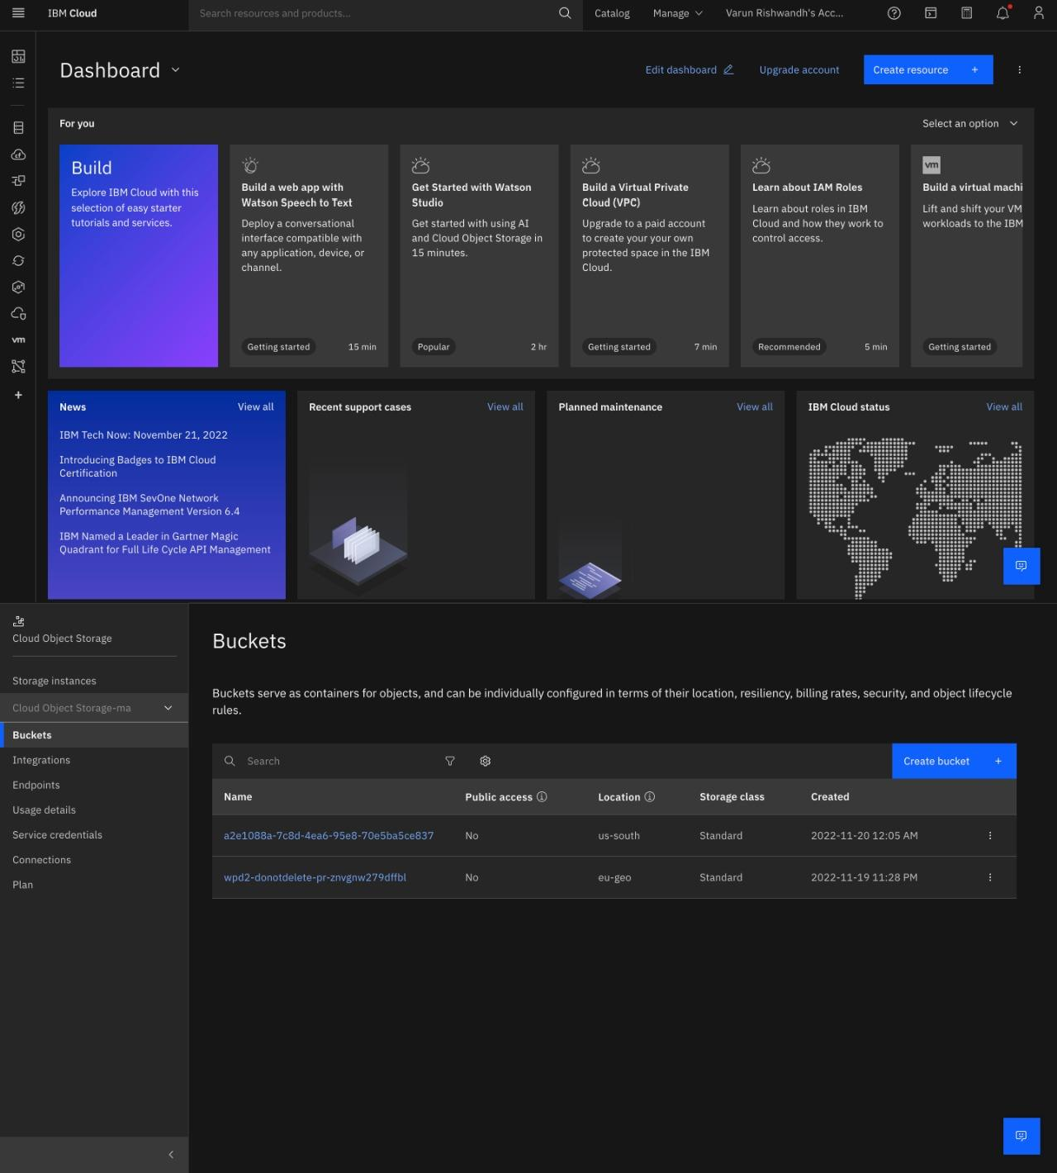

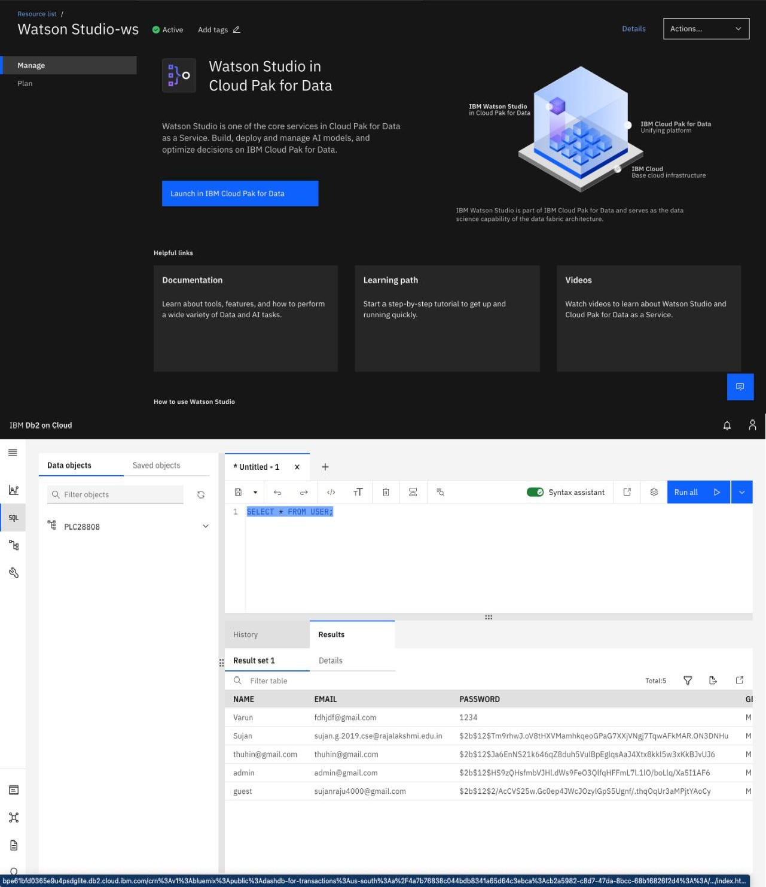

**RESULT:**

Thus virtual server instances has been created in IBM cloud successfully.