REAL-TIME CHAT APPLICATION
Project Abstract

Abstract
The Real-Time Chat Application is a web-based communication platform designed to provide fast, secure, one-to-one messaging between registered users. Built on the MERN stack (MongoDB, Express.js, React.js, and Node.js) with Socket.IO for real-time communication, the system enables users to register, log in securely, view available contacts, and exchange private messages instantly without refreshing the page.
User authentication is handled using JSON Web Tokens (JWT), while bcrypt securely hashes passwords before they are stored in the database, ensuring data protection throughout the application.

Objective
The primary objective of this project is to design and develop a reliable chat system that supports secure user registration and login, real-time private messaging, and persistent message history — while demonstrating practical, full-stack development skills.

System Design
Frontend
The frontend is built with React.js, providing a dynamic and responsive user interface. Axios handles communication between the React frontend and the backend REST APIs, while React Router manages navigation between the authentication and chat pages.
Backend
The backend is developed using Node.js and Express.js, which manage API requests, user authentication, user management, and message-related operations.
Database
MongoDB serves as the database, with Mongoose providing schema-based data modelling. Two core data models — User and Message — store user information, authentication data, online/offline status, timestamps, and chat messages.
Real-Time Communication
Socket.IO enables bidirectional communication between clients and the server, delivering messages instantly through private chat rooms that ensure messages reach only their intended recipients. Message history is persisted in MongoDB, allowing users to retrieve past conversations after logging in again.

System Architecture
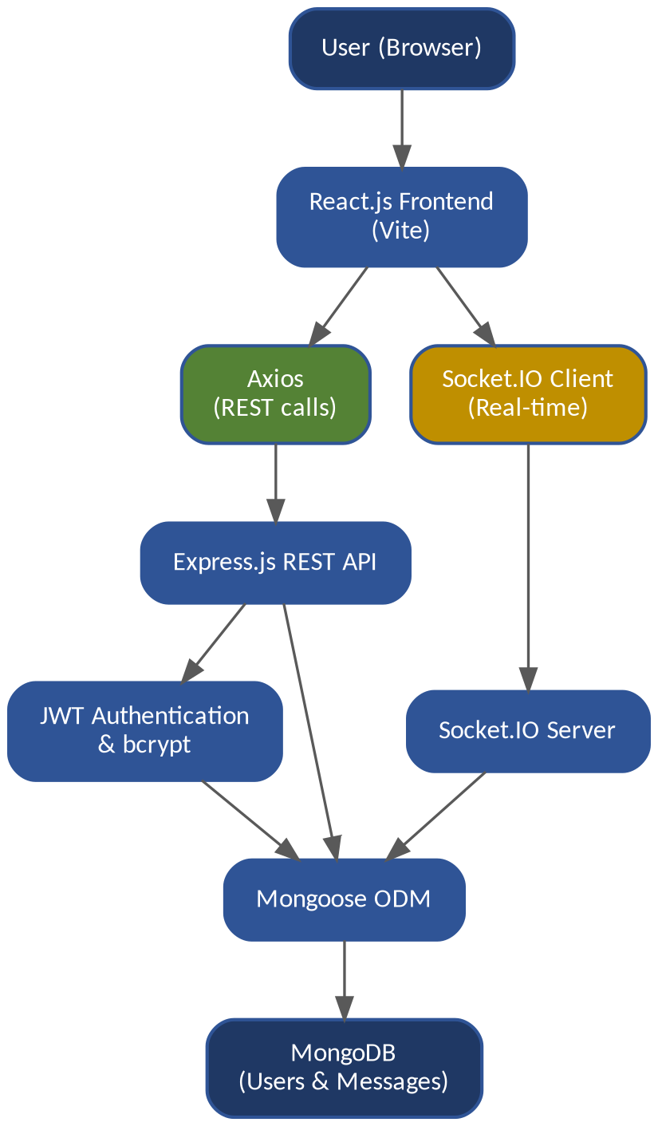

Technologies, Libraries & Packages
Category | Technology / Package | Purpose
Frontend | React.js | Build the user interface
Frontend | Vite | React development and build tool
Frontend | JavaScript, HTML5, CSS3 | Application logic, structure and styling
Frontend | React Router | Navigation between pages
API Communication | Axios | Send HTTP requests to the backend
Backend | Node.js | JavaScript runtime environment
Backend | Express.js | Build REST APIs and the backend server
Database | MongoDB | Store users and messages
Database | Mongoose | Schema modelling and database operations
Authentication | JWT | User authentication and protected APIs
Security | bcrypt | Password hashing
Real-Time | Socket.IO | Instant bidirectional messaging
Configuration | dotenv | Securely store environment variables
Backend | CORS | Enable frontend-backend communication
Development | Nodemon | Auto-restart backend during development
Version Control | Git & GitHub | Track and manage project source code
API Testing | Postman / Thunder Client | Test REST API endpoints

Key Features
Core Features (Phase 1)
- User registration and secure login
- JWT-based authentication
- Listing of available/registered users
- Private one-to-one messaging
- Persistent message storage and history
- Online / offline status tracking
Future Enhancements
- Typing indicators
- Read / unread message status
- User search functionality
- Message timestamps and profile pictures
- Emoji support
- Group chat functionality

Development Methodology
The project follows a REST API-first development approach, in which the basic communication between the React frontend, Express backend, and MongoDB database is established before implementing real-time Socket.IO functionality. This approach makes the application easier to develop, test, debug, and maintain.

Conclusion
Overall, this project demonstrates practical knowledge of full-stack web development, REST API design, database management, authentication, password security, real-time communication, and Git/GitHub-based project management — combining these skills into a functional, secure, and scalable real-time chat platform.

