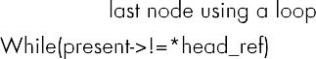
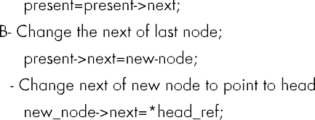

6
10 20 30 45 34 56
6
1 2 11 12 56 90

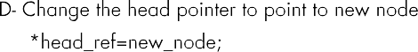
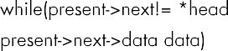
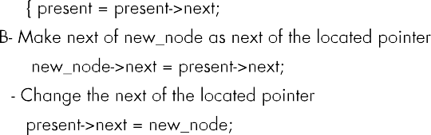


10 20 30 34 45 56 1 2 11 12 56 90

struct Node *next; void sortedInsert(struct Node** head_ref, struct Node* new_node)

6 345 68

