PROJECT REPORT TEMPLATE

1. INTRODUCTION :

* 1. OVERVIEW :

1 .Travel request submission: Employees can submit their travel requests through the application. The application will prompt the employee to enter details such as the purpose of the travel, dates of travel, destination, mode of transportation, and estimated expenses.

2 .Approval workflow: The travel request is then sent to the employee's manager for approval. The manager can approve, reject or request further information from the employee.

* 1. PURPOSE :

1. Simplify the travel approval process: With an employee travel approval application, employees can easily submit travel requests, and managers can quickly review and approve them. This can help to reduce the administrative burden on both employees and managers.
2. Improve compliance with corporate travel policies: An employee travel approval application can enforce corporate travel policies and ensure that employees are traveling in a compliant manner. The application can also provide real-time updates on travel expenses and ensure that the expenses are within the allocated budget.

1. .PROBLBM DEFINITION & DESIGN THINKING

2.1 EMPATHY MAP :

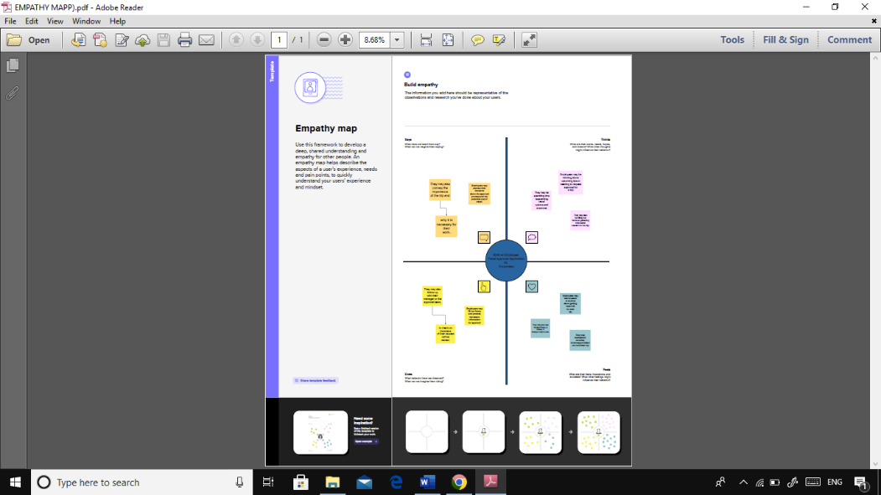

2.2 IDEATION & BRAINSTORMING MAP

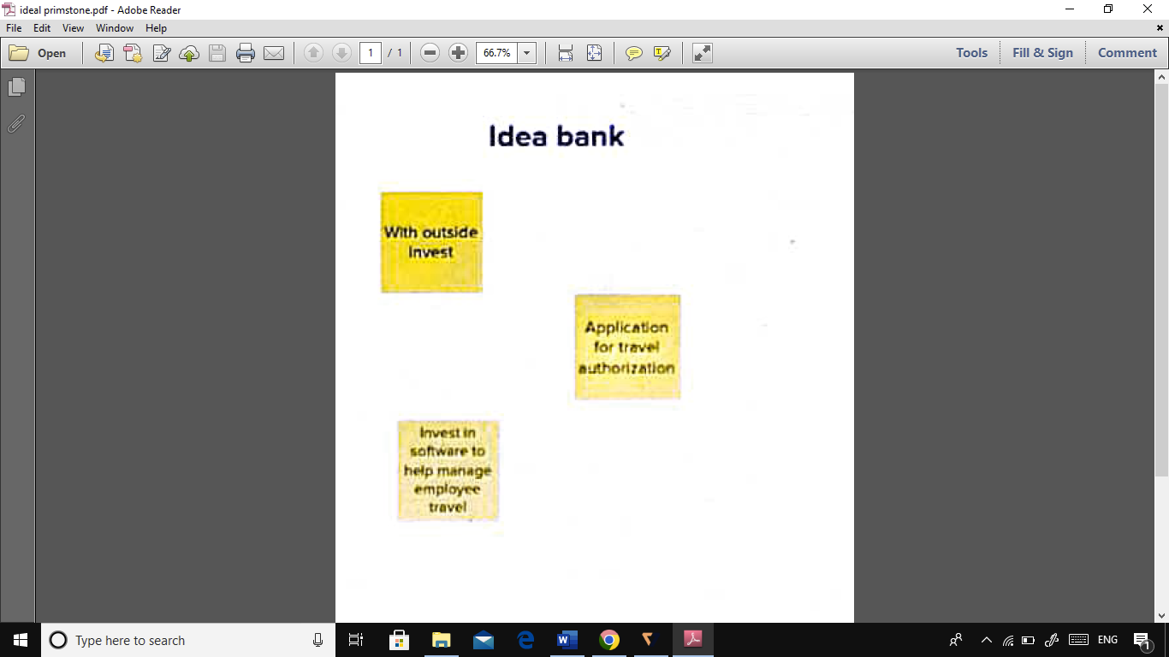

3. RESULT

3.1 DATA MODEL :

|  |  |
| --- | --- |
| OBJECT NAME | FIELD IN THE OBJECT |
| OBJECT 1 | |  |  | | --- | --- | | FIELD LABLE | DATA TYPE | | DEPARTMENT | TEXT | | TRAVEL APPROVAL | AUTO NUMBER | |
| OBJECT 2 | |  |  | | --- | --- | | FIELD LABLE | DATA TYPE | | EXPANSE ITEM | PICKLIST | | STUDENT | CURRENCY | | TRAVEL APPROVAL | MASTER -DETAIL RELATIONSHIP | | TRAVEL APPROVAL | ROLL – UP SUMMARY | |

3.2 : ACTIVITY & SCREENSHOT ;

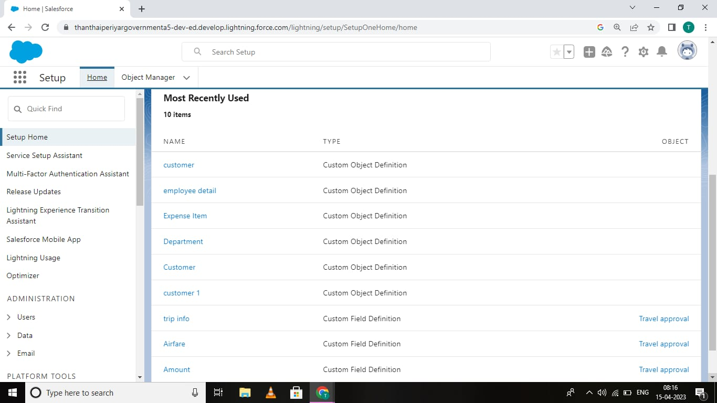

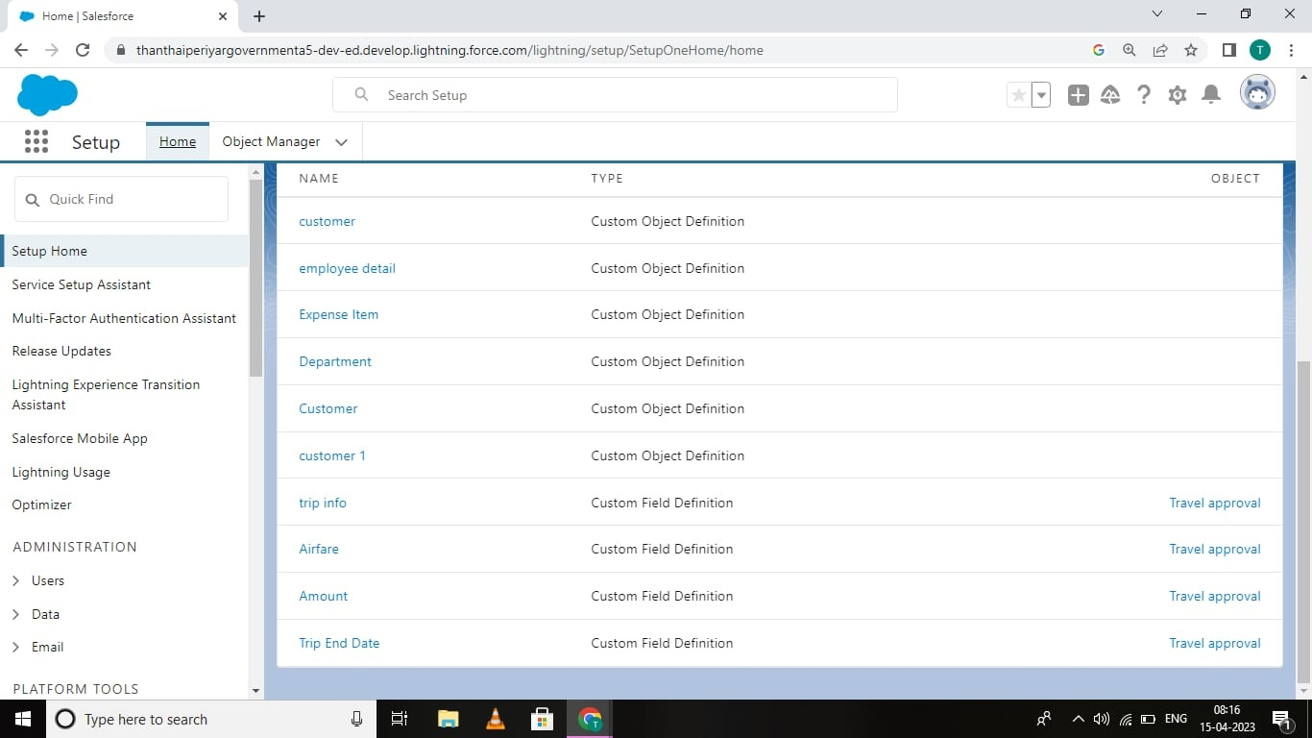

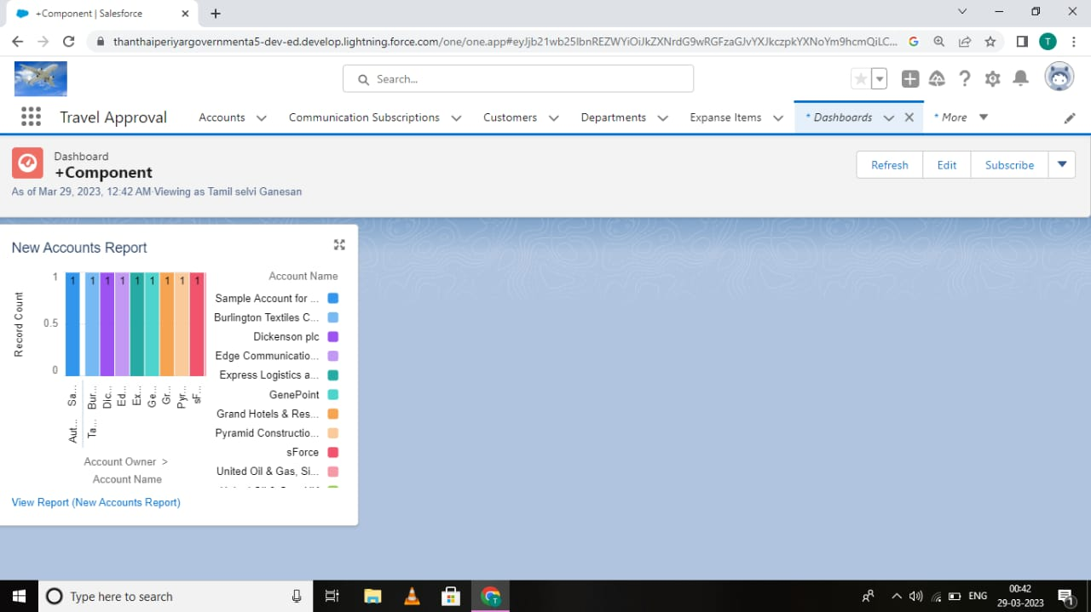

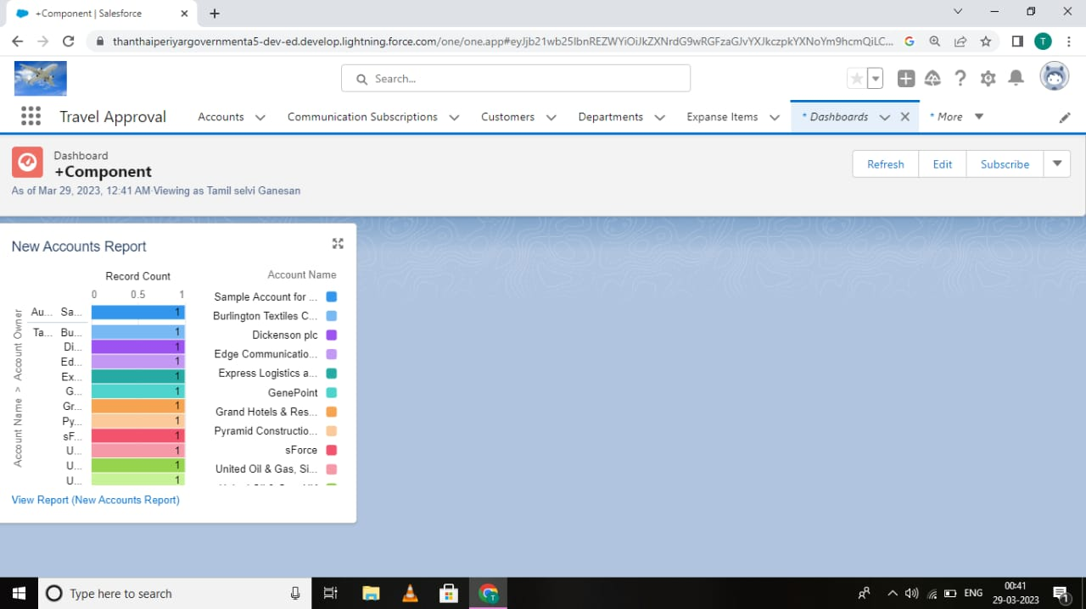

4. TRAILHEAD PROFILE PUBLIC URL ;

TEAM LEADER - <https://trailblazer.me/id/tganesan6>

TEAM MEMBER 1 - <https://trailblazer.me/id/pnallaiya>

TEAM MEMBER 2 - <https://trailblazer.me/id/rbalakrishnan28>

TEAM MEMBER 3 - <https://trailblazer.me/id/ssubramaniyam8>

5. ADVANTAGES & DISADVANTAGE :

ADVANTAGES :

1. Streamlined process: The application can simplify and automate the travel approval process, reducing the administrative burden on both employees and managers.
2. Improved compliance: The application can enforce corporate travel policies, ensure that employees are traveling in a compliant manner, and provide real-time updates on travel expenses.
3. Increased efficiency: By automating the travel booking process and providing real-time updates on travel requests, the application can increase efficiency and productivity for both employees and managers.

DISADVANTAGE :

1. Initial cost: Developing and implementing an employee travel approval application can be expensive, especially for small businesses.
2. Technical requirements: The application requires technical expertise to develop and maintain, which can be challenging for some organizations.
3. Resistance to change: Employees and managers may be resistant to changing their current travel approval process, especially if they are used to traditional methods like paper-based forms or emails.
4. Security concerns: The application may be susceptible to security threats, such as data breaches or unauthorized access to sensitive information.

6.APPLICATION :.

1. Identify the requirements: Work with stakeholders, including employees, managers, and corporate travel managers, to identify the features and functionality required for the application. Some of the key features to consider include travel request submission, approval workflow, budget tracking, travel booking, reporting and analytics, and mobile accessibility.
2. Design the application: Once you have identified the requirements, design the application architecture, user interface, and user experience. Consider factors such as ease of use, visual appeal, and integration with existing systems.
3. Develop the application: Use programming languages and software development tools to build the application. Ensure that the application is scalable, secure, and meets the identified requirements.

7. CONCLUSION :

Building an employee travel approval application for corporates can help organizations to optimize their travel approval process, reduce costs, improve compliance with corporate travel policies, and enhance the employee experience. While there may be some initial costs and technical challenges associated with developing and implementing the application, the benefits can outweigh the disadvantages in the long run.

By working closely with stakeholders to identify requirements, designing an application that is user-friendly and visually appealing, developing a scalable and secure application, testing thoroughly, deploying to a production environment, training users, and maintaining and updating the application regularly, organizations can build an effective employee travel approval application that meets their specific needs.

8. FUTURE SCOPE :

1. Integration with emerging technologies: The application could be integrated with emerging technologies such as AI, machine learning, and blockchain to further streamline the travel approval process, improve compliance, and enhance the overall travel experience.
2. Increased customization: Organizations may require more customized solutions to meet their specific needs. The application could offer greater flexibility and customization options to meet these demands.
3. Enhanced mobile capabilities: As mobile technology continues to evolve, the application could become even more mobile-friendly, allowing employees and managers to submit and approve travel requests on-the-go.