# PROJECT REPORT TEMPLEATE

**BUILD A EMPLOYEE TRAVEL APPROVAL APPLICATION FOR CORPORATES**

**TEAM ID : NM2023TMID18356**

**1.INRODUCTION**

**1.1 Overview :**

The project aim is to provide real-time knowledge for all the students who have basic knowledge of Salesforce and Looking for a real-time project.

This project will also help to those professionals who are in cross-technology and wanted to switch to Salesforce with the help of this project they will gain knowledge and can include into their resume as well.

**1.2 Purpose :**

* Job positing
* Rewards & Incentives
* Resolving conflicts
* Performance Appraisal .
* Training & Development .
* Maintaining Healthy Work culture.
* Organizing various activities.
* Payroll management.

**2. Problem Definition & Design Thinking**

**2.1 Empathy map** :

An empathy map is a collaborative visualization used to articulate what we know about a particular type of user. It externalizes knowledge about users in order to

1. create a shared understanding of user needs, and aid in decision making
2. aid in decision making

|  |  |
| --- | --- |
| PROJECT NAME | BUILDA EMPLOYEE TRAVEL APPROVAL APPLICATION FOR CORPORATES |
| TEAM ID | NM2023TMID17857 |
| DATE | 21 / 03 / 2023 |
| NAME | THAMILSELVI.N |

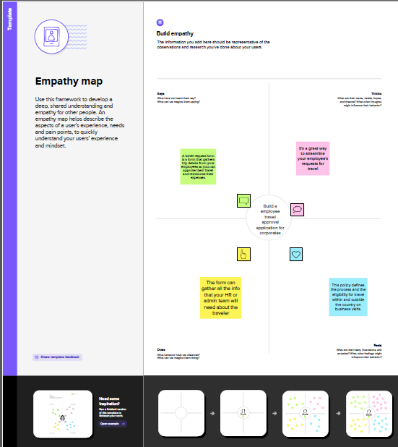

**2.2 Brainstorming :**

Brainstorming is a group problem-solving method that involves the spontaneous contribution of creative ideas and solutions.

This technique requires intensive, freewheeling discussion in which every member of the group is encouraged to think aloud and suggest as many ideas as possible based on their diverse knowledge.

|  |  |
| --- | --- |
| PROJECT NAME | BUILDA EMPLOYEE TRAVEL APPROVA APPLICATION FOR CORPORATES |
| TEAM ID | NM2023TMID17857 |
| DATE | 28 / 03 / 2023 |
| NAME | TAMILSELVI.N |

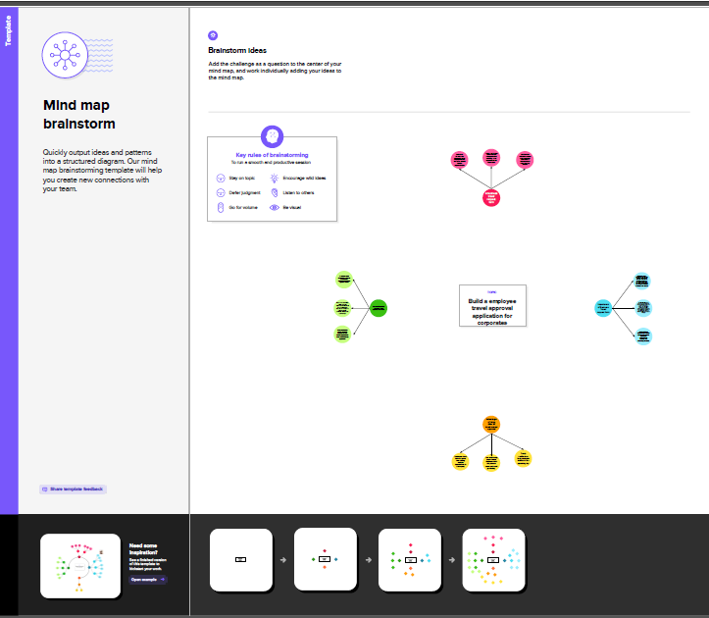

# RESULT

**3.1 Data Model :**

|  |  |  |  |
| --- | --- | --- | --- |
| Object name | | Field label | Data type |
| **1** | Department | Department | Currency |
| Travel approval | Travel approval | Currency |
| **2** | Expense item | Expense item | Currency |
| Account | Account | Currency |

**3.2 Activity & Screenshort :**

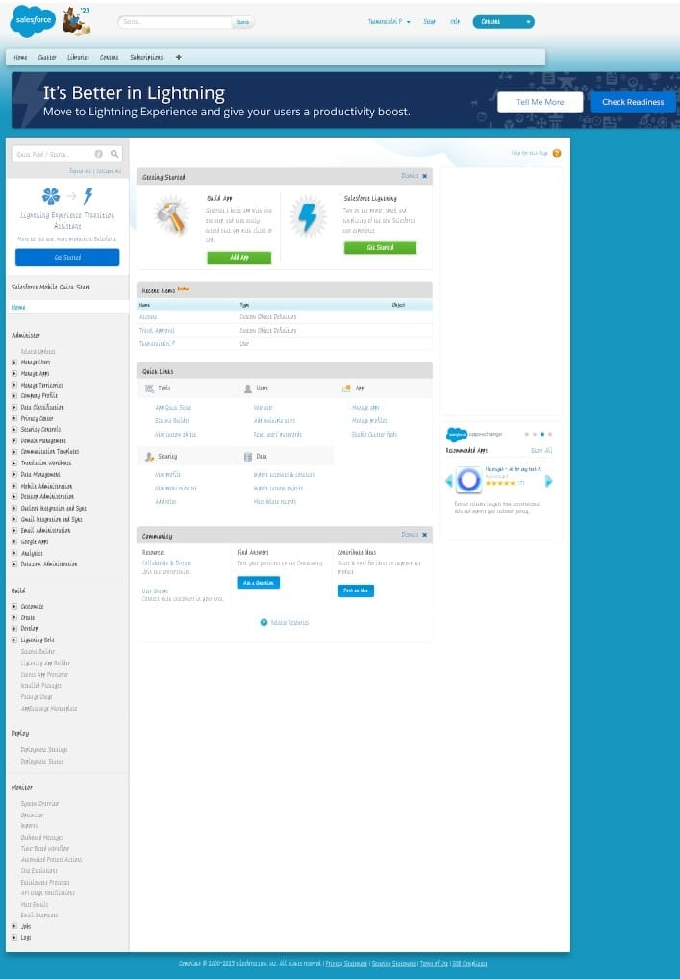

# TRAILHEAD PROFILE PUBLIC URL

Team Leader - https://trailblazer.me/id/tnagaraj15

Team Member 1 - https://trailblazer.me/id/sugab4

Team Member 2 - https://trailblazer.me/id/suryv11

Team Member 3 - http://trailblazer.me/id/tselvi35

# ADVANTAGES & DISADVANTAGES

**Advantages :**

* Approvals on time .
* Faster process.
* Increase compliance and reduce costs.
* Customize approval workflows.
* Improve employee relation .

**Disadvantages :**

* Travel expenses
* Lack of productivity
* It harms health and fitness
* Traveling can be anxious
* Insufficient information

**6.APPLICTION**

# 

* The travel support system is a small sample application for naturalONE. As a sample application ,its focus is to show naturalONE functionality rather than being a full-fledged

travel support application.

* The Travel support system (TSS) allows you to request and approve business trips . Flights , hotels and even more external information such as cell phone expenses or car rentals can be entered with the trip request. For destination , weather information can be queried.
* A Manager can do both, request own trip as well as approve trips that have been requested by employees. After the manager has approved single or multiple requests, the manager can print an itinerary or receive the itinerary as a PDF files .

# CONCLUSION

In conclusion , This blog concludes with the advantages and disadvantage of business travel . The primary purpose of business travel is to develop new ideas about business operations . On the other hand, the disadvantage of business travel is that it enchances the organizations expense . So it may affect the growth of the organization.

# FUTURE SCOPE

The project has a very vast scope in future . The project can be implemented on internet in future.