FITNESS & WELLNESS CLUB – BUDGET SUMMARY

✨ Introduction
A Budget Summary is a financial plan that shows the estimated income and expenses of the Fitness & Wellness Club. It helps the club manage money properly and organize activities such as yoga sessions, fitness events, awareness programmes, workshops, and competitions.

Estimated Income
Source of Income | Amount (₹)
Membership Fees | ₹15,000
Event Registration Fees | ₹8,000
Sponsorship & Donations | ₹10,000
Institution Support | ₹7,000
Total Income | ₹40,000

Estimated Expenses
Expense Category | Amount (₹)
Yoga & Fitness Equipment | ₹8,000
Guest Trainer / Instructor | ₹7,000
Fitness Events & Activities | ₹6,000
Prizes & Certificates | ₹4,000
Posters & Promotional Materials | ₹3,000
Refreshments & Wellness Activities | ₹5,000
Emergency & Miscellaneous Expenses | ₹2,000
Total Expenses | ₹35,000
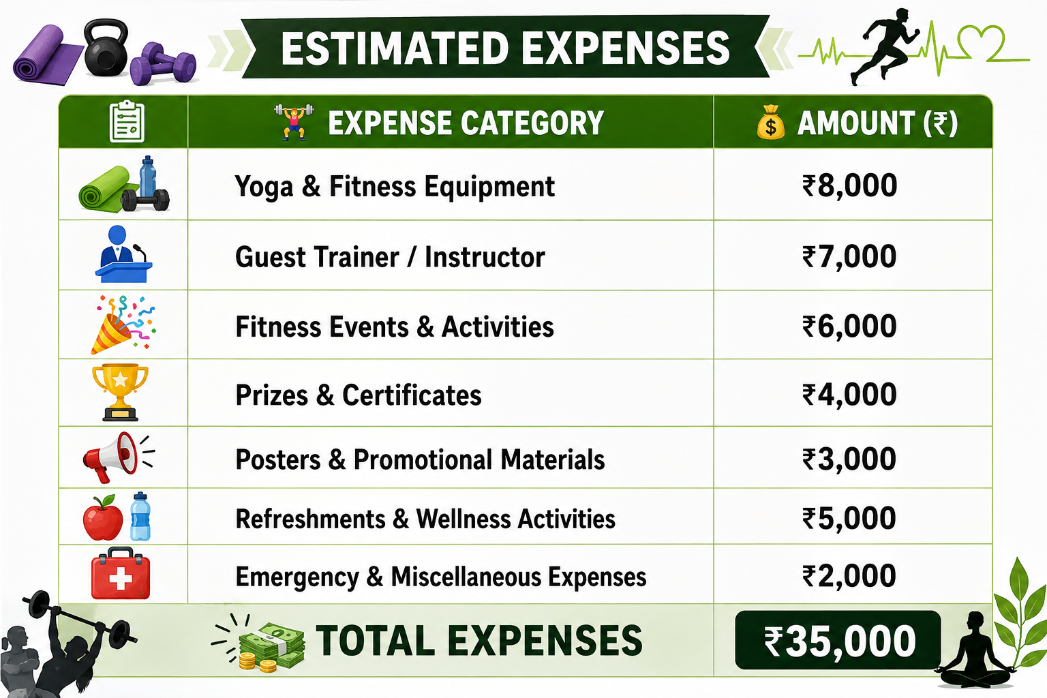

- Budget Overview

    - Total Income: ₹40,000
    - Total Expenses: ₹35,000
    - Remaining Balance: ₹5,000

Major Areas of Spending

Health & Wellness Programmes
Funds are used to conduct yoga sessions, meditation programmes, mental wellness activities, and health awareness campaigns.


Fitness Activities

The budget supports fitness challenges, exercise sessions, sports activities, and wellness workshops.
- Student Motivation
Prizes, certificates, and recognition awards are provided to encourage active participation and maintain enthusiasm among club members.


Event Promotion

Money is allocated for creating posters, banners, invitations, and awareness materials to promote club activities.


Financial Goal of the Club
“Spend wisely, stay healthy, and build a stronger wellness community!”
The Fitness & Wellness Club aims to use its budget responsibly so that maximum benefits reach students. Proper financial planning ensures that every activity is conducted successfully while maintaining a healthy balance for future programmes.


A Healthy Investment Today Creates a Healthier Tomorrow!

